**GUJARAT TECHNOLOGICAL UNIVERSITY**

**Chandkheda, Ahmedabad**

 

A Report On-

***AUTOMATIC PLANT WATERING SYSTEM***

Submitted by:

1. Shaikh Rukhsar A. 160320111050

2. Barot Yatri S. 160320111003

3. Jhala Dhanvi V. 160320111018

B. E. III, Semester – VI

Electronics & Communication Department

Internal Guide:Ms. Sneha Shah HOD: Mosam K Pandya

Sign: Sign:

**Abstract**

Herein we introduce automatic plant watering system, which is considered as one of the most commonly used and the most beneficial automated systems nowadays, which help people in their daily activities by reducing or completely replacing their effort. This system uses sensor technology along with microcontroller and other electronics in order to behave like smart switching system which senses soil moisture level and irrigates the plant if necessary. Purpose of this work is to show how someone can easily make own and cheap automatic plant watering system in just few hours by connecting certain electronic components and other materials required. In our experiment, we connected all required materials exactly as shown in this paper, in order to test whether our system will work properly or not. Although the system made in

that way would be the most appropriate for home usage as solution for some daily and usual issues, there is a wide spectrum of possibilities of implementing these systems as a long-term solution for many agricultural and medical problems, some of which are undernourishment and air pollution as most prominent, dangerous and important ones. As one possible agricultural solution, this system can be very helpful in keeping vegetables and other useful and specific plants watered for bigger harvest, which enables farmers from all around world to breed crops of these plants which are the most wanted and the most commonly used in diet. As medical solution, these systems can be used for purpose of cultivating certain plants that are famous and well known by their ability to remove air pollutants and therefore reduce the concentration

of toxic pollutants in the air as well the occurrence of respiratory diseases. Future possibilities include some challenging and demanding ideas like joining plants of similar variety and characteristics into complex connections of plants, called “Internet of plants”. There are also many other possibilities like using more than one sensor or solar power supply for experimental purposes, but the fact is however, that, independently of the materials used and the way in which they are connected, this type of automated systems can be very helpful in solving very wide of human-related problems nowadays.

**Introduction**

Since nowadays, in the age of advanced electronics and technology, the life of human being should be simpler and more convenient, there is a need for many automated systems that are capable of replacing or reducing human effort in their daily activities and jobs. Here we introduce one such system, named as automatic plant watering system,which is actually a

model of controlling irrigation facilities that uses sensor technology to sense soil moisture

with a microcontroller in order to make a smart switching device to help millions of people

Can we automatically water our home and garden plants without bothering our neighbors when we decide to go on vacation or somewhere else for a long period.

**Block diagram**

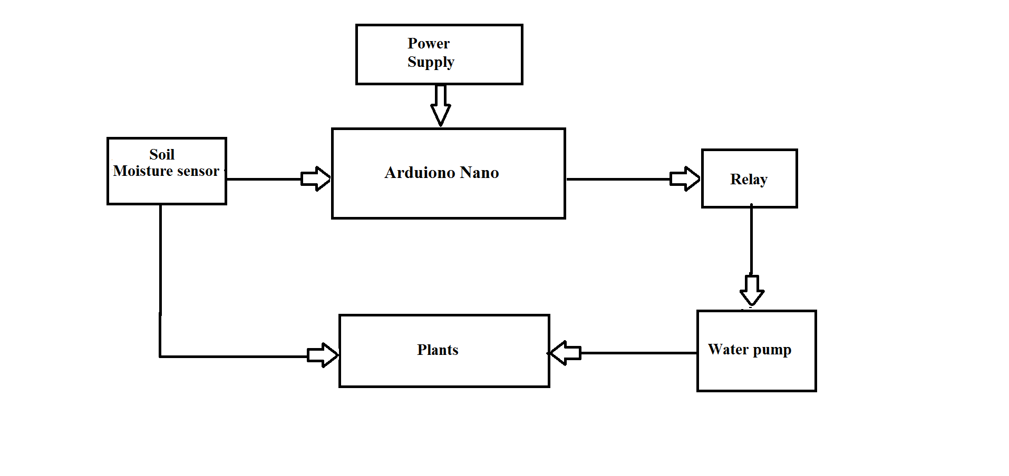

**Materials and Methods**

Although there are some companies selling these systems made in various ways, there is a simple way in which one can build his/her own plant watering system in just a few hours, if all required materials are available along with basic required knowledge about electronics. For the purpose of building this system one will need to properly connect following:



In our experiment, we connected all required materials exactly as shown in Figure above, in order to test whether our system will work properly or not. Also, the overall behavior and the appearance of our plan.

Working principle

The main working principle behind this system is in connecting the soil moisture sensor, which was previously embedded into the plant, to the Arduino microcontroller, which is also connected to other electronic components listed above as shown in Figure above. Measurement of soil

moisture is done by the sensor which forwards the information and parameters regarding the soil moisture to the microcontroller, which controls the pump. If the level of soil moisture drops below a certain value, the microcontroller sends the signal to the relay module which then

runs a pump and certain amount of water is delivered to the plant. Once the enough water is delivered, the pump stops doing its work. Power supply has a task to power the complete system and the recommended voltage should respect the input supply range for the microcontroller, that

is, from 7V to 12V. Relay module is a simple circuit consisting of a single transistor, several resistors, diodes and a relay and it is controlled digitally by microcontroller. Since the complete system should be embedded in a small box, Arduino Nano is a perfect microcontroller for this

purpose because of its dimensions and its work performance. Soil moisture module is consisting of the two parts: amplifier circuit and probes. This module has digital and analog outputs, where digital output is set to logical 1 when the threshold is activated. The threshold is set by

potentiometer. Analog output gives the real time information regarding the moisture in the plant and this output is used in the system. Water pump is connected to the relay module and it only works when the relay module gets a command from the microcontroller, whose working principle is described via flow chart diagram in figure.



**Components**

**Arduino Nano:** The Arduino Nano is a small, complete, and breadboard-friendly board based on the ATmega328P (Arduino Nano 3.x). It has more or less the same functionality of the Arduino Duemilanove, but in a different package.

|  |  |
| --- | --- |
| Microcontroller | ATmega328 |
| Architecture | AVR |
| Operating Voltage | 5 V |
| Flash Memory | 32 KB of which 2 KB used by bootloader |
| SRAM | 2 KB |
| Clock Speed | 16 MHz |
| Analog IN Pins | 8 |
| EEPROM | 1 KB |
| DC Current per I/O Pins | 40 mA (I/O Pins) |
| Input Voltage | 7-12 V |
| Digital I/O Pins | 22 (6 of which are PWM) |
| PWM Output | 6 |
| Power Consumption | 19 mA |
| PCB Size | 18 x 45 mm |
| Weight | 7 g |
| Product Code | A000005 |

**Relay:**

A Relay is an electrically operated switch.

**Soil Moisture Sensor:**

Soil moisture sensor measures the volumetric water content in soil.Soil moisture sensor are used in numerous research applications e.g in agricultural science including irrigation planning,climate research etc.

**Conclusion and Future Possibilities**

Although it seems to be more demanding and challenging, there are many other possibilities like creating complex connections of plants of similar variety or so-called Internet of Plants. Also, using more than one sensor is another idea for an experimental venture, but there are

also many other experimental and challenge-like ideas such as using solar power supply, timer for setting irrigation system etc. However, independently of the way used to construct it, there is no doubt that this system can be very helpful in solving many problems. Amount of water released from the process of watering the plant. Although it can be very helpful for humanity in general, agriculturists, craftsmen, and botanists are the people who could have the biggest benefit of using this system.