This documents are for the proof of running this project call Library management system. I may not cover all the details testing of this project. Please consider it.

Firstly, I like to share the Screenshot of the option 1.

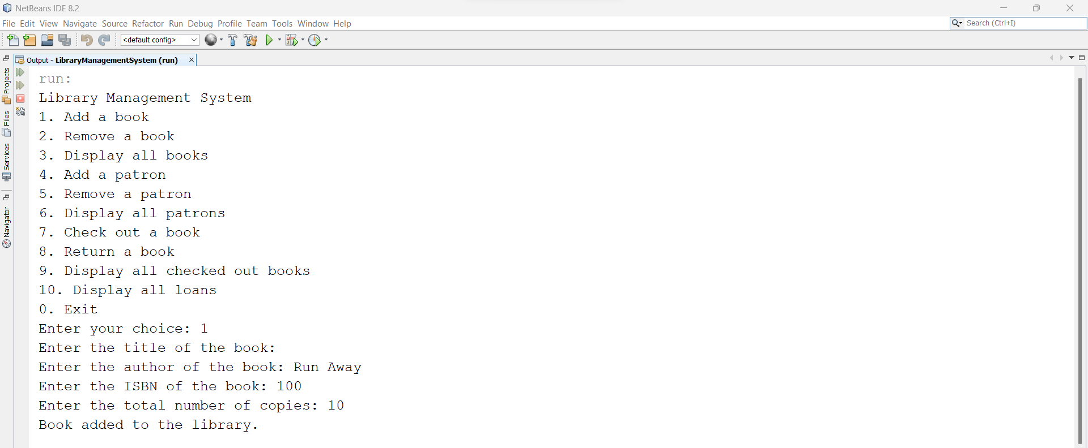

Adding another book in the list.

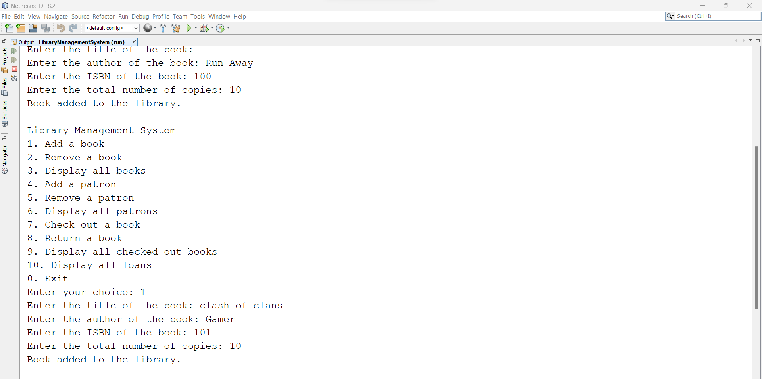

Removing a book with ISBN number, It will delete entire book of the same ISBN ID.

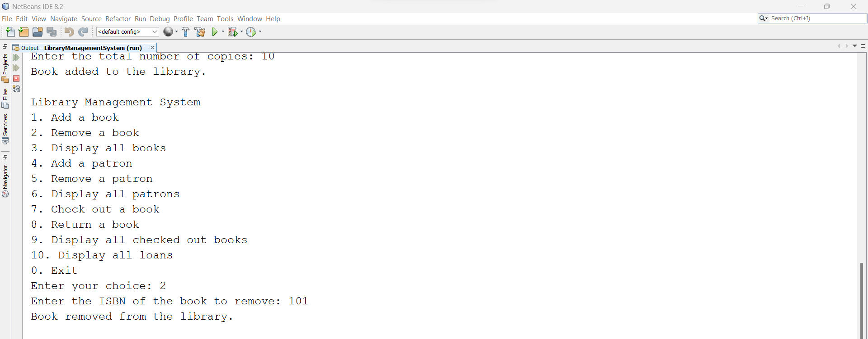

Let’s move to the next option that is number 3. It shows the remaining book that is available in the library system.

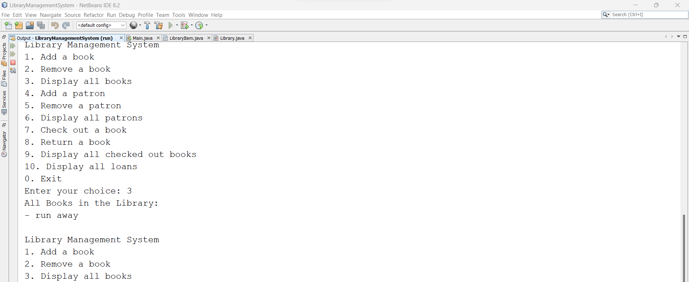

After option 3 let’s move to the option 4. This option allows us to add new patron in the library system. But I have added 2 patron here.

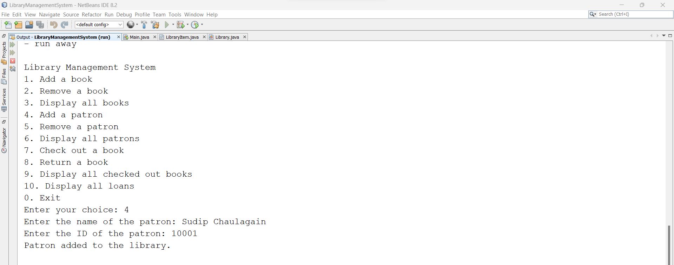

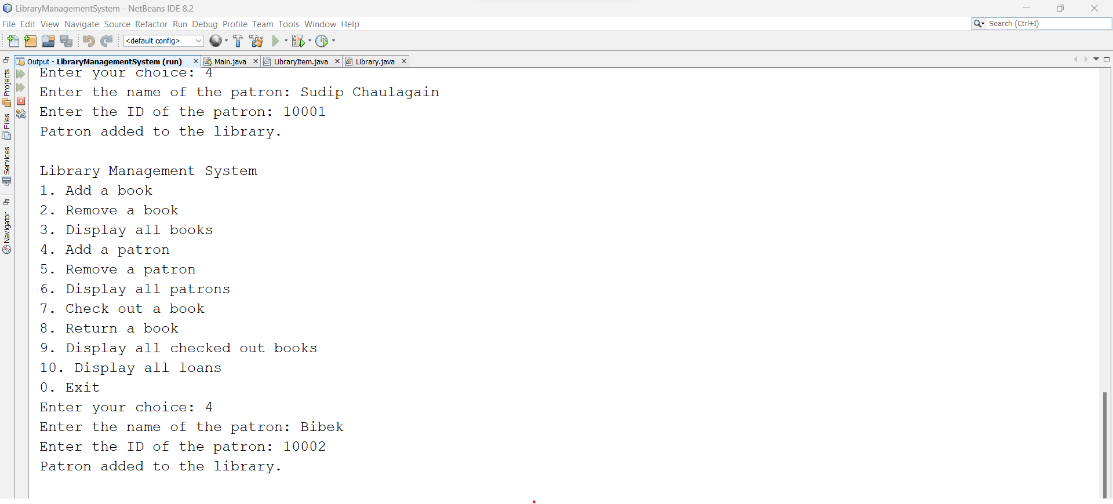

Let’s move to the option 6, whether it will display both patron or not.

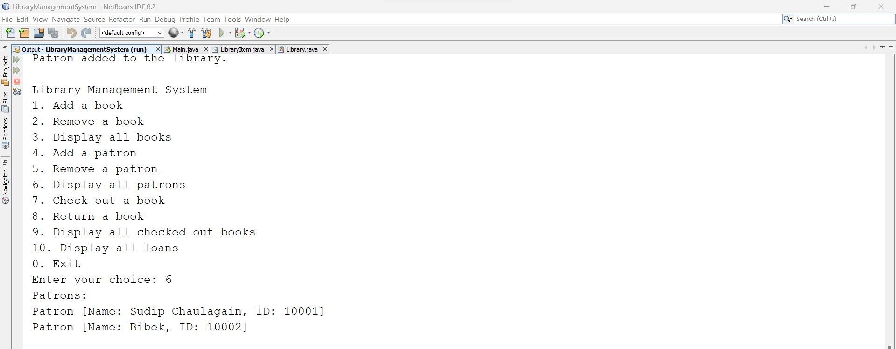

Wow, it’s worked! Now, it’s time to test option 5 to remove the patron

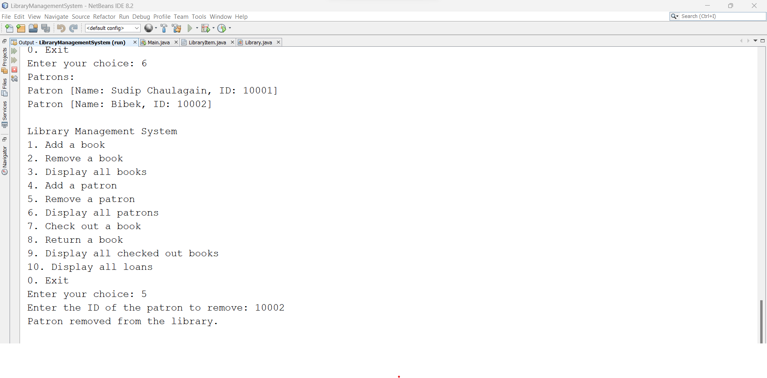

Again, Let’s try to find out the remaining patron who is available in library system.

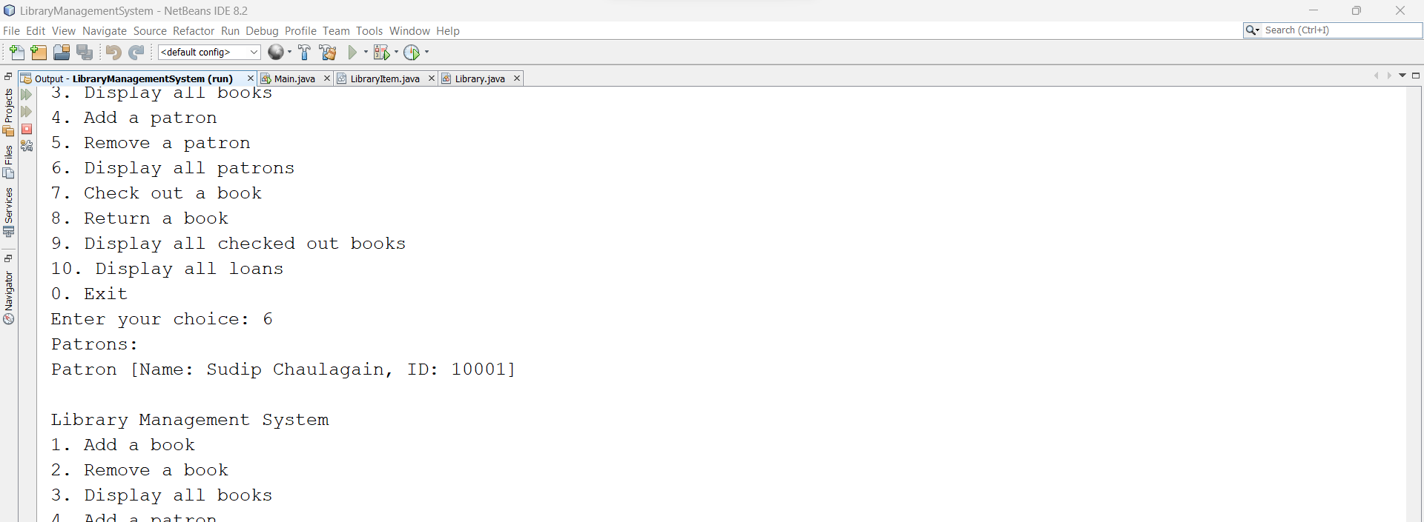

Let’s move to the option 7 where patron are try to checked out books from the library system.

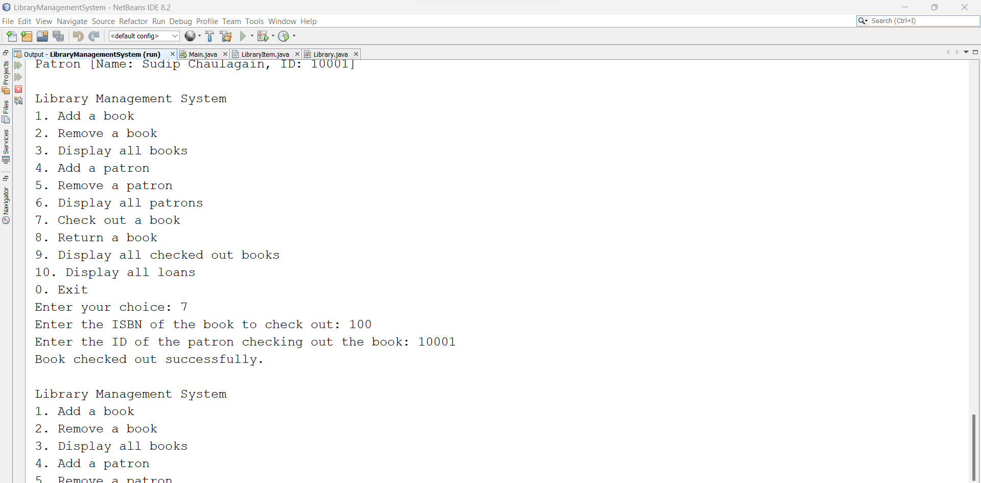

Now, It is successfully checkout the book from the library system. Then let’s move to the option 8

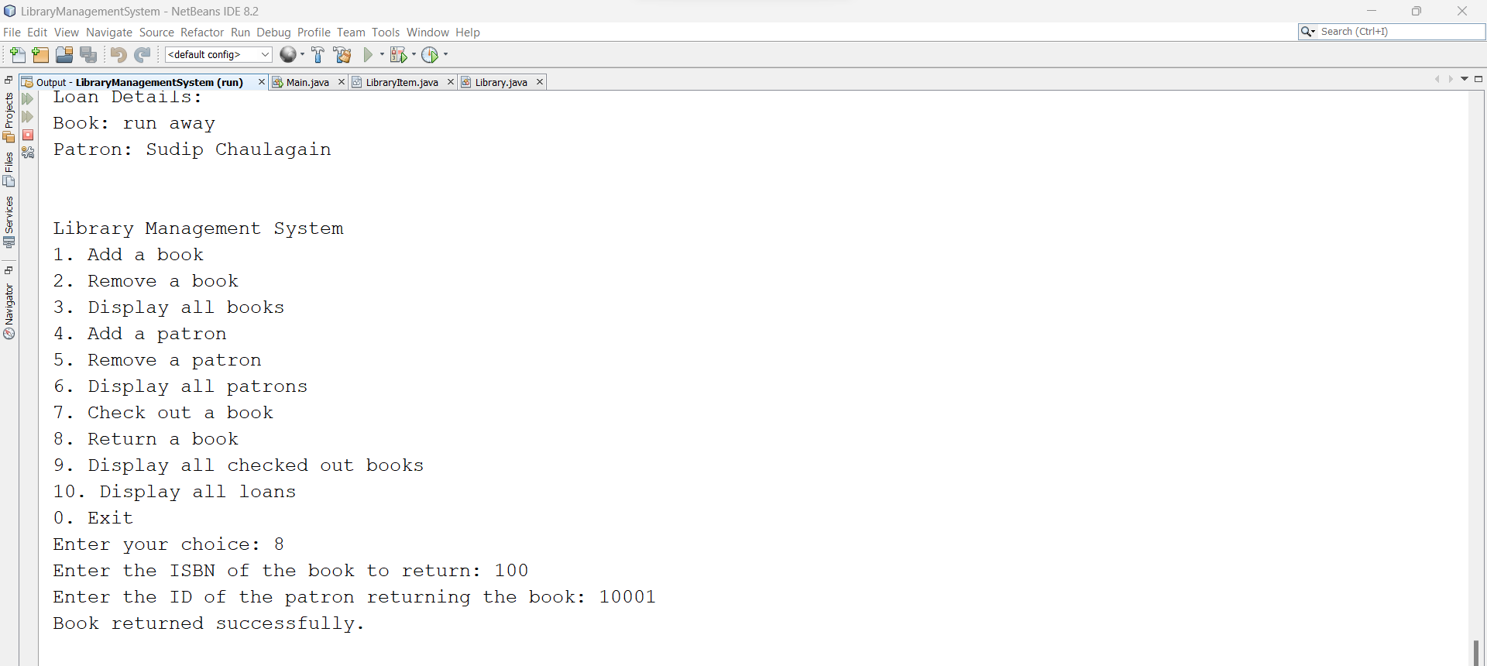

Oh, He has successfully return the book. Then, what will happen if I checkout the total loan?. Let’s move to the option 10.

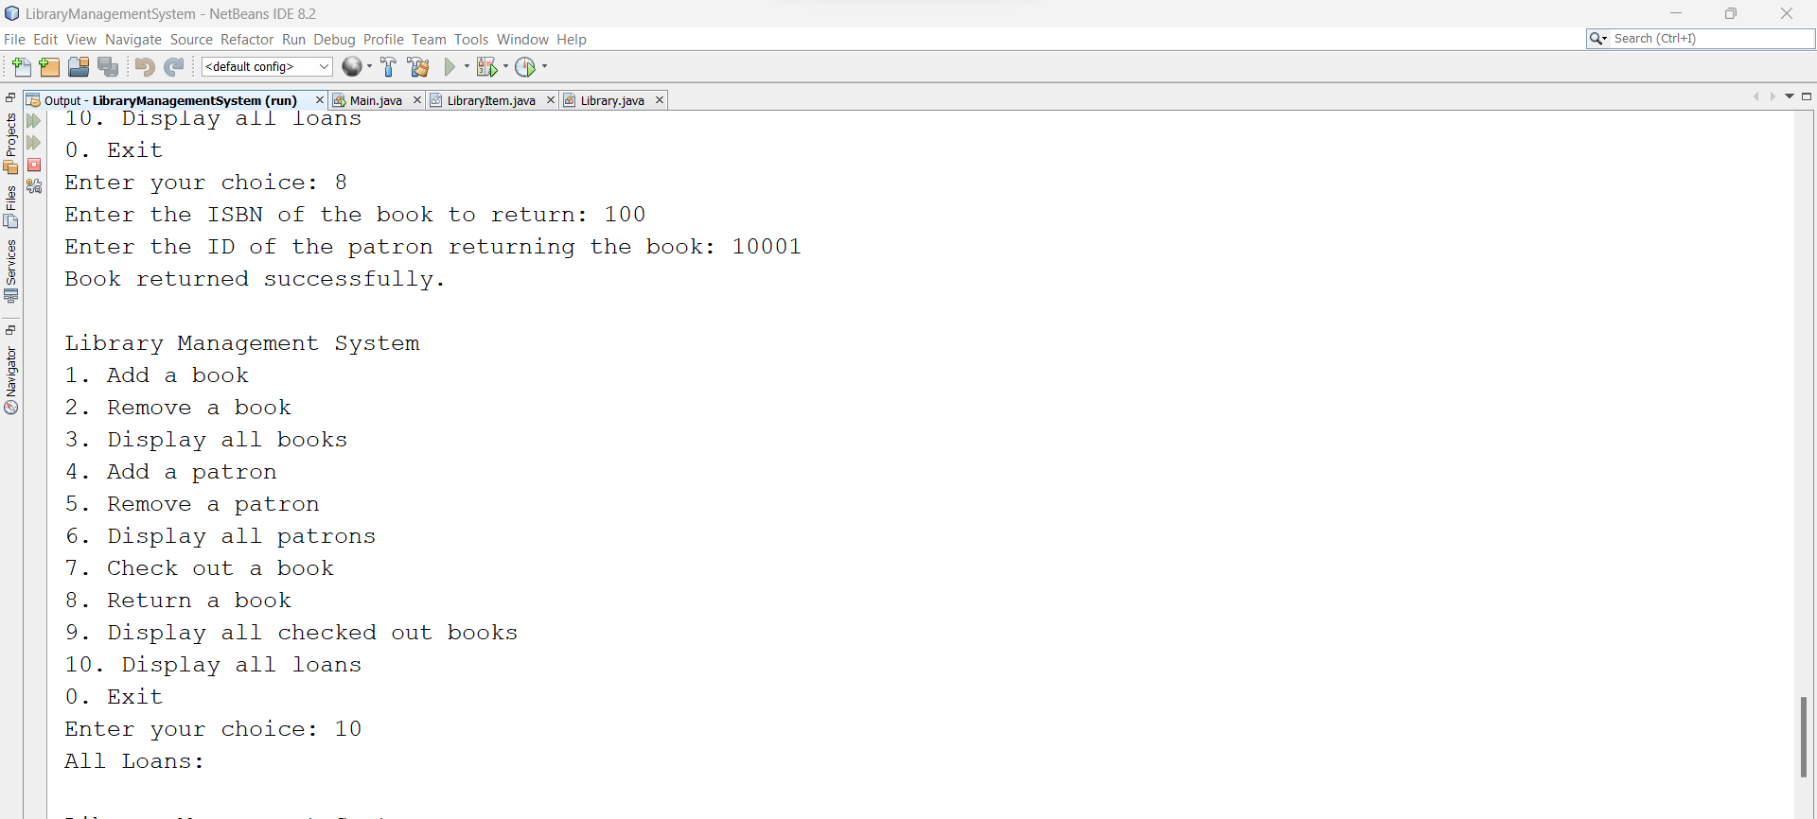

See, It shows nothing over here. Lets checkout again and try to find out loan available in the system.

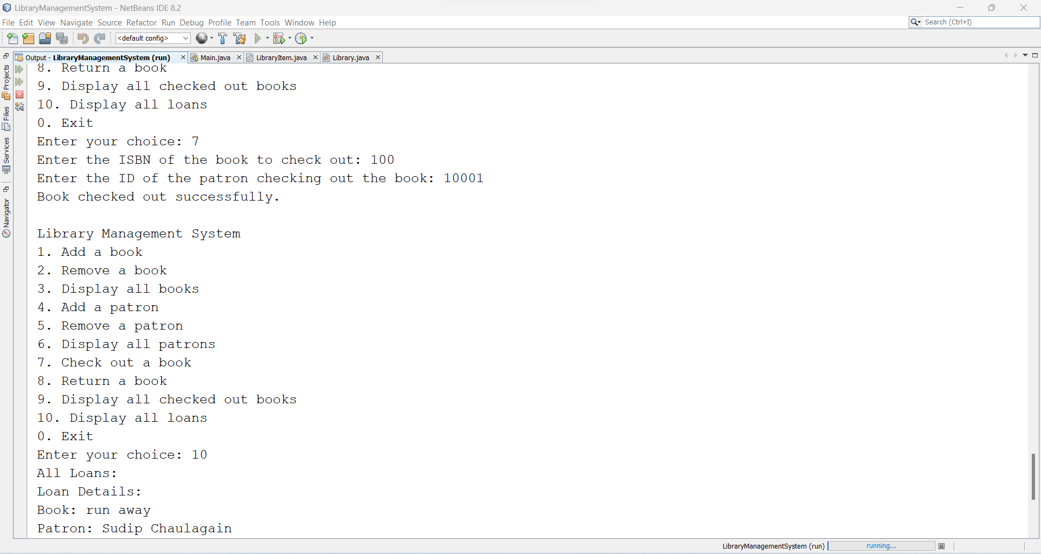

Yeah, It shows the loan available in the system. Then, let’s move to option 9 which shows us the detail information about the checkout books.

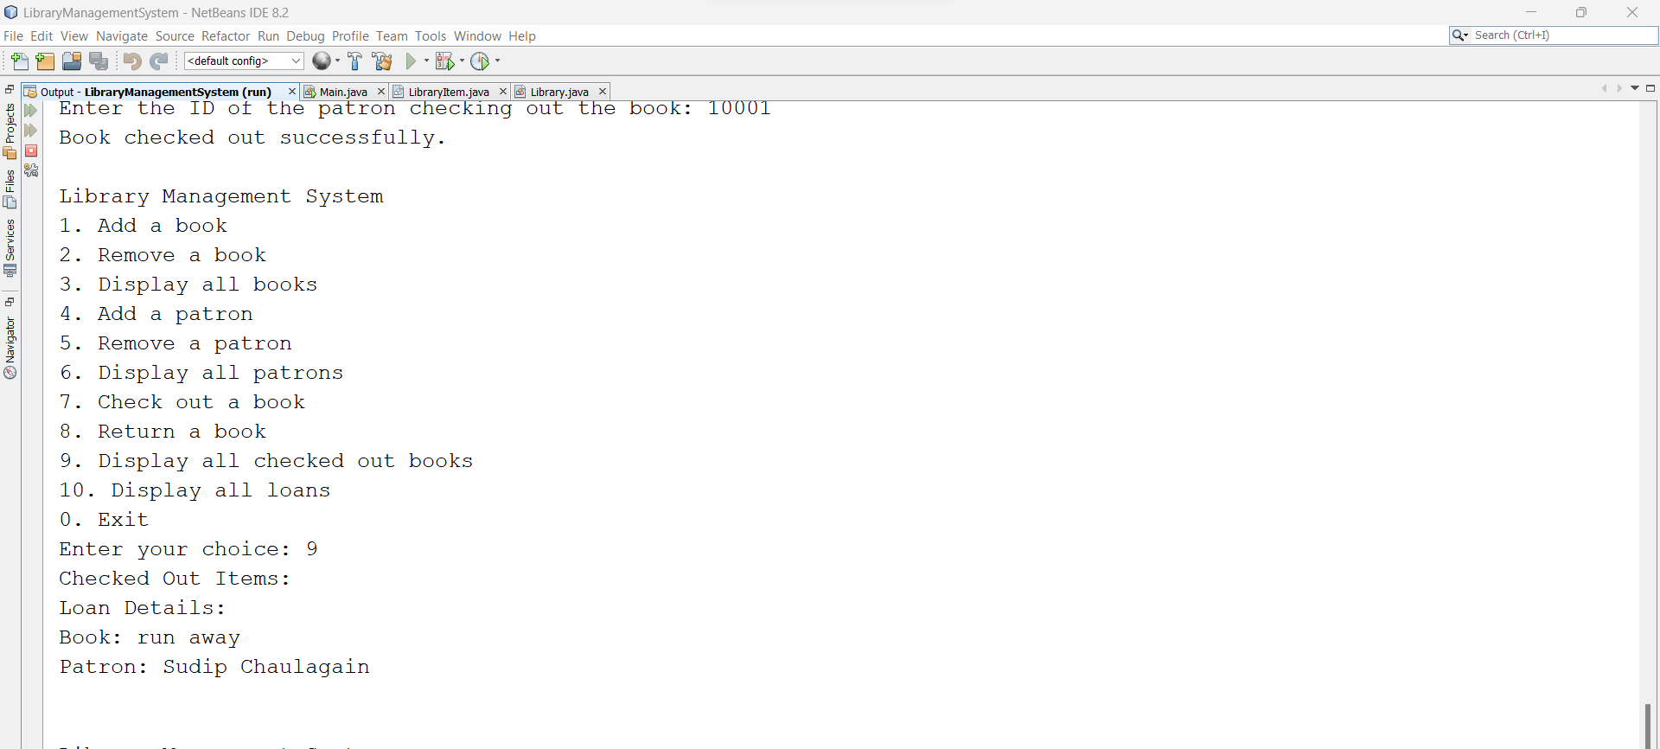

Here, we go. It shows the name of the book and person who checkout the book from the system

Finally, It’s time to terminate the system. Let’s move to option 0 to exist the system.

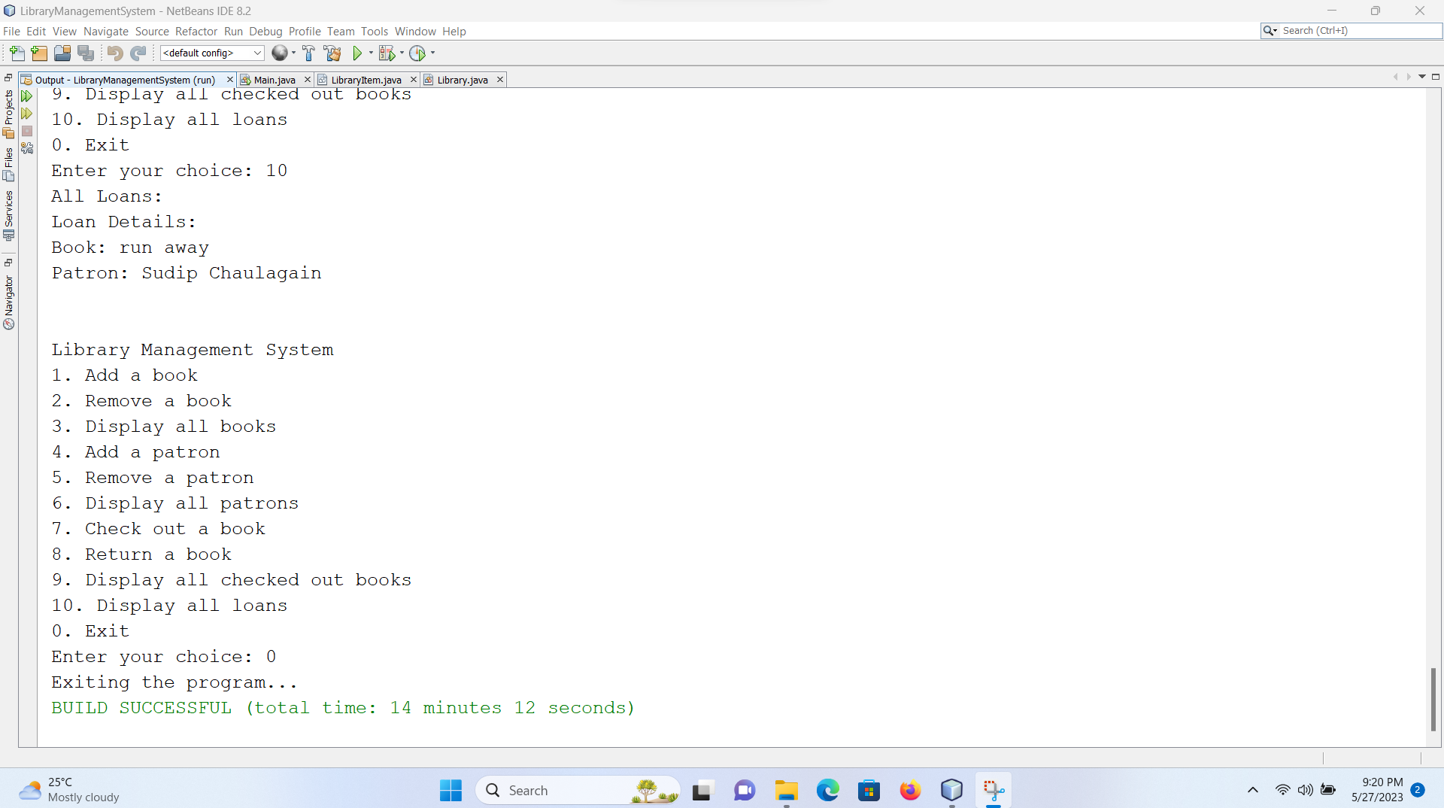

This all are the proofs that I have screenshot the result. If you want, you can run and test the system for other test.