**PIZZA SALES SQL QUERIES**

1. **KPI’s**
2. **Total Revenue**

SELECT SUM(total_price) AS Total_Revenue FROM pizza_sales

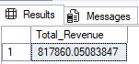

1. **Average Order Value**

SELECT SUM(total_price) / COUNT(DISTINCT order_id) AS Avg_Order_Value FROM pizza_sales

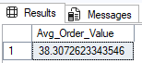

1. **Total Pizza Sold**

SELECT SUM(quantity) AS Total_Pizza_Sold FROM pizza_sales

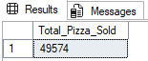

1. **Total Orders**

SELECT COUNT(DISTINCT order_id) AS Total_Orders FROM pizza_sales

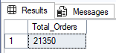

1. **Average Pizza Per Order**

SELECT CAST(CAST(SUM(quantity) AS DECIMAL(10,2))/

CAST(COUNT(DISTINCT order_id) AS DECIMAL(10,2)) AS DECIMAL(10,2))

AS Avg_Pizza_Per_Order FROM pizza_sales

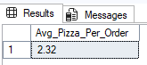

1. **BUSINESS REQUIREMENT**
2. **Daily Trend for Total Orders**

SELECT DATENAME(DW, order_date) AS Order_Day, COUNT(DISTINCT order_id) AS Total_Orders

FROM pizza_sales

GROUP BY DATENAME(DW, order_date)

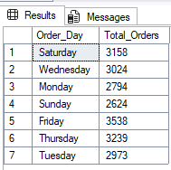

1. **Month Trend for Total Orders**

SELECT DATENAME(MONTH, order_date) AS Month_Name, COUNT(DISTINCT order_id) AS Total_Order

FROM pizza_sales

GROUP BY DATENAME(MONTH, order_date)

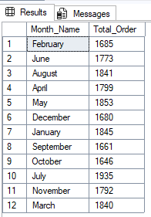

1. **Percentage of Sales by Pizza Category**

SELECT pizza_category, SUM(total_price) AS Total_Sales, SUM(total_price) * 100 / (SELECT SUM(total_price) FROM pizza_sales) AS PCT_Sales

FROM pizza_sales

GROUP BY pizza_category

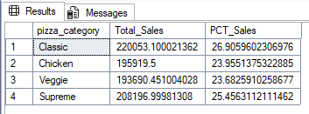

1. **Percentage of Sales by Pizza Size**

SELECT pizza_size, CAST(SUM(total_price) AS DECIMAL(10,2)) AS Total_Sales, CAST(SUM(total_price) * 100 /

(SELECT SUM(total_price) FROM pizza_sales) AS DECIMAL(10,2)) AS PCT_Sales

FROM pizza_sales

GROUP BY pizza_size

ORDER BY PCT_Sales DESC

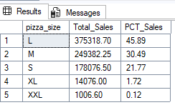

1. **Top 5 Pizza by Revenue**

SELECT TOP 5 pizza_name, SUM(total_price) AS Total_Revenue FROM pizza_sales

GROUP BY pizza_name

ORDER BY Total_Revenue DESC

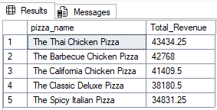

1. **Bottom 5 Pizza by Revenue**

SELECT TOP 5 pizza_name, SUM(total_price) AS Total_Revenue FROM pizza_sales

GROUP BY pizza_name

ORDER BY Total_Revenue ASC

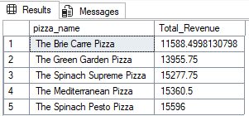

1. **Top 5 Pizza by Quantity**

SELECT TOP 5 pizza_name, SUM(quantity) AS Total_Quantity FROM pizza_sales

GROUP BY pizza_name

ORDER BY Total_Quantity DESC

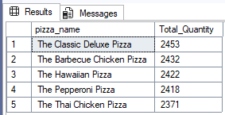

1. **Bottom 5 Pizza by Quantity**

SELECT TOP 5 pizza_name, SUM(quantity) AS Total_Quantity FROM pizza_sales

GROUP BY pizza_name

ORDER BY Total_Quantity ASC

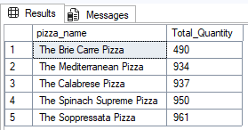

1. **Top 5 Pizza by Order**

SELECT TOP 5 pizza_name, COUNT(DISTINCT order_id) AS Total_Orders FROM pizza_sales

GROUP BY pizza_name

ORDER BY Total_Orders DESC

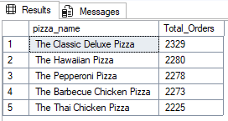

1. **Bottom 5 Pizza by Order**

SELECT TOP 5 pizza_name, COUNT(DISTINCT order_id) AS Total_Orders FROM pizza_sales

GROUP BY pizza_name

ORDER BY Total_Orders ASC

