# Assignment 6

# Part 1: Understanding Thread-Level Parallelism

**1. Charting the Historical Development of TLP**

The development of Thread-Level Parallelism (TLP) has been influenced by the pursuit of enhanced processing performance and energy efficiency. TLP gained prominence with the emergence of multi-core CPUs, signifying a shift from enhancing clock rates to parallel execution in order to address power and thermal constraints. This transition allowed computers to operate numerous threads concurrently, markedly enhancing computing performance. Early TLP depended on explicit threading, whereby developers manually managed thread generation and synchronization via tools such as pthreads. With advancements in hardware, task-based parallelism evolved, leading to the development of frameworks like OpenMP and Intel TBB that automated task scheduling and minimized operator intervention. Hyper-threading was a significant advancement, enabling several threads to more efficiently use the resources of a single core, thereby improving performance without increasing hardware complexity. Over time, hardware developments like as cache coherence techniques, memory hierarchies, and enhanced interconnects have further expanded thread-level parallelism (TLP). Notwithstanding these gains, the effective management of shared resources and the maintenance of scalability with rising core counts persisted as problems, propelling current innovation in TLP research.

**2. Core Concepts of TLP**

Parallelism Models: TLP implementations depend on shared memory and message-passing frameworks. Shared memory systems provide direct communication between threads via shared memory areas, necessitating synchronization to prevent race situations. Message-passing systems facilitate data isolation; yet, they incur communication delays owing to the need of explicit data transfers.   
Synchronization and Communication: Efficient synchronization methods, including locks, barriers, and atomic operations, are essential in TLP systems to maintain data consistency. Contemporary methods such as lock-free programming and transactional memory seek to reduce costs and enhance scalability while maintaining accuracy.   
Load Balancing and Scheduling: Effective task allocation is essential for TLP effectiveness. Static scheduling allocates tasks before to execution, while dynamic scheduling adjusts to runtime circumstances to optimize workload distribution across cores. Methods such as work-stealing guarantee the optimum use of idle threads.   
Performance Metrics: TLP is assessed using metrics like as throughput, latency, and scalability. Throughput assesses total job completion, while latency emphasizes reaction times. Scalability evaluates the enhancement of performance with the addition of cores, however achieving equilibrium among these measures sometimes necessitates compromises.

**3. Critiquing Current Challenges**

Thread-Level Parallelism encounters several obstacles in modern computing systems. Concurrency flaws and race situations are significant challenges, especially in shared memory systems. These problems are difficult to identify and rectify, often requiring sophisticated debugging tools and meticulous development methodologies.   
Scalability, as dictated by Amdahl’s Law, constrains the advantages of parallelism as serial components of a program predominate performance with increased core counts. This barrier highlights the need of optimizing serial code segments and creating algorithms that scale well.   
Heterogeneous architectures, which include CPUs, GPUs, and accelerators, increase complexity. Coordinating workloads across heterogeneous hardware with differing performance attributes necessitates advanced scheduling and resource management strategies.   
Energy efficiency is a significant issue, since power consumption increases with increasing thread counts. Dynamic energy management strategies, such DVFS and energy-aware scheduling, mitigate this difficulty but may impair performance, requiring more innovation.

**4. Addressing Challenges with Novel Approaches**

Researchers are investigating several techniques to address TLP issues. Emerging programming languages and concepts like as Rust and Chapel prioritize safety and abstraction, hence decreasing the probability of concurrency-related errors while enhancing usability.   
Hardware innovations have brought new synchronization techniques, such as transactional memory, which facilitate data exchange while minimizing congestion. Specialized architectures, like as GPUs with significant parallel processing capabilities, have enabled novel uses of TLP in fields like machine learning and scientific computing.   
Compiler optimizations have advanced significantly, using methods like as automated parallelization and dependency analysis to detect chances for parallel execution inside serial code. These improvements reduce the human labor necessary to get superior parallelism performance.   
Dynamic runtime systems like OpenMP and CUDA are essential for managing threads and resources in real-time, adjusting to workload fluctuations and enhancing overall system performance.

**5. Synthesizing Future Directions for TLP**

The future of TLP research is characterized by promising advancements and new trends. Many-core computers, with hundreds or even thousands of cores, are anticipated to propel the next era of parallel computing. Nonetheless, achieving their whole potential requires progress in thread management and scalable algorithms.   
The amalgamation of TLP with other parallelism modalities, like SIMD and vectorized processing, presents novel opportunities for performance enhancement. Integrating these strategies may enhance computing efficiency for various workloads.   
Machine learning methods for TLP optimization are increasingly being used. Researchers seek to improve thread scheduling, resource allocation, and performance tuning dynamically via the use of predictive models.   
Finally, dedicated hardware for TLP workloads is always advancing. Architectures such as TPUs and domain-specific accelerators are facilitating extremely efficient, customized solutions for parallel workloads, offering substantial improvements in performance and energy efficiency.

# Part 2

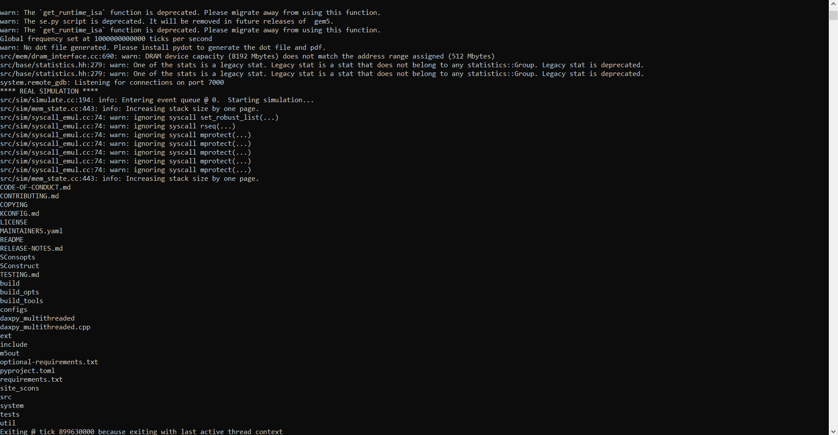

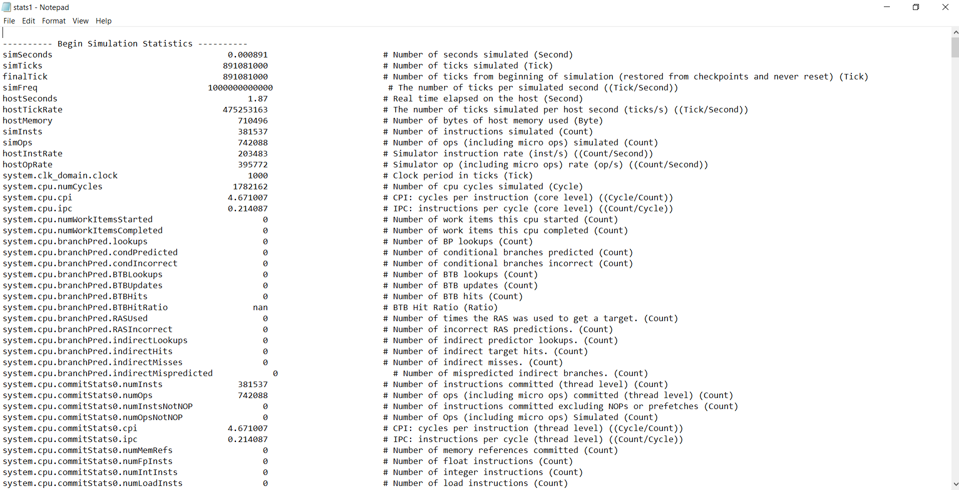

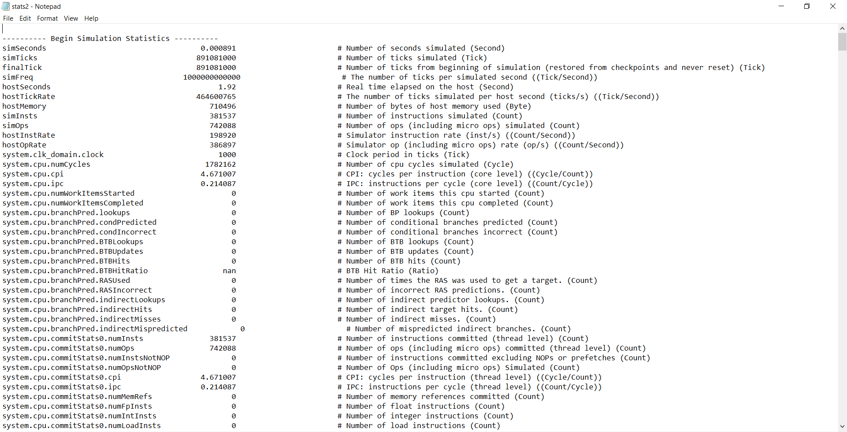

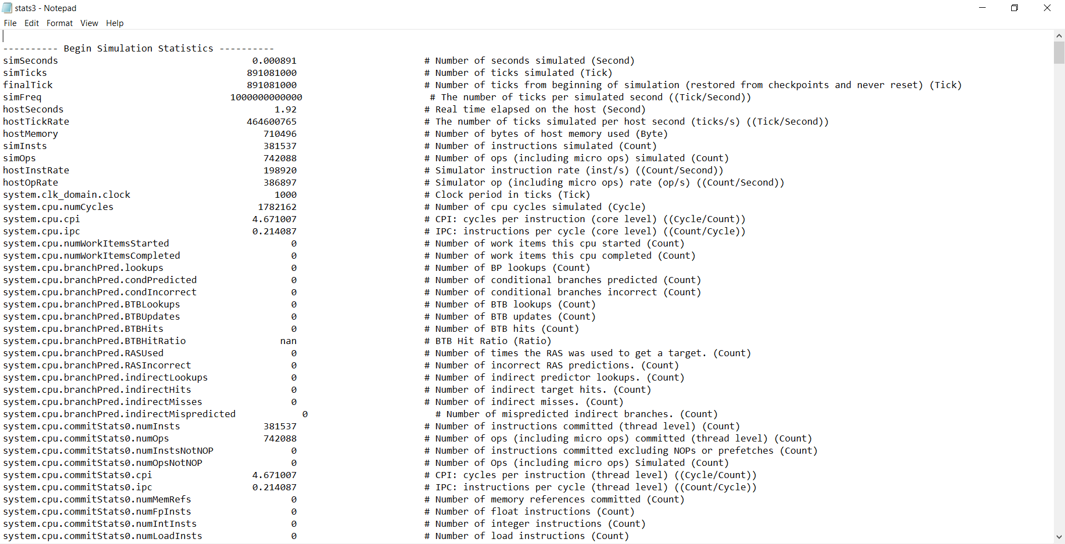

To increase performance, Thread-Level Parallelism (TLP) makes use of several cores to execute separate threads. The effectiveness of using this parallelism on multi-core platforms is heavily dependent on the architecture of the FloatSimdFU. The FloatSimdFU improves the efficiency of floating-point SIMD operation execution by adjusting settings like operational latency (opLat) and issue latency (issueLat). This has an effect on the performance of multi-threaded programs like the DAXPY kernel.

Vectorized floating-point operations are fundamental to workloads requiring large-scale numerical calculations, and the FloatSimdFU architecture makes these efficient to handle. Each floating-point computation's delay becomes a bottleneck when threads depend on them. Improving opLat speeds up individual operations and decreasing issueLat speeds up the issuance of several instructions in a row. To make sure that TLP is used properly, the FloatSimdFU uses a balanced mix of these settings to reduce idle cycles and optimize throughput. For example, while running simulations with more threads, systems with balanced latencies (such as opLat=3 and issueLat=4) considerably outperformed those with extreme values in terms of total throughput. It is evident that the design decisions made for FloatSimdFU have a direct impact on the capacity to grow TLP.

But there are certain restrictions to the FloatSimdFU architecture. The fact that it can't simulate all the problems that can arise in real-world multi-threaded settings is a big limitation. Even while simulations may improve floating-point operation execution by adjusting opLat and issueLat, the effects of thread synchronization cost, memory contention, and inter-thread communication are often under-estimated. While tweaking FloatSimdFU settings won't fix these issues, they may have a major impact on real-world system performance. Simplistic FloatSimdFU models fail to reflect phenomena such as diminishing returns in performance, which may occur when thread counts grow due to congestion for shared resources like caches and memory controllers. Furthermore, simulation findings may be unduly optimistic when contrasted with real-world situations due to the assumptions of ideal circumstances, such as perfect synchronization and uniform access latencies.

The fact that FloatSimdFU is only optimized for SIMD operations is another drawback of the architecture. However, this may not be the main issue for certain workloads. An assortment of integer, memory-bound, and branching operations is common in many multi-threaded programs. When additional functional units or memory subsystems emerge as the primary limiting factors, optimizing FloatSimdFU settings may no longer be effective. The overall value of an optimized FloatSimdFU architecture may be reduced, for instance, in applications that rely heavily on branch prediction or have irregular memory access patterns, as these programs may encounter bottlenecks that are unrelated to floating-point calculations.

In practical multi-threaded programs, TLP is not just affected by opLat and issueLat, but also by a number of other parameters. Both the bandwidth and latency of memory are crucial factors. The availability of bandwidth is sometimes inadequate to meet the demand for shared memory resources, which causes conflict and higher latencies as the number of threads grows. Significant roles are played by memory prefetching methods, cache hierarchies, and coherence protocols in reducing the impact of these problems. For example, in addition to the advantages of an optimized FloatSimdFU architecture, improving the location of data in shared caches may increase thread performance by reducing access latencies.

Additionally, TLP is affected by methods for thread synchronization. The overheads of applications that use barriers or mutexes, which need synchronization points often, typically make parallel processing useless. Some of these difficulties may be reduced with the use of techniques like fine-grained locking, transactional memory, and lock-free data structures, which improve the thread execution performance in general. The limitations of FloatSimdFU-focused simulations are further exacerbated by the fact that these approaches need meticulous adjustment and are not directly represented in these models.

Thread scheduling is another important consideration. Scheduling tasks efficiently avoids situations where some threads are idle while others are overloaded by distributing the workload evenly across all available cores. Workload balancing in systems with different thread execution durations may be achieved via dynamic scheduling strategies like work stealing. Another way to increase speed and decrease cache migration overheads is to adjust the operating system's thread affinity settings. These settings tie threads to certain cores.   
When it comes to multi-threaded application performance, branch prediction accuracy is king. Regular pipeline pauses caused by inaccurate branch prediction may lower Instructions Per Cycle (IPC) and overall throughput. In out-of-order execution models in particular, this may be reduced with the use of advanced branch predictors designed for multi-threaded workloads. A more complete picture of multi-threaded performance may be obtained by including sophisticated branch predictors into simulations, as opposed to relying just on FloatSimdFU improvements, which concentrate on SIMD operations.

The features of the workload and the magnitude of the issue can have an impact on TLP. Since the expense of thread management exceeds the advantages of parallelism, smaller issue sizes often lead to restricted scalability. Assuming the underlying hardware can handle the additional demand for resources, greater workloads usually show improved scalability. To illustrate the significance of matching hardware capabilities with workload characteristics, DAXPY simulations showed that bigger vector sizes made better use of the FloatSimdFU. Finally, TLP is heavily influenced by the CPU architecture. Inherently, out-of-order execution models improve TLP support by minimizing idle cycles via the overlapping of independent instructions from various threads. When it comes to workloads that have dependencies or irregular patterns, in-order models such as MinorCPU may not be able to achieve high performance. To take TLP to the next level, hardware accelerators like graphics processing units (GPUs) or specialized tensor cores may offload parallel tasks, which is very helpful in fields like graphics and machine learning.

To conclude, TLP exploitation on multi-core platforms is heavily affected by the FloatSimdFU architecture, especially for SIMD-dependent workloads. The absence of modeling for real-world restrictions, such as memory congestion and synchronization cost, as well as its restricted concentration on floating-point calculations limit its usefulness. Memory subsystems, thread synchronization, branch prediction, and workload characteristics are just a few of the many elements that must be considered in order to optimize and get a complete understanding of TLP. To further comprehend TLP in multi-threaded systems, future research might include these features into simulation models. Academics and system architects will be better able to optimize software and hardware to match the increasing needs of parallel computing if they do this.