practice development
- Resistor bridge
Assemble the circuit of figure 1 considering that the Wheatstone bridge must be in balance, that is $V_{A}-V_{B}$ = 0V, when the precision potentiometer R1 has a value of 1Kohm. To do this, determine the value of resistors R2, R3 and R4 according to what was seen in class and considering that R1 will change from 1KΩ to 10KΩ.

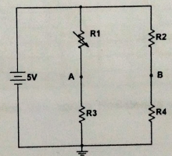
Carry out the calibration, of the resistive bridge, according to the resistance variation in R1 and setting $V_{AB(max)}$ = 2.5V.
- Signal amplification.
Once the resistance bridge has been calibrated, proceed to connect it to the circuit in figure 2, in which you must use the LM741 energized with +-7V. adjust the gain of the circuit in figure 2 so that its $V_{out}$ goes from zero to 5V in the $V_{AB}$ range established for the resistive bridge.

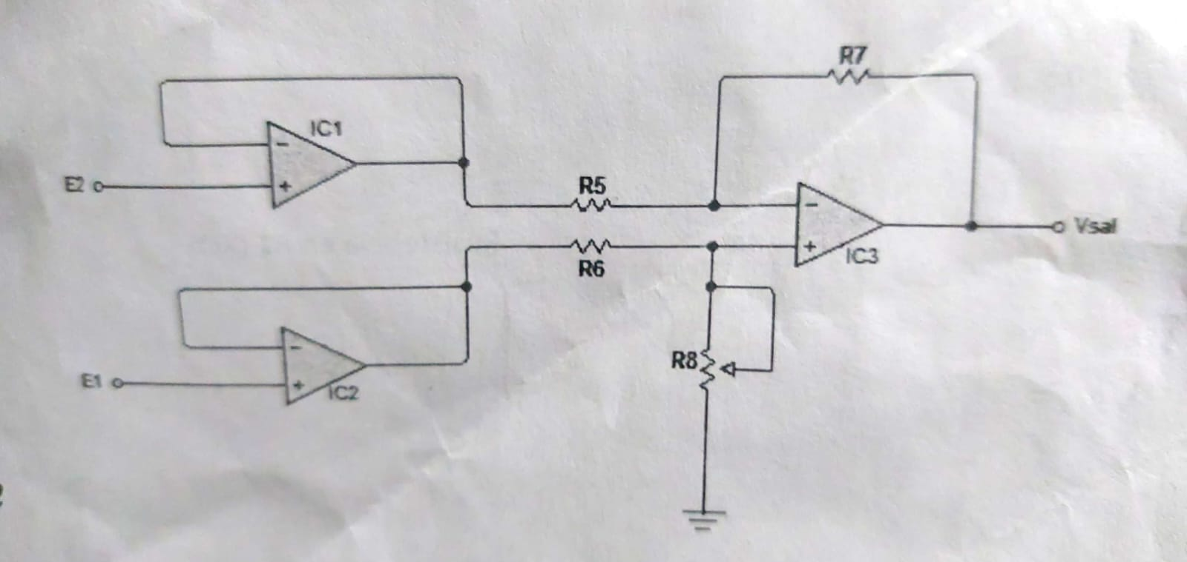

Set the required resistor values ​​for R5, R6, R7, and R8. Subsequently, proceed to fill in table 1, adjusting the value of R1 each time with the ohmmeter without it being energized and measuring the voltages that are requested in said table with the DC voltmeter after energizing the circuit.

Resistor R1  (Ω) | $$V_{B}$$  (Volts)  Medido | $$V_{A}$$  (Volts)  Medido | $$V_{A}-V_{B}$$  (Volts)  Medido | $$V_{SAL}$$  (Volts)  Medido | Resistencia en R1 (Ω)  Calculada
1000 | 3.3405 | 3.429 | 0.0884 | -0.8 | 0.916
2000 | 3.3405 | 2.47 | -0.8706 | -2.1 | 2.048
3000 | 3.3405 | 2.01 | -1.3306 | -2.8 | 2.975
4000 | 3.3405 | 1.66 | -1.6806 | -3.6 | 4.024
5000 | 3.3405 | 1.429 | -1.9116 | -4 | 4.997
6000 | 3.3405 | 1.245 | -2.0956 | -4.5 | 6.032
7000 | 3.3405 | 1.108 | -2.2336 | -4.7 | 7.025
8000 | 3.3405 | 1.007 | -2.3336 | -4.8 | 7.930
9000 | 3.3405 | 0.91 | -2.4306 | -4.91 | 8.989
10000 | 3.3405 | 0.837 | -2.5036 | -4.92 | 9.947

Then make the graph $V_{out}$ against Resistance in R1 and obtain the equation for said graph.

