SIGNAL LOST
A Fog-of-War Stealth Strategy Game
A Course Project Report
Submitted in the partial fulfillment of the completion of the course
SOFTWARE ENGINEERING AND SYSTEM DESIGN
(24CS301PC311)
In III Year, I Semester B. Tech-CSE
Submitted by
Uzma Yasmeen
(Hall Ticket Number)
Under the supervision of the faculty
Dr. <Faculty Name>
<Assistant or Associate Professor>,
School of Computer Science & Artificial Intelligence
2026-2027
Department of Computer Science & Artificial Intelligence
SR University
Warangal, Telangana, India

INDEX
1. Abstract
2. Introduction
2.1 Problem Statement
2.2 Objectives
2.3 Scope
3. Software Requirements Specification
3.1 Functional Requirements
3.2 Non-Functional Requirements
3.3 Hardware and Software Requirements
4. System Analysis
4.1 Existing System
4.2 Proposed System
5. System Design
5.1 System Architecture
5.2 Use Case Diagram
5.3 Class Diagram
5.4 Sequence Diagram
5.5 Activity Diagram
5.6 Guard State Machine
6. Methodology
6.1 Development approach
6.2 Version control
6.3 Testing strategy
6.4 Verification by exhaustive search
7. Implementation
7.1 Module organisation
7.2 Fog of war
7.3 Pathfinding and pursuit
7.4 Undo
7.5 Saved progress and artwork
7.6 Output Screenshots
8. Conclusion
8.1 Summary
8.2 What the project demonstrates
8.3 Limitations
8.4 Future work
9. References

1. Abstract
Signal Lost is a turn-based stealth strategy game developed in Java. The player must escape a facility that is hidden by a fog of war, collecting keys and reaching an exit while avoiding guards. Visibility is computed as a breadth-first flood fill from the player's position, so that walls block sight and tiles already visited remain on the map as a dimmer memory. Guards patrol fixed routes and raise an alarm when they see the player, and a hunter responds to that alarm by pursuing the player using A* search.
The project was undertaken to demonstrate graph algorithms, design patterns and layered architecture in a single application. Because the game is turn-based and deterministic, every decision it makes is plain logic that can be tested. Five design patterns are used: Command for undoable turns, Strategy for guard behaviours, State for guard modes, Observer for the alarm, and Factory for guards and levels.
The completed system has ten levels, six playable characters, three lives per run, a limited hint system, a star rating based on turns taken and times seen, and saved progress for each player. It is verified by 205 automated tests in 25 test classes. These include an architectural test that fails the build if the game rules ever refer to the user interface, and a fairness test that checks every level can be completed. Level difficulty was calibrated using an exhaustive breadth-first search of the game tree, which confirmed that a winning route exists on every level.
Keywords: fog of war, breadth-first search, A* pathfinding, design patterns, layered architecture, automated testing.

2. Introduction
2.1 Problem Statement
Most student game projects are built in real time, and real time hides the software engineering. When a character moves across the screen sixty times a second, the important decisions — what can be seen, where an opponent moves, whether a rule was broken — are buried inside animation code. Such a project is difficult to explain, difficult to draw in UML, and very difficult to unit test, because almost nothing can be separated from the rendering that drives it.
There is a second problem with games built this way. Nobody can prove they are playable. A level is considered finished when its author manages to complete it, which treats "difficult" and "impossible" as the same thing. A level whose only key sits behind a door that never opens will pass every unit test written for it, because unit tests check that the rules behave correctly, not that the game built from those rules can be won.
Signal Lost addresses both problems. The game is turn-based, so every decision is a separate step rather than a frame of animation. The rules are written without any reference to the display, so they can be tested without opening a window. And because the game is deterministic, it can be searched rather than only played, which allows the question "can this level be completed?" to be answered directly.
2.2 Objectives
- Implement fog of war as a graph traversal, using a breadth-first flood fill bounded by a sight radius and blocked by walls, with seen terrain kept as memory separate from current visibility.
- Implement guard pursuit using A* search with a Manhattan distance heuristic and a priority queue, with deterministic tie-breaking.
- Apply design patterns where they are genuinely needed rather than for display: Command, Strategy, State, Observer and Factory.
- Keep the game rules independent of the user interface, and enforce that independence automatically.
- Verify behaviour by automated tests covering visibility, pathfinding, undo, detection, capture, scoring and saved progress.
- Verify playability by exhaustive search, confirming that every level can be completed and that its star ratings can be achieved.
- Deliver a complete, playable game rather than a technical demonstration.
2.3 Scope
The project covers a single-player desktop game with a grid-based level model, breadth-first visibility with fog memory, patrolling and hunting guards with a three-state mode machine, an observer-driven alarm, A* pathfinding, a command stack supporting exact undo, collectible keys that unlock an exit, three lives per run, a limited hint system, a star rating, ten levels with star-based unlocking, saved progress for each player, a Swing user interface, and an automated test suite.
The system does not use a network, does not store data remotely, and has no account system, multiplayer or sound. A Spring Boot and PostgreSQL leaderboard is planned as a second phase and is not implemented.
One of the three guard types described in the original proposal, a stationary sentinel with a rotating vision cone, is not implemented. The extension points it would use already exist. Other gaps are recorded in Section 8.3 and in the accompanying Software Requirements Specification.

3. Software Requirements Specification
This section summarises the requirements. The full specification, with rationale for each requirement and a complete traceability matrix, is held in the repository as docs/srs.md.
Each requirement names the automated test that verifies it. Requirements marked (D) are derived: they were not in the original proposal and were added after testing or play revealed a fault.
3.1 Functional Requirements
Visibility and fog of war
ID | Requirement | Verified by
FR-1.1 | Visible tiles are found by breadth-first flood fill from the player, limited to a sight radius of 5 | VisibilityServiceTest
FR-1.2 | Walls block the fill, so sight does not pass through them | VisibilityServiceTest
FR-1.3 | A wall next to a visible tile is itself visible, so rooms appear enclosed | VisibilityServiceTest
FR-1.4 | A tile once seen stays drawn as remembered terrain, without its occupants | FogOfWarTest
FR-1.5 | A developer toggle reveals the whole map for testing | FogOfWarTest

Turns and movement
ID | Requirement | Verified by
FR-2.1 | A turn is one player action followed by one move from every guard | TurnWithGuardsTest
FR-2.2 | The player moves one adjacent tile per turn, or waits | GameStateTest
FR-2.3 | A move into a wall or off the grid is refused and costs no turn | GameStateTest
FR-2.4 | A move onto a guard is refused; guards block movement | TurnWithGuardsTest
FR-2.5 | Each level has a turn limit, after which the attempt fails | TurnLimitTest

Guards, detection and capture
ID | Requirement | Verified by
FR-3.1 | A patroller walks a fixed route, reversing at each end | GuardTest
FR-3.2 | A hunter moves towards the player's last known position using A* | GuardTest, AStarPathfinderTest
FR-3.3 | A guard is in exactly one of three modes: PATROL, ALERT, HUNT | GuardTest
FR-3.4 | (D) A hunter moves two tiles on alternate turns, so it gains on a fleeing player | GuardTest
FR-4.1 | A turn ending inside a guard's line of sight counts as a sighting | SpottingTest
FR-4.2 | A sighting raises an alarm, which puts every hunter into HUNT mode | AlarmTest
FR-4.3 | Sightings are counted for the whole run, not per attempt | ScoreTest
FR-5.1 | A guard in HUNT mode reaching the player captures them | CaptureTest
FR-5.2 | (D) A guard not in HUNT mode blocks the player but does not capture | CaptureTest
FR-5.3 | A run starts with three lives; a capture costs one | LivesTest
FR-5.4 | A new life resets player, keys, guards and clock, but not the sighting count | LivesTest

Keys, undo and hints
ID | Requirement | Verified by
FR-6.1 | A level may hold several keys, and all are required | MultipleKeysTest
FR-6.2 | The exit stays closed until every key is held | MultipleKeysTest
FR-7.1 | Every turn is recorded as a command object on a stack | UndoTest
FR-7.2 | Undo restores player, guards, alarm, sighting count, keys and clock | UndoTest
FR-7.3 | Undo repeats back to the start of the attempt, and is refused once it has ended | UndoTest
FR-8.1 | A hint shows one move, never a route, and expires when the player moves | HintTest, HintLifetimeTest
FR-8.2 | When the player is in a guard's sight, the hint points towards cover | HintCoverTest
FR-8.3 | (D) A level allows three hints, and neither undo nor a new life restores one | HintBudgetTest

Scoring, levels and saved progress
ID | Requirement | Verified by
FR-9.1 | Escaping scores one star, escaping within par a second, escaping unseen a third | ScoreTest
FR-9.2 | Par is calculated from the level's own geometry, not written into the level file | ScoreTest
FR-9.3 | (D) Three stars can be achieved on every level | StarRatingAchievableTest
FR-10.1 | Ten levels are provided, and every key and the exit are reachable in each | LevelIntegrityTest
FR-10.2 | (D) Every watched tile has cover within reach, so being seen can always be survived | LevelFairnessTest
FR-10.3 | Levels unlock at 0, 1, 3, 5, 8, 11, 14, 17, 20 and 23 stars | LevelIntegrityTest
FR-11.1 | Progress is saved under a player name, keeping the best result per level | ProgressTest
FR-11.2 | Saving one player's progress does not affect another's | ProgressTest
FR-11.3 | Progress is written only to the local machine | ProgressTest

3.2 Non-Functional Requirements
ID | Category | Requirement | Verified by
NFR-1 | Performance | A turn resolves quickly enough to feel instant on a 29x21 grid | manual
NFR-2 | Maintainability | No class in the six rule packages imports java.awt, javax.swing or java.applet | ArchitectureTest
NFR-3 | Testability | The whole test suite runs without opening a window | ArchitectureTest
NFR-4 | Reliability | The game is deterministic: the same input from the same state gives the same result | TurnWithGuardsTest
NFR-5 | Portability | ProgressStore takes its storage path from the caller | ArchitectureTest
NFR-6 | Privacy | The game sends no data anywhere and needs no network | by inspection

NFR-2 and NFR-4 are the two that carry the most weight. NFR-2 is what allows the test suite to run without a display, and what would allow the rules to be reused on another platform. NFR-4 is what makes the exhaustive search in Section 6.4 possible, and therefore what makes FR-9.3 and FR-10.1 checkable rather than merely claimed.
3.3 Hardware and Software Requirements
 | Requirement
Java runtime | JDK 17 or later
Operating system | Any supporting Java SE with a display; developed on Windows 11
Runtime libraries | None beyond the Java standard library
Build tool | Apache Maven 3.6 or later
Test framework | JUnit 5, test scope only
Version control | Git and GitHub
Processor | Any processor supporting a Java 17 runtime
Memory | 512 MB available to the JVM
Display | 1024 x 700 or larger
Storage | About 5 MB for the application, under 10 KB for saved progress
Input | Keyboard; the mouse is used only on the menu screens

The display figure is a real lower bound. The board is deliberately not scaled down to fit a smaller window, because reducing the tile size makes the puzzle harder to read without making it easier to solve.

4. System Analysis
4.1 Existing System
There is no single system that Signal Lost replaces. What exists is a set of common approaches to building games of this kind, each with weaknesses that this project was designed to avoid.
Real-time architecture. The usual approach to a stealth game is a continuous simulation driven by a frame loop, with floating-point positions, interpolated movement and detection evaluated by casting rays many times a second. Three engineering consequences follow. The logic cannot be separated from the rendering, because state advances as a function of elapsed frame time. Behaviour is not reproducible, because the same inputs produce slightly different results on different hardware. And the design cannot be drawn honestly, because the rules are spread across update methods rather than held in identifiable objects.
Visibility by ray casting. Line of sight is usually found by casting rays from the observer and recording what each one hits first. This is fast, but it computes line of sight literally, so visibility leaks through the diagonal gaps between wall corners, and walls bounding a lit room are often left dark so that rooms do not appear enclosed. A large body of corrective algorithms exists for exactly these artefacts, which suggests the underlying model fits a grid imperfectly.
Verification by play. A level is usually validated by its author completing it. This shows that one person can win once. It does not show that the level can be won in general, that its difficulty rating can be reached, or that it is not in fact impossible. Unit tests, where they exist, usually check that individual rules behave correctly, which is a much weaker claim.
4.2 Proposed System
Problem | Solution in Signal Lost | Enforced by
Logic cannot be tested without the UI | All game logic is in six packages that reference no user-interface type | ArchitectureTest
Behaviour is not reproducible | A discrete, deterministic turn model with no dependence on elapsed time | TurnWithGuardsTest
Patterns are obscured by the frame loop | Command, Strategy, State, Observer and Factory, each an identifiable set of classes | Section 5.3
Ray casting leaks through corners | Visibility as breadth-first traversal of the grid graph | VisibilityServiceTest
Playability is only claimed | Exhaustive search of the game tree proves a winning route exists | LevelIntegrityTest
Difficulty thresholds may be unreachable | Star thresholds derived from level geometry and checked attainable | StarRatingAchievableTest

The main advantages are that the rules can be tested in isolation, that a failing scenario can be written down as a sequence of moves and reproduced exactly, that visibility behaves correctly at corners without special cases, that playability is demonstrated rather than assumed, and that moving the game to another platform means writing a new interface rather than a new game.
Two costs were accepted. A turn-based model gives up the tension of continuous movement. And visibility is recomputed each turn rather than updated incrementally, which is more work per turn than necessary. Neither matters at this grid size.

5. System Design
The diagrams are generated from Mermaid source held in docs/uml.md, so they are version-controlled as text and cannot drift away from the code.
5.1 System Architecture

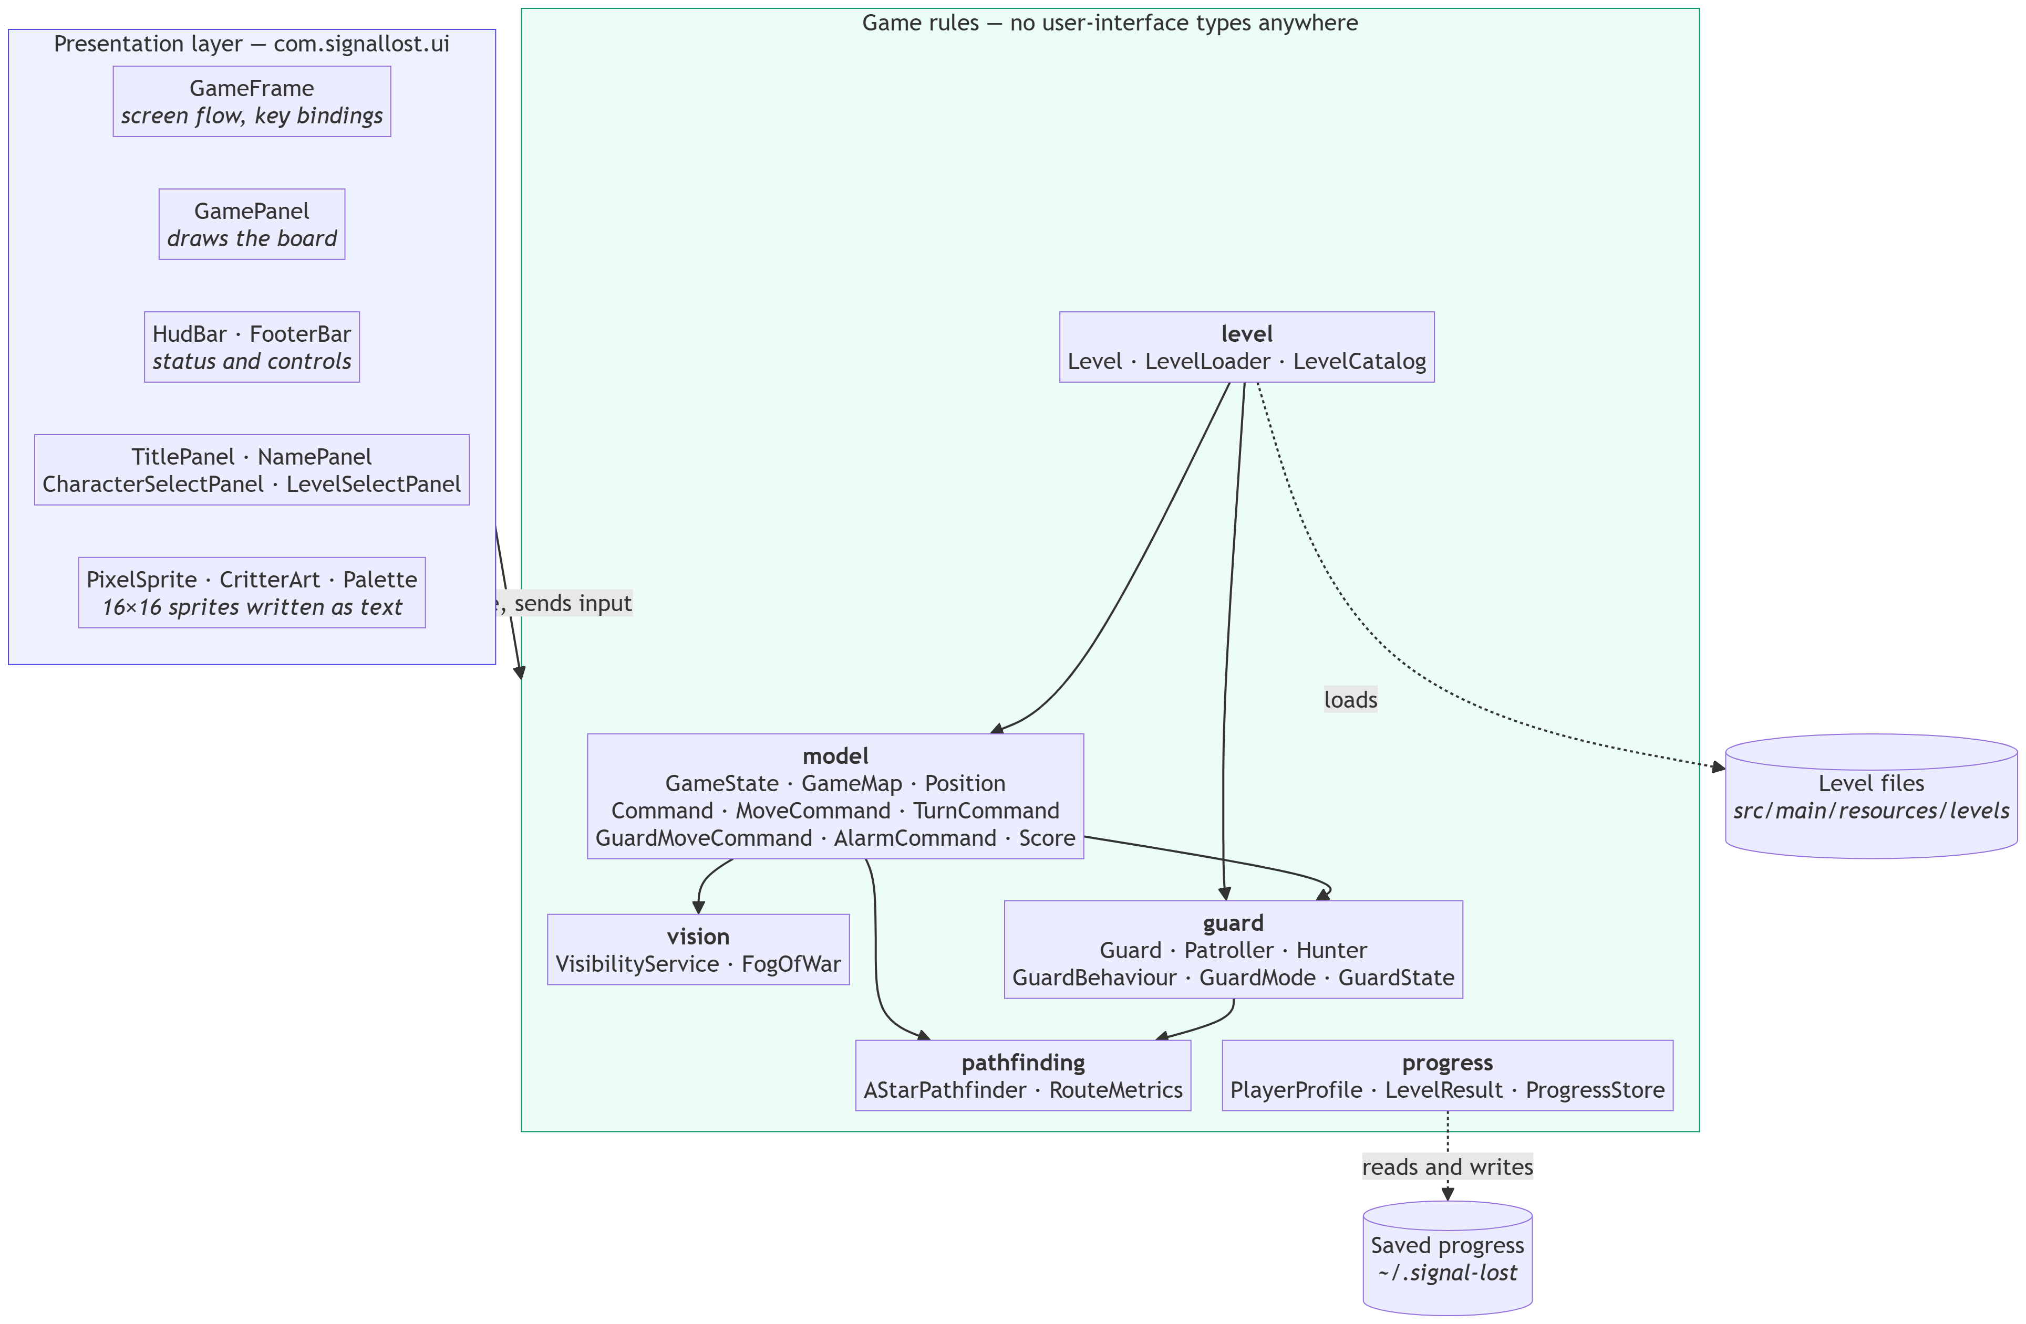

The system has two layers with one permitted direction of dependency. The presentation layer reads game state and forwards input. The rules layer knows nothing about it.
This is enforced rather than conventional. ArchitectureTest scans every source file in the six rule packages and fails the build if any of them imports java.awt, javax.swing or java.applet. The test was added after seeing how easily the property could be lost: one model class using java.awt.Color as a convenient way to hold a colour would compile, pass every other test, and tie the rules permanently to the desktop.
5.2 Use Case Diagram
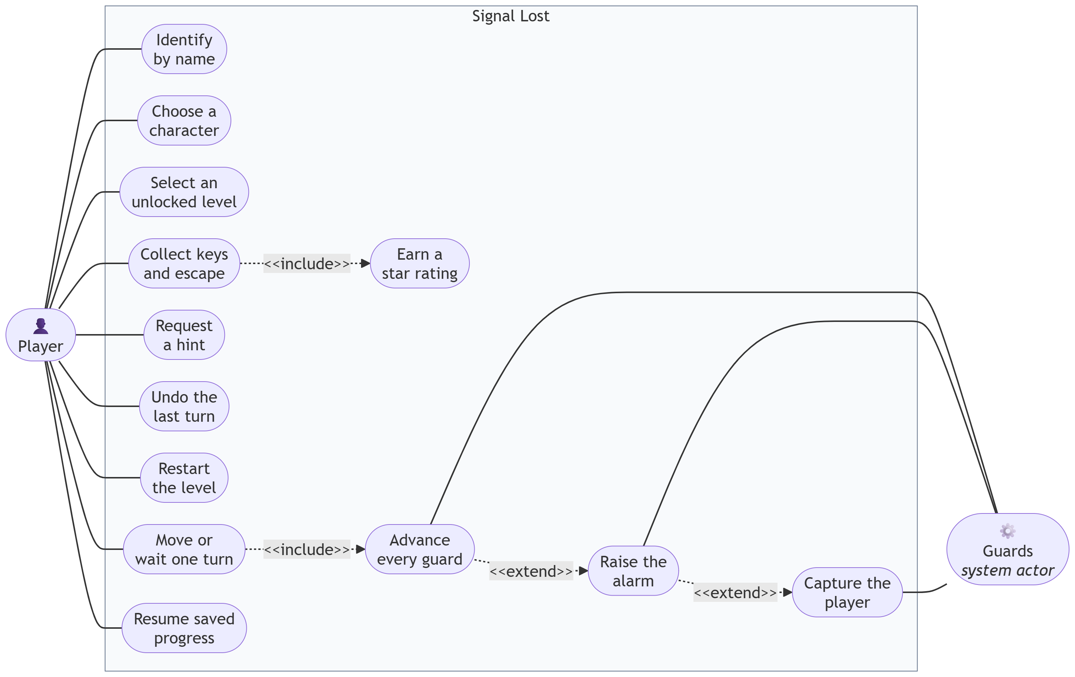
The player is the only human actor. Guards are a system actor, because they act every turn without being invoked and because two of the most important events in the game, the alarm and a capture, start with them. The include relationship from Move or wait one turn to Advance every guard captures the central rule: there is no player action that does not also give every guard a move.
5.3 Class Diagram
The class model is shown in three parts for legibility.
5.3.1 Core model and the Command pattern
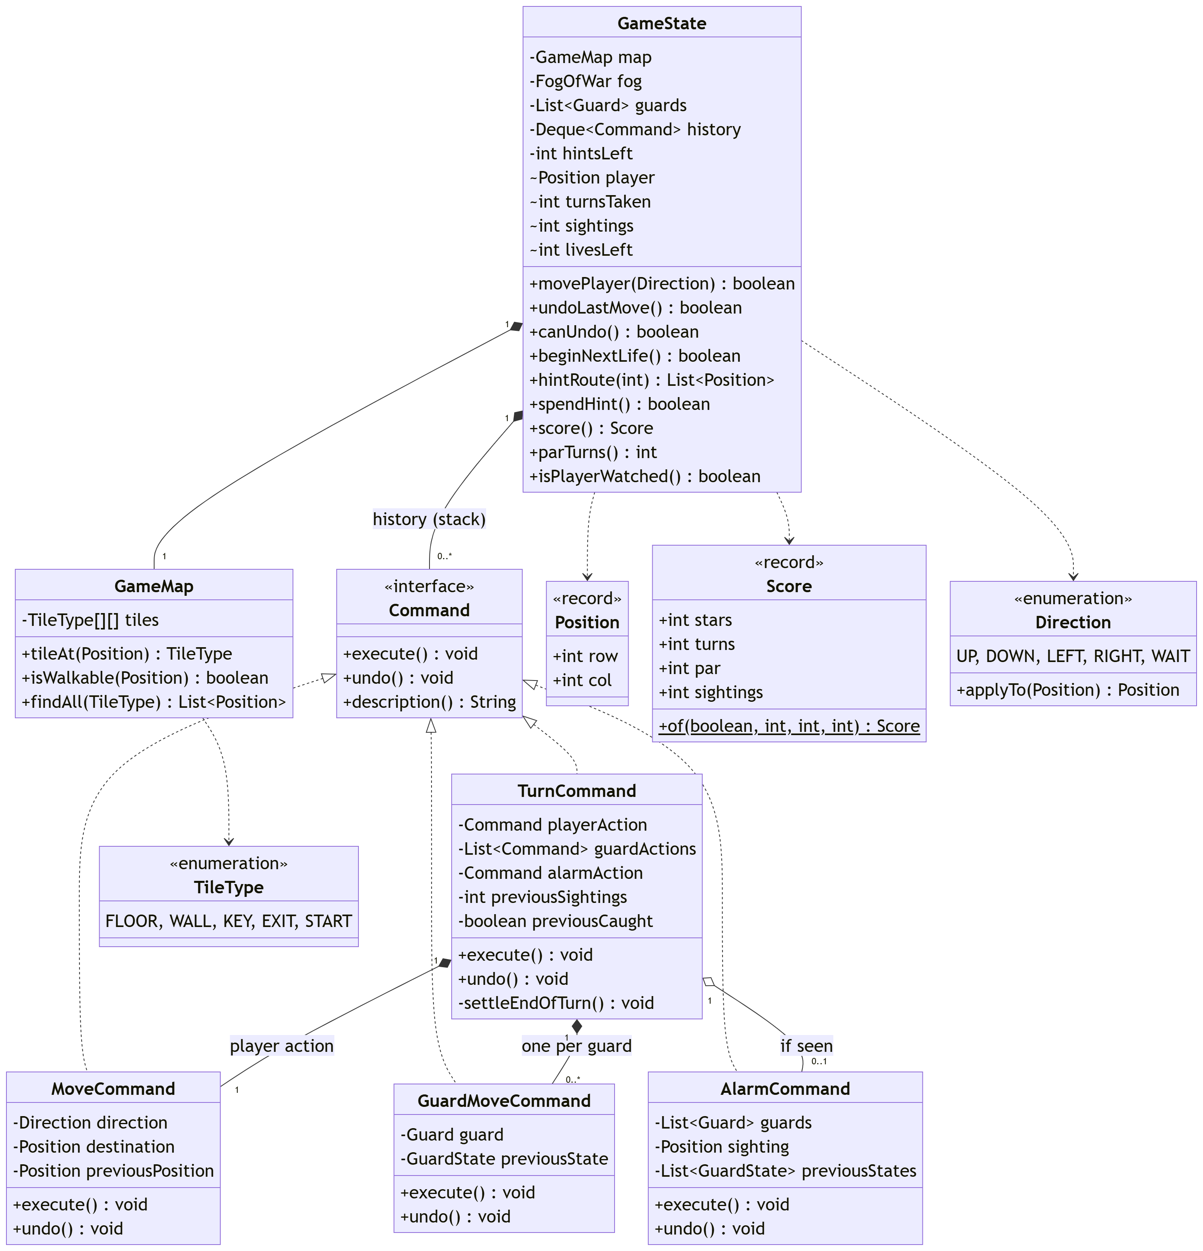
GameState holds the mutable position of play. Its mutable fields are package-private, so only command objects in the same package can write to them.
The Command pattern is used at two levels. A TurnCommand represents one whole turn and owns the smaller commands that make it up: a MoveCommand for the player, a GuardMoveCommand for each guard, and an AlarmCommand if the player was seen. Undoing a turn means undoing each part in reverse order, so nothing can be missed.
5.3.2 Guards: State, Strategy and Observer

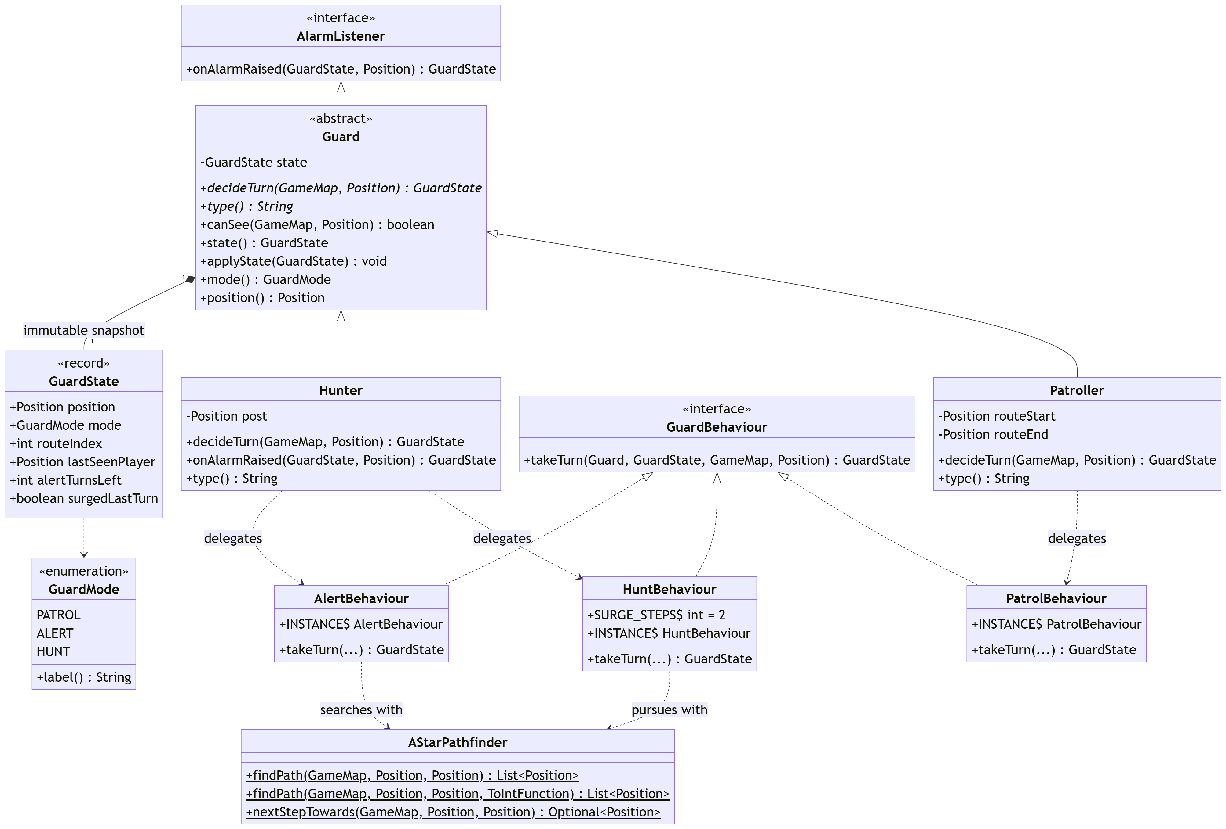

Three patterns meet at the guard. GuardMode is the State and decides which behaviour applies. GuardBehaviour is the Strategy, with three stateless implementations selected by that mode. AlarmListener is the Observer, through which one guard's sighting reaches every other guard without any of them holding a reference to the others.
GuardState is an immutable record holding a guard's whole condition. A guard does not change itself; it calculates a new state and has one applied. This is what makes undo exact, because GuardMoveCommand restores the previous record rather than trying to reverse each field.
5.3.3 Vision, levels and progress
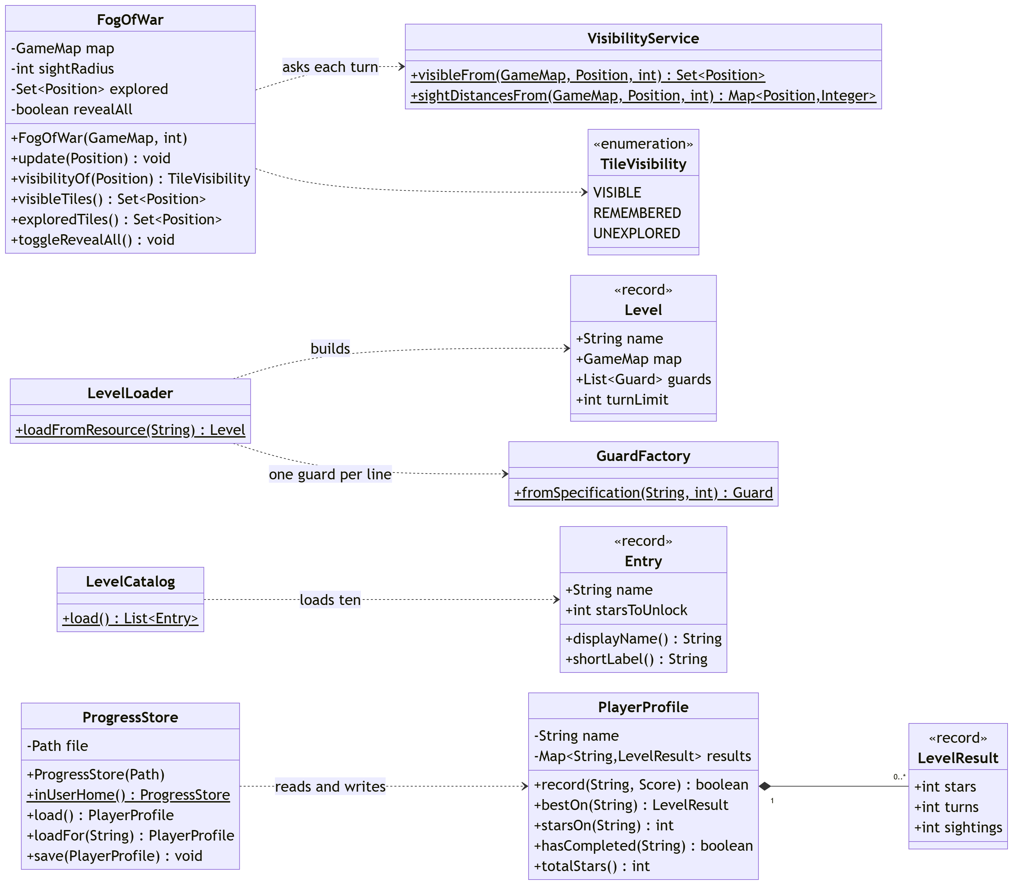
VisibilityService is stateless and calculates what is visible from a position. FogOfWar adds memory, classifying each tile as VISIBLE, REMEMBERED or UNEXPLORED. Keeping them separate makes the geometry testable on its own.
LevelLoader and GuardFactory form the Factory pattern, building a level and its guards from a text file so that adding a level needs no code change. ProgressStore is the only class in the rules layer that touches the file system, and it takes its path from the caller.
5.4 Sequence Diagram
5.4.1 Taking one turn

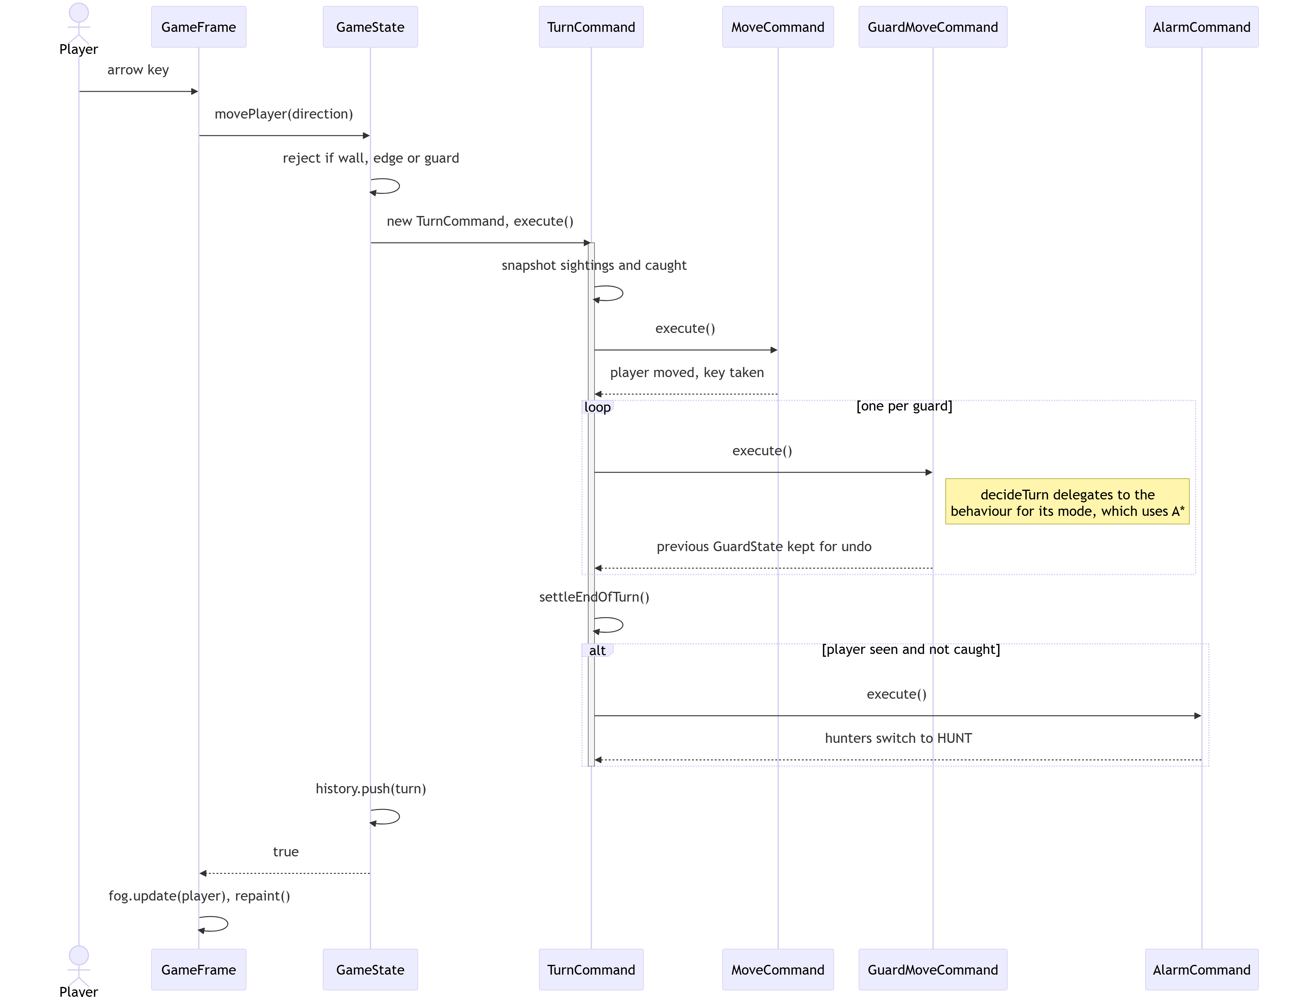

This is the system's main flow. The ordering is where the difficulty of the game comes from: the player acts, then every guard acts, and only then is it decided whether the player was seen. Moving to a tile that is safe when you leave is therefore no guarantee, because a guard may turn a corner and be looking at it by the time the turn ends.
5.4.2 Undoing a turn

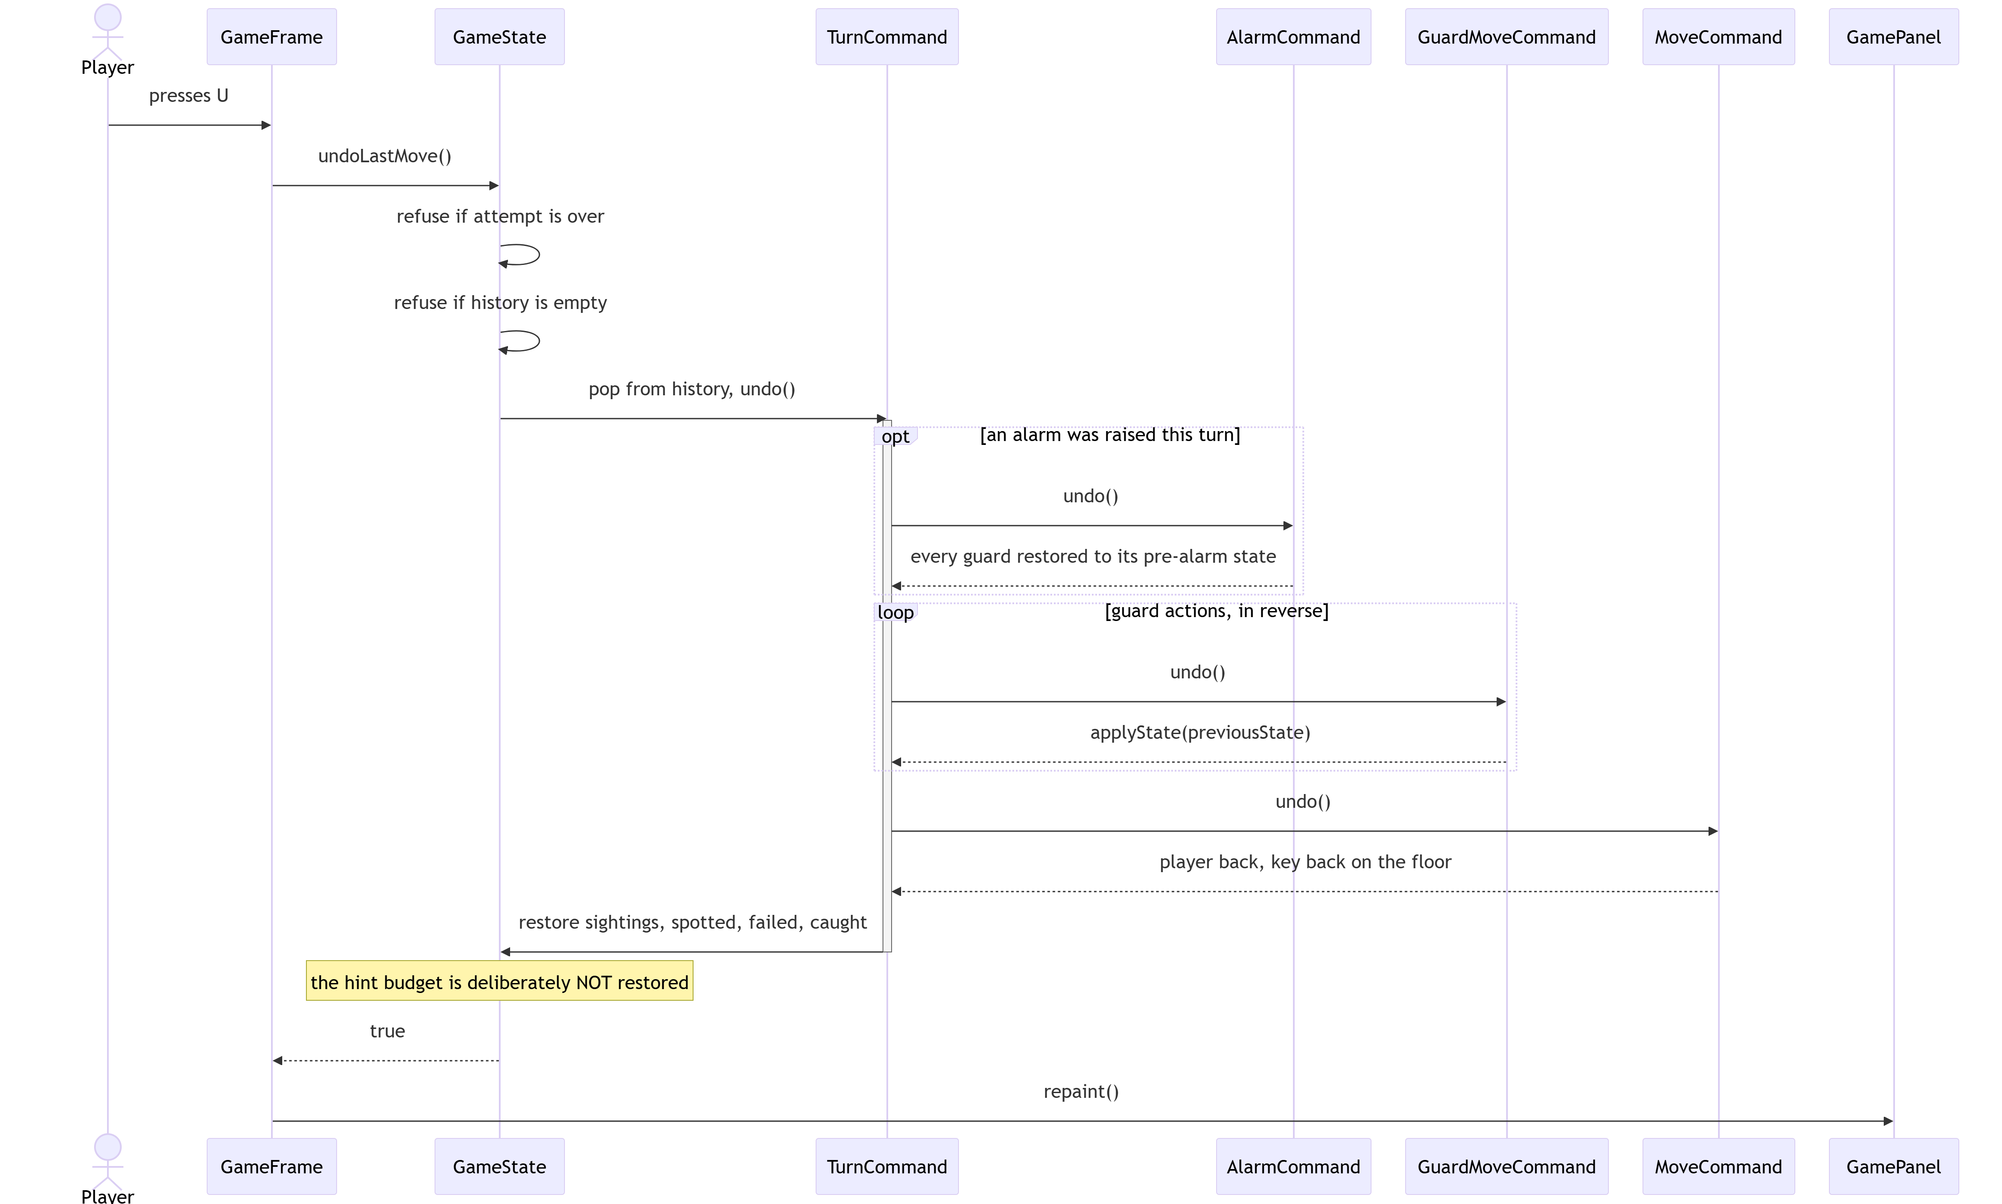

Undo pops the turn and reverses its parts in the opposite order: the alarm first, then each guard, then the player. Nothing is recalculated; everything is restored from values captured at the time.
One omission is deliberate. The hint budget is not restored, because if it were, three hints would be unlimited: a player could ask, undo, and repeat.
5.5 Activity Diagram
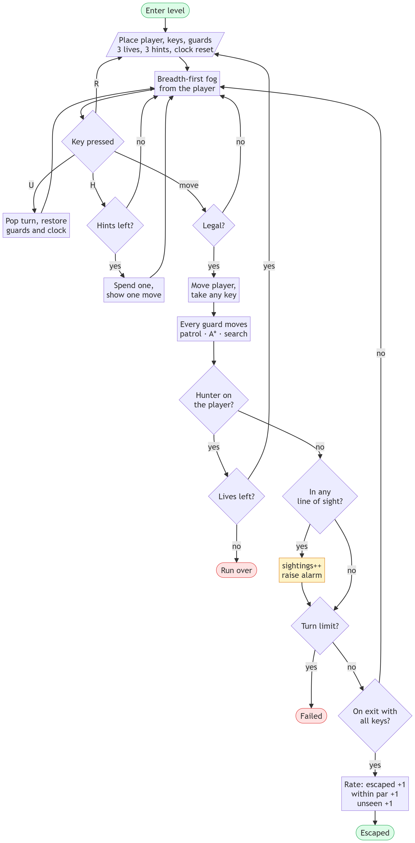
The diagram follows one attempt at a level from entry to rating, including undo, hints and restart, and both ways of failing: capture, which costs a life, and the turn limit, which ends the attempt.
5.6 Guard State Machine
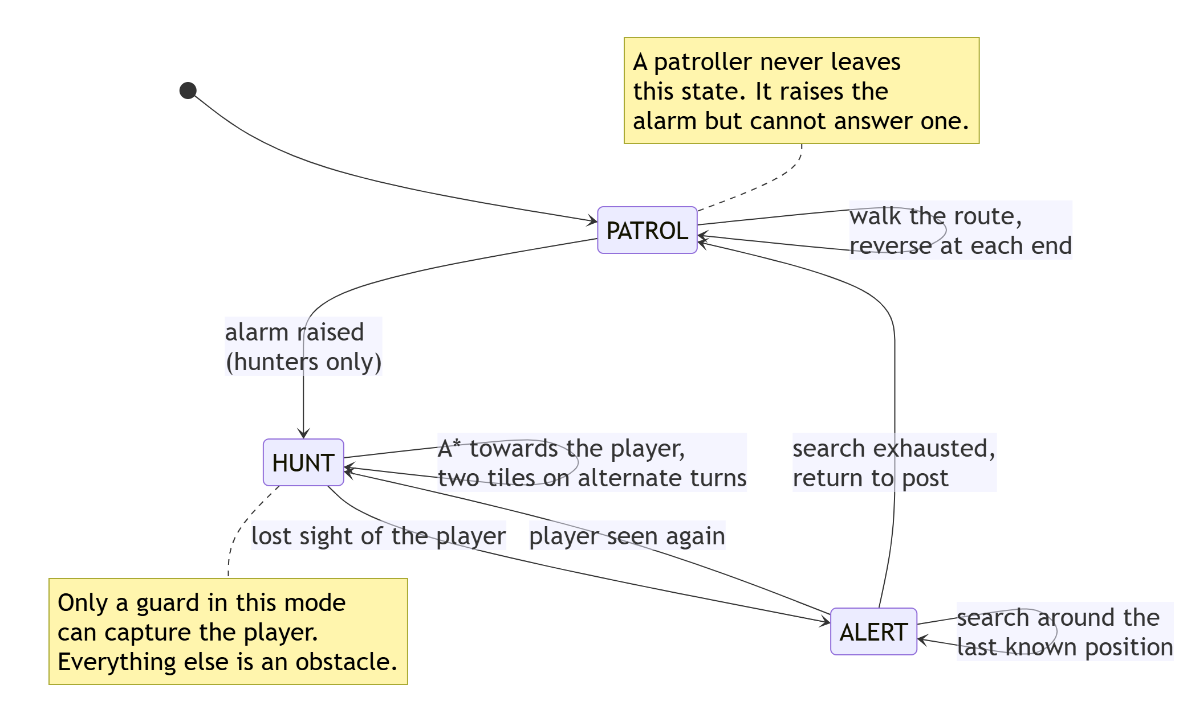
Only a guard in HUNT mode can capture the player. A patroller that walks into the player blocks them and nothing more. This rule was adopted after the stricter version made a single-width corridor on level 1 impossible to pass, which made the level unwinnable.

6. Methodology
6.1 Development approach
Development was incremental, with each stage producing a working program rather than a layer of an unfinished one.
Stage | Delivered
1 | Grid model, breadth-first fog of war, playable board
2 | Command pattern, undo stack, six characters
3 | A* pathfinding, patrolling and hunting guards, hints
4 | Detection, line-of-sight overlay, turn limit
6 | Ten levels, title screen, player names, saved progress
7 | This report, the SRS and the UML diagrams

Stage 5, the sentinel guard, was deferred in favour of stage 6, on the judgement that a complete game with two guard types shows more than an incomplete one with three. Stage 8, the Spring Boot leaderboard, is phase 2.
6.2 Version control
Git was used throughout and the repository is published on GitHub. There are thirty-eight commits, each limited to one concern.
6.3 Testing strategy
Testing was done at four levels:
- Unit tests on individual rules, such as visibility geometry, pathfinding and scoring.
- Integration tests on whole turns, where the player acts, guards respond and the outcome is checked.
- Property tests across all ten levels at once: that every key is reachable, that every watched tile has cover within reach, and that three stars can be achieved.
- Architectural tests on the source itself, failing the build if the dependency rule in Section 5.1 is broken.
The order of events was often the reverse of the textbook one. Several of the most significant faults were found by playing rather than by testing: a hunter that escorted the player instead of catching them, a level whose only key stood behind a door that never opened, and a star rating that could not be achieved. In each case a test was written afterwards to prevent that kind of fault returning. The test suite is therefore a record of mistakes already made as much as a specification written in advance. The property tests at level 3 exist precisely because unit tests had proved unable to find faults of that kind.
6.4 Verification by exhaustive search
Because the game is deterministic, the question "can this level be won?" has a definite answer. A solver was written that performs a breadth-first search over the whole game tree, with each state identified by player position, turn count and the set of keys still to collect.
The solver established three things that testing had not. Level 1 was unwinnable with both guards in place, which no amount of play would have distinguished from a level that was merely hard. The star thresholds were unreachable: on level 1 the fastest escape took 38 turns and the fastest unseen escape took 56, against a par of 51, so the speed star and the stealth star excluded each other. And the solver itself was wrong twice before it was right. One version stored states without the turn count, which is unsound while a clock is running, and a later one recorded how many keys were held rather than which, so holding the first key and holding the third looked identical. Both versions reported winnable levels as lost.
That last point is worth noting. A verification tool is software too, and is no more trustworthy than the software it checks until it has itself been checked.

7. Implementation
7.1 Module organisation
Package | Lines | Responsibility
model | 1,148 | Game state, map, commands, undo stack, scoring
guard | 612 | Guard types, modes, behaviours, the alarm
progress | 284 | Player profiles and saved progress
level | 258 | Level and catalogue loading from text
pathfinding | 213 | A* search and route metrics
vision | 189 | Visibility and fog memory
Total | 2,704 | No user-interface dependency

7.2 Fog of war
Visibility is a breadth-first flood fill from the player's tile, bounded by the sight radius and blocked by walls. Walls next to a visible tile are marked visible in the same pass, so rooms appear enclosed.
A flood fill was chosen over ray casting. Because it spreads only between adjacent tiles, visibility cannot leak through the diagonal gap between two wall corners, which ray-cast implementations have to correct for explicitly. Sight bending around a corner follows naturally from the traversal.
7.3 Pathfinding and pursuit
A* is used over the grid graph, with a Manhattan distance heuristic and a priority queue ordered by estimated total cost. Ties are broken deterministically so identical situations always resolve identically.
A second version of the method accepts a cost for each tile. This is used by the hint system rather than by the guards: tiles under observation cost more to cross, and tiles near a hunting guard more still, so the route returned avoids being seen rather than being shortest.
A hunter moving at exactly the player's speed can never close a gap. The first version did this, so a chase stayed at whatever distance it started and the hunter appeared to accompany the player rather than chase them. The fix was to let a hunter take two steps on alternate turns, giving a net gain of half a tile per turn. Running in a straight line now loses, and breaking line of sight wins. A hunter that always took two steps was tried first and proved impossible to escape, because capture arrived in four turns where the nearest cover was five away.
7.4 Undo
Every turn is a TurnCommand holding a MoveCommand, one GuardMoveCommand per guard, and an AlarmCommand where one was raised. Each sub-command keeps the state it replaced. Guards keep an immutable GuardState record holding position, mode, route index, last known player position, remaining alert turns and surge status.
Undo therefore restores the guards, the alarm, the sighting count, the keys and the clock, not only the player's position. What makes this exact is that guards are never changed field by field, only replaced whole.
7.5 Saved progress and artwork
Progress is stored as a properties file in the user's home directory, keyed by player name, holding the best result for each level. Writing merges rather than overwrites, so one player's progress cannot disturb another's. A file that is missing, empty or damaged is treated as "no progress" rather than shown as an error. ProgressStore takes its path from the caller, so a platform without a home directory can supply its own.
All sprites are 16x16 pixel art written as arrays of strings in Java source, where each character names a colour supplied by the character that owns the sprite. The same shape data therefore produces a ginger cat and a pink rabbit. Artwork lives in the repository as readable text and can be reviewed like any other source.
7.6 Output Screenshots
The images below are renders of the running game, produced by a tool that drives the real game with A* rather than scripted keystrokes, so they cannot fall out of step with the build.
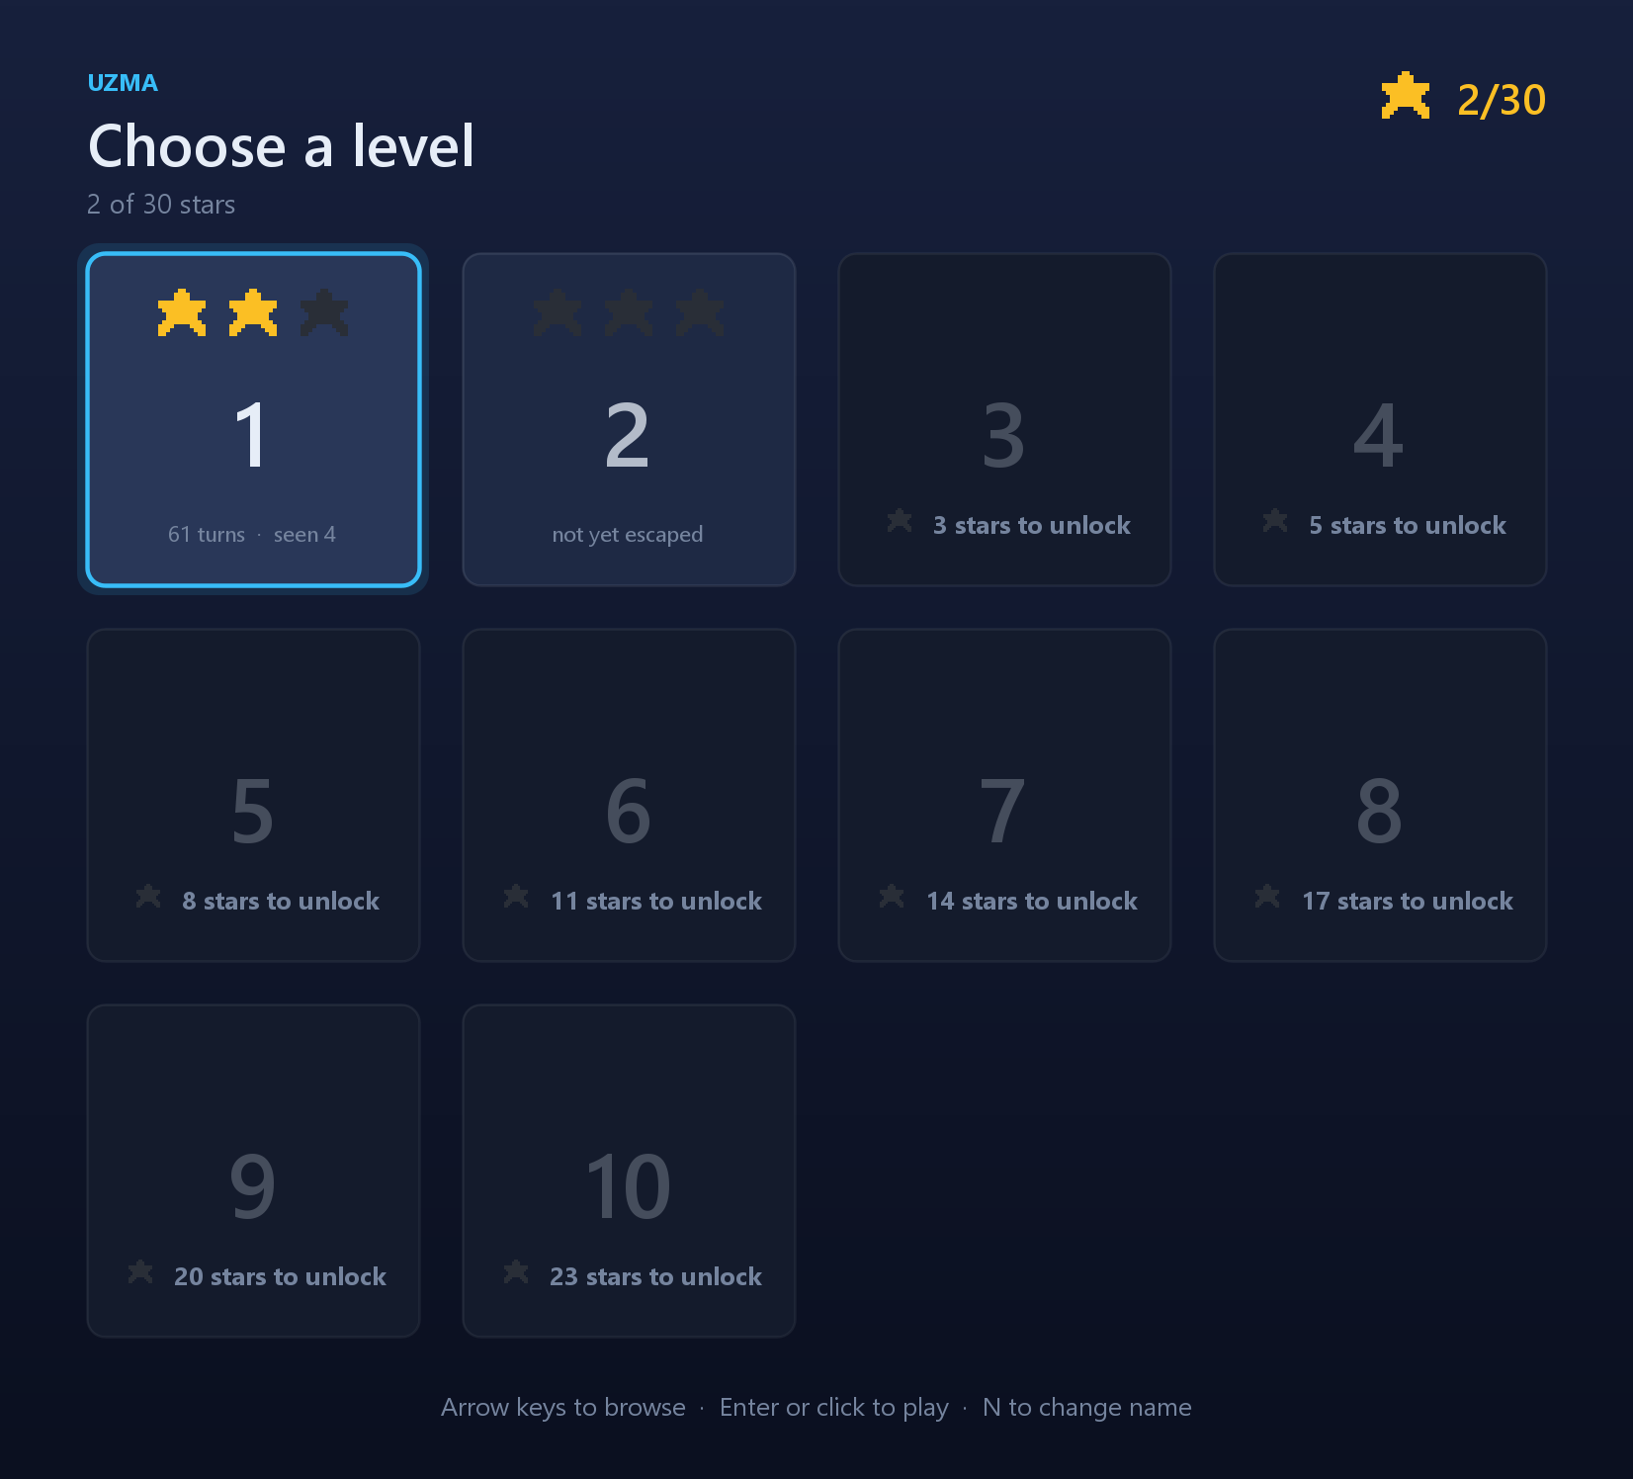
Figure 7.1 — Level selection. Levels unlock against accumulated stars, and each box shows the best rating achieved on it.
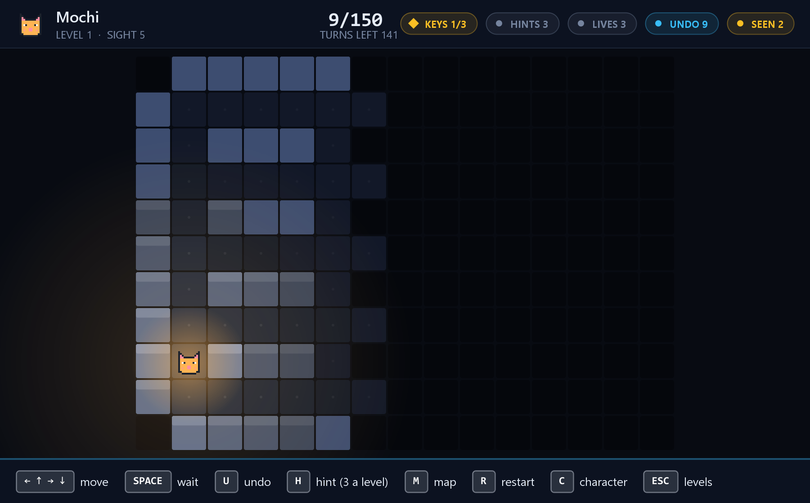
Figure 7.2 — Fog of war. Bright tiles are currently visible, dim tiles are remembered terrain, and black is unexplored.
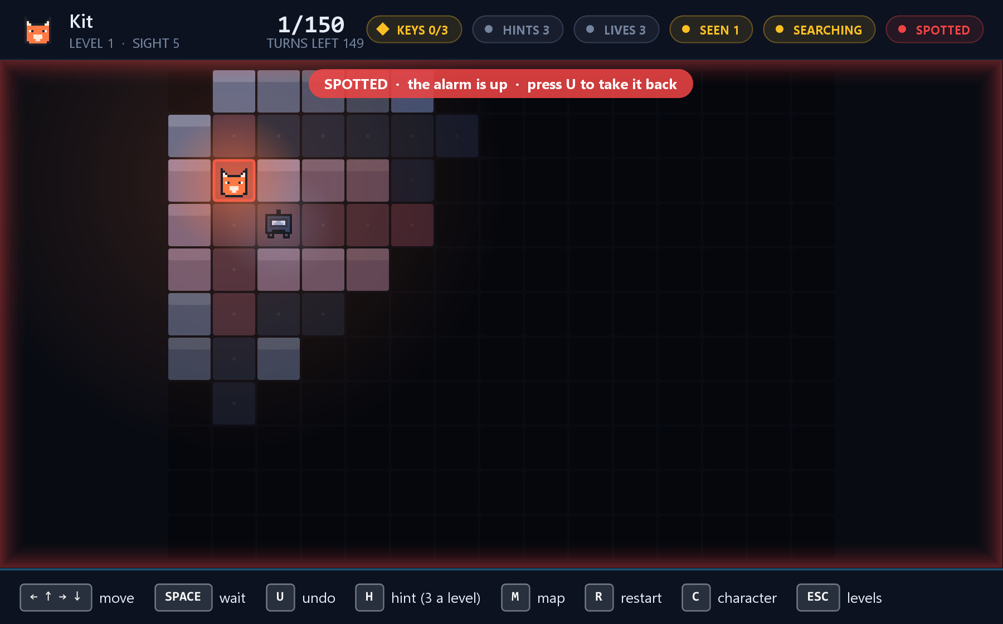
Figure 7.3 — Spotted. The guard's line of sight is drawn in red, the alarm is raised, and a hunter begins moving towards the sighting.
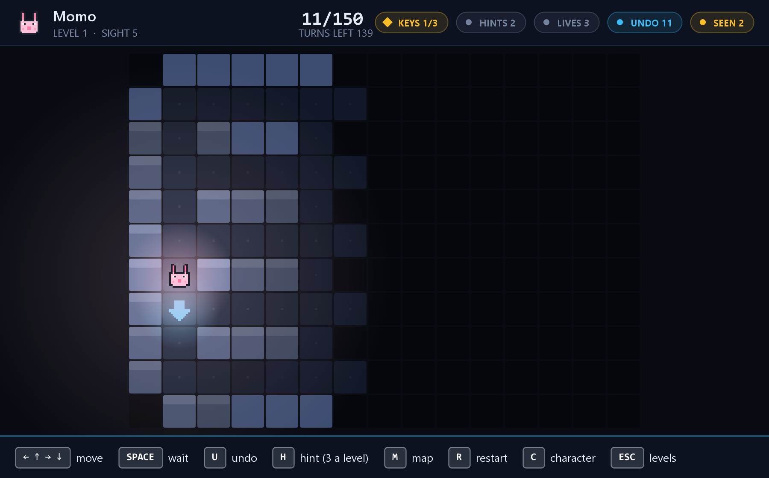
Figure 7.4 — A hint. One suggested move, shown for a single turn, routed to avoid being seen rather than to be shortest.
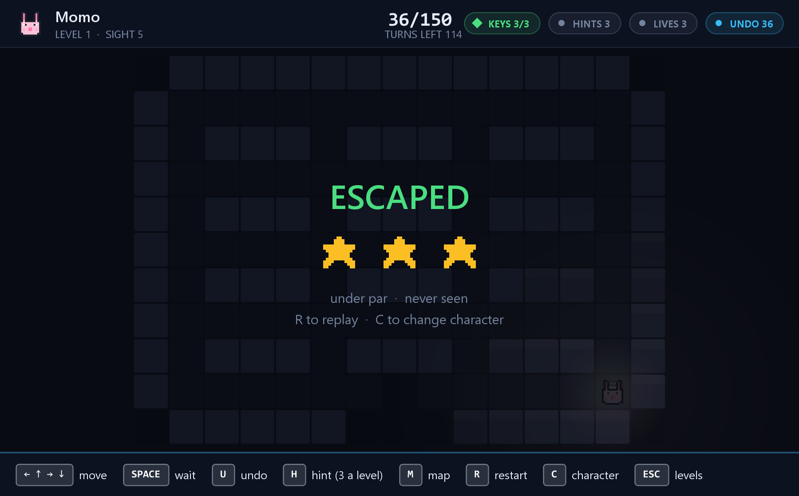
Figure 7.5 — Escaped. The rating screen, showing turns taken against par and the stars awarded.
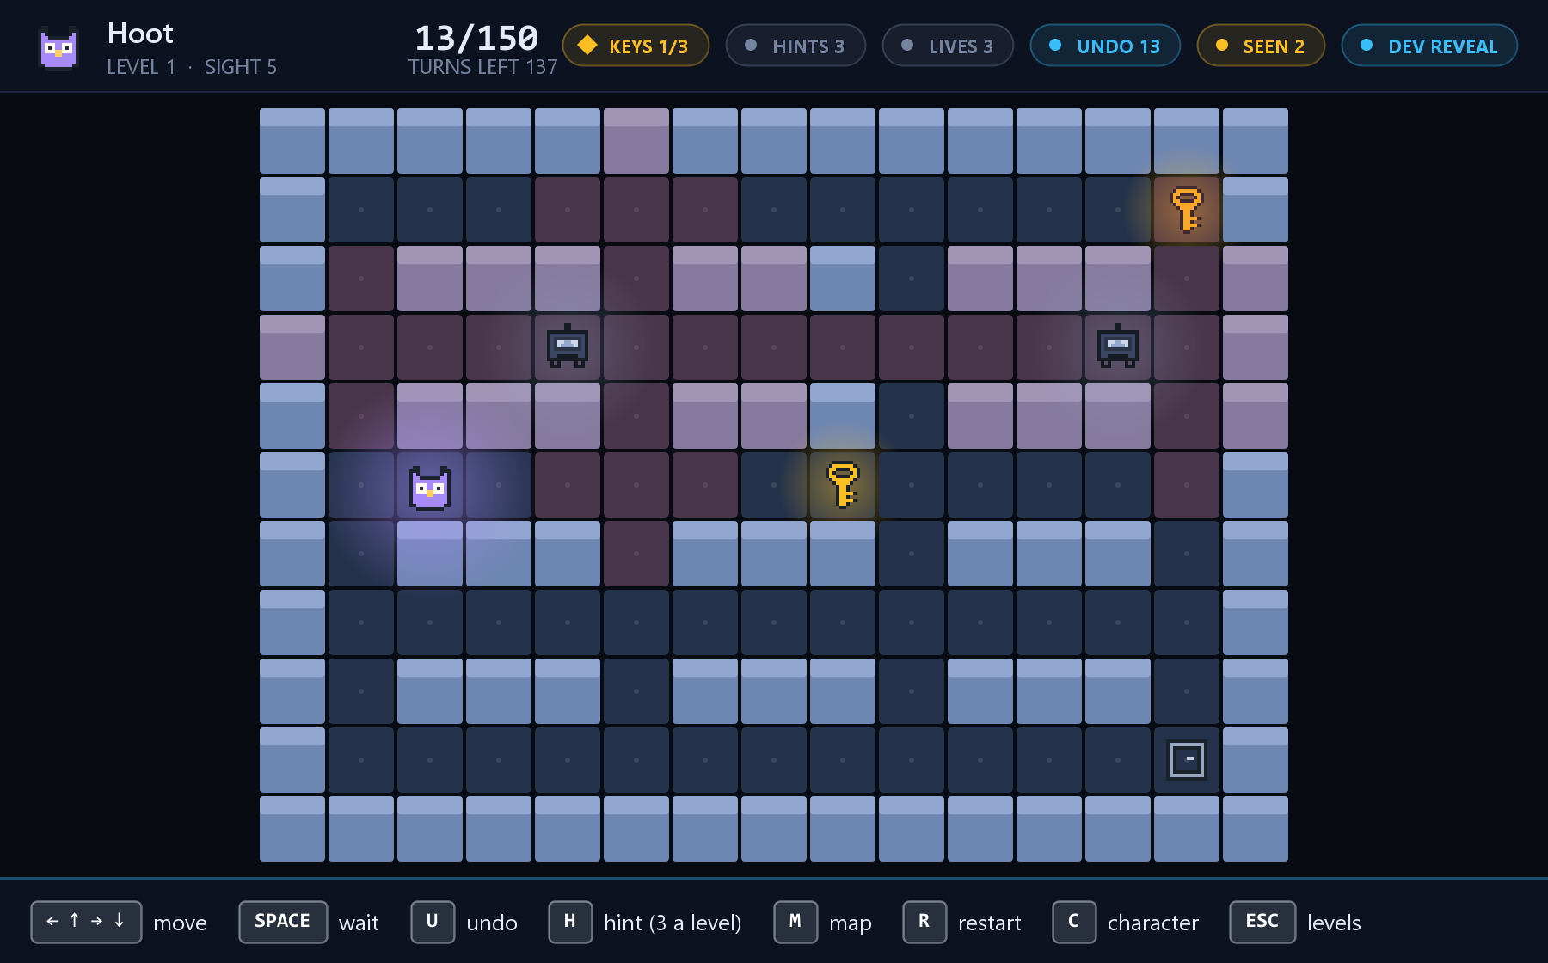
Figure 7.6 — Developer reveal. The whole map with every guard shown, used to check guard behaviour against expectation.

8. Conclusion
8.1 Summary
Signal Lost was delivered as a complete, playable turn-based stealth game in Java, with ten levels, six characters, two guard types, exact undo, a limited hint system, star-based scoring and saved progress. The rules are 2,704 lines across six packages and are verified by 205 automated tests in 25 test classes.
All seven objectives in Section 2.2 were met. Fog of war is a bounded breadth-first flood fill, pursuit uses A* with a Manhattan heuristic and a priority queue, five design patterns are applied where they carry structural weight, the separation of rules from interface is enforced by a test, behaviour is verified by testing, playability is verified by search, and the result is a finished game.
8.2 What the project demonstrates
An architectural rule that nothing enforces will not survive. The separation between rules and interface is the project's most useful property, and also one that a single convenient import would quietly destroy. Writing a test that fails the build on such an import turns an intention into a guarantee.
Passing tests and a working game are different claims. The project's most instructive fault was a level that could not be won while every test passed, because the tests checked that each rule behaved correctly and nothing checked that the game built from those rules could be finished.
Tools need checking too. The solver written to validate the levels was itself wrong twice, each time reporting winnable levels as unwinnable.
8.3 Limitations
- The sentinel guard with a rotating vision cone is not implemented.
- No performance budget is measured; NFR-1 is claimed rather than verified.
- Nothing in the game teaches its rules. A new player learns that red tiles are watched, and that only hunters capture, by being caught.
- No accessibility conformance is claimed. The line-of-sight overlay in particular conveys meaning by colour alone.
- Automated testing of the interface covers navigation and key bindings only; nothing checks what is drawn.
8.4 Future work
Term | Work
Near | The sentinel guard; an in-game tutorial; a colour-blind-safe line-of-sight overlay
Phase 2 | The Spring Boot and PostgreSQL leaderboard with daily levels. Score and LevelResult are already plain data records for this purpose
Longer | An Android release. Because the rules import no user-interface type, this needs a new interface layer rather than a new game; the only rules-layer change identified is giving ProgressStore a platform-appropriate path

9. References
- Hart, P. E., Nilsson, N. J. and Raphael, B. (1968). "A Formal Basis for the Heuristic Determination of Minimum Cost Paths." IEEE Transactions on Systems Science and Cybernetics, 4(2), pp. 100–107.
- Dijkstra, E. W. (1959). "A Note on Two Problems in Connexion with Graphs." Numerische Mathematik, 1(1), pp. 269–271.
- Gamma, E., Helm, R., Johnson, R. and Vlissides, J. (1994). Design Patterns: Elements of Reusable Object-Oriented Software. Addison-Wesley.
- IEEE Std 830-1998. IEEE Recommended Practice for Software Requirements Specifications. Institute of Electrical and Electronics Engineers.
- Oracle Corporation. Java SE 17 Documentation. https://docs.oracle.com/en/java/javase/17/
- The JUnit Team. JUnit 5 User Guide. https://junit.org/junit5/docs/current/user-guide/
- Mermaid. Diagramming and charting tool. https://mermaid.js.org/
- Yasmeen, U. (2026). Signal Lost — source repository. https://github.com/Uzma-Yasmeen/SignalLost

