LARGE LANGUAGE MODELS
Can an LLM Actually Do EDA? I Hid Statistical Traps in 60 Datasets to Find Out
On a controlled synthetic benchmark, GPT-5.6 Sol usually identified the right problem—but without a diagnostic checklist, it often stopped at a plausible hypothesis instead of proving it.
An LLM can generate an exploratory data analysis report in seconds. It can summarize columns, point out missing values, describe correlations, and produce polished observations that sound like the work of an experienced analyst.
But EDA is not a report. It is a search for structure.
The hard part is noticing what a standard summary can hide: a relationship that reverses inside subgroups, a U-shaped effect with almost zero Pearson correlation, two variables that matter only through an interaction, missingness that carries information, or residual variance that quietly grows with a predictor.
So I built a benchmark around a question that is much easier to score than “Did the model find interesting insights?”
If I know exactly what is hidden in a dataset, can an LLM find it—and can it support the finding with evidence?
I tested GPT-5.6 Sol in ChatGPT on September 26, 2026, using 60 synthetic datasets spanning ten EDA challenge families. I compared two workflows: an open-ended analysis based on a standard EDA profile, and a structured workflow that added a fixed diagnostic checklist.
The headline result was revealing:
- The open-ended workflow named the correct hidden phenomenon in 27 of 30 cases (90%).
- But only 15 of 30 cases (50%) were fully verified with evidence.
- Another 12 cases (40%) were directionally correct but remained unverified hypotheses.
- The remaining 3 cases (10%) were missed entirely—and all three were heteroscedasticity.
- With the structured diagnostic workflow, 30 of 30 guided cases were fully verified on this deliberately strong synthetic benchmark.
The most useful lesson was not that the model was “good” or “bad” at EDA. It was that recognizing a plausible pattern and establishing that the pattern is actually present are different tasks.
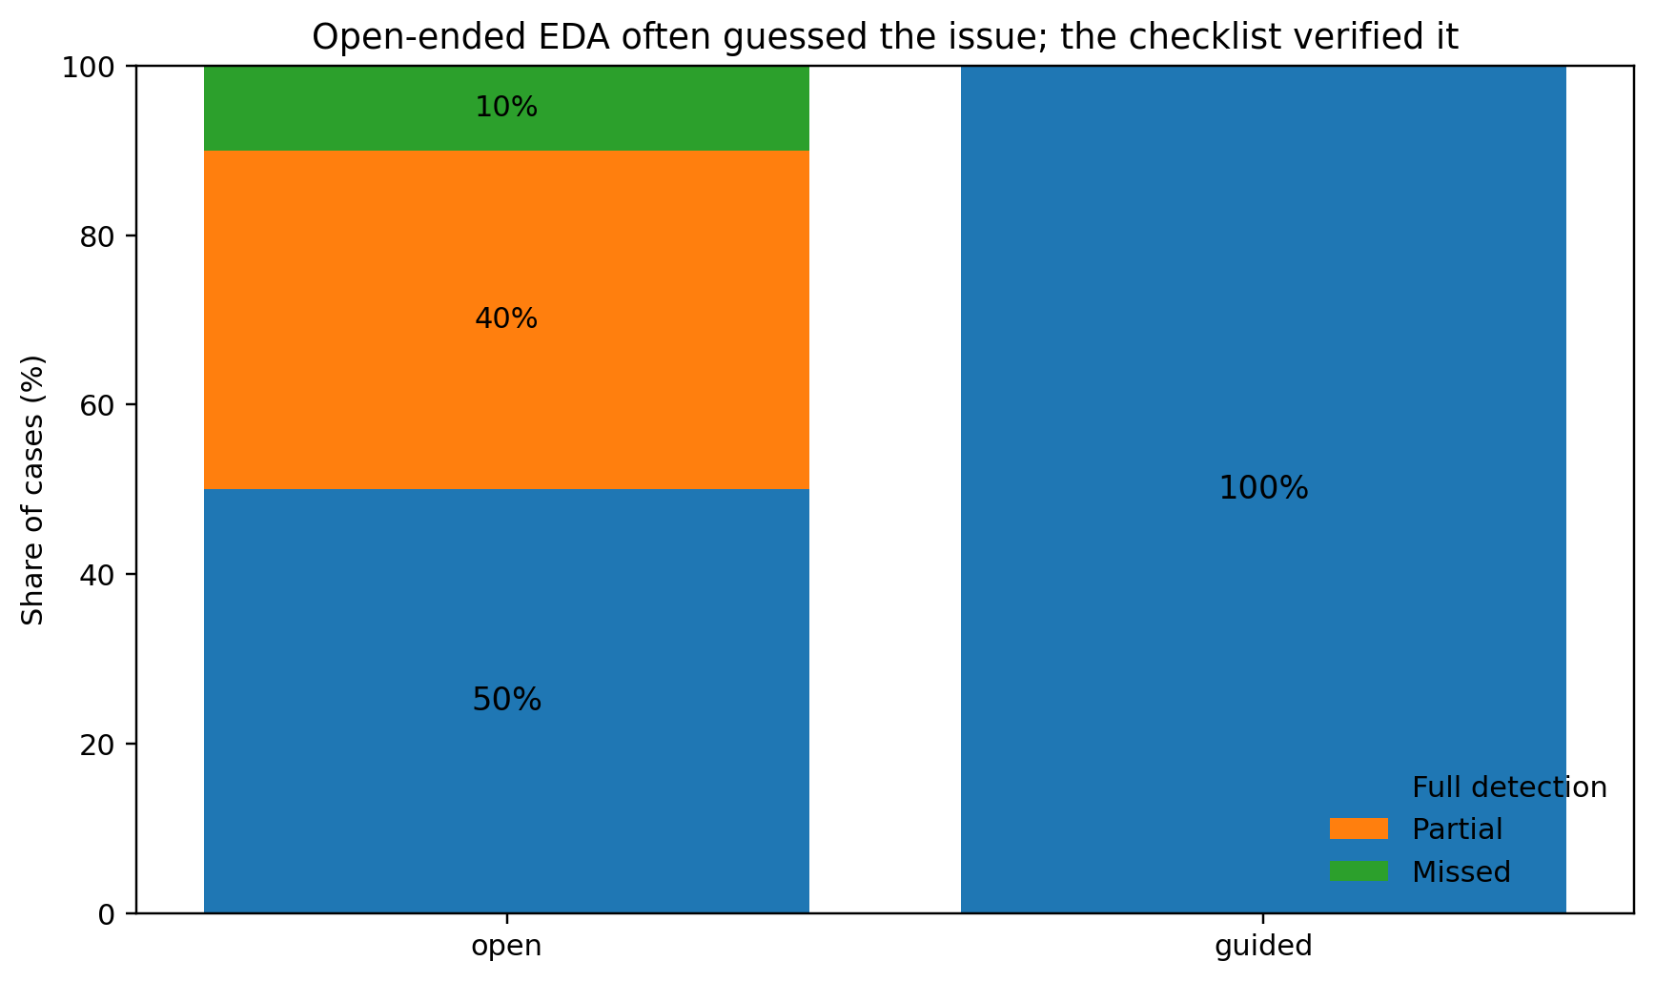
Figure 1. Open-ended EDA fully verified 50% of cases, partially identified 40%, and missed 10%. The structured workflow fully verified all 30 guided cases. Image by author.
Workflow | Correct primary diagnosis | Fully verified | Partial | Missed | Evidence-based score
Open-ended | 90% | 50% | 40% | 10% | 70%
Structured | 100% | 100% | 0% | 0% | 100%

Why use synthetic data for an EDA benchmark?
Most demonstrations of “AI for EDA” start with a real dataset and ask a model to find insights. That makes the output easy to admire but surprisingly hard to evaluate.
If a model finds five patterns, how do we know whether those were the important five? Did it miss another ten? Did it confidently describe something that is not actually there?
Synthetic data solves that problem because the data-generating process gives us an answer key.
For this experiment, every dataset shared the same schema and the same business context:
- observation_date
- segment
- exposure_hours
- engagement_score
- account_age_months
- workflow_status
- outcome_value
Only the hidden mechanism changed.
I used ten challenge families:
Challenge | Hidden structure
Clean control | No major hidden issue
Data quality | Invalid values, aliases, and duplicate records
Rare subgroup | A small segment with materially different outcomes
Target leakage | An operational field that almost partitions the target
Temporal drift | A large regime shift over time
Informative missingness | Missingness associated with the outcome
Nonlinear relationship | A strong U-shaped relationship hidden by weak linear correlation
Interaction effect | Weak marginal effects but a strong pairwise interaction
Simpson's paradox | Pooled and within-group relationships with opposite signs
Heteroscedasticity | Error variance increasing with a predictor

I generated three independent replicas of each challenge for each workflow. That produced 60 datasets and 134,025 rows in total, with a median of roughly 2,277 rows per case.
The model never received the hidden challenge label during diagnosis. The label was used only when the completed analyses were scored.
What exactly did GPT-5.6 Sol see?
I wanted the comparison to measure analytical reasoning rather than differences in code execution, tool choice, or chart-generation behavior. So I separated computation from interpretation.
Python generated a reproducible EDA profile for every dataset. GPT-5.6 Sol then interpreted that profile.
This makes the experiment narrower than a fully autonomous “upload a CSV and let an agent do anything” workflow, but it makes the comparison much cleaner: the model saw the same classes of evidence in every case, and the two conditions differed only in how systematic that evidence became.
Workflow 1: open-ended EDA
For the 30 open-ended cases, the model received:
- shape and data types
- missingness percentages
- duplicate counts
- descriptive statistics
- Pearson and Spearman correlations with the target
- target summaries by categorical group
- quarterly target summaries
It was then asked to identify the most important pattern, anomaly, data-quality issue, or modeling risk.
Crucially, it did not receive extra advanced diagnostics tailored to the case after making an initial observation.
Workflow 2: structured EDA
The other 30 cases received the same basic profile plus a fixed diagnostic panel. The panel checked:
- improvement from a quadratic term over a linear fit
- pairwise interaction gain
- residual variance behavior and a Breusch-Pagan test
- pooled versus within-segment correlations
- target differences between missing and observed records
- categorical effect sizes
- first-half versus second-half target shifts
- semantic data-quality rules and duplicates
For example, the nonlinear diagnostic was intentionally simple:
linear = LinearRegression().fit(x.reshape(-1, 1), y)
x_quad = np.column_stack([x, x**2])
quadratic = LinearRegression().fit(x_quad, y)
quadratic_gain = (
quadratic.score(x_quad, y)
- linear.score(x.reshape(-1, 1), y)
)
The goal was not to build an exhaustive automated EDA library. It was to test what happens when an LLM moves from “What catches my attention?” to “Which important failure modes have I explicitly ruled in or ruled out?”
I scored a good guess differently from a demonstrated finding
This distinction became the core of the experiment.
Each case received a score from 0 to 2:
- 0 — Missed: the primary diagnosis was incorrect or absent.
- 1 — Partial: the model named the correct phenomenon, but the available evidence did not establish it.
- 2 — Full: the model correctly identified the phenomenon and supported it with evidence available in that workflow.
This matters because a sentence such as “This may be Simpson's paradox” is not equivalent to showing that the pooled relationship is negative while the within-group relationships are positive.
If I had measured only the final label, open-ended EDA would have looked excellent: 90% exact-label accuracy.
Under the evidence-based rubric, however, the open workflow achieved 70% of the maximum possible score, because many of its correct diagnoses were still hypotheses. The structured workflow reached 100% on these strong synthetic cases.
The three clean-control replicas were also correctly recognized in both conditions. That is important: the model was not being rewarded simply for always declaring that something unusual must be present.
What open-ended EDA found easily
Five challenge families were fully detected in all three open-ended replicas:
- clean controls
- data-quality problems
- rare subgroups
- target leakage
- temporal drift
These problems leave strong fingerprints in the kinds of summaries analysts already inspect routinely.
Rare subgroups
When a small segment had dramatically different outcomes, the grouped target summaries made the pattern difficult to miss. In one guided case, the rare segment differed from the remaining population by 3.70 standard deviations, while segment membership explained about 37% of the target variance.
This is exactly the kind of pattern where an LLM is useful: the evidence is already present, but the model can quickly translate a table into a readable analytical observation.
Target leakage
Leakage was also visible without sophisticated modeling because the suspicious variable had both statistical strength and problematic semantics.
In one representative case, workflow_status explained roughly 71% of the variance in outcome_value. Mean outcomes increased from about 60 for Open, to 71 for Reviewed, to 80 for Resolved.
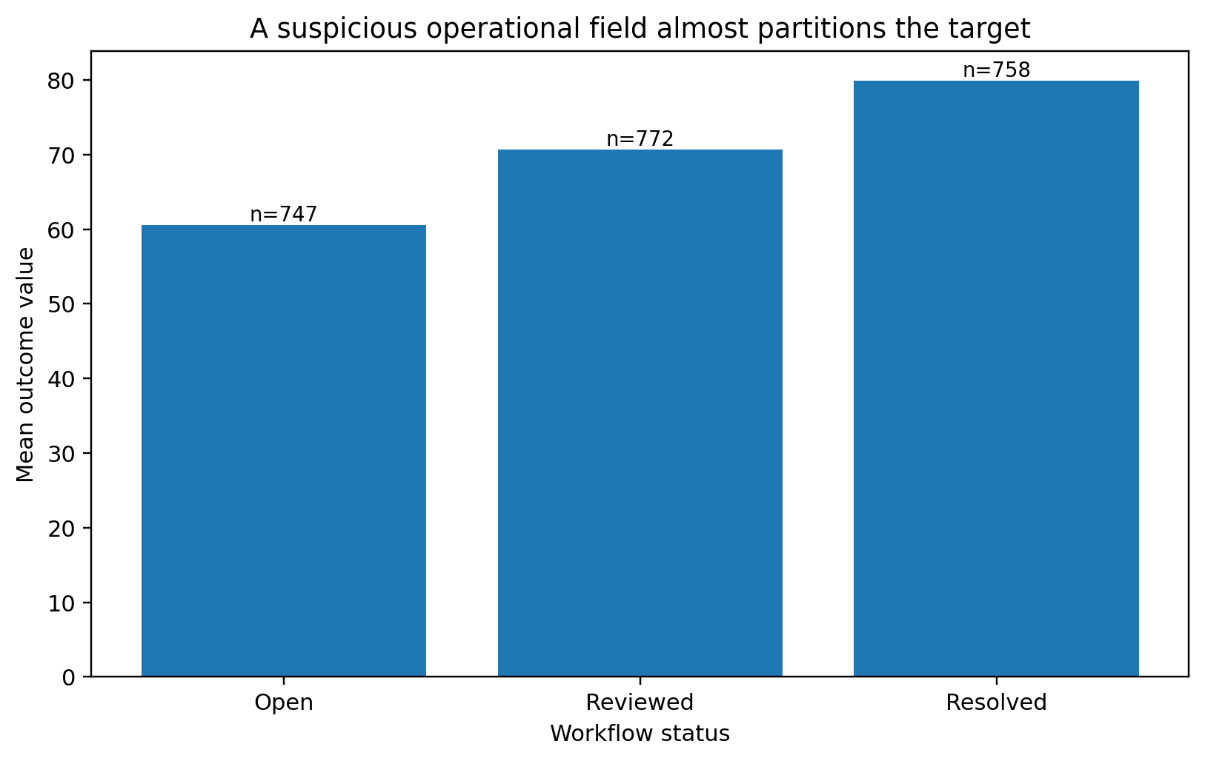
Figure 2. An operational workflow field almost partitions the target. Statistical strength plus its business meaning makes it a strong leakage candidate. Image by author.
A purely statistical system might celebrate that variable. A useful EDA workflow has to ask whether the field would actually be available at prediction time.
Temporal drift
Temporal drift was similarly obvious once outcomes were summarized over time. In one guided replica, the difference between the first and second halves of the year reached 1.64 standard deviations.
The general pattern is straightforward: open-ended LLM analysis performed best when the problem was visible in a summary it was already likely to inspect.
The model often guessed the harder problems correctly—but could not prove them
Four challenge families followed a more interesting pattern in the open-ended condition:
- informative missingness
- nonlinear relationships
- interaction effects
- Simpson's paradox
Across all 12 of those open-ended cases, GPT-5.6 Sol named the correct phenomenon. But every one received only 1/2 because the basic profile did not contain enough evidence to establish the mechanism.
That gap between good suspicion and verified analysis is where the experiment became useful.
Simpson's paradox: the right hypothesis before the decisive test
In one open-ended case, the pooled correlation between exposure_hours and outcome_value was -0.705. Large differences between segment means made aggregation bias suspicious, so the model proposed Simpson's paradox.
The fixed diagnostic then tested the idea directly. The median within-segment correlation was +0.610.
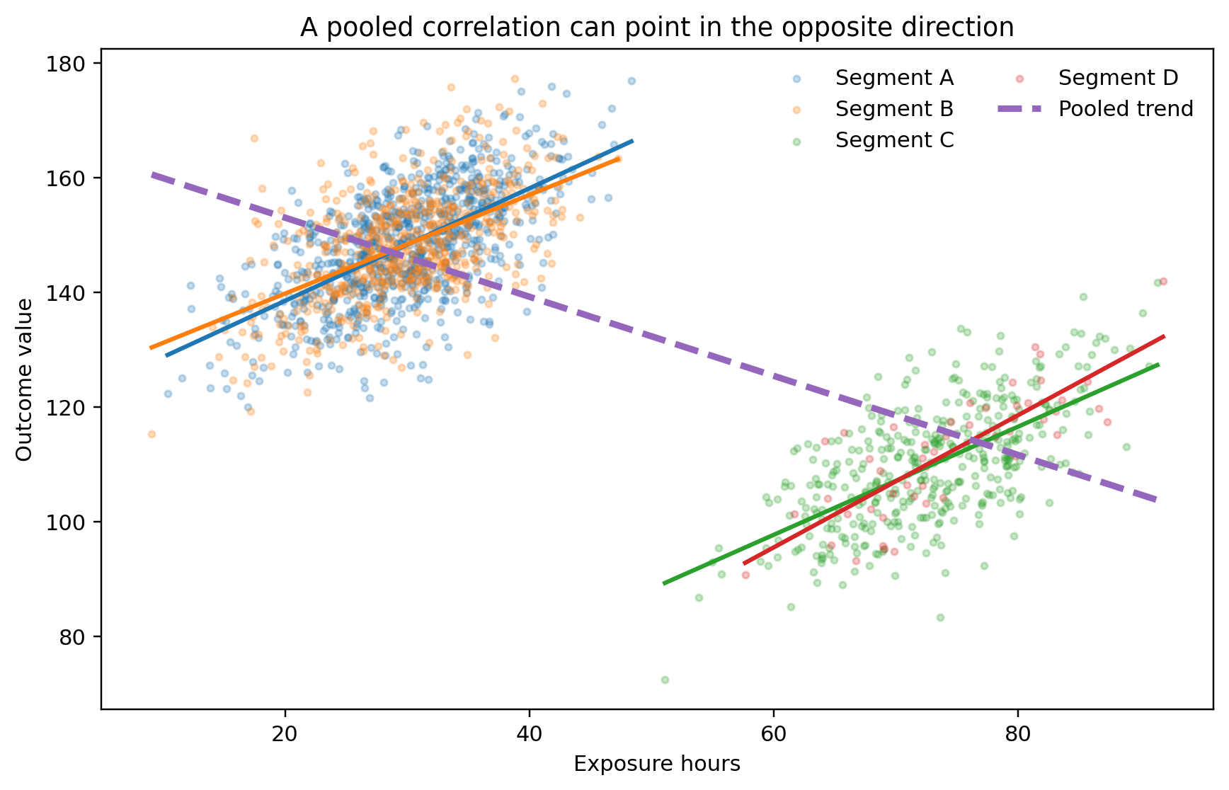
Figure 3. The pooled relationship is negative even though the within-segment relationships are positive. Image by author.
The initial diagnosis was insightful. But it was still a hypothesis until the subgroup relationships were calculated.
Nonlinearity: Pearson correlation can be almost useless
The nonlinear cases produced the same dynamic.
The open-ended profile showed weak linear correlations and an unusual target distribution, which led the model to suspect a nonlinear relationship. The structured diagnostic made the idea measurable.
In one case, adding a quadratic term increased R² by 0.880 over the corresponding linear fit.
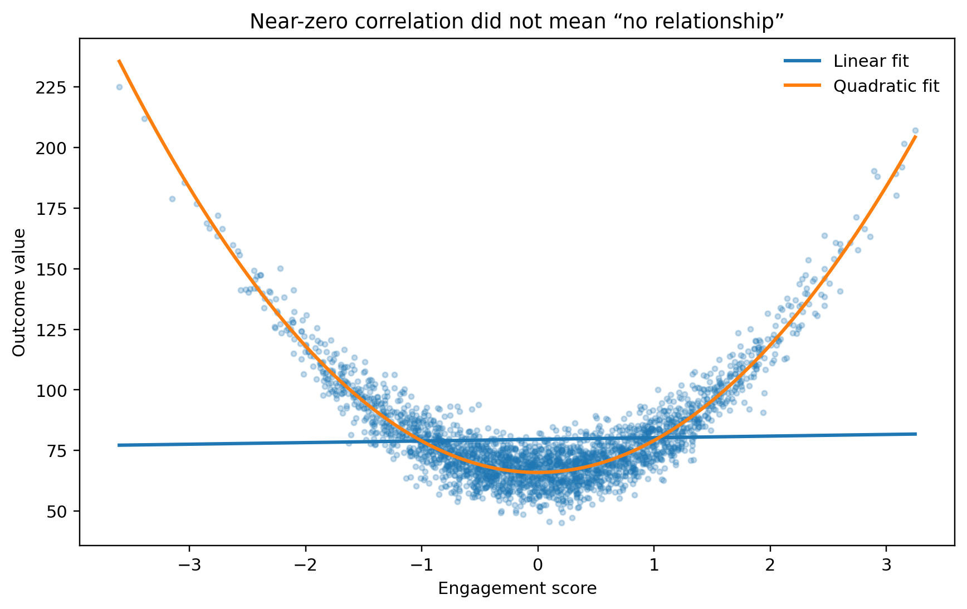
Figure 4. Pearson correlation is close to zero, yet the underlying relationship is strong and highly structured. Image by author.
This is a useful reminder for human analysts as well: a weak correlation is not evidence that two variables are unrelated.
Interaction effects: weak marginal signals can hide strong joint structure
The interaction cases had weak individual relationships with the target. An analyst looking only at marginal correlations could easily dismiss them.
The model correctly suspected hidden multivariate structure, but the fixed interaction scan was what established it. In representative guided cases, adding the strongest pairwise interaction increased R² by approximately 0.81-0.82.
Informative missingness: “25% missing” is not the real finding
In the informative-missingness cases, the open-ended workflow correctly treated the amount of missing data as important. But simply reporting that a column is 25% missing is descriptive, not analytical.
The more useful question is whether rows with missing values behave differently.
In one guided case, the mean target difference between missing and observed records was approximately 1.13 standard deviations.
That turns “we have missing values” into a modeling and data-collection insight.
The one problem open-ended EDA missed every time
All three open-ended misses were heteroscedasticity cases.
The basic profile looked healthy. exposure_hours had a strong positive relationship with the target, with correlations around 0.77-0.80 in two of the missed replicas. There were no striking missingness patterns, invalid records, subgroup anomalies, workflow leakage, or temporal shifts.
So the open-ended analysis concluded that exposure was simply the dominant predictor.
What it did not inspect was the residual structure.
Once a linear model was fitted, the magnitude of the residuals clearly increased with exposure. In the representative case below, the correlation between absolute residual size and exposure was 0.288, and the Breusch-Pagan test strongly rejected constant variance (p < 1e-15).
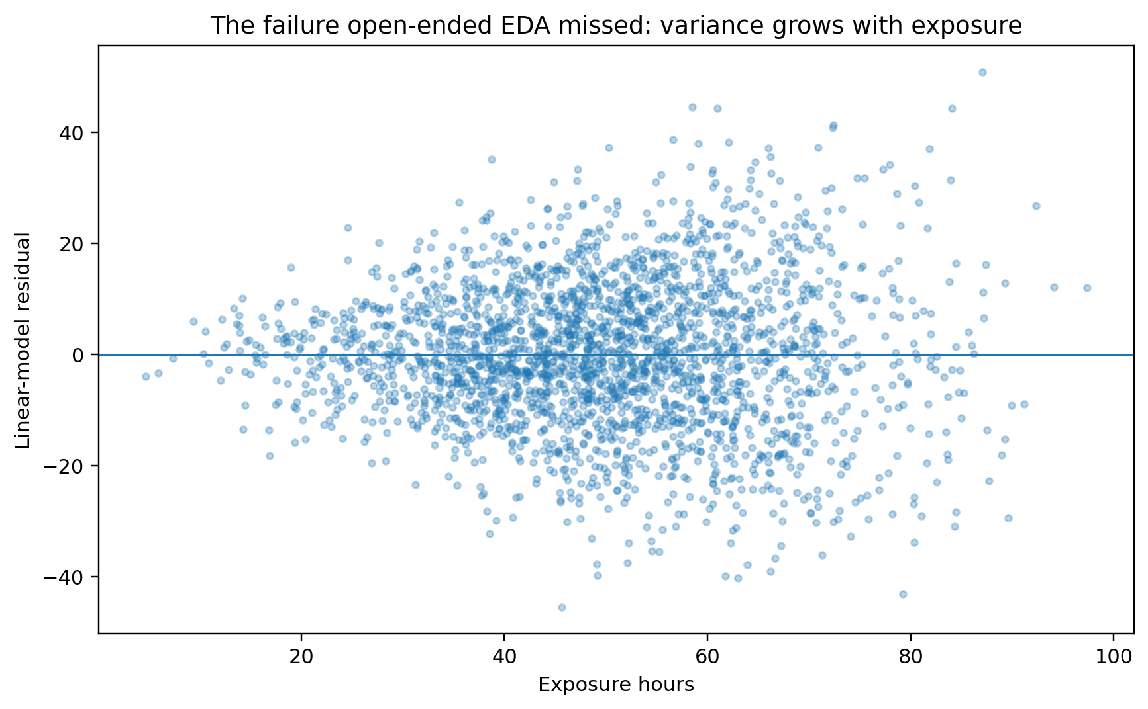
Figure 5. The mean relationship looks straightforward, but prediction uncertainty grows with exposure. Image by author.
This was the most valuable failure in the benchmark because it explains why an open-ended workflow can be incomplete.
Standard EDA naturally gravitates toward means, distributions, missingness, and correlations. Heteroscedasticity lives in the conditional variance. Unless the workflow explicitly asks about residual behavior, nothing in a conventional summary forces the analyst—or the LLM—to look there.
The checklist did not make the model smarter. It made the analysis systematic.
The pattern-level scores show the difference clearly.
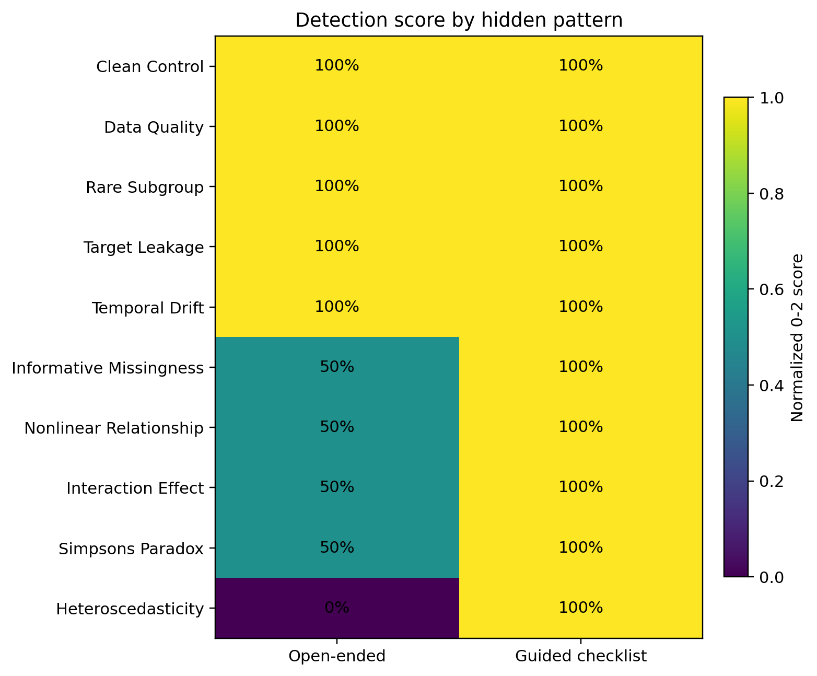
Figure 6. Open-ended EDA handled visible problems well, partially identified several second-order structures, and missed changing variance entirely. The fixed checklist verified every planted pattern in the guided set. Image by author.
The structured workflow did not give GPT-5.6 Sol a magical new capability. Most of the hard cases were already within reach: the model often suspected the correct explanation from the basic profile.
The checklist changed which questions had to be answered before the analysis could stop.
That distinction is familiar elsewhere in technical work. Code review checklists exist because reviewers do not spontaneously remember every failure mode. Production ML monitoring does not wait for someone to notice drift by eye. Statistical assumptions are tested because a plausible-looking fit is not enough.
EDA benefits from the same discipline.
A practical architecture for LLM-assisted EDA
If I were building an LLM EDA assistant for real work, I would not ask the model to “analyze this dataset” and accept the resulting narrative as the analysis.
I would separate the workflow into five stages.
1. Deterministic profiling
Use code to calculate the facts that should not depend on language-model behavior:
- schema and data types
- missingness and duplicates
- distributions and invalid ranges
- subgroup summaries
- basic correlations
- time slices
2. LLM hypothesis generation
Let the model do what it did well in this experiment: connect pieces of evidence and propose explanations.
Examples:
- “This operational field may be leakage.”
- “The pooled relationship may be hiding a subgroup reversal.”
- “Weak marginal correlations may be masking an interaction.”
At this stage, those statements should be treated as hypotheses, not conclusions.
3. Fixed verification tests
Run a compact set of diagnostics regardless of whether the model remembered to ask for them:
- compare linear and simple nonlinear fits
- test plausible low-order interactions
- inspect residual variance and model assumptions
- compare aggregate and subgroup relationships
- test missingness indicators against outcomes
- slice time whenever timestamps exist
- audit suspiciously predictive operational fields for leakage
The exact checklist should depend on the domain, but the important part is that it is predefined rather than improvised after the first interesting observation.
4. LLM explanation
Once the diagnostics exist, use the model to translate them into a concise narrative: what matters, why it matters, and what should be investigated next.
This is where LLMs are genuinely helpful. They can connect statistical evidence with business semantics much faster than a static automated-reporting library.
5. Human review for semantic and causal claims
Some EDA questions remain impossible to settle from the table alone.
A field may look like leakage, but only someone who understands when it is generated can confirm that. A temporal shift may be a data problem, a product launch, a pricing change, or seasonality. A subgroup effect may reflect a real operational difference or a collection bias.
The model can surface those questions. A domain expert still has to answer them.
What this benchmark does—and does not—show
There are several reasons not to read the 100% structured score as a universal claim about LLM EDA.
First, the data are synthetic. That is what gives the benchmark ground truth, but real company datasets contain overlapping problems, weaker effects, undocumented definitions, and messy causal histories.
Second, the planted effects were deliberately strong enough to be discoverable. A 3.70-standard-deviation rare-subgroup effect is not subtle. The guided workflow's perfect score therefore shows that the checklist was sufficient for these benchmark cases—not that it will find every weak real-world anomaly.
Third, this experiment tested one model configuration: GPT-5.6 Sol in ChatGPT. It should not be interpreted as a ranking of LLMs or a general capability estimate for all models.
Fourth, this benchmark isolated interpretation from computation. Python generated the profiles and diagnostic statistics; the LLM interpreted them. A fully autonomous data-analysis agent introduces additional failure modes around tool selection, code execution, plotting, retries, and state management.
Finally, the three replicas per challenge measure variation in the synthetic data generation, not the full sampling variability of repeated model calls. A larger follow-up should repeat the same cases across multiple models and fresh model sessions.
Those limitations are precisely why I find the central result more useful than the headline percentages.
Conclusion
Before this experiment, the question I had in mind was simple:
Can an LLM actually do EDA?
After running the benchmark, I think that question is too broad.
GPT-5.6 Sol often had good analytical instincts. In the open-ended condition, it named the correct hidden phenomenon in 90% of cases. It caught obvious quality issues, rare subgroups, leakage, and drift, and it often suspected harder structures such as nonlinearity, interactions, informative missingness, and Simpson's paradox.
But when I required the model to demonstrate those findings rather than merely mention them, only 50% of the open-ended cases were fully verified. Heteroscedasticity was missed in every open replica.
The fixed diagnostic workflow closed that gap on this synthetic benchmark.
So the practical lesson is not “let the LLM do EDA for you.” It is closer to this:
Use the LLM to generate hypotheses and explain evidence. Use a deterministic diagnostic process to decide whether the hypotheses are actually true.
That combination is less magical than an autonomous AI analyst.
It is also much closer to how I would want a reliable analyst—human or machine—to work.

