VISUALIZATION
- Data visualization in Python is the process of creating graphical representations of data using Python libraries. Instead of looking at raw numbers in a spreadsheet, you turn that data into charts, graphs, and plots that are easier to understand and analyze.
- In python, data visualization has multiple libraries like matplotlib, seaborn, plotly etc.
- Let us dive deeper into matplotlib and seaborn.

MATPLOTLIB
- Matplotlib is a comprehensive Python library for creating static, animated, and interactive visualizations. It was created by John D. Hunter in 2003 and has become the foundational plotting library in the Python ecosystem.
- What makes Matplotlib unique is its MATLAB-style syntax and complete control over every aspect of a figure. It integrates seamlessly with NumPy arrays and Pandas DataFrames, making it an essential tool for data scientists, researchers, and developers

Key Features:

Wide variety of plot types likes line, bar, scatter, histogram, pie, 3D plots, etc.

Extensive customization options for colors, labels, fonts, and styles

Support for multiple output formats (PNG, PDF, SVG, JPG)

Ability to create multiple subplots within a single figure

Object-oriented API for embedding in applications

Animated plots to show changes over time

PYPLOT
Pyplot is a module within the Matplotlib library that provides a collection of functions for creating and customizing plots quickly and easily. It mimics MATLAB's plotting interface, making it familiar to users from that background.
To Import the matplotlib in python:
import matplotlib.pyplot as plt

Some of the plots in matplotlib:

LINE PLOT
A line plot is a type of graph that displays data as a series of points connected by straight lines. It shows how values change over a continuous interval, such as time, distance, or any ordered sequence.
Code snippet:
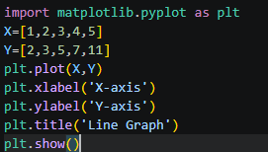
Output:
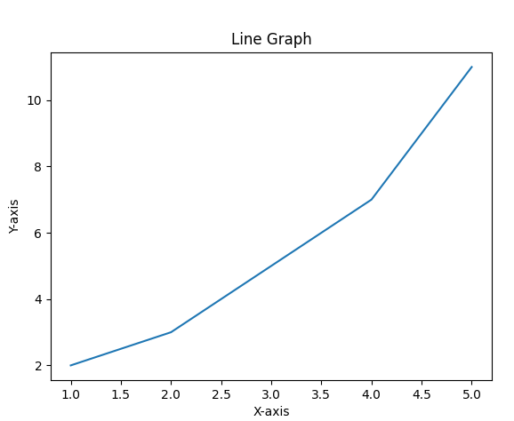

BAR PLOT
A bar plot (also called a bar chart or bar graph) is a graphical representation of data where rectangular bars of different heights or lengths are used to compare values across different categories.
Code snippet:
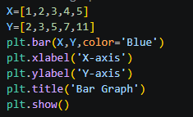
Output:
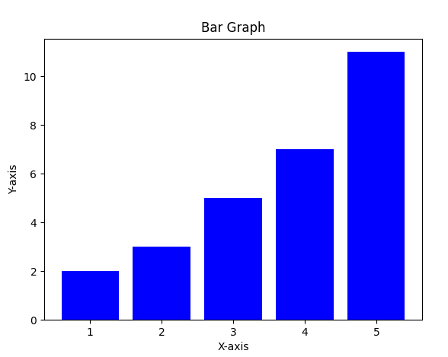

HISTOGRAM
A histogram is a graphical representation that organizes a group of data points into bins (intervals) and shows how many data points fall into each bin using bars. It shows the distribution or shape of numerical data.
Code snippet:
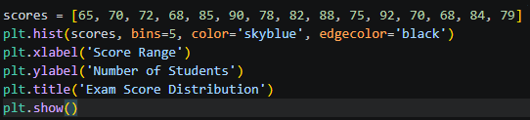
Output:
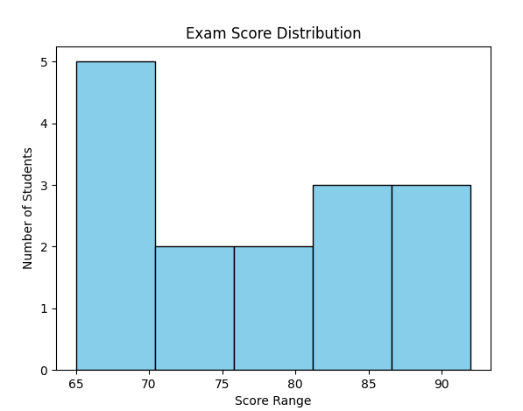
- SCATTER PLOT
A scatter plot (also called a scatter diagram or scatter graph) is a type of graph that uses individual dots or points to show the relationship between two numerical variables. Each dot represents one data point with its position determined by its X and Y values.
Code snippet:
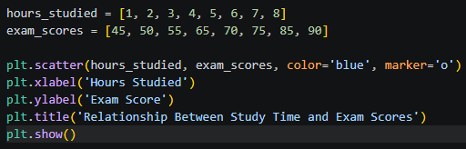
Output:
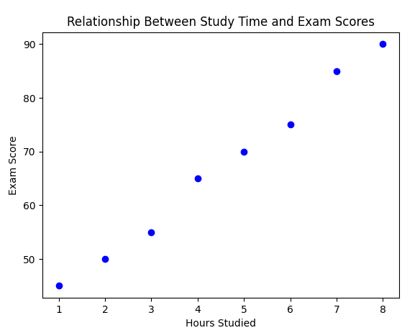

PIECHART PLOT
A pie chart is a circular graph that is divided into slices to show proportions or percentages of a whole. Each slice represents a category, and the size of the slice is proportional to its value.
Code snippet:
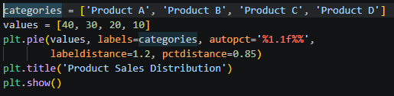
Output:
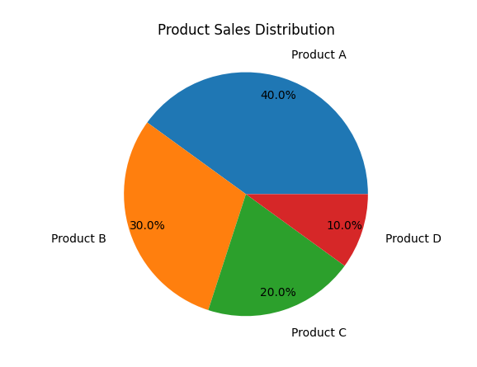

AREA CHART
An area chart is a line plot where the area between the line and the x-axis is filled with color. It shows how a quantity changes over time while emphasizing the total volume or magnitude of change.
Code snippet:
- Using fill_between() function
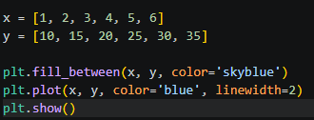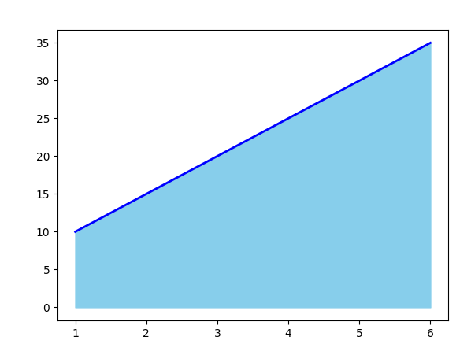

- Using stackplot() function
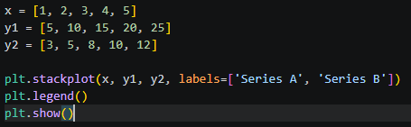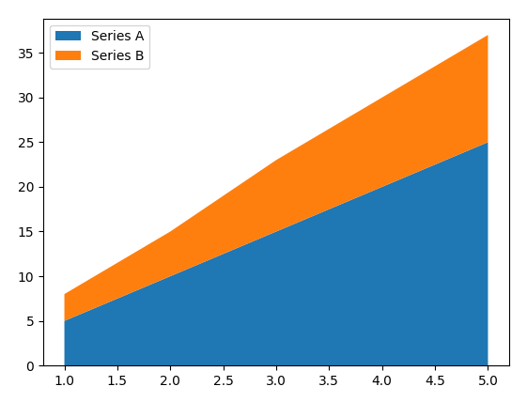

SEABORN

Seaborn is a Python data visualization library built on top of Matplotlib. It provides a high-level interface for creating attractive statistical graphics with very little code.Let us see the different plots in each category.
Key Features of Seaborn
- Built on top of Matplotlib (uses Matplotlib for rendering)
- Works directly with pandas DataFrames
- Beautiful default color palettes and themes
- Built-in statistical estimation (confidence intervals, regression lines)
- Simplified syntax requiring fewer lines of code
- Specialized plots like violin plots, swarm plots, and heatmaps
- Figure-level functions for multi-plot grids
Here are some sample codes for some of the graphs.

Scatter plot:
A scatter plot in Seaborn is a relational plot that displays individual data points as dots to show the relationship between two numerical variables. Seaborn's scatter plot automatically adds features like color coding, size encoding, and confidence ellipses with minimal code.
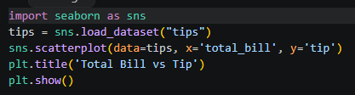
Output:
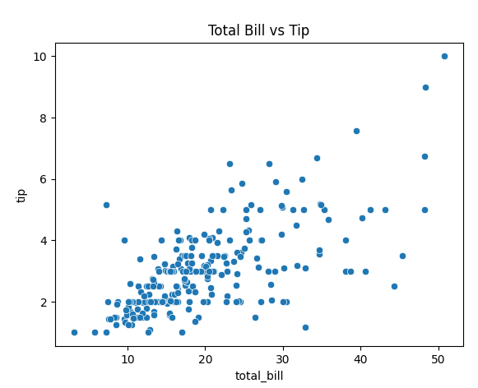
- LINE PLOT
A line plot in Seaborn is a relational plot that connects data points with lines to show trends over a continuous interval. Seaborn's line plot automatically adds a shaded confidence interval around the line, showing uncertainty in the data.
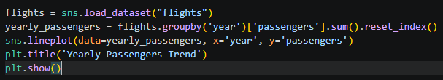
Output:
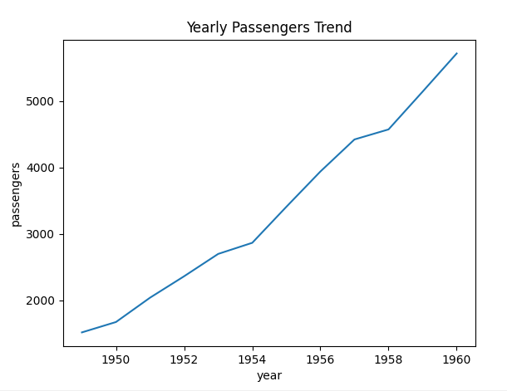
- BAR PLOT
A bar plot in Seaborn is a categorical plot that displays the average or aggregate value of a continuous variable for each category using rectangular bars. Seaborn bar plot automatically adds error bars showing confidence intervals or standard deviations.
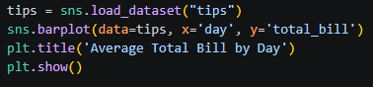
Output:
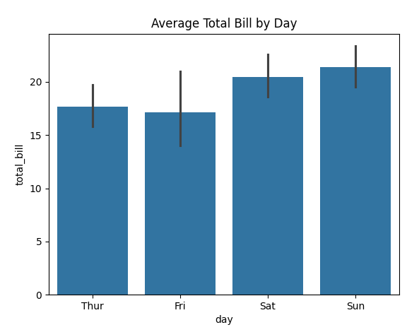
- COUNT PLOT
A count plot is a categorical plot that shows the number of observations (counts) in each category using bars. It is essentially a histogram for categorical data instead of numerical data.
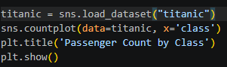
Output:
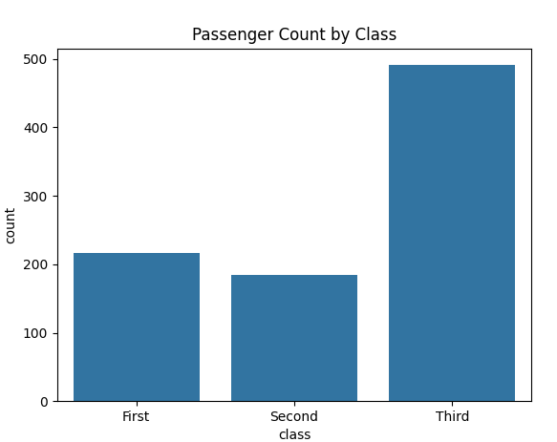
- BOX PLOT
A box plot (also called box-and-whisker plot) is a standardized way of displaying the distribution of a dataset based on a five-number summary: minimum, first quartile (Q1), median, third quartile (Q3), and maximum.
Code snippet:
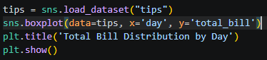
Output:
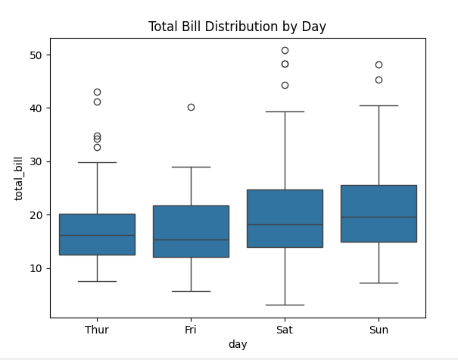
- HISTOPLOT
A histogram in Seaborn is a plot that shows the distribution of a continuous dataset by dividing the data into bins (intervals) and counting how many data points fall into each bin. The height of each bar represents the frequency or density of data within that range.\
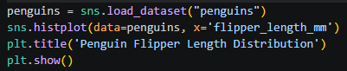
Output:
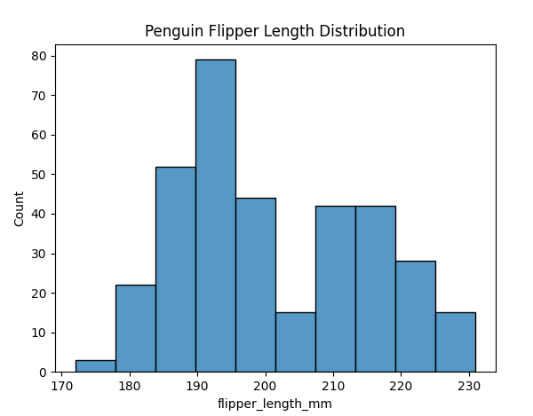

KDEPLOT
A KDE plot (Kernel Density Estimate plot) is a smooth curve that represents the probability density distribution of a continuous dataset. Unlike histograms which use bars, KDE plots create a continuous smooth line showing where data points are most concentrated.
Code snippet:
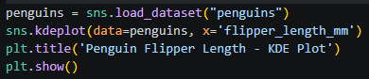
Output:
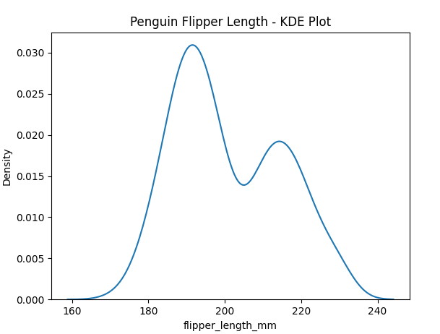

- HEATMAP
A heatmap is a graphical representation of data where values are depicted using colors. It uses a color gradient to show the magnitude of values in a matrix format, making it easy to spot patterns, correlations, and variations in large datasets.
Code snippet:
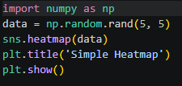
Output:
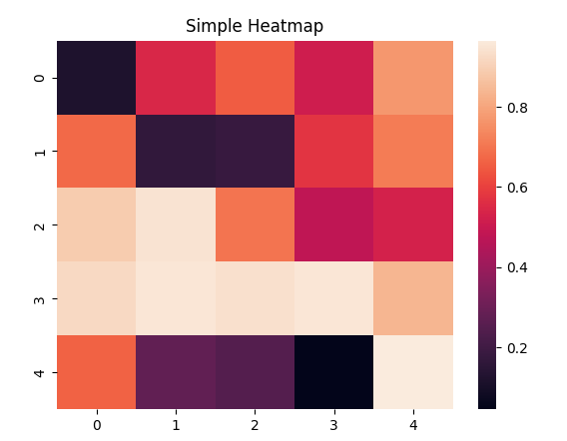
- REGPLOT
A regplot (regression plot) is a scatter plot with an overlaid regression line that shows the relationship between two numerical variables. It automatically fits a statistical model (usually linear regression) and visualizes the trend in the data.
Code snippet:
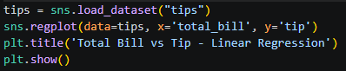
Output:
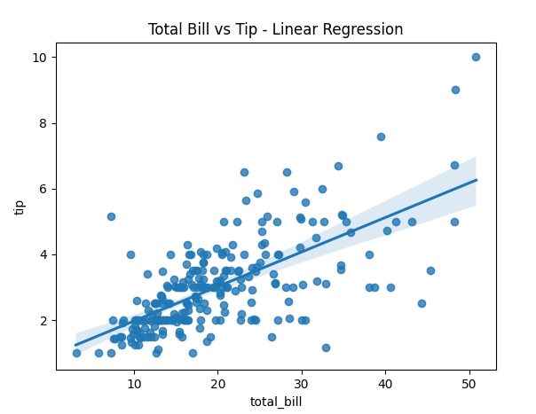
COMPARISON OF MATPLOTLIB AND SEABORN
Matplotlib:
- Core Library: Matplotlib is a comprehensive library for creating static, animated, and interactive visualizations in Python. It provides a low-level interface for creating plots with fine-grained control over every aspect of the figure.
- Flexibility: Matplotlib allows users to create any type of plot imaginable, from basic line plots and scatter plots to complex 3D plots and geographical maps.
- Mature: Matplotlib has been around for a long time and is a well-established library in the Python ecosystem. Many other libraries, including Seaborn, are built on top of Matplotlib.
- Customization: Matplotlib offers extensive customization options, allowing users to customize every aspect of a plot, including colors, line styles, markers, fonts, annotations, and more.
- Integration: Matplotlib can be easily integrated with other libraries and frameworks, such as NumPy, Pandas, SciPy, which makes it a versatile choice for data visualization in various contexts.
Advantages of Matplotlib:
- High degree of customization and control over plots.
- Wide range of plot types and styles.
- Strong community support and extensive documentation.
- Well-suited for creating publication-quality figures and graphics.

Seaborn:
- High-Level Interface: Seaborn is built on top of Matplotlib and provides a high-level interface for creating attractive and informative statistical graphics. It simplifies the process of creating complex visualizations by providing default aesthetics and convenient functions for common tasks.
- Statistical Plotting: Seaborn specializes in statistical plotting and offers a variety of plot types specifically designed for visualizing relationships in data, such as scatter plots, bar plots, box plots, violin plots, pair plots, and more.
- Aesthetics: Seaborn comes with built-in themes and color palettes that make it easy to create visually appealing plots with minimal effort. It also provides tools for fine-tuning plot aesthetics, such as controlling the size of plot elements and adjusting the color palette.
- Integration with Pandas: Seaborn seamlessly integrates with Pandas dataframes, allowing users to easily plot data stored in Pandas data structures without the need for extensive data manipulation.
Advantages of Seaborn:
- Simplified syntax and high-level functions for creating complex plots.
- Built-in support for statistical plotting and data exploration.
- Attractive default aesthetics and color palettes.
- Seamless integration with Pandas dataframes for data visualization.
- Ideal for exploratory data analysis and quick visualization of relationships in data.
Overall, the choice between Matplotlib and Seaborn depends on the specific requirements of data visualization task. Matplotlib is preferred for its flexibility and fine-grained control over plots, while Seaborn is preferred for its ease of use, statistical plotting capabilities, and attractive default aesthetics. Many users combine both libraries, leveraging the strengths of each as needed.

