Machine Learning-Based Prediction and Structural Interpretation of Nuclear Receptor and Stress Response Toxicity Using the Tox21 Dataset
Chukwudum Hillary Uzoh
Independent Researcher

Abstract
Predicting compound toxicity from molecular structure is a central challenge in computational toxicology and drug safety assessment. In this study, we benchmark Random Forest and XGBoost classifiers trained on Extended Connectivity Fingerprints (ECFP) for multi-task toxicity prediction across all 12 endpoints of the Tox21 dataset, using a scaffold-based train/test split to ensure a realistic assessment of generalization to structurally novel compounds. Mean ROC-AUC across all 12 tasks was 0.703 for Random Forest and 0.714 for XGBoost, with no single model dominating uniformly across tasks. We then apply SHAP (SHapley Additive exPlanations) interpretability analysis to four mechanistically distinct endpoints — NR-AhR, NR-AR, SR-p53, and NR-ER-LBD — and map the top predictive fingerprint bits back to their corresponding chemical substructures using RDKit. We find that the top-ranked predictive substructures are entirely non-overlapping across the four tasks, and that substructure coherence correlates with model performance: the three best-performing tasks yield chemically plausible, receptor-consistent structural signatures, while the weakest-performing task (NR-ER-LBD) produces noisier, less interpretable explanations, including a spurious organometallic outlier. These results suggest that combining multi-task benchmarking with substructure-level interpretability offers a more complete and trustworthy picture of structure-toxicity relationships than predictive performance metrics alone.
Keywords: QSAR, Tox21, machine learning, SHAP, molecular fingerprints, toxicity prediction, cheminformatics

1. Introduction
Assessing the toxicity of chemical compounds is a critical step in drug development, environmental risk assessment, and industrial chemical safety, yet traditional experimental toxicology remains slow, costly, and often reliant on animal testing. These constraints have motivated growing interest in computational toxicology, where machine learning models are trained to predict toxic endpoints directly from a compound's molecular structure, enabling rapid, low-cost pre-screening of large chemical libraries before physical testing is undertaken.
A major catalyst for this field was the Tox21 Data Challenge, a collaborative effort by the U.S. National Institutes of Health, Environmental Protection Agency, and Food and Drug Administration to compile a large, publicly available library of compounds screened against 12 toxicity-relevant biological pathways, spanning seven nuclear receptor assays and five stress response assays (Huang & Xia, 2017). The dataset was later integrated into MoleculeNet, a standardized benchmark suite for molecular machine learning released alongside the open-source DeepChem library (Wu et al., 2018), which is the access route used in the present study.
While numerous studies have benchmarked predictive performance on Tox21, comparatively fewer combine rigorous multi-task benchmarking with substructure-level interpretability grounded in real chemical structures. A model that predicts toxicity accurately but cannot explain which structural features drove that prediction offers limited value to a chemist seeking to understand or redesign a compound. This study addresses that gap directly.
This paper has two aims. First, we benchmark two widely used tree-based ensemble classifiers, Random Forest and XGBoost, across all 12 Tox21 endpoints using a scaffold-based data split, which better reflects real-world generalization to novel chemical space than a random split. Second, for a representative subset of four mechanistically distinct tasks, we apply SHAP interpretability analysis to identify the fingerprint features driving each model's predictions, and map these back to actual chemical substructures using RDKit. In doing so, we test whether model performance and explanation quality are related — that is, whether a model's interpretability can itself serve as an informal signal of its reliability.

2. Methods

2.1 Dataset
The Tox21 dataset was accessed via DeepChem's molnet module (Wu et al., 2018), comprising approximately 7,800 compounds tested across 12 toxicity endpoints (seven nuclear receptor assays: NR-AR, NR-AR-LBD, NR-AhR, NR-Aromatase, NR-ER, NR-ER-LBD, NR-PPAR-gamma; five stress response assays: SR-ARE, SR-ATAD5, SR-HSE, SR-MMP, SR-p53) (Huang & Xia, 2017). Not all compounds were tested against every endpoint; missing labels were excluded on a per-task basis using DeepChem's weight-masking convention.

2.2 Molecular Featurization
Molecules were featurized as 1024-bit Extended Connectivity Fingerprints (ECFP, radius 2), generated via DeepChem's built-in ECFP featurizer for the benchmarking phase, and independently regenerated via RDKit's GetMorganFingerprintAsBitVect with bit-tracking enabled for the substructure-mapping phase (Landrum, n.d.).

2.3 Data Splitting
A scaffold-based train/validation/test split (DeepChem's ScaffoldSplitter) was used rather than a random split, ensuring structurally related compounds were not distributed across both training and test sets — providing a more realistic estimate of generalization to novel chemical space.

2.4 Model Training and Benchmarking
Two tree-based ensemble classifiers were trained independently for each of the 12 tasks: Random Forest (Breiman, 2001) (scikit-learn; 200 estimators, random_state=42) and XGBoost (Chen & Guestrin, 2016) (300 estimators, max_depth=6, learning_rate=0.1, random_state=42).
- Random Forest (scikit-learn; 200 estimators, random_state=42)
- XGBoost (300 estimators, max_depth=6, learning_rate=0.1, random_state=42)
Each model was trained per-task on the full training set, with missing labels excluded. Performance was evaluated using ROC-AUC on the held-out scaffold-split test set.

2.5 Interpretability Analysis
For four selected tasks — NR-AhR, NR-AR, SR-p53, and NR-ER-LBD — SHAP TreeExplainer values (Lundberg & Lee, 2017) were computed on a sample of the test set (n=50 per task) for the Random Forest model. Mean absolute SHAP value per fingerprint bit was used to rank feature importance. For each task's top 5 bits, RDKit (Landrum, n.d.) was used to identify a representative compound activating that bit and render the corresponding substructure.

2.6 Computational Environment
All analysis was performed in Python 3.10 using RDKit, DeepChem 2.8.0, scikit-learn, XGBoost, and SHAP, on a standard consumer laptop (8GB RAM, CPU only).

3. Results

3.1 Multi-Task Benchmark: Random Forest vs. XGBoost
Table 1. Random Forest vs. XGBoost ROC-AUC across all 12 Tox21 tasks.
Task | RF ROC-AUC | XGB ROC-AUC | Difference
NR-AR | 0.734 | 0.682 | -0.053
NR-AR-LBD | 0.848 | 0.807 | -0.041
NR-AhR | 0.796 | 0.800 | +0.004
NR-Aromatase | 0.659 | 0.710 | +0.051
NR-ER | 0.603 | 0.682 | +0.079
NR-ER-LBD | 0.626 | 0.721 | +0.095
NR-PPAR-gamma | 0.709 | 0.605 | -0.104
SR-ARE | 0.658 | 0.647 | -0.011
SR-ATAD5 | 0.631 | 0.670 | +0.040
SR-HSE | 0.636 | 0.709 | +0.074
SR-MMP | 0.779 | 0.778 | -0.001
SR-p53 | 0.752 | 0.757 | +0.005
Mean | 0.703 | 0.714 | +0.012

Mean ROC-AUC across all 12 tasks was 0.703 for Random Forest and 0.714 for XGBoost. Neither model dominated uniformly: XGBoost outperformed Random Forest by a wide margin on NR-ER-LBD (+0.095) and NR-ER (+0.079), while Random Forest outperformed XGBoost on NR-PPAR-gamma (+0.104) and the NR-AR family. This task-dependent split suggests that model selection for toxicity prediction may benefit from a per-endpoint approach rather than a single default algorithm, particularly for tasks with smaller effective sample sizes or more complex decision boundaries between receptor subtypes.

3.2 Deep-Dive Task Performance and Structural Predictors
Table 2. Summary of the four deep-dive tasks, Random Forest performance, and dominant SHAP-identified substructure themes.
Task | Biological Category | RF ROC-AUC | Dominant Substructure Theme
NR-AhR | Nuclear Receptor | 0.796 | Nitrogen-rich groups (amines, sulfonamide, lactone)
SR-p53 | Stress Response | 0.752 | Aromatic/electrophilic motifs (nitrile-aromatic, O-heterocycles)
NR-AR | Nuclear Receptor | 0.734 | N-heterocycles and carbonyls (imidazole, hydantoin)
NR-ER-LBD | Nuclear Receptor | 0.626 | Mixed/noisy (includes spurious organometallic outlier)

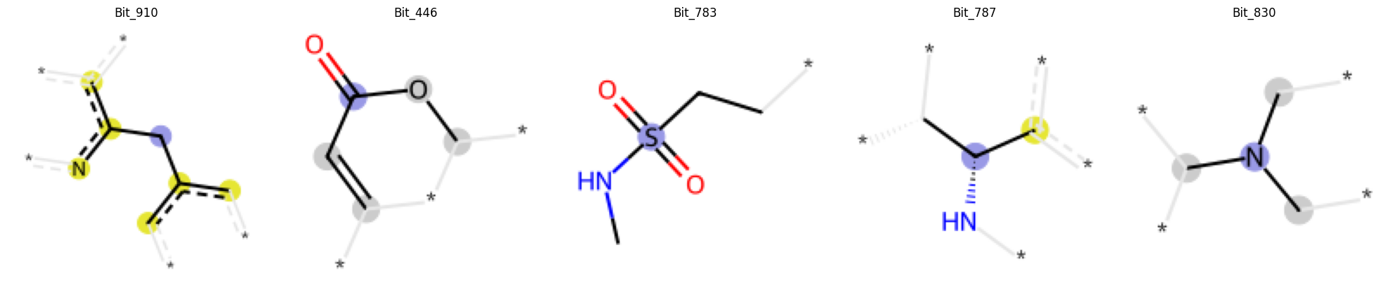
Figure 1. Top 5 SHAP-identified fingerprint bits and corresponding chemical substructures for NR-AhR (ROC-AUC 0.796).
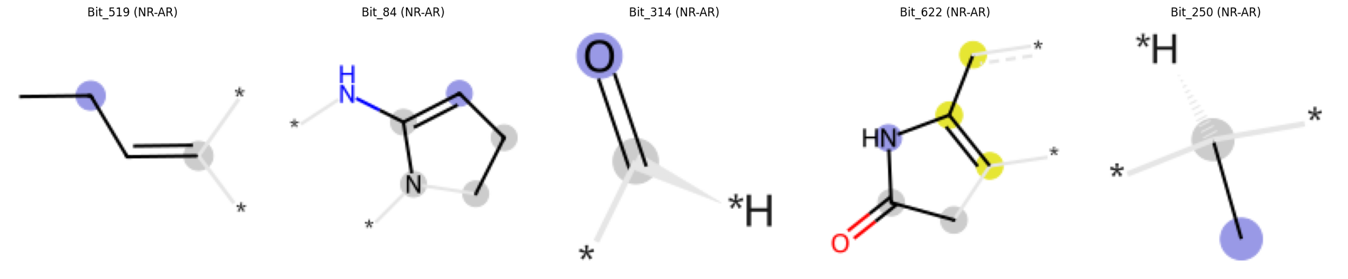
Figure 2. Top 5 SHAP-identified fingerprint bits and corresponding chemical substructures for NR-AR (ROC-AUC 0.734).
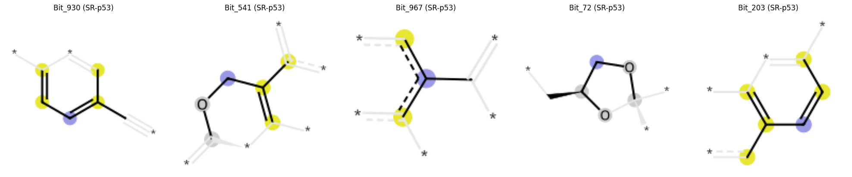
Figure 3. Top 5 SHAP-identified fingerprint bits and corresponding chemical substructures for SR-p53 (ROC-AUC 0.752).
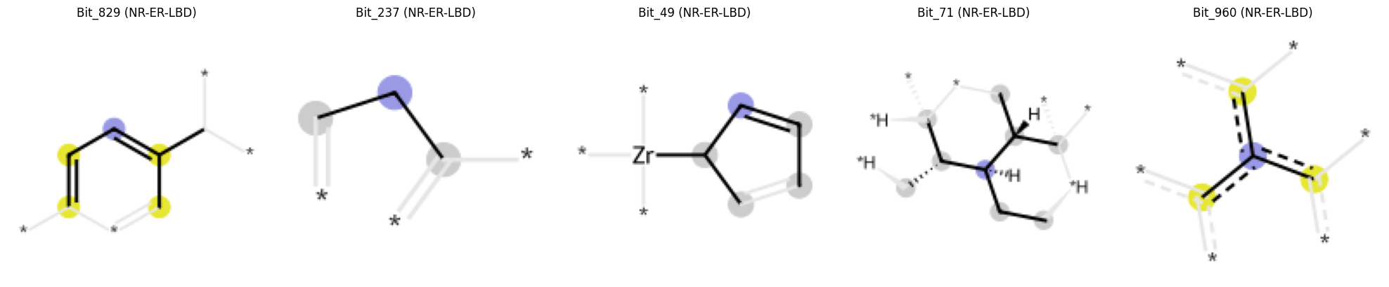
Figure 4. Top 5 SHAP-identified fingerprint bits and corresponding chemical substructures for NR-ER-LBD (ROC-AUC 0.626). Note the physically implausible zirconium-containing fragment (Bit_49), discussed in Section 4.
Across all four tasks, the top 5 SHAP-ranked fingerprint bits were entirely non-overlapping — no single bit appeared among the top predictors for more than one task, indicating that predictive performance for each endpoint is driven by distinct, task-specific structural features rather than a shared generic toxicophore.
NR-AhR (ROC-AUC 0.796): Top substructures were dominated by nitrogen-containing functional groups, including an amidine-like motif, a sulfonamide, and secondary/tertiary amines, alongside one oxygen-based lactone.
NR-AR (ROC-AUC 0.734): Top substructures centered on nitrogen heterocycles and carbonyl-containing rings, including an imidazole-like ring and a hydantoin-like ring.
SR-p53 (ROC-AUC 0.752): Top substructures were predominantly aromatic and oxygen-heterocyclic, including an aromatic nitrile, a benzofuran-like bicyclic system, and a dioxolane ring.
NR-ER-LBD (ROC-AUC 0.626): Top substructures were comparatively less chemically coherent, including two generic branching-carbon fragments and one fragment containing zirconium, an organometallic element inconsistent with typical small-molecule toxicophores.

4. Discussion
Comparing these results to prior published work provides useful context. The original MoleculeNet benchmark study reported multitask and graph-based baseline models achieving test set ROC-AUC in the range of approximately 0.80–0.82 on Tox21 under a random train/test split (Wu et al., 2018) — a substantially easier evaluation protocol than the scaffold split used here, since random splitting allows structurally similar compounds to appear in both training and test sets. Under a scaffold split more directly comparable to the present study's protocol, a more recent benchmark evaluating pretrained molecular representation baselines reported a mean Tox21 ROC-AUC of 0.748 ± 0.002, averaged across 10 random seeds (Liu et al., 2026). Our scaffold-split Random Forest and XGBoost mean ROC-AUC scores (0.703 and 0.714, respectively) fall modestly below this figure, which is plausible given that our models used a fixed configuration (200–300 estimators) without hyperparameter tuning or validation-set model selection, and relied on fixed ECFP fingerprints rather than pretrained or graph-based representations, which have shown a modest edge specifically under scaffold-split evaluation. This comparison suggests the benchmark figures reported here are broadly consistent with, if somewhat conservative relative to, the published Tox21 benchmark landscape under comparable evaluation protocols.
On the benchmark comparison, neither Random Forest nor XGBoost was categorically superior across the 12 Tox21 tasks. XGBoost's advantage was concentrated in the estrogen receptor family (NR-ER, NR-ER-LBD), while Random Forest performed better on NR-PPAR-gamma and the androgen receptor family. This pattern suggests that task-dependent model selection, rather than a fixed default algorithm, may offer meaningful gains in a production toxicity-screening pipeline, and it echoes a broader finding in the QSAR literature that no single tree-based ensemble method dominates uniformly across heterogeneous biological targets.
On interpretability and reliability, a central finding of this study is that SHAP explanation coherence tracked model performance: the three best-performing tasks (NR-AhR, SR-p53, NR-AR) produced chemically plausible, receptor-consistent substructures, while the weakest-performing task (NR-ER-LBD) produced the least coherent explanation set, including a physically implausible organometallic fragment. This suggests that interpretability output can serve as an informal internal validity check — a model's explanations should be trusted in proportion to its demonstrated predictive performance, not treated as independently authoritative.
On chemical plausibility, several of the substructures identified here align with literature-reported receptor chemistry. For NR-AhR, the aryl hydrocarbon receptor's ligand-binding pocket has been shown through recent crystal structures to accommodate a chemically diverse range of ligands via specific hydrogen-bonding and hydrophobic contacts within its PAS-B domain (Dai et al., 2022), consistent with the nitrogen-rich functional groups (amines, sulfonamide) identified as predictive in this study. For NR-AR, the hydantoin-like substructure identified among the top SHAP features is structurally consistent with a well-established class of androgen receptor antagonists — including enzalutamide, apalutamide, and nilutamide — which share a hydantoin or thiohydantoin core as their central pharmacophore (Ma et al., 2022). For SR-p53, the aromatic and electrophilic motifs identified (including an aromatic nitrile) are consistent with the established mechanism by which polycyclic and heterocyclic aromatic compounds require metabolic activation to electrophilic intermediates capable of forming DNA adducts, triggering the DNA damage response that activates p53 (Xue & Warshawsky, 2005). These correspondences support the interpretation that the SHAP-identified substructures reflect genuine, literature-consistent structure-activity relationships rather than dataset artifacts, for the three best-performing tasks.
Several limitations should be noted. The SHAP sample size (n=50 per task) limits the statistical robustness of substructure rankings and may itself contribute to the noisier results observed for NR-ER-LBD. A single scaffold-based train/test split was used rather than repeated cross-validation, meaning reported ROC-AUC values carry some split-dependent variance that was not quantified here. Only the Random Forest model was interpreted in depth; XGBoost SHAP values were not computed due to a library version incompatibility between XGBoost 3.x and the installed SHAP release, which is noted here as a methods limitation rather than a substantive finding.
Future work could extend this interpretability analysis to all 12 Tox21 tasks, incorporate graph neural network architectures capable of learning structural representations directly rather than relying on fixed fingerprints, validate the identified substructures systematically against curated toxicophore databases, and increase SHAP sample sizes using cloud or GPU compute to improve the statistical robustness of substructure rankings, particularly for weaker-performing tasks such as NR-ER-LBD.

5. Conclusion
This study benchmarked Random Forest and XGBoost classifiers across all 12 Tox21 toxicity endpoints and found that neither model dominated uniformly, with performance differences concentrated in specific receptor families. Applying SHAP interpretability analysis to four mechanistically distinct tasks revealed that predictive performance for each endpoint was driven by distinct, non-overlapping structural features, and that the chemical coherence of these SHAP-identified substructures tracked model performance — the best-performing models yielded chemically plausible, literature-consistent explanations, while the weakest-performing model produced noisier, less trustworthy output. These findings support the broader argument that predictive accuracy and interpretability should be assessed jointly, rather than in isolation, when developing machine learning models for computational toxicology.

Acknowledgments
The author declares no external funding for this work. The author thanks the developers and maintainers of the open-source packages that made this research possible, including RDKit, DeepChem, scikit-learn, XGBoost, and SHAP.

Data Availability Statement
The Tox21 dataset used in this study is publicly available via DeepChem's MoleculeNet module (Wu et al., 2018). The code used for data processing, model training, SHAP interpretability analysis, and substructure mapping, along with the trained model outputs and figures presented in this paper, is available at:
https://github.com/Uzo-Hill/tox21-toxicity-prediction-shap

References
Breiman, L. (2001). Random forests. Machine Learning, 45(1), 5–32. https://doi.org/10.1023/A:1010933404324
Chen, T., & Guestrin, C. (2016). XGBoost: A scalable tree boosting system. In Proceedings of the 22nd ACM SIGKDD International Conference on Knowledge Discovery and Data Mining (pp. 785–794). ACM. https://doi.org/10.1145/2939672.2939785
Dai, S., Qu, L., Li, J., Zhang, Y., Jiang, L., Wei, H., Guo, M., Chen, X., & Chen, Y. (2022). Structural insight into the ligand binding mechanism of aryl hydrocarbon receptor. Nature Communications, 13, 6234. https://doi.org/10.1038/s41467-022-33858-w
Huang, R., & Xia, M. (2017). Tox21 challenge to build predictive models of nuclear receptor and stress response pathways as mediated by exposure to environmental chemicals and drugs. Frontiers in Environmental Science, 5, 3. https://doi.org/10.3389/fenvs.2017.00003
Landrum, G. (n.d.). RDKit: Open-source cheminformatics. Retrieved from https://www.rdkit.org (version 2026.03.4; https://doi.org/10.5281/zenodo.591637)
Liu, Y., Zhou, Y., & Fan, W. (2026). Enhancing molecular property predictions by learning from bond modelling and interactions. In Proceedings of the International Conference on Learning Representations (ICLR 2026). https://doi.org/10.48550/arXiv.2603.00568
Lundberg, S. M., & Lee, S.-I. (2017). A unified approach to interpreting model predictions. In Advances in Neural Information Processing Systems 30 (pp. 4765–4774).
Ma, L., Zhou, Y., Yang, D., Wang, M.-W., Lu, W., & Jin, J. (2022). Synthesis of hydantoin androgen receptor antagonists and study on their antagonistic activity. Molecules, 27(18), 5867. https://doi.org/10.3390/molecules27185867
Wu, Z., Ramsundar, B., Feinberg, E. N., Gomes, J., Geniesse, C., Pappu, A. S., Leswing, K., & Pande, V. (2018). MoleculeNet: A benchmark for molecular machine learning. Chemical Science, 9(2), 513–530. https://doi.org/10.1039/C7SC02664A
Xue, W., & Warshawsky, D. (2005). Metabolic activation of polycyclic and heterocyclic aromatic hydrocarbons and DNA damage: A review. Toxicology and Applied Pharmacology, 206(1), 73–93. https://doi.org/10.1016/j.taap.2004.11.006

