**CCAI: Final Skills Exam**

**Instructor: Tran Dac Tot**

**Topology**



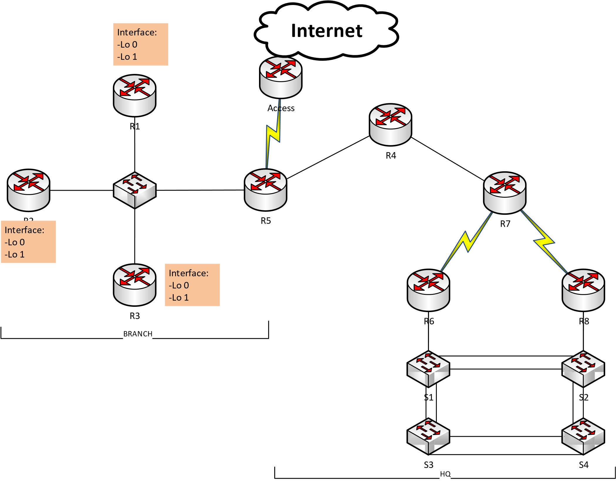

2019 . All rights reserved. This document is Cisco Public.

# Part 1: IPv4 (60 points)

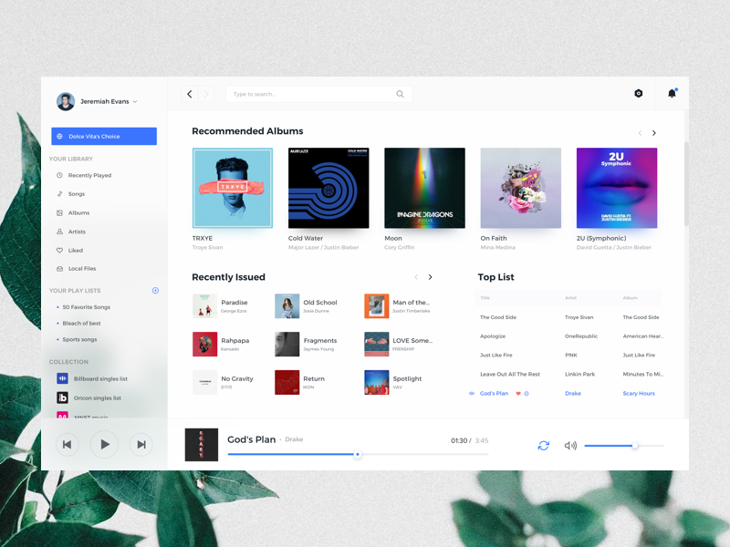



## 1) Addressing Scheme

* HQ area is used network address X.X.X.X/A
* Branch area is used network address Y.Y.Y.Y/B
* Address table:

|  |  |
| --- | --- |
| Network | Address |
| R7  R6 | 202.0.100.0/30 |
| R7  R8 | 202.0.100.4/30 |
| R5  ACCESS | 202.0.100.8/30 |

* Host number requirement for VLAN HQ site

|  |  |  |
| --- | --- | --- |
| VLAN | Name | Host Number |
| 10 | TEAM1 | 500 |
| 20 | TEAM2 | 200 |
| 30 | TEAM3 | 100 |
| 40 | GUEST | 100 |
| 50 | SERVERS | 50 |
| 60 | Management(Native) | 50 |

* Host number requirement for Branch site

|  |  |  |  |
| --- | --- | --- | --- |
| Device |  | Interface | Host Number |
| R1 | Lo 0 |  | 200 |
| R1 | Lo 1 |  | 300 |
| R2 | Lo 0 |  | 100 |
| R2 | Lo 1 |  | 100 |
| R3 | Lo 0 |  | 200 |
| R3 | Lo 1 | | 100 |

## 2) PPP Connections

* Configuration PPP connection between R7 and R6 router using PAP authentication
* Configuration PPP connection between R7 and R8 router using CHAP authentication

## 3) Routing

* Configure OSPF routing protocol in HQ site
* Configure static routing protocol in Branch site
* On R5, configure a default route to ACCESS router and propagate it to OSPF process
* On R5, configure static route (use summary route) to Branch site and propagate OSPF process in HQ site.
* Set passive on appropriate interface

## 4) Switching

* Switch S2 is VTP Server, remain switchs are VTP client
* Change spanning tree protocol to Rapid PVST+ mode
* S1 is root bridge for VLAN 10, 20, 30, 40. S2 is root bridge for remain VLANs
* Use network address of Management VLAN assign to switch
* Configure SSH on all switches
* Configure router-on-a-stick Inter-VLAN routing on R6 for VLAN 10, 20, 30, 40 and R8 for VLAN 50,

60.

* Configure EtherChannel with LACP protocol for all links between switch.

## 5) NAT and DHCP

* Configure NAT overload on Access allow private addresses of HQ and Branch site can access Internet.
* Setup an Web in Servers VLAN, configure port forwarding allow hosts from Internet can access the HTTP and HTTPS service.
* Setup DHCP server on R4 to assign IP address and other parameters to host in VLAN 10, 20, 30, 40 automatically.

## 6) Other requirements

* Create ACL not allow users on GUEST VLAN access to all network of HQ and Branch but can use to the Internet.
* Create ACL allow only SERVERS VLAN can SSH to switches

# Part 2: IPv6 (20 points)

## 1) Address Scheme

* For the networks connect routers

|  |  |
| --- | --- |
| Network | Address |
| Access  R5 | 2001:ABBA:AAAA:1::/64 |
| R7  R6 | 2001:ABBA:CCCC:1::/64 |
| R7  R8 | 2001:ABBA:DDDD:1::/64 |
| R4  R5 | 2001:ABBA:EEEE:1::/64 |
| R4  R7 | 2001:ABBA:FFFF:1::/64 |

* Assign static link-local address for all interface using FE80::/10 range.
* Use the first five subnets of network 2001
* :ABBA:BBBB:/48 for five VLAN 10, 20, 30, 40, 50. The default gateway will be used the first IP address. Remark: assign appropriate static link-local address by yourself.

## 2) Routing

* Configure IPv6 static routing in HQ site.
* Configure a default route from R5 to Access and R5 is also default gateway for all remain networks
* Configure inter-VLAN routing using the same sub-interface for each VLAN in above IPv4 configuration.

## 3) DHCP

* Setup Stateless DHCPv6 on R7 router to assign IP address and other information for VLAN 10, 20,30 and 40 dynamically. Use 2001:4860:4860::8888 for DNS Server address.
* Configure relay agent on appropriate interfaces.

# Part 3: Q&A (20 points)

## Appendix

**Address Table**

|  |  |  |  |  |
| --- | --- | --- | --- | --- |
| No. | Device/Host | IP Adsress | Subnet mask/Prefix | Default gateway |
| 1 |  |  |  |  |
| 2 |  |  |  |  |
| … |  |  |  |  |