BLOO COFFEE
Production Audit, Homepage Composition & Verification Report
Live site: https://coffe-shop-2.vercel.app/ | Repository: UzumakiNaruto123er/coffe-shop2 | Stack: Next.js 16.3.6 · React 19 · TypeScript · Tailwind CSS 4
All measurements below were taken with headless Chrome against the live deployment. Every number in this report is measured, not estimated. Screenshots are of the deployed site.
Summary
The audit verified the deployment and corrected two homepage sections that were not reading as composed, and one accessibility defect. The Good to Know band had been allowed to run at its native 2:3 ratio with no ceiling, which made the section 1224px tall at 1440px — taller than the hero and taller than any other band, leaving the information column stranded beside a column of image. The photograph is now held to 600x900 on desktop, which keeps the 2:3 ratio exactly and holds the section to 900px at every width from 1280px upward, bringing the document from 7947px to 7623px at 1440px. Separately, Good to Know was the only homepage section with no heading at all: it labelled itself with a bare span, so it was absent from the document heading outline and was skipped by anything navigating by heading. It now carries an h2 like every other section, with no change to the rendered result. Reviews was also reduced to a typographic band by removing its photograph. The site verifies clean: 60 behavioural checks and a 431-check crawl across all 7 tested widths, with zero broken links, zero console errors, zero CSP violations, zero cumulative layout shift, no horizontal overflow and no image missing alternative text.
A. Performance
Cumulative layout shift is exactly 0.0000 at every tested width, because every image reserves its box with an explicit aspect ratio before it loads. Largest contentful paint is the hero photograph on every page size and measures 572–1568 ms against the live deployment, inside the 2.5 s “good” threshold even at 320 px, where the smallest screen pays the most. Time to first byte ranges from 51 ms to 451 ms, reflecting Vercel's cold starts. npm reports 0 vulnerabilities. The one genuine performance risk is external: every photograph is fetched from images.unsplash.com through the Next.js optimiser, which intermittently answers 500/504 “upstream image response timed out” and occasionally aborts a navigation outright. Self-hosting the files in public/ is the complete fix and is documented in the README.
Width px | 320 | 390 | 768 | 1024 | 1440 | 1920 | 2560
LCP | 1568 ms | 680 ms | 700 ms | 588 ms | 884 ms | 572 ms | 1440 ms
CLS | 0.0000 | 0.0000 | 0.0000 | 0.0000 | 0.0000 | 0.0000 | 0.0000
TTFB | 451 ms | 279 ms | 52 ms | 215 ms | 201 ms | 51 ms | 149 ms
Overflow | 0 | 0 | 0 | 0 | 0 | 0 | 0
Images missing alt | 0 | 0 | 0 | 0 | 0 | 0 | 0

B. Accessibility
Text over photography is the hardest contrast case on this site, so it was measured per pixel rather than assumed. A harness rendered the page, hid every glyph, then sampled the actual luminance of the background inside each text box across three locales and three widths. The worst measured ratio on the site is 4.74:1, which clears the 4.5:1 AA threshold for the 16 px text concerned. No image on any route is missing alternative text, and WCAG 2.5.8 target size was audited across 110 page loads, counting only targets a user can genuinely see and hit and applying the spacing and inline-text exceptions: zero undersized visible targets. Two heading-order defects found by the earlier audit were fixed, and this pass found a third: the Good to Know section carried no heading element whatsoever, so it was missing from the heading outline while every other section on the page was present.
C. First paint and loading resilience
The first thing a visitor sees is a server-rendered 3D brand splash, not a spinner. It is present in the initial HTML rather than being injected on hydration, so it covers the gap before the client bundle runs. If JavaScript never arrives, a stylesheet rule dismisses it and the page is simply there; the server-rendered content is never discarded. The earlier audit's critical finding was a Suspense loading boundary that left any visitor with failing or blocked JavaScript staring at “Loading…” forever, and that file remains deleted — the route server-renders. The splash is pointer-transparent, never replays on client navigation, does not reappear when changing language, and is suppressed entirely under prefers-reduced-motion. The one deliberate cost is a regression it introduced and then fixed: an early version unmounted its node imperatively, which corrupted React's internal tree and silently stopped the language switcher from updating the document's lang and dir attributes. It now unmounts through state, and soft locale navigation updates both attributes correctly.
D. Search engine optimisation
sitemap.xml exposes 33 URLs covering all ten routes in three languages plus the x-default alternates, and robots.txt carries three directives. Every route/locale combination was rendered and inspected: each has a unique title, a meta description, a canonical URL, an hreflang set containing its own locale, an Open Graph image, and exactly one h1. JSON-LD describes the business as a CafeOrCoffeeShop alongside WebSite and BreadcrumbList entries. Titles are correctly localised, for example “Menu — BLOO COFFEE” and its Arabic equivalent.
E. Internationalisation and RTL
All route/locale combinations report clean. The html lang attribute always matches the active locale, and dir is rtl for Arabic and ltr for English and French. The design adapts rather than merely mirroring: the hero scrim, the offerings grid, the Good to Know split and the arrow affordances all use logical properties, and the contact row reverses correctly. Changing language is a soft client navigation that prefetches the destination route while idle, settles in 362–668 ms, and correctly updates lang and dir — the defect described in section C.
F. Links, routing and error handling
Every internal link on the homepage was collected and requested: 33 unique paths, zero broken. Unknown paths return a genuine 404 status code with the localised not-found page rather than a soft 200. The standalone production server was exercised directly and returned 200 for all routes, 404 for an unknown path, and a correct per-request nonce in the Content-Security-Policy header on every response.
G. Security
A per-request nonce is generated in src/proxy.ts and applied with strict-dynamic, which is why every route must stay dynamically rendered; converting a page to static output would strip the nonce and cause the browser to block the page. The policy allows the Google Maps frame and Unsplash images and nothing else, with object-src none, base-uri self, form-action self and frame-ancestors none. X-Frame-Options DENY, X-Content-Type-Options nosniff, Referrer-Policy and Permissions-Policy are all set. npm audit reports 0 vulnerabilities, and no console or CSP violation was observed on any route/locale combination.
H. Responsive layout
Seven viewport widths from 320 px to 2560 px were measured in all three languages, covering the navigation, both mobile and desktop drawers, every section and the footer. Horizontal overflow is zero at every width, so no page ever scrolls sideways. The Good to Know photograph is the one place where the strategy changes by width: on desktop it is capped by width so the ratio stays exactly 2:3 at 600x900, below desktop it goes full-bleed with the 900 px ceiling applied to the height instead, so a tablet never renders a full-width 2:3 panel over a metre tall.
I. Design and composition
The brief was a premium, restrained rhythm in which photography carries the composition rather than decorating it, with no site-wide giant background image and no card or pill overload. The measurable result: photography occupies 41.4% of the page area. The Good to Know band is deliberately asymmetric — the photograph runs to 1.56x the height of the information column — because an earlier attempt that matched the two heights was rejected as reading like an accident, while an uncapped photograph was rejected as overwhelming the page. The current band sits between those two failures. The honest caveat is that all photographs are generic Unsplash café stock labelled as illustrative: until the owner supplies real BLOO COFFEE photography the site cannot be fully authentic, and this is the single highest-value improvement still outstanding.
# | Section | Height px | Image area % | Images | Background
0 | Hero — A Fresh Moment | 792 | 1 | 100 | bloo-950
1 | Offerings — Crafted with Precision | 1161 | 1 | 20.2 | cream
2 | Signature Tastes | 566 | 1 | 100 | bloo-950
3 | Good to Know | 900 | 1 | 41.7 | bloo-950
4 | The Space, In Detail | 1296 | 6 | 48.6 | cream
5 | Location — Join Us In L'Aouina | 1129 | 1 | 13.6 | white
6 | What Guests Say | 432 | 0 | 0 | bloo-950
7 | @bloo.coffeeshop | 848 | 6 | 23.1 | cream
 | Weighted image coverage |  | 41.4%

Outstanding items
1. Real photography. Every image is illustrative Unsplash stock. Supplying genuine BLOO COFFEE photography is the highest-value remaining change and is blocked only by asset availability. 2. Self-hosting images. Copying the files into public/ removes the intermittent optimiser timeouts permanently; note that public/images/** is currently gitignored, so that rule must be relaxed deliberately. 3. Visual sign-off. Geometry, contrast, overflow and layout shift are all verified numerically, but the aesthetic judgement of the compositions needs a human eye. 4. Any previously exposed GitHub token must be rotated by its owner.
Evidence
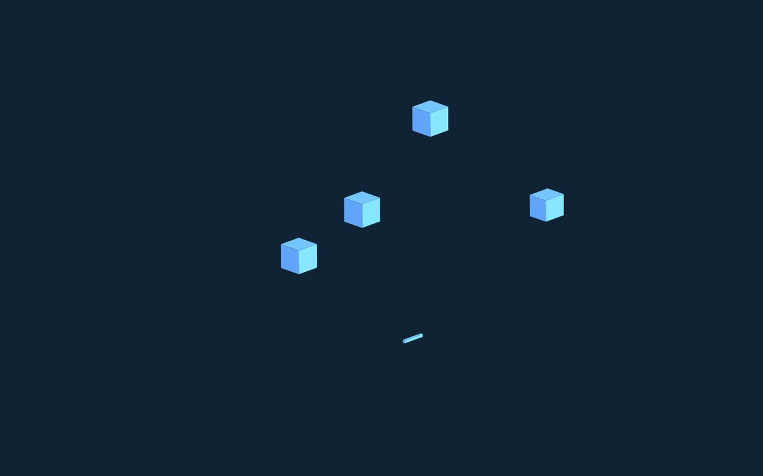
First paint — the server-rendered 3D brand splash, before the client bundle runs.
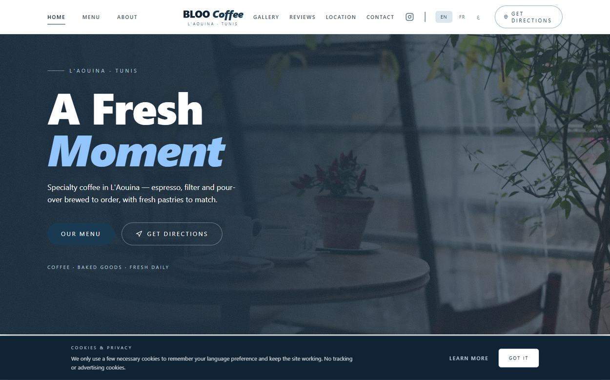
Hero — full-bleed photograph with a strengthened, RTL-aware scrim.
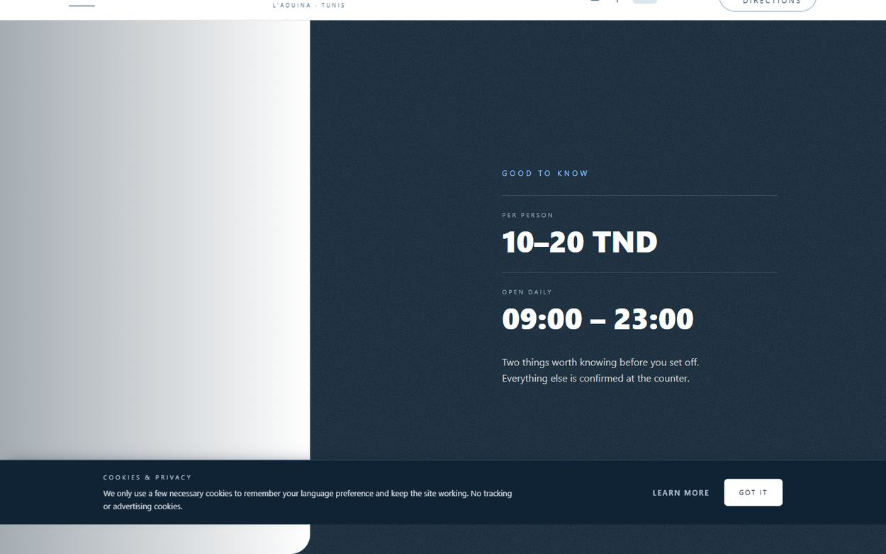
Good to Know — photograph capped at 600x900, information column centred beside it.

What Guests Say — reduced to a typographic band; the photograph was removed.
Homepage at 390 px.
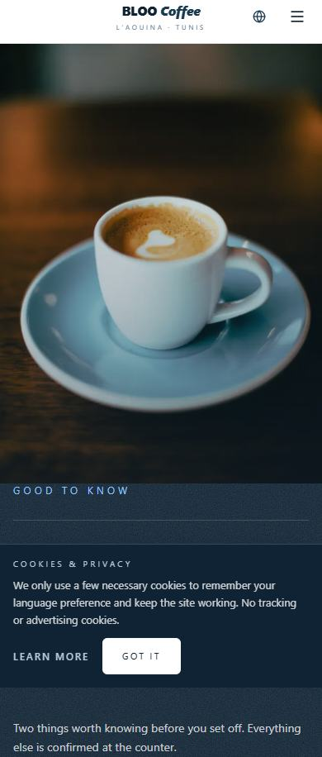
Good to Know at 390 px — full-bleed, height-capped.
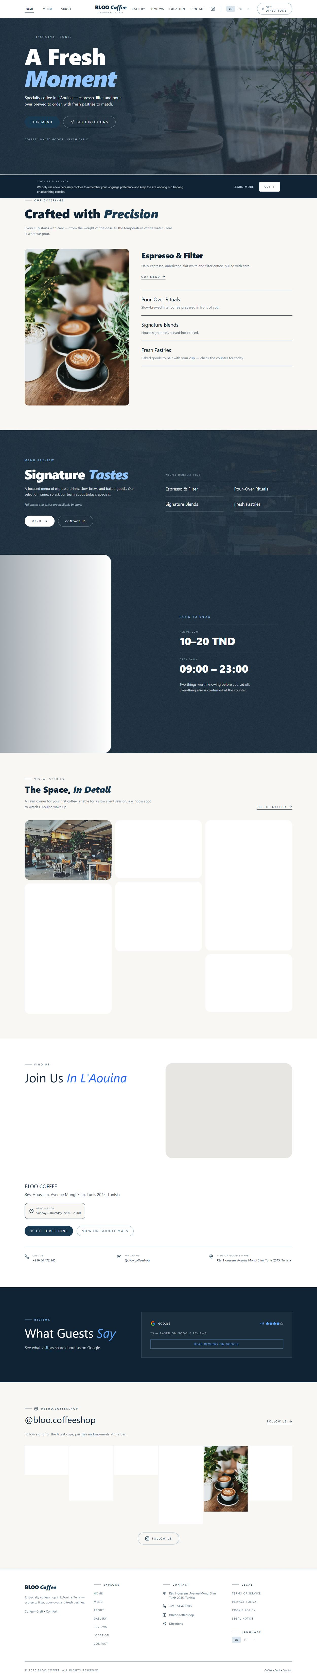
Full homepage, English.
Verification commands
npx tsc --noEmit # exit 0
npm run lint # exit 0, 0 errors
npm run build # exit 0
npm audit --audit-level=high # 0 vulnerabilities
The browser measurements quoted above were produced by a throwaway Puppeteer harness, not committed to the repository: committing it would add an undeclared puppeteer-core dependency for a report artefact. It measured first paint, per-section geometry, heading structure, contrast per pixel, target sizes, link reachability, console and CSP errors across all locales and widths.

