Python Script Execution Screenshots
Block 1: Mount Google Drive
Block 2: Import required Python libraries
Block 3: Define file paths
Block 4: Import portfolio dataset
# Step 1: Import Portfolio Dataset
# Step 2: Dataset Structure Validation
Single screenshot for Block 1 – Block 4: Step 2
|
Mounted at /content/drive
Libraries imported successfully.
Pandas version: 2.2.3
Project root: /content/drive/MyDrive/Banking_Stress_Testing_V2_Python
Input file: /content/drive/MyDrive/Banking_Stress_Testing_V2_Python/data/portfolio_sample_10000.csv
Input file exists: True
Portfolio dataset imported successfully.
Rows: 10000
Columns: 15
|
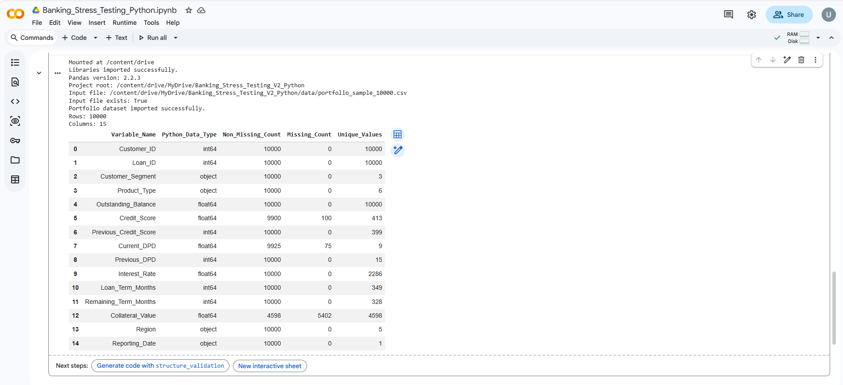
# Step 3: Record Count Validation
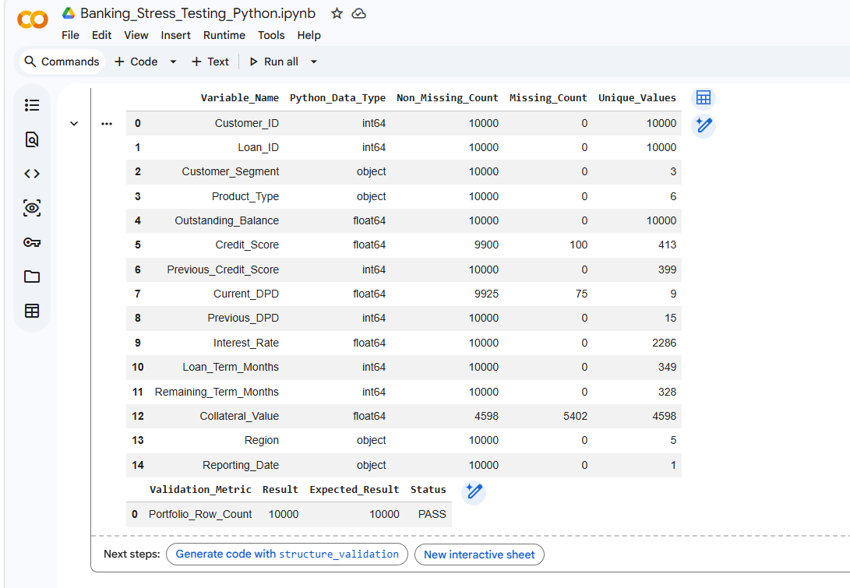
# Step 4: Numeric Variable Validation

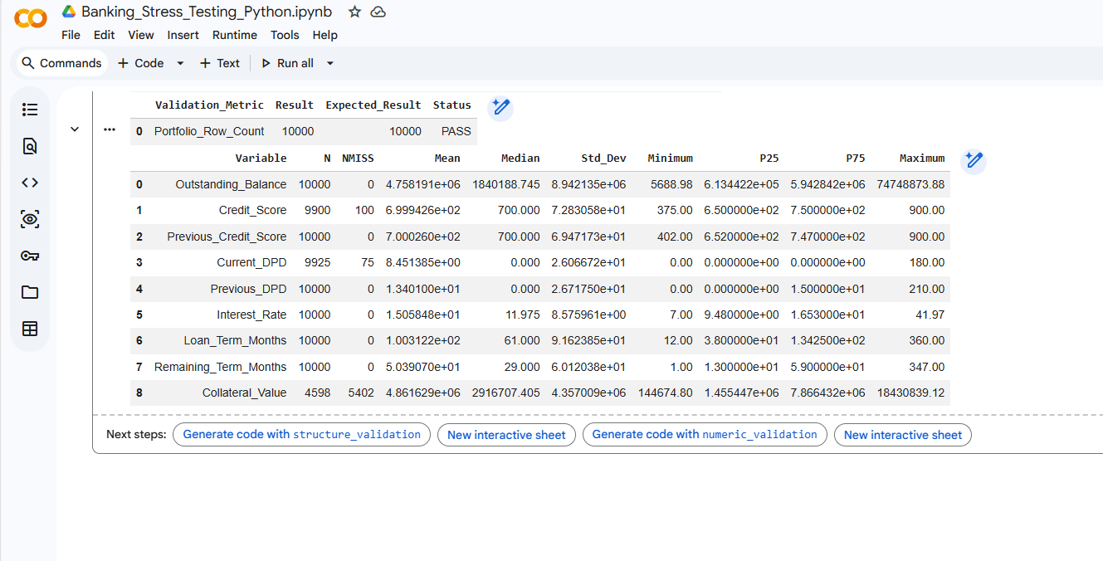
# Step 5: Categorical Variable Validation
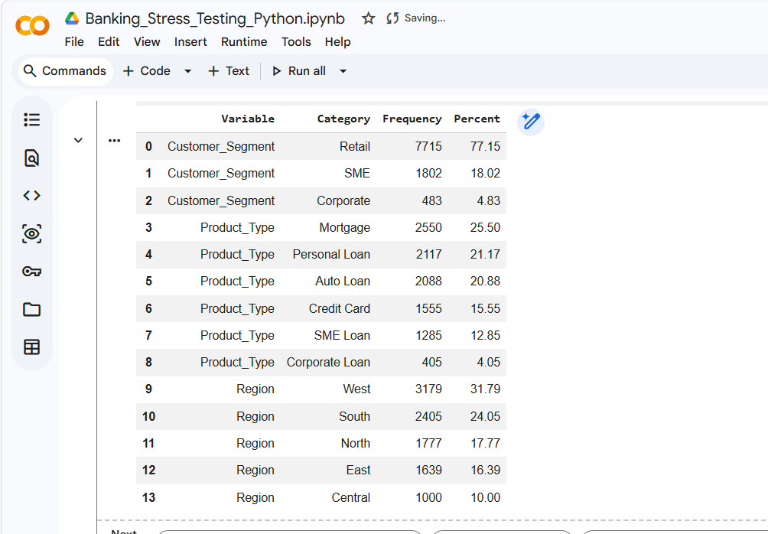
# Step 6: Data Quality Validation
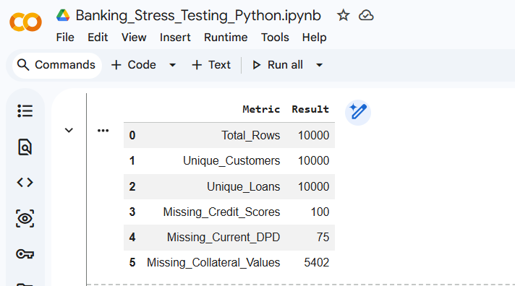
# Step 7: Secured Loan Collateral Validation
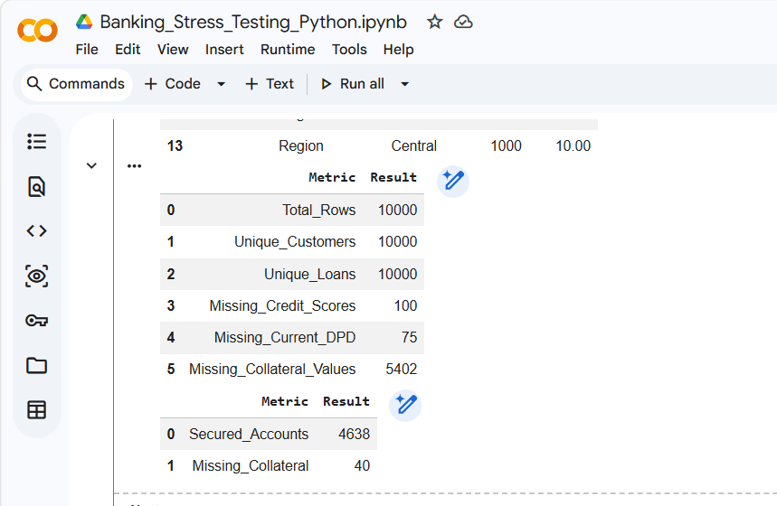
# Step 8: Save Raw Portfolio Output
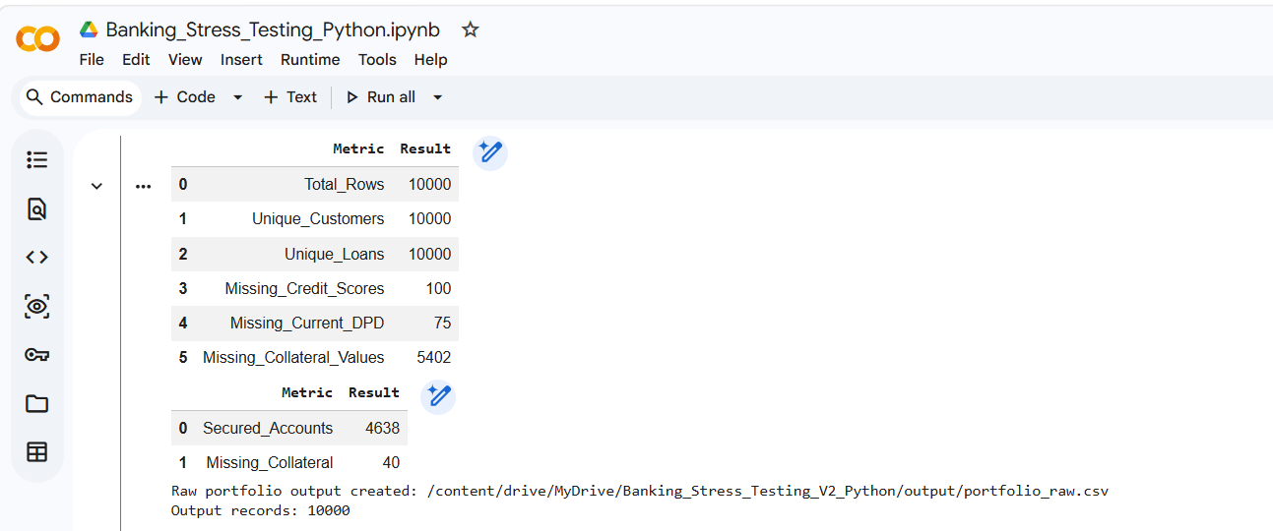

# Step 9: Final Phase 01 Validation Summary
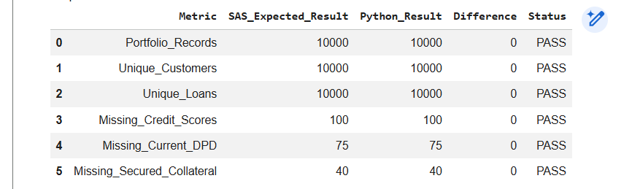
# Step 10: Completion Message
