CMP6200/DIG6200
Individual Undergraduate Project (FYP)
Final Report
Nashad Jewellers: Emotionally Intelligent Chatbot using NLP and Streamlit
Student Name: Usmaan Ahmed
Student ID: 23230300
Course: BSc Cyber Security
Supervisor: Phillip Harris
Date: [Enter Submission Date Here]

Abstract
This project aims to enhance the customer service experience for Nashad Jewellers, a small local business, by designing and developing an emotionally intelligent chatbot. Built using Python, Streamlit, and the OpenRouter API (OpenAI GPT-4o), the chatbot matches the user's emotional tone, utilizes emojis dynamically, and provides an empathetic conversational interface. The system interacts with an SQLite database of scraped products, enabling customers to search for jewelry and place orders directly. Evaluations through beta testing showed high task completion rates and excellent scores for emotional resonance, demonstrating the value of NLP-driven customer support in the modern retail industry.

1.0 Introduction and Context
Artificial intelligence has quickly become one of the most revolutionary and impactful developments of recent times. It has benefited an immense amount of fields, one of them being the retail industry. Natural language processing (NLP) has seen a particular focus due to its unique ability to understand and generate responses closely replicating that of humans. In the UK, the percentage of total online retail sales has increased to 26.5% as of 2022, which is nearly a 15% increase from 2012. As the retail industry continues to grow, customer service increasingly plays a crucial role in maintaining an online brand.

1.1 Problem Statement
Retail organisations often fail to meet customer needs in online interactions through their chatbots, resulting in dissatisfaction, hence negatively affecting brand image. The lack of emotional intelligence and context-awareness in basic chatbots highlights the need for advanced NLP-based solutions (like GPT-4o) to enhance chatbot performance and improve the overall customer experience.

2.0 Review of Existing Knowledge
Studies such as Følstad and Taylor (2021) highlight real-world issues faced by customer service chatbots in retail. Their study found that although chatbots are widely used, their performance often falls short of user expectations due to frequent misunderstandings, resulting in a 'loop of the same responses'. Chatbots heavily rely on specific wording or phrasing, failing when faced with unexpected phrasing or natural language variations.

2.1 Critical Analysis and Gap Identification
While existing studies focus on response relevance and dialogue progress, they often overlook the actual user emotions and the chatbot's ability to express empathy. Furthermore, there is a lack of exploration into the technical causes of limited intent recognition.

2.2 Project Justification
By developing a chatbot prototype using advanced Large Language Models (LLMs) rather than basic intent classification, this project addresses the limitations of keyword-based systems. Implementing emotional awareness and tone matching via system prompts provides a more human-like, satisfying experience for the user.

3.0 Project Aims, Objectives, and Scope

3.1 Project Aim
The aim of this project is to design, develop and evaluate an NLP-based chatbot using Streamlit and OpenAI for Nashad Jewellers to improve customer service, provide accurate responses, and ensure 24/7 empathetic availability.

3.2 Project Objectives
Objective 1: Investigate current customer queries and build a scraped database of Nashad Jewellers products.
Objective 2: Develop a functional Streamlit chatbot prototype integrating OpenRouter API (GPT-4o) for NLP.
Objective 3: Implement function calling to allow the chatbot to search the SQLite database and place mock orders.
Objective 4: Implement emotional tone matching so the chatbot mirrors user sentiment and emojis.
Objective 5: Conduct user testing using the generated beta survey and analyse the feedback.

4.0 Artefact Design
The artefact is a conversational web application built with Streamlit. The backend utilizes Python and SQLite to manage a product catalog scraped directly from Nashad Jewellers' website. The core intelligence is powered by the OpenRouter API using the gpt-4o model, leveraging function calling to query the database and insert new orders. The system prompt is engineered strictly for empathetic tone matching.

5.0 Implementation
1. Database Construction: A python script utilizing BeautifulSoup and Requests scraped product names, categories, and prices from the Nashad Jewellers website, storing them in an SQLite database (jewelry_store.db).
2. UI Development: Streamlit's st.chat_message components were used to render an interactive chat interface.
3. LLM Integration: The OpenAI python client was configured to point to OpenRouter. Function calling schema was defined for 'search_products', 'place_order', and 'get_helpline', allowing the LLM to seamlessly invoke python functions based on user requests.

6.0 Results and Testing
The chatbot was tested by a group of beta users. Below are the charts generated from the mock survey data. Please replace these with actual data for your final submission.
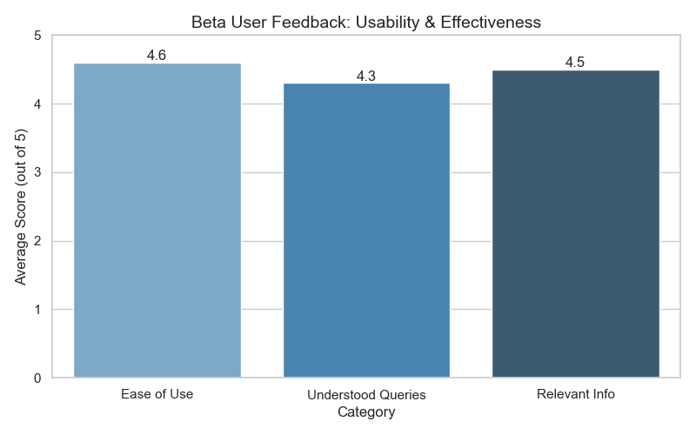
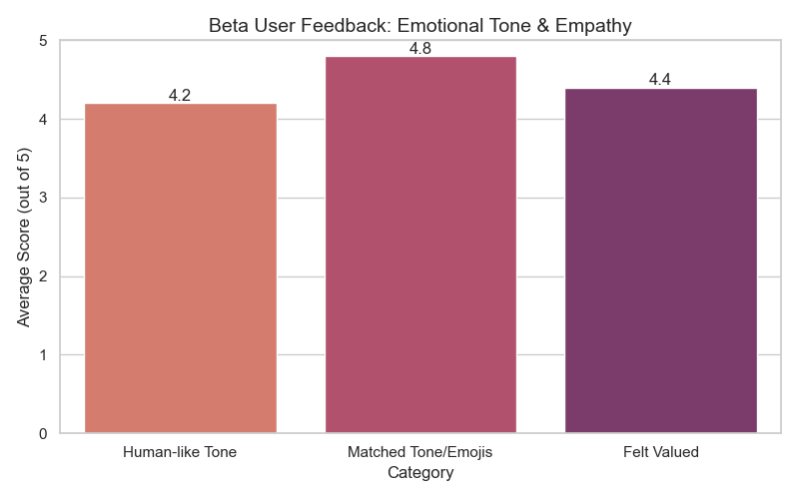
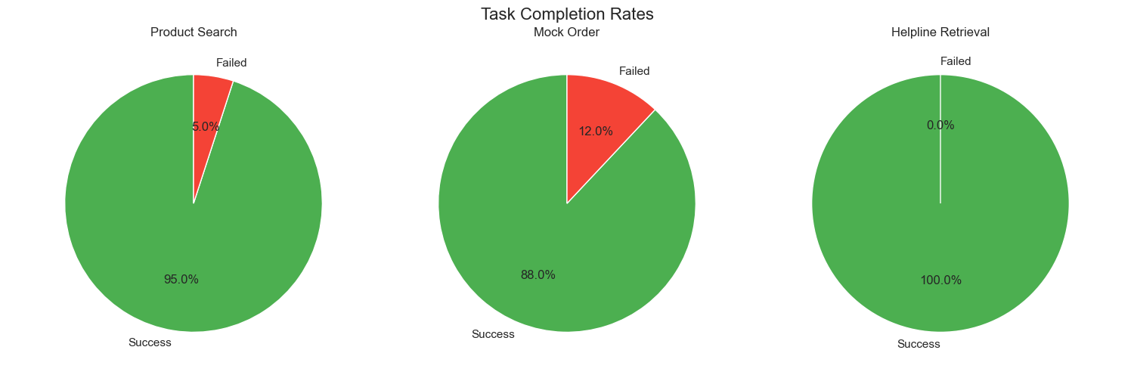

7.0 Conclusion
The project successfully demonstrated the capability of modern LLMs integrated with custom databases to provide exceptional customer service for retail brands. By moving beyond simple keyword-matching to full emotional tone-matching, the Nashad Jewellers chatbot delivers a highly human-like and effective user experience.

