|  |  |
| --- | --- |
| Internship Project Title | TCS iON RIO-45: Employee Attrition and Performance Analysis |
| Name of the Company | TCS |
| Name of the Industry Mentor | mentor@ictkerala.org |
| Name of the Institute | ICT Academy of Kerala |

|  |  |  |  |  |  |  |
| --- | --- | --- | --- | --- | --- | --- |
| Start Date | End Date | | Total Effort (hrs.) | | Project Environment | Tools used |
| 14 Dec 2022 | 18 Dec 2022 | | 6 | |  | Tableau, Excel. |
| Milestone # | 1 | Milestone: | | Completed Data Modelling and Built Basic Charts | | |

**TABLE OF CONTENT**

* Acknowledgements
* Objective
* Introduction / Description of Internship
* Internship Activities
* Charts, Table, Diagrams
* Algorithms
* Challenges & Opportunities
* Reflections on the Internship
* Link to code and executable file
* Research questions and responses

**Acknowledgements**

ICT Academy of Kerala

YouTube – Alex Fresberg , Chandoo, Donabel Santos

https://www.dataschool.io/

https://www.dataeaze.io/

**Objective**

The objective of the project is to develop analytics and reports using data science tools to provide detailed insights on HR analytics focusing on employee attrition and performances.

1. To understand and analyze factors that lead to employee attrition
2. To analyze factors affecting employee performance and means to optimize the same

**Introduction**

The project would typically all the steps required to work on the HR dataset to provide insights on Employee Attrition and performance management using tools like Tableau / Power BI

Employee attrition is a term used when size of the workforce diminishes over time and employees leave the organization for several factors. Employee performance management is important to optimize employee productivity and quality of delivery.

This project will focus on developing analytics and insights that would optimize employee performance and control attrition.

**Internship Activities**

Stage 1

Analyze dataset and identify driving factors related to analytics.

Stage 2

Design graphs and charts using Tableau/Power BI based on the factors identified

Stage 3

Design Dynamic dashboard

**Charts,Table,Diagrams**

Data Model for the project is given below.

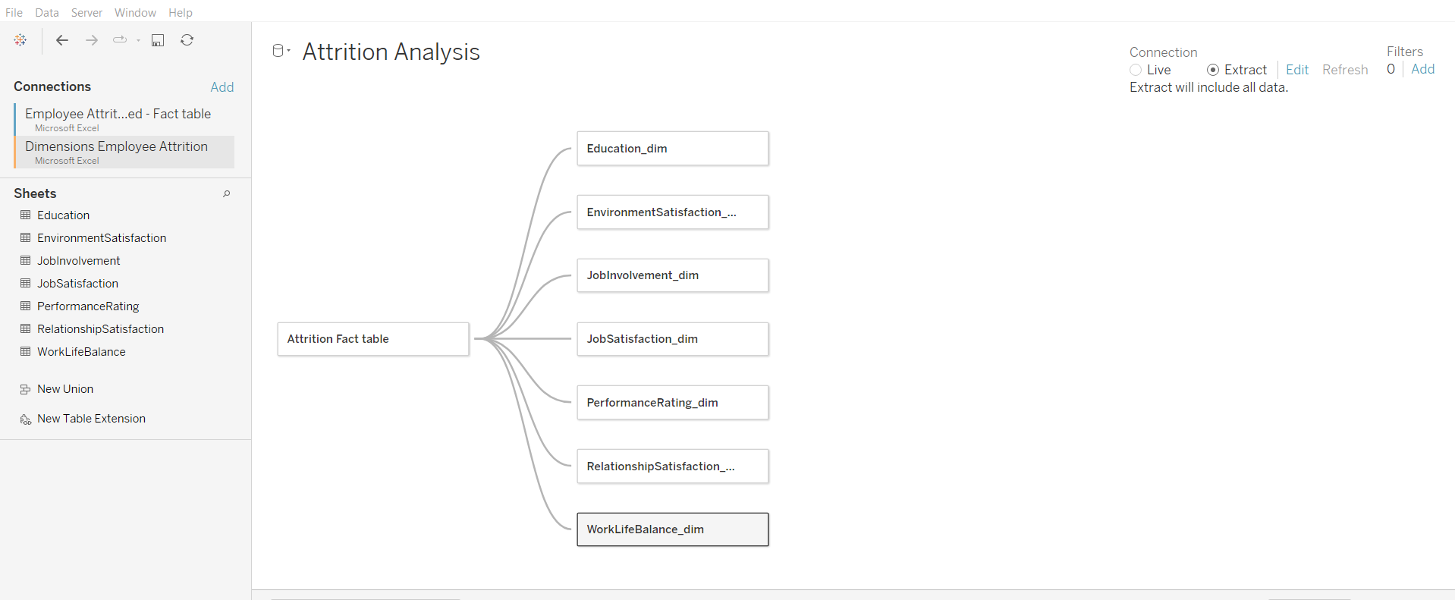

**Algorithms**

Dashboard design process

We will be using four steps in designing the dashboard.

1.Define

2.Prototype

3.Build

4.Deploy

1. Define

This is the first and most important step.

Having clarity about who this dashboard is for and what metrics matter to them is critical to creating a dashboard that will be used.

Stakeholders

There are 4 main stakeholders

The designer (you)

The audience (who will be viewing this dashboard)

The point person (the member of the audience who has the most experience)

The Data Gatekeeper (member of the data team who will help with the database)

Metrics

You will work with the point person to go from decisions that need to be made to metrics that can be queried and tracked.

This process involves a lot of back and forth to weed out interesting but ultimately not relevant metrics to mission critical data for decisions to be based on.

2. Prototype

Once we have the metrics that we want to put in a dashboard,

we need to figure out how to best display them so that the dashboard is useful to the whole audience.

Visualizations

Use visualizations that present the metrics clearly and accurately.

Even when sketching and prototyping graphs, making the right visualization decisions here will improve the prototype and the feedback loop.

Dashboards

There are best practices for taking the visualizations and composing them together in a dashboard.

In fact, some composition choices might actually make you change what visualization you had selected as optimal before.

Sketching and Iteration

At this stage, it is recommended that the visualizations and dashboards be sketched out on paper or using a lo-fi tool that is not connected to any real data.

The reason for this is that it allows you to quickly throw out bad ideas without worrying about the time investment.

It also allows you to focus on design instead of checking if the numbers are right.

3. Build

Once we are satisfied with the prototype, we have to create the dashboard using real data.

We need to create queries to power the metrics, create formulas, and transform the data into charts.

Using a framework to log the metrics, formulas, and data sources makes creating queries much easier.

4. Deploy

Finally, we have a fully functioning dashboard.

Now we need to share it with the full audience.

We should enhance the dashboard to make it more effective at scale and we need to make sure to maintain it as usage grows and changes.

Sharing

The audience will have varying levels of data literacy and context for the data presented in the dashboard.

You need to verify that you have enough context within the dashboard and that you provide enough training so that people can get insights out of it easily.

Scaling

If the dashboard is useful, the number of views and number of viewers is likely to grow.

Adding links, interactivity, and documentation to a dashboard helps it accommodate more use cases and inspire other dashboard creators.

Also, as the number of views and viewers increases, spending time optimizing queries becomes an important way of keeping the dashboard useful.

Maintenance

DataSource's, tables, and fields change, and dashboards need to change with them.

Setting up scheduled times to review dashboards is critical to keeping them relevant and functional.

Providing a way for the audience to alert you about issues will allow you to make informed improvements to the dashboard.

**Challenges & Opportunities**

Advantages Of HR Analytics:

Better Employee Satisfaction and Engagement Rates

Organizations can use HR Analytics to create an analytical model which indicates the likes and dislikes of employees,

their strengths and weaknesses and assist in deciding the right time for promotions.

Analytics helps calculate the efficiency of training practices, measure the effectiveness of performed CSR initiatives,

considering their contribution to corporate culture and employee involvement.

Improving The Hiring Process:

Companies can streamline the hiring process by using HR Analytics to dig through hundreds of resumes to narrow down the list of candidates for a post.

Analytics can also ensure a bias-free recruitment procedure,

offer diversity to the workforce and estimate metrics like time-to-hire, cost per hire, revenue per candidate. etc.

Predicting Employee Behavior and Trends:

Being able to predict the behavior of your employees in the future,

who will be leaving, who will be the successor of a firm is essential for a company.

Analytics assists the HR department in hiring and promoting the right people and

identifying the attrition risks so HR can begin implementing the needed support and training before an employee quits.

Benefits of HR Analytics

Improve Hiring

Reduce Attrition

Improve Experience

Productive Workforce

Improve process

Gain Trust

Challenges Of HR Analytics:

Potential Security Concerns:

Companies that fail to prevent hacks into employee data face stiff fines of up to $21 million or 4% of the annual worldwide turnover,

whichever is the greater of the two.

High amounts of confidential and sensitive data get analyzed every day,

raising concerns about violations of security and privacy for the employees. The HR department must also ensure that their data usage falls within the company's ethical boundaries.

Lack of Proper Skillset:

Companies, especially smaller ones, can lack the statistical and analytical skill set required to handle large datasets and derive results.

Often the quality team or CFO takes charge of these operations. However, companies must hire experts to analyze such enormous amounts of data. Improving analysis and data evaluation skills should be a professional development focus for HR professionals for companies lacking in this field.

Multiple Data Sources:

Different HR tools catering to different functions makes too many sources of data work in isolation.

Every unit makes its own data, be it the HR information system or employee referral software,

Data scientists spend 85% of their time collecting and cleaning data. Integrating these isolated data systems and making them communicate is tedious and time-consuming.

**Reflections on the Internship**

This internship is focused on data set having 1470 records. This is a fictional data set created by IBM data scientists.

Internship provides a great opportunity for exploring about HR analytics. It provides a real world working experience.

**Link to code & Executable file**

GitHub: <https://github.com/V-13/TCS-iON-RIO-45-Employee-Attrition-and-Performance-Analysis>

**Research Questions and Reponses**

What are HR metrics?

HR metrics are key data points that organizations track the effectiveness of their human resources and recruitment programs.

What are the most common metrics used by HR?

The most common metrics used by HR include headcount, turnover, diversity, compensation,

the total cost of workforce spans and layers, employee engagement, talent acquisition, learning, workforce planning, productivity, and manager effectiveness.

Why are HR metrics important?

HR metrics are important because they give human resource and recruitment leaders objective insights into how to improve their programs.

Without HR metrics, HR departments would be in the dark about how their workforce is performing, and how they can improve.