**Stock market analysis using kafka streaming**

Defining Steps and procedures

**Kafka –**

Distributed event store and steam-processing platform.

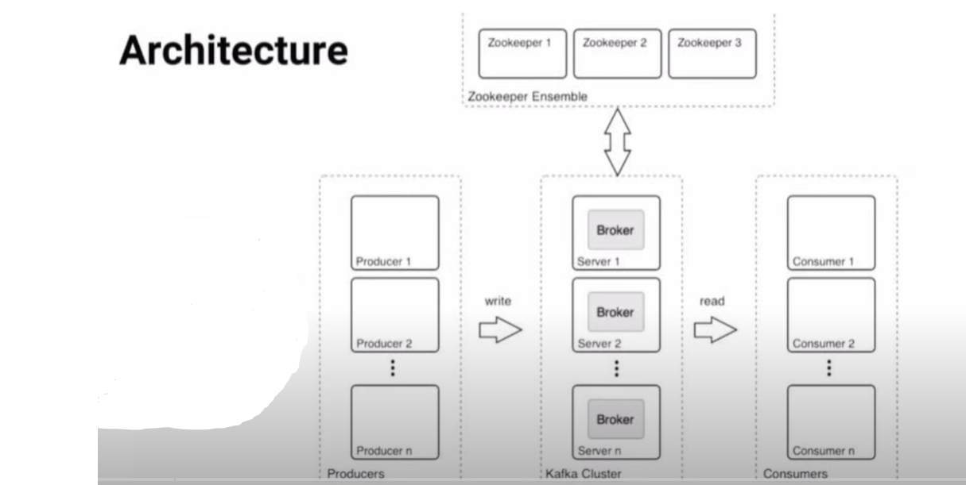

**zookeeper**

* cluster management
* failure detection & recovery
* store ACLs (access control list) & secrets
* distributed key value pair
* provides distributed synchronization/ reliable co-ordination.

All the implementation screenshots ->

Ec2 instance running --

Unzipping tar kafka --

wget https://downloads.apache.org/kafka/3.4.0/kafka_2.12-3.4.0.tgz

tar -xvf kafka_2.12-3.4.0.tgz

java -version

sudo yum install java-1.8.0-openjdk

java -version

cd kafka_2.12-3.3.1

Do a "sudo nano config/server.properties" - change ADVERTISED_LISTENERS to public ip of the EC2 instance

**Start Zoo-keeper:**

bin/zookeeper-server-start.sh config/zookeeper.properties

If you want to stop 🡪 sudo bin/zookeeper-server-stop.sh

Start Kafka-server:

Duplicate the session & enter in a new console --

export KAFKA_HEAP_OPTS="-Xmx256M -Xms128M"

cd kafka_2.12-3.3.1

bin/kafka-server-start.sh config/server.properties

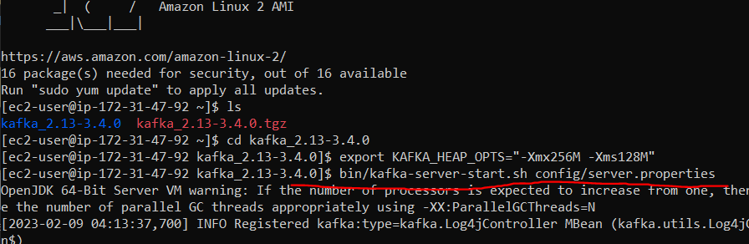

Create the topic:

Duplicate the session & enter in a new console --

cd kafka_2.12-3.3.1

bin/kafka-topics.sh --create --topic demo_testing2 --bootstrap-server {Public IP of your EC2 Instance:9092} --replication-factor 1 --partitions 1

ex - bin/kafka-topics.sh --create --topic demo_testing3 --bootstrap-server 18.222.144.249:9092 --replication-factor 1 --partitions 1

Start Producer:

bin/kafka-console-producer.sh --topic demo_testing2 --bootstrap-server {Public IP of your EC2

Instance:9092}

Ex- bin/kafka-console-producer.sh --topic demo_testing3 --bootstrap-server 18.222.144.249:9092

Start Consumer:

Duplicate the session & enter in a new console --

cd kafka_2.12-3.3.1

bin/kafka-console-consumer.sh --topic demo_testing2 --bootstrap-server {Public IP of your EC2 Instance:9092}

ex- bin/kafka-console-consumer.sh --topic demo_testing3 --bootstrap-server 18.222.144.249:9092

* while creating crawler, go to glue and select crawler and to create crawler,
* firstly you need have s3 bucket name to assign, create I am role and create database and finally create crawler.
* Working on Athena query editor by assigning database to the left and go to settings and set the end target or target location where query can store temporary results by choosing any bucket location.
* Then preview the query results by clicking on table.



