**Step by Step Process – sort of Industry level**

**Tableau Data Analysis Project: Sales Insights:**

**1 - Problem Statement**

* Atliq Hardware is a company, which supplies hardware peripherals to different clients like nomad stores, electrical stores, wholesale stores etc.
* They have head office in the **Delhi** with **sales director Bhavin Patel** and have other branches in the other parts of India with respective regional managers assigned.
* The problem here is the company sales are declining, where sales director unable to know decremented sales and even hard to check all excel sheets from regional managers, so he always keep listioning to the regional managers sugar-coated sayings.
* So in that case **Tableau or Data Analyst** will help to see sales insights of all regional branches clients and their performance and decide for betterment. The tool is so power that on one click you can see the clear insights of the company sales performance region wise or at ground level.

**2 - Data Discovery**

* **AIMS GRID**

**PURPOSE OF THE PROJECT-**

To unlock sales insights that are not visible before for sales team for decision support & automate them to reduced manual time spent in data gathering.

**Who are involved like stakeholders:**

Sales director

Marketing team

Customer service team

Data & analytics team(inhouse) or third party

It team

**End result**

An automated dashboard providing quick & latest sales insights in order to support data driven decision making.

**Success criteria**

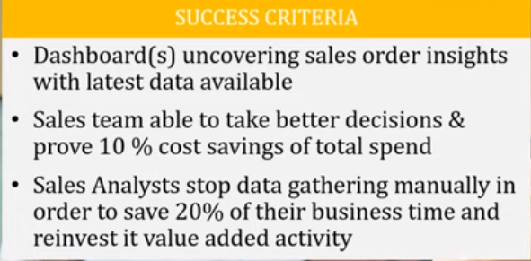

* There several steps performed here…
* Sales management system designed by software engineers with help of database ex-Mysql.
* Database has all the information for the requirements.
* Data analysts with the help of database extract the data and transform, and finally load the data.
* In the below you can see the process of data extraction.

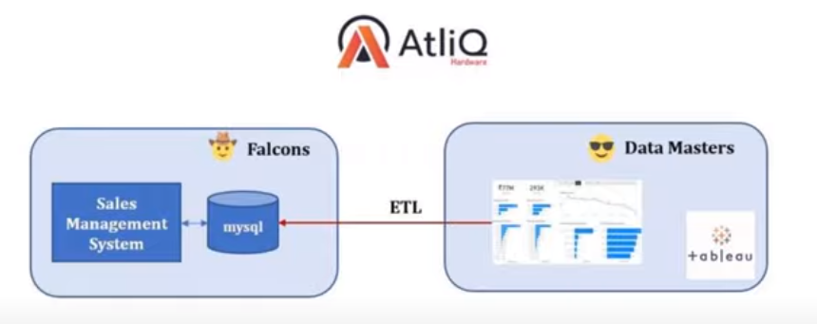

* Big company uses Olap- system (online analytical processing system) using data warehouses for replication or storing data copy in various blocks to save from any data loses.
* They do have a separate team called data engineers handle the data and does data wrangling, data mining etc.
* Data miners have direct connect to the data analysts, so that they can transfer data for the analysis.
* The below diagram shows the process and role of data miners.

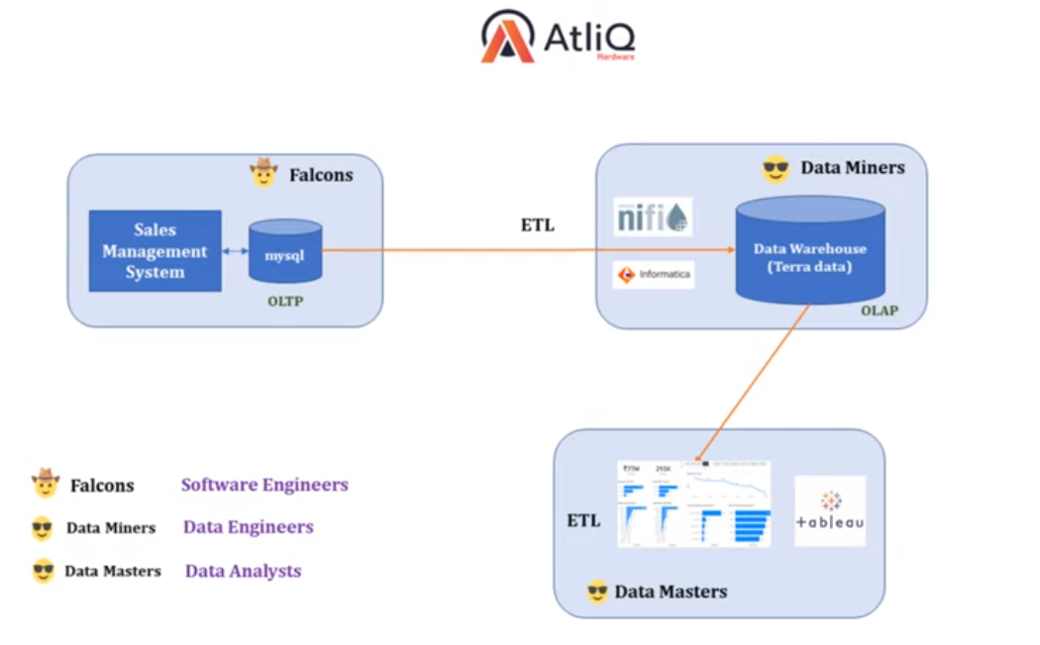

**3 - Data Analysis Using SQL**

* Installed Mysql (developer edition) which consist of all developer tools needed.
* Data Analysis Using SQL

1. Show all customer records

* SELECT * FROM customers;

1. Show total number of customers

* SELECT count(*) FROM customers;

1. Show transactions for Chennai market (market code for chennai is Mark001

* SELECT * FROM transactions where market_code='Mark001';

1. Show distinct product codes that were sold in Chennai

* SELECT distinct product_code FROM transactions where market_code='Mark001';

1. Show transactions where currency is US dollars

* SELECT * from transactions where currency="USD"

1. Show transactions in 2020 join by date table

* SELECT transactions.*, date.* FROM transactions INNER JOIN date ON transactions.order_date=date.date where date.year=2020;

1. Show total revenue in year 2020,

* SELECT SUM(transactions.sales_amount) FROM transactions INNER JOIN date ON transactions.order_date=date.date where date.year=2020 and transactions.currency="INR\r" or transactions.currency="USD\r";

1. Show total revenue in year 2020, January Month,

* SELECT SUM(transactions.sales_amount) FROM transactions INNER JOIN date ON transactions.order_date=date.date where date.year=2020 and transactions. Currency date.month_name="January" and (transactions.currency="INR\r" or transactions.currency="USD\r");

1. Show total revenue in year 2020 in Chennai

* SELECT SUM(transactions.sales_amount) FROM transactions INNER JOIN date ON transactions.order_date=date.date where date.year=2020 and transactions.market_code="Mark001";

* These are some of the operations performed on the table in the Database.
* Sql helps us see the insights of the data in the database.
* Finds which data has to be removed or data cleaning before the visualisation.
* **Finally you export .sql file or into excel file or if you are using licensed tableau you can directly connect to tableau using mysql.**

**4 - Data Cleaning & ETL in Tableau –**

* Here firstly, we will create a data model like star schema.
* Transaction table be fact table surrounded by dimension tables [customers, date, markets, products].
* Filters the markets table by removing unwanted.
* Filter the currency by converting the usd to inr by creating normalized currency table for storing the coverts.

**5 - Build Tableau Dashboard –**

* Created worksheets like [Revenue, Sales Quantity, Revenue by Markets, Sales Quantity by Markets, Top 5 Customers by Revenue, Top 5 Products by Revenue, Revenue by Year, Year, Month].
* Finally Dashboard – Sales Insights Dashboard.
* The Dashboard will show the complete analysis of sales insights very clearly.