**Youtube Data Analysis**

dataset from kaggle -

<https://www.kaggle.com/datasets/datasnaek/youtube-new>

* data ingestion – from data sources
* data lake - design and build new data architecture
* aws cloud - provider
* etl design - extract, tranform, load data efficiently
* scalability - data architecture scale efficiently
* reporting - build businesss inteligence tier, dashboards
* build data lake from scraatch in s3
* joining structured and semi-structured data
* lake house architecture design
* data lake vs data warehouse
* etl in aws glue spark jobs
* amazon sagemaker jupter notebooks
* amazon sns for alerting
* sql using amazon athena and spark sql
* bi dashboards
* youtube
* what is trending - factors inlcudes user interactions
* no of shares, views, likes, comments
* not most viewes videos
* setup - aws account
* IAM user and groups
* s3 - buckets
* transfer data from windows to s3 in commandline using hive pattern commands
* lake house architecure
* all types of data stored - structured or unstructred data or etc.
* aws glue catalog
* glue -> crawler -> data catalog -> job(schedule or event)-> transform -> load to get the target data
* de_youtube_cleansed_table
* de_youtube_cleansed
* Streamline Youtube analysis on structured and semi-structured youtube videos data from data ingestion to building etl pipeline to visualize data in QuickSight.

Dataset -> Data Ingestion (S3) -> Lambda -> Data Catalog -> Job-> Athena -> Quicksight.

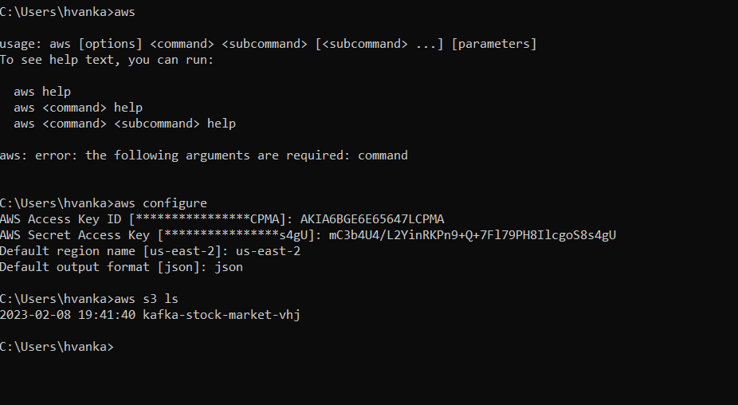

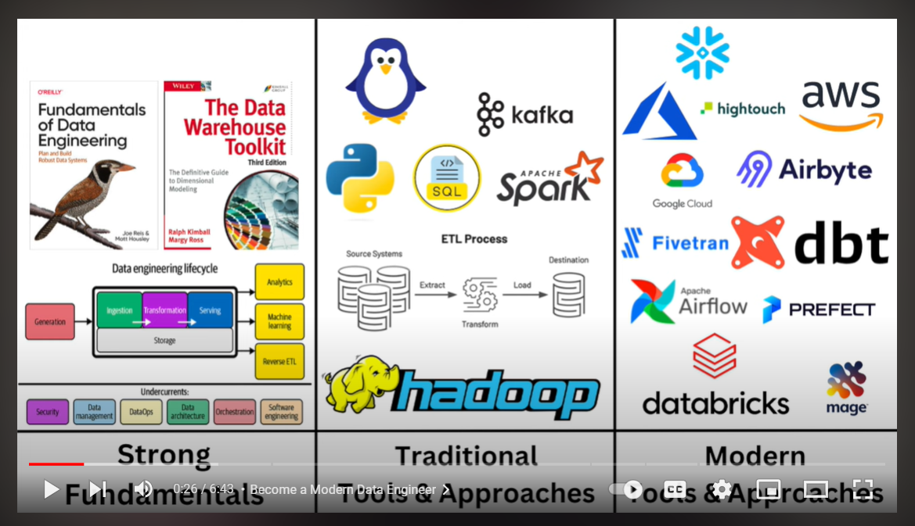

# To copy all JSON Reference data to same location:

aws s3 cp . s3://de-youtube-analysis-using-raw-data/youtube/raw_statistics_data/ --recursive --exclude "*" --include "*.json"

# To copy all data files to its own location, following Hive-style patterns:

aws s3 cp CAvideos.csv s3://de-youtube-analysis-using-raw-data/youtube/raw_statistics_region_data/region=ca/

aws s3 cp DEvideos.csv s3://de-youtube-analysis-using-raw-data/youtube/raw_statistics_region_data/region=de/

aws s3 cp FRvideos.csv s3://de-youtube-analysis-using-raw-data/youtube/raw_statistics_region_data/region=fr/

aws s3 cp GBvideos.csv s3://de-youtube-analysis-using-raw-data/youtube/raw_statistics_region_data/region=gb/

aws s3 cp INvideos.csv s3://de-youtube-analysis-using-raw-data/youtube/raw_statistics_region_data/region=in/

aws s3 cp JPvideos.csv s3://de-youtube-analysis-using-raw-data/youtube/raw_statistics_region_data/region=jp/

aws s3 cp KRvideos.csv s3://de-youtube-analysis-using-raw-data/youtube/raw_statistics_region_data/region=kr/

aws s3 cp MXvideos.csv s3://de-youtube-analysis-using-raw-data/youtube/raw_statistics_region_data/region=mx/

aws s3 cp RUvideos.csv s3://de-youtube-analysis-using-raw-data/youtube/raw_statistics_region_data/region=ru/

aws s3 cp USvideos.csv s3://de-youtube-analysis-using-raw-data/youtube/raw_statistics_region_data/region=us/

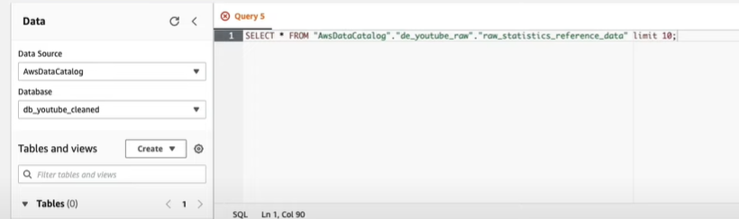

Json data failed to get queried.

Json SerDe libraries -

Serialized and deserialized

Data cleaning semi- structured pipeline

Json

-> json s2 bukcet

-> aws lambda, json to apache parquet

-> s3 cleansed bucket / aws data wrangler

-> amazon athena / glue catalog

* Created lambda python file and assigned outputs to get created such as glue catalog, database, s3 parquet file.

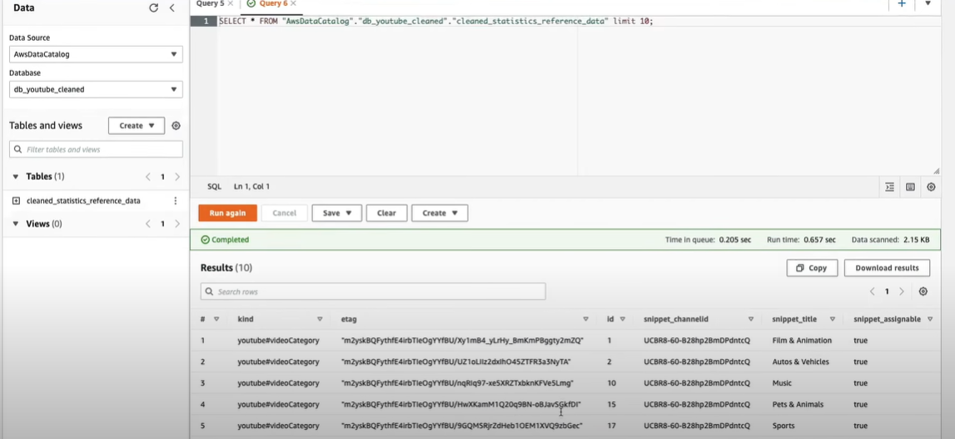

* Changing the data type string to bigint -> preprocessing
* After that recreating the parquet/ database catalog by deleting the previous one.
* Instead of querying data using join operations or any operations and retrieving the data, we creating the **job and event**
* While create add target format as parquet and it create spark job gives default code and insert data with our specific requirements

* Building etl pipeline

* Now building the reporting version
* Now finally on to quicksight to visualize the reports - on choosing database data source.

