1)

**import** org.openqa.selenium.By;

**import** org.openqa.selenium.JavascriptExecutor;

**import** org.openqa.selenium.Keys;

**import** org.openqa.selenium.WebDriver;

**import** org.openqa.selenium.WebElement;

**import** org.openqa.selenium.chrome.ChromeDriver;

**import** org.openqa.selenium.chrome.ChromeOptions;

**import** org.testng.Assert;

**import** org.testng.annotations.Test;

**import** io.github.bonigarcia.wdm.WebDriverManager;

**public** **class** Test1 {

@Test

**public** **void** f() **throws** InterruptedException {

WebDriverManager.*chromedriver*().setup();

ChromeOptions co=**new** ChromeOptions();

co.addArguments("--remote-allow-origins=*");

WebDriver driver=**new** ChromeDriver();

driver.get("https://www.amazon.in");

driver.manage().window().maximize();

Thread.*sleep*(1000);

driver.findElement(By.*xpath*("//*[@id=\"twotabsearchtextbox\"]")).sendKeys("bag");

Thread.*sleep*(1000);

driver.findElement(By.*xpath*("//*[@id=\"nav-search-submit-button\"]")).click();

Thread.*sleep*(1000);

driver.findElement(By.*xpath*("//*[@id=\"search\"]/div[1]/div[1]/div/span[1]/div[1]/div[3]/div/div/div/div/div/div/div/div[2]/div/div/div[1]/h2/a/span")).click();

Thread.*sleep*(1000);

**for**(String s:driver.getWindowHandles())

{

driver.switchTo().window(s);

}

Thread.*sleep*(1000);

JavascriptExecutor js = (JavascriptExecutor) driver;

js.executeScript("window.scrollBy(0,350)", "");

Thread.*sleep*(1000);

WebElement a= driver.findElement(By.*xpath*("//*[@id=\"quantity\"]"));

a.click();

a.sendKeys(Keys.***ARROW_DOWN***);

a.sendKeys(Keys.***ARROW_DOWN***);

a.sendKeys(Keys.***ENTER***);

Thread.*sleep*(1000);

driver.findElement(By.*xpath*("//*[@id=\"add-to-cart-button\"]")).click();

Thread.*sleep*(1000);

Assert.*assertEquals*(driver.findElement(By.*xpath*("//*[@id=\"NATC_SMART_WAGON_CONF_MSG_SUCCESS\"]/span")).getText(), "Added to Cart");

Thread.*sleep*(1000);

driver.findElement(By.*xpath*("//*[@id=\"sw-gtc\"]/span/a")).click();

Thread.*sleep*(1000);

Assert.*assertEquals*(driver.findElement(By.*xpath*("//*[@id=\"sc-subtotal-amount-activecart\"]/span")).getText()," 13,497.00");

Thread.*sleep*(1000);

driver.findElement(By.*xpath*("//*[@id=\"sc-buy-box-ptc-button\"]/span/input")).click();

Thread.*sleep*(1000);

driver.findElement(By.*xpath*("//*[@id=\"ap_email\"]")).sendKeys("9360777518");

Thread.*sleep*(1000);

driver.findElement(By.*xpath*("//*[@id=\"continue\"]")).click();

Thread.*sleep*(1000);

driver.findElement(By.*xpath*("//*[@id=\"ap_password\"]")).sendKeys("hari@2003");

Thread.*sleep*(1000);

driver.findElement(By.*xpath*("//*[@id=\"signInSubmit\"]")).click();

Thread.*sleep*(1000);

System.***out***.print(driver.findElement(By.*xpath*("//*[@id=\"a-page\"]/section/div/div[4]/form/label/span")).getText());

}

}

OUTPUT:

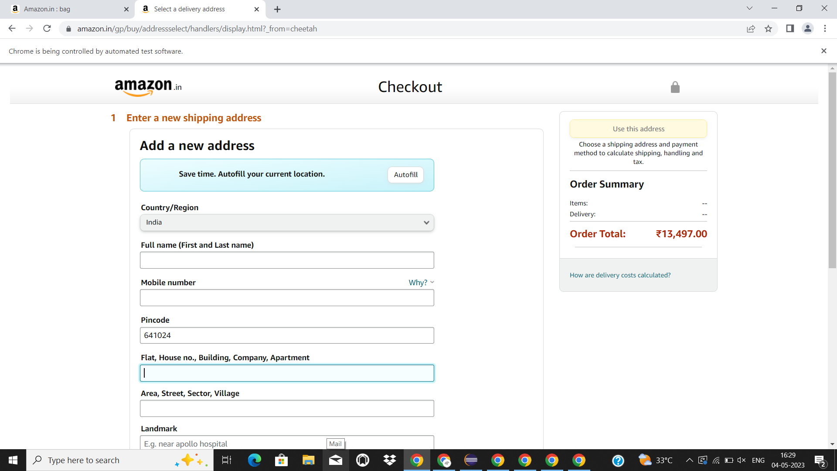

2)

**import** java.util.List;

**import** org.openqa.selenium.By;

**import** org.openqa.selenium.JavascriptExecutor;

**import** org.openqa.selenium.Keys;

**import** org.openqa.selenium.WebDriver;

**import** org.openqa.selenium.WebElement;

**import** org.openqa.selenium.chrome.ChromeDriver;

**import** org.openqa.selenium.chrome.ChromeOptions;

**import** org.testng.annotations.Test;

**import** io.github.bonigarcia.wdm.WebDriverManager;

**public** **class** Test2 {

@Test

**public** **void** f() **throws** InterruptedException {

WebDriverManager.*chromedriver*().setup();

ChromeOptions co=**new** ChromeOptions();

co.addArguments("--remote-allow-origins=*");

WebDriver driver=**new** ChromeDriver();

driver.get("https://www.amazon.in");

driver.manage().window().maximize();

Thread.*sleep*(1000);

driver.findElement(By.*xpath*("//*[@id=\"twotabsearchtextbox\"]")).sendKeys("bag");

Thread.*sleep*(1000);

driver.findElement(By.*xpath*("//*[@id=\"nav-search-submit-button\"]")).click();

Thread.*sleep*(1000);

JavascriptExecutor js = (JavascriptExecutor) driver;

js.executeScript("window.scrollBy(0,350)", "");

Thread.*sleep*(1000);

driver.findElement(By.*xpath*("//*[@id=\"p_89/American Tourister\"]/span/a/div/label/i")).click();

Thread.*sleep*(1000);

List<WebElement> e=driver.findElements(By.*xpath*("//h2[@class='a-size-mini a-spacing-none a-color-base s-line-clamp-4']"));

Thread.*sleep*(1000);

Integer c=0;

**for**(WebElement i:e)

{

System.***out***.println(i.getText());

c++;

**if**(c==6)

{

**break**;

}

}

}

}

OUTPUT

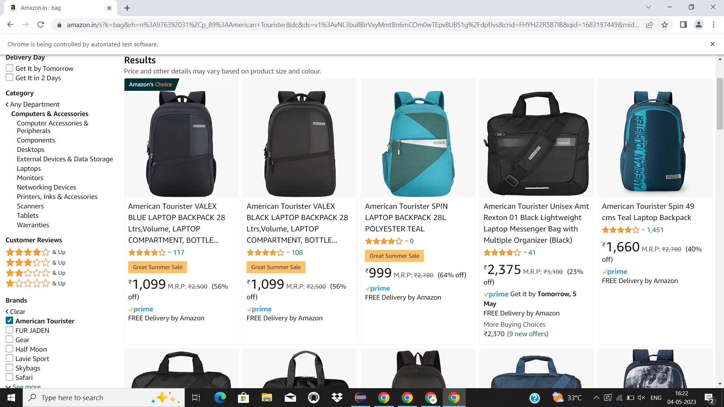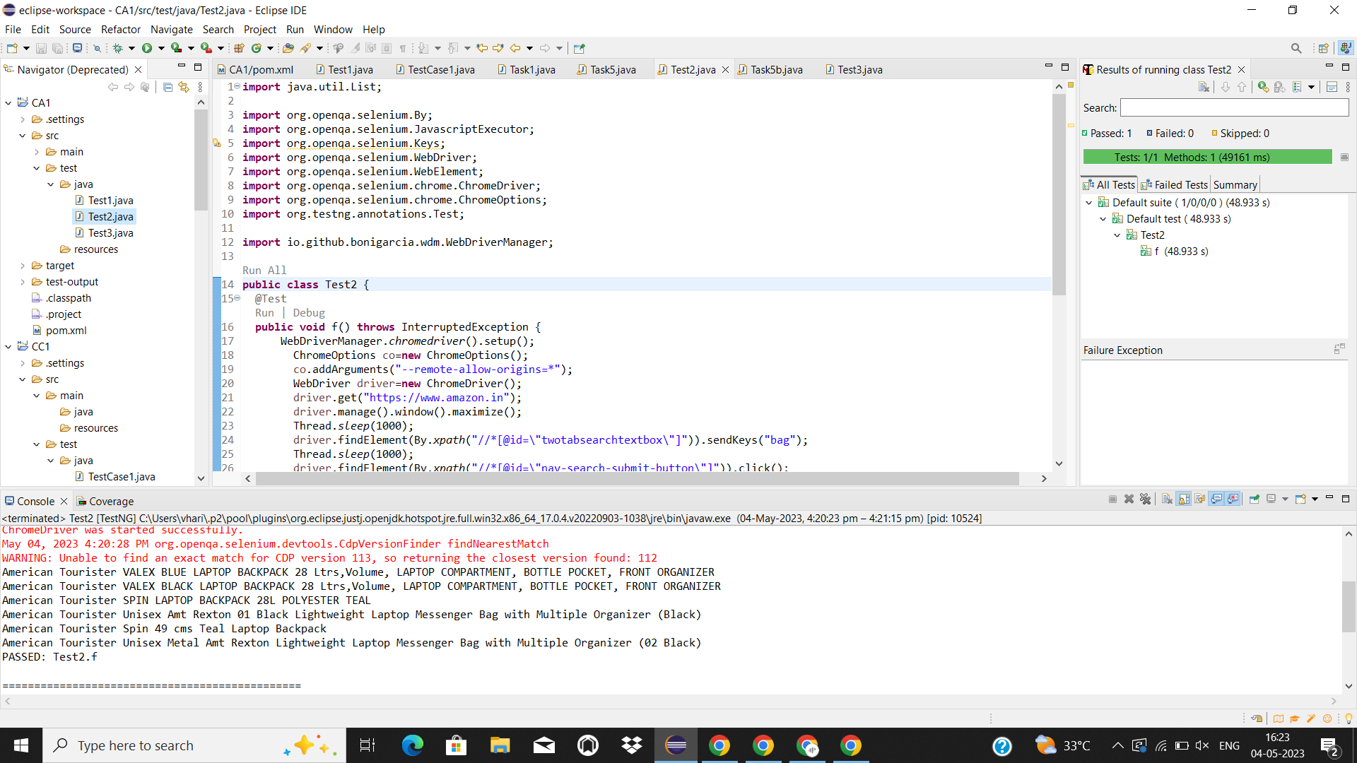

3)

**import** org.openqa.selenium.By;

**import** org.openqa.selenium.WebDriver;

**import** org.openqa.selenium.chrome.ChromeDriver;

**import** org.openqa.selenium.chrome.ChromeOptions;

**import** org.testng.annotations.Test;

**import** io.github.bonigarcia.wdm.WebDriverManager;

**public** **class** Test3 {

@Test

**public** **void** f() **throws** InterruptedException {

WebDriverManager.*chromedriver*().setup();

ChromeOptions co=**new** ChromeOptions();

co.addArguments("--remote-allow-origins=*");

WebDriver driver=**new** ChromeDriver();

driver.get("https://www.amazon.in");

driver.manage().window().maximize();

Thread.*sleep*(1000);

driver.findElement(By.*xpath*("//*[@id=\"nav-link-accountList\"]")).click();

Thread.*sleep*(1000);;

driver.findElement(By.*xpath*("//*[@id=\"ap_email\"]")).sendKeys("9360777518");

Thread.*sleep*(1000);

driver.findElement(By.*xpath*("//*[@id=\"continue\"]")).click();

Thread.*sleep*(1000);

driver.findElement(By.*xpath*("//*[@id=\"ap_password\"]")).sendKeys("hari@2003");

Thread.*sleep*(1000);

driver.findElement(By.*xpath*("//*[@id=\"signInSubmit\"]")).click();

Thread.*sleep*(1000);

driver.findElement(By.*xpath*("//*[@id=\"nav-link-accountList\"]")).click();

Thread.*sleep*(1000);

driver.findElement(By.*xpath*("//*[@id=\"a-page\"]/div[2]/div/div[2]/div[1]/a/div/div")).click();

Thread.*sleep*(1000);

System.***out***.print(driver.findElement(By.*xpath*("//*[@id=\"a-page\"]/section/div/div[4]/form/label")).getText());

}

}

OUTPUT

