1)

package day4;

import org.openqa.selenium.By;

import org.openqa.selenium.JavascriptExecutor;

import org.openqa.selenium.WebDriver;

import org.openqa.selenium.chrome.ChromeDriver;

import org.openqa.selenium.chrome.ChromeOptions;

import io.github.bonigarcia.wdm.WebDriverManager;

public class Task1 {

public static void main(String[] args) throws InterruptedException {

// TODO Auto-generated method stub

WebDriverManager.chromedriver().setup();

ChromeOptions co=new ChromeOptions();

co.addArguments("--remote-allow-origins=*");

WebDriver driver=new ChromeDriver();

driver.get("https://demo.opencart.com/index.php?route=account/register&language=en-gb");

driver.manage().window().maximize();

System.out.print(driver.getTitle());

driver.findElement(By.id("input-firstname")).sendKeys("HariPrasath");

driver.findElement(By.id("input-lastname")).sendKeys("V");

driver.findElement(By.id("input-email")).sendKeys("Hari@gmail.com");

driver.findElement(By.id("input-password")).sendKeys("Hari@123");

Thread.sleep(1000);

JavascriptExecutor js = (JavascriptExecutor) driver;

js.executeScript("window.scrollBy(0,350)", "");

Thread.sleep(1000);

driver.findElement(By.id("input-newsletter-yes")).click();

driver.findElement(By.name("agree")).click();

driver.findElement(By.xpath("//*[@id=\"form-register\"]/div/div/button")).click();

}

}

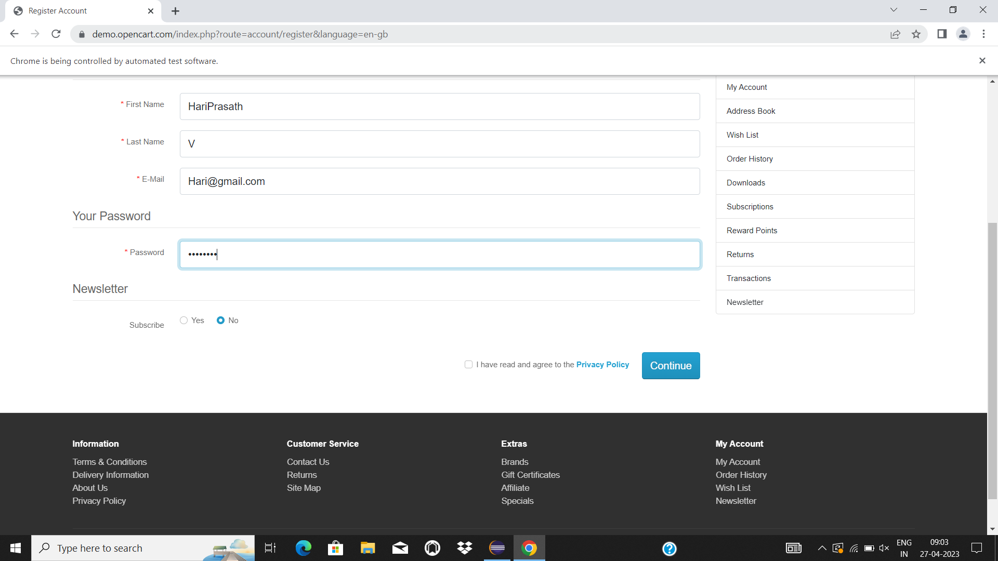

2)

**package** day4;

**import** org.openqa.selenium.By;

**import** org.openqa.selenium.JavascriptExecutor;

**import** org.openqa.selenium.WebDriver;

**import** org.openqa.selenium.chrome.ChromeDriver;

**import** org.openqa.selenium.chrome.ChromeOptions;

**import** io.github.bonigarcia.wdm.WebDriverManager;

**public** **class** Task2 {

**public** **static** **void** main(String[] args) **throws** InterruptedException {

// **TODO** Auto-generated method stub

WebDriverManager.*chromedriver*().setup();

ChromeOptions co=**new** ChromeOptions();

co.addArguments("--remote-allow-origins=*");

WebDriver driver=**new** ChromeDriver();

driver.get("https://demo.opencart.com/index.php?route=account/register&language=en-gb");

driver.manage().window().maximize();

System.***out***.print(driver.getTitle());

driver.findElement(By.*id*("input-firstname")).sendKeys("HariPrasath");

driver.findElement(By.*id*("input-lastname")).sendKeys("V");

driver.findElement(By.*id*("input-email")).sendKeys("Hari@gmail.com");

driver.findElement(By.*id*("input-password")).sendKeys("Hari@123");

Thread.*sleep*(1000);

JavascriptExecutor js = (JavascriptExecutor) driver;

js.executeScript("window.scrollBy(0,350)", "");

Thread.*sleep*(1000);

driver.findElement(By.*id*("input-newsletter-yes")).click();

driver.findElement(By.*name*("agree")).click();

}

}

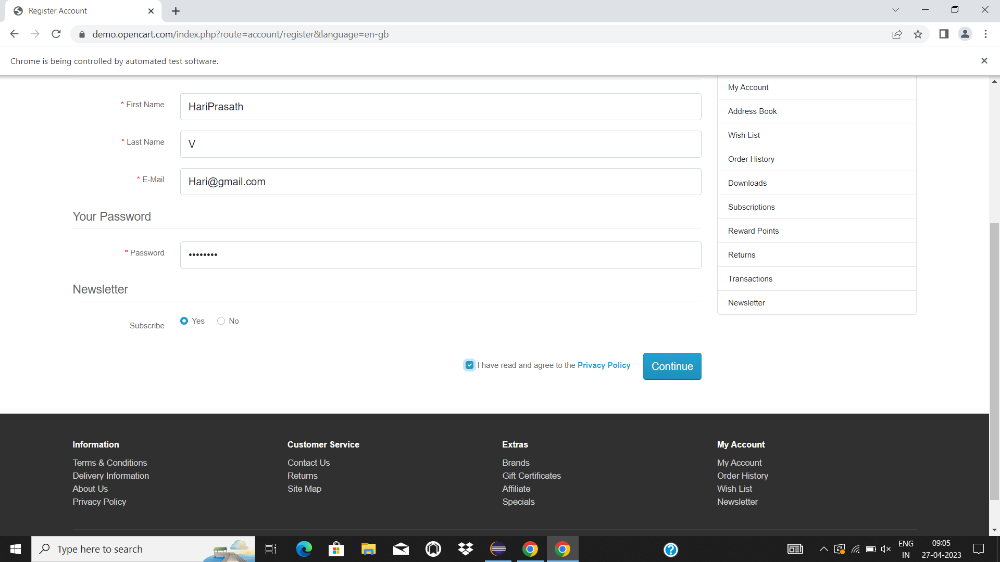

3)

package day4;

import org.openqa.selenium.By;

import org.openqa.selenium.JavascriptExecutor;

import org.openqa.selenium.By.ByXPath;

import org.openqa.selenium.WebDriver;

import org.openqa.selenium.chrome.ChromeDriver;

import org.openqa.selenium.chrome.ChromeOptions;

import io.github.bonigarcia.wdm.WebDriverManager;

public class Task3 {

public static void main(String[] args) throws InterruptedException {

// TODO Auto-generated method stub

WebDriverManager.chromedriver().setup();

ChromeOptions co=new ChromeOptions();

co.addArguments("--remote-allow-origins=*");

WebDriver driver=new ChromeDriver();

driver.get("https://demo.opencart.com/index.php?route=checkout/voucher&language=en-gb");

driver.manage().window().maximize();

driver.findElement(By.xpath("//*[@id=\"input-to-name\"]")).sendKeys("Hariprasath");

driver.findElement(By.xpath("//*[@id=\"input-to-email\"]")).sendKeys("Hariprasath@gmail.com");

driver.findElement(By.xpath("//*[@id=\"input-from-name\"]")).sendKeys("Hariprasath");

driver.findElement(By.xpath("//*[@id=\"input-from-email\"]")).sendKeys("Hariprasath@gmail.com");

driver.findElement(By.xpath("//*[@id=\"input-theme-7\"]")).click();

Thread.sleep(1000);

JavascriptExecutor js = (JavascriptExecutor) driver;

js.executeScript("window.scrollBy(0,550)", "");

Thread.sleep(1000);

driver.findElement(By.xpath("//*[@id=\"form-voucher\"]/div[8]/div/div/input")).click();

Thread.sleep(2000);

driver.findElement(By.xpath("//*[@id=\"form-voucher\"]/div[8]/div/button")).click();

}

}

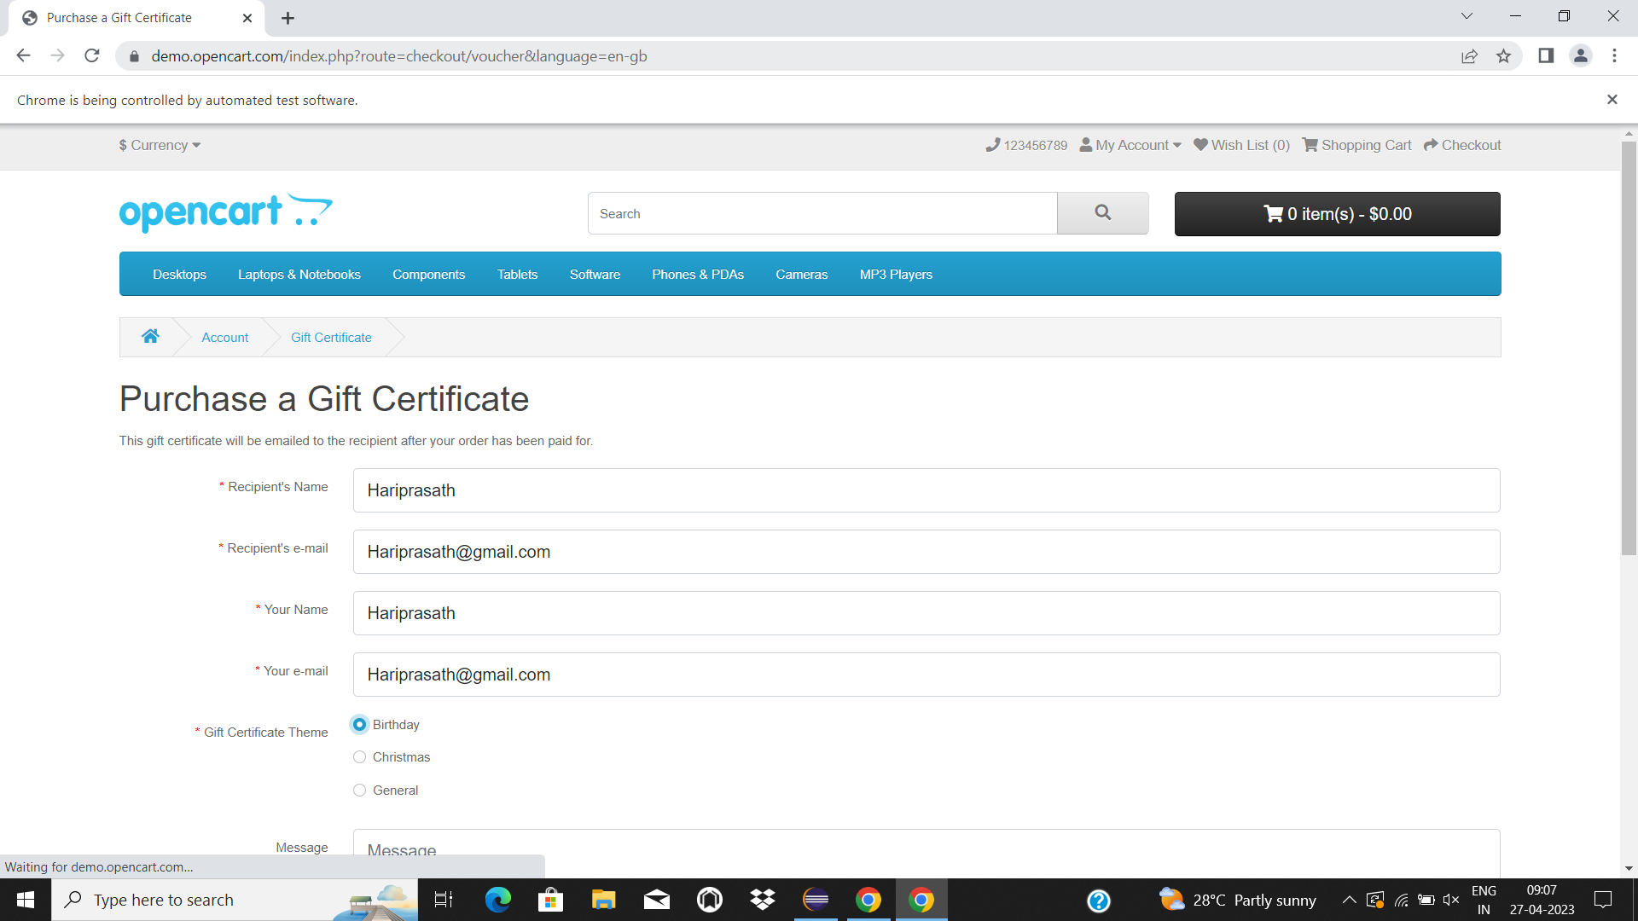

4)

package day4;

import org.openqa.selenium.By;

import org.openqa.selenium.JavascriptExecutor;

import org.openqa.selenium.WebDriver;

import org.openqa.selenium.chrome.ChromeDriver;

import org.openqa.selenium.chrome.ChromeOptions;

import io.github.bonigarcia.wdm.WebDriverManager;

public class Task4 {

public static void main(String[] args) throws InterruptedException {

// TODO Auto-generated method stub

WebDriverManager.chromedriver().setup();

ChromeOptions co=new ChromeOptions();

co.addArguments("--remote-allow-origins=*");

WebDriver driver=new ChromeDriver();

driver.navigate().to("https://j2store.net/free/");

driver.manage().window().maximize();

Thread.sleep(1000);

JavascriptExecutor js = (JavascriptExecutor) driver;

js.executeScript("window.scrollBy(0,550)", "");

Thread.sleep(1000);

driver.findElement(By.xpath("//*[@id=\"Mod112\"]/div/div/ul/li[1]/a/img")).click();

Thread.sleep(1000);

driver.navigate().back();

Thread.sleep(1000);

driver.navigate().forward();

Thread.sleep(1000);

driver.navigate().refresh();

Thread.sleep(1000);

driver.close();

}

}

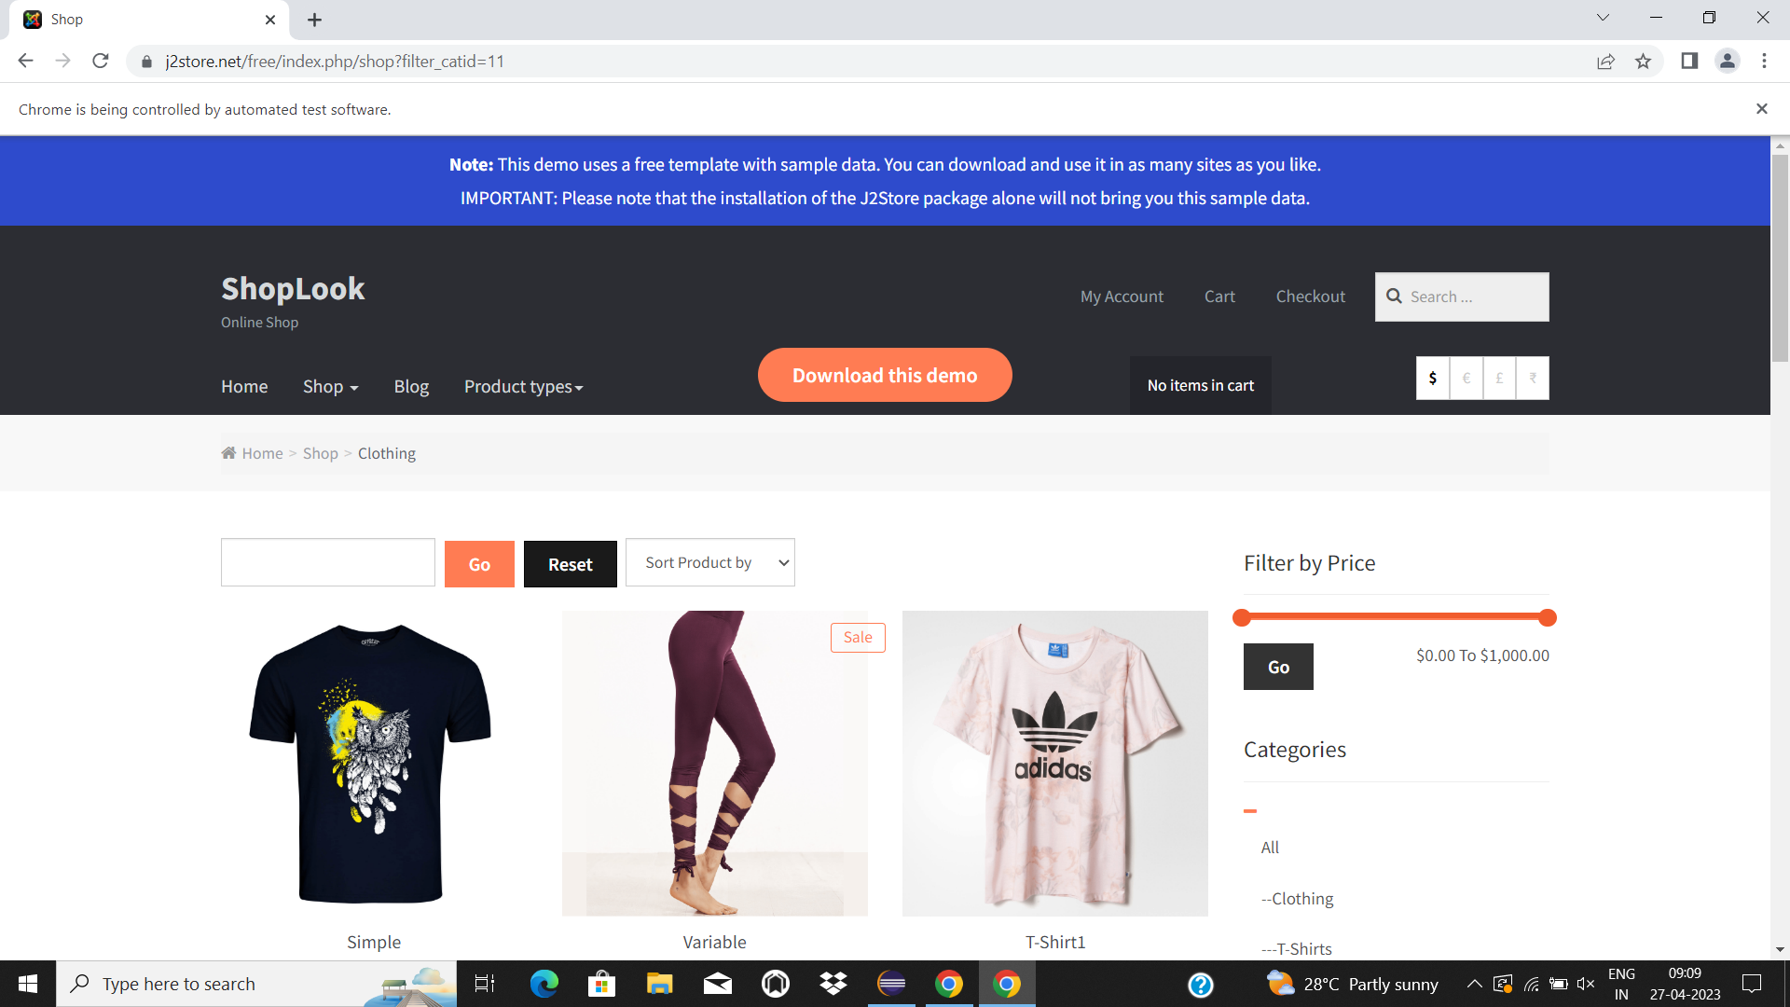

5a)

package day4;

import org.openqa.selenium.By;

import org.openqa.selenium.JavascriptExecutor;

import org.openqa.selenium.WebDriver;

import org.openqa.selenium.chrome.ChromeDriver;

import org.openqa.selenium.chrome.ChromeOptions;

import io.github.bonigarcia.wdm.WebDriverManager;

public class Task5a {

public static void main(String[] args) throws InterruptedException {

// TODO Auto-generated method stub

WebDriverManager.chromedriver().setup();

ChromeOptions co=new ChromeOptions();

co.addArguments("--remote-allow-origins=*");

WebDriver driver=new ChromeDriver();

driver.navigate().to("https://j2store.net/free/");

driver.manage().window().maximize();

if(driver.getCurrentUrl().equals("https://j2store.net/free/"))

{

System.out.println("url Validated");

}

Thread.sleep(1000);

JavascriptExecutor js = (JavascriptExecutor) driver;

js.executeScript("window.scrollBy(0,550)", "");

Thread.sleep(1000);

driver.findElement(By.xpath("//*[@id=\"Mod112\"]/div/div/ul/li[1]/a/img")).click();

if(driver.getCurrentUrl().equals("https://j2store.net/free/index.php/shop?filter_catid=11"))

{

System.out.println("url Validated");

}

}

}

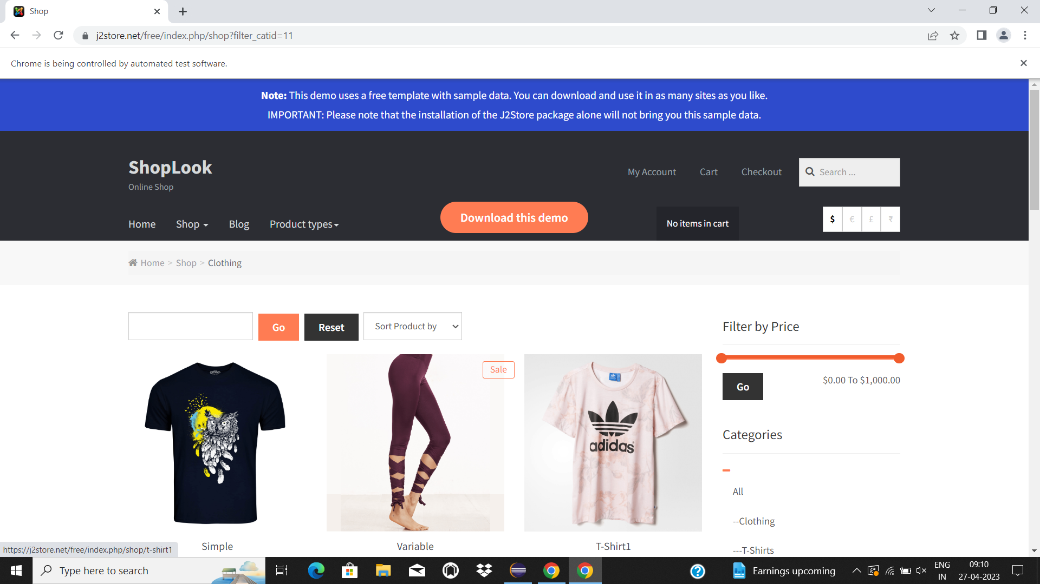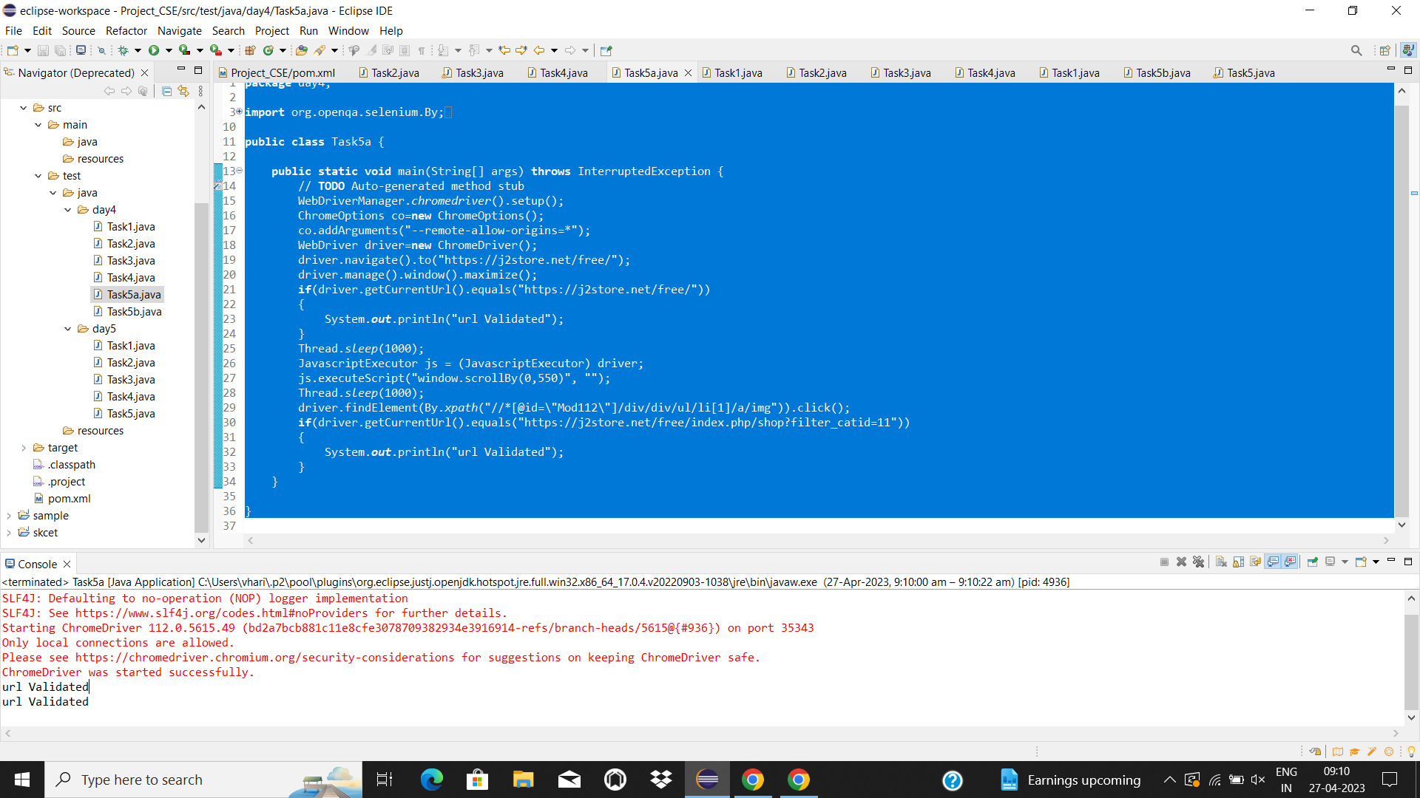

5b)

package day4;

import java.util.List;

import org.openqa.selenium.By;

import org.openqa.selenium.JavascriptExecutor;

import org.openqa.selenium.WebDriver;

import org.openqa.selenium.WebElement;

import org.openqa.selenium.chrome.ChromeDriver;

import org.openqa.selenium.chrome.ChromeOptions;

import com.beust.jcommander.internal.Console;

import io.github.bonigarcia.wdm.WebDriverManager;

public class Task5b {

public static void main(String[] args) throws InterruptedException {

// TODO Auto-generated method stub

WebDriverManager.chromedriver().setup();

ChromeOptions co=new ChromeOptions();

co.addArguments("--remote-allow-origins=*");

WebDriver driver=new ChromeDriver();

driver.get("https://j2store.net/free/");

driver.manage().window().maximize();

Thread.sleep(1000);

JavascriptExecutor js = (JavascriptExecutor) driver;

js.executeScript("window.scrollBy(0,550)", "");

Thread.sleep(1000);

driver.findElement(By.xpath("//*[@id=\"Mod112\"]/div/div/ul/li[1]/a/img")).click();

List<WebElement> l=driver.findElements(By.xpath("//h2[@class='product-title']"));

for(WebElement e:l)

{

System.out.println(e.getText());

}

}

}

