1)

package day5;

import org.openqa.selenium.By;

import org.openqa.selenium.WebDriver;

import org.openqa.selenium.chrome.ChromeDriver;

import org.openqa.selenium.chrome.ChromeOptions;

import org.openqa.selenium.interactions.Actions;

import io.github.bonigarcia.wdm.WebDriverManager;

public class Task1 {

public static void main(String[] args) {

// TODO Auto-generated method stub

WebDriverManager.chromedriver().setup();

ChromeOptions co=new ChromeOptions();

co.addArguments("--remote-allow-origins=*");

WebDriver driver=new ChromeDriver();

driver.navigate().to("https://demoqa.com/droppable/");

driver.manage().window().maximize();

Actions builder = new Actions(driver);

builder.dragAndDrop(driver.findElement(By.xpath("//*[@id=\"draggable\"]")), driver.findElement(By.xpath("//*[@id=\"droppable\"]"))).perform();

}

}

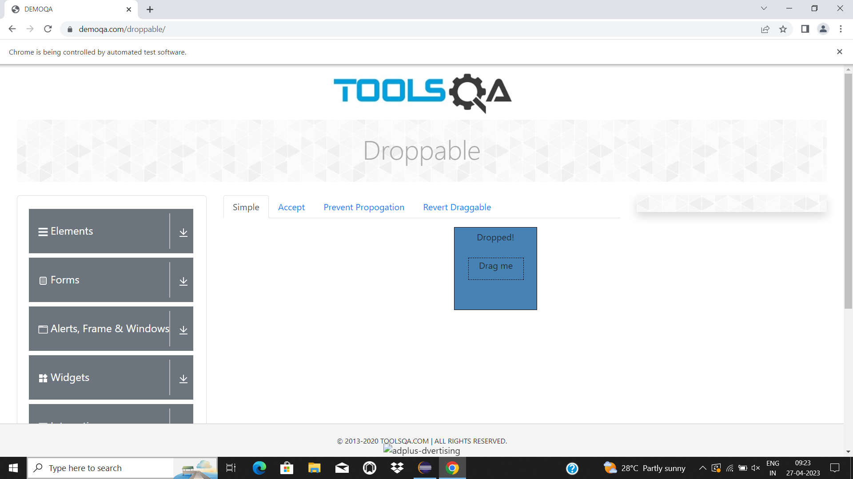

2)

package day5;

import org.openqa.selenium.By;

import org.openqa.selenium.WebDriver;

import org.openqa.selenium.chrome.ChromeDriver;

import org.openqa.selenium.chrome.ChromeOptions;

import org.openqa.selenium.interactions.Actions;

import io.github.bonigarcia.wdm.WebDriverManager;

public class Task2 {

public static void main(String[] args) {

// TODO Auto-generated method stub

WebDriverManager.chromedriver().setup();

ChromeOptions co=new ChromeOptions();

co.addArguments("--remote-allow-origins=*");

WebDriver driver=new ChromeDriver();

driver.navigate().to("https://jqueryui.com/droppable/");

driver.manage().window().maximize();

driver.switchTo().frame(0);

Actions builder=new Actions(driver);

builder.clickAndHold(driver.findElement(By.xpath("//*[@id=\"draggable\"]"))).build().perform();

builder.release(driver.findElement(By.xpath("//*[@id=\"droppable\"]"))).build().perform();

}

}

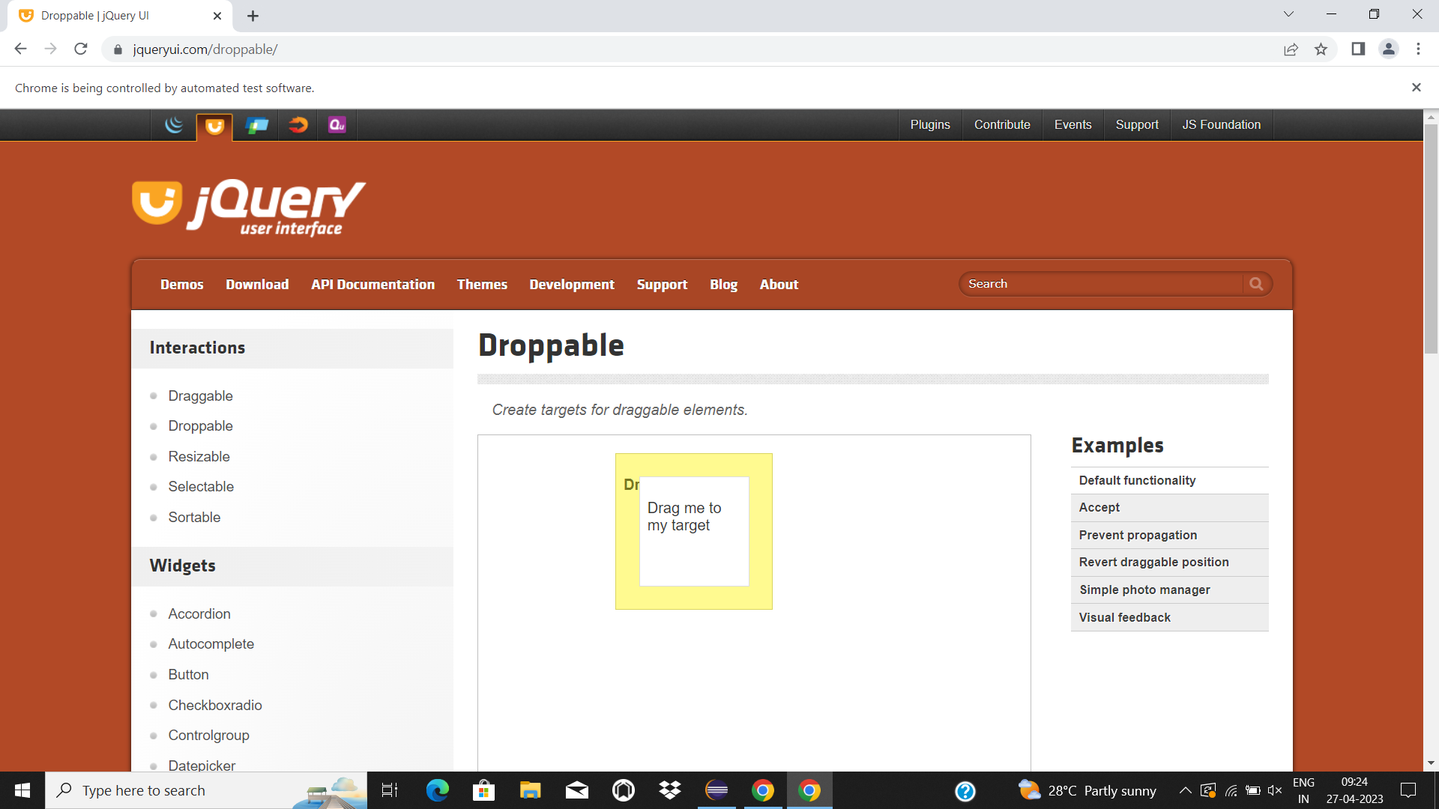

3)

package day5;

import org.openqa.selenium.Alert;

import org.openqa.selenium.By;

import org.openqa.selenium.WebDriver;

import org.openqa.selenium.chrome.ChromeDriver;

import org.openqa.selenium.chrome.ChromeOptions;

import io.github.bonigarcia.wdm.WebDriverManager;

public class Task3 {

public static void main(String[] args) throws InterruptedException {

// TODO Auto-generated method stub

WebDriverManager.chromedriver().setup();

ChromeOptions co=new ChromeOptions();

co.addArguments("--remote-allow-origins=*");

WebDriver driver=new ChromeDriver();

driver.navigate().to("https://demo.guru99.com/test/delete_customer.php");

driver.manage().window().maximize();

driver.findElement(By.xpath("/html/body/form/table/tbody/tr[2]/td[2]/input")).sendKeys("401");

Thread.sleep(1000);

driver.findElement(By.name("submit")).click();

Thread.sleep(1000);

Alert a=driver.switchTo().alert();

a.dismiss();

Thread.sleep(1000);

driver.findElement(By.xpath("/html/body/form/table/tbody/tr[2]/td[2]/input")).clear();

driver.findElement(By.xpath("/html/body/form/table/tbody/tr[2]/td[2]/input")).sendKeys("402");

Thread.sleep(1000);

driver.findElement(By.name("submit")).click();

Thread.sleep(1000);

Alert a2=driver.switchTo().alert();

a2.accept();

System.out.print(a2.getText());

}

}

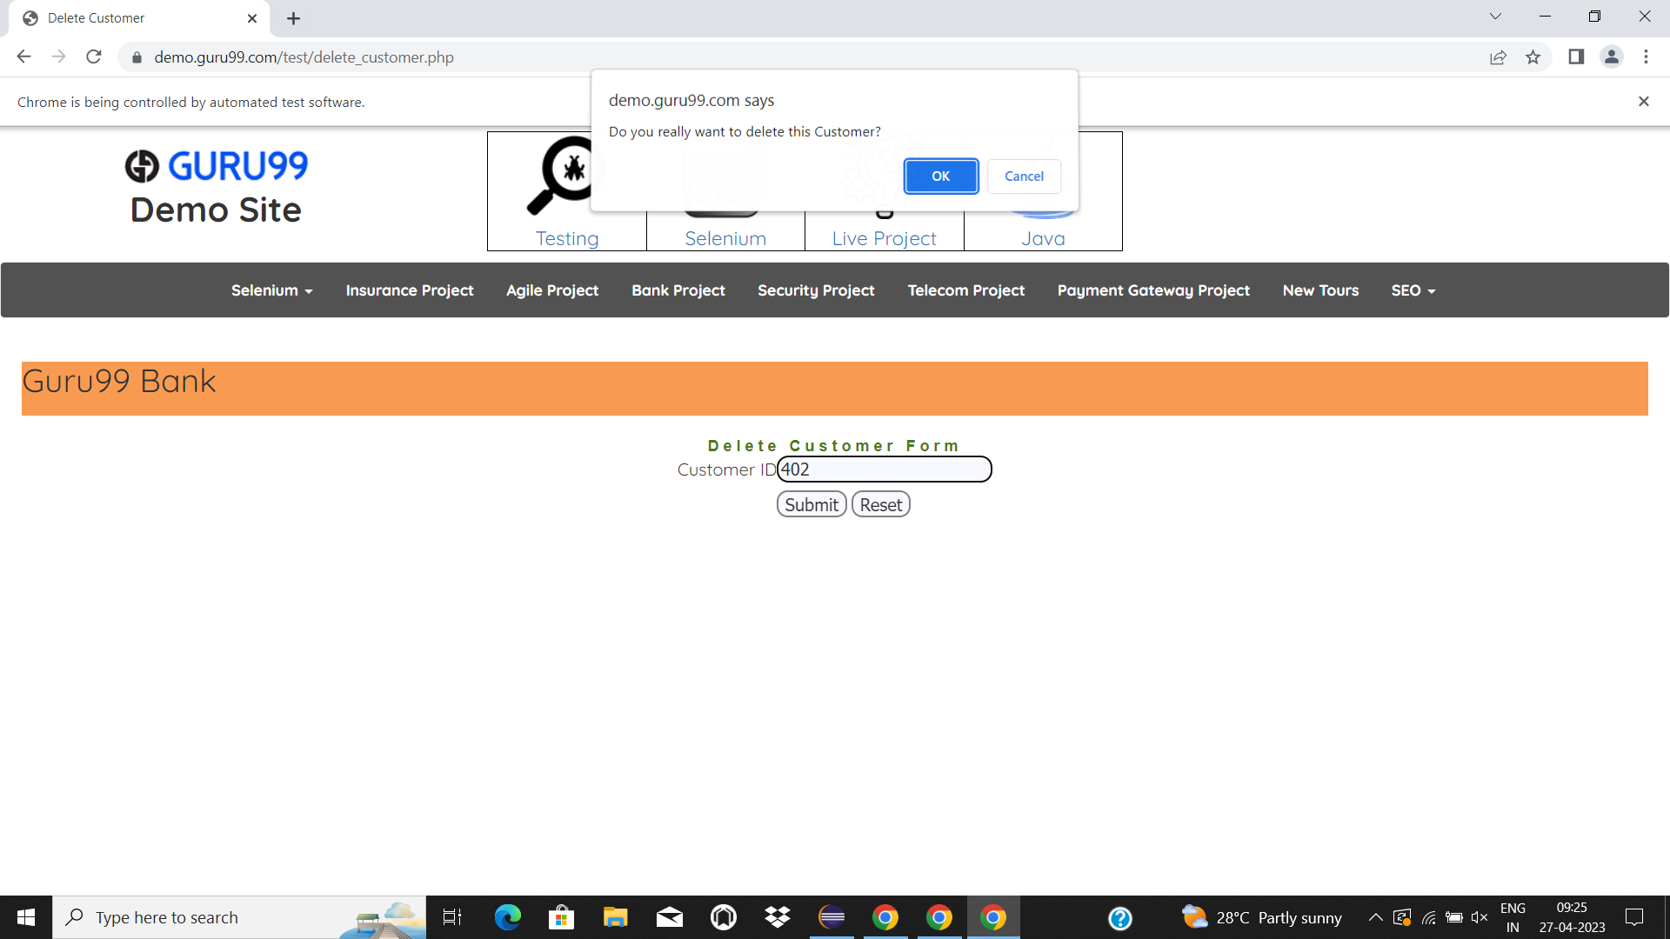

4)

package day5;

import org.openqa.selenium.By;

import org.openqa.selenium.JavascriptExecutor;

import org.openqa.selenium.Keys;

import org.openqa.selenium.WebDriver;

import org.openqa.selenium.WebElement;

import org.openqa.selenium.chrome.ChromeDriver;

import org.openqa.selenium.chrome.ChromeOptions;

import io.github.bonigarcia.wdm.WebDriverManager;

public class Task4 {

public static void main(String[] args) throws InterruptedException {

// TODO Auto-generated method stub

WebDriverManager.chromedriver().setup();

ChromeOptions co=new ChromeOptions();

co.addArguments("--remote-allow-origins=*");

WebDriver driver=new ChromeDriver();

driver.navigate().to("https://www.abhibus.com/bus-ticket-booking");

driver.manage().window().maximize();

Thread.sleep(1000);

WebElement sour=driver.findElement(By.id("source"));

Thread.sleep(1000);

sour.sendKeys("Hyderabad");

Thread.sleep(2000);

sour.sendKeys(Keys.ENTER);

Thread.sleep(1000);

WebElement dest=driver.findElement(By.id("destination"));

Thread.sleep(1000);

dest.sendKeys("Bangalore");

Thread.sleep(2000);

dest.sendKeys(Keys.ENTER);

Thread.sleep(1000);

WebElement datepicker=driver.findElement(By.id("datepicker1"));

JavascriptExecutor js=(JavascriptExecutor) driver;

js.executeScript("arguments[0].setAttribute('value','28-04-2023')", datepicker);

Thread.sleep(1000);

driver.findElement(By.id("seo_search_btn")).click();

}

}

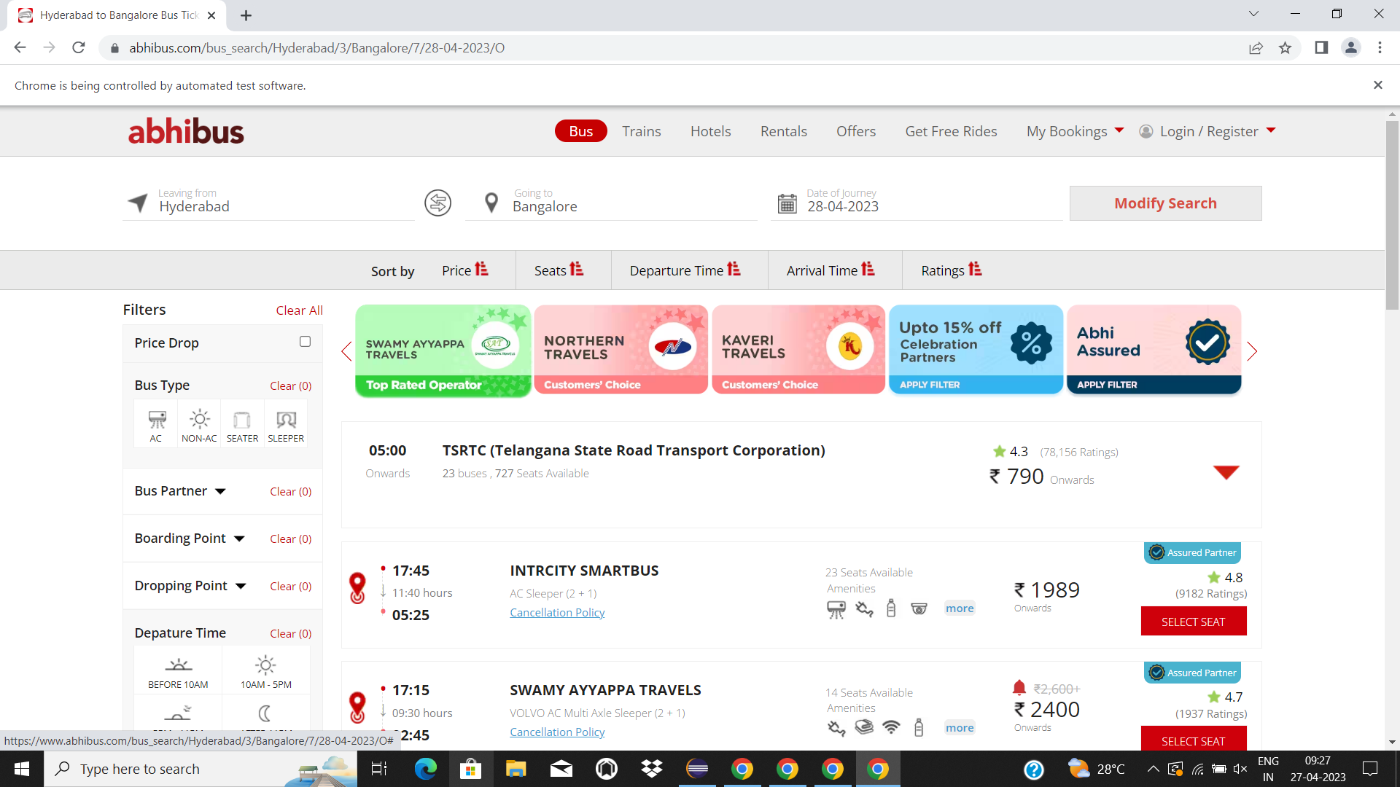

5)

package day5;

import java.awt.Window;

import org.openqa.selenium.By;

import org.openqa.selenium.Keys;

import org.openqa.selenium.WebDriver;

import org.openqa.selenium.WindowType;

import org.openqa.selenium.chrome.ChromeDriver;

import org.openqa.selenium.chrome.ChromeOptions;

import io.github.bonigarcia.wdm.WebDriverManager;

public class Task5 {

public static void main(String[] args) throws InterruptedException {

// TODO Auto-generated method stub

WebDriverManager.chromedriver().setup();

ChromeOptions co=new ChromeOptions();

co.addArguments("--remote-allow-origins=*");

WebDriver driver=new ChromeDriver();

driver.get("https://www.google.com");

driver.findElement(By.id("APjFqb")).sendKeys("Apple");

driver.findElement(By.id("APjFqb")).sendKeys(Keys.ENTER);

System.out.println(driver.getWindowHandle());

System.out.println(driver.getTitle());

driver.switchTo().newWindow(WindowType.TAB);

driver.get("https://www.google.com");

driver.findElement(By.id("APjFqb")).sendKeys("Selenium");

driver.findElement(By.id("APjFqb")).sendKeys(Keys.ENTER);

System.out.println(driver.getWindowHandle());

System.out.println(driver.getTitle());

driver.switchTo().newWindow(WindowType.TAB);

driver.get("https://www.google.com");

driver.findElement(By.id("APjFqb")).sendKeys("Cucumber");

driver.findElement(By.id("APjFqb")).sendKeys(Keys.ENTER);

System.out.println(driver.getWindowHandle());

System.out.println(driver.getTitle());

System.out.println(driver.getWindowHandles().size());

}

}

