1)

package day7;

import org.openqa.selenium.By;

import org.openqa.selenium.WebDriver;

import org.openqa.selenium.chrome.ChromeDriver;

import org.openqa.selenium.chrome.ChromeOptions;

import org.openqa.selenium.interactions.Actions;

import org.testng.Assert;

import org.testng.annotations.Test;

import io.github.bonigarcia.wdm.WebDriverManager;

public class Task1 {

@Test

public void test1() {

WebDriverManager.chromedriver().setup();

ChromeOptions co=new ChromeOptions();

co.addArguments("--remote-allow-origins=\*");

WebDriver driver=new ChromeDriver();

driver.navigate().to("https://demo.wpeverest.com/user-registration/guest-registration-form/");

driver.manage().window().maximize();

String title=driver.getTitle();

String t="Guest Registration Form – User Registration";

Assert.assertEquals(title, t);

}

}

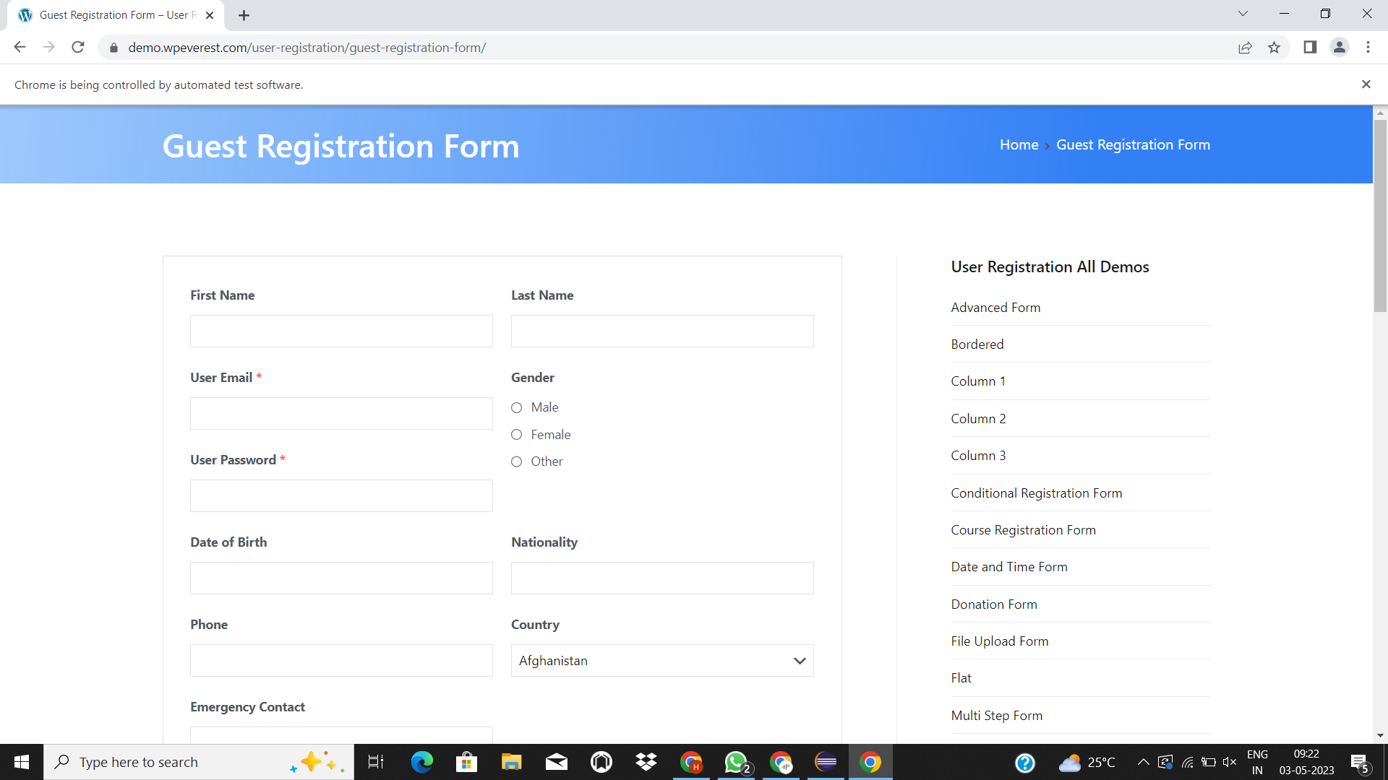

2)

package day7;

import org.testng.Assert;

import org.testng.annotations.BeforeMethod;

import org.testng.annotations.BeforeSuite;

import org.testng.annotations.BeforeTest;

import org.testng.annotations.Test;

import net.bytebuddy.build.Plugin.Factory.UsingReflection.Priority;

import java.util.\*;

public class Task2 {

int a,b,c;

@Test(priority = 1)

public void add() {

c=a+b;

Assert.assertEquals(c, (a+b));

}

@Test(priority = 4)

public void subract() {

c=a-b;

Assert.assertEquals(c, (a-b));

}

@Test(priority = 3)

public void multiply() {

c=a\*b;

Assert.assertEquals(c, (a\*b));

}

@Test(priority = 2)

public void divide() {

c=a/b;

Assert.assertEquals(c, (a/b));

}

@BeforeTest

public void beforeTest()

{

Scanner input=new Scanner(System.in);

a=input.nextInt();

b=input.nextInt();

input.close();

}

}

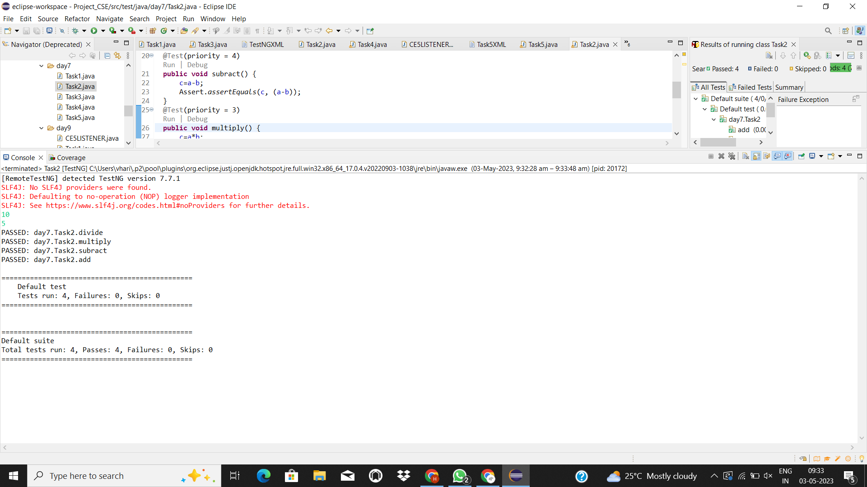

3)

package day7;

import org.openqa.selenium.By;

import org.openqa.selenium.WebDriver;

import org.openqa.selenium.WebElement;

import org.openqa.selenium.chrome.ChromeDriver;

import org.openqa.selenium.chrome.ChromeOptions;

import org.testng.Assert;

import org.testng.annotations.AfterMethod;

import org.testng.annotations.BeforeMethod;

import org.testng.annotations.Test;

import io.github.bonigarcia.wdm.WebDriverManager;

public class Task3 {

WebDriver driver;

@Test

public void method() throws InterruptedException {

Thread.sleep(3000);

driver.findElement(By.xpath("//\*[@id=\"app\"]/div[1]/div/div[1]/div/div[2]/div[2]/form/div[1]/div/div[2]/input")).sendKeys("Admin");

driver.findElement(By.name("password")).sendKeys("admin123");

driver.findElement(By.xpath("//\*[@id=\"app\"]/div[1]/div/div[1]/div/div[2]/div[2]/form/div[3]/button")).click();

Thread.sleep(2000);

Assert.assertEquals(driver.getCurrentUrl(), "https://opensource-demo.orangehrmlive.com/web/index.php/dashboard/index");

}

@BeforeMethod

public void beforeMethod()

{

WebDriverManager.chromedriver().setup();

ChromeOptions co=new ChromeOptions();

co.addArguments("--remote-allow-origins=\*");

driver=new ChromeDriver();

driver.navigate().to("https://opensource-demo.orangehrmlive.com/web/index.php/auth/login");

driver.manage().window().maximize();

}

@AfterMethod

public void afterMethod() throws InterruptedException

{

Thread.sleep(5000);

driver.close();

}

}

4)

package day7;

import org.openqa.selenium.By;

import org.openqa.selenium.WebDriver;

import org.openqa.selenium.WebElement;

import org.openqa.selenium.chrome.ChromeDriver;

import org.openqa.selenium.chrome.ChromeOptions;

import org.testng.Assert;

import org.testng.annotations.AfterMethod;

import org.testng.annotations.BeforeClass;

import org.testng.annotations.BeforeMethod;

import org.testng.annotations.BeforeTest;

import org.testng.annotations.Test;

import io.github.bonigarcia.wdm.WebDriverManager;

public class Task4 {

WebDriver driver;

@Test

public void signin() throws InterruptedException {

Thread.sleep(3000);

driver.findElement(By.xpath("//\*[@id=\"app\"]/div[1]/div/div[1]/div/div[2]/div[2]/form/div[1]/div/div[2]/input")).sendKeys("Admin");

driver.findElement(By.name("password")).sendKeys("admin123");

driver.findElement(By.xpath("//\*[@id=\"app\"]/div[1]/div/div[1]/div/div[2]/div[2]/form/div[3]/button")).click();

Thread.sleep(2000);

Assert.assertEquals(driver.getCurrentUrl(), "https://opensource-demo.orangehrmlive.com/web/index.php/dashboard/index");

}

@Test(dependsOnMethods = "signin")

public void signout() throws InterruptedException

{

Thread.sleep(2000);

driver.findElement(By.xpath("//\*[@id=\"app\"]/div[1]/div[1]/header/div[1]/div[2]/ul/li/span")).click();

Thread.sleep(2000);

driver.findElement(By.xpath("//\*[@id=\"app\"]/div[1]/div[1]/header/div[1]/div[2]/ul/li/ul/li[4]/a")).click();

}

@BeforeClass

public void beforeMethod()

{

WebDriverManager.chromedriver().setup();

ChromeOptions co=new ChromeOptions();

co.addArguments("--remote-allow-origins=\*");

driver=new ChromeDriver();

driver.navigate().to("https://opensource-demo.orangehrmlive.com/web/index.php/auth/login");

driver.manage().window().maximize();

}

}

5)

package day7;

import org.openqa.selenium.By;

import org.openqa.selenium.WebDriver;

import org.openqa.selenium.chrome.ChromeDriver;

import org.openqa.selenium.chrome.ChromeOptions;

import org.testng.Assert;

import org.testng.annotations.Test;

import io.github.bonigarcia.wdm.WebDriverManager;

public class Task5 {

@Test(groups = "smoketest")

public void test1() {

WebDriverManager.chromedriver().setup();

ChromeOptions co=new ChromeOptions();

co.addArguments("--remote-allow-origins=\*");

WebDriver driver=new ChromeDriver();

driver.navigate().to("https://godaddy.com/");

driver.manage().window().maximize();

Assert.assertEquals(driver.getTitle(), "Domain Names, Websites, Hosting & Online Marketing Tools - GoDaddy IN");

Assert.assertEquals(driver.getCurrentUrl(), "https://www.godaddy.com/en-in");

}

@Test(groups = "Regressiontest")

public void test2() throws InterruptedException

{

WebDriverManager.chromedriver().setup();

ChromeOptions co=new ChromeOptions();

co.addArguments("--remote-allow-origins=\*");

WebDriver driver=new ChromeDriver();

driver.navigate().to("https://godaddy.com/");

driver.manage().window().maximize();

Thread.sleep(15000);

driver.findElement(By.xpath("//\*[@id=\"id-631b049a-e9c0-4d24-8710-c504745206dd\"]/div[2]/div[1]/ul/li[1]/button")).click();

driver.findElement(By.xpath("//\*[@id=\"id-631b049a-e9c0-4d24-8710-c504745206dd\"]/div[2]/div[1]/ul/li[1]/div/div[2]/div[1]/ul/li[2]/a")).click();

}

@Test(groups = "Regressiontest")

public void test3() throws InterruptedException

{

WebDriverManager.chromedriver().setup();

ChromeOptions co=new ChromeOptions();

co.addArguments("--remote-allow-origins=\*");

WebDriver driver=new ChromeDriver();

driver.navigate().to("https://godaddy.com/");

driver.manage().window().maximize();

Thread.sleep(15000);

driver.findElement(By.xpath("//\*[@id=\"id-631b049a-e9c0-4d24-8710-c504745206dd\"]/div[2]/div[1]/ul/li[1]/button")).click();

driver.findElement(By.xpath("//\*[@id=\"id-631b049a-e9c0-4d24-8710-c504745206dd\"]/div[2]/div[1]/ul/li[1]/div/div[2]/div[1]/ul/li[2]/a")).click();

}

}