XYZ Company: Absenteeism Analysis Report

Prepared by: Vincent Holguin

# Executive Summary

XYZ has been experiencing significant absenteeism, affecting productivity. The analysis investigates various factors such as age, reasons for absences, and the impact of unjustified absences. The report concludes with recommendations to address these issues and improve productivity.

# Data Overview and Methodology

The data was connected and analyzed using Tableau Desktop. Various factors such as children, pets, BMI, smoker, drinker, day, season, education, and travel distance were analyzed but did not show significant variability (Example chart on Page 3).

# Key Findings

- Age Analysis: A spike in absenteeism at ages 28 and 38, notably influenced by specific employees.  
- Reason for Absences: Unjustified absences are high, indicating potential misuse.  
- Absenteeism by Hours: Certain employees with medical conditions contribute significantly to absenteeism, especially in March and July.

# Detailed Analysis

## Age Analysis

- A notable spike in absenteeism at ages 28 and 38.  
- Employee number 3 (age 38) and employee number 28 (age 28) have the highest incident counts. This creates a spike at those age values.  
- 28 is the age with the most employees, correlating with higher incidents seemingly by chance.

## Reason for Absences

- Highest reasons include generic doctor and dentist visits, followed by unjustified absences (Page 4).  
- Filtering top employees shows significant medical consultations, indicating possible accommodations for medical conditions.

## Unjustified Absences

- Employee 5 has the most unjustified absences.  
- Unjustified absences peak in July and October.  
- Employees 20, 22, and 11 have high unjustified absences.

## Absenteeism by Hours

- Employee 11 has the highest absenteeism in hours, with many unjustified absences.  
- Absenteeism spikes in March (Employee 9) and July (Employees 9 and 28) (Page 5). This is most likely a result of their medical conditions.

# Recommendations

- Investigate Employee 11's high unjustified absences and take necessary actions.  
- Address Employee 5's unjustified absences.  
- Touch base with Employee 7 regarding November absences.  
- Develop contingency plans for employees with medical conditions (3, 9, 28) during March and July. Possible action includes: shifting workload in Q2 to other team members, onboarding contractors or interns to handle workload for March to July.  
- Review and potentially revise the company's system for reporting and validating absences to prevent misuse.

# Conclusion

Addressing the issues outlined will help reduce absenteeism and improve overall productivity. Implementing the recommendations will ensure fair handling of absences and better accommodation for employees with medical conditions.

# Appendices

Visuals and Graphs

Incidents by season. Shows no significant findings alone, similar to other categories.

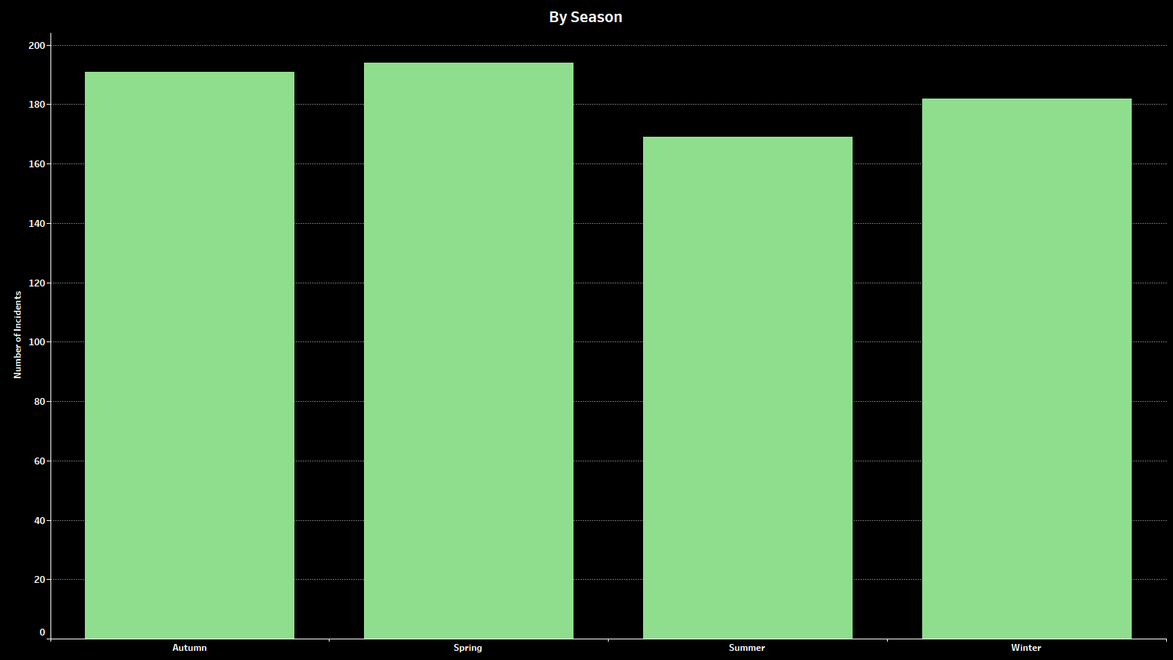

All incidents grouped by reason for absence.

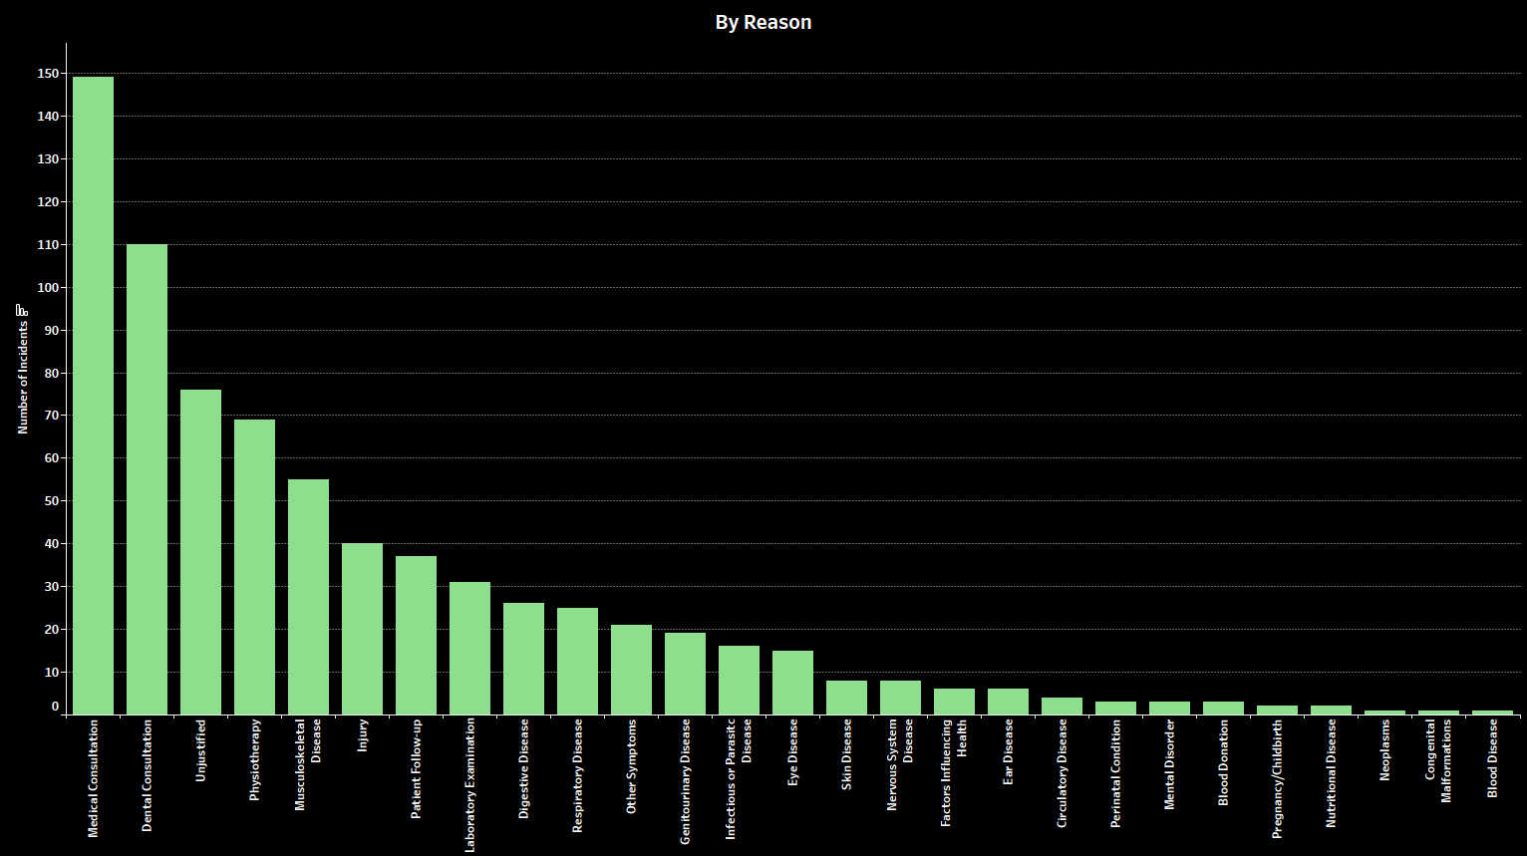

Filtered Results for Employee 9. Points towards health conditions flaring up in March and July.

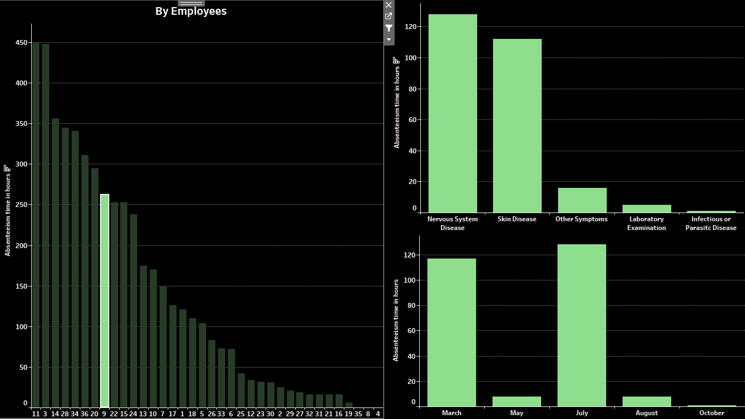

Categories based on incidents

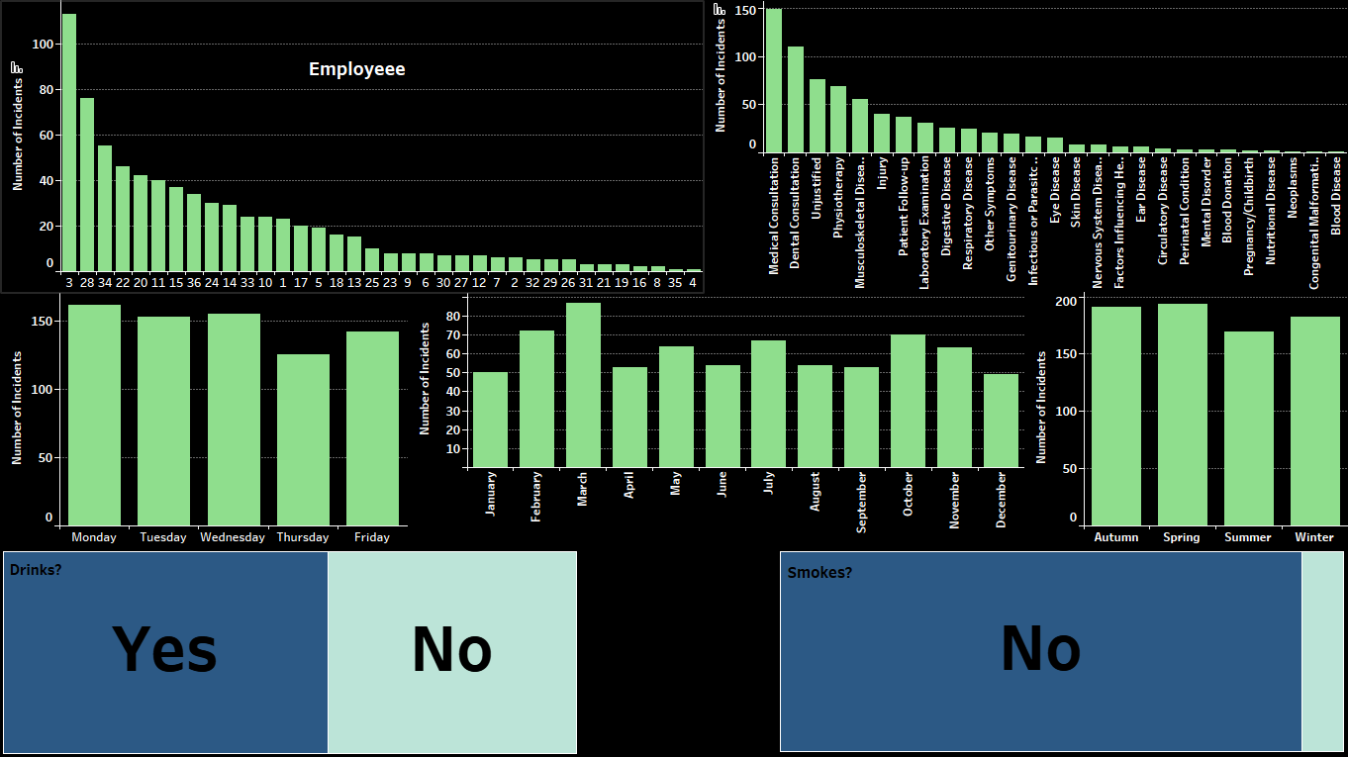

Categories based on hours

