InvoiceFlow: Intelligent Accounts-Payable Automation
Sample case study for Zensar Content Studio. The company, product and all figures in this document are fictional and exist only to demonstrate the features of the application.

Executive summary
InvoiceFlow automates accounts-payable invoice processing for a mid-size manufacturer. Uploaded PDF invoices are read, key fields are extracted and invoices under the approval threshold are approved automatically. In a six-month pilot, 86% of invoices were approved without manual work, the average processing time fell from 9 minutes to 42 seconds per invoice and late-payment penalties dropped by 71%.

Background and problem
Before the pilot the finance team keyed every invoice by hand. The main challenges were:
- Manual data entry caused errors in 6% of invoices.
- Invoices waited an average of 11 days for approval.
- Month-end closing needed three extra working days.
- The team had no single view of invoice status.

Solution overview
InvoiceFlow combines document understanding, business rules and ERP integration in one service. Finance staff only review exceptions, and every decision is recorded for audit.

Architecture
The platform has four core components and a review console. The Upload Service receives PDF invoices by e-mail or web upload. The Extraction Engine reads the vendor, invoice number, dates and amounts. The Rules Engine applies the approval threshold and vendor rules. The ERP Connector exports approved invoices to SAP S/4HANA. Invoices above the threshold go to the Review Console.
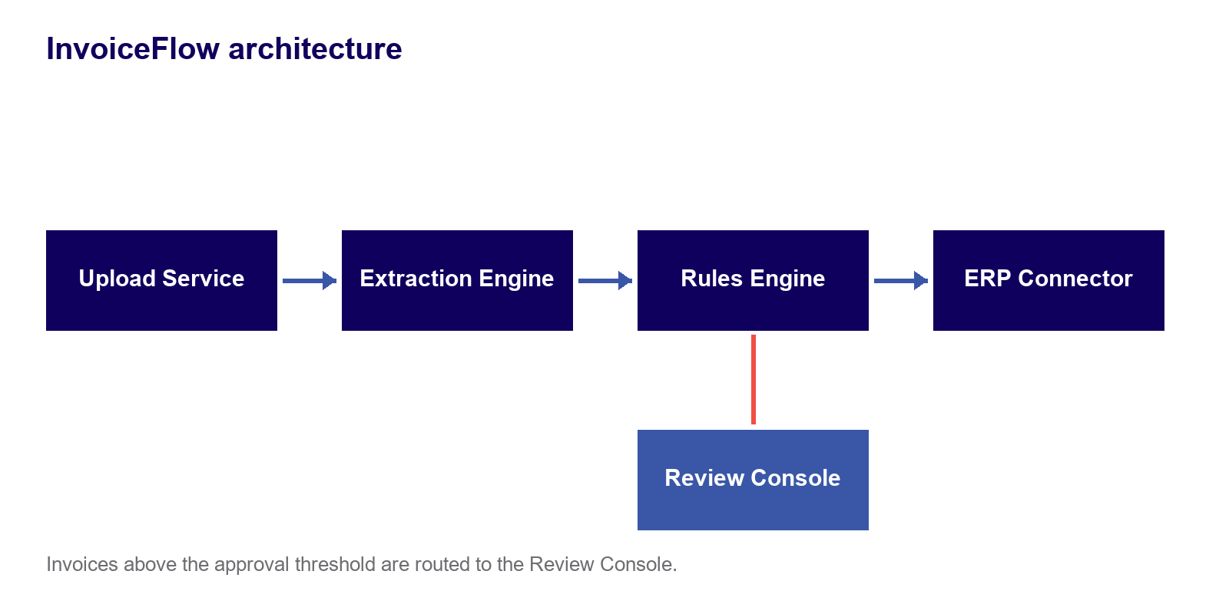
Figure 1: InvoiceFlow architecture

Workflow
Each invoice moves through the same pipeline:
- Receive: the Upload Service collects the PDF invoice from e-mail or the web portal.
- Extract: the Extraction Engine reads vendor, invoice number, dates and amount.
- Validate: the Rules Engine checks the amount against the approval threshold.
- Review: invoices above the threshold are routed to an analyst in the Review Console.
- Export: approved invoices are posted to SAP S/4HANA through the ERP Connector.

Technology stack
- Python services with FastAPI for the Upload and Rules services.
- A local document-understanding model for field extraction.
- PostgreSQL for invoice records and the audit trail.
- SAP S/4HANA integration through standard OData APIs.

Implementation timeline
- Phase 1 (January 2026): discovery and process mapping with the finance team.
- Phase 2 (February 2026): extraction model tuned on 2,000 historical invoices.
- Phase 3 (March 2026): rules engine and ERP connector built and tested.
- Phase 4 (April to June 2026): pilot with three business units and weekly reviews.

Results
The pilot met every target. 86% of invoices were approved automatically, processing time fell to 42 seconds per invoice, data-entry errors fell to 0.4% and month-end closing became 3 days faster.
Metric | Before | After
Processing time (minutes) | 9.0 | 0.7
Error rate (%) | 6.0 | 0.4
Approval wait (days) | 11 | 2
Auto-approved (%) | 0 | 86
Table 1: Pilot results before and after InvoiceFlow
Invoices processed per month during the pilot:
Month | Invoices
January | 820
February | 910
March | 1,040
April | 1,180
May | 1,260
June | 1,340
Table 2: Monthly invoice volume

Before and after
Compared with the manual process, InvoiceFlow changes how the team works. Before, analysts keyed every invoice and chased approvals by e-mail. After, analysts only handle exceptions, approvals are tracked in one console, and vendors are paid on time. Manual processing versus automated processing: 9 minutes versus 42 seconds per invoice.

Client perspective
"InvoiceFlow gave our finance team its time back. We now spend our days on vendor relationships instead of data entry." - Head of Finance Operations, pilot customer

Risks and mitigations
- Unusual invoice layouts: low-confidence fields are always sent for review.
- ERP downtime: approved invoices are queued and retried automatically.
- Change resistance: analysts were trained in two short workshops.

Recommendations and next steps
- Roll out to the remaining five business units in the next quarter.
- Add purchase-order matching to raise automatic approval above 90%.
- Publish a monthly dashboard of processing time and exceptions.

Conclusion
InvoiceFlow turned invoice processing from a manual bottleneck into a measured, largely automatic pipeline. The pilot results support a full rollout.

References
Pilot measurement log, January to June 2026 (fictional).

