**Fake News Detection Using NLP**

**312621104015: Kishore Kumar V**

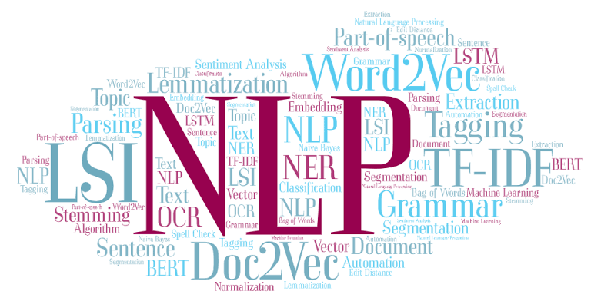

**Introduction:**

Developing a fake news detection system is a complex task that typically involves natural language processing (NLP) and machine learning techniques. Here are some key steps for the development of such a system:

**Data Collection:**

Gather a large and diverse dataset of news articles, including both real and fake news, labeled appropriately.

**Data Preprocessing**:

Clean and preprocess the text data by removing stop words, punctuation, and special characters.

Tokenize the text and convert it to a numerical format.

**Feature Engineering**:

Extract relevant features from the text, such as word frequencies, n-grams, and metadata like publication source or author.

**Model Selection**:

Choose appropriate machine learning or deep learning models for classification, such as logistic regression, decision trees, random forests, or neural networks.

**Training:**

Train the selected model on the labeled dataset, using a suitable evaluation metric like accuracy, precision, recall, or F1 score

.

**Cross-Validation:**

Implement cross-validation techniques to assess the model's performance and avoid overfitting.

**Model Evaluation**:

Evaluate the model on a separate test dataset to determine its accuracy in detecting fake news.

**Fine-Tuning**:

Optimize the model's hyperparameters for better performance.

**Deployment:**

Integrate the model into a web application, browser extension, or any platform where users can check the authenticity of news articles.

**Continuous Monitoring and Updates:**

Continuously update the model with new data to keep it relevant as fake news tactics evolve.

This is just the initial part of developing a fake news detection system. The subsequent parts may involve more advanced techniques, such as using deep learning models like LSTMs or Transformers, addressing issues like class imbalance, and implementing user-friendly interfaces for end-users. Let me know if you'd like to delve deeper into any of these steps or need more information on a specific aspect.

**Conclusion:**

Finally, we will summarize the results of our project and discuss

its implications. We will also provide recommendations for future work in this

area.

A good starting point for this project would be to explore the

various techniques used in natural language processing for fake news

detection. One such technique is sentiment analysis, which can help identify

the intention and biases of an author by analyzing the emotions displayed in a

news story or social media post ². Another technique is fact-checking, which

involves analyzing the content of a news piece against