**PROJECT**

**MARKET BASKET IN INSIGHTS**

**PHASE 2: INNOVATION**

**OBJECTIVE:**

To revolutionize market basket analysis and provide valuable insights for enhanced business strategies and customer satisfaction.

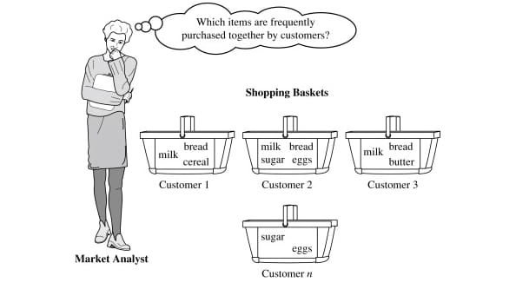

**INNOVATION:**

Innovations in market basket insights can revolutionize the way businesses analyze customer purchasing behavior. By leveraging advanced data analytics techniques, machine learning, and artificial intelligence, businesses can uncover deeper insights, identify hidden patterns, and make more accurate predictions. These innovations can lead to personalized recommendations, targeted promotions, and improved customer experiences. It's an exciting time for market basket insights!



**1. SOLUTION OVERVIEW:**

Our innovative solution, named "SmartBasket Insights," is designed to transform traditional market basket analysis. It utilizes advanced machine learning algorithms, real-time data processing, and intuitive visualization to uncover hidden patterns, optimize product placement, and elevate the overall shopping experience.

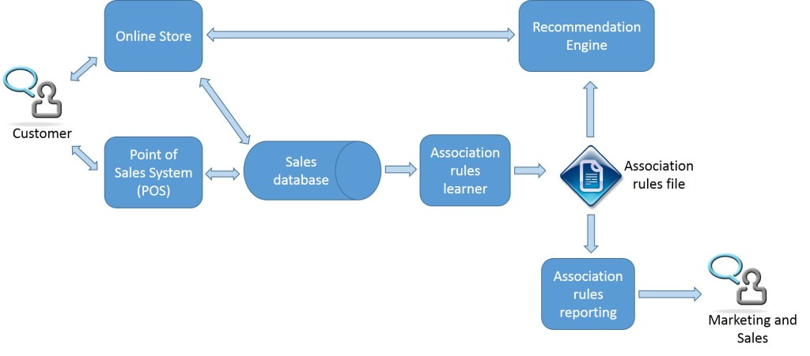

**2. KEY FEATURES:**

* Dynamic Recommendation Engine: Utilizing machine learning to provide personalized product recommendations in real-time based on customer preferences and historical data.
* Predictive Analytics: Forecasting future market trends and customer behavior to proactively adjust inventory, marketing strategies, and pricing.
* Real-time Dashboards: Interactive and visually appealing dashboards for instant insights, allowing businesses to make data-driven decisions on the fly.

**3. TECHNOLOGY STACK:**

Our solution leverages a powerful combination of the following technologies:

* Machine Learning: TensorFlow and Scikit-Learn for predictive analytics and recommendation algorithms.
* Real-time Data Processing: Apache Kafka for streaming data processing.
* Visualization: PowerBI for interactive dashboards and Tableau for in-depth data exploration.

**4. IMPLEMENTATION PLAN:**

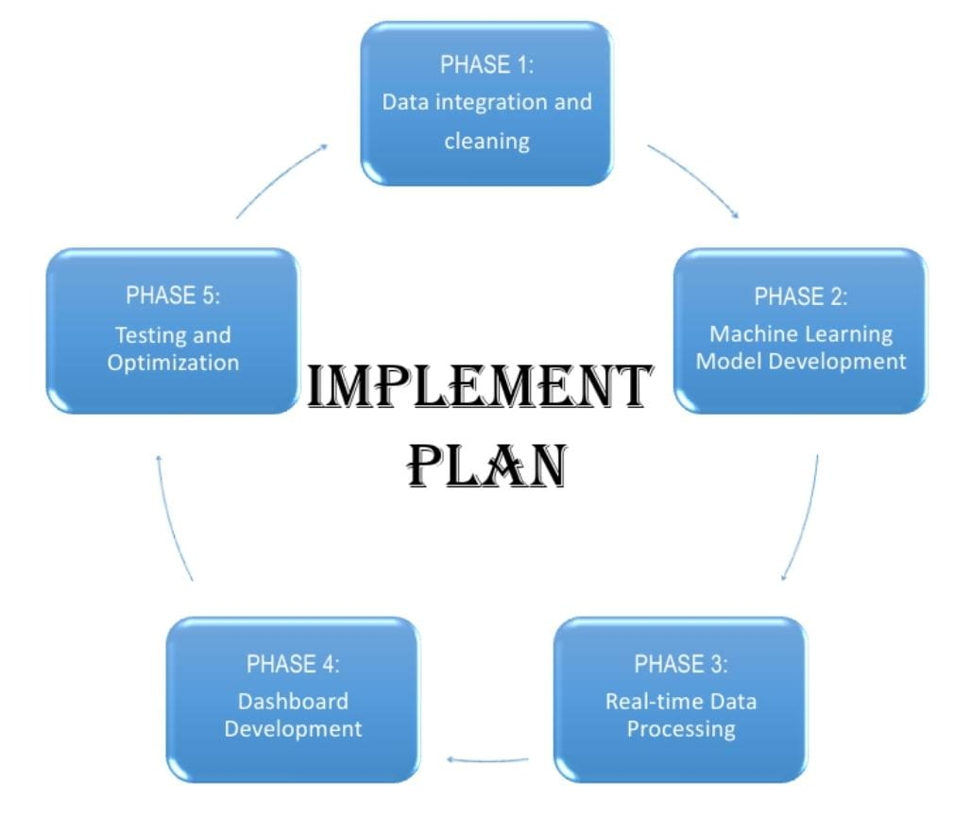

**PHASE 1**: Data Integration and Cleaning

* Integrate data sources, including POS systems and customer databases.
* Cleanse and preprocess data to ensure accuracy.

**PHASE 2:** Machine Learning Model Development

* Develop and train machine learning models for product recommendations and trend forecasting.
* Test models using historical data.

**PHASE 3**: Real-time Data Processing

* Implement real-time data processing using Apache Kafka for seamless data flow.
* Ensure low-latency processing for instant insights.

**PHASE 4**: Dashboard Development

* Create interactive dashboards for easy visualization of market basket insights.
* Integrate user-friendly features for customization.

**PHASE 5**: Testing and Optimization

* Conduct thorough testing to identify and resolve any issues.
* Optimize algorithms and dashboards based on user feedback.

**5. EXPECTED BENEFITS**:

* Enhanced Customer Experience: Personalized recommendations lead to increased customer satisfaction and loyalty.
* Improved Inventory Management: Anticipate demand and optimize inventory levels, reducing waste and costs.
* Strategic Decision-Making: Access to real-time insights empowers businesses to make informed decisions for increased profitability.

**6. EVALUATION AND ASSESSMENT:**

Key performance indicators (KPIs) will be established, including customer engagement, sales uplift, and inventory turnover. Regular assessments will ensure the solution aligns with business goals and adapts to evolving market dynamics.

**7. RISKS AND MITIGATION:**

Potential risks, such as data security and algorithm accuracy, will be closely monitored. Regular updates and security protocols will be implemented to mitigate any emerging risks.

**8. BUDGET AND RESOURCES:**

A detailed budget breakdown, along with resource requirements, is provided in the attached financial document. This includes costs for development, testing, deployment, and ongoing maintenance.

**9. TIMELINE**:

The project timeline is outlined in the attached Gantt chart, illustrating the phased approach for seamless execution. Timely delivery is a priority, and the schedule will be actively managed.

**10. CONCLUSION:**

"SmartBasket Insights" is poised to redefine market basket analysis, providing businesses with unprecedented insights and empowering them to stay ahead of the competition. We believe this solution will not only meet but exceed expectations, driving innovation and success in the retail sector.