**PROJECT**

**MARKET BASKET INSIGHTS**

**PHASE 4 : DEVELOPMENT PART 2**

**OVERVIEW**

This project is focused on market basket analysis. We will begin by lmporting and preprocessing the dataset.

**# IMPORT LIBRARIES**

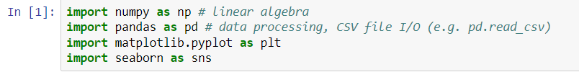

**#LOADING THE DATASET**

Let's start by loading the dataset into a DataFrame using pandas.



**#INITIALIZE EXPLORATION**

We'll perform an initial exploration of the dataset to understand its structure and characteristics.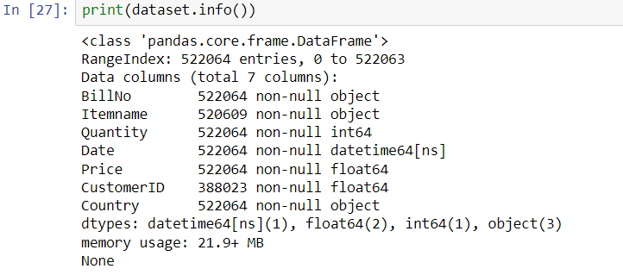

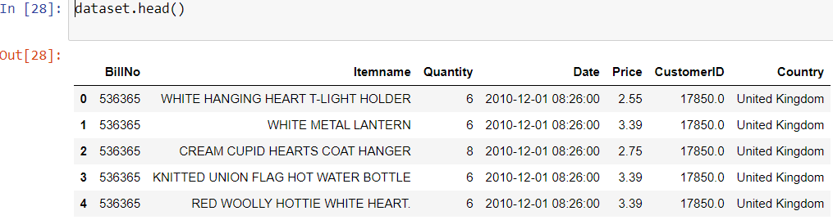

**#PREPROCESSING**

We'll preprocess the data to ensure it's ready for analysis.

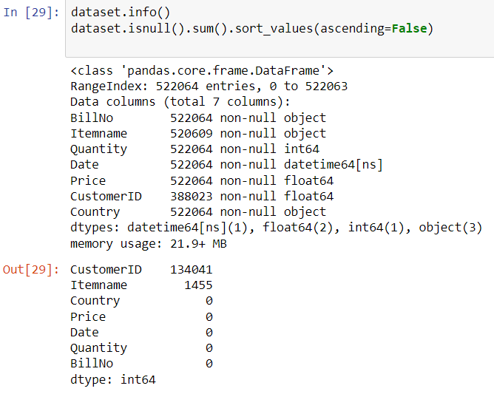

**#TYPE CONVERSION**

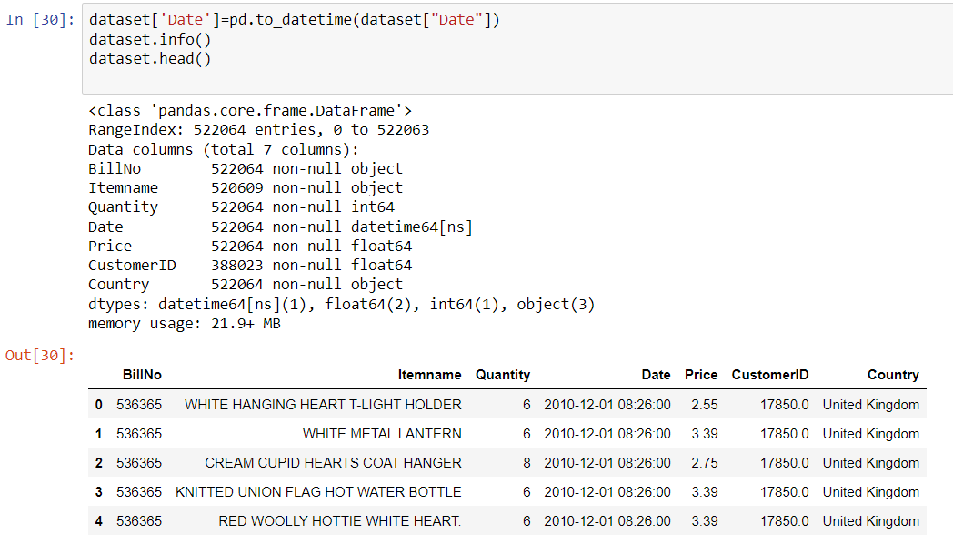



**#TRANSACTION**

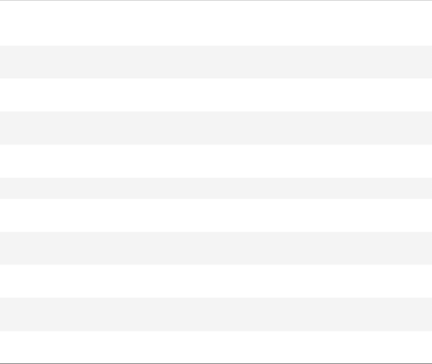

Transactions are fundamental to market basket analysis because the goal is to identify patterns and associations between items frequently bought together.



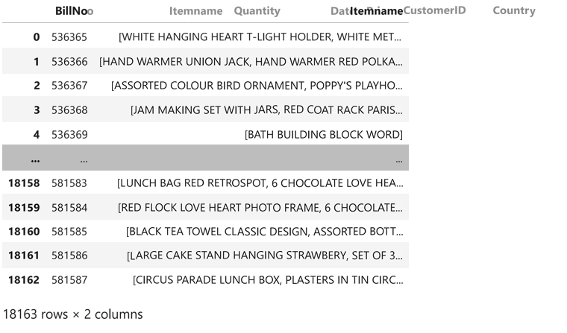

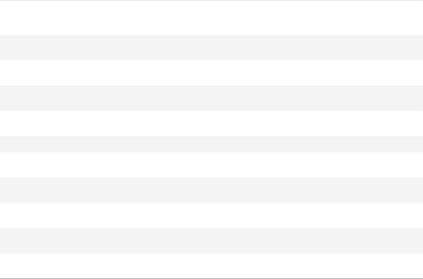

**#ASSOCIATION RULE MINING:**

Market basket analysis aims to discover associations or relationships between items in transactions.

Algorithms like Apriori or FP-growth are applied to identify frequent itemsets, which are sets of items that often appear together in transactions

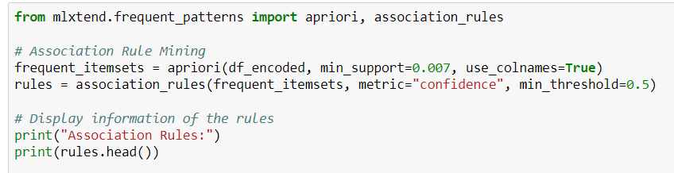

**#USING APRIORI ALGORITHM**

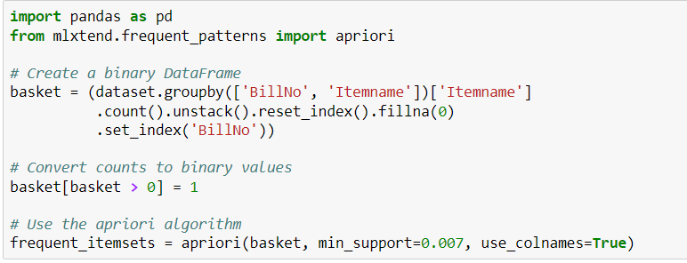

**#VISUALIZATION**

Visualization is powerful for conveying complex patterns and relationships in market basket analysis results. It enables stakeholders to quickly grasp insights and make informed decisions based on the discovered associations in transaction data.

