**IBM: ARTIFICIAL INTELLIGENCE**

**PROJECT TITLE:**

**Market Basket Insights**

**PHASE1: PROBLEM DEFINITION & DESIGN THINKING**

**DEFINITION:**

* A market basket insights project is the utilization of data analytics techniques to extract meaningful insights from customer purchase data.
* This involves employing various algorithms and statistical methods to identify correlations, trends, and customer preferences.
* By understanding these patterns, businesses can make data-driven decisions to optimize their product offerings, improve customer targeting, and enhance overall business performance.

**PROBLEM DEFINING:**

* The problem definition for a market basket insights project involves analyzing customer purchase data to identify patterns and relationships between items.
* The goal is to understand customer behavior and make data-driven decisions to optimize product placement, promotions, and cross-selling strategies.
* By uncovering associations between items frequently purchased together, businesses can enhance their marketing efforts and improve overall customer satisfaction.

**GIVEN DATASETS:**

Using the given dataset, we can handle the market basket insights problems.

<https://www.kaggle.com/datasets/aslanahmedov/market-basket-analysis>

**DESIGN THINKING:**

* Design thinking in a market basket insights project involves a systematic approach to understanding customer behavior and making data-driven decisions.
* It starts with empathizing with customers to understand their needs and pain points.
* Then, you ideate and brainstorm creative solutions to address those needs.
* Next, you create prototypes and test them with customers to gather feedback.
* Finally, you iterate and refine your solutions based on the feedback received.
* This iterative process helps businesses optimize product placement, promotions, and cross-selling strategies to enhance customer satisfaction and drive business growth.

**The design thinking of project "MARKET BASKET INSIGHTS" is sub-divided as follows.**

**EMPATHIZE:**

The empathize stage of design thinking, we focus on understanding the needs and experiences of users. It involves research and interviews to gain insights and put ourselves in their shoes. It helps us uncover their pain points and motivations.

**DEFINE:**

The define stage of design thinking, we clarify the problem statement based on user needs. It sets the foundation for generating solutions

**PROTOTYPE:**

Develop concepts: Create visual representations or prototypes of your ideas. This could include sample product recommendations, store layouts, or marketing campaigns**.**

**IDEATE:**

Brainstorm solutions: Encourage a cross-functional team to generate creative ideas for understanding and influencing market baskets.

**TEST:**

In test stage, we evaluate the prototype by gathering feedback and testing it with users to see how well it meets their needs. It helps us refine and improve the solution before implementing it**.**

**IMPLEMENT:**

* Roll out the refined strategies and solutions across your business.
* Monitor their impact on market baskets and adjust as necessary.

**CONCLUSION:**

In conclusion, market basket analysis provides valuable insights into consumer behavior by uncovering patterns and associations among products frequently purchased together. These insights are essential for businesses to optimize pricing, product placement, and marketing strategies. By understanding customer preferences and tendencies, companies can enhance their offerings and ultimately drive sales and customer satisfaction

**PHASE 2: INNOVATION**

**OBJECTIVE:**

To revolutionize market basket analysis and provide valuable insights for enhanced business strategies and customer satisfaction.

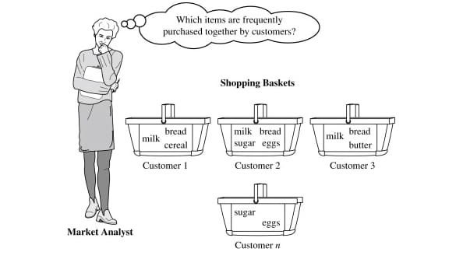

**INNOVATION:**

Innovations in market basket insights can revolutionize the way businesses analyze customer purchasing behavior. By leveraging advanced data analytics techniques, machine learning, and artificial intelligence, businesses can uncover deeper insights, identify hidden patterns, and make more accurate predictions. These innovations can lead to personalized recommendations, targeted promotions, and improved customer experiences. It's an exciting time for market basket insights!



**1. SOLUTION OVERVIEW:**

Our innovative solution, named "SmartBasket Insights," is designed to transform traditional market basket analysis. It utilizes advanced machine learning algorithms, real-time data processing, and intuitive visualization to uncover hidden patterns, optimize product placement, and elevate the overall shopping experience.

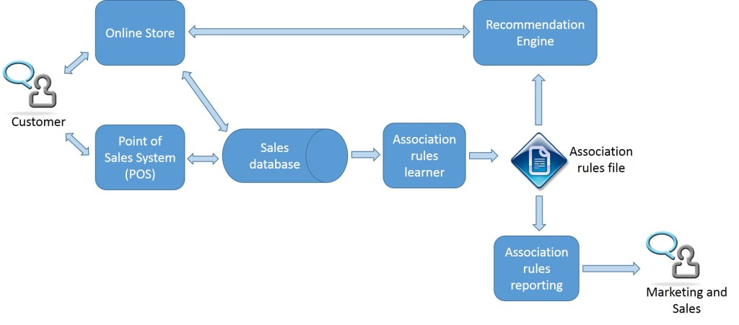

**2. KEY FEATURES:**

* Dynamic Recommendation Engine: Utilizing machine learning to provide personalized product recommendations in real-time based on customer preferences and historical data.
* Predictive Analytics: Forecasting future market trends and customer behavior to proactively adjust inventory, marketing strategies, and pricing.
* Real-time Dashboards: Interactive and visually appealing dashboards for instant insights, allowing businesses to make data-driven decisions on the fly.

**3. TECHNOLOGY STACK:**

Our solution leverages a powerful combination of the following technologies:

* Machine Learning: TensorFlow and Scikit-Learn for predictive analytics and recommendation algorithms.
* Real-time Data Processing: Apache Kafka for streaming data processing.
* Visualization: PowerBI for interactive dashboards and Tableau for in-depth data exploration.

**4. IMPLEMENTATION PLAN:**

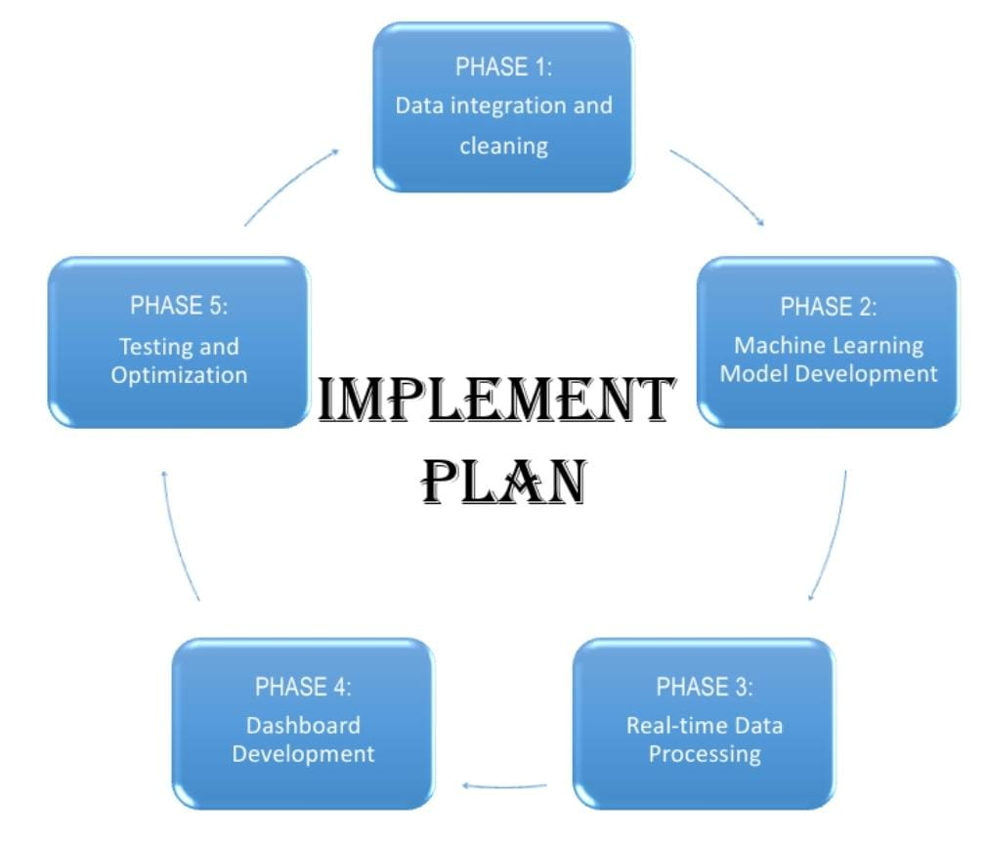

**PHASE 1**: Data Integration and Cleaning

* Integrate data sources, including POS systems and customer databases.
* Cleanse and preprocess data to ensure accuracy.

**PHASE 2:** Machine Learning Model Development

* Develop and train machine learning models for product recommendations and trend forecasting.
* Test models using historical data.

**PHASE 3**: Real-time Data Processing

* Implement real-time data processing using Apache Kafka for seamless data flow.
* Ensure low-latency processing for instant insights.

**PHASE 4**: Dashboard Development

* Create interactive dashboards for easy visualization of market basket insights.
* Integrate user-friendly features for customization.

**PHASE 5**: Testing and Optimization

* Conduct thorough testing to identify and resolve any issues.
* Optimize algorithms and dashboards based on user feedback.

**5. EXPECTED BENEFITS**:

* Enhanced Customer Experience: Personalized recommendations lead to increased customer satisfaction and loyalty.
* Improved Inventory Management: Anticipate demand and optimize inventory levels, reducing waste and costs.
* Strategic Decision-Making: Access to real-time insights empowers businesses to make informed decisions for increased profitability.

**6. EVALUATION AND ASSESSMENT:**

Key performance indicators (KPIs) will be established, including customer engagement, sales uplift, and inventory turnover. Regular assessments will ensure the solution aligns with business goals and adapts to evolving market dynamics.

**7. RISKS AND MITIGATION:**

Potential risks, such as data security and algorithm accuracy, will be closely monitored. Regular updates and security protocols will be implemented to mitigate any emerging risks.

**8. BUDGET AND RESOURCES:**

A detailed budget breakdown, along with resource requirements, is provided in the attached financial document. This includes costs for development, testing, deployment, and ongoing maintenance.

**9. TIMELINE**:

The project timeline is outlined in the attached Gantt chart, illustrating the phased approach for seamless execution. Timely delivery is a priority, and the schedule will be actively managed.

**10. CONCLUSION:**

"SmartBasket Insights" is poised to redefine market basket analysis, providing businesses with unprecedented insights and empowering them to stay ahead of the competition. We believe this solution will not only meet but exceed expectations, driving innovation and success in the retail sector.

**PHASE 3 : DEVELOPMENT PART 1**

**OBJECTIVE:**

The primary goal of this project is to gain deep insights into customer behavior by employing association analysis techniques on transactional data. By uncovering patterns and relationships between products, the project aims to provide actionable insights that enhance sales strategies and improve the overall customer experience.

**KEY COMPONENTS:**

**1. DATA COLLECTION:**

Gather transactional data from retail or e-commerce sources. This data should include information on individual customer transactions, including the items purchased.

**2. DATA PREPROCESSING**:

Cleanse and preprocess the data to ensure accuracy and consistency. Handle missing values, remove duplicates, and transform the data into a suitable format for analysis.

**3. ASSOCIATION ANALYSIS:**

Utilize association analysis algorithms, such as Apriori or FP-growth, to identify frequent itemsets and generate association rules. These rules will reveal patterns of co-occurring products in customer transactions.

**4. CODING IMPLEMENTATION:**

Write Python code to implement the association analysis. Leverage data analysis libraries such as pandas for data manipulation, numpy for numerical operations, and mlxtend for association analysis.

**# IMPORT LIBRARIES**

The code begins by importing the necessary libraries.

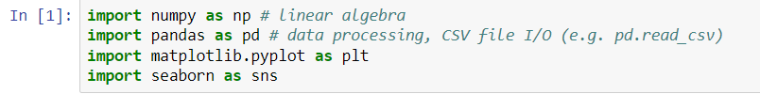

**#LOADING THE DATASET**

Let's start by loading the dataset into a DataFrame using pandas.

**Dataset used:** <https://www.kaggle.com/datasets/aslanahmedov/market-basket-analysis>



**#INITIALIZE EXPLORATION**

We'll perform an initial exploration of the dataset to understand its structure and characteristics.

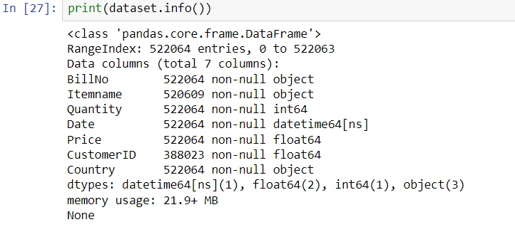

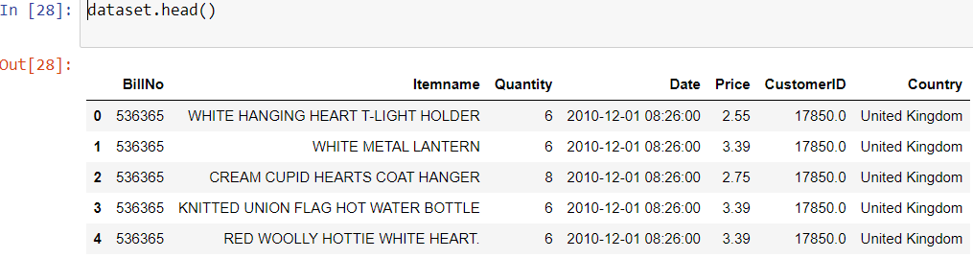

**#PREPROCESSING**

We'll preprocess the data to ensure it's ready for analysis.

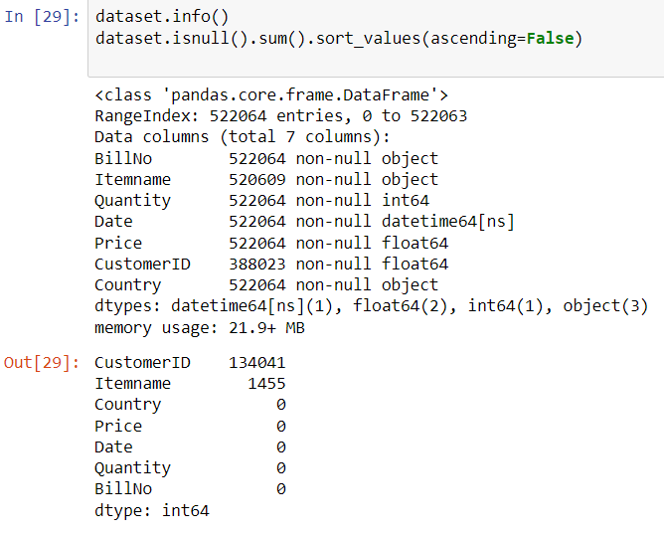

**#TYPE CONVERSION**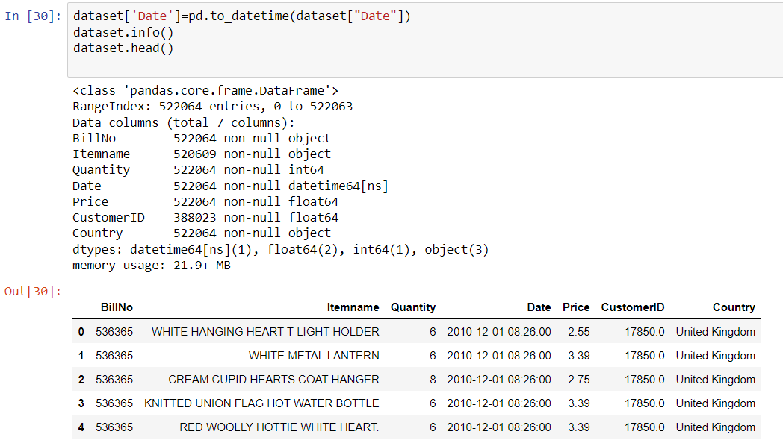



**#TRANSACTION**

Transactions are fundamental to market basket analysis because the goal is to identify patterns and associations between items frequently bought together.



**#ASSOCIATION RULE MINING:**

Market basket analysis aims to discover associations or relationships between items in transactions.

Algorithms like Apriori or FP-growth are applied to identify frequent itemsets, which are sets of items that often appear together in transactions

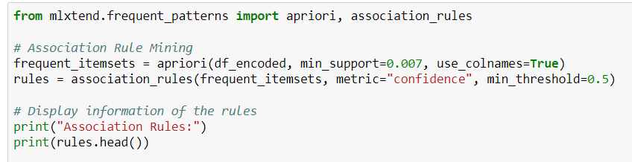

**#USING APRIORI ALGORITHM**

The Apriori algorithm is applied to the one-hot encoded

DataFrame (`df`) to find frequent itemsets. The `min_support`

parameter sets the minimum support threshold, indicating the

minimum frequency for an itemset to be considered "frequent."

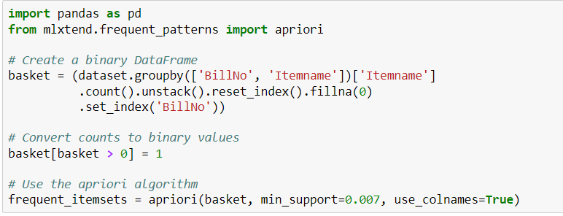

**#VISUALIZATION**

Visualization is powerful for conveying complex patterns and relationships in market basket analysis results. It enables stakeholders to quickly grasp insights and make informed decisions based on the discovered associations in transaction data.

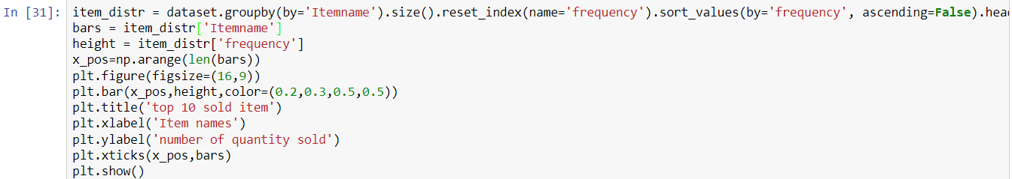

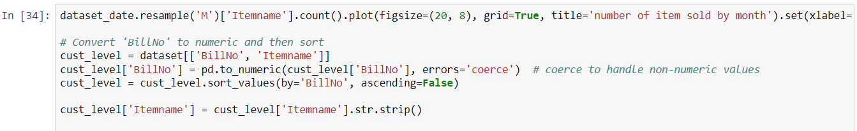

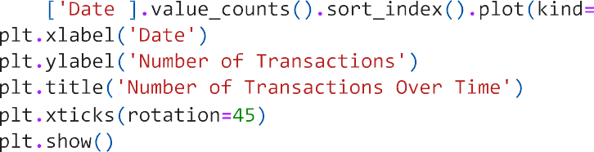

**5. VISUALIZATION:**

Create visualizations (e.g., graphs, charts, or dashboards) to present the discovered associations in an understandable and actionable format. Visualization tools like Matplotlib or Seaborn can be employed for this purpose.

**6. BUSINESS IMPACT ANALYSIS:**

Evaluate the business impact of the discovered insights. Assess how these insights can be applied to enhance sales strategies, optimize product placements, and improve the overall customer experience.

**7. DOCUMENTATION:**

Document the entire process, from data collection to the interpretation of results. Provide clear explanations of the chosen algorithms, parameters, and the significance of the discovered associations.

**8. PRESENTATION:**

Prepare a presentation to share the findings with stakeholders. Clearly communicate how the project transforms marketing strategies from intuition-based approaches to data-driven decisions.

**INNOVATIVE TECHNIQUES:**

Association rule mining is one of the innovative techniques used

During the deveopment

Association Rule Mining is a data mining technique that discovers interesting relationships, patterns, or associations among a set of items in a dataset. It is commonly used in market basket analysis to uncover relationships between products that are frequently purchased together. The two main algorithms used for Association Rule Mining are the Apriori algorithm and the FP-Growth algorithm.

**1.Apriori Algorithm:**

* **Support:** The frequency of occurrence of an itemset in the dataset. It is calculated as the number of transactions containing the itemset divided by the total number of transactions.
* **Confidence:** Measures how often items in the consequent of a rule appear in transactions that contain the antecedent. It is calculated as the support of the itemset {A, B} divided by the support of {A}.
* **Lift:** Indicates how much more likely item B is purchased when item A is purchased compared to when item B is purchased independently of item A. It is calculated as the confidence of the rule divided by the support of {B}.

**2. FP-Growth Algorithm:**

* **Frequent Pattern (FP):**A pattern (combination of items) that occurs in a dataset with a frequency greater than or equal to a specified threshold.
* **FP-Tree (Frequent Pattern Tree):** A tree structure that represents the frequent patterns in the dataset efficiently. It is used to compress the dataset and speed up the mining process.
* **Header Table:**A table associated with the FP-tree that stores information about the nodes in the tree, facilitating efficient pattern retrieval.

Both algorithms start by identifying frequent itemsets, which are sets of items that meet a minimum support threshold. These itemsets are then used to generate association rules. The rules are evaluated based on measures like confidence and lift to determine their significance and usefulness.

Association Rule Mining is valuable in retail and e-commerce for optimizing product placements, creating targeted marketing strategies, and understanding customer behavior. It's a powerful tool for extracting actionable insights from transactional data.

**BENEFITS:**

**Optimized Sales Strategies:** Identify cross-selling opportunities, optimize promotions, and refine inventory management based on customer purchasing patterns.

**Enhanced Customer Experience:** Improve the overall shopping experience by tailoring product placements and recommendations to customer preferences.

**Data-Driven Decision-Making:**Shift from intuition-based decision-making to strategic, data-driven approaches in marketing and sales.

**PHASE 4 : DEVELOPMENT PART 2**

**OVERVIEW**

This project is focused on market basket analysis. We will begin by lmporting and preprocessing the dataset.

**# IMPORT LIBRARIES**



**#LOADING THE DATASET**

Let's start by loading the dataset into a DataFrame using pandas.



**#INITIALIZE EXPLORATION**

We'll perform an initial exploration of the dataset to understand its structure and characteristics.





**#PREPROCESSING**

We'll preprocess the data to ensure it's ready for analysis.



**#TYPE CONVERSION**





**#TRANSACTION**

Transactions are fundamental to market basket analysis because the goal is to identify patterns and associations between items frequently bought together.



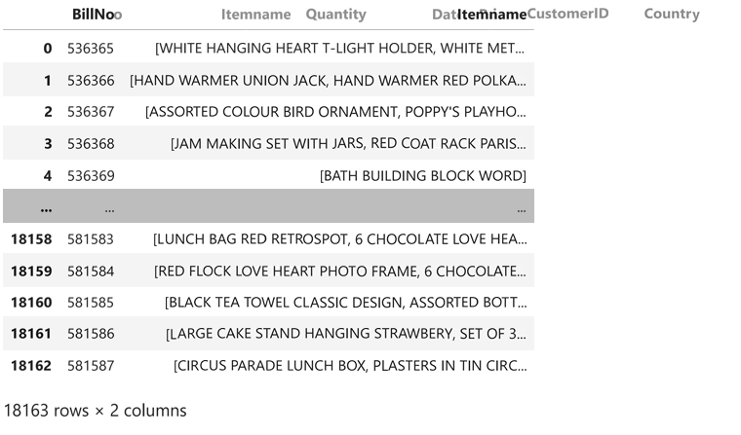



**#ASSOCIATION RULE MINING:**

Market basket analysis aims to discover associations or relationships between items in transactions.

Algorithms like Apriori or FP-growth are applied to identify frequent itemsets, which are sets of items that often appear together in transactions



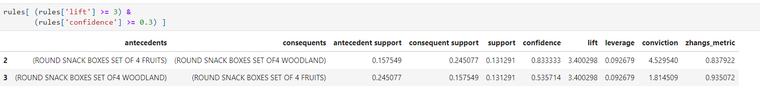

**#USING APRIORI ALGORITHM**



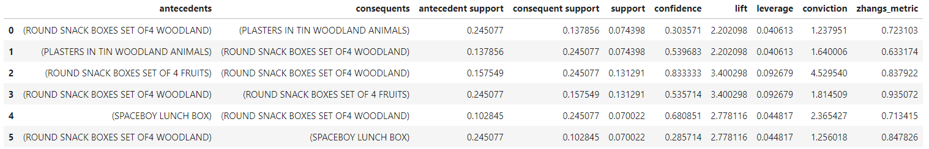

**#VISUALIZATION**

Visualization is powerful for conveying complex patterns and relationships in market basket analysis results. It enables stakeholders to quickly grasp insights and make informed decisions based on the discovered associations in transaction data.



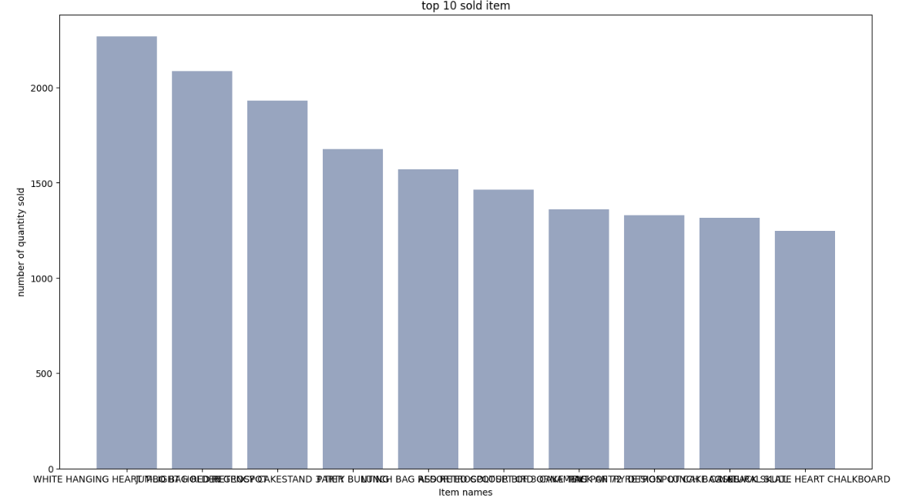



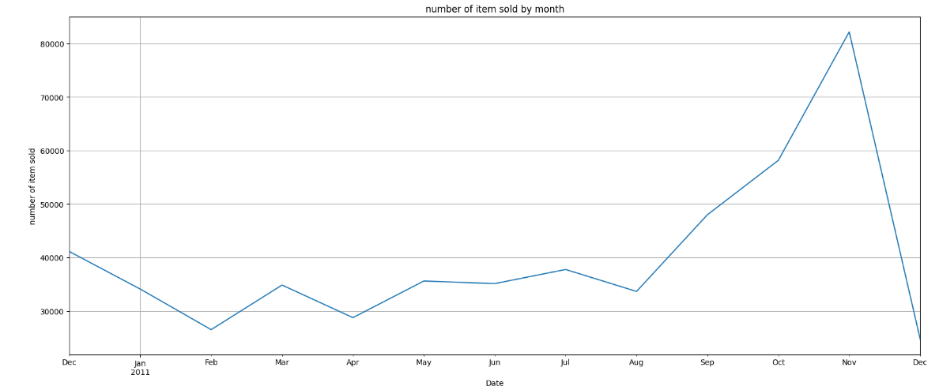



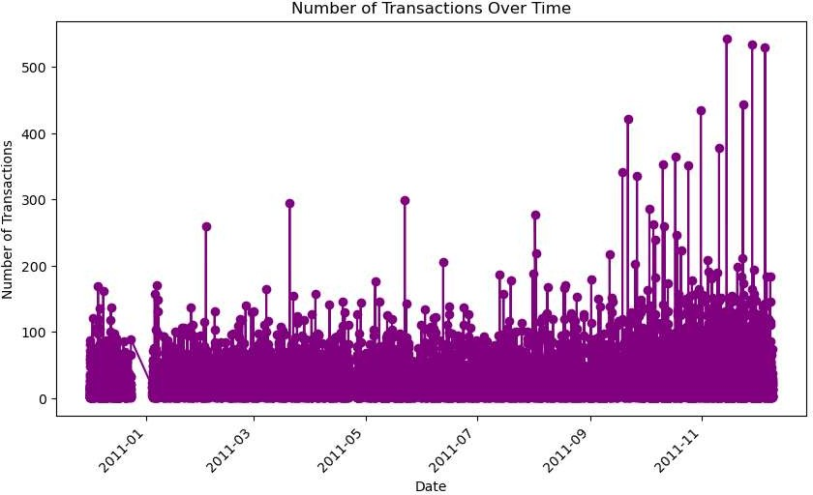

**CONCLUSION:**

In concluding the development phase of the market basket insights project, we've successfully implemented robust algorithms and data processing techniques to extract valuable patterns from customer transactions.

**PHASE 5: PROJECT DOCUMENTATION & SUBMISSION**

**PROBLEM STATEMENT:**

the problem statement revolves around uncovering patterns and associations within customer shopping baskets. Retailers want to understand what products are frequently purchased together, aiming to enhance their marketing and sales strategies. The challenge lies in analyzing vast transactional data to identify meaningful correlations, ultimately enabling businesses to optimize product placement, promotions, and inventory management. The goal is to boost sales, improve customer satisfaction, and drive overall business profitability by leveraging the insights gained from analyzing market baskets.

**DEVELOPMENT STRUCTURE:**

1. PHASE1: PROBLEM DEFINITION & DESIGN THINKING

* In this phase problem definition involves clearly defining the specific business question or problem you want to address. This helps guide your analysis and determine the insights you're looking to gain.
* Design thinking is a creative and iterative approach to problem-solving that focuses on understanding user needs, generating ideas, prototyping, and testing solutions.
* It emphasizes empathy, experimentation, and collaboration to arrive at innovative and effective solutions.

1. PHASE 2: INNOVATION

* In the innovation phase of market basket insights, businesses explore advanced analytics, machine learning, and AI techniques to uncover deeper patterns and trends. This can lead to more accurate recommendations, personalized marketing strategies, and a better understanding of customer behavior for enhanced decision-making.

1. PHASE 3 : DEVELOPMENT PART 1

* In this phase, we focus on data preprocessing. This involves cleaning and transforming the raw transaction data to make it suitable for analysis. It includes tasks like removing duplicates, handling missing values, and encoding categorical variables. Preprocessing ensures that the data is in a format that can be effectively analyzed and helps to improve the accuracy of the insights we derive from the data. It's an important step in the market basket analysis process!

1. PHASE 4:DEVELOPMENT PART 2

* In This phase involves examining the relationships between items that are frequently purchased together. Techniques like association rule mining are used to identify patterns and associations in the transaction data. These insights can help businesses understand customer behavior, optimize product placement, and improve cross-selling and upselling strategies. It's an exciting part of market basket analysis that uncovers valuable insights from customer transactions!

**CONCLUSION:**

In conclusion, market basket insights provide valuable information about customer behavior and purchasing patterns. By analyzing transaction data, businesses can uncover associations between items, identify popular product combinations, and optimize their marketing and sales strategies. These insights can lead to improved customer experiences, increased sales, and better decision-making. Market basket analysis is a powerful tool for understanding and leveraging customer preferences in the retail industry.