Network

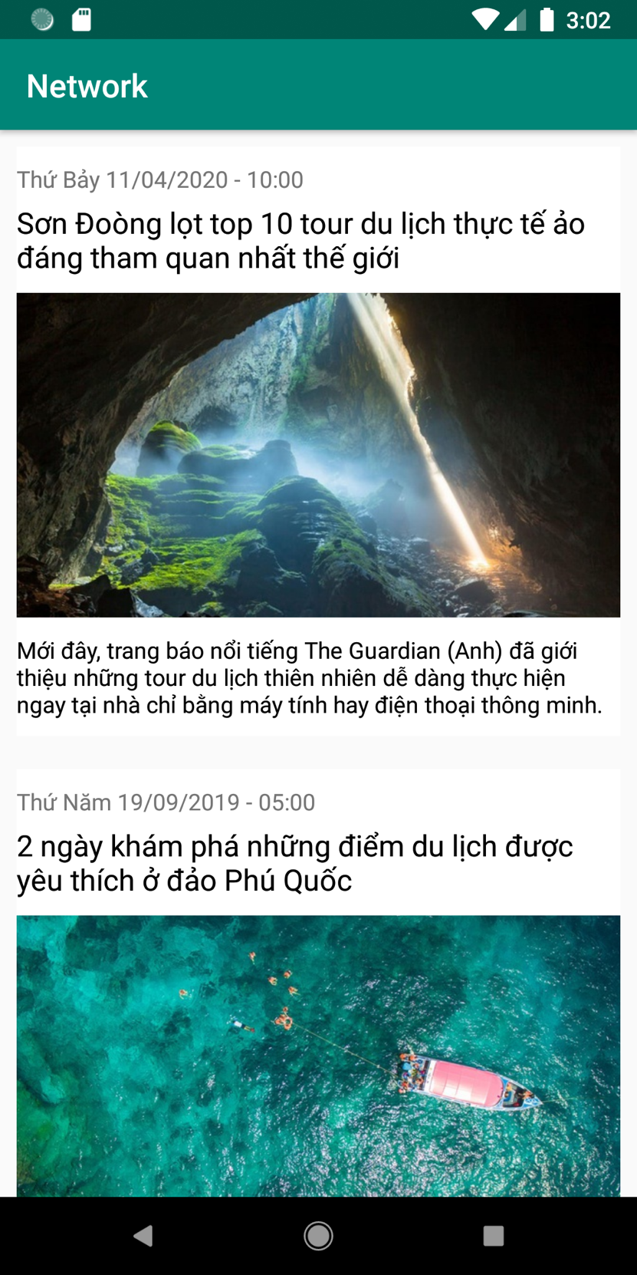

Project Structure:

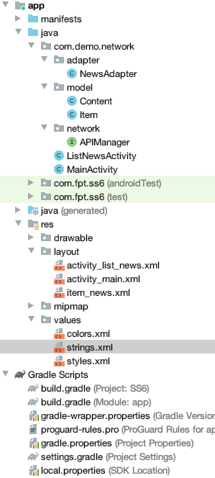

Add library retrofit, glide, recyclerview, gson to file build.gradle:

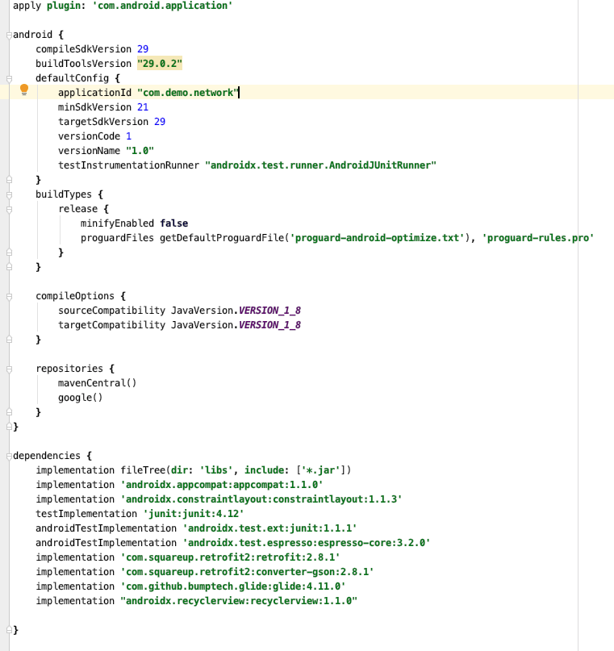

File manifest.xml:

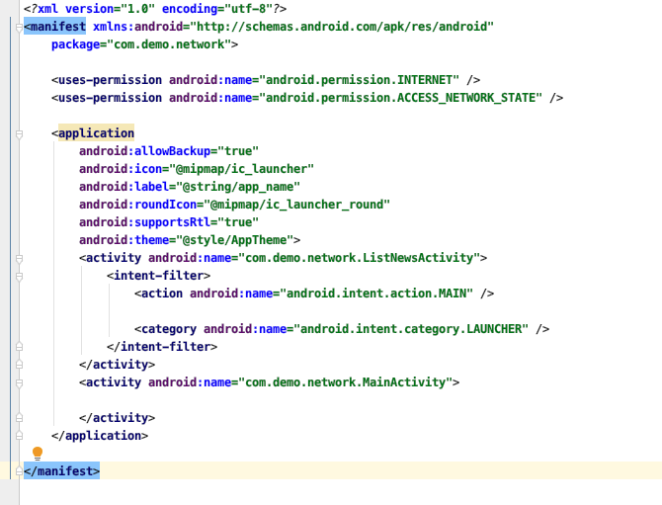

File Content.java:
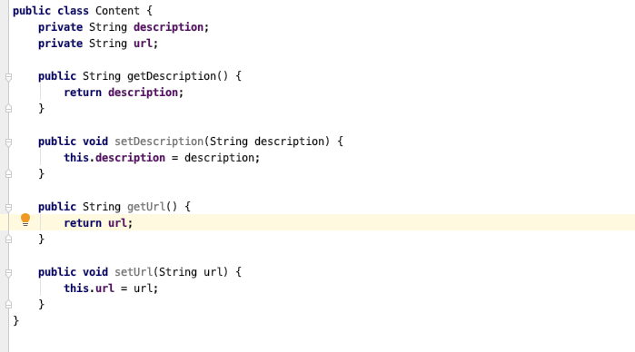

File Item.java:
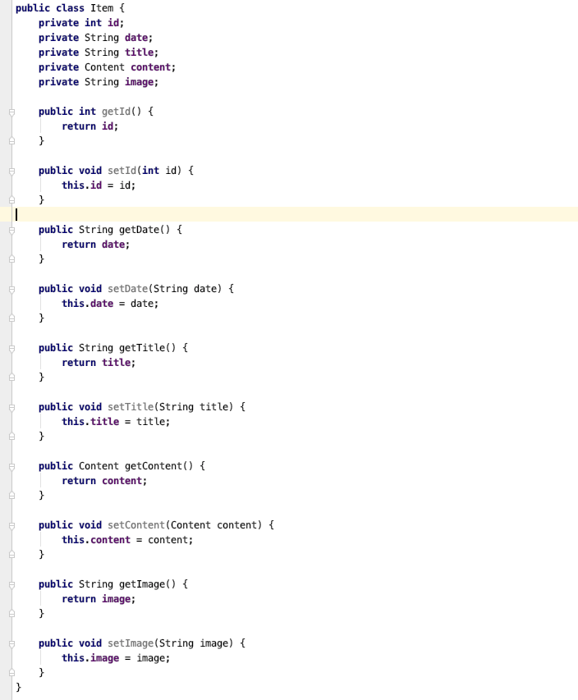

File APIManager.java
- Dùng https://newsapi.org
- @GET(“/v2/top-headlines?sources=bbc-news&apiKey=d3a2a12e0f4942c9a6959efa6643f1fc”)

File Layout item_news.xml

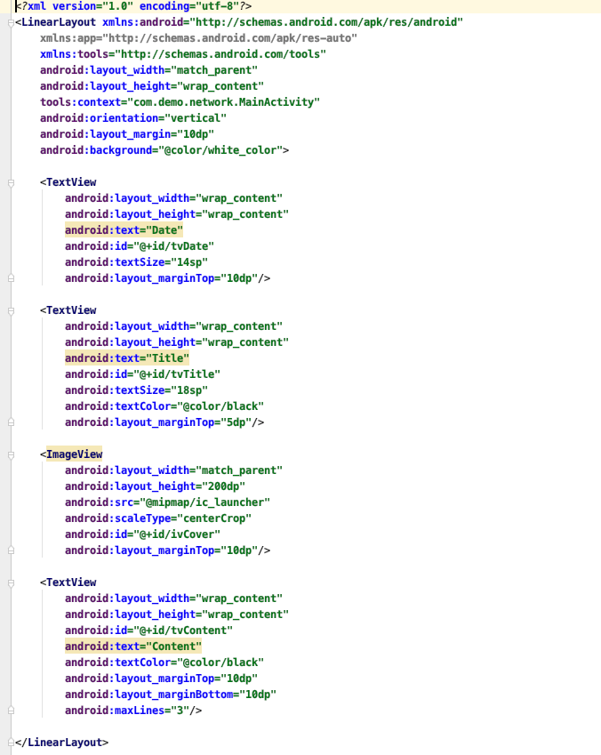

File layout activity_list_news.xml
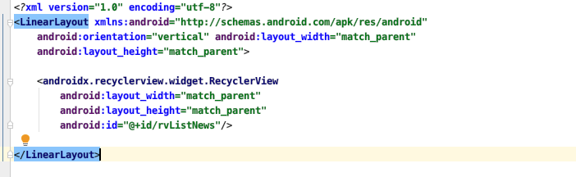

File NewsAdapter.java

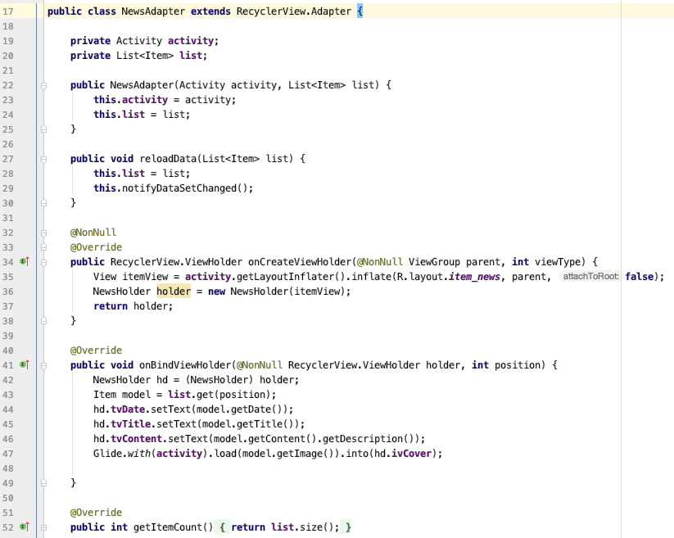
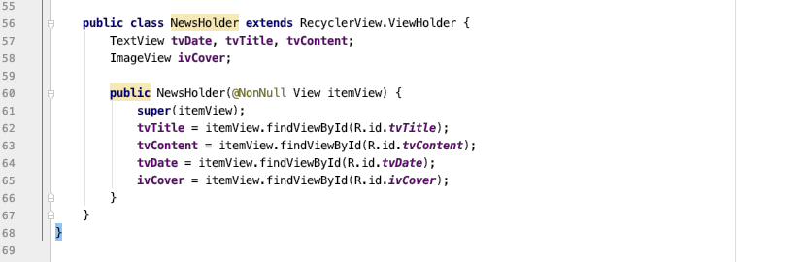

File ListNewsActivity.java

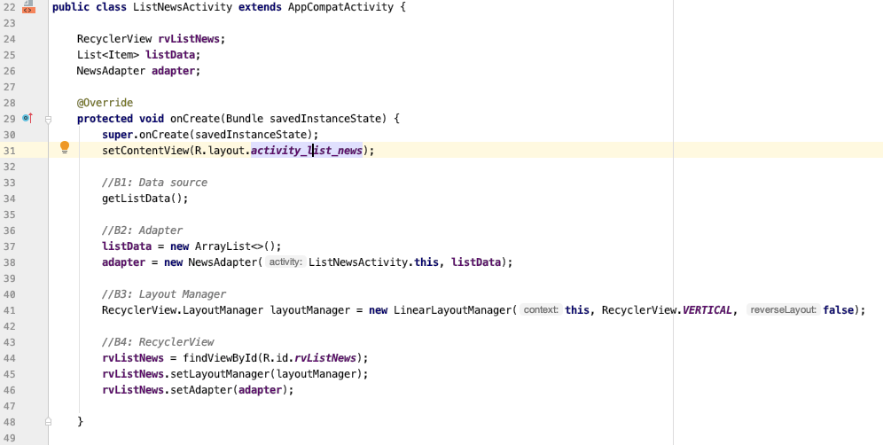
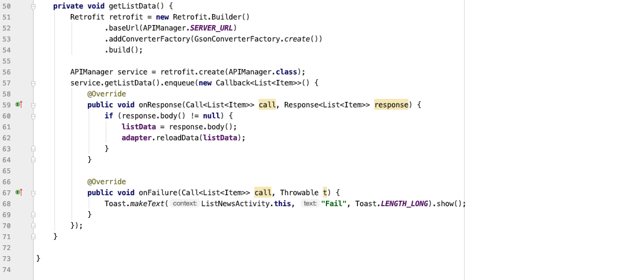

Run Project

