Final Project Report

OpenSpace and Climate Reanalyzer Interface

Team Violet:
Brianna Gannett, Brennon Tiensivu, Hunter Savarese, Matthew Keast, Emily Scott

Clients:
Dr. Sean Birkel, Mr. Shawn Laatsch, Mr. Micah Acinapura, Dr. Carter Emmart

Version Control

Version | Date Finalized
1.0 | 05-06-26

Executive Summary
Climate data is increasingly abundant, but misconceptions and gaps in public understanding about modern climate patterns and weather events still remain. Providing educators and communicators with tools for exploring climate datasets and sharing this data interactively can help address this problem. Improved communication and engagement with climate information can help foster a population that is better informed about the state of the modern climate. This knowledge is important for understanding climate change and its mitigation efforts, supporting science-based policy discussions, and helping individuals make informed decisions about personal environmental impacts.

Our capstone project was to develop a software system that aims to help bridge an existing gap between historic climate datasets and public interaction. Our team of capstone students completed this project over two semesters, developing the Climate Reanalyzer and OpenSpace Interface. This interface connects the Climate Reanalyzer image dataset with the OpenSpace interactive data visualization software, providing a platform for accessing maps produced by Climate Reanalyzer in immersive planetarium systems. With this interface, users are able to interactively project a wide range of global climate maps onto a virtual Earth and explore them across space and time. Available maps include surface air temperature anomalies, sea ice extent, precipitation patterns, and other oceanic and atmospheric variables, with temporal coverage spanning multiple decades. As a fully open-source system, the interface is accessible to educators, researchers, and planetarium professionals alike. It provides a versatile platform for climate communication that can serve both informal exploration and structured presentations, making complex climate data more accessible and engaging for diverse audiences.

The system, as per its name, depends on two existing applications for its functionality. The first of these is Climate Reanalyzer, a platform for visualizing climate and weather forecast models produced by Dr. Sean Birkle and the Climate Change Institute at the University of Maine. The second application is OpenSpace, a space visualization application with capabilities to explore overlays on a 3D earth projection. The interface is made up of two main components: a tile server hosted at the University of Maine that supplies available maps formatted for requests, and a locally executable user interface for browsing said maps in OpenSpace. Our process followed a largely incremental agile approach with regular scrum meetings, sprints, and a large focus on documentation. In addition, we used continuous integration and testing strategies within our source control to help collaborate effectively. Overall, we were able to accomplish the vision that our clients gave us and implement all of the mandatory software requirements to produce our interface by employing various software development skills and strategies central to the capstone course. This final project report details the goals and implementation process of the project, as well as the end results our capstone team was able to achieve through the course of our time working on the Climate Reanalyzer and OpenSpace Interface.

TABLE OF CONTENTS
Executive Summary 1
TABLE OF CONTENTS 2
Glossary 5
Problem 10
Requirements 11
Requirement 1: Map-Tile Conversion 11
Requirement 2: Downloading and Saving Map Files 13
Requirement 3: Admins Uploading Large Data Files 14
Requirement 4: The System Listing Available ClimateReanalyzer Maps 16
Requirement 5: Multiple Tile Levels 17
Requirement 6: Animating Maps and Data 18
Requirement 7: Error and Feedback Handling 20
Non-Functional Requirements 21
Design 24
User Interface 24
Architecture 27
DevOps and CI/CD 29
Testing 29
Results 31
Requirement Satisfaction 32
Next Steps 33
Our Next Steps as a Team 33
How to Maintain the Project 33
A Message For the Next Team 33
Summary and Conclusions 35
Document Summary 35
Conclusion 35
References 37
Citations 37
Bibliography 38
Acknowledgements 38
Appendix A - System Requirements Specification 39
1. Introduction 40
1.1 Purpose of This Document 40
1.2. References 40
1.3. Purpose of the Product 41
1.4. Product Scope 41
2. Functional Requirements 42
Map - Tile Conversion 43
Download and Save Map Files 44
Admins Uploading Large Data Files 46
List Available CR Maps 47
Multiple tile levels 48
Animating Maps and Data 49
Handling Errors and Status Feedback 51
3. Non-Functional Requirements 52
4. User Interface 54
5. Deliverables 55
6. Open Issues 55
Appendix B - System Design Document 56
1 Introduction 57
1.1 Purpose of This Document 57
1.2 References 57
2 System Architecture 58
2.1 Architectural Design 58
2.2 Decomposition Description 59
3 Persistent Data Design 60
3.1 Database Descriptions 60
3.2 File Description 61
4 Requirements Matrix 66
Appendix C - User Interface Design Document 68
1. Introduction 69
1.1 Purpose of This Document 69
1.2 References 69
2. User Interface Standards 70
3. User Interface Walkthrough 72
3.1 Navigation Diagram 72
3.2 Screen Descriptions 72
4. Data Validation 73
4.1 Data Items 74
Appendix D - Code Inspection Report 75
1. Introduction 76
1.1 Purpose of This Document 76
1.2 References 76
1.3 Coding and Commenting Conventions 76
1.4 Defect Checklist 77
2. Code Inspection Process 80
2.1 Description 80
2.2 Impressions of the Process 81
2.3 Inspection Meetings 81
3. Modules Inspected 82
4. Defects 83
Appendix E - Administrator Manual 86
1. Introduction 87
1.1 Purpose of This Document 87
1.2 References 87
2. System Overview 88
2.1 Background 88
2.2 Hardware and Software Requirements 88
3. Administrative Procedures 89
3.1 Installation 89
3.2 Routine Tasks 89
3.3 Periodic Administration 89
3.4 User Support 89
4. Troubleshooting 90
4.1 Dealing with Error Messages and Failures 90
4.2 Known Bugs and Limitations 91
Appendix F - User Guide 93
Introduction 94
Intended Readership 94
Applicability Statement 94
Purpose 94
How to Use this Document 94
Related Documents 95
Conventions 95
Problem Reporting Instructions 96
Error Messages and Recovery Procedures 104
Appendix G - Team Review and Sign-Off 107
Appendix H - Document Contributions 108

Glossary
This is the glossary of terms used in the Final Report for the Climate Reanalyzer and OpenSpace Interface, which may be unfamiliar to a general user. Entries are formatted in the format as seen below. The glossary is organized in alphabetical order.

Term | Definition
Admin | A privileged user responsible for uploading data, managing the tile server, and maintaining system resources.
Agile Development | An iterative software development approach emphasizing incremental progress, collaboration, and adaptability.
Animation (Temporal Visualization) | A sequence of maps displayed over time to visualize changes in climate variables.
Apache HTTP Server | Web server software used to host and serve map tiles to requesting clients.
ARCSIM VM | The virtual machine environment provided for running and testing the system.
Backend | The server-side portion of the system responsible for data processing, storage, and tile generation.
Bash Scripting | A scripting method used to automate tasks such as tile generation and server operations.
Browser Compatibility | The ability of the application to function correctly across different web browsers (e.g., Chrome).
Cache (Tile Caching) | The storage of previously generated tiles to reduce redundant processing and improve performance.
Catalog (Map Catalog) | A list of available maps including metadata such as dataset type, date, and resolution.
CI/CD Pipeline | Automated workflow that integrates code changes, runs tests, and ensures code quality before deployment.
Client | The user-facing application (UI or OpenSpace) that requests data from the tile server.
Client-Server Architecture | A system structure where clients request services or data from centralized servers.
Climate Dataset | A structured collection of climate-related variables such as temperature, precipitation, or wind.
Climate Reanalyzer | A platform providing climate and weather data visualizations based on reanalysis datasets.
Commit Message | A descriptive message attached to a code change that explains what was modified.
Continuous Deployment (CD) | The process of automatically preparing and releasing validated code changes.
Continuous Integration (CI) | The practice of automatically testing and validating code when changes are committed.
Data Layer | A selectable visual dataset displayed on the map (e.g., temperature, precipitation).
Dataset | A structured collection of related data points used for analysis or visualization.
DevOps | Practices combining software development and IT operations to improve collaboration and automation.
End-to-End Testing | Testing that simulates complete user workflows to verify system functionality.
Error Handling | Mechanisms for detecting, managing, and communicating system errors to users.
Frontend | The user-facing interface that allows interaction with the system.
GDAL | Geospatial Data Abstraction Library used to process and convert geospatial image data into tiles.
GitHub | A platform for hosting, versioning, and collaborating on source code.
GitHub Actions | A tool used to automate CI/CD workflows such as testing and validation.
Globe Projection | The mapping of 2D tile images onto a 3D spherical Earth model.
Image Tile | A small segment of a larger map image used for efficient rendering and zooming.
Interface | The bridge connecting Climate Reanalyzer data with OpenSpace visualization.
Layer Toggle | A UI control allowing users to enable or disable specific map layers.
Latency | The delay between a user request and the system’s response.
Local Storage | Storage on a user’s device used to save downloaded map data for offline use.
Map Overlay | A visual layer placed on the 3D Earth model to display climate data.
Map-Tile Conversion | The process of converting full map images into smaller tiles usable by OpenSpace.
Metadata | Descriptive information about data, including time, resolution, and variable type.
Open Source | Software whose source code is publicly available for use and modification.
OpenSpace | A visualization platform used to display geospatial and astronomical data in immersive environments.
Planetarium | A dome-based projection environment used for immersive scientific visualization.
Playwright | A testing framework used for automated end-to-end testing of web applications.
Postconditions | The expected state of the system after a requirement or operation is completed.
Preconditions | Conditions that must be met before a system operation can occur.
Pull Request | A request to merge code changes into the main project repository, typically reviewed by peers.
Reanalysis | A method combining historical observations with models to create continuous climate datasets.
Repository | A storage location for source code and project files.
Requirement | A defined feature or constraint that the system must satisfy.
Resolution | The level of detail in an image or map, often tied to zoom level.
Scrum | An Agile framework involving iterative development cycles (sprints) and regular meetings.
Server | A system that processes requests and provides data or services to clients.
Source Image | The original full-sized map image obtained from Climate Reanalyzer.
Sprint | A fixed time period in Agile development during which specific tasks are completed.
System Architecture | The overall structure and organization of system components and their interactions.
Tile Level | A specific zoom level of map tiles providing different resolutions.
Tile Server | A server responsible for generating, storing, and delivering map tiles.
UI (User Interface) | The graphical interface through which users interact with the system.
Unit Testing | Testing individual components or functions in isolation.
Uptime | The percentage of time a system remains operational and accessible.
URL Endpoint | A specific address used to request resources from the tile server.
Use Case | A description of how users interact with the system to achieve a goal.
User | Any individual interacting with the system to view or explore climate data.
Version Control | A system for tracking and managing changes to source code.
Virtual Machine (VM) | A software-based simulation of a computer used to run applications in a controlled environment.
Visualization | The graphical representation of data to aid understanding and analysis.
Workflow | A sequence of automated or manual steps used to complete a task.
Zoom Functionality | The ability to increase or decrease map detail by loading different tile levels.

Problem
The Climate Reanalyzer is an online platform for viewing current and historical climate and weather forecast data. The website uses reanalysis, the method of combining historical weather observations and computer models to produce a continuous climate and weather record, and it contains weather data from the past 80 years. Among the multiple capabilities of Climate Reanalyzer is the feature of producing map visualizations of weather variables for many queries of different climate datasets, timeframes, and weather variable types such as air temperature, precipitation, and wind speed.

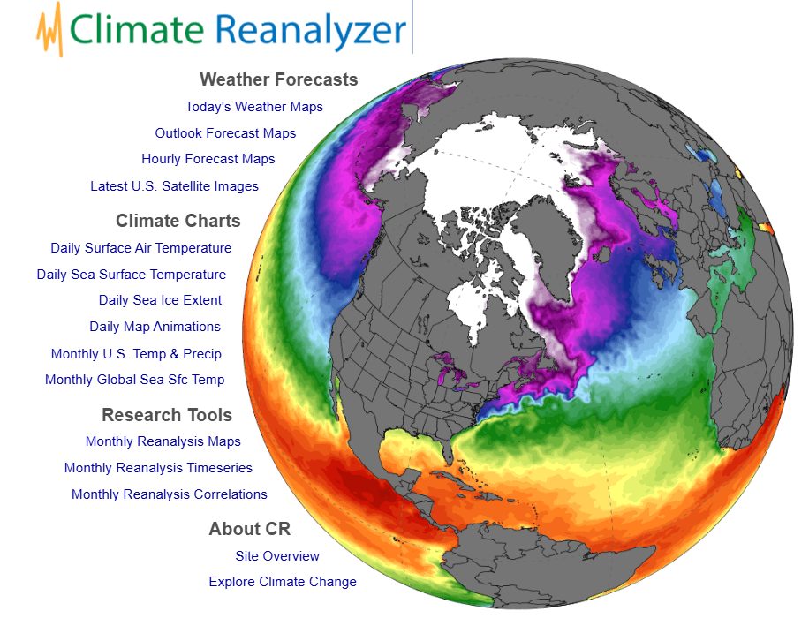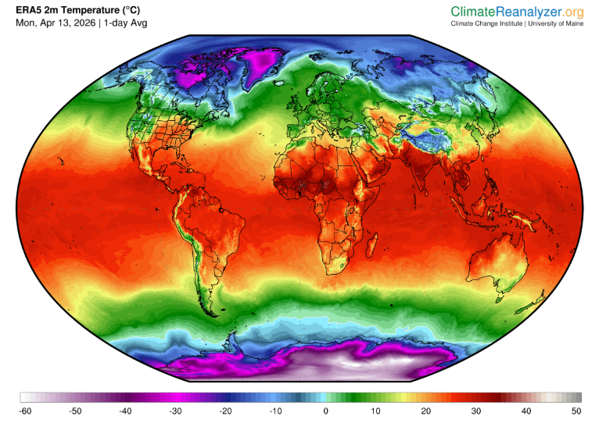
Fig 1: Climate Reanalyzer landing page. Fig 2: Example map from Climate
Reanalyzer (2m Temperature).

The problem that our clients identified was that Climate Reanalyzer was not maximizing the full utility of the maps it produces. Climate data compiled in Climate Reanalyzer was only available through the website itself. This meant that, though an abundance of climate data was made available and searchable, there were limited ways to interact with the data. Our clients wanted to introduce an additional, interactive map browser to better take advantage of the capabilities of Climate Reanalyzer.

The solution for our capstone team to develop was an interface between Climate Reanalyzer and Openspace, the interactive space data visualization application used by planetariums to explore space and create entertaining and informative presentations on many kinds of data. Openspace allows users to project a collection of map tiles, or subsections, onto the 3D globe for exploration and analysis. To project any image on the Earth in OpenSpace, it must first be systematically tiled to create the map segments that can be wrapped around the 3D globe visualization. Then it must be made available on a server that can respond to user prompted requests from OpenSpace.

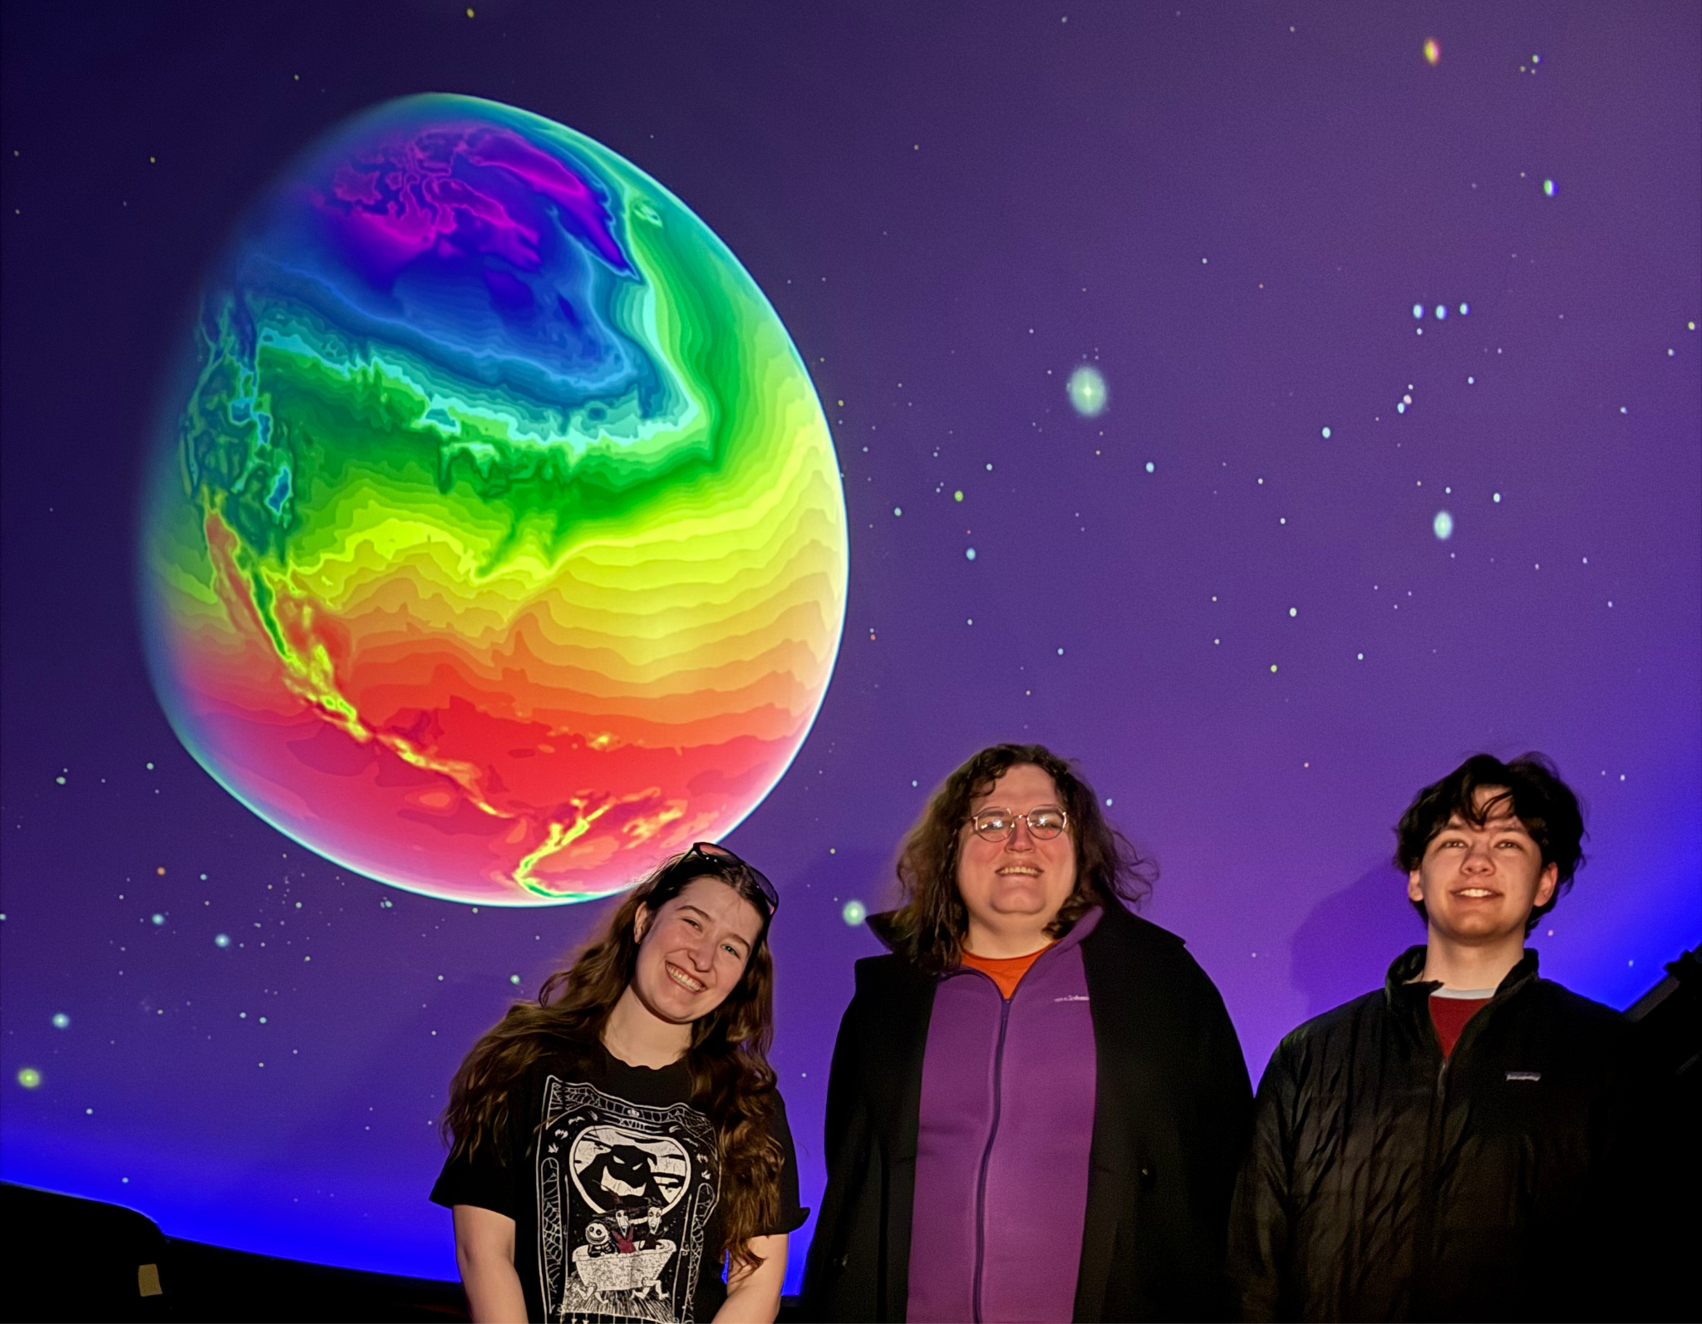
Fig 3: System functionality of Climate Reanalyzer and OpenSpace Interface to convert map from Climate Reanalyzer (left) into a map overlay on the Earth shown in a planetarium projection through the OpenSpace application (right).

Our project needed two main components to supply Climate Reanalyzer maps for browsing and viewing in OpenSpace. First was an image tile server that would process Climate Reanalyzer maps in order to supply map segments in the format OpenSpace requires. Then we needed a user interface component that could open independently or within the OpenSpace application to browse and visualize available maps. The final result from implementing these two components would be the visualization of Climate Reanalyzer maps in overlays on the Earth in planetarium projections as shown in Figure 3.

Requirements
The requirements for the ClimateReanalyzer and OpenSpace interface were originally discussed in our first meeting with our clients in September, 2025 and were initially published in our “SRS” document. Our requirements are split into 2 sections below. The first is our Functional Requirements, What our project needs to do, and Non-functional requirements, the traits that the project needs to have. You can find a brief description of our requirements in the following sections, and can find more specifics in our “SRS” document.

Functional Requirements

The functional requirements describe what main features our system should have and how they are met. We have a total of 7 functional requirements we strived to meet. We will be describing what each of our functional requirements is in brief here. Each requirement will have a diagram and an associated use case they are designed to meet. The full details of these requirements are available in the “SRS” document.

Requirement 1: Map-Tile Conversion
The first requirement we designed for our system is Map-Tile conversion. This requirement was designed as our highest priority requirement, as getting the maps from ClimateReanalyzer translated into a format readable by OpenSpace is needed for our project to function.

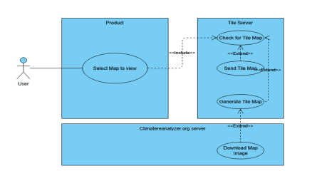
Fig 4: Requirement 1 use case diagram

Number | 1
Name | Map - Tile Conversion
Summary | The system shall allow OpenSpace to display a tile map generated from a 2x1 map image when requested.
Priority | 5
Preconditions | A user must request a map image
Postconditions | The map image will be displayed within OpenSpace.
Primary Actor | User
Secondary Actors | Climatereanalyzer.org image data, Tile Server, OpenSpace, system
Trigger | When the user selects a map to load.
Main Scenario | Step | Action
 | 1 | The user requests a new map.
Extensions | 2  3  Step  2a | The System checks if that map is already available.  The system sends requested tile data to OpenSpace for display. Branching Action  If not already available, the system downloads the map image.
 | 2b | The system calls for GDAL and Apache to generate a tile map.
 | 2c | The system stores the tile map on the tile server.

Requirement 2: Downloading and Saving Map Files
The second requirement for our project was to download and save map data to be used in an offline environment. This requirement had been discussed as a dream feature, but as a lower priority. It was designed so that portable planetariums or planetariums in places with unstable internet connections could still use our project and gain the benefits of the data we provide.

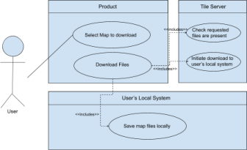
Fig 5: Downloading and saving tiles use case diagram.m

Number | 2
Name | Download and Save Map Files
Summary | The system should be able to download and save files containing 2:1 maps, allowing them to be used in the OpenSpace simulation on demand.
Priority | 2
Preconditions | ● The system has a connection to the internet.  ● There are files present in the tile server  ● There is sufficient space on the user’s system for the download
Postconditions | ● The selected maps are successfully saved to local storage. ● The system can access and load the saved maps on demand without needing to redownload them.
Primary Actor | User

Main Scenario | Step | Action
 | 1 | The user selects the tiles to download.
 | 2 | The System connects to the tile server.
 | 3 | The system downloads the files from the tile server and saves them locally to the user’s device.
Extensions | Step | Branching Action
 | 2a | If the download fails due to the connection to the tile server, the system will alert the user.
 | 3a | If the download fails (due to connection loss), the system pauses and will alert the user.
 | 3a | If the download fails due to storage issues, the system alerts the user to the insufficient space and prompts them to clear space or choose a different storage location.

Requirement 3: Admins Uploading Large Data Files
The third requirement is that the system should allow for uploading files with large file sizes. This is a relatively high-priority requirement, as once the maps taken from ClimateReanalyzer are translated into the tiled format, they become much larger in file size. These files must be able to be uploaded and stored on our server.
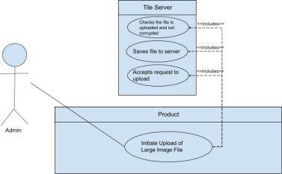
Fig 6: Uploading Large Data Files Use Case Diagram
Number | 3
Name | Admins Uploading Large Data Files
Summary | The system shall allow administrators to upload large source images to be used by the tile server.
Priority | 4
Preconditions | ● The system has a connection to the internet.  ● There are files present on the local machine  ● There is sufficient space on the server to upload
Postconditions | ● The selected tiles are successfully saved on the server. ● The system can access and load the uploaded image.
Primary Actor | Admin
Secondary Actors | Tile server
Trigger | When the user initiates the request to download tiles to use them offline.
Main Scenario | Step | Action
 | 1 | The admin finds a large image file to upload.
 | 2 | The admin connects to the server.
 | 3 | The admin uploads the file to the server
Extensions | Step | Branching Action
 | 2a | If the upload fails due to the connection to the tile server, the system will alert the user.
 | 3a | If the upload fails (due to connection loss), the system pauses and will alert the user.
 | 3a | If the upload fails due to storage issues, the server alerts the admin to the insufficient space.

Requirement 4: The System Listing Available ClimateReanalyzer Maps
The fourth requirement we designed for our project is that our project must have a way for users to find and open a specific map. This is a high-priority requirement as the user not being able to find a map to display would be unintuitive and could cause frustration. This would either delay the use of the project or cause the user to stop trying to use it.

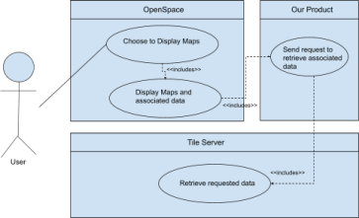
Fig 7: System Listing Available Maps Use Case diagram.
.
Number | 4
Name | List Available CR Maps
Summary | The system shall expose a list of available Climate Reanalyzer maps with the layer name, date/time, and resolution. So the presenters can pick one in OpenSpace.
Priority | 4
Preconditions | ● The tile server is reachable  ● CR list is available
Postconditions | ● The map layer is selected  ● Metadata is cached for retrieval.
Primary Actor | User
Secondary Actors | Tile server, OpenSpace, ClimateReanalyzer.org
Trigger | The user opens the “Select map”.
Main Scenario | Step | Action
 | 1 | User requests a list of maps.
Extensions | 2  3  Step | System fetches map catalog.  System returns a list, user selects one.  Branching Action
 | 2a | If CR is not reachable. The system will serve the last known local catalog.

Requirement 5: Multiple Tile Levels
The fifth requirement for our project is that our system should create tiled maps in a way that OpenSpace can use them for zooming in and out on the globe for higher resolution images. This is an important requirement to meet as the data being displayed is important and should be viewable in multiple different resolutions.
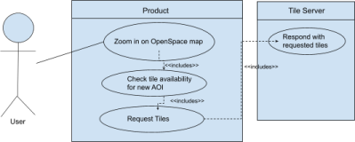
Fig 8: Multiple Tile Level Use Case Diagram

Number | 5
Name | Multiple tile levels
Summary | The system shall provide inner (zoomed) layers of tiles upon request
Priority | 4
Preconditions | ● The server must successfully connect with OpenSpace ● The map must be loaded in OpenSpace  ● The user must zoom in to trigger new tile requests
Postconditions | ● Tile layers will be provided while there is sufficient resolution in the CR image.
Primary Actor | User
Secondary Actors | Tile server, OpenSpace, Climatereanalyzer.org
Trigger | When the user interacts with the OpenSpace interface and zooms in
Main Scenario | Step | Action
 | 1  2  3 | The user zooms in on the map in OpenSpace.  OpenSpace requests the necessary tiles from the tile server. The tile server responds with the requested image tiles
Extensions | Step | Branching Action
 | 2a | If there are more tile levels that can be loaded, OpenSpace requests these from the tile server.
 | 2b | If no further tile levels remain, OpenSpace will not load zoomed data.

Requirement 6: Animating Maps and Data
The sixth requirement for our project is that there should be a system in place to cache multiple maps, and change between them on a set interval to emulate an animation showing change over time. This was also a low-priority requirement that would be considered as a stretch goal for our project. It was designed to add more functionality and entertainment when used to display data to a group of people.
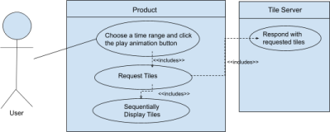
Fig 9: Animating Maps and Data Use Case Diagram
Number | 6
Name | Animating Maps and Data
Summary | The system shall display an ‘animation’ of data over a chosen time range for a region upon request.
Priority | 2
Preconditions | ● The server must successfully connect with OpenSpace ● The maps must be loaded in OpenSpace
Postconditions | ● The maps over the time the user chose will be shown sequentially, giving the idea that an animation for the weather during that time is being shown.
Primary Actor | User
Secondary Actors | Tile server, OpenSpace, Climatereanalyzer.org

Trigger | When the user chooses a time range and chooses to view the ‘animation’ of the data over that time range.
Main Scenario | Step | Action
 | 1 | The user chooses to play the animation.
 | 2 | OpenSpace requests the tiles for those times from the tile server.
 | 3 | The tile maps are shown sequentially to give the illusion of an animation
Extensions | Step | Branching Action
 | 2a | If there are no tiles present in the tile server for the time the user requested, the system will display an error message explaining that the time range is invalid.

Requirement 7: Error and Feedback Handling
The final Functional Requirement we designed for our project was to have Error Handling and Feedback for the user. This is also a high priority for us, as the usability of the project is important for both our clients and us. Having errors that are informative helps with the user experience of our project and increases the likelihood that a user will continue to use our project to learn or teach others.
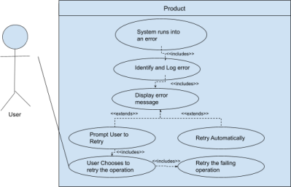
Fig 10: Error and Feedback Handling Use Case Diagram

Number | 7
Name | Handling Errors and Status Feedback
Summary | The system shall alert users when tile retrieval, downloads, uploads, or catalog refreshes fail, displaying descriptive and actionable error messages.
Priority | 4
Preconditions | ● The system encounters an issue (e.g., connection failure, missing tiles, invalid user request)
Postconditions | ● The user is shown an error message that describes the error and why it happened.
Primary Actor | User
Secondary Actors | Tile server, OpenSpace
Trigger | An error or unexpected behavior happens while the program is running
Main Scenario | Step | Action
 | 1 | A request or operation fails.
 | 2 | The system identifies the error and its cause.
 | 3 | The system displays an informational message to the user
Extensions | Step | Branching Action
 | 3a | The system logs the error and relevant logistical information, such as time, for the admin to analyze later.
 | 3b | If retrying the action is an option, the system prompts the user to retry.

Non-Functional Requirements
Non-functional requirements are the set of requirements we designed for important traits our system should have. This section covers requirements that involve things like uptime, what browsers and operating systems are needed to use it, and things like general intuitiveness for a user of the project. These are as important as the functional requirements, but are also less visible to the users of our project. This section will list the non-functional requirements we designed for our project, and more information on each can be found in our “SRS” document.

Non-Functional Requirement #1
Requirement ID. 3.1:
The application should maintain stable performance under simulated concurrent usage, with response times under 2 seconds for all core functionalities when tested with a representative load using automated tools.
Priority - 3
Non-Functional Requirement #2
Requirement ID. 3.2:
The application should be able to run on Chrome and all major Operating Systems.
Priority - 3
Non-Functional Requirement #3
Requirement ID. 3.3:
The application’s interface should be intuitive enough that new users are able to complete core application functions (e.g., downloading tiles, uploading maps) without direction at least 85% of the time.
Priority - 5
Non-Functional Requirement #4
Requirement ID. 3.4:
The application should be able to run both with and without an internet connection.
Priority - 2
Non-Functional Requirement #5
Requirement ID. 3.5:
The application must detect corrupted or missing map/tile data and notify the user with a clear error message, without crashing or losing existing unsaved work.
Priority - 3
Non-Functional Requirement #6
Requirement ID. 3.6:
The application’s codebase shall conform to the group’s coding standards and be structured to facilitate maintainability
Priority - 1
Non-Functional Requirement #7
Requirement ID. 3.7:
The application should work with the target OpenSpace versions and run on the ARCSIM-provided Linux VM.
Priority - 4
Non-Functional Requirement #8
Requirement ID. 3.8:
The tile service must be ready within 20 seconds after the process starts on the ARCSIM VM.
Priority - 3
Non-Functional Requirement #9
Requirement ID. 3.9:
All source code shall be publicly accessible on GitHub
Priority - 3
Non-Functional Requirement #10
Requirement ID. 3.10:
The application shall be available 99% of the time
Priority - 4

Design

User Interface
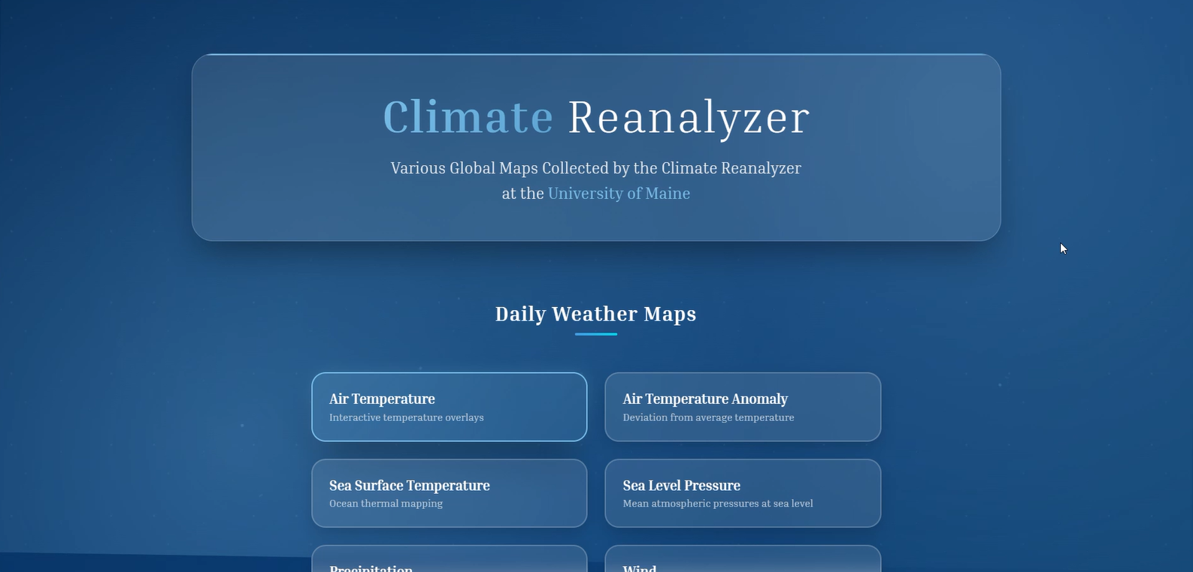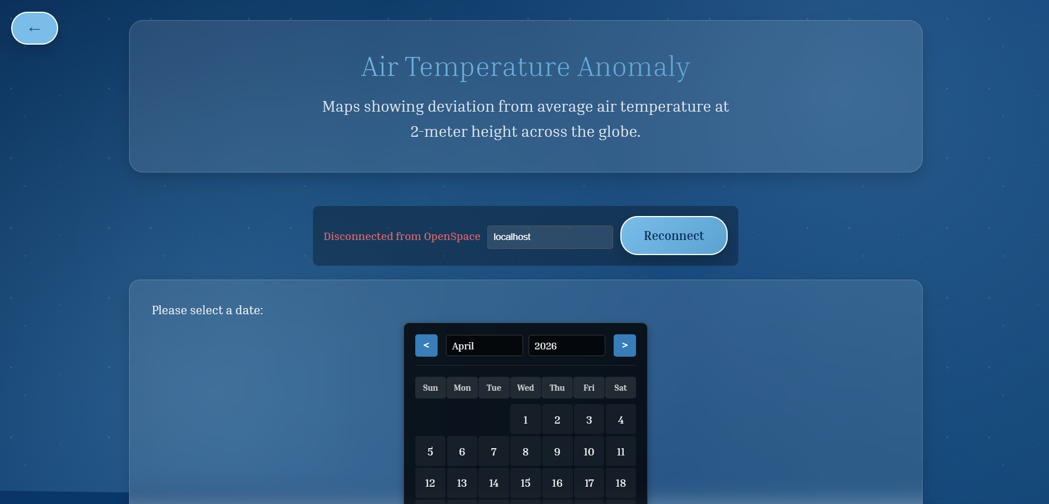
Fig 11: The landing page of the Climate Reanalyzer and Fig 12: One of the informational pages of the Climate
OpenSpace Interface Reanalyzer and OpenSpace Interface

Inclusivity and Accessibility
We knew from the first meeting we held with our clients that the project would be accessed by a plethora of unique people from different backgrounds, both technical and demographic. Because of this, we wanted to make sure that the design of the user interface was carefully chosen to make an intuitive and friendly interface that anybody would be able to use.

We made sure to include things that appeared to be ‘bells and whistles’ that had actual function when it came to accessibility. For example, when you hover over a button, the button gradually changes from a darker to a lighter blue from left to right – featured below in Figures 13 and 14. This helps users who may be less technically inclined when they are using the application.
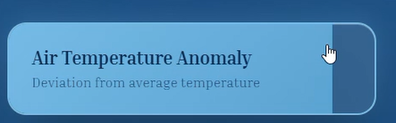
Fig 13: Air Temperature Button in its usual state of dark Fig 14: Air Temperature Button Filling with light blue
blue, as the user hovers over it.

Additionally, we decided that should an error occur with the connection between OpenSpace and our interface, it should be something that is very self-explanatory and easy to handle for our less technical users. We didn’t want the users to have to restart the page or run commands to try to fix the connection. To solve this, we decided to include an informational section at the top of the informational pages where the connectivity status between OpenSpace and our application was clearly stated, along with the button that, when clicked,d would automatically run the command to reconnect the two. This way, it is simple and easy for even the least technically experienced users.

Fig 15: The informational section showing the lack of connectivity to OpenSpace

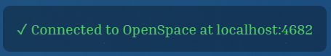
Fig 16: The informational section showing a healthy connection to OpenSpace after the user
selected the ‘Reconnect’ button.

Finally, since this project is bridging the gap between the rest of the world and the climate data collected here at UMaine with the Climate Reanalyzer, our team decided to keep the color scheme representative of this relationship. We found the official colors of UMaine and decided to base our color scheme around those. We also chose to include not only our team’s logo, but also the logo of the university. This way, when others are using the interface and exploring the new data they have access to, they are also able to feel a bit of where the data is coming from.
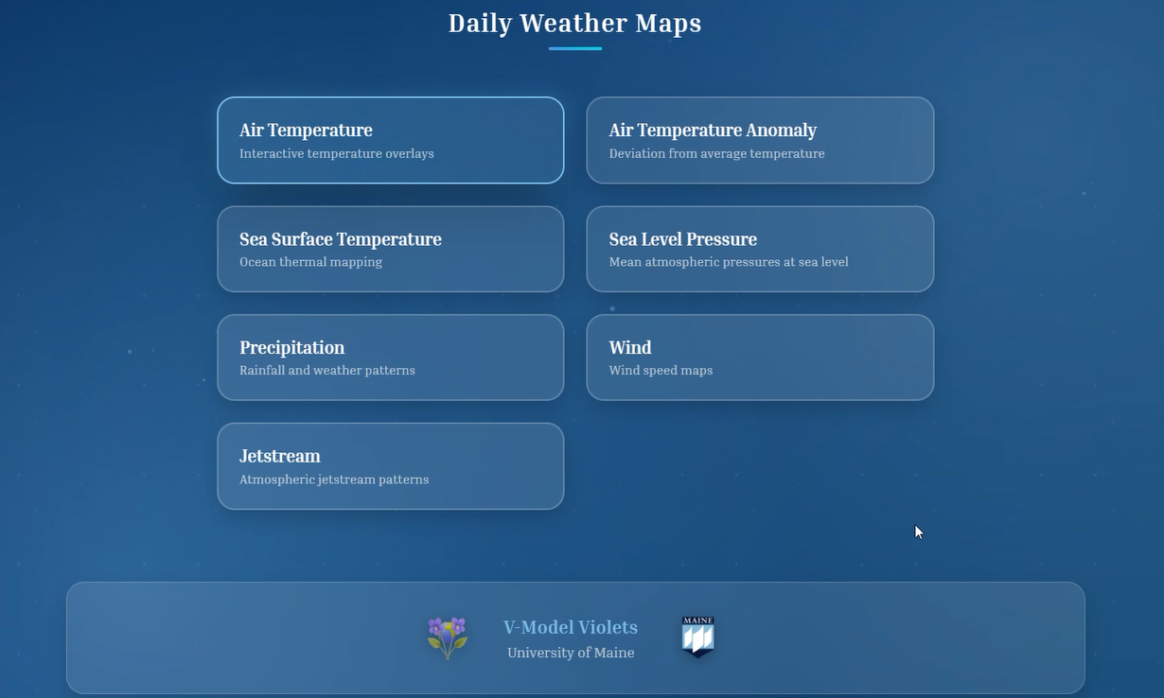
Fig 17: The footer of the user interface showing both the logos of the V-Model Violets and the University of Maine
alongside the titles for both groups.

Landing Page
The landing page has self-descriptive buttons that link to other pages, and each of the pages of data has a clear back button to return to the landing page should the user please.

Fig 18: The landing page the user is first directed to when they access the interface.

Informational Pages
The informational pages have a calendar picker for the users to have an intuitive date-picking experience. The users are able to scroll through the calendar by month by clicking on the arrow buttons at the top left, or by clicking on the month and year labels at the top and selecting the desired times via a drop-down window. Once the user has chosen a date, they can hit the submit button, and either watch the new data appear in OpenSpace, or they will receive an alert that there is no data present for that date.
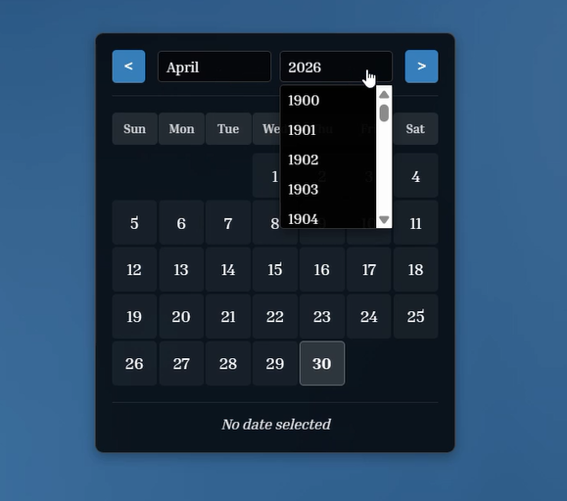
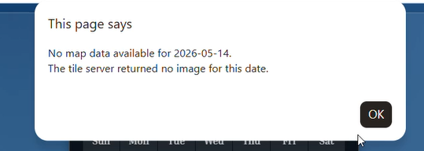
Fig 20: Alert informing the user of a lack of data for the date they
chose

Fig 19: Calendar picker interface with the year
dropdown selected.

At the bottom of the page, there is also a layer selection dropdown where the user can choose from the layers that they have recently selected. They can toggle between the layers as well as just toggle the layer off entirely if they wish to move on to a new category of data.
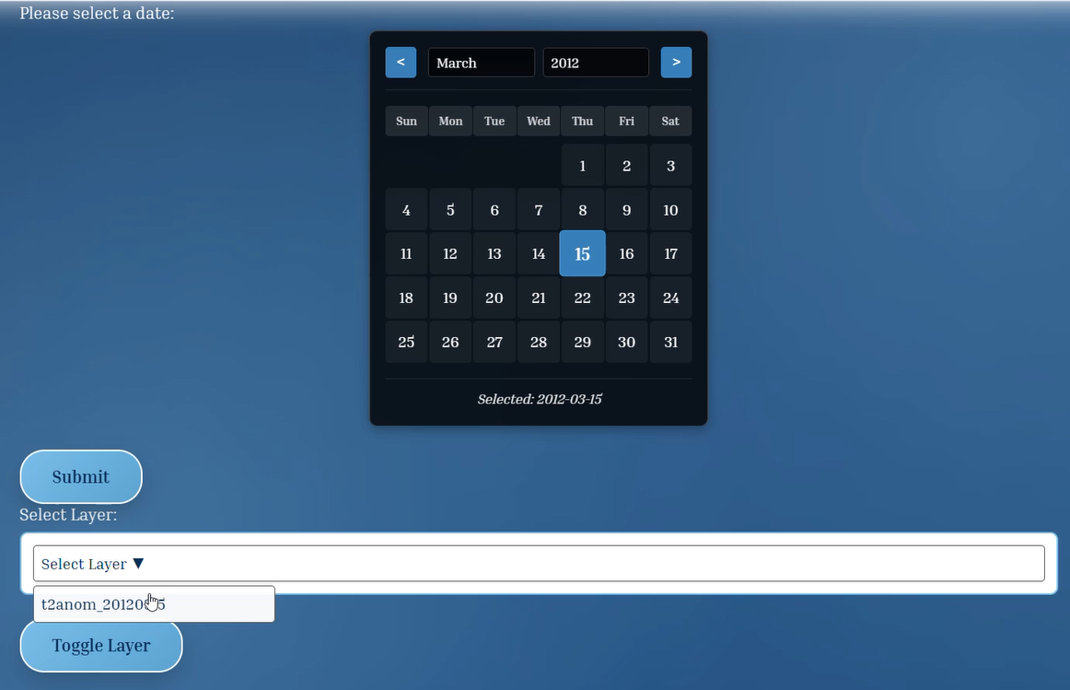
Fig 21: Image depicting the layer dropdown menu for the currently selected map.

Conclusion
Overall, we are extremely proud of the user interface that we designed and completed. The interface is something that has received high praise during user tests and presentations. We, as the V-Model Violets, are able to say with great pride that the user interface is something that we designed and worked hard to realize for our client and users.

Architecture
The OpenSpace and Climate Reanalyzer Interface uses a client server architecture that connects Climate Reanalyzer map data to OpenSpace. Instead of it being one application, the system is separated into two main cooperating components. The image tile server and the user interface component. This design allows the tile server to handle data processing and storage while the user interface focuses on allowing users to browse, select, and load maps inside OpenSpace

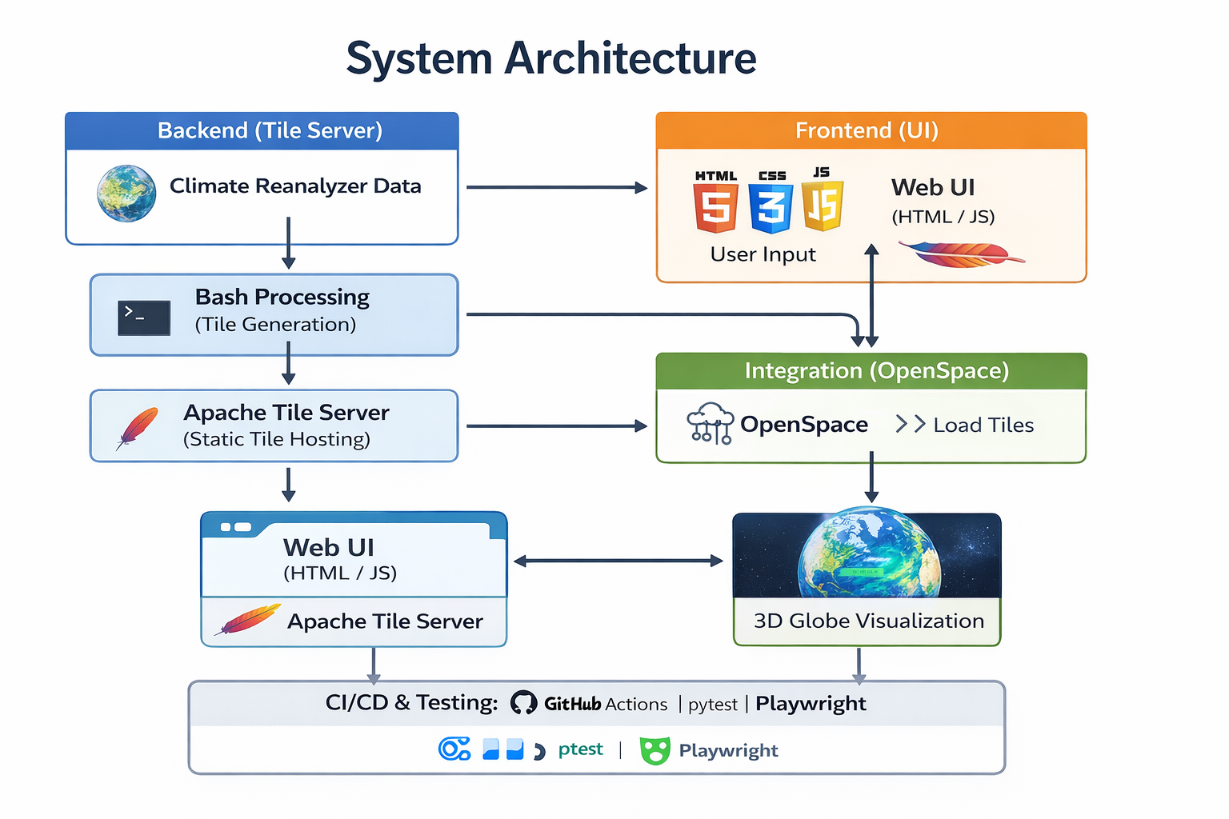
Fig: 22: Image of System Architecture Design.

The image tile server acts as the primary data source for the system. Climate Reanalyzer provides large climate and weather map images, and the tile server converts those images into smaller map tiles using GDAL. These tiles are stored on the server and made available through Apache HTTPD, allowing OpenSpace to request only the tiles it needs for visualization. If a requested map has already been processed, the server can serve the existing tiles. If not, the system can download the source image, generate the required tile set, and store it for later use.

The user interface component runs separately from the tile server and is used to browse available Climate Reanalyzer maps. Users can select a dataset, date, map through the interface, and the interface communicates with the tile server to retrieve the correct map catalog or tile data. OpenSpace then loads the selected tiles and displays them as an overlay on the 3D globe.

Climate Renalyzer provides the original climate images, the tile server processes and serves those images as map tiles, the UI allows users to select maps, and OpenSpace displays the final visualization. This design supports maintainability, performance, and future expansion because each component can be updated without rewriting the entire system.

DevOps and CI/CD
To maintain code quality and consistency across the team throughout development, we established a CI/CD pipeline built around automated checks, standardized workflows, and peer review practices. These tools and processes were designed to catch issues early and keep the codebase in a reliable state at every stage of development.

Our pipeline runs automatically on every push and pull request to the repository. At its core is a commit message validator, implemented as a GitHub Actions workflow, that enforces a standardized commit format across all contributors. Every commit must begin with an approved type prefix, such as feat, fix, chore, refactor, test, docs, or ci, followed by a short description of the change. This convention kept our project history clean, traceable, and easy to audit, which proved especially useful when tracking down when and why a particular change was introduced. The workflow is defined in validate-commit-message.yml and runs on Ubuntu, checking each commit in a push against the list of valid prefixes before allowing it to proceed.

To complement the pipeline, we also integrated Husky pre-commit hooks into our local development workflow. These hooks run linting and style checks automatically before a commit is finalized, meaning that code style violations are caught on the contributor's machine before they ever reach the remote repository. This removed the need to rely on individual discipline to maintain formatting standards and ensured that every commit that entered the codebase met the same baseline requirements.

All changes to the codebase were also required to pass through peer code review before being merged. No contributor merged their own pull request. This practice served multiple purposes: it distributed knowledge of the codebase across the whole team, surfaced bugs and design issues before they became entrenched, and gave every team member visibility into changes happening outside their primary area of work. Combined with the automated checks, code review formed the final human layer of quality assurance before any change reached the main branch.

Together, these practices formed a lightweight but effective DevOps culture within the team. By automating the mechanical aspects of quality enforcement and reserving human review for higher-level concerns, we were able to collaborate efficiently across multiple areas of the project without sacrificing consistency or introducing avoidable regressions.

Testing
Testing was a central part of our development process, and we built out a multi-layered suite that covered everything from individual functions to full user interactions. All tests are integrated into our GitHub Actions pipeline and run automatically on every push alongside the commit message validator, meaning the entire test suite acts as a continuous safety net throughout development.

The most comprehensive layer of our testing was our Playwright end-to-end test suite, which achieves 100% coverage of user-facing actions. Playwright allowed us to simulate real user behavior in a browser environment, clicking through the interface, selecting dates, submitting maps, toggling layers, and handling error states, exactly as a user would. This gave us confidence that the full flow of the application worked correctly end-to-end, not just that individual pieces functioned in isolation. Any change that broke a user-facing interaction would be caught immediately by the pipeline before it could be merged.

Alongside the end-to-end suite, we wrote unit tests covering all implemented functions across both the frontend and backend. These tests validate the behavior of individual components in isolation, ensuring that functions return correct outputs, handle edge cases appropriately, and do not regress as the codebase evolves. Having full unit test coverage meant that when changes were made to one part of the system, we could quickly verify that nothing else had broken as a side effect.

We also implemented automated tile server URL checks, which verify that image sets on the tile server are accessible and return valid responses. These checks catch broken links, misconfigured paths, and server availability issues before they reach deployment, which was particularly important given that the tile server is a dependency our frontend relies on to display any map data at all.

Together, these three layers of testing, end-to-end, unit, and server validation, combined with their full integration into the CI/CD pipeline, gave the team reliable confidence throughout development. Rather than discovering issues during manual testing or after delivery, our pipeline surfaced problems at the earliest possible moment and made it straightforward to identify exactly what changed and where the failure originated.

Results
The final results of our project was a working OpenSpace and Climate Reanalyzer Interface that connects Climate Reanalyzer map data with the OpenSpace visualization environment. Our team completed the two main components needed for the system which is an image tile server, and a user interface for browsing and selecting maps. Together, these components allow Climate Reanalyzer maps to be processed into tile based data and displayed as overlays on the OpenSpace 3D globe.

The finished user interface includes a landing page with map category options, individual map pages, a calendar picker, a submit button for loading selected dates, and connection status. These features allow the users to interact with the system without needing to manually access files, or use command line tools. The interface also provides alerts when no data is available for a selected date.

The project also successfully demonstrated map visualization in OpenSpace. Climate Reanalyzer maps could be loaded as overlays on the Openspace, allowing users to view climate and weather data in an interactive 3D environment. This was the most important final outcome of the project because it shows that the system could accomplish the clients main request which is moving Climate Reanalyzer map data beyond the website and into an immersive visualization tool.

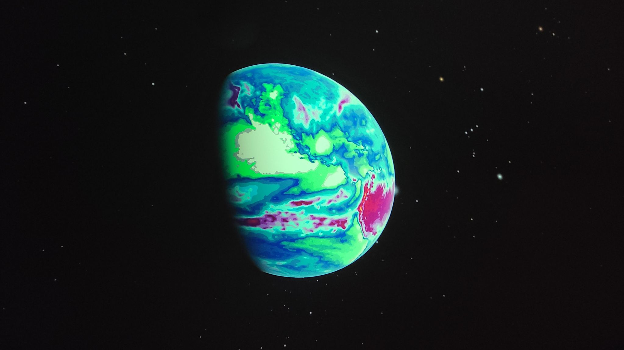
Fig 23: OpenSpace visualization in planetarium Fig 24: Climate Reanalyzer data in openspace platform
In addition to the main user features. The team completed automated testing and development checks. Playwright tests were used to verify user actions in the UI, unit tests checked the individual frontend and backend functions and the tiler server URL checks confirmed that hosted images were accessible. These testing results helped confirm that the finished system was stable enough to demonstrate and hand off.

The final result is a working open source system that connects Climate Reanalyzer data with OpenSpace. The project produces a usable interface, working map loading functionality, OpenSpace visualization, and supporting tests and documentation for future maintenance. The core system was completed and demonstrated successfully.

Requirement Satisfaction
Now that we are finished with our work on the project, we would like to reflect on the requirements we set for the project and those that ended up unmet. The majority of our requirements were met successfully, including our highest priority ones. For example, our most important Functional Requirements, for having a way to find maps and for having a system in place that successfully tiles them for use with OpenSpace, were both met. These 2 are the backbone of the project, and most of our time went into making sure these were met.

We also met most, if not all, of our Non-functional requirements. Some of these requirements ended up not being as important as we initially thought. For example, the Non-functional requirement for having a 99% uptime was met, but that seems like mostly a technicality. The front end of our project has no “uptime” to speak of, as it is a locally run HTML file. As it isn’t hosted anywhere and runs locally, it can’t be tracked for uptime. The server itself does have a trackable uptime, and we strove to make sure it was always available, but as the server is not owned by us and we have no way to bring it back online if it fails, it is now mostly up to our client, who is the server owner.

Some requirements did go unmet as well. The first is the requirement for downloading and saving maps locally for use without an internet connection. This was a low-priority requirement that we had decided would be a nice feature for the project, but ended up being put to the side as development happened. It was more important for us to meet the baseline features needed for this project to be considered successful than to add bonus features. The second requirement that went unmet is in a similar situation. This requirement is the requirement for animating tiles within OpenSpace. This was discussed early on with our clients as something they would really like to have implemented, but made it clear that it was more of an “if time permits” requirement. We unfortunately had to leave this requirement unmet for similar reasons to the first one listed above. We wanted the project to have its important functionality down so that it could be considered a successful project.

Next Steps
This section outlines the next steps for the project, both with and without our team's involvement. It also includes a message to any future Capstone team that inherits the project, so they have a better idea of what this project meant to our team.

Our Next Steps as a Team
With the completion of the University of Maine Computer Science capstone course sequence, the V-Model Violets will be moving on from active development of the Climate Reanalyzer and OpenSpace Interface. Each member of the team will be graduating and moving into the next chapter of their professional careers. With that being said, this project is something the entire team is very proud of, and team members remain open to contributing to it in the future should opportunities arise. If not, this project can be worked on by our clients or future capstone groups.

How to Maintain the Project
Maintaining this project is super easy, The entire codebase is open source and publicly available across our two GitHub repositories. Anyone, whether a future capstone team, a member of the original V-Model Violets, or any interested contributor, can clone either repository and begin working from there. The repositories contain all of the source code, documentation, and configuration files needed to understand and continue the project. Links to both repositories are below:
User Interface: https://github.com/V-Model-Violets/OpenSpace-x-ClimateReanalyzer-UI
Tile Server: https://github.com/V-Model-Violets/OpenSpace-x-ClimateReanalyzer-Server
Beyond just cloning the repositories, the Administrator Manual is also in the Appendices of this document. That outlines the entire flow of the project in detail. New maintainers are encouraged to review that document alongside the rest of the appendices to build a full picture of how the system is structured and how it is intended to be operated.

A Message For the Next Team
During our meetings with our clients, they tossed around the idea of using another year of the COS Capstone with another team to extend the project. In the event that this happens, we have prepared a message for the succeeding team:

We are very grateful that you have chosen the project which we started with our clients. We had an overwhelmingly positive and rewarding experience over the course of this past year (2025-2026), and we hope that you will as well. We spoke with our clients a bit at our Acceptance test this year, and they mentioned how they have known each other for years, and that this was always a project that they had wanted to realize, but just didn’t have the time or means to do so until this year. Despite this, they seemed to genuinely care about our wellbeing and grades in the course and were willing to work with us on the project's scope and requirements to fit the course. We look forward to seeing what you accomplish during your year with the project, and hope that you have as positive an experience as we did.

Summary and Conclusions

Document Summary

Our capstone project, titled OpenSpace and Climate Reanalyzer Interface, was a comprehensive capstone project for University of Maine Computer Science students on V-Model Violets. This project was developed in collaboration with Dr. Sean Birkel, a Research Assistant Professor at the Climate Change Institute, and Sean Laatsch, the Director of the Versant Planetarium at the University of Maine. The project also received major contributions from Dr. Carter Emmart and Micah Acinapura from the OpenSpace team. The Climate Reanalyzer and Openspace Interface was designed and developed to serve as a new resource for exploring climate data. Our clients observed an underutilized tool in Climate Reanalyzer’s extensive collection of climate maps and proposed a solution within the scope of a two-semester capstone project. The goal of this project was to create an image map server that enables the use of Climate Reanalyzer maps in the OpenSpace application for visualizations in planetariums or other research settings.

Throughout the project, we established a list of system requirements, developed a system design, drafted a user interface, and implemented these designs as well as supporting documentation in order to produce an operational product. We established a collaborative agile development process, and we employed many principles of the software development life cycle to plan, design, develop, and test our software. We also utilized a CI/CD pipeline built to standardize and check our code quality. The result was the creation of our backend tile server, creating and serving map tiles through bash scripting and Apache HTTPD hosting, and our frontend user interface, running HTML/JS/CSS to support straightforward user interaction through interfaces in OpenSpace and web browsers, working in tandem. We met most of the requirements we set, including all of our high priority requirements, in order to produce a fully-functioning system for Climate Reanalyzer map browsing within OpenSpace. Furthermore, the project is open source and available for future capstone groups or other developers to contribute to and add functionality.

Conclusion
The computer science capstone course provided many opportunities for learning and experience with creating a real world solution that our clients proposed through the development of a software system. In addition to general sharpening of development skills, our team had a few major takeaways from the project we took on, both from successes and from challenges we faced. The course provided a unique process of working with clients and each other in order to complete two semesters of work towards a singular project, and this came with unique experiences and learning moments. The first takeaway was that scheduling is a difficult task and it can be challenging or impossible at times to organize a meeting with five group members as well as multiple clients. This made consistent communication imperative to the success of our project in order to fill in every member on duties and the general direction of the project. We were able to succeed by setting up brief weekly post-class meetings and by all actively participating in discussions and planning in our Discord chat.

Another takeaway, and the root of the biggest challenge of our project, was that depending on external data or system setup can result in major setbacks if the dependencies are delayed. We managed this by forgoing some nonessential requirements in order to focus on the delivery and quality of essential requirements. We likely could have better managed this by working harder to facilitate the provision of the necessary data.

Overall, our capstone group thoroughly enjoyed working together and alongside all of our clients and instructors: Dr. Sean Birkel, Sean Laatsch, Dr. Carter Emmart, Micah Acinapura, and Dr. Terry Yoo. We are thankful for all of the support and guidance we received, and we are proud of our work to embrace this support and deliver a functional product to our clients.

References
Source | Reason
Climate Reanalyzer | Source of climate and weather data used by the project.
OpenSpace | Visualization platform for displaying map overlays on a 3D globe
GDAL Documentation | Used for map image/tile conversion
Apache HTTP Server Documentation | Used for hosting and serving files
Github Docs | Used for version control and repository workflow
Github Actions Documentation | Used for CI/CD automation
Playwright Documentation | Used for end to end browser testing
SommerVille, Software Engineering | Software engineering reference used in project documentation

Citations
Birkel, S. (n.d.). Weather forecasts. Climate Reanalyzer. https://climatereanalyzer.org/
OpenSpace Team. (n.d.). OpenSpace. https://www.openspaceproject.com/
GDAL/OGR contributors. (n.d.). GDAL documentation. Open Source Geospatial Foundation. https://gdal.org/
Apache Software Foundation. (n.d.). Apache HTTP Server Project. https://httpd.apache.org/
GitHub. (n.d.). GitHub Docs. https://docs.github.com/
GitHub. (n.d.). GitHub Actions Documentation. https://docs.github.com/en/actions
Microsoft. (n.d.). Playwright documentation. https://playwright.dev/
Sommerville, I. (2015). Software engineering (10th ed.). Pearson Education.

Bibliography
Birkel, S. (n.d.). Climate Reanalyzer: Weather forecasts. Climate Change Institute, University of
Maine. https://climatereanalyzer.org/
OpenSpace Team. (n.d.). OpenSpace. American Museum of Natural History.
https://www.openspaceproject.com
Apache Software Foundation. (n.d.). Apache HTTP Server Project. https://httpd.apache.org/
Team V-Model Violets. (2025). System Requirement Specification — Climate Reanalyzer X
OpenSpace Interface.
Team V-Model Violets. (2025). Software Design Document — Climate Reanalyzer X OpenSpace
Interface.
Team V-Model Violets. (2025). User Interface Design Document — Climate Reanalyzer X
OpenSpace Interface.
Team V-Model Violets. (2025). Code Inspection Summary — Climate Reanalyzer X OpenSpace
Interface.
Team V-Model Violets. (2025). Administrator Manual — Climate Reanalyzer X OpenSpace
Interface.
Team V-Model Violets. (2025). User Guide/User Manual — Climate Reanalyzer X OpenSpace
Interface.

Acknowledgements
The V-Model Violets would like to thank Dr Sean Birkel, Shawn Laatsch, Micash Acinapura, Dr. Carter Emmart, and Dr Terry Yoo, for their guidance, feedback and support throughout the development of the OpenSpace and Climate Reanalyzer Interface. Their input helped our team understand the goals of the project and shaped the final system into a tool that works. Their guidance also helped us stay organized throughout the requirements, design, implementation, testing, documentation and the final phase of the project.

Appendix A - System Requirements Specification

Table of Contents

Appendix A – System Requirements Specification (SRS) 7
1. Introduction 8
1.1 Purpose of This Document 8
1.2. References 8
1.3. Purpose of the Product 9
1.4. Product Scope 9
2. Functional Requirements 10
Map Tile Conversion 11
Downloading and Saving Map Files 12
Admins Uploading Large Data Files 14
System Listing Available Climate Reanalyzer Maps 15
Multiple Tile Levels 16
Animating Maps and Data 17
Error and Feedback Handling 19
3. Non-Functional Requirements 20
4. User Interface 22
5. Deliverables 23
6. Open Issues 23

Introduction

This project, titled OpenSpace and Climate Reanalyzer Interface, is a comprehensive capstone project for University of Maine Computer Science students on V-Model Violets (formerly known as Team Violet). This project will be developed in collaboration with Dr. Sean Birkel, a Research Assistant Professor at the Climate Change Institute, and Sean Laatsch, the Director of the Versant Planetarium at the University of Maine. This project will also be collaborating with Dr. Carter Emmart and Micah Acinapura from the OpenSpace team. The goal of this project is to create an image map server that utilizes data from the Climate Reanalyzer, enabling its use by OpenSpace and in planetariums or other research settings.

1.1 Purpose of This Document

The purpose of this System Requirements Specification (SRS) document is to define and describe the requirements (functional and non-functional) for the OpenSpace and Climate Reanalyzer Interface. This document will serve as a reference for our team, the clients, and the teaching staff for the Capstone class, outlining the system’s structure, design rationale, and technical specifications that support performance, security, and maintainability. The SDD is intended for:
- Capstone Team Members: To lay out the project requirements to ensure the client’s needs are met
- Clients: To ensure that the project is on the right track
- University of Maine Faculty: To assess the progress of the project

1.2. References

The table below lists the sources being used for this project currently:
Title | Author(s) | Publisher / Organization | Date | Citation
Climate Reanalyzer | Dr. Sean Birkel | Climate Change Institute, University of Maine | Ongoing | Birkel, S. (n.d.). Weather forecasts. Climate Reanalyzer. https://climatereanalyzer.org/
OpenSpace | OpenSpace Team | American Museum of Natural History | Ongoing | OpenSpace. (n.d.). OpenSpace. https://www.openspaceproject.com
Apache HTTPD Server Documentation | Apache Software Foundation | Open Source | 1997-Current | Apache Software Foundation. (n.d.). Apache HTTP Server Project. https://httpd.apache.org/
Software Engineering (10th Edition) | Ian Sommerville | Pearson Education | 2015 | Sommerville, I. (2015). Software engineering (10th ed.). Pearson Education.

1.3. Purpose of the Product

The Climate Reanalyzer OpenSpace interface project is set out to make the data gathered and used on the University of Maine’s Climate Reanalyzer available for use in the OpenSpace planetarium software. This allows for coverage of data that OpenSpace may not have readily available yet. The incorporation of the Climate Reanalyzer into the OpenSpace system will allow for immersive and interactive displays of historical climate data across the globe in a planetarium setting. This product will allow for data such as temperature, climate change data, atmospheric pressure, and much more to be overlaid onto a model of Earth that OpenSpace has integrated into their software. The product will address both missing data and inconsistencies in existing data to provide a more accurate model of Earth in its current state and in previous generations. In conclusion, the product will help enhance science education for teaching and learning.

1.4. Product Scope

The Climate Reanalyzer (CR) system will provide a connection between the Climate Reanalyzer platform and the OpenSpace visualization software that is used in planetariums. Our primary goal is to make global climate and weather data from the CR visual on display for planetariums and other large digital environments.

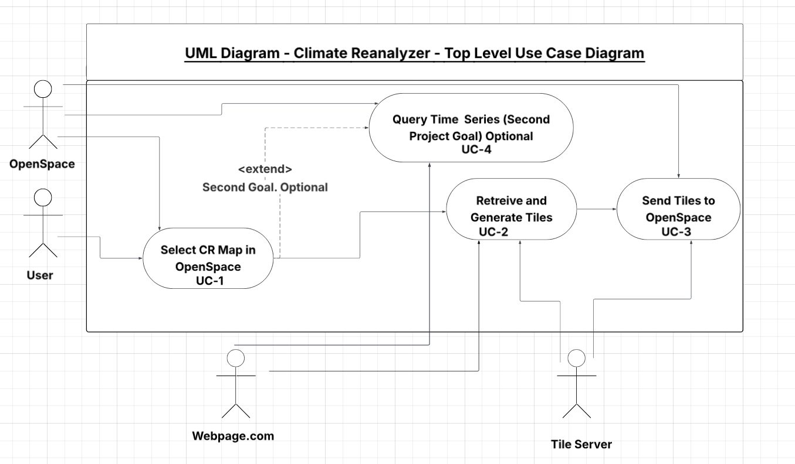
Figure 1.1 Top-Level Use Case Diagram: Climate Reanalyzer

Figure 1.1 shows the overall scope of the system and how it will connect to the actors. The Interface will allow users to select and load climate maps from the webpage. The system will get that information, convert the map data into a tile map that can be sent to OpenSpace for viewing. The optional feature UC-4 will let the system show time series data from the CR, which is the second project goal. This diagram shows the inside system boundary and what the external.

2. Functional Requirements

This section is where the Functional Requirements for the OpenSpace and Climate Reanalyzer Interface are found. These are the requirements that explain what the project will do, and they focus more on specific actions that can be taken and how they will function. There are tests included for each requirement that describe specifically how we will verify the system’s function.

Use Case #1: Map-Tile Conversion
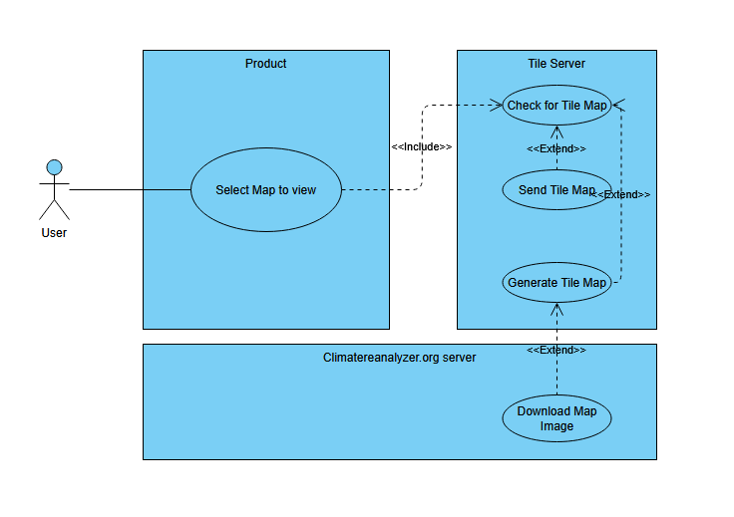
Figure 2.1: Map-tile Conversion Use Case Diagram

Number | 1
Name | Map - Tile Conversion
Summary | The system shall allow OpenSpace to display a tile map generated from a 2x1 map image when requested.
Priority | 5
Preconditions | A user must request a map image
Postconditions | The map image will be displayed within OpenSpace.
Primary Actor | User
Secondary Actors | Climatereanalyzer.org image data, Tile Server, OpenSpace, system
Trigger | When the user selects a map to load.
Main Scenario | Step | Action
 | 1 | The user requests a new map.
 | 2 | The System checks if that map is already available.
 | 3 | The system sends requested tile data to OpenSpace for display.
Extensions | Step | Branching Action
 | 2a | If not already available, the system downloads the map image.
 | 2b | The system calls for GDAL and Apache to generate a tile map.
 | 2c | The system stores the tile map on the tile server.
Open Issues | Should the System automatically download and store all data from Climate Reanalyzer?  Should the system only download new maps to the server if the map is requested directly?

Test for Functional Requirement #1
To test this requirement, we will write some test code that will simulate a call from a user for a specific map. If the map is sent correctly, or if it is downloaded and stored correctly on the server, the test will pass. Otherwise, the test will fail.

Use Case #2: Downloading and Saving Map Files

User

Product
Tile Server

Select Map to download

User’s Local System

Check requested files are present
<<includes>>

Initiate download to user’s local system

Save map files locally

Download Files
<<includes>>
<<includes>>
Figure 2.2: Downloading and Saving Tile Files Use Case Diagram

Number | 2
Name | Download and Save Map Files
Summary | The system should be able to download and save files containing 2:1 maps, allowing them to be used in the OpenSpace simulation on demand.
Priority | 2
Preconditions | - The system has a connection to the internet.  - There are files present in the tile server  - There is sufficient space on the user’s system for the download
Postconditions | - The selected maps are successfully saved to local storage.  - The system can access and load the saved maps on demand without needing to redownload them.
Primary Actor | User
Secondary Actors | Tile server, OpenSpace system
Trigger | When the user initiates the request to download maps to use them offline.
Main Scenario | Step | Action
 | 1 | The user selects the tiles to download.
 | 2 | The System connects to the tile server.
 | 3 | The system downloads the files from the tile server and saves them locally to the user’s device.
Extensions | Step | Branching Action
 | 2a | If the download fails due to the connection to the tile server, the system will alert. the user
 | 3a | If the download fails (due to connection loss), the system pauses and will alert the user.
 | 3a | If the download fails due to storage issues, the system alerts the user to the insufficient space and prompts them to clear space or choose a different storage location.
Open Issues | If the download fails, should the system automatically attempt to resume the download once the connection has been restored, or should it wait for another prompt from the user?

Test for Functional Requirement #2

To test this requirement, a request will be sent to the system to download a specific set of tiles for later use in the OpenSpace simulation. Once the request is made, the system should connect to the remote server, retrieve the requested tile files, and store them in the designated local directory. After the download process completes, the storage location will be checked to verify that the tile files exist and are accessible. If the files exist and are accessible, the test passes; otherwise, the test fails.

Use Case #3: Admins Uploading Large Data Files

Admin

Tile Server

Product

Checks the file is uploaded and not corrupted

Accepts request to upload

Initiate Upload of Large Image File
<<includes>>

Saves file to server
<<includes>>
<<includes>>
Figure 2.3: Admin Uploading Large Data Files Use Case Diagram

Number | 3
Name | Admins Uploading Large Data Files
Summary | The system shall allow administrators to upload large source images to be used by the tile server.
Priority | 4
Preconditions | - The system has a connection to the internet.  - There are files present on the local machine  - There is sufficient space on the server to upload
Postconditions | - The selected tiles are successfully saved on the server.  - The system can access and load the uploaded image.
Primary Actor | Admin
Secondary Actors | Tile server
Trigger | When the user initiates the request to download tiles to use them offline.
Main Scenario | Step | Action
 | 1 | The admin finds a large image file to upload.
 | 2 | The admin connects to the server.
 | 3 | The admin uploads the file to the server
Extensions | Step | Branching Action
 | 2a | If the upload fails due to the connection to the tile server, the system will alert the user.
 | 3a | If the upload fails (due to connection loss), the system pauses and will alert the user.
 | 3a | If the upload fails due to storage issues, the server alerts the admin to the insufficient space.
Open Issues | If the upload fails, should the server save the upload progress, or should it delete progress until there is sufficient space?

Test for Functional Requirement #3

To test this requirement, we will attempt to upload an image to the server. Then the server will be checked to see if the images are present. If they are, the test passes. If the images are not present, the test fails.

Use Case #4: The System listing available Climate Reanalyzer Maps

User

OpenSpace
Our Product

Choose to Display Maps

Tile Server
<<includes>>

Send request to retrieve associated data

Retrieve requested data

Display Maps and associated data
<<includes>>
<<includes>>
Figure 2.4: Listing Available Climate Reanalyzer Maps Use Case Diagram

Number | 4
Name | List Available CR Maps
Summary | The system shall expose a list of available Climate Reanalyzer maps with the layer name, date/time, and resolution. So the presenters can pick one in OpenSpace.
Priority | 4
Preconditions | - The tile server is reachable  - CR list is available
Postconditions | - The map layer is selected  - Metadata is cached for retrieval.
Primary Actor | User
Secondary Actors | Tile server, OpenSpace, ClimateReanalyzer.org
Trigger | The user opens the “Select map”.
Main Scenario | Step | Action
 | 1 | User requests a list of maps.
 | 2 | System fetches map catalog.
 | 3 | System returns a list, user selects one.
Extensions | Step | Branching Action
 | 2a | If CR is not reachable. The system will serve the last known local catalog.
Open Issues | Is this possible? Can it auto-refresh?

Test for Functional Requirement #4

To test this requirement, we will create a mock CR and serve it a catalog. We will then confirm that the program lists accurate data and selection returns the correct layer ID. If it does so, the test passes; otherwise, the test fails.

Use Case #5: Multiple tile levels

Fig 2.5: Being able to view tile maps on multiple levels, use case diagram

User

Product
Tile Server

Zoom in on OpenSpace map

Respond with requested tiles

Check tile availability for new AOI
<<includes>>
<<includes>>

Request Tiles
<<includes>>

Number | 5
Name | Multiple tile levels
Summary | The system shall provide inner (zoomed) layers of tiles upon request
Priority | 4
Preconditions | - The server must successfully connect with OpenSpace  - The map must be loaded in OpenSpace  - The user must zoom in to trigger new tile requests
Postconditions | - Tile layers will be provided while there is sufficient resolution in the CR image.
Primary Actor | User
Secondary Actors | Tile server, OpenSpace, Climatereanalyzer.org
Trigger | When the user interacts with the OpenSpace interface and zooms in
Main Scenario | Step | Action
 | 1 | The user zooms in on the map in OpenSpace.
 | 2 | OpenSpace requests the necessary tiles from the tile server
 | 3 | The tile server responds with the requested image tiles
Extensions | Step | Branching Action
 | 2a | If there are more tile levels that can be loaded, OpenSpace requests these from the tile server.
 | 2b | If no further tile levels remain, OpenSpace will not load zoomed data
Open Issues | Should the system store all of the tile levels individually, or calculate image cropping and transformation upon request for a new tile level?

Test for Functional Requirement #5

To test this requirement, we will visit server URLs specifying the inner tile layers that should be available and verify that an image is returned. This should call the server and request a tile, which the server should recognize and identify as an available layer, with which it will respond. If the image is displayed at the URL, the test passes; otherwise, the test fails.

Use Case #6: Animating Maps and Data

Fig 2.6: Being able to view a certain time span in OpenSpace in a way that looks like an animated use case diagram

User

Product
Tile Server

Choose a time range and click the play animation button

Respond with requested tiles

Request Tiles
<<includes>>
<<includes>>

Sequentially Display Tiles
<<includes>>

Number | 6
Name | Animating Maps and Data
Summary | The system shall display an ‘animation’ of data over a chosen time range for a region upon request.
Priority | 2
Preconditions | - The server must successfully connect with OpenSpace  - The maps must be loaded in OpenSpace
Postconditions | - The maps over the time the user chose will be shown sequentially, giving the idea that an animation for the weather during that time is being shown.
Primary Actor | User
Secondary Actors | Tile server, OpenSpace, Climatereanalyzer.org
Trigger | When the user chooses a time range and chooses to view the ‘animation’ of the data over that time range.
Main Scenario | Step | Action
 | 1 | The user chooses to play the animation.
 | 2 | OpenSpace requests the tiles for those times from the tile server.
 | 3 | The tile maps are shown sequentially to give the illusion of an animation
Extensions | Step | Branching Action
 | 2a | If there are no tiles present in the tile server for the time the user requested, the system will display an error message explaining that the time range is invalid.
Open Issues | Should users be allowed to adjust playback speed?

Test for Functional Requirement #6

A request will be sent for a supported time-series dataset over a short range of timestamps. The system should retrieve and display tiles in order. If the animation shows correct visual progression without failure, the test passes; otherwise, it fails. Request a tile, which the server should recognize and identify as an available layer, with which it will respond. If the image is displayed at the URL, the test passes; otherwise, the test fails.

Use Case #7: Error and Feedback Handling

Fig 2.7: Being able to view a certain time span in OpenSpace in a way that looks like an animated use case diagram

User

Product

System runs into an error

Identify and Log error
<<includes>>

Display error message
<<includes>>

Prompt User to Retry
Retry Automatically
<<extends>>
<<extends>>

User Chooses to retry the operation
<<includes>>

Retry the failing operation
<<includes>>

Number | 7
Name | Handling Errors and Status Feedback
Summary | The system shall alert users when tile retrieval, downloads, uploads, or catalog refreshes fail, displaying descriptive and actionable error messages.
Priority | 4
Preconditions | - The system encounters an issue (e.g., connection failure, missing tiles, invalid user request)
Postconditions | - The user is shown an error message that describes the error and why it happened.
Primary Actor | User
Secondary Actors | Tile server, OpenSpace
Trigger | An error or unexpected behavior happens while the program is running
Main Scenario | Step | Action
 | 1 | A request or operation fails.
 | 2 | The system identifies the error and its cause.
 | 3 | The system displays an informational message to the user
Extensions | Step | Branching Action
 | 3a | The system logs the error and relevant logistical information, such as time, for the admin to analyze later.
 | 3b | If retrying the action is an option, the system prompts the user to retry.
Open Issues | Are there certain features that the system should automatically restart without prompting the user?

Test for Functional Requirement #7

A failure will be forced by removing server connectivity and initiating a tile request. If the user receives a descriptive error message that matches the expected failure type, the test passes; otherwise, it fails.

3. Non-Functional Requirements

This section is where the Nonfunctional Requirements for the OpenSpace and Climate Reanalyzer Interface are found. These are the requirements that explain how the product will operate, and they focus more on how the project operates and less so on what the project can do. There are tests included for each requirement that describe specifically how we will verify the system’s function.

Non-Functional Requirement #1

Requirement ID. 3.1:
The application should maintain stable performance under simulated concurrent usage, with response times under 2 seconds for all core functionalities when tested with a representative load using automated tools.
Priority - 3
Test: Run a stress test of many uses at once over a short period of time. If everything works as planned, it will pass; otherwise fail.

Non-Functional Requirement #2

Requirement ID. 3.2:
The application should be able to run on Chrome and all major Operating Systems.
Priority - 3
Test: Attempt to open the browser application on Chrome, as well as on Windows, Mac, and Linux systems. If all runs successfully,y it will pass; otherwise, it fails.

Non-Functional Requirement #3

Requirement ID. 3.3:
The application’s interface should be intuitive enough that new users are able to complete core application functions (e.g., downloading tiles, uploading maps) without direction at least 85% of the time.
Priority - 5
Test: Perform usability testing with a handful of various people and gauge their understanding of the program's operation through observation and post-test questions. If the vast majority of people (at least 85%) can understand with little assistance from the proctor, the program passes; otherwise, it fails.

Non-Functional Requirement #4

Requirement ID. 3.4:
The application should be able to run both with and without an internet connection.
Priority - 2
Test: Test that the base functions of the application work both when connected to wifi and with no wifi or service connection.

Non-Functional Requirement #5

Requirement ID. 3.5:
The application must detect corrupted or missing map/tile data and notify the user with a clear error message, without crashing or losing existing unsaved work.
Priority - 3
Test: Provide corrupted or incomplete data files and verify that the application displays a descriptive error message and continues functioning normally.

Non-Functional Requirement #6

Requirement ID. 3.6:
The application’s codebase shall conform to the group’s coding standards and be structured to facilitate maintainability
Priority - 1
Test: Read through all code to determine whether or not the code follows the standards set by our group.

Non-Functional Requirement #7

Requirement ID. 3.7:
The application should work with the target OpenSpace versions and run on the ARCSIM-provided Linux VM.
Priority - 4
Test: Install ARMSIM VM, validate it works with OpenSpace.

Non-Functional Requirement #8

Requirement ID. 3.8:
The tile service must be ready within 20 seconds after the process starts on the ARCSIM VM.
Priority - 3
Test: Restart the service, measure the time it takes to start.

Non-Functional Requirement #9

Requirement ID. 3.9:
All source code shall be publicly accessible on GitHub
Priority - 3
Test: Verify that any GitHub user can access the repository holding the source code

Non-Functional Requirement #10

Requirement ID. 3.10:
The application shall be available 99% of the time
Priority - 4
Test: Log tile server uptime for a week through requests at regular intervals and calculate if availability is 99% or better

4. User Interface

See User Interface Design Document for OpenSpace and Climate Reanalyzer Interface

5. Deliverables

The following deliverable items will be supplied as described below to the clients, Dr. Sean Birkel and Shawn Laastch, throughout the development of the specified software. Most deliverable items will be made available as both a hard copy and a digital PDF.

Item | Format | Date of Delivery
Systems Requirement Specification | -Document Hard Copy  -Document Digital Copy | 10/29/2025
System Design Document | -Document Hard Copy  -Document Digital Copy | 11/17/2025
User Interface Design Document | -Document Hard Copy  -Document Digital Copy | 12/3/2025
User Manual | -Document Hard Copy  -Document Digital Copy | 5/8/2026
Administrator Manual | -Document Hard Copy  -Document Digital Copy | 5/8/2026
Copies of all Biweekly Status Reports | -Document Hard Copy  -Document Digital Copy | Every two weeks-  Mondays starting  10/20/2025
All source code | -GitHub Repository | 5/8/2026
The executable program | -Web Application  -Open Space Interface | 5/8/2026

6. Open Issues

The following are issues that have been identified and not yet concluded. These issues will be addressed later in the development process according to the projected resolution dates.

- Tile server availability (2/16/2026)
- Function to process images from climate reanalyzer into tiles (2/2/2026)
- Function to select desired tiles based on area of interest and available data (2/9/2026)
- WMS file to store data for each map to be loaded into OpenSpace (2/23/2026)
- OpenSpace asset files for each map to be loaded (2/23/2026)
- JS webpage that can be opened within OpenSpace to browse the CR catalog (3/30/2026)

Appendix B - System Design Document
Table of Contents

Appendix B – System Design Document (SDD) 24
1 Introduction 25
1.1 Purpose of This Document 25
1.2 References 25
2 System Architecture 26
2.1 Architectural Design 26
2.2 Decomposition Description 27
3 Persistent Data Design 28
3.1 Database Descriptions 28
3.2 File Description 29
Directory Summary 29
File Descriptions 31
4 Requirements Matrix 34

Introduction

This project, titled OpenSpace and Climate Reanalyzer Interface, is a comprehensive capstone project for University of Maine Computer Science students on V-Model Violets (formerly known as Team Violet). This project will be developed in collaboration with Dr. Sean Birkel, a Research Assistant Professor at the Climate Change Institute, and Sean Laatsch, the Director of the Versant Planetarium at the University of Maine. This project will also be collaborating with Dr. Carter Emmart and Micah Acinapura from the OpenSpace team. The goal of this project is to create an image map server that utilizes data from the Climate Reanalyzer, enabling its use by OpenSpace and in planetariums or other research settings.

Purpose of This Document

The purpose of this System Design Document (SDD) is to detail the architecture, components, interfaces, and data flow for the OpenSpace and Climate Reanalyzer Interface. This document will serve as a blueprint for our team, the clients, and the teaching staff for the Capstone class, outlining the functionality of the system, possible constraints, and expectations regarding performance, security, and design. The SDD is intended for:
- Capstone Team Members: To guide the group through the implementation process, as well as ensure the client’s needs are met.
- Clients: To show how we plan to construct the system in a transparent and informative way
- University of Maine Faculty: To assess the progress of the project

References

The table below lists the sources being used for this project currently:
Title | Author(s) | Publisher / Organization | Date | Citation
Climate Reanalyzer | Dr. Sean Birkel | Climate Change Institute, University of Maine | Ongoing | Birkel, S. (n.d.). Weather forecasts. Climate Reanalyzer. https://climatereanalyzer.org/
OpenSpace | OpenSpace Team | American Museum of Natural History | Ongoing | OpenSpace. (n.d.). OpenSpace. https://www.openspaceproject.com
Apache HTTPD Server Documentation | Apache Software Foundation | Open Source | 1997-Current | Apache Software Foundation. (n.d.). Apache HTTP Server Project. https://httpd.apache.org/
Software Engineering (10th Edition) | Ian Sommerville | Pearson Education | 2015 | Sommerville, I. (2015). Software engineering (10th ed.). Pearson Education.

System Architecture

This section introduces the general architecture of the OpenSpace and Climate Reanalyzer Interface. Section 2.1 features the general architectural design (including a diagram and a brief write-up). Section 2.2 features the more detailed decomposition design. It has a diagram that is a more broken-down and specific version of the one found in 2.1, as well as a brief write-up.

Architectural Design

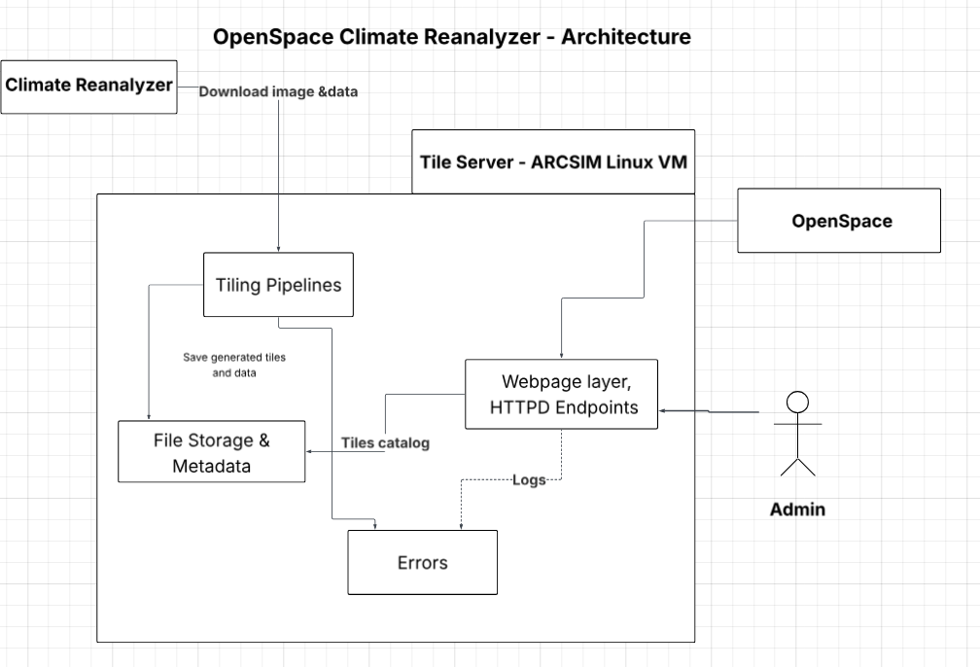
Figure 2.1 OpenSpace - Climate Reanalyzer Architecture

The OpenSpace and Climate Reanalyzer system is a client-server architecture that connects available data from the Climate Reanalyzer to the OpenSpace platform. Figure 2.1 shows the architecture and how the components interact. The goal is to show data flow between the tile server and OpenSpace’s platform. This design will allow OpenSpace to request the map tiles it needs.
At the top, the Climate Reanalyzer (CR) is an external data provider. These images will be fetched by the tile server, which will convert the map images to smaller tiles using GDAL utilities. The Tile Server will expose the API via Apache HTTPD that lets OpenSpace request individual tiles or map catalogs. Administrators can also upload new images through the same API. When OpenSpace requests a new map, the server will check whether it already exists. If not, it will download the source image and generate the required tiles, then serve them to the client.
The system runs on a Linux virtual machine (ARCSIM VM) provided by the University of Maine. It will use Apache HTTPD as the web service and GDAL for the image tiling and JSON metadata handling. OpenSpace will communicate with the server via HTTPS requests to retrieve tiles and catalogs for visualization in the planetarium environment. This setup will allow efficient performance and cross-platform compatibility.

Decomposition Description
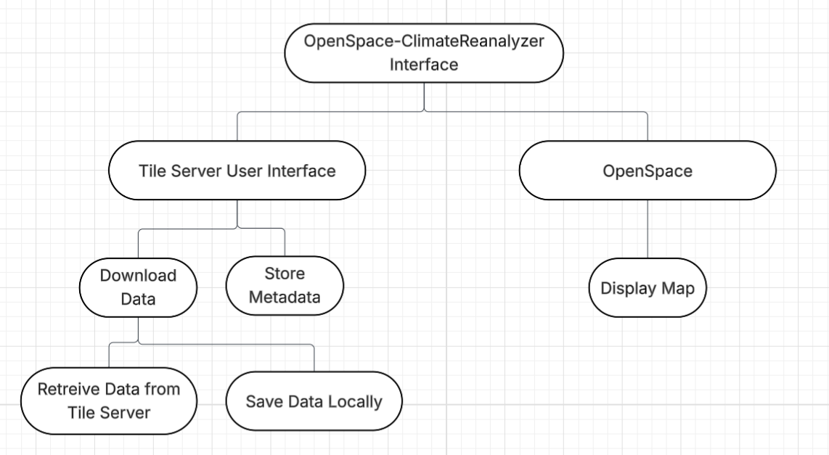
Figure 2.2 OpenSpace - Climate Reanalyzer Decomposition Diagram

This section describes the decomposition of the OpenSpace and Climate Reanalyzer Interface system we are developing. It highlights and describes a more in-depth description of what was described in section 2.1. Our system is mostly procedural, hence the structural decomposition diagram seen above (Figure 2.2).
Our system is a client-server model, which means that clients request services and servers provide them. For the OpenSpace and Climate Reanalyzer Interface, the client would be the user interface for the Tile Server that is brought up in the OpenSpace application itself. The server is the actual tile server, which holds the maps and metadata that have been previously uploaded.
Our system’s functions are broken down into two main sections: actions handled through the tile server and actions handled through OpenSpace itself. The main functions of the Tile Server are to download data to the user’s local system and to store the associated metadata. The function that OpenSpace serves is to display the maps that have been saved or cached from the tile server.

Persistent Data Design

In this section, we will cover Database design and File Structure. The design of the database will show how we will store the data in our server and how it interacts with the interface and Openspace. Our file structure shows the direct format of the server along with data types. This information will be used to build our product, and can work as a guide for developers.

Database Descriptions

For our project, we need to create a Tile server that will serve as a database of maps and tiled map data. Our product will be interfacing this data with the Openspace Project to allow Openspace to load and display these maps when requested. The database should not be complex and should not require any form of login authentication, as all of the maps are publicly sourced and free to access by anyone. Access to the database will be exclusively through a browser within Openspace, and will only allow for downloading of files and requesting new maps to be added to the database from ClimateReanalyzer. Manually adding and deleting files will only be allowed through direct access to the Linux machine provided to us by Dr. Sean Birkel.
Data types in the database itself include:
- Map_id: uuid, <1Kb, The specific ID for each map.
- Rectangular_map: PNG image, 10-100Mb, The unaltered base image of the map
- Map_tile: png image, 1-10Mb, A single Tile of the map after modification
- tiled_map_file, tif compressed image, 1-10Gb, The tiled tif format compressed image
- Tiled_map_data: WMS tile image index file, 10Mb, Index file for getting each tile.
- Map_metadata: JSON, <100Kb, JSON data used to communicate with the server.
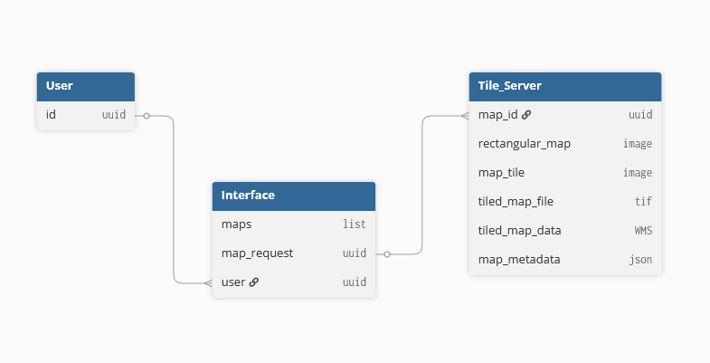Figure 3.1 OpenSpace - Climate Reanalyzer Database Schema

File Description
File Structure:

/OpenSpace-x-ClimateReanalyzer/
├─ .devcontainer/
│ └─ devcontainer.json
├─ .github/
│ └─ CODEOWNERS
│ └─ workflows/
│ └─ validate-commit-message.yml
├─ webconf/
│ └─ {map_id}.webconf
├─ data/
│ ├─ Earth
│ │ ├─ Bmng
│ │ │ └─ {map_id}/{z}/{x}/{y}.idx
│ │ │ └─ {map_id}/{z}/{x}/{y}.jpg
│ │ │ └─ {map_id}/{z}/{x}/{y}.mrf
│ │ ├─ Gebco
│ │ │ └─ {map_id}/{z}/{x}/{y}.ppg
│ │ │ └─ {map_id}/{z}/{x}/{y}.png
│ │ │ └─ {map_id}/{z}/{x}/{y}.mrf
│ ├─ source_images/
│ │ └─ {map_id}.tif
├─ documents/
│ └─ {document_id}
├─ genconf.sh
├─ setup-ahtse.sh
├─ README.md
└─ .gitignore

Directory Summary
- .devcontainer/
Contains the Visual Studio Code development container configuration. Defines the environment, tools, and extensions required for development consistency.
- .github/
Contains repository-level configuration files used by GitHub, including:
  - CODEOWNERS – Defines repository ownership and review responsibilities.
  - workflows/ – Contains CI/CD pipeline definitions (for example, commit message validation)
- webconf/
Contains configuration files (.webconf) that define how specific datasets (maps or layers) are rendered within the visualization engine.
- data/
Stores all imagery and elevation datasets. Data is organized in a hierarchical, tile-based structure that supports multi-resolution map rendering.
- documents/
Contains project documentation, dataset metadata, or generated reports.
- Shell Scripts:
  - genconf.sh – Generates configuration files for datasets.
  - setup-ahtse.sh – Initializes the Advanced Hierarchical Tile Service Engine (AHTSE) used to serve tiled raster data.
- README.md
Provides a project summary, setup instructions, and contributor information.
- .gitignore
Defines which files and directories are excluded from version control.

Data Directory Structure:
├─ data/
│ ├─ Earth
│ │ ├─ Bmng
│ │ │ └─ {map_id}/{z}/{x}/{y}.idx
│ │ │ └─ {map_id}/{z}/{x}/{y}.jpg
│ │ │ └─ {map_id}/{z}/{x}/{y}.mrf
│ │ ├─ Gebco
│ │ │ └─ {map_id}/{z}/{x}/{y}.ppg
│ │ │ └─ {map_id}/{z}/{x}/{y}.png
│ │ │ └─ {map_id}/{z}/{x}/{y}.mrf
│ ├─ source_images/
│ │ └─ {map_id}.tif

- The data/ directory contains the geospatial raster data used by the visualization system.
Files are stored by dataset and tile coordinate, allowing for efficient retrieval at multiple zoom levels.
- A typical file path is formatted as follows:
data/Earth/<DatasetName>/<MapID>/<Z>/<X>/<Y>.<extension>
- Where:
- MapID – A string identifying the dataset (for example, “BlueMarble”).
- Z – Integer representing the zoom level (0 = lowest resolution).
X – Integer representing the horizontal tile coordinate.
- Y – Integer representing the vertical tile coordinate.

File Descriptions

Index File (.idx)

Purpose: Holds metadata about tile positions and sizes within the associated Meta
- ​​Raster Format (MRF) data file
  - Purpose: Provides structural and metadata information describing a multi-resolution raster dataset.
- Image Tiles (.jpg, .png, .ppg)
  - Purpose: Contain the actual raster image data used for display at specific coordinates and zoom levels.
- Source Imagery (.tif)
  - Purpose: High-resolution GeoTIFF source images are used to generate the tiled datasets.
- Web Configuration File (.webconf)
  - Purpose: Defines how datasets are displayed in the web visualization interface, including paths, zoom parameters, and projection details.
  - Key Fields
    - RegExp (string) = "./tile/." - URL/path pattern that this configuration applies to.
    - Size (int int int int) = "4978 6322 1 3" - Raster width, height, bands, and data-type code.
    - PageSize (int int int int) = "512 512 1 3" - Tile width, tile height, bands, and data-type code.
    - DataFile (string, path) = "/<project-path>/data/Earth/Bmng/test.pjg" - Backing raster data file.
    - IndexFile (string, path) = "/<project-path>/data/Earth/Bmng/test.idx" - Index file mapping tiles within DataFile.
    - SkippedLevels (int) = 0 - Number of pyramid levels omitted from serving.
    - Example webconf:

RegExp .*/tile/.*
Size 4978 6322 1 3
PageSize 512 512 1 3
DataFile /<project-path>/data/Earth/Bmng/test.pjg
IndexFile /<project-path>/data/Earth/Bmng/test.idx
SkippedLevels 0

- Development Container Configuration (devcontainer.json)
  - Purpose: Defines the local development environment used by the team.
  - Key Fields:
    - name (string) = "Ubuntu" - Human-readable environment name.
    - image (string) = "mcr.microsoft.com/devcontainers/base:noble" - Base container image.
    - features (object)
    - ghcr.io/devcontainers/features/git-lfs:1 (object) - Enables Git LFS.
    - ghcr.io/devcontainers-extra/features/apt-packages:1 (object)
    - packages (string) = "gdal-bin,libgdal-dev,build-essential,cmake,apache2,apache2-dev,libapr1-dev,libaprutil1-dev,libjpeg-dev,libpng-dev,zlib1g-dev,libcurl4-openssl-dev,sqlite3,libsqlite3-dev,git" - Apt packages to install.
    - postCreateCommand (string) = "bash setup-ahtse.sh && bash genconf.sh" - Command run after container is created.
- GitHub Workflow Configuration (validate-commit-message.yml)
  - Purpose: Defines automated actions used by GitHub to validate commit messages or run tests.
  - Key Fields:
    - Name: "Validate Commit Message" — Workflow name.
    - On: push — Event trigger.
    - Runs-on: "ubuntu-latest" — Operating system for the runner.
    - Uses: "actions/checkout@v4" — Checks out the repository.
    - Fetch-depth: 0 — Ensures full commit history is available.
    - Id: "range" — Identifier for the step calculating the commit range.
    - Shell: bash — Execution shell for steps.
    - Run (range): Script that determines the “from” and “to” commit SHAs.
    - Name (validation): "Validate commit types" — Step that checks commit message format.
    - VALID_TYPES: "feat|fix|chore|refactor|test|docs|ci" — Allowed commit prefixes.
    - Run (validation): Bash loop that validates each commit message against the allowed format.
- genconf.sh
  - Purpose: Scans ./webconf for .webconf files, validates that corresponding data/index files exist under the data root, fixes DataFile/IndexFile paths in-place, and generates ahtse.conf with Apache/AHTSE directory blocks for serving MRF tiles.
  - Key Fields:
    - DATA_FOLDER: /workspaces/OpenSpace-x-ClimateReanalyzer/data — Root directory for MRF data and tiles (can be overridden by environment variable).
    - WEBCONF_ROOT: <repo-root>/webconf — Directory containing .webconf configuration files.
    - OUT_CONF: <repo-root>/ahtse.conf — Output file generated for Apache/AHTSE configuration.
    - Required Lines: "DataFile <path>" and "IndexFile <path>" — Must be present in each .webconf file.
    - Supported Extensions: DataFile uses .ppg or .pjg; IndexFile uses .idx.
    - Swap Detection: Automatically corrects swapped file references (e.g., .idx listed as DataFile).
    - Fallback Search: Checks alternate directories if expected file paths are missing.
    - Path Normalization: Rewrites .webconf entries with verified absolute file paths.
    - Apache Block Output: Adds configuration for each dataset to ahtse.conf with:
      - Options: -Indexes -FollowSymLinks -ExecCGI
      - MRF_RegExp: */tile/.*
      - MRF_ConfigurationFile: Absolute path to the corresponding .webconf.
    - Logging and Safety: Uses strict error handling (set -euo pipefail) and detailed logging.
    - Dependencies: Requires bash, sed, awk, grep, find, and realpath/readlink.
- setup-ahtse.sh
  - Purpose: Automates installation of system dependencies; builds AHTSE-related libraries and Apache modules from source; registers/load-files for Apache; creates a site config exposing the project’s data and including the generated ahtse.conf.
  - Key Fields:
    - Package Installation: Installs core dependencies, including Apache, GDAL, build tools, and development libraries.
    - Apache Paths:
      - APXS_BIN: apxs — Apache extension tool.
      - APR_INC: APR includes the directory path.
      - AP_INC: Apache include directory path.
      - AP_LIBEXECDIR: Apache module directory path.
    - Include Paths: Adds Apache and APR include directories to environment variables (CPATH and CPLUS_INCLUDE_PATH).
    - Build Directories: Creates required folders under the user home directory — wms_modules, modules, lib, and include.
    - Dynamic Linker Config: Registers $HOME/lib in /etc/ld.so.conf.d/ahtse.conf and runs ldconfig.
    - Repositories Cloned:
    - libahtse, AHTSE, libicd, mod_mrf, mod_receive, mod_sfim, mod_reproject, mod_convert (from GitHub).
    - Build Order: Builds and installs modules in dependency order:
    - mod_receive → libicd → libahtse → mod_mrf → mod_convert → mod_reproject → mod_sfim.
    - Build Configuration: Generates local Makefile.lcl files with proper include paths; uses CMake as a fallback for libicd.
    - Installed Files:
      - Compiled modules stored in $HOME/modules.
      - Headers installed to $HOME/include.
      - Some modules are also installed in Apache’s module directory.
    - Apache Module Load Files: Creates and enables .load files in /etc/apache2/mods-available for available modules (mrf, convert, receive, retile, sfim).
    - Site Configuration:
      - Creates /etc/apache2/sites-available/100-ahtse.conf with:
      - Alias /tiles/ mapped to /workspaces/OpenSpace-x-ClimateReanalyzer/data/
    - Includes the generated ahtse.conf file.
    - Validation: Runs apachectl configtest and restarts Apache. Verifies loaded modules using apachectl -M.
Summary:
The OpenSpace-x-ClimateReanalyzer system relies on structured and standardized file formats to ensure interoperability across datasets, visualization components, and processing tools.
Each file type described here contains sufficient metadata and data fields for a developer to implement loading, parsing, and serving mechanisms within the system.

Requirements Matrix

The following table identifies which system components satisfy each of the functional requirements for the OpenSpace and Climate Reanalyzer Interface. The functional requirements are defined in more detail in the System Requirements Specification document.

Requirement  Use Case # / Name | Use Case Description | System Component(s)
1: Map - Tile Conversion | Convert the 2:1 map image into tiled map format and display it in OpenSpace. | check_availability(map_id)  download_image(CR_image)  generate_tiles(image)  send_tiles(tiles)
2: Download and Save Map Files | Download and locally store selected tile maps for offline use. | select_image(image)  generate_tiles(image)  download_tiles(tiles, path)
3: Admins Uploading Large Data Files | Upload source maps to the tile server | upload_map(map_id, path)
4: List Available CR Maps | List available Climate Reanalyzer maps and metadata | check_maps()  get_matadata(maps)  send_metadata(metadata)
5: Multiple tile levels | Provide inner layers of tiles and display in OpenSpace | generate_tiles(image, layer)  send_tiles(tiles)
6: Animating Maps and Data | Display animation of data over a chosen time range for the selected region | get_maps(map_class, time_range)  generate_tiles(image)  send_tiles(tiles)
7: Handling Errors and Status Feedback | Alert users upon system errors | catch(error)  log(error)  display(error)

Appendix C - User Interface Design Document
Table of Contents
Appendix C – User Interface Design Document (UIDD) 36
1. Introduction 36
1.1 Purpose of This Document 37
1.2 References 37
2. User Interface Standards 38
3. User Interface Walkthrough 40
3.1 Navigation Diagram 40
3.2 Screen Descriptions 41
4. Data Validation 43
4.1 Data Items 43

Introduction

This project, titled OpenSpace and Climate Reanalyzer Interface, is a comprehensive capstone project for University of Maine Computer Science students on V-Model Violets (formerly known as Team Violet). This project will be developed in collaboration with Dr. Sean Birkel, a Research Assistant Professor at the Climate Change Institute, and Sean Laatsch, the Director of the Versant Planetarium at the University of Maine. This project will also be collaborating with Dr. Carter Emmart and Micah Acinapura from the OpenSpace team. The goal of this project is to create an image map server that utilizes data from the Climate Reanalyzer, enabling its use by OpenSpace and in planetariums or other research settings.

Purpose of This Document

The purpose of this User Interface Design Document (UIDD) is to detail the standards, design, and data validation for the user interface of the OpenSpace and Climate Reanalyzer Interface. The document also describes how the user will interact with the interface to access all of the product’s functionalities. This document will serve as a blueprint for our team, the clients, and the teaching staff for the Capstone class, outlining the functionality and appearance of the user interface. The UIDD is intended for:
- Capstone Team Members: To guide the group through the implementation process, as well as ensure the client’s needs are met.
- Clients: To show how we plan to construct the system in a transparent and informative way.
- University of Maine Faculty: To assess the progress of the project.

References

The table below lists the sources being used for this project currently:
Title | Author(s) | Publisher / Organization | Date | Citation
Climate Reanalyzer | Dr. Sean Birkel | Climate Change Institute, University of Maine | Ongoing | Birkel, S. (n.d.). Weather forecasts. Climate Reanalyzer. https://climatereanalyzer.org/
OpenSpace | OpenSpace Team | American Museum of Natural History | Ongoing | OpenSpace. (n.d.). OpenSpace. https://www.openspaceproject.com
Apache HTTPD Server Documentation | Apache Software Foundation | Open Source | 1997-Current | Apache Software Foundation. (n.d.). Apache HTTP Server Project. https://httpd.apache.org/
Software Engineering (10th Edition) | Ian Sommerville | Pearson Education | 2015 | Sommerville, I. (2015). Software engineering (10th ed.). Pearson Education.

User Interface Standards
The following standards outline our goals for the appearance and functionality of our user interface regarding components, navigation, error handling, and overall design.
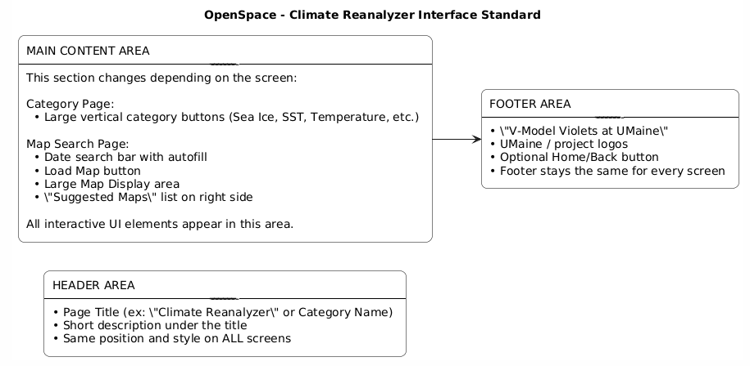
Figure 2.1 OpenSpace - Climate Reanalyzer User Interface Standard

Common Components.
Button Style: Rounded rectangle, consistent size, same colors across screens
Search Bar: autofill with consistent placement.
Category buttons: Same layout and spacing on all category pages
Suggested Maps Panel: will appear on every Map Search Page
Header title
Back/Home Navigation: Same design across all screens

Navigation Standards:
Users will always return to the Landing Page using the back button in the header
The elements of the navigation appear in consistent locations. Footer at the bottom, back button, top left of the screen
Users navigate specific map pages using vertically stacked buttons
Horizontal scrolling. The navigation will flow vertically.

Design Principles:
Minimalist layout is used across all screens
Light text on dark backgrounds. The text will be high contrast.
Consistent font styles for headed and body text.
Buttona s use consistent highlight color for interactivity.
Icons follow a unified visual style.
Important elements (search bar) will use a visual emphasis ( large size)

Error Handling
Error messages will appear directly under the search bar if the date is invalid
Warning messages will use a consistent color
Errors will not black the layout. They will appear inline so users can correct inputs easily.
The load map button remains disabled until the input is valid.

The interface will follow a consistent layout throughout all screens. The three-part layout will have a header area at the top. A main content area in the center and a footer area at the bottom. The layout is predictable, making it easier for users to navigate and find important information that will be located in the same locations across all screens. The header will include the screen title and a description, which helps users understand the context of the page and the information they can expect to see and interact with. Figure 2.1 in the “MAIN CONTENT AREA”. It says, “This section changes depending on the screen.” This means that the main content area changes depending on which page the user is on. The interface design of the main content area will remain consistent.
The main content area changes depending on the user’s workflow within the system. For example, on the Category Page, the main area displays large buttons that go vertically down the main section. These buttons are categorized, such as Sea ice, Sea Surface Temperature (SST), or temperature. On the Map search page, the main area includes the date search bar, the load map button, the map display region, and a sidebar containing suggested maps. The content varies, but the area consistently holds all of the interactive elements that the user uses. Structuring the system this way makes sure the users always know where to look on each screen.
The footer will provide information, including “V-Model Violets at Umaine”, branding Umaine logos, and an optional navigation link, such as home or back, if needed. The footer will remain the same on every page. This will help reinforce project identity. This three-part layout header, main content, and footer form the interface standard that all future screens in the system will follow. In addition to this three-part layout, the interface will use common components, navigation rules, design principles, and error handling to ensure consistency across all screens.

User Interface Walkthrough
The OpenSpace and Climate Reanalyzer Interface’s User Interface will be embedded within the OpenSpace application. Below is a walkthrough of the functions the user will have access to via the User Interface, and how the product will appear as two separate page types that the user will be able to navigate between.

3.1 Navigation Diagram
The Navigation Diagram shown in Figure 3.1 shows the two different types of pages that will be implemented in our user interface, and how the user will navigate between them. Upon opening the Climate Reanalyzer x OpenSpace Interface within the OpenSpace application, the user will be directed to the Landing Page. From there, the user will see multiple buttons that each bring the user to a corresponding Map Search Page. The user may click the back button on the top left to return to the Landing Page.

Climate Reanalyzer

Screen 1: Landing Page
Screen 2: Map Search Page
option1
option2

option…
option1
Map List
Figure 3.1: Navigation Diagram for Climate Reanalyzer x OpenSpace Interf

3.2 Screen Descriptions
The user interface will consist of two different screen types, as shown below.

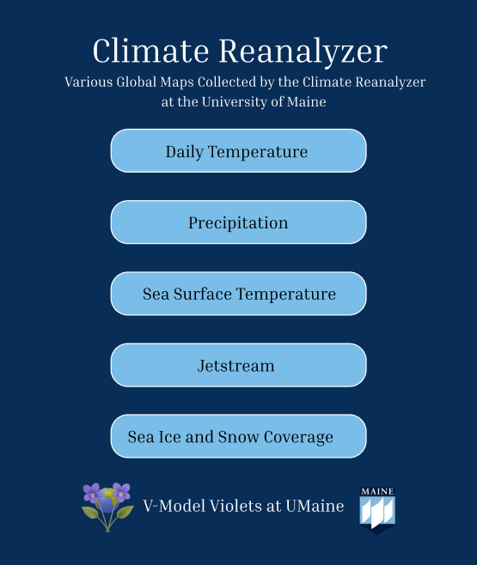
Screen 1: Landing Page
The first screen will be the landing page, which appears when the user first chooses to view the Climate Reanalyzer Maps through OpenSpace. The window will be opened in OpenSpace itself and will generally be rectangular in size,e with it being taller than it is wide. It will feature the title: “Climate Reanalyzer” at the top with a short description: “Various Global Maps Collected by the Climate Reanalyzer at the University of Maine.” It will also feature buttons with the map categories. The user will be able to choose which category they would like to view the maps of. When a category is selected, the system will navigate to a new page, Screen 2 from the Navigation diagram, displaying the maps with available dates for the user to pick from. It will also feature the V-Model Violets and the University of Maine Logos with the text “V-Model Violets at UMaine” at the bottom of the screen.

Figure 3.2.1: Screen 1: Landing Page

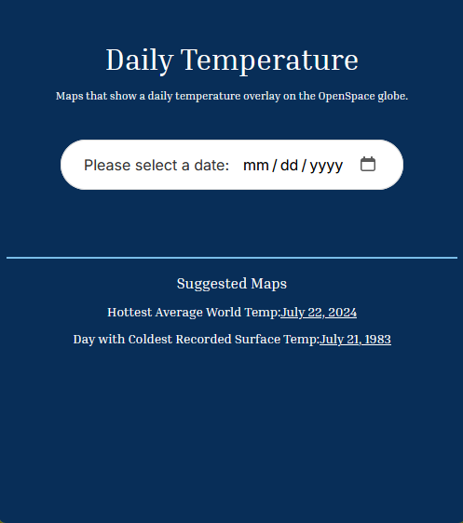
Screen 2: Map Search Page

The second screen will be the page you are directed to after making your selection on the landing page. The second screen will have different variations depending on which selection was made, but functionally, they are the same. The screen will include a title that matches the selection from screen 1, followed by a short description of the chosen option.

Underneath the description will be a calendar picker that will prompt the user to enter the desired date for the map they would like to view. The user will then either manually enter their desired date in the bar following the placeholder format, or may click the calendar icon to select a date from a calendar view.

Near the bottom of the page will also be some hand-picked interesting maps that users can select by clicking the underlined date. These options will be hard-coded in as links and will vary depending on the selection made on screen 1.
Figure 3.2.2: Screen 2: Map Search Page

Data Validation

The OpenSpace and Climate Reanalyzer Interface accepts a small range of inputs from the user that must be properly validated to allow the user to accomplish the desired actions. This section describes the inputs, including the data types, acceptable formats, and validation methods. The list will be provided below in tabular form.

4.1 Data Items

Screen | Data Item Label | Data Type | Allowed Values | Format / Example | Validation Rules
Landing Page | Category Selection Button | String (Enumeration) | “Daily Temperature”, “Precipitation”, “Sea Surface Temperature”, “Jetstream”, “Sea Ice and Snow Coverage” (there may be more depending on data) | One Selection Only | Selection required; the user must choose a valid category button before proceeding.
Map Search Page | Date Input | String (Date) | Valid dates from January 1, 1979, through the current date | MM-DD-YYYY (e.g., 01-12-1997) | Input must match MM-DD-YYYY format; invalid or future dates trigger a warning
Map Search Page | Suggested Map Link | String (URL) | Predefined links to existing datasets | https://climatereanalyzer.org/maps/... | Validation will not be needed here, as they will be given, and the user cannot change them

Appendix D - Code Inspection Report

Table of Contents

1. Introduction 3
1.1 Purpose of This Document 3
1.2 References 3
1.3 Coding and Commenting Conventions 3
1.4 Defect Checklist 4
2. Code Inspection Process 7
2.1 Description 7
2.2 Impressions of the Process 8
2.3 Inspection Meetings 8
3. Modules Inspected 9
4. Defects 11

1. Introduction

The Black Bear Scan project is a software system developed for CompoTech Inc, a defence contracting company that works with large CT scan imagery datasets. The goal of the project is to create a locally hosted web application that allows users to upload, catalog, and manage scan imagery data more efficiently.
The V-Model Violets team was assigned to perform a code inspection of the Black Bear Scan Stream project.

1.1 Purpose of This Document

The purpose of this Code Inspection Report is to document the code inspection process performed by the V-Model Violets team on the Black Bear Scan Stream Project. This report documents the steps taken during the inspection, the modules that were reviewed, and the defects that were identified. This report also summarizes the code and commenting conventions used by the team, which includes a checklist of potential defects discovered during the inspection. The document is intended for the teams involved and the course instructors.

1.2 References

Birkel, S. (n.d.). Weather forecasts. Climate Reanalyzer, Climate Change Institute, University of
Maine. https://climatereanalyzer.org/
OpenSpace Team. (n.d.). OpenSpace. American Museum of Natural History.
https://www.openspaceproject.com
Apache Software Foundation. (n.d.). Apache HTTP Server Project. https://httpd.apache.org/
Sommerville, I. (2015). Software engineering (10th ed.). Pearson Education.
Black Bear Scan Stream Team Scarlet. (2025). System Requirements Specification (SRS). CompoTech Inc. Capstone Project. SRS (Team Scarlet/Black Bear Scan Stream).docx
Black Bear Scan Stream Team Scarlet. (2025). System Design Document (SDD). CompoTech Inc. Capstone Project. SDD.docx

1.3 Coding and Commenting Conventions

Our team used our own coding and commenting conventions based on what we believed would make the project easier to read, maintain, and understand, instead of strictly following an external style guide. The focus was on keeping code consistent across the repository and making sure that each team member followed similar formatting and commenting practices. Our code conventions include using descriptive names for variables and functions, consistent indentation and formatting, and organizing files in a way that makes the structure of the project easier to read and understand.
The commenting conventions we established explain the purpose of important parts of the code. Comments are used to describe the purpose of modules and functions, and mark areas that may need additional work in the future. Keeping both the code and comments consistent, our team was able to better understand each other’s work and maintain the project efficiently.

1.4 Defect Checklist

Below is a comprehensive tabular checklist of possible defects that we discussed during our inspection process. We compiled a list of possible defects during pre-meeting inspection and had our peer team explain whether the defects need to be addressed.

 | Defect ID | Category | Brief Description | Response from Peer Team
1 | S1: Failure to Verify Uploaded Files | Security Oversight | In the ‘backend_helper.py’ @app.post(“/upload/edit/”, response_class=HTMLResponse) section, files are being added into the database before fully verifying and validating the data. This could lead to malicious entries. | They had not considered this as a possibility and will test and work to rectify this.
2 | S2: Failure to Check Uploaded File Size | Security Oversight | In the ‘backend_helper.py’ @app.post(“/upload/edit/”, response_class=HTMLResponse) section, the size of the file is not checked upon entry by the user. This could lead to possible Denial of Service attacks from malicious actors. | There are plans in the future to implement a file size check before they are accepted into the database. This has yet to be implemented.
3 | S3: Accessible JS Files for all Users | Security Oversight | The root folder is mounted, and all of the CSS, HTML, and JS scripts are located in the root folder, meaning someone could access the JavaScript even if they don’t need it. | They will change the structure so the JS will not be available to everyone.
4 | S4: Database Interaction within the Root Folder | Security Oversight | Some scripts interact with the database in the root folder of the repository. They should be inside the frontend or backend folders instead of the root. | They're just command-line interface tools that will eventually be removed. Rather than trying to exit out of everything and erase files, these files were used for testing.
5 | C1: Potential Key Name Overlap | Coding Conventions | In the ‘backend_helper.py’ file, there are two for loops that iterate over two different types of data (nrrd and dcm), but they refer to the same dictionary. Should two of the entries have the same name, wouldn’t the first be overwritten by the second? | It would overwrite the first entry. The only case in which this would happen is if the same data piece existed in both nrrd and dcm. This is more of an efficiency issue than a security issue.
6 | C2: Inconsistent Commenting | Coding Conventions | There are inconsistent levels of commenting in the files. Some files have descriptive comment headers, while others have none or very little written for them. | They plan to comment on all files in a more in-depth way before launch.
7 | C3: Scattered TODO Comments | Coding Conventions | Scattered throughout the files are a bunch of “TODO” comments. They do not appear to have any sort of organization or pattern to them. There is nowhere that ranks them in order of importance. | They have tickets made in their Jira board for these comments. The comment is thrown into the file for an easier time navigating to the location and remembering where the Jira ticket is referencing.
8 | C4: Lack of Test Suites | Coding Conventions | There is currently no testing in the repository. | There are Jira tickets made for testing, but nothing has been done yet.
9 | C5: Inconsistent Error Handling | Coding Conventions | The error handling is very detailed in some places and not in others. | They agree that this is the case. In some places, they test for every possible case, so they, in theory, do not have to check for errors again later.
10 | C6: No index.HTML file | Coding Conventions | Despite the fact that the application is made up of HTML, JS, and CSS, there is no index.HTML file present, which is typically the name for a project’s landing page. | They are not hosting the website; only using localhost. There is no need for an index.HTML file.
11 | L1: Faulty Return Logic | Logic Error | In database.py, the store_record function always returns true. Even if inserting into the database fails. In this case, users would see the success message no matter what. | They had not noticed this and agreed that they should have a try, except block there with a return false.
12 | L2: Returning an int instead of a String | Logic Error | The commented-out section in database.py at the bottom returns an int when it should be a str. Assuming the rest of the section return values are right. | That was a copy-paste issue; they will fix it.
13 | O1: Poor File/Folder Organization | Proper Organization | All the CSS, JS, and HTML files are located within the root folder. There are no other folders to separate the files. | They will organize this in the future.
14 | O2: Orphaned Pull Requests | Proper Organization | There are pull requests in the repository that have not been resolved (whether that be by merging or being denied). | N/A; did not get to this during the review.
15 | O3: GitHub Issues Organization | Proper Organization | GitHub issues appear to be partially utilized in the repository. There are two issues that are open and have been for three months. There are no other issues or boards. | N/A; did not get to this during the review.

2. Code Inspection Process

This section of the document focuses on the code inspection process. On Wednesday, March 4th, our team, V-Model Violets, reviewed our peer team, which was reviewed by our peer team. At the point of the inspection, our repository, as well as that of our peer teams, contains the actual code comprising the projects. The code inspection was done with the purpose of doing static analysis on each team’s code.

2.1 Description

Our team chose to first plan the code inspection process in our weekly team meeting on March 2nd. During this initial meeting, we assigned roles to our team members according to what each person was good at or interested in doing. Then we decided that we would all parse through our sibling team’s repository individually and take notes on things that we found.
We decided that each of the members of the team would find at least three things to discuss, as the Defect Checklist required for this document required at least 15 defects to be listed. This way, we were all obligated to find the minimum amount for our team to hit this mark. This is what we did for the two days between the initial meeting and the Code Inspection meeting.
Then on the day of the report, we kept to the roles we had chosen in the initial meeting, with the exception of the ‘reader’ role. Due to the limited time available to us in the meeting, we knew that it was unlikely we would be able to go through their entire project with a dedicated leader with our sibling team present. We instead had the moderator project the sibling team’s repository while each member of the team, regardless of their role, went through what they discovered independently. The reasoning behind this was that we figured each person would have the best understanding of their own questions since we were unable to have a team meeting before the review due to group availability. Finally, the recorder, Brianna, was the one who took the notes on what Black Bear Scan Stream said for each question, regardless of the author of said questions.

2.2 Impressions of the Process

The code inspection process was rather effective for us as a team. It was nice to get an independent view of our repository, as we knew the nitty-gritty details about our code that the other team did not. Getting an independent view helps us understand how people like our clients or predecessors will view the project once it has been delivered.
We do not believe that we missed out on much by not being able to go through the entirety of our sibling team’s repository with them, since we were all able to go through it individually. A longer time period would have allowed us to do so, but the thirty minutes we were provided in class were more than enough for just going through the questions that we had gathered before the inspection. The one thing that we think could have been done differently to make the process a bit more effective would have been to have a team meeting before the inspection, after we had all individually inspected our sibling team’s repository.

Best and Worst Units:
The best modular units of our peer team’s repository would probably be the frontend sections. We found minimal issues with their frontend when compared with their backend. Anywhere they take in user input, they make sure to sanitize it before accepting it to ensure there is no possibility of malicious input or curl commands coming from the users. The frontend is also straightforward for the most part. The worst modular units of our peer team’s repository would be the backend. The backend wasn’t necessarily bad, but it was the worst of their units. Their commenting and error handling were inconsistent. They had a few security oversight issues with their backend as well. There was no testing present via test suites for the backend either. Overall, the backend felt less polished than the other units of their repository.

2.3 Inspection Meetings
03-04 Code Inspection Meeting:
Inspector: V-Model Violets
Moderator: Emily Scott
Recorder: Brianna Gannett
Reader: Matthew Keast
Inspectors: Hunter Savarese and Brennon Tiensivu
Author: Black Bear Scan Stream (Aiden, Caitlyn, Liv, Garrett, Alex)
Date: March 4, 2026
Time Started: 2:45 PM
Time Ended: 3:15 PM
Location: Ferland Engineering Education and Design Center, Room 214
Code Units Covered:
The majority of the code that was covered in the review was database.py and backend_helper.py. The general repo structure and general comments throughout the other files were also discussed.

3. Modules Inspected
As a team, we inspected 2 major modules in Black Bear Scan Stream’s project. We looked over the general layout and some of the code for their frontend systems, and 2 modules inside their backend module specifically. This section will be in 2 parts, one looking over the frontend and one looking over the backend.

Front end:
The first module we will be looking at is their frontend. The frontend module consists of HTML, CSS, and JavaScript primarily. It is used to create the structure, styling, and functionality of the UI that will be seen and interacted with by the users. This module covers their frontend as it is described within the SDD. It contains the UI and its functionality, including the API to connect with their backend. The frontend contains the following modules:

- Home Page
  - Landing page
  - Navigates to other pages
- File Page
  - Skeleton page for files
- Upload Page
  - A page that contains functionality for uploading files to the database.
- Verify Page
  - Asks the user to verify if the upload was correct or if it failed. Then redirects to the view page.
- View Page
  - Page with functionality to view files from the database.

When these were inspected, we could not find any major faults or any functionality that did not match what was available in the SDD. It has the structure and functionality for the user to upload data files to the backend, and functionality for the user to view files already stored in the database. We did, however, notice some organizational/coding standards issues that might make the code more readable in the future and more easily maintained. The biggest of these is that all of the HTML, CSS, SCSS, and JS files are all located within one folder called “pages”. As is, this works functionally, but it isn’t very organized. We suggested they create separate folders in their repo for styles and scripts. This would clean up the file organization so that when this project is finished and is maintained by another team, it will be easier to find where problems might be, or to add more functional cleanly way. We also suggested that they add clearer commenting to their code and to clean up comments that are “TODOs”. This is a minor issue, but clean comments will also help with maintainability in the future of the project.

Back end:
The second portion of our inspection focused on the backend portion of Black Bear Scan Stream’s project. Specifically, we reviewed two modules: backend_helper.py and database.py. These modules support the server-side functionality of the application and fit within the backend architecture described in the SDD. The main job of the backend is to provide functionality to receive frontend requests, make database interactions, and process uploaded files. The backend_helper.py module primarily acts as the controller for backend behavior. It contains route logic, including the @app.post("/upload/edit/", response_class=HTMLResponse) endpoint used during the file upload process. This is the module that receives user input from the frontend and performs database operations based on those actions.
While the general functionality of backend_helper.py aligns with the design outlined in the SDD, we identified a couple of implementation issues that could impact user experience. Probably the biggest concern we had as a group was that files were uploaded into the database before being fully validated or verified. In most cases, this behavior will work if there is no malicious intent; however, there are many ways for a user to upload a file that could store malicious or malformed data. Furthermore, the uploaded files are not size-checked. Not having this safeguard could lead to unreliably large datasets being entered into the database, which can create a Denial-of-Service-like response from the product. At the very least, these missing features could cause severe performance issues. We also observed some maintainability concerns, such as inconsistent commenting, scattered TODO notes, and inconsistent error handling across different sections of the module. These notes do not directly affect functionality but could make future maintenance more difficult.
The second module we inspected was database.py, which is responsible for interacting with the project’s database. This module fits into the data access layer of the architecture described in the SDD and handles the storage and retrieval of records related to uploaded files. This module’s structure matched the intended design, but we did note some logic issues that could be troublesome. In this module, the biggest issue we found was that the store_record function always returns true, even if the database insertion fails. This means that when a user hits this function throughout their use, they could experience success messages even when database operations were not completed successfully. Going forward, the module should accurately display messages and logs that show when database operations were successful and unsuccessful. One way to do this is through try-except blocks (this is standard coding practice). We also noticed a section of code that was commented out. This section returns an integer value where a string appears to be expected, suggesting some inconsistency in the return types used within the module.
Overall, the backend modules have been designed in practice largely as outlined in the SDD, with backend_helper.py handling request processing and database.py managing persistent storage. With that being said, there are some spots where it seems simple code was prioritized over robust code. Another area of improvement consistent throughout the backend was the lack of validation checks, consistent error handling, and overall code organization. Having this would greatly improve maintainability and reliability. Based on the responses from the peer team, many of these issues have already been acknowledged and are planned to be addressed in future development stages.

4. Defects

Below is a table showing the defects uncovered during our code review. The list comprises items in our defect checklist (see section 1.4) that we deem to be true defects that need addressing. The defects are labelled by the following categories:
- Correctness - defects that do not meet their functional specifications.
- Coding Convention - defects in meeting coding conventions.
- Commenting Convention - missing or incorrect comment violations.
- User Friendliness - defects relating to user experience, including input error handling.
- Other - other defects, such as function and module organization, or refactoring.

Defect | Description | Module | Category
S1: Failure to Verify Uploaded Files | In the ‘backend_helper.py’ @app.post(“/upload/edit/”, response_class=HTMLResponse) section, files are being added into the database before fully verifying and validating the data. This could lead to malicious entries. | Backend Helper | Correctness
S2: Failure to Check Uploaded File Size | In the ‘backend_helper.py’ @app.post(“/upload/edit/”, response_class=HTMLResponse) section, the size of the file is not checked upon entry by the user. This could lead to possible Denial of Service attacks from malicious actors. | Backend Helper | User Friendliness
S3: Accessible JS files for all Users | The root folder is mounted, and all of the CSS, HTML, and JS scripts are located in the root folder, meaning someone could access the JavaScript even if they don’t need it. | Root | Other
C2: Inconsistent Commenting | There are inconsistent levels of commenting in the files. Some files have descriptive comment headers, while others have none or very little written for them. | Throughout codebase | Commenting Convention
C3: Scattered TODO Comments | Scattered throughout the files are a bunch of “TODO” comments. They do not appear to have any sort of organization or pattern to them. There is nowhere that ranks them in order of importance. | Throughout codebase | Coding Convention
C4: Lack of Test Suites | There is currently no testing in the repository. | Needs Module | Coding Convention
C5: Inconsistent Error Handling | The error handling is very detailed in some places and not in others. | Throughout codebase | Correctness
L1: Faulty Return Logic | In database.py, the store_record function always returns true. Even if inserting into the database fails. In this case, users would see the success message no matter what. | Database | Correctness
L2: Returning an int instead of a String | The commented-out section in database.py at the bottom returns an int when it should be a str. Assuming the rest of the section return values are right. | Database | Correctness
O1: Poor File/Folder Organization | All the CSS, JS, and HTML files are located within the root folder. There are no other folders to separate the files. | Root | Other

Appendix E - Administrator Manual

Table of Contents

1. Introduction 3
1.1 Purpose of This Document 3
1.2 References 3
2. System Overview 4
2.1 Background 4
2.2 Hardware and Software Requirements 4
3. Administrative Procedures 6
3.1 Installation 6
3.2 Routine Tasks 6
3.3 Periodic Administration 6
3.4 User Support 6
4. Troubleshooting 7
4.1 Dealing with Error Messages and Failures 7
4.2 Known Bugs and Limitations 8

1. Introduction

This project, titled ClimateReanalyzer and OpenSpace Interface, is a comprehensive capstone project for University of Maine Computer Science students on V-Model Violets (formerly known as Team Violet). This project will be developed in collaboration with Dr. Sean Birkel, a Research Assistant Professor at the Climate Change Institute, and Sean Laatsch, the Director of the Versant Planetarium at the University of Maine. This project will also be collaborating with Dr. Carter Emmart and Micah Acinapura from the OpenSpace team. The goal of this project is to create an image map server that utilizes data from the Climate Reanalyzer, enabling its use by OpenSpace and in planetariums or other research settings.

1.1 Purpose of This Document

This document is intended for the System Administrator for the ClimateReanalyzer and OpenSpace Interface. It is designed to provide instructions on how to install, configure, and manage the interface. It will also contain general information about the interface to allow any new administrators to find any previous documentation and learn more about the interface, what it is for, and how it is used.

1.2 References

Birkel, S. (n.d.). Climate Reanalyzer: Weather forecasts. Climate Change Institute,
University of Maine. https://climatereanalyzer.org/
OpenSpace Team. (n.d.). OpenSpace. American Museum of Natural History.
https://www.openspaceproject.com
Apache Software Foundation. (n.d.). Apache HTTP Server Project.
https://httpd.apache.org/
Sommerville, I. (2015). Software engineering (10th ed.). Pearson Education.
Team V-Model Violets (2025). System Requirement Specification - Climate Reanalyzer X OpenSpace Interface. University of Maine COS397 Computer Science Capstone 1.
Team V-Model Violets (2025). Critical Design Review Document - Climate Reanalyzer X
OpenSpace Interface. University of Maine COS397 Computer Science Capstone 1.
Team V-Model Violets (2025). System Design Document - Climate Reanalyzer X
OpenSpace Interface. University of Maine COS397 Computer Science Capstone 1.
Team V-Model Violets (2025). User Interface Design Document - Climate Reanalyzer X
OpenSpace Interface. University of Maine COS397 Computer Science Capstone 1.

2. System Overview

This section provides an overview of the OpenSpace Climate Reanalyzer Interface, including its purpose, structure, and key components. It explains how the system operates, the technologies it relies on, and the requirements needed to run and maintain it. The system uses Geospatial Data Abstraction Library (GDAL) to process large climate datasets into smaller tiles that can be efficiently stored and delivered. This section is for administrators to give a clear understanding of how the system functions before detailed procedures.

2.1 Background

The OpenSpace and Climate Reanalyzer Interface is a client-server system that allows climate data from the Climate Reanalyzer to be visualized inside OpenSpace. From the perspective of a system administrator. The main responsibility is to keep the tile server running so that OpenSpace can request and display map data correctly.

The system works by taking large climate images and converting them into smaller tiles using GDAL tools. These tiles are stored on the server and delivered through an Apache HTTP server when requested. If a dataset has not already been processed, the system can generate the required tiles when they are first requested. This helps storage and performance. The administrator is responsible for making sure this process works correctly, including managing data, monitoring performance, and ensuring the server remains accessible.

After the completion of the capstone project, the original development team will no longer be maintaining the system. The codebase is open source, so future administrators will be able to continue to update, fix, or expand the system as needed. This means long-term maintenance is flexible rather than dependent on the original team.

2.2 Hardware and Software Requirements

To run and maintain the system. The administrator will need access to the listed hardware and software.

Hardware Requirements:
- ARCSIM VM
- 8 GB of RAM, which is recommended for handling larger data sets.
- 50 GB or more for storage of map data and tiles
- Stable internet connection
Software Requirements:
- Operating Systems: Windows, Linux.
- Apache HTTP server
- GDAL
- Bash
- Python (for tests)

3. Administrative Procedures

This section serves as important information for the program admin to have. It outlines information such as the installation process, routine and periodic tasks the administrator must perform, as well as the ways in which users are able to get support.

3.1 Installation

Three possible types of users will interact with the system: the system administrator, the user, and code maintainers.

The system administrator will need to have access to the virtual machine hosted at the University of Maine. So long as they have access to that, there is nothing else that they will need to install in order to add more data to the system.

The code maintainers will need to follow the installation steps on the Climate Reanalyzer and OpenSpace Interface UI repository on the V-Model Violets GitHub. They will need to clone the repository locally to edit and maintain the code.

The user will need to have only OpenSpace itself downloaded. From within OpenSpace, they will be able to navigate to the Climate Reanalyzer and OpenSpace Interface page and view the data from there.

3.2 Routine Tasks

There are no routine tasks that must be performed.

3.3 Periodic Administration

The only periodic task to be performed will be the periodic running of a shell script in the terminal of the virtual machine environment. This will be performed by Dr. Sean Birkel when new data is added to the server.
To run the sh script: sh script-name-here.sh

3.4 User Support

Should the user require or desire support, there are various avenues they may use to get the specific support they desire. OpenSpace and the Climate Reanalyzer and OpenSpace Interface are all open source, so they are accessible and maintained by members of the general public. The Climate Reanalyzer itself is run by Dr. Sean Birkel at the University of Maine. Users may reach out to any of the below areas, but responses will most likely be prompted from OpenSpace.
OpenSpace-based support:
- support via email at support@openspaceproject.com
- GitHub and documentation at https://github.com/OpenSpace

Climate Reanalyzer and OpenSpace Interface support:
- User Interface code and documentation at https://github.com/V-Model-Violets/OpenSpace-x-ClimateReanalyzer-UI
- Server code and documentation at https://github.com/V-Model-Violets/OpenSpace-x-ClimateReanalyzer-Server
- V-Model Violet’s general GitHub profile https://github.com/V-Model-Violets

Climate Reanalyzer support/questions:
- Support via email at reanalyzer@gmail.com

4. Troubleshooting

This section guides the identification and resolution of common issues encountered while using the system. It outlines typical error scenarios, their causes, and recommended troubleshooting steps, along with known limitations that may impact functionality. This information helps users and administrators diagnose problems and understand current system constraints.

4.1 Dealing with Error Messages and Failures

When using the system, most errors fall into three categories: connection issues, data input issues, and rendering issues.

- OpenSpace Connection Failures
  - If the frontend portion of the project is unable to connect to OpenSpace, the UI will display an error such as “OpenSpace API not available” or “Disconnected from OpenSpace.”
  - Common causes:
    - OpenSpace is not running
    - Incorrect IP address or port
    - WebSocket connection blocked
  - Troubleshooting Tips:
    - Ensure OpenSpace is running
    - Verify the IP address in the input field
    - Refresh the page and reconnect using the “Connect” button
- Tile Server Errors
  - If tiles fail to load (blank image icon), the issue is usually with the Apache tile server.
  - Common causes:
    - Tile Server is down
    - Software Bug
  - Troubleshooting Tips:
    - Reach out to Sean Birkel for Umaine VM status (reanalyzer@gmail.com)
    - Reach out to the development team for a fix
- Invalid or Missing Date Selection:
  - If the user clicks “Submit” without selecting a date, an alert is triggered.
  - Common Causes:
    - Date was not selected
  - Troubleshooting steps:
    - Ensure a date is selected in the calendar before submitting
    - If the calendar is not rendering, check that calendar-picker.js is properly loaded in the web console
- JavaScript Runtime Errors
  - Errors such as missing DOM elements or undefined variables may appear in the browser console.
  - Common Causes:
    - Code Bugs
  - Troubleshooting Tips:
    - Open browser developer tools (F12 → Console)
    - Check for missing script imports or incorrect element IDs
    - Ensure all scripts are loaded in the correct order

4.2 Known Bugs and Limitations

Below are known issues and design limitations identified in the current system.

- Hardcoded Tile Server URL:
  - Location: submitDate() in search-page.js
  - Issue: The current implementation has the server URL hardcoded
    - baseUrl = "http://localhost:54139/tiles/Tif/Bmng/tile";
    - Impact:
      - Limits deployment flexibility
      - Requires code changes if server location changes
    - Fix
      - This will be fixed in the final implementation when the team has full access to Climate Reanalyzer data
  - OpenSpace Dependency
    - Issue:
      - Full functionality depends on OpenSpace being available
    - Impact:
      - If OpenSpace is not running, only partial functionality works (UI only)
    - Fix:
      - Using the current modal viewer as a fallback for showing data
      - Ensure OpenSpace is launched before using the system
  - Calendar Picker Limitations
    - Location: calendar-picker.js
    - Issue:
      - Custom-built calendar (to support OpenSpace browser) lacks advanced features
    - Impact:
      - No keyboard input
      - No direct typing of dates
    - Reason not fixed:
      - Native HTML date inputs are not supported reliably in OpenSpace’s embedded browser
    - Fix:
      - Use mouse-based date picking
  - No Validation of Available Data
    - Issue:
      - The system does not verify whether tile data exists for a selected date
    - Impact:
      - Users may select a valid date, but see missing tiles
    - Fix:
      - Manually ensure the dataset contains tiles for the selected date
      - Future improvement: add server-side metadata validation
  - No Error Feedback from Tile Requests
    - Issue:
      - Failed image loads are not explicitly handled
    - Impact:
      - Users see blank or broken images without explanation
    - Fix:
      - Check the browser network tab for failed requests
      - Future improvement: add image error handling

Appendix F - User Guide
TABLE OF CONTENTS
Introduction 2
Intended Readership 2
Applicability Statement 2
Purpose 2
How to Use this Document 2
Related Documents 3
Conventions 3
Problem Reporting Instructions 4
Overview 5
Instructions 6
Reference Section 8
Error Messages and Recovery Procedures 12
Glossary 14

Introduction
This project, titled ClimateReanalyzer and OpenSpace Interface, is a comprehensive capstone project for University of Maine Computer Science students on V-Model Violets (formerly known as Team Violet). This project will be developed in collaboration with Dr. Sean Birkel, a Research Assistant Professor at the Climate Change Institute, and Sean Laatsch, the Director of the Versant Planetarium at the University of Maine. This project will also be collaborating with Dr. Carter Emmart and Micah Acinapura from the OpenSpace team. The goal of this project is to create an image map server that utilizes data from the Climate Reanalyzer, enabling its use by OpenSpace and in planetariums or other research settings.

Intended Readership
This document is intended for the General User, Science Communicators, and Planetarium Employees as a User Guide for the ClimateReanalyzer and OpenSpace Interface. It is designed to provide instructions on how the program works, its functionality, its capabilities, and how to use the program. This guide is designed to explain this in the most general way possible, as most users of this program will be general users and science communicators who may not have any computer programming background. The most relevant section of this guide for these readers will be the instructions and error handling sections.

Applicability Statement
This issue of the User Guide is designed for the 0.9 release of our software. If you are using a newer version,sion you can find the updated version of this document at https://github.com/V-Model-Violets

Purpose
The purpose of this project is to create a user-friendly interface to browse and view climate data sourced from ClimateReanalyzer within the data visualization program OpenSpace. This User Guide is designed as a helpful guide for the general user to set up and use the project at home or for planetarium staff to use in planetariums worldwide. As these steps are extremely similar,ilar the guide will be a general setup and help guide as there are no differencesetupt up or use for different users.

How to Use this Document
This section contains a short explanation of each major section in this document. Use this to find the section of the document you are looking for at a glance.
Introduction: This section of the document. Contains general information about the project and this document itself. Use this as a “start here” to find where in the document is most helpful to you.
Overview: A more in-depth look at the project. This section will explain what the project does and how it works. Go here for a general understanding of the project.
Instructions: This section will contain step-by-step instructions for how to use the project. Go here to learn how to install and use the project.
Reference Section: This section will contain helpful reference material for using the project. Go here to try and solve specific problems, or for direct instructions for specific functionality.
Error Messages and Recovery Procedures: This section contains Error message information and recovery procedures. Go here if you get an error message and need a solution.
Glossary: This section contains a glossary of terms used in this document. Go here to find definitions of these terms.

Related Documents
Birkel, S. (n.d.). Climate Reanalyzer: Weather forecasts. Climate Change Institute,
University of Maine. https://climatereanalyzer.org/
OpenSpace Team. (n.d.). OpenSpace. American Museum of Natural History.
https://www.openspaceproject.com
Apache Software Foundation. (n.d.). Apache HTTP Server Project.
https://httpd.apache.org/
Sommerville, I. (2015). Software engineering (10th ed.). Pearson Education.
Team V-Model Violets (2025). System Requirement Specification - Climate Reanalyzer X OpenSpace Interface. University of Maine COS397 Computer Science Capstone 1.
Team V-Model Violets (2025). Critical Design Review Document - Climate Reanalyzer X
OpenSpace Interface. University of Maine COS397 Computer Science Capstone 1.
Team V-Model Violets (2025). System Design Document - Climate Reanalyzer X
OpenSpace Interface. University of Maine COS397 Computer Science Capstone 1.
Team V-Model Violets (2025). User Interface Design Document - Climate Reanalyzer X
OpenSpace Interface. University of Maine COS397 Computer Science Capstone 1.

Conventions
There are no major stylistic conventions used in this document. The interface is very straightforward, ward with no direct input from the user beyond clicking on interactable buttons with a mouse.

Problem Reporting Instructions
Report all software problems by going to GitHub at https://github.com/V-Model-Violets/OpenSpace-x-ClimateReanalyzer-UI and opening a new issue.
Background (System Overview)
OpenSpace and Climate Reanalyzer Interface is a system designed to allow users to view and interact with climate data within the OpenSpace visualization environment. From a user’s perspective, the system acts as a connection between Climate Reanalyzer data and OpenSpace, which enables the selection, loading, and display of global climate maps in an interactive 3D format.
The basic operations of the system include selecting datasets, choosing dates, loading map tiles, and displaying those maps in OpenSpace. Users interact with the system through a simple interface where they can choose available climate datasets, select specific dates, and display those maps directly in OpenSpace. The system takes user input, then retrieves the appropriate map from the Climate Reanalyzer source or tile server, and outputs a visual representation of that data onto the OpenSpace platform. This allows users to explore climate patterns such as temperature, precipitation, atmospheric conditions, and other environmental data visually and interactively. The system also supports features such as zooming into different levels of map details, and matching the dates so the OpenSpace platform has the same date as the map selected.
The system assumes that the users have basic computer skills, being able to use a web browser, clicking buttons, and selecting options from the drop-down menus. Users will also need a basic knowledge of the OpenSpace software. Being able to open an HTML file and being able to connect the UI to OpenSpace. No programming knowledge is required. The interface is designed to be easy and consistent. General users and planetarium staff can operate it with minimal training.
Instructions
This section provides step-by-step instructions for connecting the Climate Reanalyzer and OpenSpace Interface within the OpenSpace application, as well as each operation within the interface. In order to follow these instructions, users must first install and run OpenSpace and be familiar with accessing maps in the application. Instructions for this are provided in official documentation on the OpenSpace Project website (https://docs.openspaceproject.com/). Below is a list of operations users can perform in the interface. For each operation, we include a description of the operation and its outcomes, cautions and warnings related to the operation, instructions on procedures to perform the operation, and potential errors and causes while performing the operation.
- Launching the User Interface
  - Users can open the UI for the OpenSpace and Climate Reanalyzer interface directly from a downloaded copy of the OpenSpace-x-ClimateReanalyzer-UI repository. This allows the user to access all of the functionalities of the interface.
  - Cautions and warnings:
    - Users must download the most recent version of the software in its entirety for the operation to succeed.
    - Users must have a browser capable of opening HTML files.
  - Instructions:
    - Download the OpenSpace-x-ClimateReanalyzer-UI files from GitHub.
    - Open the downloaded folder in your file explorer and open the index.html file to view in your browser.
  - Potential errors:
    - Incorrect/Incomplete download: If the source code is not fully downloaded to the user’s local file system, the index.html file will not display the UI as expected.
    - Malformed file path: If the path to the index.html file in the browser does not match the correct path, the browser will not be able to access the UI.
- General Page Navigation
  - The main page navigation of the interface consists of selecting weather variable types under “Daily Weather Maps” to view available maps for each variable type, such as Air Temperature or Precipitation, and returning to the home page.
  - Cautions and warnings:
    - Data is only available for the weather variable types listed
    - Users should be sure to select the correct variable for the map type they wish to view and interpret. Brief descriptions of each variable are included in the UI.
  - Instructions:
    - Click on any of the weather variable buttons to navigate to the page for that map type.
    - Click on the back arrow in the top left corner of the screen to return to the home page.
  - Potential errors:
    - Page navigation failure: Navigation may fail if the source code was not correctly downloaded.
- OpenSpace Connection
  - From any page under Daily Weather Maps, the user can connect or reconnect to OpenSpace in order to show a selected map in the OpenSpace Application.
  - Cautions and warnings:
    - OpenSpace must be installed on the user’s device.
    - Users may need to click Reconnect after OpenSpace completes launching.
  - Instructions:
    - Launch OpenSpace on your device.
    - From any weather variable page, click the Reconnect button to establish a connection with OpenSpace with the default localhost hostname.
  - Potential errors:
    - Unable to form OpenSpace connection: If the user has not launched the OpenSpace application on the local system where the UI is installed, a connection will not be established.
- Browse Dates for Maps
  - Users will be able to browse maps by date via the calendar module in the weather maps pages. It is important to note that the interface has limited data currently, and most date searches will come up empty.
  - Cautions and warnings:
    - The calendar picker includes many dates with currently no data.
    - The user must navigate to the correct layer in the OpenSpace application to view the map there.
  - Instructions:
    - With a weather variable selected, select a month and year within the calendar module to view the desired days.
    - Select the day that you wish to view a map for.
    - Hit the submit button below the calendar module.
    - If a map result shows up, click it to open. If not, there is no map in the system for that date.
  - Potential errors:
    - No map data available: If the user clicks Submit after selecting a date without a pop-up, it will inform the user that there is no map data available for the selected date.
    - No date selected: If the user clicks submit without selecting a date in the calendar pickpop-up popup will direct the user to select a date.
- Toggle between map layers
  - From any page under Daily Weather Maps, the user can toggle between map layers that have previously been submitted through the map browser during the session.
  - Cautions and warnings:
    - If the user resets a session, saved map layers will be lost from the layers; the elector and the calendar picker will need to be used to view the layers again.
    - The Select Layer dropdown contains variable IDs for each layer. areich is a shortened version of the previously selected weather variable name and date.
  - Instructions:
    - Click on the Select Layer dropdown menu below the calendar picker, and select one of the previously opened maps.
    - Click on the Toggle Layer button to reopen the selected map
  - Potential errors:
    - Empty layer selection dropdown: If the user has not submitted any valid maps during the session, then the layer selection dropdown will be empty,y and there will be no toggleable layers.
    - No layer selected: If the user clicks Toggle Layer without selecting a layer via the dropdown pop-up, it will direct the user to select a layer.
Reference Section
This section describes the system capabilities and operations of the Climate Reanalyzer and OpenSpace Interface. The system consists of a web-based user interface that enables users to select climate datasets, retrieve tiled imagery from a server, and display the data within the OpenSpace visualization platform. The operations described below include functional descriptions, parameters, usage syntax, examples, and potential error conditions.

- Calendar Picker Operations
  - Functional Description
    - The calendar picker provides functionality for an interactive interface that allows the user to select a date. It is implemented as a custom JavaScript component to ensure compatibility with embedded browser environments that may not support native HTML date inputs. It allows the user to browse dates and transform them into a standard format.
  - Cautions and Warnings
    - The calendar picker requires a valid DOM container element. If the specified container does not exist, the component will fail to initialize. Invalid date inputs provided programmatically will be ignored without updating the interface.
  - Formal Description
    - Operation: CalendarPicker Constructor
      - Required Parameters:
        - containerId (string): The ID of the HTML element where the calendar will be rendered
      - Optional Parameters:
        - minYear (number): Minimum selectable year
        - maxYear (number): Maximum selectable year
        - onDateSelect (function): Callback executed when a date is selected
      - Default Options:
        - minYear = 1900
        - maxYear = current year + 10
        - onDateSelect = no operation
      - Order and Syntax:
        - new CalendarPicker(containerId, options)
      - Examples
        - new CalendarPicker("dateInput")
        - new CalendarPicker("dateInput", { minYear: 1940, maxYear: 2030 })
      - To retrieve a value:
        - getValue() → returns date in "YYYY-MM-DD" format
      - To set a value:
        - setValue("2026-03-04")
      - Inputs:
        - containerId (string, required): The ID of the target HTML container element
        - minYear (number, optional): Lower bound for selectable years
        - maxYear (number, optional): Upper bound for selectable years
        - onDateSelect (function, optional): Callback triggered on date selection
      - Outputs:
        - Rendered calendar widget mounted in the specified container
        - getValue() returns the selected date as a string in "YYYY-MM-DD" format
        - setValue() updates the displayed date; no output if the date string is invalid
      - Possible Error Messages and Causes
        - “Calendar container with ID not found”: The specified container element does not exist
        - No update after setting a value: Invalid date string provided
      - Cross-References
        - Used by the Search Page Operation.
- OpenSpace Connection Operation
  - Functional Description
    - Establishes a WebSocket connection to the OpenSpace application. Upon connection, the system initializes access to the OpenSpace API and enables communication for updating simulation time and rendering tile layers.
  - Cautions and Warnings
    - This operation requires the OpenSpace API script to be loaded. If the API is unavailable, the connection cannot be established. Network issues or incorrect host configuration may prevent a successful connection.
  - Formal Description
    - Operation: connectToOpenSpace()
      - Required Parameters:
        - None (host defaults to user input or "localhost")
      - Optional Parameters:
        - Host (string, from UI input field)
        - Port (number, default = 4682)
      - Default Options:
        - Host = "localhost"
        - Port = 4682
      - Order and Syntax:
        - connectToOpenSpace()
      - Examples
        - Connect using default settings
        - Connect using the user-provided IP address
      - Inputs:
        - Host (string, optional): IP address or hostname entered via the UI input field; defaults to "localhost."
        - Port (number, optional): Port number for the WebSocket connection; defaults to 4682
      - Outputs:
        - Active WebSocket connection to OpenSpace
        - Initialized OpenSpace API object ready for subsequent operations
      - Possible Error Messages and Causes
        - “OpenSpace API not available”: Required script not loaded
        - “Disconnected from OpenSpace”: Connection lost
        - Initialization failure: API connected, but the library failed to load
      - Cross-References
        - Used by Search Page Initialization and OpenSpace Update Operation.
- Date Submission Operation
  - Functional Description
    - Processes the selected date from the calendar picker, initializes the tile server URL, and updates the OpenSpace environment with the selected date and imagery.
  - Cautions and Warnings
    - A date must be selected before submission. If no date is selected, the operation will not proceed.
  - Formal Description
    - Operation: submitDate()
      - Required Parameters:
        - None (uses selected date from calendar picker)
      - Optional Parameters:
        - None
      - Default Options:
        - Base URL defaults to the local tile server
      - Order and Syntax:
        - submitDate()
      - Examples
        - User selects date → submits → visualization loads
      - Inputs:
        - Selected date (string, required): Read implicitly from the CalendarPicker instance via getValue(); must be in "YYYY-MM-DD" format
        - Base URL (string, optional): Tile server base URL; defaults to the local tile server
      - Outputs:
        - Initialized tile server URL passed to the Tile Display Operation
        - Selected date and imagery submitted to the OpenSpace environment via the OpenSpace Update Operation
      - Possible Error Messages and Causes
        - “Please select a date first.”: No date selected
        - OpenSpace update failure: Connection not established or API error
      - Cross-References
        - Uses Calendar Picker and OpenSpace Update Operation
- Tile Display Operation
  - Functional Description
    - Retrieves and displays map tiles from the configured tile server based on the selected dataset and date.
  - Cautions and Warnings
    - Requires a valid tile server base URL. If not set or unavailable, no image data will be displayed.
  - Formal Description
    - Operation: Tile Retrieval and Display
      - Required Parameters:
        - Base tile server URL
        - Selected date
      - Optional Parameters:
        - None
      - Examples
        - Tile images are automatically retrieved after date submission
      - Inputs:
        - Base tile server URL (string, required): Set by the Date Submission Operation; must be valid and reachable
        - Selected date (string, required): Used to identify which tile images to retrieve
      - Outputs:
        - Map tile images rendered in the interface for the given date and dataset
      - Possible Error Messages and Causes
        - Missing image: Base URL not set or server unavailable
      - Cross-References
        - Used by Date Submission Operation.
- Hosted Layer Creation Operation
  - Functional Description
    - Generates GDAL-compatible XML configurations and submits them to OpenSpace to create new image layers sourced from a tile server.
  - Cautions and Warnings
    - Invalid resolution or format values will cause errors. Tile server URLs must follow the expected structure.
  - Formal Description
    - Operations:
      - createTileServerGdalXml(layerName, date, resolution, format, options)
      - buildOpenSpaceLayerConfig(layerName, xmlString)
      - addHostedLayerToOpenSpace(apiObject, params)
    - Required Parameters:
      - layerName (string)
      - date (string or token)
      - resolution (string)
      - format (string)
    - Optional Parameters:
      - options (object)
      - layerOverrides (object)
    - Default Options:
      - Projection = EPSG:4326
    - Examples
      - Create a static layer
      - Create a temporal layer using a date token
    - Inputs:
      - createTileServerGdalXml: layerName (string, required), date (string or token, required), resolution (string, required), format (string, required), options (object, optional)
      - buildOpenSpaceLayerConfig: layerName (string, required), xmlString (string, required)
      - addHostedLayerToOpenSpace: apiObject (object, required), params (object, required), layerOverrides (object, optional)
    - Outputs:
      - createTileServerGdalXml: GDAL-compatible XML configuration string for the tile layer, using EPSG:4326 projection by default
      - buildOpenSpaceLayerConfig: Structured layer configuration object ready for submission to OpenSpace
      - addHostedLayerToOpenSpace: New image layer registered and active in OpenSpace via the API
    - Possible Error Messages and Causes
      - Unsupported resolution or format
      - Missing required parameters
      - API submission failure
    - Cross-References
      - Used by OpenSpace Update Operation and Tile Server Integration.

Error Messages and Recovery Procedures
The Climate Reanalyzer and OpenSpace interface have multiple error-handling notification protocols in place. Errors may occur due to failed connections or missing data, in which case, necessary information will be shown in the user interface. This section describes each error message users may encounter and how to troubleshoot issues.
Failure to Connect to OpenSpace
Should the Interface fail or be unable to connect to OpenSpace, a message will appear in red below the header for said page reading, “Disconnected from OpenSpace”.
To reconnect, the user should hit the blue ‘Reconnect’ button to the right of the message. The user will know when the connection has been successful as the red error message will change to a green success message reading, “Connected to OpenSpace”.
The most common reason this error will occur is that the user is attempting to run the interface without having OpenSpace open on their system as well. Ensure OpenSpace is open and running before hitting ‘Reconnect’.
Detailed Steps:
- Check that OpenSpace is Open
- Hit the ‘Reconnect’ button
  - The interface has successfully reconnected
    - Resume use of the application as usual
  - The interface has not reconnected
    - Double-check that OpenSpace is open and running properly
    - Restart OpenSpace
    - Hit the ‘Reconnect’ button again
    - Repeat Step 2 until Step 2a is the outcome

Failure to Bring Up a Map
Should the system fail to bring up that which is present on the map server, the globe in OpenSpace will have no changes, turn all over blue, or turn all over gray, depending on the other settings the user has selected for the globe.
This failure occurs when the map cannot access the server. In order to remedy this problem, the user can restart OpenSpace itself and try again. If the failure is still occurring, it is likely that the tile server itself is down. If the server is down for whatever reason, the server manager, Dr. Sean Birkel, is the one who must assess and remedy the problem. Dr. Sean Birkel can be contacted via email at birkel@maine.edu.
Detailed Steps:
- Close OpenSpace Entirely
- Reopen OpenSpace and the Interface
- Ensure the interface is connected to OpenSpace
- Pick the date on the calendar picker in the OpenSpace
  - The map has successfully appeared
    - Resume use of the application as usual
  - The map has still not appeared
    - Try a different date’s map
    - Contact the server manager about the issue
    - Wait until the server is no longer having issues
    - Resume use of the application as usual

Selected Date has no Correspondence. ding Data
Should a map not be present for a date selected by the user, the system will inform the user as such and will not bring up a map. This is not unexpected behavior for the system, and the user just has to navigate to aonate in which there is a map present.

Glossary
This is the glossary of terms used in the User Guide for the Climate Reanalyzer and OpenSpace interface,erface which may be unfamiliar to a general user. Entries are formatted in the following as seen below. The glossary is organized in alphabetical order.

Term | Definition | References
API (Application Programming Interface) | A system that allows two applications to communicate | 9, 10, 11
Callback Function | A function that runs after an event (e.g., date selection) | 8
Climate Reanalyzer (CR) | A platform for visualizing climate and weather forecast models | 2, 3, 5, 6, 8, 12
The library |  | 10, 11
HTML (HyperText Markup Language) | The file format used to create the interface (index.html) | 5, 6, 8
JavaScript | Programming language used to implement interactive features like the calendar | 8
Layer (Visualization Layer) | A map or dataset displayed on the OpenSpace globe | 9, 10, 11
Localhost | The local machine address used for testing (typically 127.0.0.1) | 6, 9, 10, 11
OpenSpace | An open-source interactive data visualization software designed to visualize the entire known universe and portray our ongoing efforts to investigate the cosmos | 2, 3, 5, 6, 8–12
GDAL (Geospatial Data Abstraction Library)The library | Library used for geospatial data processing | 9
Port | A communication endpoint (e.g., 4682 used by OpenSpace) | 9
Projection (Map Projection) | Method used to display Earth data on a 2D/3D surface | 11
Tile / Tiles / Tiled | Rectangular sections of a larger file are used to project the full map onto the 3D globe | 5, 6, 8–12
Tile Layer Configuration (GDAL XML)The configuration | Configuration file format used to define map layers | 10, 11
User Interface (UI) | The visual layout (buttons, menus, calendar) that users interact with | 5, 6, 9
WebSocket | Communication protocol used to connect the interface to OpenSpace | 9

Appendix G - Team Review and Sign-Off
We, the team at V-Model Violets, all agree and sign off on all the information provided in this document. The document has been reviewed by all members, and we agree on its content, and it is formatted in a way we all agree on. No one in the team has any major issues with the document or its layout. Any minor issues may be listed in the comments below.

Signed
V-Model Violets Team:

Emily Scott: Date: 05/06/2026

Comments:______________________________________________________________________________________________________________________________________________

Brianna Gannett: Date: 05/06/2026

Comments:______________________________________________________________________________________________________________________________________________

Brennon Tiensivu: Date: 05/06/2026

Comments:______________________________________________________________________________________________________________________________________________

Hunter Savarese: Date: 05/06/2026

Comments:______________________________________________________________________________________________________________________________________________

Matthew Keast: Date: 05/06/2026

Comments:______________________________________________________________________________________________________________________________________________

Appendix H - Document Contributions

Emily Scott’s contributions: Completed Requirements Section, Unmet Requirements section, and Appendices. 20%

Brianna Gannet’s Contributions: Worked on the format, completed the User Interface Section Glossary, and other preliminaries. 20%

Brennon Tiensivu’s Contributions: Completed the Dev/Ops CI/CD part of the design section and the what to do next and maintenance sections. 20%

Hunter Savarese’s Contributions: Completed the Architecture part of the document, the results section, and the References, Bibliography, and related sections. 20%

Matthew Keast’s Contributions: Completed the Executive Summary, The problem, the conclusion sections. 20%

