

User Interface Design Document

OpenSpace and Climate Reanalyzer Interface

Team Violet:
Brianna Gannett, Brennon Tiensivu, Hunter Savarese, Matthew Keast, Emily Scott

Clients:
Dr. Sean Birkel, Mr. Shawn Laatsch, Micah Acinapura

Version Control

Version | Date Finalized
1.0 | Nov 17, 2025
2.0 | Dec 3, 2025

Table of Contents

Page

1. Introduction 2
1.1 Purpose of This Document 3
1.2 References 3
2. User Interface Standards 4
3. User Interface Walkthrough 5
3.1 Navigation Diagram 5
3.2 Screen Descriptions 6
4. Data Validation 8
4.1 Data Items
Appendix A – Agreement Between Customer and Contractor 9
Appendix B – Team Review Sign-off 10
Appendix C – Document Contributions 11

Introduction

This project, titled OpenSpace and Climate Reanalyzer Interface, is a comprehensive capstone project for University of Maine Computer Science students on V-Model Violets (formerly known as Team Violet). This project will be developed in collaboration with Dr. Sean Birkel, a Research Assistant Professor at the Climate Change Institute, and Sean Laatsch, the Director of the Versant Planetarium at the University of Maine. This project will also be collaborating with Dr. Carter Emmart and Micah Acinapura from the OpenSpace team. The goal of this project is to create an image map server that utilizes data from the Climate Reanalyzer, enabling its use by OpenSpace and in planetariums or other research settings.

Purpose of This Document

The purpose of this User Interface Design Document (UIDD) is to detail the standards, design, and data validation for the user interface of the OpenSpace and Climate Reanalyzer Interface. The document also describes how the user will interact with the interface to access all of the product’s functionalities. This document will serve as a blueprint for our team, the clients, and the teaching staff for the Capstone class, outlining the functionality and appearance of the user interface. The UIDD is intended for:
- Capstone Team Members: To guide the group through the implementation process, as well as ensure the client’s needs are met.
- Clients: To show how we plan to construct the system in a transparent and informative way.
- University of Maine Faculty: To assess the progress of the project.

References

The table below lists the sources being used for this project currently:
Title | Author(s) | Publisher / Organization | Date | Citation
Climate Reanalyzer | Dr. Sean Birkel | Climate Change Institute, University of Maine | Ongoing | Birkel, S. (n.d.). Weather forecasts. Climate Reanalyzer. https://climatereanalyzer.org/
OpenSpace | OpenSpace Team | American Museum of Natural History | Ongoing | OpenSpace. (n.d.). OpenSpace. https://www.openspaceproject.com
Apache HTTPD Server Documentation | Apache Software Foundation | Open Source | 1997-Current | Apache Software Foundation. (n.d.). Apache HTTP Server Project. https://httpd.apache.org/
Software Engineering (10th Edition) | Ian Sommerville | Pearson Education | 2015 | Sommerville, I. (2015). Software engineering (10th ed.). Pearson Education.

User Interface Standards
The following standards outline our goals for the appearance and functionality of our user interface regarding components, navigation, error handling, and overall design.
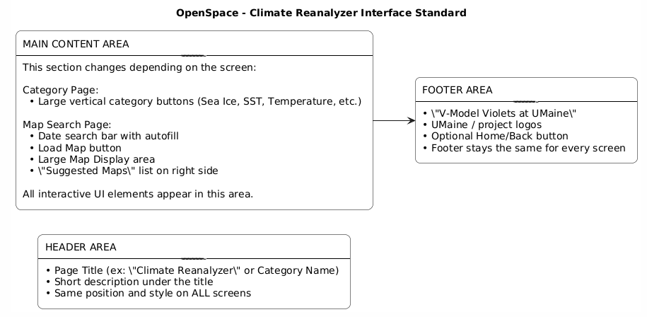

Figure 2.1 OpenSpace - Climate Reanalyzer User Interface Standard

Common Components.
Button Style: Rounded rectangle, consistent size, same colors across screens
Search Bar: autofill with consistent placement.
Category buttons: Same layout and spacing on all category pages
Suggested Maps Panel: will appear on every Map Search Page
Header title
Back/Home Navigation: Same design across all screens

Navigation Standards:
Users will always return to the Landing Page using the back button in the header
The elements of the navigation appear in consistent locations. Footer at the bottom, back button top left of screen
Users navigate specific map pages using vertically stacked buttons
Horizontal scrolling. The navigation will flow vertically.

Design Principles:
Minimalist layout is used across all screens
Light text on dark backgrounds. The text will be high contrast.
Consistent font styles for headed and body text.
Buttons use consistent highlight color for interactivity.
Icons follow a unified visual style.
Important elements (search bar) will use a visual emphasis ( larger size.)

Error Handling
Error messages will appear directly under the search bar if date is invalid
Warning messages will use a consistent color
Errors will not black the layout. The will appear inline so users can correct inputs easily.
Load map button remains disabled until the input is valid.

The interface will follow a consistent layout throughout all screens. The three-part layout will have a header area at the top. A main content area in the center and a footer area at the bottom. The layout is predictable, making it easier for users to navigate and find important information that will be located in the same locations across all screens. The header will include the screen title and a description, which helps users understand the context of the page and the information they can expect to see and interact with. Figure 2.1 in the “MAIN CONTENT AREA”. It says “This section changes depending on the screen.” This means that the main content area changes depending on which page the user is on. The interface design of the main content area will remain consistent.
The main content area changes depending on the user’s workflow within the system. For example, on the Category Page, the main area displays large buttons that go vertically down the main section. These buttons are categorized, such as Sea ice, Sea Surface Temperature (SST), or temperature. On the Map search page, the main area includes the date search bar, the load map button, the map display region, and a sidebar containing suggested maps. The content varies, but the area consistently holds all of the interactive elements that the user uses. Structuring the system this way makes sure the users always know where to look on each screen.
The footer will provide information, including “V-Model Violets at Umaine”, branding Umaine logos, and an optional navigation link, such as home or back, if needed. The footer will remain the same on every page. This will help reinforce project identity. This three-part layout header, main content, and footer form the interface standard that all future screens in the system will follow. In addition to this three-part layout, the interface will use common components, navigation rules, design principles, and error handling to ensure consistency across all screens.

User Interface Walkthrough
The OpenSpace and Climate Reanalyzer Interface’s User Interface will be embedded within the OpenSpace application. Below is a walkthrough of the functions the user will have access to via the User Interface, and how the product will appear as two separate page types that the user will be able to navigate between.

3.1 Navigation Diagram
The Navigation Diagram shown in Figure 3.1 shows the two different types of pages that will be implemented in our user interface, and how the user will navigate between them. Upon opening the Climate Reanalyzer x OpenSpace Interface within the OpenSpace application, the user will be directed to the Landing Page. From there, the user will see multiple buttons that each bring the user to a corresponding Map Search Page. The user may click the back button on the top left to return to the Landing Page.

Climate Reanalyzer

Screen 1: Landing Page
Screen 2: Map Search Page
option1
option2

option…
option1
Map List
Figure 3.1: Navigation Diagram for Climate Reanalyzer x OpenSpace Interface

3.2 Screen Descriptions
The user interface will consist of two different screen types as shown below.

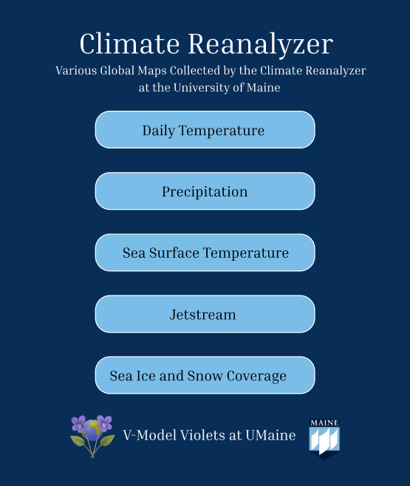
Screen 1: Landing Page
The first screen will be the landing page, which appears when the user first chooses to view the Climate Reanalyzer Maps through OpenSpace. The window will be opened in OpenSpace itself and will generally be rectangular in size with it being taller than it is wide. It will feature the title: “Climate Reanalyzer” at the top with a short description: “Various Global Maps Collected by the Climate Reanalyzer at the University of Maine.” It will also feature buttons with the map categories. The user will be able to choose which category they would like to view the maps of. When a category is selected, the system will navigate to a new page, Screen 2 from the Navigation diagram, displaying the maps with available dates for the user to pick from. It will also feature the V-Model Violets and the University of Maine Logos with the text “V-Model Violets at UMaine” at the bottom of the screen.

Figure 3.2.1: Screen 1: Landing Page

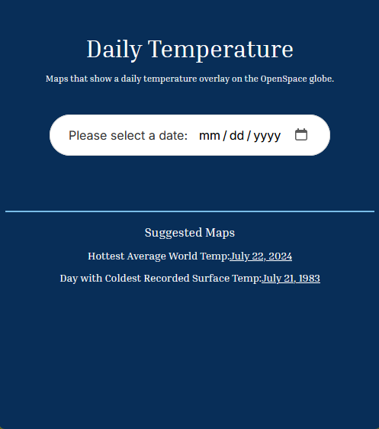
Screen 2: Map Search Page

The second screen will be the page you are directed to after making your selection on the landing page. The second screen will have different variations depending on which selection was made, but functionally, they are the same. The screen will include a title that matches the selection from screen 1, followed by a short description of the chosen option.

Underneath the description will be a calendar picker that will prompt the user to enter the desired date for the map they would like to view. The user will then either manually enter their desired date in the bar following the placeholder format, or may click the calendar icon to select a date from a calendar view.

Near the bottom of the page will also be some hand-picked interesting maps that users can select by clicking the underlined date. These options will be hard-coded in as links and will vary depending on the selection made on screen 1.
Figure 3.2.2: Screen 2: Map Search Page

Data Validation

The OpenSpace and Climate Reanalyzer Interface accepts a small range of inputs from the user that must be properly validated to allow the user to accomplish the desired actions. This section describes the inputs, including the data types, acceptable formats, and validation methods. The list will be provided below in tabular form.

4.1 Data Items

Screen | Data Item Label | Data Type | Allowed Values | Format / Example | Validation Rules
Landing Page | Category Selection Button | String (Enumeration) | “Daily Temperature”, “Precipitation”, “Sea Surface Temperature”, “Jetstream”, “Sea Ice and Snow Coverage” (there may be more depending on data) | One Selection Only | Selection required; the user must choose a valid category button before proceeding.
Map Search Page | Date Input | String (Date) | Valid dates from January 1, 1979, through the current date | MM-DD-YYYY (e.g., 01-12-1997) | Input must match MM-DD-YYYY format; invalid or future dates trigger a warning
Map Search Page | Suggested Map Link | String (URL) | Predefined links to existing datasets | https://climatereanalyzer.org/maps/... | Validation will not be needed here, as they will be given, and the user cannot change them

Appendix A – Agreement Between Customer and Contractor

The team at V-Model Violets and our clients, Dr. Sean Birkel, Shawn Laatsch, and the team at The OpenSpace Project, all agree that the documentation provided here adequately represents how the product’s user interface should be designed. This document shows the appearance and functionality of the user interface of the product within the OpenSpace interface. As the product is developed, changes may be made to this document to cover changing interface needs based on continuous feedback. If changes are made, the clients will be notified of the changes so they remain up to date on the design of the user interface.

Signed
V-Model Violets Team:

Emily Scott: Emily Scott Date: 12/08/2025

Brianna Gannett: Brianna Gannett Date: 12/08/2025

Brennon Tiensivu: Brennon Tiensivu Date: 12/08/2025

Hunter Savarese: Hunter Savarese Date: 12/08/2025

Matthew Keast: Matthew Keast Date: 12/08/2025

Clients:

Dr. Sean Birkel:_________________________________________ Date:_____/_____/_____

Shawn Laatsch:_________________________________________ Date:_____/_____/_____

Micah Acinapura:_______________________________________ Date:_____/_____/_____

Appendix B – Team Review Sign-off

We, the team at V-Model Violets, all agree and sign off on all the information provided in this document. The document has been reviewed by all members, and we agree on its content, and it is formatted in a way we all agree on. No one in the team has any major issues with the document or its layout. Any minor issues may be listed in the comments below.

Signed
V-Model Violets Team:

Emily Scott: Emily Scott Date: 12/08/2025

Comments:______________________________________________________________________________________________________________________________________________

Brianna Gannett: Brianna Gannett Date: 12/08/2025

Comments:______________________________________________________________________________________________________________________________________________

Brennon Tiensivu: Brennon Tiensivu Date: 12/08/2025

Comments:______________________________________________________________________________________________________________________________________________

Hunter Savarese: Hunter Savarese Date: 12/08/2025

Comments:______________________________________________________________________________________________________________________________________________

Matthew Keast: Matthew Keast Date: 12/08/2025

Comments:______________________________________________________________________________________________________________________________________________

Appendix C – Document Contributions

Emily Scott’s contributions: Completed half of section 3. 20%

Brianna Gannet’s Contributions: Completed half of section 3. 20%

Brennon Tiensivu’s Contributions: Completed section 4. 20%

Hunter Savarese’s Contributions:. Completed section 2. 20%

Matthew Keast’s Contributions: Completed sections 1. Contributed to section 3. Added Appendices A - C. 20%

