Challenge 1:
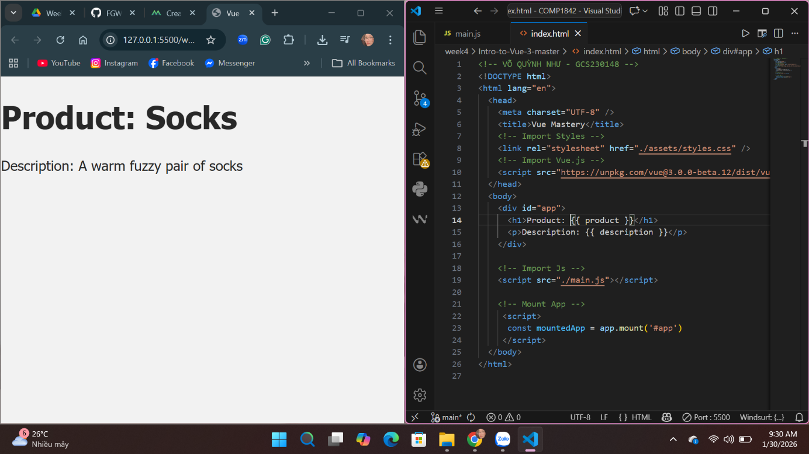
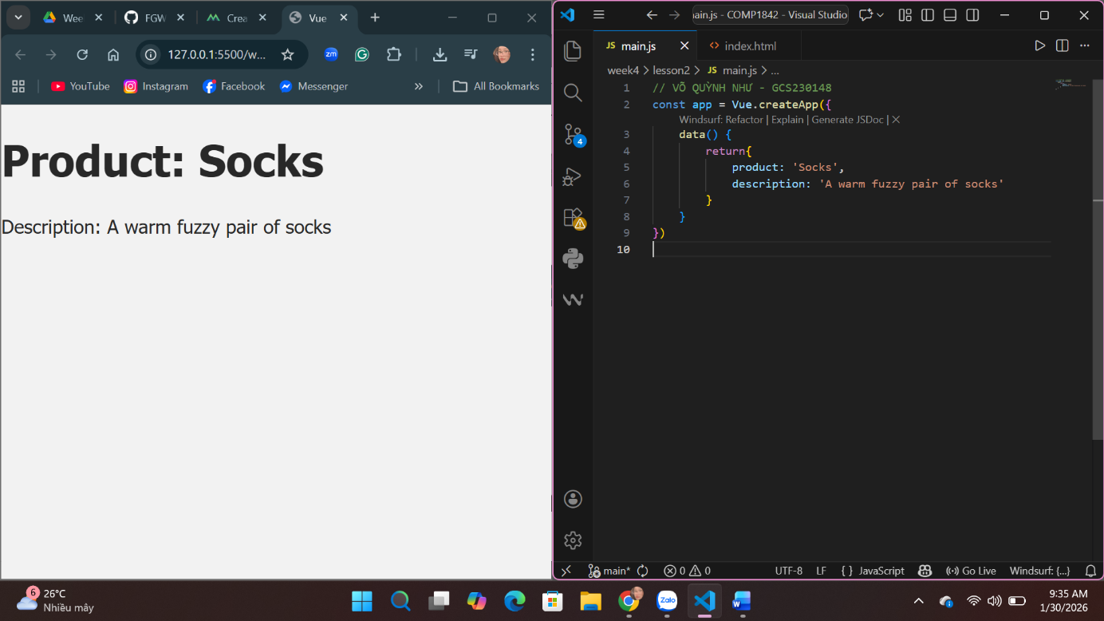

Challenge 2:
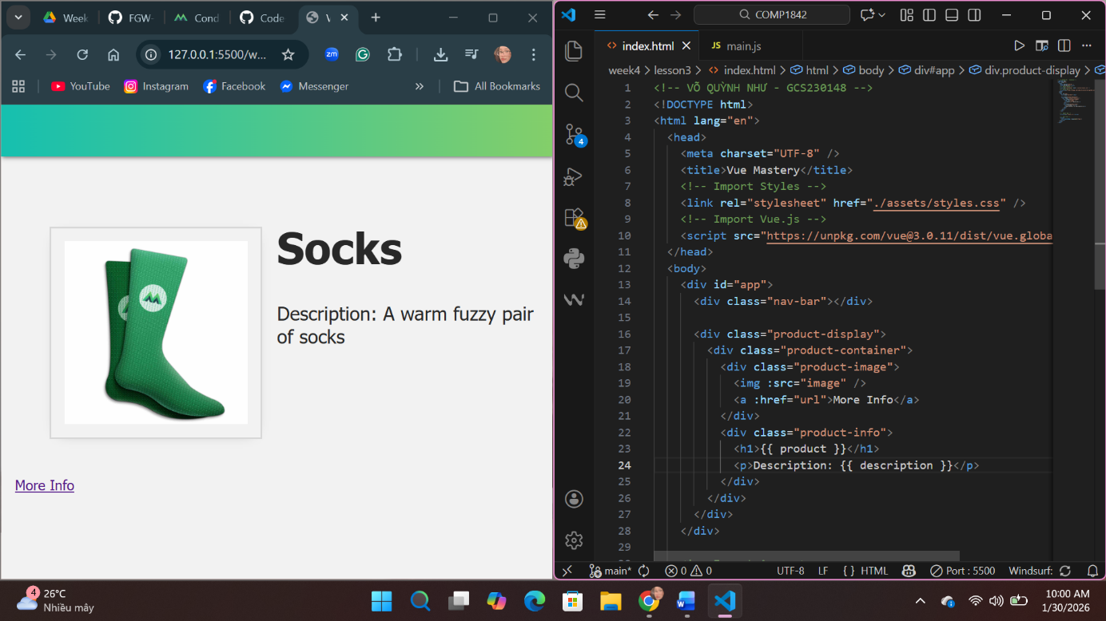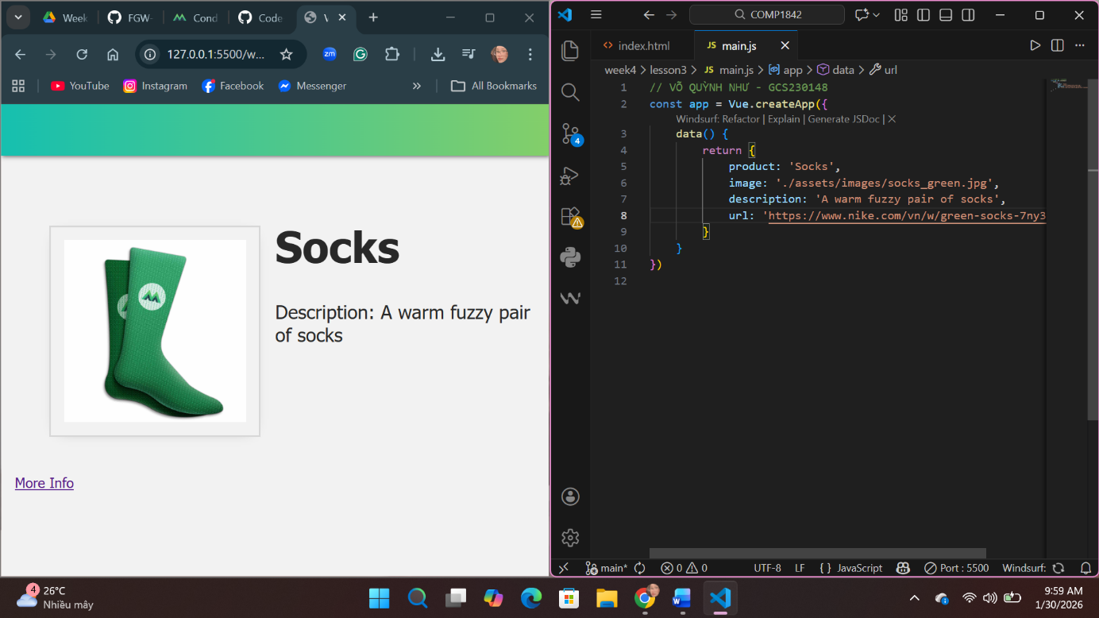

Challenge 3:
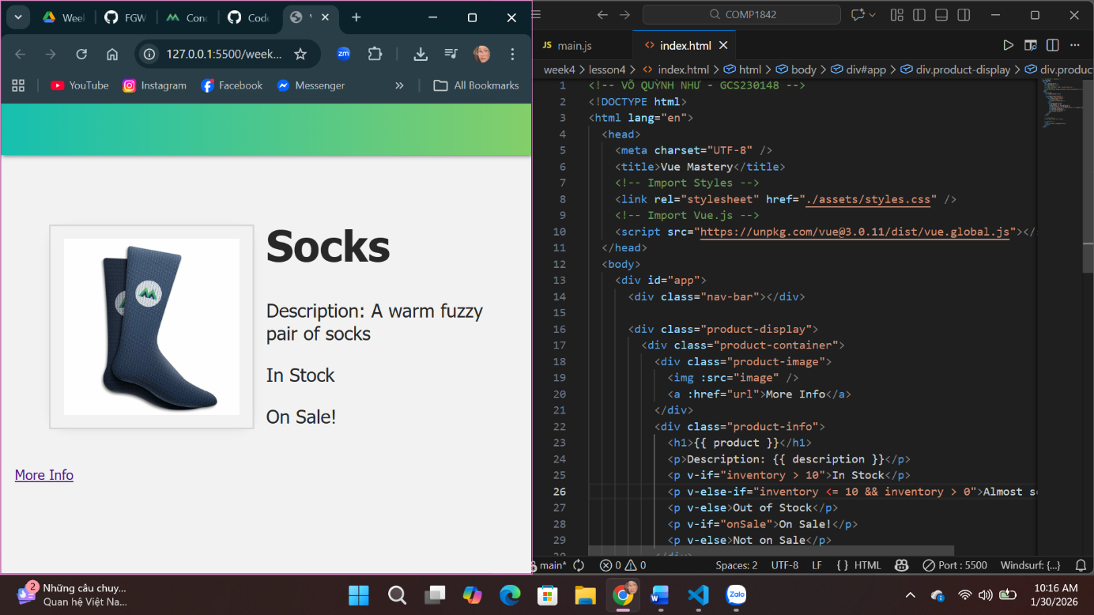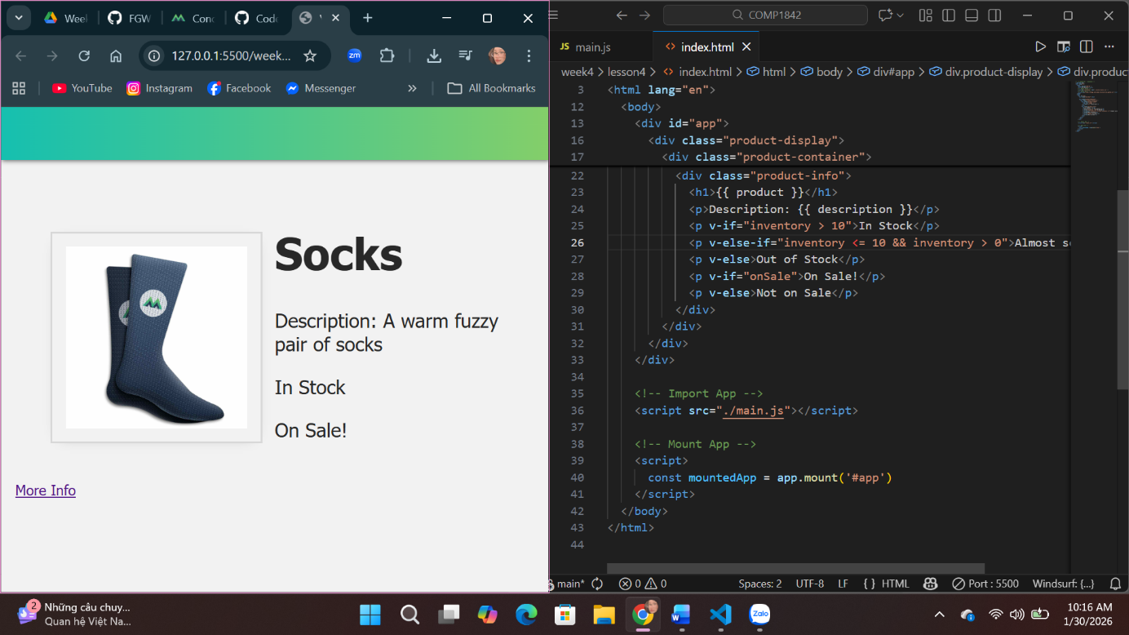

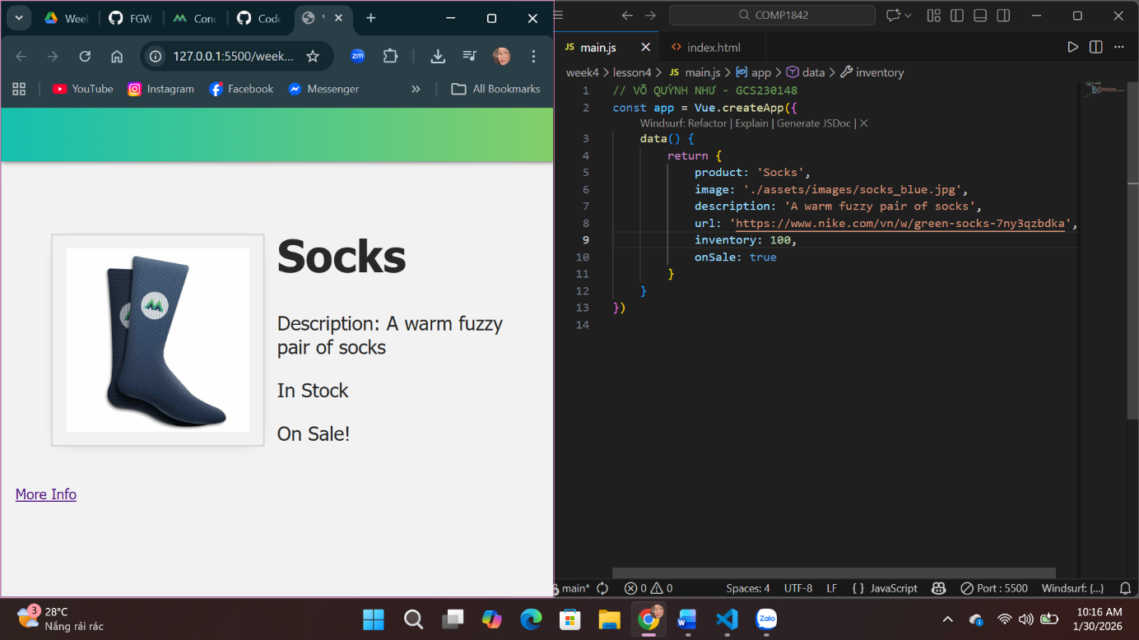

UNDERSTANDING PART:
From studying these 4 lessons, I learned how Vue.js connects JavaScript data with HTML to create a dynamic web page. I understood that the HTML file is responsible for the page structure and layout, while the JavaScript file controls the data and logic of the application. Through the data() function, I learned how to define variables such as product name, image, description, inventory, and sale status, and how these values can be displayed directly on the page using mustache syntax ({{ }}). I also understood how v-bind (or : shorthand) is used to link attributes like image source and links dynamically, which makes the page more flexible. In addition, conditional rendering with v-if, v-else-if, and v-else helped me understand how Vue can show different messages based on data values, such as stock availability or sale status. This made me realize how Vue simplifies decision-making logic inside HTML. Overall, these files helped me understand the basic concept of reactive data, how Vue updates the UI automatically when data changes, and how separating structure and logic makes code easier to read, manage, and scale for larger projects.

