**ADT Final Project Part-2**

**Part 1 Conceptual Diagram/Schema**

**Customer collection:**

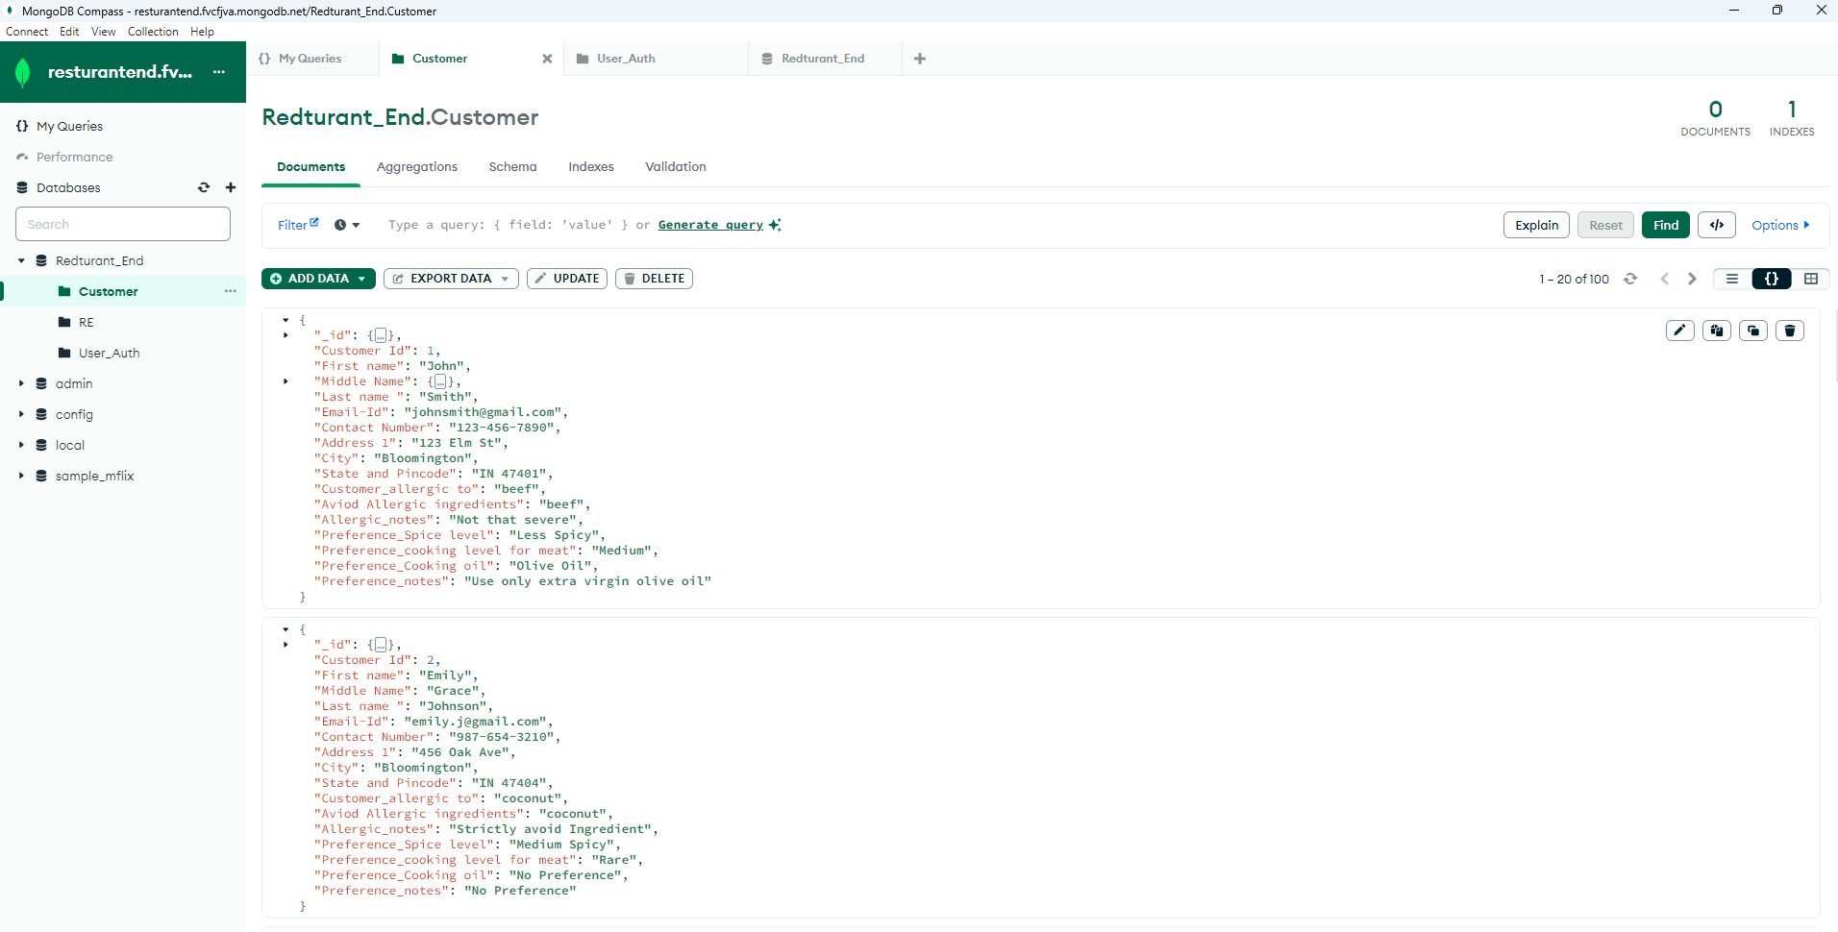

**Customer Information:**

Customer ID: Unique identifier for the customer.

First Name: The customer's first name.

Middle Name: The customer's middle name.

Last Name: The customer's last name.

Email-ID: The customer's email address.

Contact Number: The customer's contact number.

Address 1: The customer's street address.

City: The city where the customer resides.

State and Pincode: The state abbreviation and postal code of the customer's location.

Customer Allergic to: Specifies what the customer is allergic to.

Avoid Allergic Ingredients: Indicates that the customer wants to avoid ingredients they are allergic to.

Allergic Notes: Additional notes regarding the allergy.

Preference_Spice Level: Indicates the customer's preference for the spice level of their food.

Preference_Cooking Level for Meat: Specifies the customer's preference for the cooking level of meat

Preference_Cooking Oil: Specifies the customer's preferred cooking oil

Preference Notes: Additional notes regarding preferences.

The relation depicted here is that of customer profile, where each field provides specific information about the customer. This data will be used by a restaurant to tailor their offerings to meet the customer’s preferences and allergy restrictions.

The relation in the customer’s table is One-to-One. Each JSON document represents information about a single customer.

**User Authentication collection:**

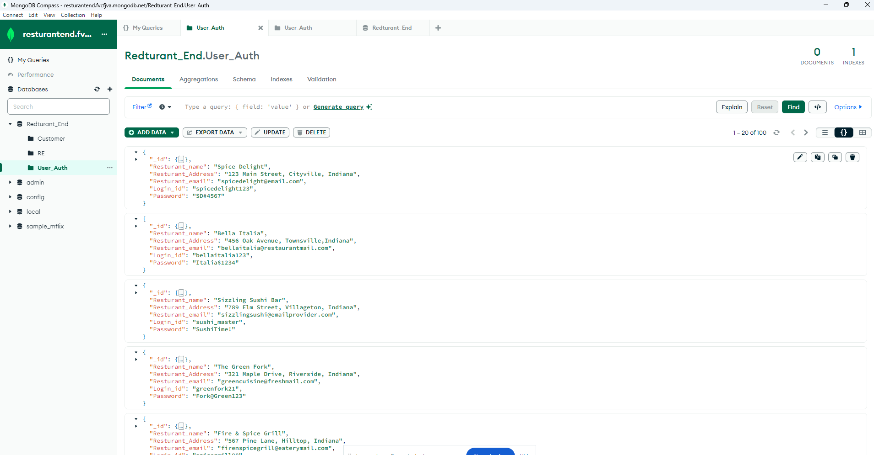

Restaurant Name: The name of the restaurant.

Restaurant Address: The address of the restaurant.

Restaurant Email: The email address associated with the restaurant.

Login ID: The login ID for accessing the restaurant's system or account.

Password: The password associated with the login.

The relation depicted here is that of a single restaurant entity. Each field provides specific information about the restaurant, mainly the Login ID and Password.

This collection represents a One-to-One relation. Each JSON document represents information about the restaurant entities.

**Part 2 Database Constraints**

For our databases, following are the constraints that need to be applied:

1. Customer Id must be an integer and be unique.
2. Email-ID must contain the ‘@’ symbol and be unique.
3. Contact Number must be a 10-digit integer value.
4. Preference_Spice level must be either Less Spicy, Medium Spicy, Very Spicy, No Preference or Blank.
5. Preference_cooking level for meat must be either Rare, Medium, Well Done, No Preference or Blank.
6. Preference_Cooking oil must be either Olive Oil, Vegetable Oil, Olive Oil, No Preference or Blank.
7. Restaurant Email must contain the ‘@’ symbol.
8. Login_id must be unique.
9. Password must be secretive i.e., encrypted.

**Part 4 Overall Contribution Summary**

|  |  |  |  |
| --- | --- | --- | --- |
| Name | task | contribution | AVR Time spent (hrs.) |
| Nikhil | Conceptional Schema  Database  Code | Mapped the tables and connections.  Provided ideas for table fields and added related data.  Worked on relevant application queries. | 7.2 hrs. |
| Vivek | Conceptional Schema  Database  Code | Provided ideas and requirements.  Provided complete mapped data.  Created initial structure for database. | 7.5 hrs. |
| Shivangi | Conceptional Schema  Database  Code | Worked on basic design.  Designed constraints and table division.  Worked on uploading data to MongoDB | 7.1 hrs. |