Day 2 : 19.03.2025

1. **What is DAM and why do we use it?**  
   DAM (Digital Asset Management) in AEM is used to store, manage, and distribute digital assets like images, videos, and documents. It provides version control, metadata management, and asset transformation capabilities.
2. **Create a Folder in DAM, Upload Images, and Use Image Component**

**Steps to Create a Folder and Upload Images:**

**Navigate to DAM:**

* 1. Go to **AEM > Navigation > Assets > Files**.
  2. Click **Create > Folder**.

**Upload Images:**

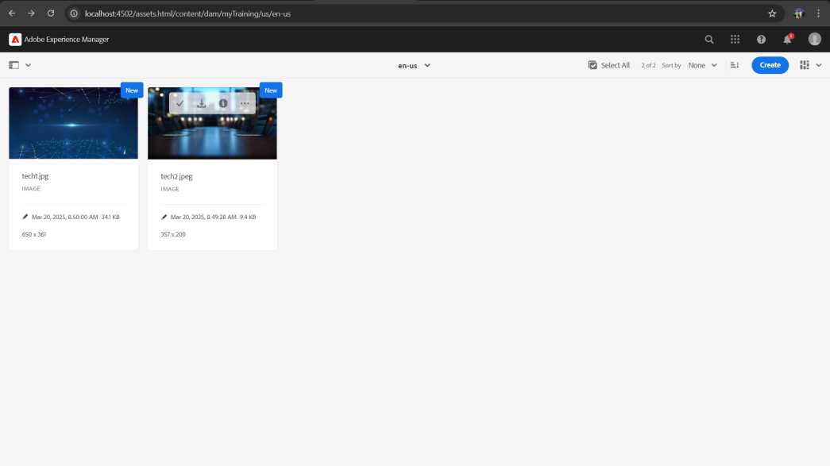

**Author Images on a Page Using Image Component:**

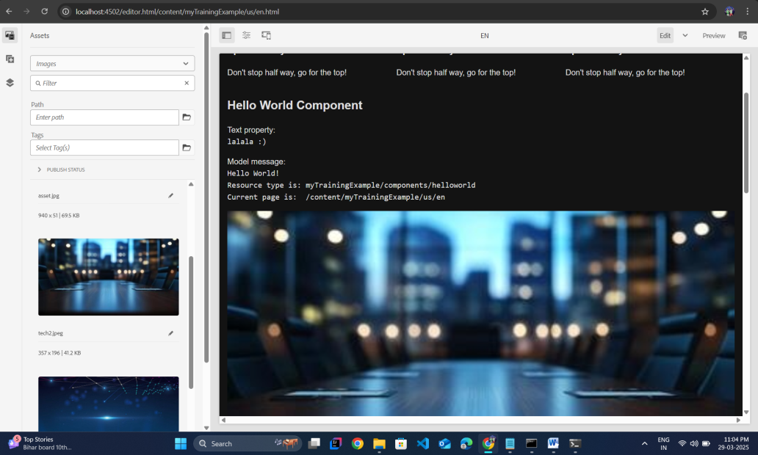

**Publish the page**

Access the published page using the url :

<http://localhost:4503/content/myTraining/us/en.html>

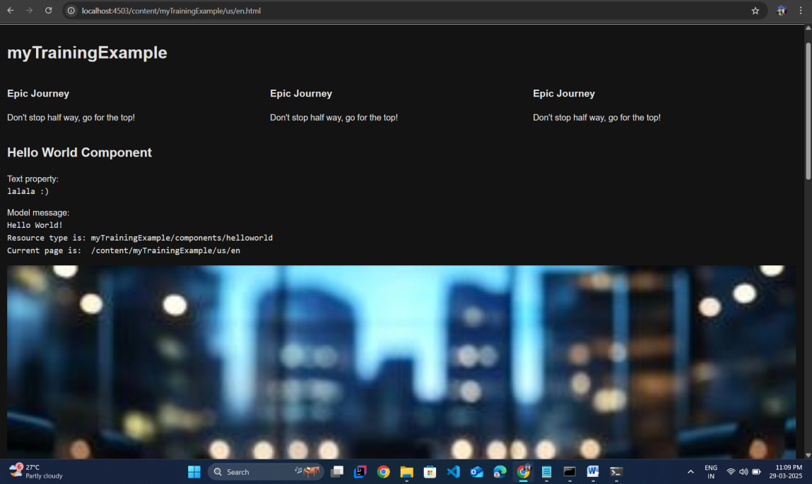

1. **What are renditions?**  
   Renditions are automatically generated variations of an image in different sizes and resolutions.

To check renditions:

* 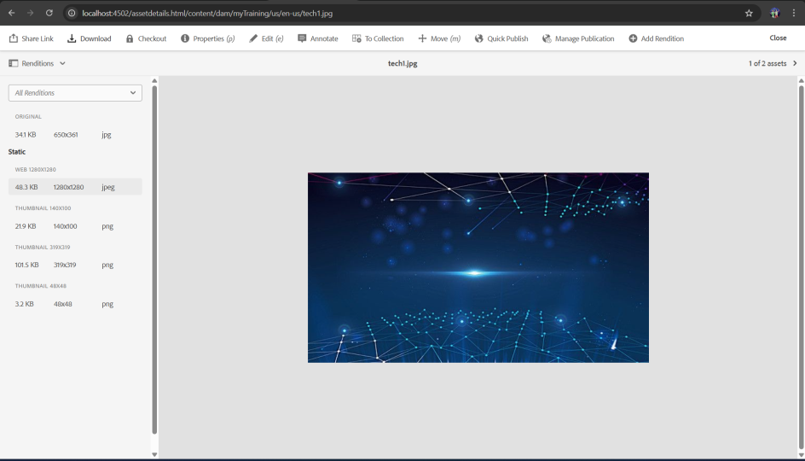Go to AEM > Assets and select an image.
* Click Renditions to see available versions.

1. 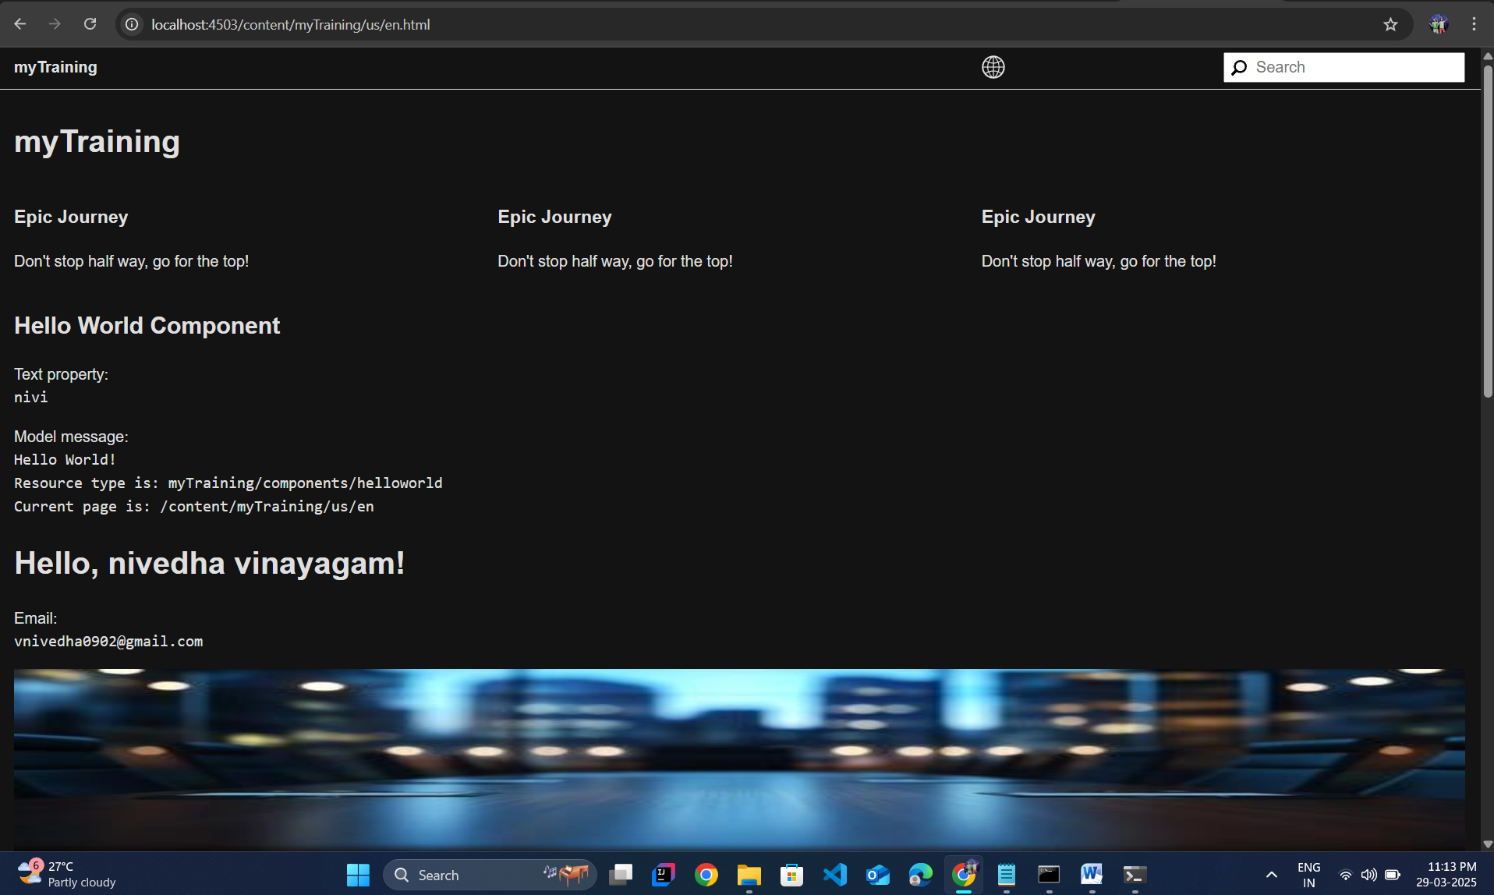**Add FirstName and LastName Fields to HelloWorld Component**
2. **Use of @ValueMapValue Annotations**

@ValueMapValue is an annotation in AEM Sling Models used to inject properties from a resource’s ValueMap. It simplifies retrieving values like text fields, numbers, or booleans from AEM components.

1. **Why use Package Manager?**

**Package Manager** in AEM is a tool used to create, install, and transfer content packages between AEM instances. It helps in packaging components, templates, assets, and configurations for deployment or backup.

1. **Configure Replication Agent & Publish Page**

Steps to Configure Replication Agent (4502 → 4503):

Go to AEM Replication Settings:

* Open AEM > Tools > Deployment > Replication.
* Click on Agents on Author.

Edit the Default Agent (publish)

* Click on the Default Replication Agent.
* Set Transport URI: http://localhost:4503/bin/receive.
* Click Save & Test Connection.