Students: Orsat Puljizević ER2058
Zvonimir Pipić ER2059
Course: Application security
Excersise: User registration process

The component for user registration and log in is made using flask for python and postgresql. The purpose of the component is to register new users into the database and validate them on log in. It requests users username and e-mail. The passwords are hashed and salted with bcrypt library.

Functional requirements
- Account creation by entering username, email and password.
- System should validate input formats and prevent duplicate emails and usernames.
- Activation token should be generated for every new user and sent via email.
- Account is activated after valid token is used, before that there is no access.
- User can request new activation token.
- User should be able to login using either username or email and password.
- Information is stored in a PostgresSQL database.

Nonfunctional requirements
- Passwords should be hashed using bcrypt and stored as hashes.
- Activation token should be generated using cryptographically secure random values.
- Response time from the forms should be minimal.
- Activation tokens expire after 24 hours.
- Error message should not reveal sensitive information.
- Emails and usernames should be unique, enforced by the database.

Implementation

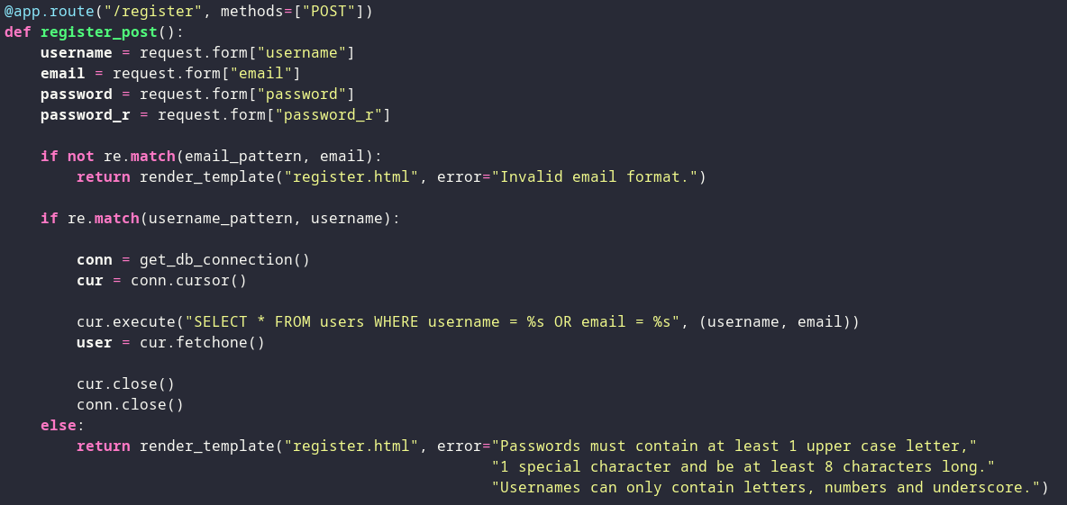

During registration we first check if email and username is valid, then, if it is, we check if username or e-mail is already taken.

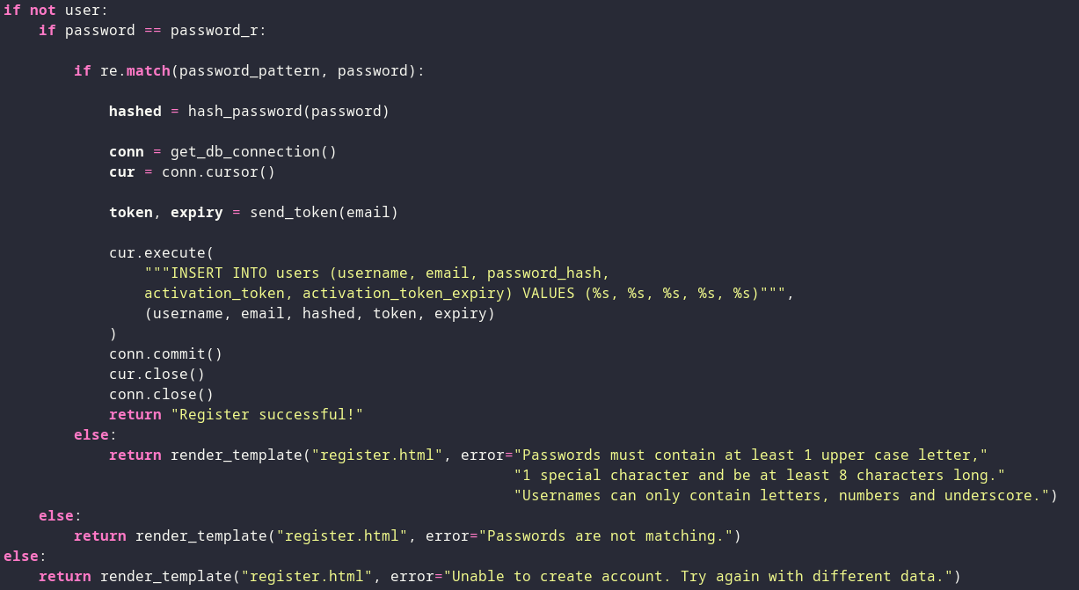
If the username and e-mail are not taken we procede. Password and repeated password must match. Finally if the password matches our regex for requirements the user is added to the database, but the account is not yet activated.

Theese regexes define username, e-mail and password requirements.

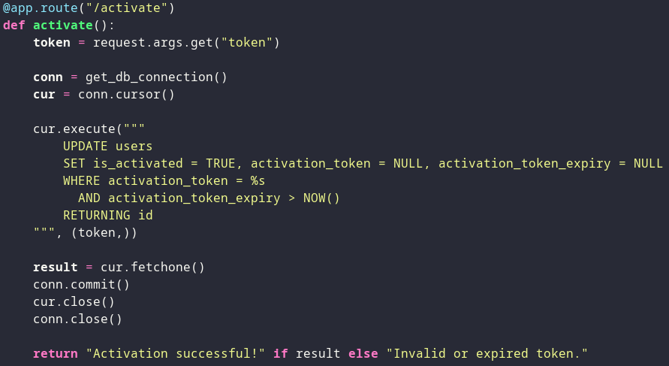

Users will get an e-mail with the activation link. If the link is clicked within the next 24 hours the account will be activated.

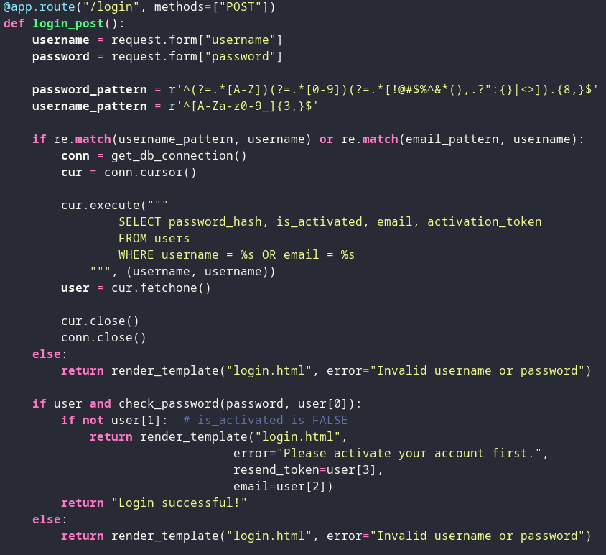

During log in procedure again we first check the validity of the username or e-mail before we insert it in a SQL queuery. If the given password has the same hash as the hash stored in a database the password is correct. We also check if the account is activated.

Tech stack
Frontend uses HTML5 and Jinja2 templates (form Flask).
Backend uses following Python libraries:
- Flask: used for routing, request handling, input validation, password hashing, token generation, sending emails, template rendering
- bcrypt: password hashing
- secrets: random token generation
- re: regex validation
- smtplib: email sending
- dotenv: storing sensitive passwords (e.g. email)
Database layer consists of PostgreSQL and psycopg2 which is used for communication with the database.

Architecture diagram

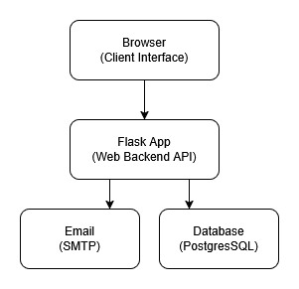
Database

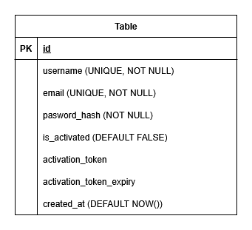

Registration flow

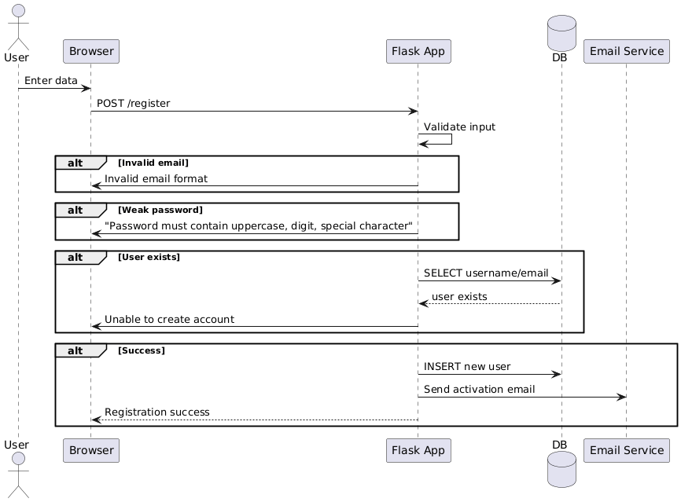

Login flow

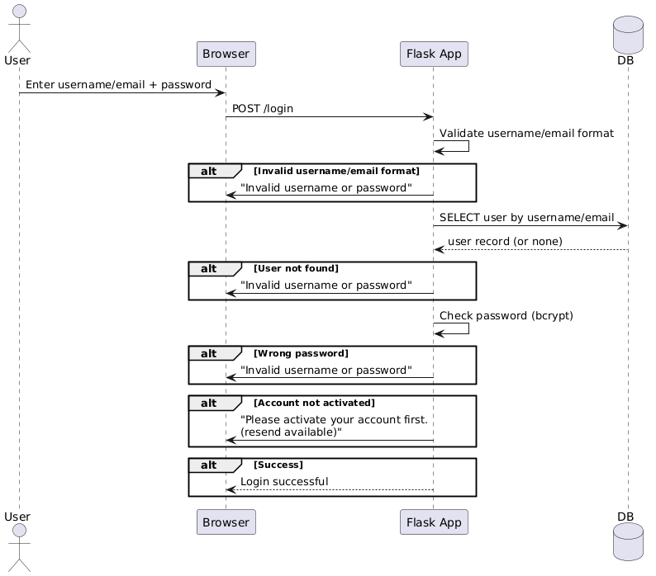
Resend confirmation email flow
