STUDENT PERFORMANCE DASHBOARD

Submitted by

Vinayak Pradhan
25MCI10186
25MAM4A

Submitted to

Ms. Amanjot Kaur

in partial fulfilment for the award of the degree of
Master of Computer Application



Chandigarh University

CERTIFICATE

This is to certify that the project report entitled Hospital Data Management System
Submitted to Chandigarh University in partial fulfilment of the requirement for the award of the degree of MASTERS OF COMPUTER APPLICATIONS ( MCA AI & ML) , is an
original work carried out by Mr./ Ms. Vinayak Pradhan
UID No.: 25MCI10186 under the guidance of Er. Sweta.

The matter embodied in this project is a genuine work done by the student and has not
been submitted whether to this University or to any other University / Institute for the fulfilment of the requirement of any course of study.

Name of Student: Vinayak Pradhan Name of Guide: Er. Sweta
UID : 25MCI10186 EID: E15013

ACKNOWLEDGEMENT

We deem it a pleasure to acknowledge our sense of gratitude to our project guide, Er. Sweta (Assistant Professor, UIC) under whom we have carried out the project work. Her incisive and objective guidance and timely advice encouraged us with constant flow of energy to continue the work.
We wish to reciprocate in full measure the kindness shown by Dr. Krishan Tuli (H.O.D, University Institute of Computing) who inspired us with his valuable suggestions in successfully completing the project work.
We shall remain grateful to Dr. Manisha Malhotra, Additional Director, University Institute of Computing, for providing us a strong academic atmosphere by enforcing strict discipline to do the project work with utmost concentration and dedication.
Finally, we must say that no height is ever achieved without some sacrifices made at some end and it is here where we owe our special debt to our parents and our friends for showing their generous love and care throughout the entire period of time.
Date: 10/27/2025
Place: Chandigarh University, Mohali, Punjab.
By: VINAYAK PRADHAN, UID- 25MCI10186.

ABSTRACT
This project presents an interactive Pathfinding Algorithms Visualization System designed to demonstrate, analyze, and compare the operational mechanics of classical search algorithms within a grid-based environment. The system enables users to define a starting point, destination node, and obstacle distribution, and then visually observes how each algorithm explores the search space to determine a navigable path.
The visualization includes three widely-used algorithms: Breadth-First Search (BFS), Depth-First Search (DFS), and A* — representing uninformed and informed search paradigms in artificial intelligence. While BFS guarantees shortest-path discovery through level-order exploration and DFS emphasizes deep traversal but may result in sub-optimal paths, A* integrates cost and heuristic estimation to compute the most efficient route with optimal performance in many cases. The simulation highlights critical algorithm characteristics such as node expansion behavior, memory footprint, time complexity, heuristic influence, optimality, and completeness.
Developed using Python, Numpy, and Matplotlib, the system provides real-time grid animation, search progression visualization, and comparative insights, enabling intuitive learning for users. This tool supports foundational understanding in graph traversal, heuristic-based optimization, and motion planning, making it valuable for educational and research applications in domains including robotics, navigation systems, game development, and autonomous AI agents. By offering transparent algorithm execution and traceable decision paths, the system bridges theoretical concepts with practical visualization, aiding learners in grasping the trade-offs and efficiency considerations in modern pathfinding techniques.

INDEX
- Title
- Problem statement
- Aim ................................................................................................. 1
- Introduction ..................................................................................... 1
- Objective...........................................................................................1
- Related Work………........................................................................ 3
- Requirements…..….………………………………………………..3
- Implementation….... ........................................................................ 4
- Results.............................................................................................. 5
- Project Outcomes.............................................................................. 7
- Bibliography...................................................................................... 8

INTRODUCTION
PROBLEM STATEMENT
The primary objective of this project is to design and develop a visual learning system that demonstrates how classical pathfinding algorithms operate in a grid-based environment with obstacles. The system aims to provide an intuitive understanding of algorithmic decision-making, search techniques, and path optimization in artificial intelligence.
Specific objectives include:
- To implement and visualize multiple pathfinding algorithms such as
- Breadth-First Search (BFS)
- Depth-First Search (DFS)
- A* Search Algorithm
- To create a grid-based environment where users can define:
- Start node
- Goal node
- Obstacle positions
- To compare algorithm performance in terms of:
- Execution behavior
- Path optimality
- Search efficiency
- Number of nodes explored
- Time and space utilization (conceptual understanding)
- To illustrate traversal patterns and decision-making logic, allowing users to visually track how each algorithm explores the search space.
- To highlight differences between uninformed and informed search strategies through interactive visualization and animation.
- To develop an educational tool that assists students and beginners in understanding core concepts of:
- Graph traversal
- Heuristic-based search
- Artificial intelligence planning
- Robotics path navigation
SCOPE OF THE PROJECT
The scope of this project encompasses the design, development, and evaluation of a Pathfinding Algorithms Visualization System capable of illustrating how various search algorithms operate in a grid environment with obstacles. The system primarily focuses on demonstrating algorithmic behavior, path discovery strategies, and performance characteristics for educational and analytical purposes.

The scope includes:

Grid-Based Environment Simulation

Representation of a 2D grid as a search space

Placement of start and goal nodes

Random or user-defined obstacles

Implementation of Core Pathfinding Algorithms

Breadth-First Search (BFS)

Depth-First Search (DFS)

A* Search Algorithm

Visualization and Animation

Real-time graphical representation using Python (Matplotlib)

Visualization of explored nodes, frontier, and final path

Step-by-step algorithm execution display

User Interaction and Inputs

User-defined start and end points

Ability to configure grid and obstacles

Option to select algorithm for comparison

Performance Comparison (Conceptual)

Comparison of traversal patterns

Path optimality analysis

Understanding time and space behavior of each algorithm

Educational and Research Utility

Helps students understand pathfinding and search algorithms

Useful for AI, machine learning, robotics, and game development learning

Acts as a foundational platform for advanced navigation systems

TOOLS USED

1. Programming Language

Python

Chosen for its simplicity, readability, and strong support for scientific computing and visualization.

Ideal for implementing algorithm logic and graphical simulations.

2. Python Libraries / Frameworks

NumPy

Used for array manipulation and grid representation.

Helps in managing matrix-based operations for node tracking.

Matplotlib

Primary library for grid plotting and visualization.

Enables stepwise graphical display of traversal, visited nodes, and final path.

Collections (deque)

Utilized for queue implementation in BFS to optimize storage and performance.

Heapq

Used to implement priority queue for A* algorithm to efficiently process nodes based on cost.

3. Development Environment

Jupyter Notebook / VS Code

Used for writing, executing, and testing code.

Supports interactive coding, debugging, and real-time visualization.

4. Version Control (Optional but Recommended)

Git & GitHub

For code management, collaboration, and version control.

Helps track project development history.

5. Visualization Platform

Python Matplotlib GUI / Notebook Output

Used to display animation of grid search operations.

Allows step-by-step demonstration of algorithm traversal.

6. Operating System

Windows / Linux / macOS

Cross-platform support ensures portability and easy execution.

LITERATURE REVIEW
EXISTING SYSTEM – EXISTING SOLUTIONS AND GAPS
Pathfinding algorithms such as BFS, DFS, Dijkstra, and A* have been widely studied in artificial intelligence, robotics, and computer science for tasks involving route planning and navigation. Many online platforms and educational tools demonstrate these algorithms, including algorithm visualization websites, coding learning platforms, and game-AI simulators. These systems help users understand how search strategies operate in grid-based or graph environments.
However, existing tools have certain limitations. Many provide only the final result without showing real-time node exploration steps. Several platforms focus on a single algorithm instead of offering a comparative view. In addition, many demos lack user interaction features such as custom obstacle placement, start-goal configuration, or adjustable grid environments. Some visualizers also do not emphasize heuristic functions or explain the decision-making process in A*.
This project addresses these gaps by offering a simple, interactive, and educational visualization tool that allows users to define the grid environment and visually observe how BFS, DFS, and A* explore paths, expand nodes, and compute results. The system highlights algorithmic differences, path optimality, and search efficiency, serving as a valuable learning aid for students and beginners in AI and pathfinding.
SYSTEM DESIGN
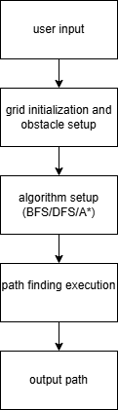
ARCHITECTURE

Fig 1: System Architecture

IMPLEMENTATION
TOOLS
1. Programming Language
- Python
  - Used for implementing search algorithms and visualization logic.
  - Selected due to ease of algorithm implementation and strong support libraries.
2. Libraries & Packages
Library | Purpose
NumPy | Grid/matrix handling, numerical operations
Matplotlib | Visualizing grid, visited nodes & final path
Collections (deque) | Efficient queue implementation (BFS)
Heapq | Priority queue for A* algorithm
Time (optional) | Animation delay for visualization steps
3. Development Environment / IDE
- Jupyter Notebook
  - Interactive testing & visualization
- VS Code / PyCharm (optional)
  - For full script development
4. Version Control (optional)
- Git
- GitHub
  - To store code, track revisions, and share project
5. Operating System
- Windows / Linux / macOS
  - Project is platform-independent and runs on any OS supporting Python
6. Hardware Requirements
- Standard laptop/PC
- Minimum 4GB RAM
- Python installed environment
CODE
import matplotlib.pyplot as plt
import numpy as np
# (1 = obstacle, 0 = free cell)
grid = [
[0,1,0,1,0,1,1,0],
[1,0,1,0,1,0,1,0],
[0,0,0,0,1,0,0,0],
[0,1,1,0,0,1,1,0],
[0,1,0,0,0,1,0,0],
[0,0,1,0,0,0,0,1],
[0,1,0,1,0,0,0,0],
[1,0,0,1,0,1,0,0]
]

def get_user_node(prompt):
while True:
try:
r = int(input(f"{prompt} row (0-{len(grid)-1}): "))
c = int(input(f"{prompt} col (0-{len(grid[0])-1}): "))
if (0 <= r < len(grid)) and (0 <= c < len(grid[0])) and grid[r][c] == 0:
return (r, c)
else:
print("Invalid cell (outside grid or obstacle). Try again.")
except Exception as e:
print("Invalid input, enter integers only.")

start = get_user_node("Enter START")
goal = get_user_node("Enter GOAL")

def bfs(grid, start, goal):
from collections import deque
rows, cols = len(grid), len(grid[0])
directions = [(0,1), (1,0), (0,-1), (-1,0)]
queue = deque([(start, [start])])
visited = set([start])
while queue:
(r, c), path = queue.popleft()
if (r, c) == goal:
return path
for dr, dc in directions:
nr, nc = r + dr, c + dc
if 0 <= nr < rows and 0 <= nc < cols and grid[nr][nc] == 0 and (nr, nc) not in visited:
visited.add((nr, nc))
queue.append(((nr, nc), path + [(nr, nc)]))
return None

def dfs(grid, start, goal):
rows, cols = len(grid), len(grid[0])
directions = [(0,1), (1,0), (0,-1), (-1,0)]
stack = [(start, [start])]
visited = set([start])
while stack:
(r, c), path = stack.pop()
if (r, c) == goal:
return path
for dr, dc in directions:
nr, nc = r + dr, c + dc
if 0 <= nr < rows and 0 <= nc < cols and grid[nr][nc] == 0 and (nr, nc) not in visited:
visited.add((nr, nc))
stack.append(((nr, nc), path + [(nr, nc)]))
return None

def heuristic(a, b):
return abs(a[0] - b[0]) + abs(a[1] - b[1])

def astar(grid, start, goal):
import heapq
rows, cols = len(grid), len(grid[0])
directions = [(0,1), (1,0), (0,-1), (-1,0)]
open_set = []
heapq.heappush(open_set, (0, start, [start]))
g_cost = {start: 0}
visited = set()
while open_set:
_, current, path = heapq.heappop(open_set)
if current == goal:
return path
if current in visited:
continue
visited.add(current)
for dr, dc in directions:
nr, nc = current[0] + dr, current[1] + dc
neighbor = (nr, nc)
if 0 <= nr < rows and 0 <= nc < cols and grid[nr][nc] == 0:
new_cost = g_cost[current] + 1
if neighbor not in g_cost or new_cost < g_cost[neighbor]:
g_cost[neighbor] = new_cost
f_cost = new_cost + heuristic(neighbor, goal)
heapq.heappush(open_set, (f_cost, neighbor, path + [neighbor]))
return None

def plot_grid_path(grid, path, start, goal, title):
grid_np = np.array(grid)
plt.figure(figsize=(6,6))
plt.imshow(grid_np, cmap='Greys', origin='upper')
if path:
px, py = zip(*path)
plt.plot(py, px, marker='o', color='red', linewidth=2, markersize=8, label='Path')
plt.scatter([start[1]], [start[0]], color='green', s=120, label='Start')
plt.scatter([goal[1]], [goal[0]], color='blue', s=120, label='Goal')
plt.xticks(range(len(grid[0])))
plt.yticks(range(len(grid)))
plt.title(title)
plt.legend()
plt.grid(False)
plt.show()

# Visualize
plot_grid_path(grid, bfs(grid, start, goal), start, goal, 'BFS Path')
plot_grid_path(grid, dfs(grid, start, goal), start, goal, 'DFS Path')
plot_grid_path(grid, astar(grid, start, goal), start, goal, 'A* Path')

SCREENSHOTS
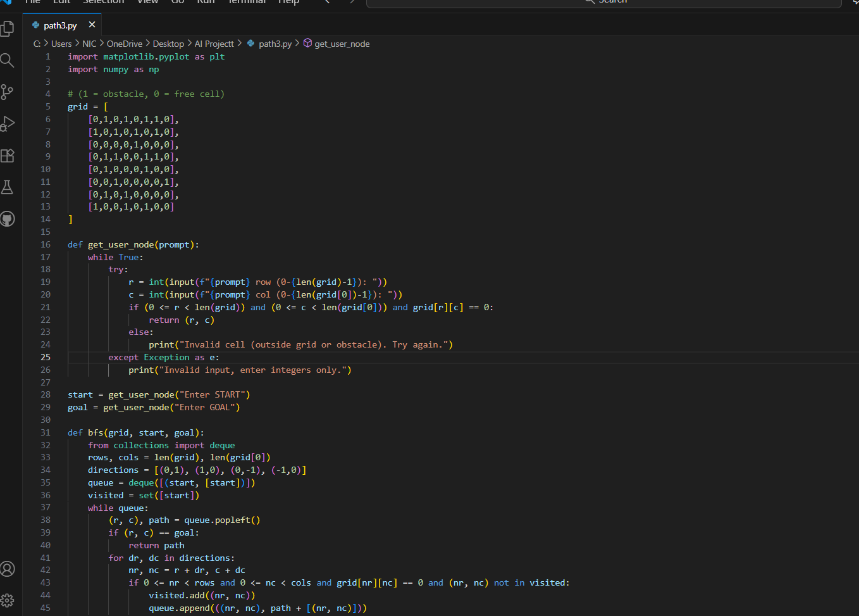

Fig 2: Implementation
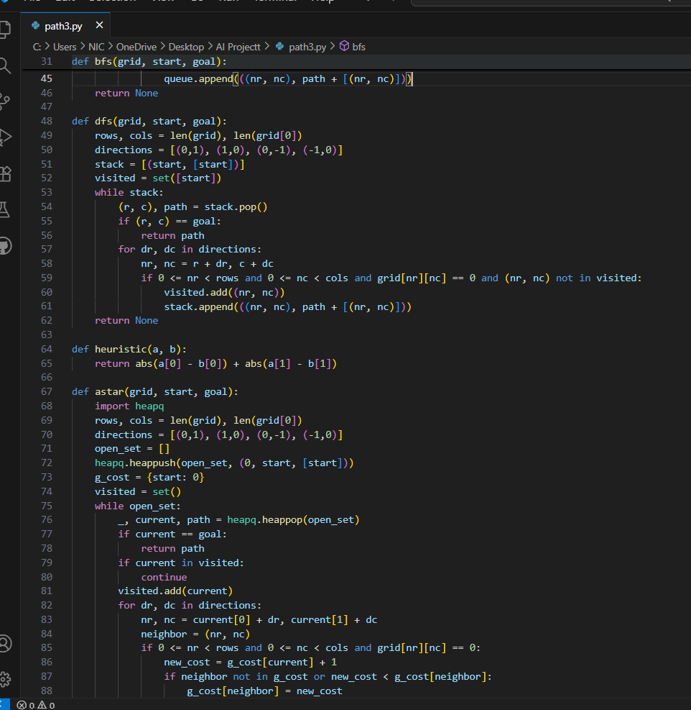

Fig 3: Implementation

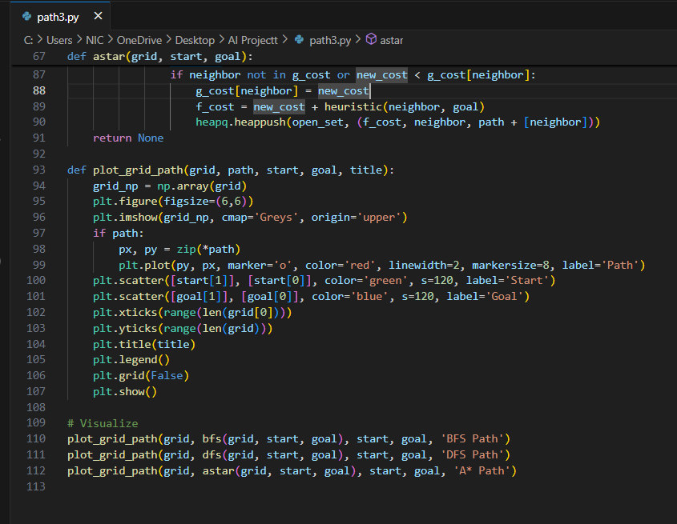

Fig 4: Implementation

RESULT AND VISUALIZATION
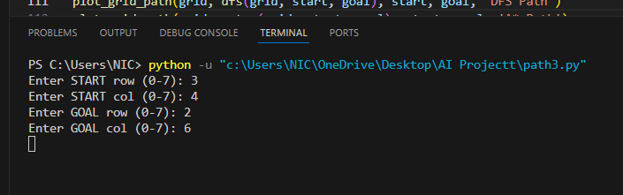

Fig 5: Start and Goal Input

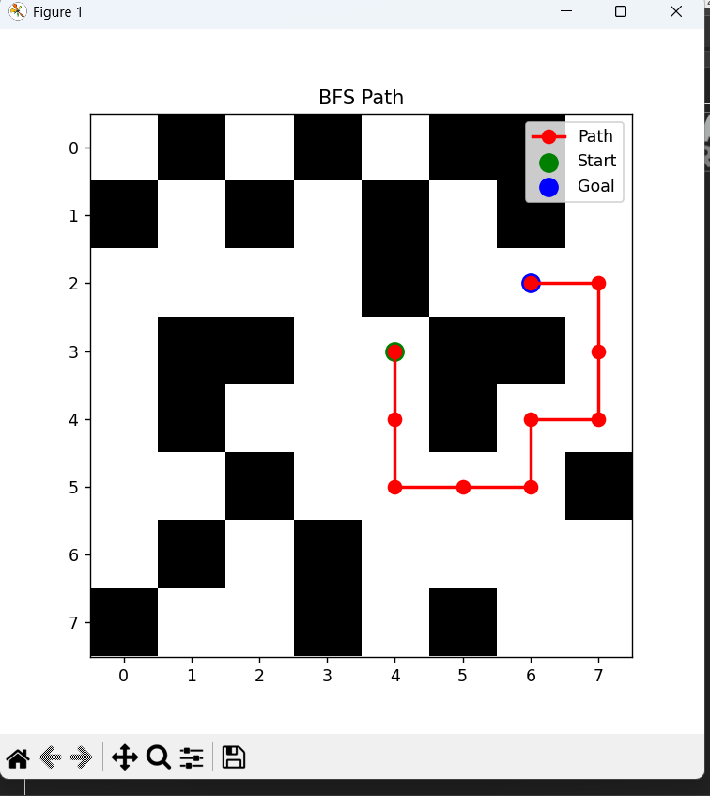

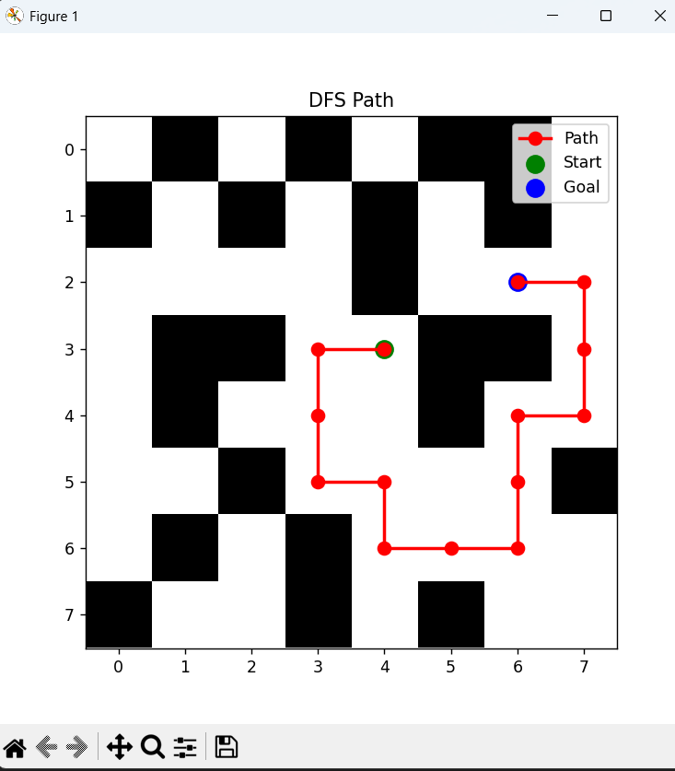
Fig 6: BFS Path

Fig 7: DFS Path
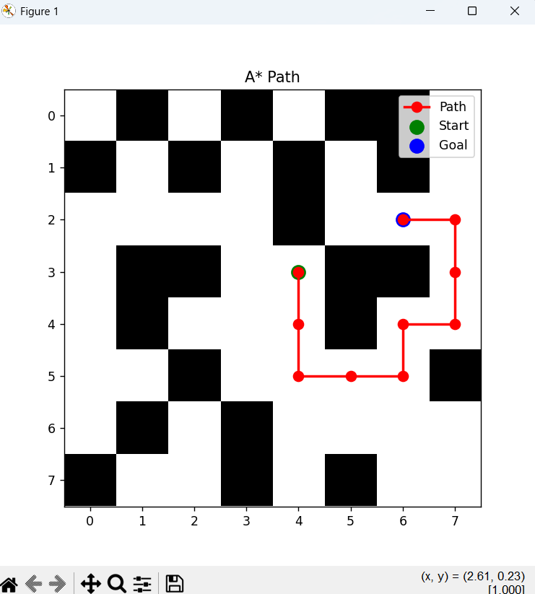

Fig 8:A* Path
PERFORMANCE
- BFS
  - Guarantees shortest path
  - Expands large area → more nodes explored
- DFS
  - Fast but not reliable for optimal path
  - May get stuck in deep unnecessary branches
- A*
  - Most efficient in finding shortest path
  - Uses heuristic (Manhattan distance)
  - Balanced between speed and optimality
CONCLUSION
This project successfully demonstrates and compares three fundamental pathfinding algorithms — BFS, DFS, and A* — through a visual, interactive grid system. The implementation highlights how each algorithm explores nodes, handles obstacles, and attempts to reach the goal node.
The visualization effectively enhances conceptual understanding by animating node expansion and path construction. It clearly showcases differences in optimality, speed, search strategy, and computational efficiency, validating theoretical characteristics:
- BFS identifies the shortest path by exploring level by level.
- DFS explores depth-first and may not always find the optimal path.
- A* intelligently uses heuristics to find the most efficient solution with minimal exploration.
Overall, the system fulfills its objective as a valuable educational tool for students and beginners in AI, graph theory, robotics, and pathfinding.

Future Scope & Improvements
This project can be enhanced in several ways to make it more robust and advanced:
Technical Enhancements
- Add additional algorithms: Dijkstra, Greedy Best-First Search, Bidirectional BFS
- Support weighted grids and dynamic obstacles
- Integrate diagonal movements and terrain costs
UI & Interaction Improvements
- Add GUI with tkinter / PyQt / web interface
- Allow users to draw obstacles manually
- Provide controls for speed, pause, and step-by-step execution
Performance Extensions
- Compare execution time and memory usage numerically
- Display algorithm complexity and performance metrics
Practical Applications
- Extend to real-time robot path planning
- Use with sensor-based obstacle detection
- Convert grid to real-world map navigation simulation
Smart AI Features
- Implement machine-learning–based heuristics
- Add path replanning for dynamic environments

GITHUB

Bibliography
- Russell, S., & Norvig, P. (2021). Artificial Intelligence: A Modern Approach (4th Edition). Pearson Education.
- Cormen, T. H., Leiserson, C. E., Rivest, R. L., & Stein, C. (2022). Introduction to Algorithms (4th Edition). MIT Press.
- Goodrich, M. T., & Tamassia, R. (2014). Algorithm Design and Applications. Wiley.
- Lafore, R. (2017). Data Structures and Algorithms in Python. Pearson.
- VanderPlas, J. (2016). Python Data Science Handbook. O’Reilly Media.
- Matplotlib Documentation – https://matplotlib.org
- NumPy Documentation – https://numpy.org
- GeeksforGeeks – “Pathfinding Algorithms” tutorials and examples. https://www.geeksforgeeks.org
- Red Blob Games – “A* Pathfinding Tutorial”. https://www.redblobgames.com/pathfinding
- Stanford CS221 – Search and Planning Lecture Notes. Stanford University.
- MIT OpenCourseWare – 6.034 Artificial Intelligence. https://ocw.mit.edu
- TutorialsPoint – Graph and pathfinding basics. https://www.tutorialspoint.com

