# Medical Shop Automation

# Software Engineering | B.Tech 3rd Year, 1st Semester

Department of Computer Science and Engineering

*Submitted by*

**K. Deepika (R200**)

*Team members:*

V. Mani Kumar Reddy

M. Kowshik

J. Sharanya

V. Premnath

# Under the guidance of

# N. SATYANANDARAM

# Lecturer, Department of CSE



DEPARTMENT OF COMPUTER SCIENCE AND ENGINEERING

RAJIV GANDHI UNIVERSITY OF KNOWLEDGE TECHNOLOGIES

RK VALLEY, Vempalli (M)

Kadapa (Dist),

Andhra Pradesh(S), 516330

**User Requirement Document**

# Description:

# 

The **Medical Shop Automation System** is a comprehensive software solution designed to streamline the day-to-day operations of a medical store. The system manages inventory, tracks sales, and automates supplier management, ensuring efficient and accurate handling of medicines and related transactions. It provides an intuitive interface for managing stock, suppliers, and sales records, reducing manual effort and minimizing errors in record-keeping.

This project aims to improve operational efficiency, enhance customer service, and maintain accurate records of stock levels, orders, and suppliers, all while ensuring compliance with expiration dates and inventory regulations.

# Table of Contents

1. Introduction
   * 1.1 Purpose
   * 1.2 Intended Audience
   * 1.3 Stakeholders
   * 1.4 Product Vision
2. Technologies
   * 2.1 System in Context
3. Requirements
   * 3.1 Functional Requirements
4. Non-Functional Requirements
   * 4.1 Reliability
   * 4.2 Usability
   * 4.3 Availability
   * 4.4 Accessibility
   * 4.5 Performance
   * 4.6 Security
   * 4.7 Platform Compatibility
5. Work Assignment to Team
6. Work Breakdown Structure (WBS) for MSA
7. Use Case Specification
8. ER Diagram
9. Class Diagram

10. Sample UI

# 1. Introduction

* 1. **Purpose**

The purpose of this SRS document is to define the requirements for the Medical Shop Automation (MSA) software developed . This document will serve as a comprehensive guide for the development team and stakeholders to ensure that the software meets the needs of its users.

# Intended Audience

This document is intended for:

* + - The development team at Group 5.
    - The stakeholders including Medical Shop owner (pharmacist),supplier, customer, doctor
    - Quality assurance teams
    - End-users who will be using the software

# Stakeholders

* + - Client – Pharmacist and Doctors
    - Users – Individuals who use the MSA Tool

# Product Vision

The MSA software aims to transform the operational efficiency of medical shops through automation. To develop an intelligent, user-friendly, and scalable **Medical Shop Automation System** that streamlines the inventory, sales, and supplier management processes, ensuring seamless operations, enhanced customer satisfaction, and improved profitability for medical shops of all sizes. It will also generate valuable insights through data analysis to support strategic decision-making and increase profitability.

# Technologies

* 1. **System in Context** The MSA software will operate as a standalone web-based application, integrated into the daily operations of medical shops. It will be accessible via modern web browsers on desktop and laptop computers. The system will interface with vehicle databases and provide real-time management.

# Technologies:

**Frontend:**

* + - HTML
    - CSS
    - Bootstrap
    - JavaScript

# Backend:

* + - Servlets
    - JDBC
    - JSP

# Database:

* + - MySQL

# 3. Requirements

**User Management**

* + - **Customers:** Checking availability of medicines, checking prices, modifying or canceling orders, viewing prescriptions.
    - **Pharmacist:** Supervise daily operation, ensuring smooth coordination, monitoring sales (analyzing maintenance needs), add new products, decisions on expiration return and refund.
    - **Doctor:** Accessing previous prescription and medical history of the patient, create new prescriptions and suggesting medicines that are recommended necessarily for the treatment of a frequently diagnosed diseases.
    - **Supplier:** Accessing themedicines through the user interface, and update the newly available stock of medicines so that the pharmacist can buy them, and supply them to the respective medical shops.

# Customer Management

* + - Customer Signup
      * Customers can register by providing personal details such as name, email address, phone number.
    - Customer Login
      * Registered customers can log in to the system using their credentials.
    - Order History
      * Customers can view their past orders and order status through their account dashboard.
    - Medicine Search
      * Customers can search for medicines by name, availability, category and price.­­
    - Add to Cart
      * Customers can add medicines to their cart.
    - Checkout Process
      * The checkout process includes placing all the items in the cart

**Inventory Management**

* + - Add New Medicines
      * Pharmacist and Supplier can add new medicines, including details such as type, category, medicine ID, price, and

Expiry date

* + - Update Inventory
      * Pharmacist can update inventory when new medicines arrive, including medicine details and availability status.

# Financial Management

* + - Store Financial Details
      * Accountants can store financial details, including sales, and revenue.
    - Financial Reporting
      * The system generates financial reports to track revenue and expenses.

# Security and Access Control

* + - User Authentication
      * The system enforces user authentication to ensure that only authorized personnel can access specific functionalities.
    - Role-based Access
      * Different user roles ( customer, pharmacist, doctor, supplier) have different levels of access to system functionalities.

# Non-Functional Requirements

* 1. **Reliability**

The system should consistently perform all required functions without failure. Regular backups should be implemented to prevent data loss.

# Usability

The user interface should be intuitive and easy to navigate for all user types, including administrators, customers, managers, staff, and accountants.

# Availability

The system should be available 24/7, with minimal downtime for maintenance.

# Accessibility

The system should be accessible from various devices and comply with accessibility standards to accommodate users with disabilities.

# Performance

The system should handle multiple concurrent users without performance degradation and should have quick response times for all operations.

# Security

User authentication and authorization must be enforced. Sensitive data should be encrypted, and the system should comply with data protection regulations.

# Platform Compatibility

The system should be compatible with modern web browsers and should not require any special hardware or software for access.

**Context Diagram :-**

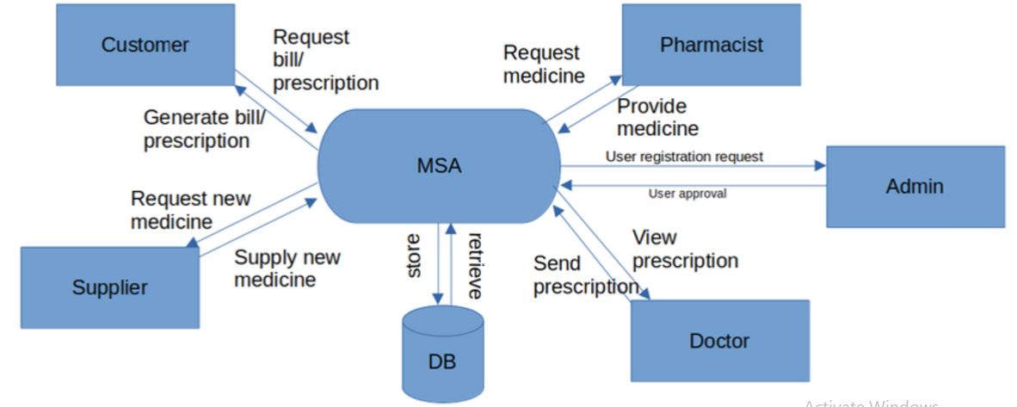

1. **Work Assignment to Team**

Work Name Assigned Person

Requirements Gathering EntireTeam

Interface Mani, Sharanya

Story board Deepika, Kowshik

WBS Mani, Premnath

URD Premnath, Sharanya

SRS Entire Team

Risk Analysis Entire Team

Front end Design Sharanya , Kowshik ,

Backend Design (Database) Deepika, P­remnath

Code Integration Mani, Kowshik

Testing Entire Team

Final Demo Entire Team

# Work Breakdown Structure (WBS) for MSA

* 1. Project Initiation:
     + 1.1 Requirement Gathering
     + 1.2 Feasibility Analysis
     + 1.3 Project Plan Creation
     + 1.4 Resource Allocation
  2. System Design:
     + 2.1 Architectural Design
     + 2.2 Database Design
     + 2.3 UI/UX Design
  3. Development:
     + 3.1 Frontend Development
     + 3.2 Backend Development
     + 3.3 Database Development
  4. Testing:
     + 4.1 Unit Testing
     + 4.2 Integration Testing
     + 4.3 System Testing
     + 4.4 User Acceptance Testing (UAT)
  5. Maintenance and Support:
     + 5.1 Bug Fixes
     + 5.2 Performance Optimization
     + 5.3 Regular Updates and Enhancement

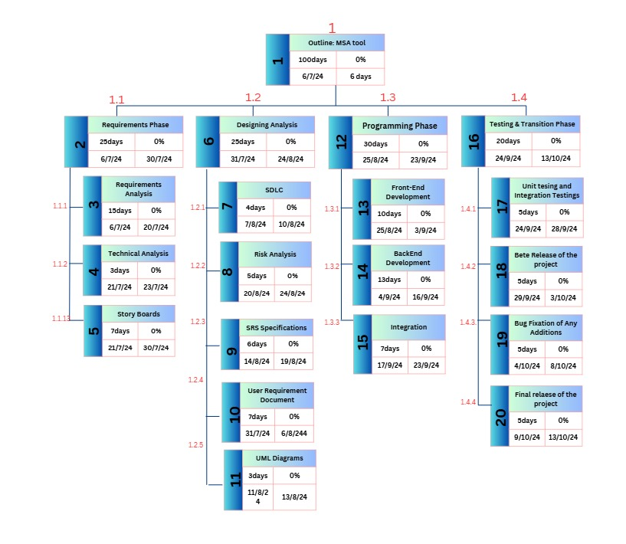**Work Breakdown Diagram:**

**Use Case Diagram:**

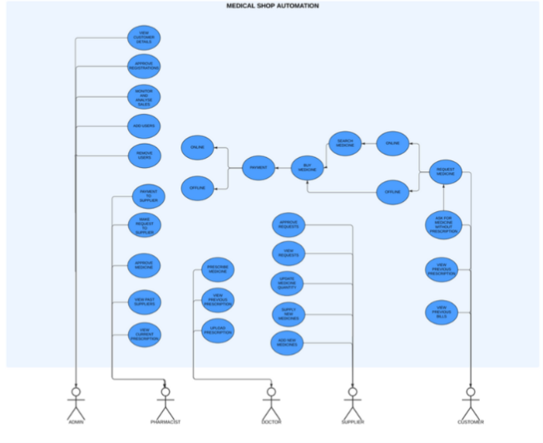

**System wise Requirements (Received) :-**

1. ***ACTORS***

**Customer (CS):**

* + Interacts with the system to view available medicines, search with filters, order medicines, view prescriptions.

**Pharmacist (PH):**

* + Oversees operations by viewing reports and statistics, setting pricing , and evaluating profitability.

**Supplier(SU):**

* + Uses the system through interface and updates the newly available medicines stock.

**Doctor (DR):**

* + Manages user Prescriptions, Diagnosis of patient condition, update the prescription through the MSA portal or software .

1. ***EVENTS (Use Cases)***
2. **Register/Login:**
   * Users (Customers, Pharmacists, Supplier, Doctor) log into the system to access functionalities based on their roles.
3. **View Available Medicines(Customer/Pharmacist/Supplier):**
   * Customers browse through a list of available Medicines to buy.
4. **Search Medicines(Customer):**
   * Customers utilize advanced search filters to find specific types of medicines based on various criteria.
5. **Order Medicines(Customer):**
   * Customers order a medicine and track the order status through the system.
6. **View Prescriptions(Customer):**
   * Customer can view and get knowledge about their previous and current prescriptions, and order appropriate medicines they need.
7. **Add to Cart (Customer):**
   * Customer can add individual elements to their cart, like bookmarking the to buy later whenever it is necessary, or collecting multiple items and placing a single order.
8. **View Prescriptions (Doctor):**
   * Doctor can view and get knowledge about their previous prescriptions and Diagnose accordingly

1. **Upload Prescription (Doctor):**
   * Create a new prescription and update the patient details and diagnosis
2. **Search Medicines (Doctor):**
   * Doctors utilize advanced search filters to find specific types of medicines based on various criteria
3. **Add Product (Pharmacist):**
   * Adding new medicines to the inventory or the medical shop software

.

1. **Search Medicines(Pharmacist):**
   * Pharmacists utilize advanced search filters to find specific types of medicines based on various criteria.
2. **Expiring Today Medicines(Pharmacist)**
   * Pharmacist identifies the expiring medicines by taking or considering the expiry date of a medicine and remove it from the inventory
3. **Sales Report (Pharmacist):**
   * Generates the sales of a particular day and analyses the total statistics of the sales.
   * The generated reports can be printed
4. **Remove Medicines (Pharmacist):**
   * Pharmacist has the privilege to remove the medicines when,
     + the medicine has reached its expiry date
     + to update the inventory
     + add products with updated prices
5. **Search Medicines (Supplier):**
   * Suppliers utilize advanced search filters to find specific types of medicines based on various criteria
6. **Remove Medicines (Supplier):**
   * Supplier can remove the medicines whenever he wants to stop the supply.
7. **Add Product (Supplier):**
   * Adding new medicines to the software whenever stock is available to refill the inventory
8. **Logout:**
   * Safely withdraw from the application software without compromising the security.
9. ***USER VISIBLE EVENTS***
10. ***Customer :***

|  |  |  |  |  |  |  |
| --- | --- | --- | --- | --- | --- | --- |
| Serial No | Actor | Actions | Object | Frequency | Arrival Pattern | Response |
| 1 | Customer | Register/Login | Account | Daily | Random | Access granted/denied |
| 2 | Customer | View Medicines | Medicine List | Frequently | On-demand | Display available medicines |
| 3 | Customer | Search Medicines | Medicine | Frequently | Random | Display search results |
| 4 | Customer | Order Medicines | Order | Occasionally | On-demand | Order confirmation/status |
| 5 | Customer | View Prescriptions | Prescription | Occasionally | Random | Display prescription details |
| 6 | Customer | Add to Cart | Cart | Frequently | On-demand | Item added to cart |
| 18 | Customer | Logout | Session | Daily | Random | Session terminated safely |

1. ***Supplier:***

|  |  |  |  |  |  |  |
| --- | --- | --- | --- | --- | --- | --- |
| Serial No | Actor | Actions | Object | Frequency | Arrival Pattern | Response |
| 1 | Supplier | Register/Login | Account | Daily | Random | Access granted/denied |
| 15 | Supplier | Search Medicines | Medicine | Occasionally | Random | Display search results |
| 16 | Supplier | Remove Medicines | Medicine | Occasionally | On-demand | Medicine removed |
| 17 | Supplier | Add Product | Medicine | Occasionally | Random | Medicine added to system |
| 18 | Supplier | Logout | Session | Daily | Random | Session terminated safely |

1. ***Doctor***

|  |  |  |  |  |  |  |
| --- | --- | --- | --- | --- | --- | --- |
| Serial No | Actor | Actions | Object | Frequency | Arrival Pattern | Response |
| 1 | Doctor | Register/Login | Account | Daily | Random | Access granted/denied |
| 7 | Doctor | View Prescriptions | Prescription | Occasionally | On-demand | Display prescription details |
| 8 | Doctor | Upload Prescription | Prescription | Occasionally | On-demand | Prescription uploaded |
| 9 | Doctor | Search Medicines | Medicine | Occasionally | Random | Display search results |
| 18 | Doctor | Logout | Session | Daily | Random | Session terminated safely |

1. ***Pharmacist:***

|  |  |  |  |  |  |  |
| --- | --- | --- | --- | --- | --- | --- |
| Serial No | Actor | Actions | Object | Frequency | Arrival Pattern | Response |
| 1 | Pharmacist | Register/Login | Account | Daily | Random | Access granted/denied |
| 2 | Pharmacist | View Medicines | Medicine List | Frequently | On-demand | Display available medicines |
| 11 | Pharmacist | Search Medicines | Medicine | Frequently | Random | Display search results |
| 10 | Pharmacist | Add Product | Medicine | Occasionally | Random | Medicine added to inventory |
| 12 | Pharmacist | Expiring Today Medicines | Medicine | Occasionally | Daily | Display expiring medicines |
| 13 | Pharmacist | Sales Report | Sales Data | Daily | End of Day | Generate report |
| 14 | Pharmacist | Remove Medicines | Medicine | Occasionally | On-demand | Medicine removed |
| 18 | Pharmacist | Logout | Session | Daily | Random | Session terminated safely |

1. ***FUNCTIONAL REQUIREMENTS : Use-Case Overview***

# Medical Shop Automation System: Use Case Table

|  |  |  |  |  |  |
| --- | --- | --- | --- | --- | --- |
| **UID** | **Actor** | **Use Case Name** | **Priority** | **Stability** | **Verifiability** |
| UC-MED-ALL-RG | All | Register | High | Stable | Verifiable |
| UC-MED-ALL-LG | All | Login | High | Stable | Verifiable |
| UC-MED-CS-VM | Customer | View Available Medicines | High | Stable | Verifiable |
| UC-MED-CS-SM | Customer | Search Medicines | High | Stable | Verifiable |
| UC-MED-CS-OM | Customer | Order Medicines | High | Stable | Verifiable |
| UC-MED-CS-VP | Customer | View Prescriptions | Medium | Stable | Verifiable |
| UC-MED-CS-AC | Customer | Add to Cart | High | Stable | Verifiable |
| UC-MED-DT-VP | Doctor | View Prescriptions | High | Stable | Verifiable |
| UC-MED-DT-UP | Doctor | Upload Prescription | High | Stable | Verifiable |
| UC-MED-DT-SM | Doctor | Search Medicines | Medium | Stable | Verifiable |
| UC-MED-PH-AP | Pharmacist | Add Product | High | Stable | Verifiable |
| UC-MED-PH-SM | Pharmacist | Search Medicines | High | Stable | Verifiable |
| UC-MED-PH-ETM | Pharmacist | Expiring Today Medicines | Medium | Stable | Verifiable |
| UC-MED-PH-SR | Pharmacist | Sales Report | High | Stable | Verifiable |
| UC-MED-PH-RM | Pharmacist | Remove Medicines | High | Stable | Verifiable |
| UC-MED-SP-SM | Supplier | Search Medicines | Medium | Stable | Verifiable |
| UC-MED-SP-RM | Supplier | Remove Medicines | Medium | Stable | Verifiable |
| UC-MED-SP-AP | Supplier | Add Product | High | Stable | Verifiable |
| UC-MED-ALL-LO | All | Logout | High | Stable | Verifiable |

***­­***

1. Use Case Specification

## UC-MED-ALL-RG : Register

|  |  |
| --- | --- |
| Use Case ID | UC-MED-ALL-RG |
| Use Case Name | Register |
| Actors | User |
| Description | Allows new users to register in the system by providing necessary details such as username, password, and email. |
| Pre-conditions | The user must have valid registration details. |
| Post-conditions | The user is successfully registered and redirected to the login page. |
| Main Flow | 1. User accesses the registration page. 2. User fills in the required details (username, password, email, etc.). 3. User submits the form. 4. System validates the input data. 5. System creates a new user account and stores it in the database. 6. System displays a success message and redirects the user to the login page. |
| Alternative Flows | If the input data is invalid, an error message is displayed and the user is prompted to correct the details. |
| Priority | High |
| Status | Stable |
| Verifiable | Yes |

## UC-MED-ALL-LG : Login

|  |  |
| --- | --- |
| Use Case ID | UC-MED-ALL-LG |
| Use Case Name | Login |
| Actors | User |
| Description | Allows registered users to log in to the system by providing their username and password. |
| Pre-conditions | The user must be registered in the system. |
| Post-conditions | The user is successfully logged in and redirected to the dashboard. |
| Main Flow | 1. User accesses the login page. 2. User enters their username and password. 3. User submits the login form. 4. System verifies the credentials against the database. 5. If credentials are valid, the user is granted access to the dashboard. 6. System displays a welcome message. |
| Alternative Flows | If the credentials are invalid, an error message is displayed and the user is prompted to try again. |
| Priority | High |
| Status | Stable |
| Verifiable | Yes |

## UC-MED-CS-VM : View Available Medicines

|  |  |
| --- | --- |
| Use-Case ID | UC-MED-CS-VM |
| Use-case Name | View Available Medicines |
| Description | The customer views a list of available medicines in the system. |
| Pre-conditions | 1. The user must be logged in as a Customer. |
| Success guarantee | The user can see the list of medicines available in the inventory. |
| Frequency of use | High |
| Main success scenario | 1. The user accesses the 'View Medicines' section. 2. The system displays a list of available medicines along with their details such as name, type, and quantity. |
| Extensions | 1. If there are no available medicines, the system displays a message indicating the unavailability. |
| Frequency of occurrence | High |

## UC-MED-CS-SM : Search Medicines

|  |  |
| --- | --- |
| Use-Case ID | UC-MED-CS-SM |
| Use-case Name | Search Medicines |
| Description | The customer searches for specific medicines based on various filters like name, type, or manufacturer. |
| Pre-conditions | 1. The user must be logged in as a Customer. |
| Success guarantee | The user finds the desired medicines based on the search criteria. |
| Frequency of use | High |
| Main success scenario | 1. The user accesses the 'Search Medicines' section. 2. The user enters search criteria such as name or type. 3. The system returns a list of medicines matching the search criteria. |
| Extensions | 1. If no medicines match the search criteria, the system displays a message indicating no results. |
| Frequency of occurrence | High |

## UC-MED-CS-OM : Order Medicines

­­­

|  |  |
| --- | --- |
| Use-Case ID | UC-MED-CS-OM |
| Use-case Name | Order Medicines |
| Description | The customer places an order for selected medicines. |
| Pre-conditions | 1. The user must be logged in as a Customer. 2. The selected medicines must be available in sufficient quantity. |
| Success guarantee | The user successfully places an order and receives an order confirmation. |
| Frequency of use | High |
| Main success scenario | 1. The user selects medicines from the list or cart. 2. The user proceeds to checkout. 3. The user provides delivery details and payment information. 4. The system processes the order and provides a confirmation. |
| Extensions | 1. If the selected medicines are out of stock, the system alerts the user. 2. If payment fails, the system allows retrying with different payment options. |
| Frequency of occurrence | High |

## UC-MED-CS-VP : View Prescriptions

|  |  |
| --- | --- |
| Use-Case ID | UC-MED-CS-VP |
| Use-case Name | View Prescriptions |
| Description | The customer views their uploaded or doctor-prescribed prescriptions. |
| Pre-conditions | 1. The user must be logged in as a Customer. |
| Success guarantee | The user can view their prescriptions for reference or ordering medicines. |
| Frequency of use | Medium |
| Main success scenario | 1. The user accesses the 'View Prescriptions' section. 2. The system displays the list of prescriptions uploaded by the user or prescribed by a doctor. |
| Extensions | 1. If there are no prescriptions, the system displays a message indicating the absence of prescriptions. |
| Frequency of occurrence | Medium |

## UC-MED-CS-AC : Add to Cart

|  |  |
| --- | --- |
| Use-Case ID | UC-MED-CS-AC |
| Use-case Name | Add to Cart |
| Description | The customer adds selected medicines to the cart for future ordering. |
| Pre-conditions | 1. The user must be logged in as a Customer. |
| Success guarantee | The selected medicines are added to the cart for future checkout. |
| Frequency of use | High |
| Main success scenario | 1. The user selects a medicine from the list. 2. The user clicks the 'Add to Cart' button. 3. The system adds the selected medicine to the user's cart. |
| Extensions | 1. If the medicine is out of stock, the system alerts the user and prevents adding to the cart. |
| Frequency of occurrence | High |

# UC-MED-DT-UP : Upload Prescription

|  |  |
| --- | --- |
| Use-Case ID | UC-MED-DT-UP |
| Use-case Name | Upload Prescription |
| Description | The doctor upload prescription. |
| Pre-conditions | 1. The user must be logged in as a Doctor. |
| Success guarantee | The user can upload prescription. |
| Frequency of use | High |
| Main success scenario | 1. The user accesses the "Upload Prescription" section. 2. The system allows the user to upload prescription. |
| Frequency of occurrence | High |

1. **UC-MED-DT-SM : Search Medicines**

|  |  |
| --- | --- |
| Use-Case ID | UC-MED-DT-SM |
| Use-case Name | Search Medicines |
| Description | The doctor search medicines. |
| Pre-conditions | 1. The user must be logged in as a Doctor. |
| Success guarantee | The user can search medicines. |
| Frequency of use | Medium |
| Main success scenario | 1. The user accesses the "Search Medicines" section. 2. The system allows the user to search medicines. |
| Frequency of occurrence | High |

# UC-MED-PH-AP : Add Product

|  |  |
| --- | --- |
| Use-Case ID | UC-MED-PH-AP |
| Use-case Name | Add Product |
| Description | The pharmacist add product. |
| Pre-conditions | 1. The user must be logged in as a Pharmacist. |
| Success guarantee | The user can add product. |
| Frequency of use | High |
| Main success scenario | 1. The user accesses the "Add Product" section. 2. The system allows the user to add product. |
| Frequency of occurrence | High |

1. **UC-MED-PH-SM : Search Medicines**

|  |  |
| --- | --- |
| Use-Case ID | UC-MED-PH-SM |
| Use-case Name | Search Medicines |
| Description | The pharmacist search medicines. |
| Pre-conditions | 1. The user must be logged in as a Pharmacist. |
| Success guarantee | The user can search medicines. |
| Frequency of use | High |
| Main success scenario | 1. The user accesses the "Search Medicines" section. 2. The system allows the user to search medicines. |
| Frequency of occurrence | High |

# UC-MED-PH-ETM : Expiring Today Medicines

|  |  |
| --- | --- |
| Use-Case ID | UC-MED-PH-ETM |
| Use-case Name | Expiring Today Medicines |
| Description | The pharmacist expiring today medicines. |
| Pre-conditions | 1. The user must be logged in as a Pharmacist. |
| Success guarantee | The user can expiring today medicines. |
| Frequency of use | Medium |
| Main success scenario | 1. The user accesses the "Expiring Today Medicines" section. 2. The system allows the user to expiring today medicines. |
| Frequency of occurrence | High |

# UC-MED-PH-SR : Sales Report

|  |  |
| --- | --- |
| Use-Case ID | UC-MED-PH-SR |
| Use-case Name | Sales Report |
| Description | The pharmacist sales report. |
| Pre-conditions | 1. The user must be logged in as a Pharmacist. |
| Success guarantee | The user can sales report. |
| Frequency of use | High |
| Main success scenario | 1. The user accesses the "Sales Report" section. 2. The system allows the user to sales report. |
| Frequency of occurrence | High |

1. **UC-MED-PH-RM : Remove Medicines**

|  |  |
| --- | --- |
| Use-Case ID | UC-MED-PH-RM |
| Use-case Name | Remove Medicines |
| Description | The pharmacist remove medicines. |
| Pre-conditions | 1. The user must be logged in as a Pharmacist. |
| Success guarantee | The user can remove medicines. |
| Frequency of use | High |
| Main success scenario | 1. The user accesses the "Remove Medicines" section. 2. The system allows the user to remove medicines. |
| Frequency of occurrence | High |

1. **UC-MED-SP-SM : Search Medicines**

|  |  |
| --- | --- |
| Use-Case ID | UC-MED-SP-SM |
| Use-case Name | Search Medicines |
| Description | The supplier search medicines. |
| Pre-conditions | 1. The user must be logged in as a Supplier. |
| Success guarantee | The user can search medicines. |
| Frequency of use | Medium |
| Main success scenario | 1. The user accesses the "Search Medicines" section. 2. The system allows the user to search medicines. |
| Frequency of occurrence | High |

1. **UC-MED-SP-RM : Remove Medicines**

|  |  |
| --- | --- |
| Use-Case ID | UC-MED-SP-RM |
| Use-case Name | Remove Medicines |
| Description | The supplier remove medicines. |
| Pre-conditions | 1. The user must be logged in as a Supplier. |
| Success guarantee | The user can remove medicines. |
| Frequency of use | Medium |
| Main success scenario | 1. The user accesses the "Remove Medicines" section. 2. The system allows the user to remove medicines. |
| Frequency of occurrence | High |

1. **UC-MED-SP-AP : Add Product**

|  |  |
| --- | --- |
| Use-Case ID | UC-MED-SP-AP |
| Use-case Name | Add Product |
| Description | The supplier add product. |
| Pre-conditions | 1. The user must be logged in as a Supplier. |
| Success guarantee | The user can add product. |
| Frequency of use | High |
| Main success scenario | 1. The user accesses the "Add Product" section. 2. The system allows the user to add product. |
| Frequency of occurrence | High |

1. **UC-MED-ALL-LO : Logout**

|  |  |
| --- | --- |
| Use-Case ID | UC-MED-ALL-LO |
| Use-case Name | Logout |
| Description | The common logout for everyone. |
| Pre-conditions | 1. The user must be logged in. |
| Success guarantee | The user can logout. |
| Frequency of use | High |
| Main success scenario | 1. The user accesses the "Logout" section. 2. The system allows the user to logout. |
| Frequency of occurrence | High |

1. ***ER DIAGRAM***

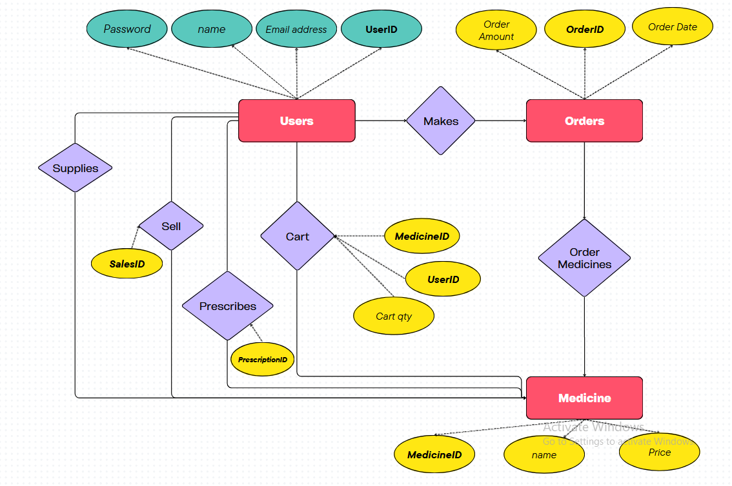

***KEY BASED ER DIAGRAM***

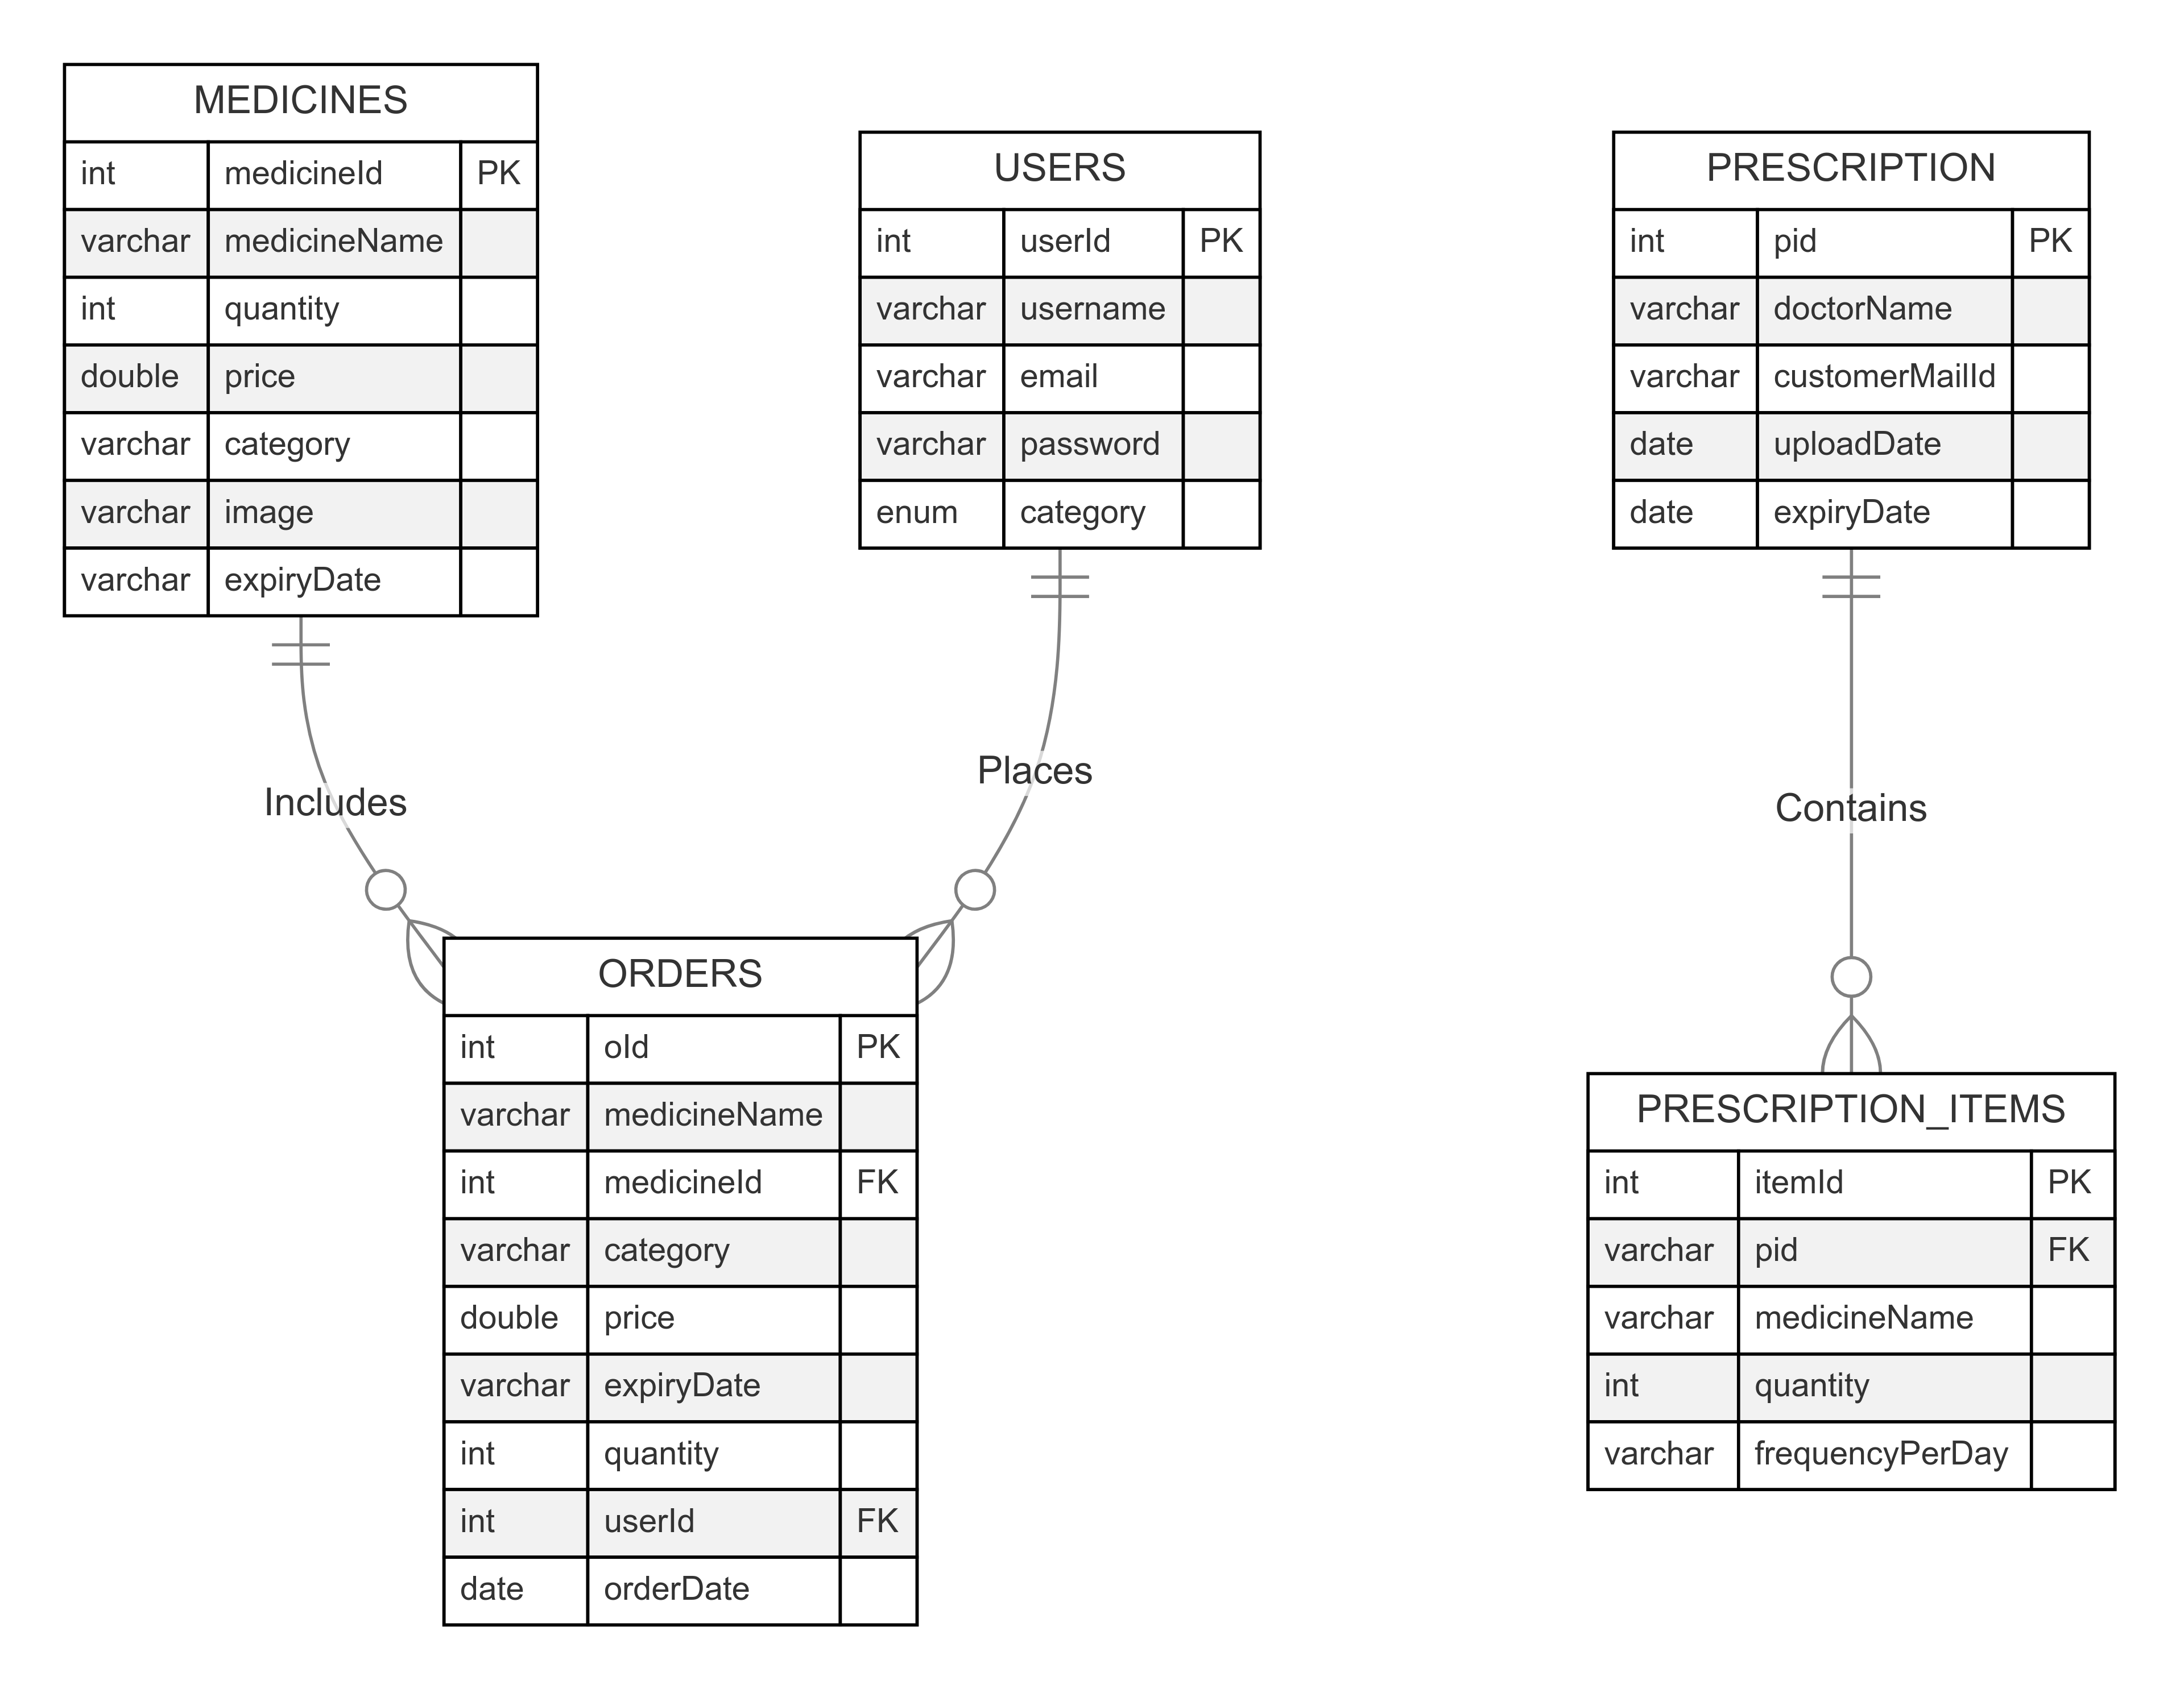

1. ***CLASS DIAGRAM***

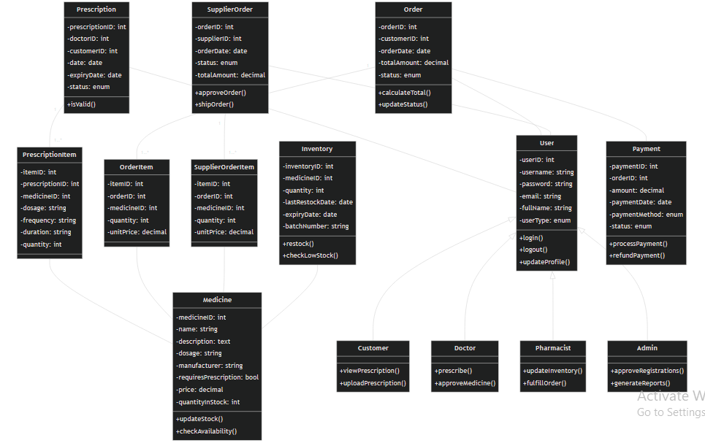

# SAMPLE UI

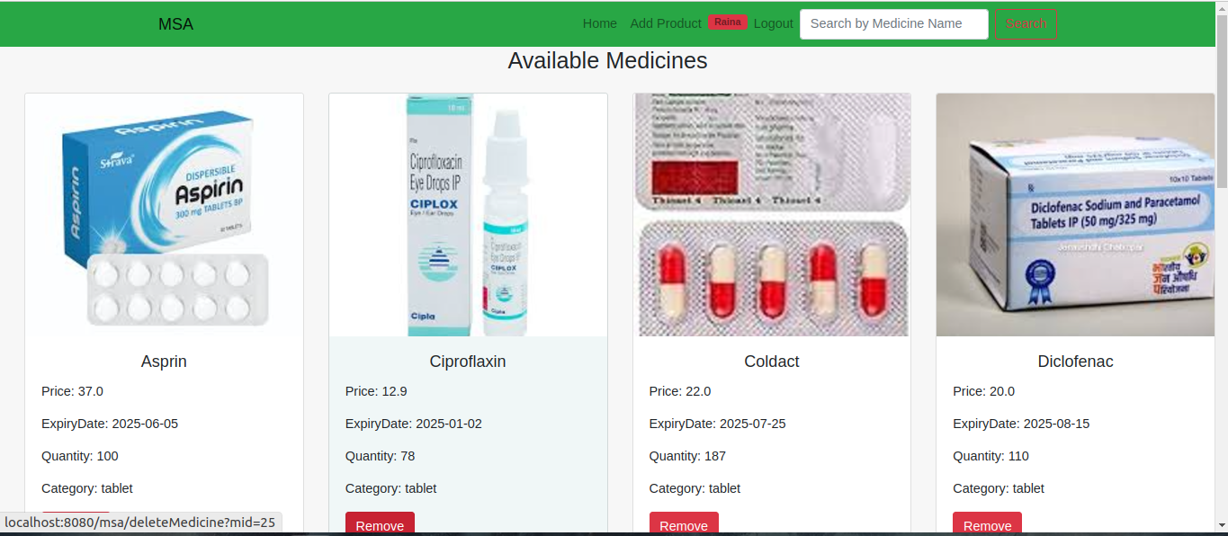

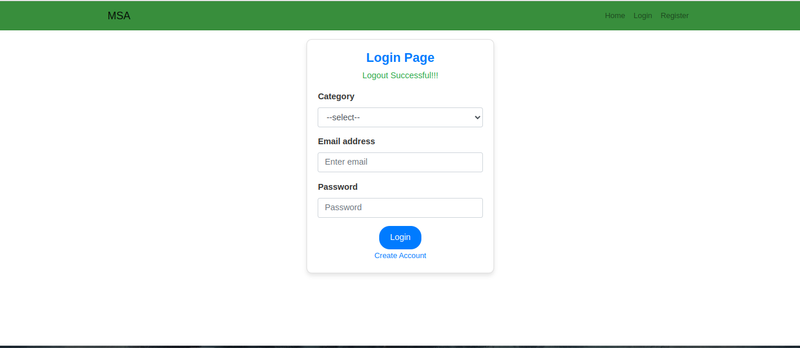

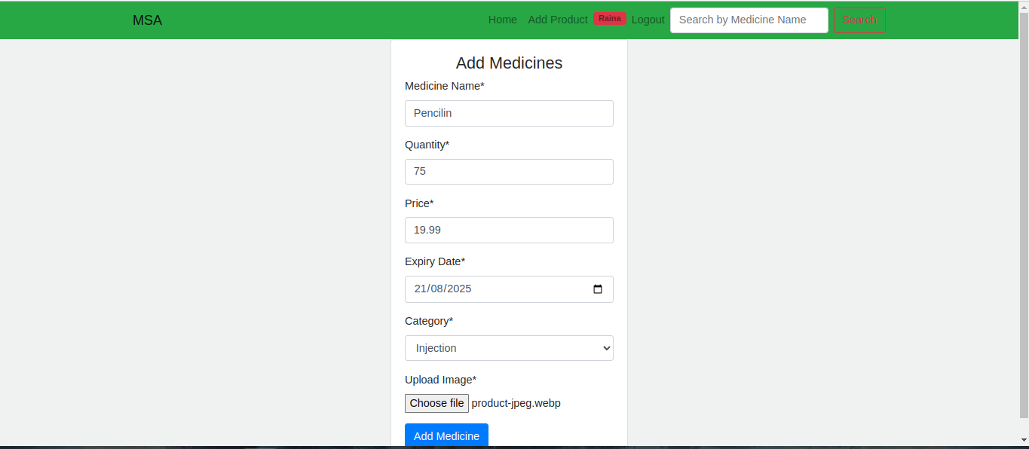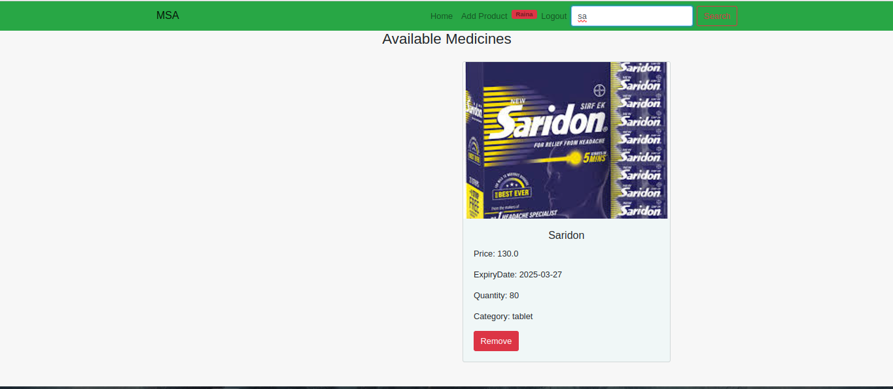

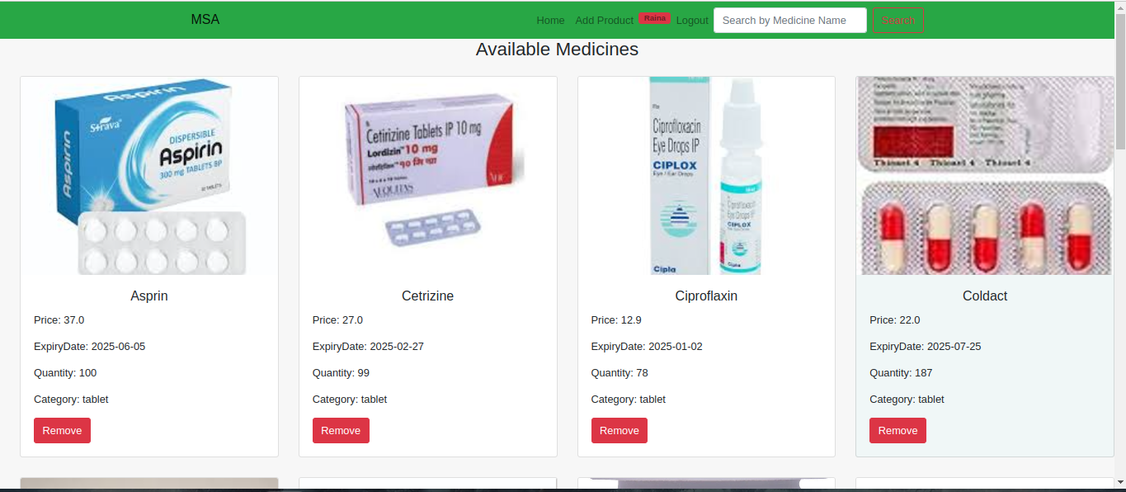

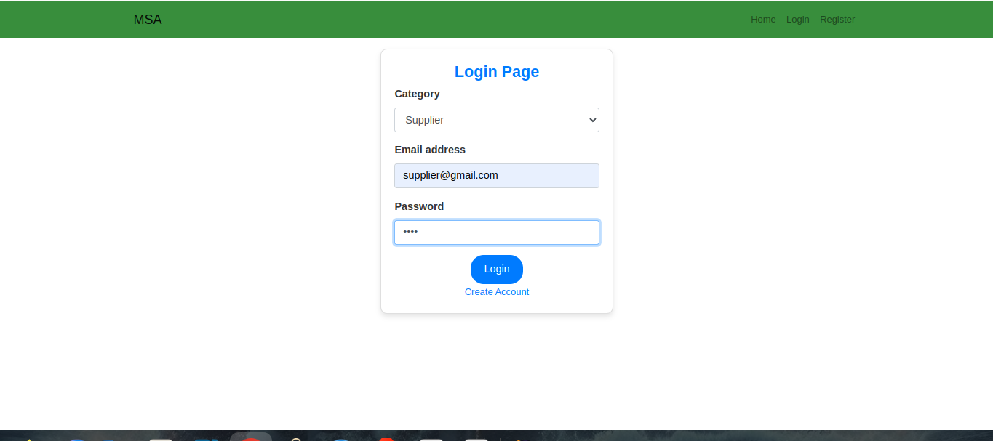

### ****Conclusion****

The Medical Shop Automation System effectively addresses the critical needs of a modern medical store by automating core processes such as inventory management, sales tracking, and supplier coordination. By reducing manual tasks and ensuring accurate record-keeping, the system enhances operational efficiency and minimizes errors, leading to better stock control and timely replenishment of medicines. Additionally, it helps maintain compliance with expiration date regulations, ensuring customer safety and satisfaction. The intuitive interface simplifies day-to-day tasks for store personnel, enabling them to focus more on customer service and less on administrative duties. This system not only optimizes the internal workflow of the medical store but also contributes to increased customer trust and business growth.

**Future Enhancements:**

The Medical Shop Automation System has significant potential for future enhancements to further improve its efficiency and scalability. One key development is integrating the system with online platforms, enabling customers to place orders and make payments online, thereby expanding the store’s reach. A mobile application could also be introduced, allowing store owners and staff to manage inventory and orders remotely. Implementing AI-driven analytics would help forecast demand, optimize stock levels, and automate restocking schedules, while automated expiry management could send timely alerts for products nearing expiration. Additionally, integrating the system with accounting software would streamline financial management and reporting.