**Medical  
 Shop**

**Automation**

Team **5Star ⭐⭐⭐⭐⭐**

**Members:**

R200347 V Premnath

R200346 V Mani Kumar Reddy

R200272 M Kowshik

R200560 J Sharanya

R201049 K Deepika

**INDEX**

1.Introduction ......................................3

1.1 Purpose  
 1.2 Scope   
 1.3 Definitions, Acronyms, and Abbreviations   
 1.4 References   
 1.5 Overview

2.Overall Description ...........................5

2.1 Product Perspective   
 2.2 Product Functions   
 2.3 User Characteristics  
 2.4 Constraints   
 2.5 Assumptions and Dependencies

3.Specific Requirements ......................7

3.1 External Interface Requirements   
 3.2 Functional Requirements   
 3.3 Non-functional Requirements

4.System Features ...............................9  
 4.1 Inventory Management

4.2 Sales and Billing   
 4.3 Prescription Management   
 4.4 Reporting and Analytics   
 4.5 User Management

5.Other Non-functional Requirements .......11

6.Technologies used....................................11

7.Appendices ..............................................12

7.1 Use Case Diagram

7.2 Context Diagram

7.3 Work Breakdown Diagram

1. **Introduction**

1.1 Purpose

* + The purpose of this document is to define the comprehensive requirements for a Medical Shop Automation system. This system aims to streamline operations, improve inventory management, and enhance customer service in medical shops or pharmacies.

1.2 Scope

* + The Medical Shop Automation system will cover inventory management, sales processing, prescription management, and basic reporting. It will be used by customers, pharmacists, and managers.

1.3 Definitions, Acronyms, and Abbreviations

* + POS: Point of Sale
  + EMR: Electronic Medical Record
  + API: Application Programming Interface
  + SKU: Stock Keeping Unit

1.4 References

* + Relevant pharmacy regulations and guidelines
  + Data protection and privacy laws

1.5 Overview

* + This document outlines the functional and non-functional requirements, system interfaces, and constraints of the Medical Shop Automation system.

1. **Overall Description**  
    2.1 Product Perspective
   * The system will be a standalone application with potential future integrations with suppliers' systems and electronic medical record (EMR) systems.

2.2 Product Functions

* + Inventory management
  + Sales and billing
  + Prescription management
  + Reporting and analytics
  + User management

2.3 User Characteristics

* + Pharmacists: Advanced medical knowledge, responsible for prescription management.
  + Managers: Business acumen, responsible for overall shop management and reporting.
  + Doctor: Medical Practitioners,responsible for prescribing medicines ,drugs.

2.4 Constraints

* + Must comply with local pharmacy regulations and data protection laws
  + Should operate on standard PC hardware
  + Must integrate with common POS hardware (barcode scanners, receipt printers)

2.5 Assumptions and Dependencies

* + Reliable internet connection for cloud-based features
  + Users have basic computer literacy
  + Regular system updates to maintain compliance with changing regulations

1. **Specific Requirements**

3.1 External Interface Requirements

* + User Interfaces:
    - Intuitive GUI for desktop application
    - Touch-friendly interface for potential tablet use
  + Hardware Interfaces:
    - Support for barcode scanners, receipt printers, and cash drawers
  + Software Interfaces:
    - Potential future API for EMR integration
  + Communications Interfaces:
    - Secure HTTPS for any internet communications
    - Support for email notifications

3.2 Functional Requirements

* + User Authentication and Authorization
  + Inventory Management
  + Sales and Billing
  + Prescription Management
  + Reporting and Analytics
  + Supplier Management
  + Customer Management

3.3 Non-functional Requirements

* + Performance: Response time <2 seconds for most operations
  + Security: Data encryption, secure user authentication, audit trails
  + Reliability: 99.9% uptime during business hours
  + Usability: Intuitive interface requiring minimal training

1. **System Features**

4.1 Inventory Management

* + Add, update, and delete product information
  + Track stock levels and expiry dates
  + Automatic reorder alerts

4.2 Sales and Billing

* + Process sales transactions
  + Generate and print receipts
  + Support multiple payment methods

4.3 Prescription Management

* + Record and validate prescriptions
  + Maintain patient medication history
  + Support for e-prescriptions

4.4 Reporting and Analytics

* + Generate sales reports (daily, weekly, monthly)
  + Inventory valuation reports
  + Profit margin analysis

4.5 User Management

* + Create and manage user accounts
  + Define user roles and permissions
  + Password policies and multi-factor authentication

1. **Other Non-functional Requirements**
   * Scalability: Support for multiple terminals and growing inventory
   * Maintainability: Modular design for easy updates and bug fixes
2. **Technologies Used**
   * **Frontend:**
     + Html
     + CSS
     + JavaScript
     + Bootstrap
   * **Backend:**
     + Java
     + SpringBoot
   * **DataBase:**
     + MySQL
   * **Other:**
     + GIT
     + GITHUB
     + GITHUB Co-Pilot

1. **Appendices**7.1 Context Diagram:

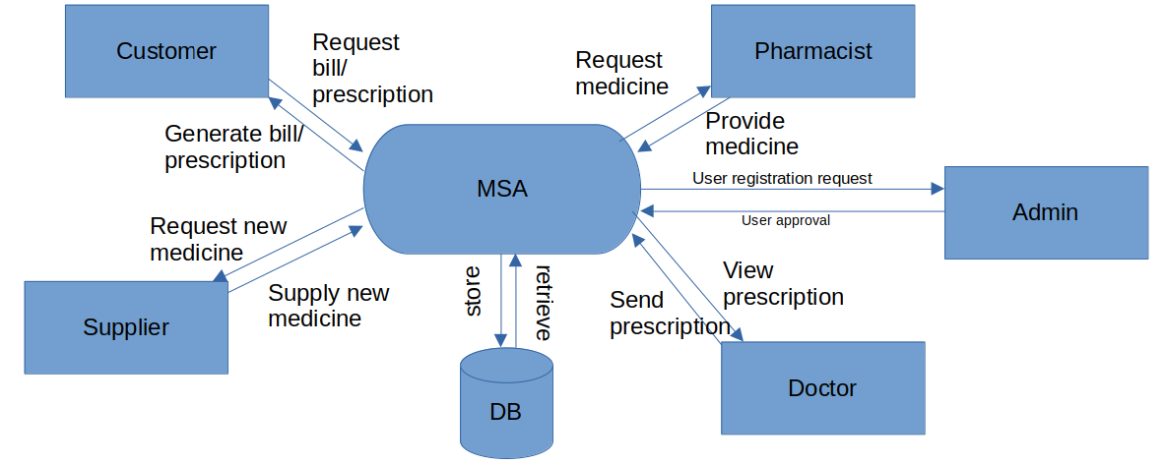

7.2 Use Case Diagram:

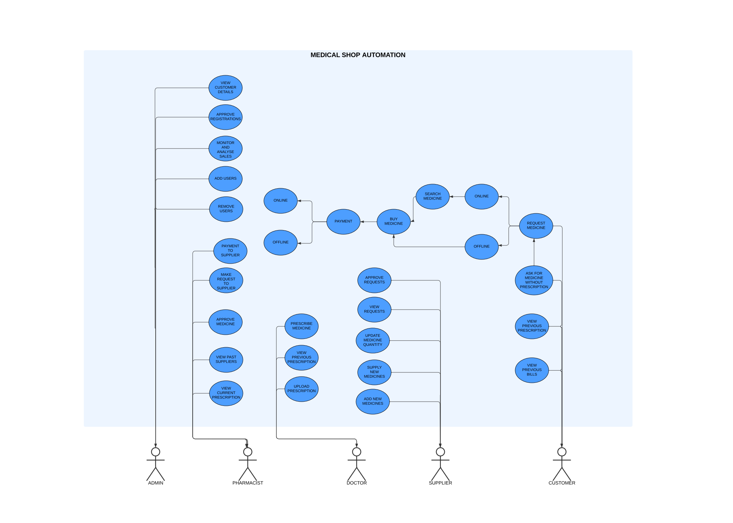

7.3 Work Breakdown Structure

