PharmaEase Architecture

1. Architectural Style: Modular Monolithic Architecture
PharmaEase follows a Modular Monolithic Architecture, where different functional modules (Customers, Druggists, Vendors, Admins) are logically separated but reside within a single deployable application. This ensures simplicity while allowing future scalability.

Key Characteristics:
- Single deployable codebase with separate modules.
- Each module follows Layered Architecture (Controller, Service, Repository).
- Shared Database Model, but logically separated per pharmacy.
- Easier maintenance and deployment on Oracle Cloud.
- Future-ready for microservices transition, if needed.

2. High-Level System Components

2.1 Backend (Spring Boot - REST API)
- Framework: Spring Boot (Java)
- Primary Role: Business logic and API services
- Layered Architecture:
  - Controller Layer → Handles API requests & responses (@RestController)
  - Service Layer → Contains business logic (@Service)
  - Repository Layer → Interacts with MySQL database (@Repository)
  - DTOs (Optional) → Used for data transfer between layers
- Key Functional Modules in Backend:
  - Authentication Module: JWT + Google OAuth
  - Customer Module: Medicine browsing, cart, orders
  - Druggist Module: Offline sales, stock management
  - Admin Module: Sales tracking, inventory control
  - Vendor Module: Medicine supply, replacements
  - Notification Module: Real-time alerts (Observer Pattern)
  - Payment Module: Strategy Pattern for multiple payment methods

2.2 Frontend (React)
- Framework: React.js (with Redux for state management)
- Primary Role: User interfaces for different roles
- Component-Based Architecture:
  - Reusable Components: Buttons, Forms, Cards, Modals
  - Container-Presenter Pattern: Separation of UI & business logic
  - Role-Specific Pages:
    - Customer Portal: E-commerce-style interface
    - Druggist Dashboard: Sales & stock management
    - Admin Dashboard: Business insights & pharmacy control
    - Vendor Panel: Order fulfillment & medicine management

2.3 Database (MySQL - Hosted on Oracle Cloud)
- Architecture: Multi-tenant model (Super Admin DB + Separate DBs per pharmacy)
- Database Structure:
  - Super Admin Database: Manages all pharmacies & global cart
  - Pharmacy-Specific Databases: Independent inventory & sales tracking
  - Tables:
    - users → Stores all user accounts (Admin, Druggist, Vendor, Customer)
    - medicines → Medicine inventory for each pharmacy
    - sales → Order and transaction history
    - vendors → Supplier details
    - notifications → Tracks unread alerts

3. System Architecture Diagram (Logical Flow)

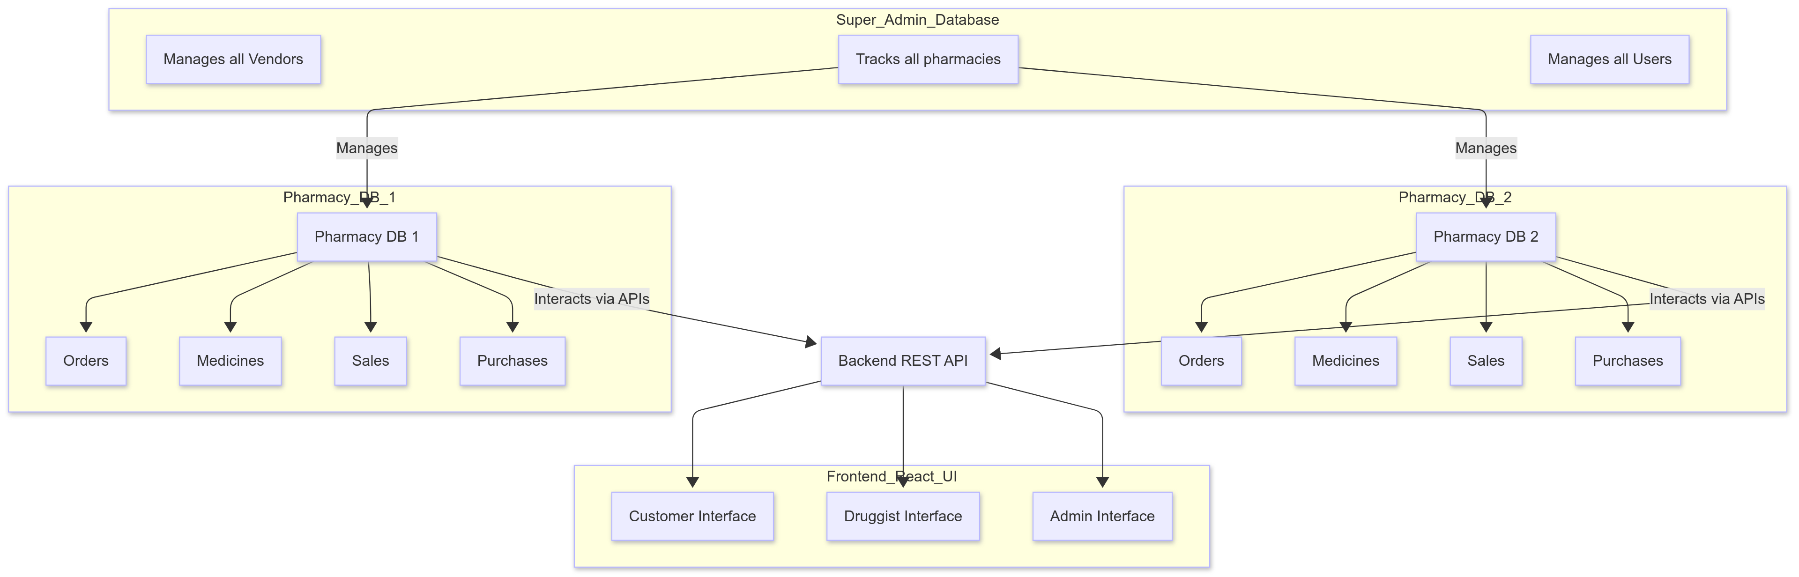

4. Communication & Data Flow
- Frontend interacts with Backend via REST APIs.
- Backend handles authentication, business logic, and data storage.
- MySQL Databases store data for pharmacies, with a Super Admin DB managing pharmacy-level access.
- Notifications (Observer Pattern) ensure real-time stock and order updates.
- Payment Module (Strategy Pattern) supports different payment gateways.

5. Deployment Strategy
- Backend: Spring Boot API deployed on Oracle Cloud.
- Frontend: React app hosted using free-tier services.
- Database: MySQL databases hosted on Oracle Cloud’s free-tier.

6. Future Scalability Plan
- Current Modular Monolithic structure allows for easy transition to Microservices if needed.
- Potential GraphQL API integration for better query performance.
- Adding Redis for caching to optimize frequent queries (e.g., medicine search).

