PharmEase

Mini Project Abstract | B.Tech 3rd Year, 2nd Semester
Department of Computer Science and Engineering
Submitted by
V Premnath (R200347)

Under the guidance of

P.Santosh Kumar

Assisstant Professor, Department of CSE



DEPARTMENT OF COMPUTER SCIENCE AND ENGINEERING

RAJIV GANDHI UNIVERSITY OF KNOWLEDGE TECHNOLOGIES

RK VALLEY, Vempalli (M)
Kadapa (Dist),
Andhra Pradesh(S), 516330

Problem Statement:
Traditional medical store management is highly dependent on manual processes, leading to inefficiencies such as stock mismanagement, expired medicine sales, supplier miscommunication, and customer dissatisfaction due to slow billing. Pharmacies struggle with tracking inventory in real-time, managing supplier records, and ensuring regulatory compliance, often resulting in financial losses and reduced operational efficiency. There is a need for a digital solution that automates these processes, enhances accuracy, and improves the overall workflow of a medical store.

PharmaEase

–A Drug Store Automation Platform

Abstract
PharmaEase is a comprehensive pharmacy automation system that optimizes day-to-day operations by automating inventory management, sales tracking, and supplier coordination. The platform reduces manual effort and errors, ensuring real-time stock monitoring, automated expiry tracking, and efficient order processing. By integrating modern technology, PharmaEase aims to streamline pharmaceutical management, enhance accuracy, and improve customer service.

Objectives
- Automate inventory tracking to prevent stock shortages and overstocking.
- Reduce manual errors in managing sales, supplier records, and medicine information.
- Enhance customer service with quick and accurate billing, including an e-commerce platform for online medicine purchases.
- Ensure regulatory compliance by monitoring expiration dates and preventing the sale of expired medicines.

Methodology & Technologies Used
- Backend: Java with Spring Boot for efficient and scalable application development.
- Database: MySQL/MongoDB to manage inventory, sales records, and supplier details.
- Frontend: React.js for an intuitive and user-friendly interface.
- API Communication: RESTful APIs to facilitate seamless data flow between components.
- Security: Role-Based Access Control (RBAC) to ensure authorized user access.

Key Features
- Automated Inventory Management: Tracks stock levels, sends alerts for low inventory.
- Supplier Management: Maintains supplier details and automates order placements.
- Sales Tracking: Records all transactions, including medicine sales and payments.
- Expiry Date Monitoring: Generates alerts for near-expiry medicines to minimize losses.
- User Roles & Access Control: Restricts unauthorized access to sensitive pharmacy data.
- Reports & Analytics: Generates reports on sales, stock, and supplier records.

Significance & Impact
PharmaEase enhances efficiency, accuracy, and compliance in pharmacy operations. By automating manual tasks, it reduces the risk of errors, improves workflow, and ensures better customer service. Compliance with expiration date regulations further increases trust and reliability in pharmaceutical businesses.

Expected Outcomes
- A fully functional drug store automation system with inventory, sales, and supplier management.
- Minimized manual effort and reduced stock mismanagement.
- Improved customer experience through fast billing and service.
- A scalable solution that can support multiple pharmacy branches.

Future Scope
- AI-based demand forecasting for optimized stock management.
- Barcode scanning for faster billing and inventory updates.
- Cloud-based expansion to manage multiple pharmacy branches efficiently.
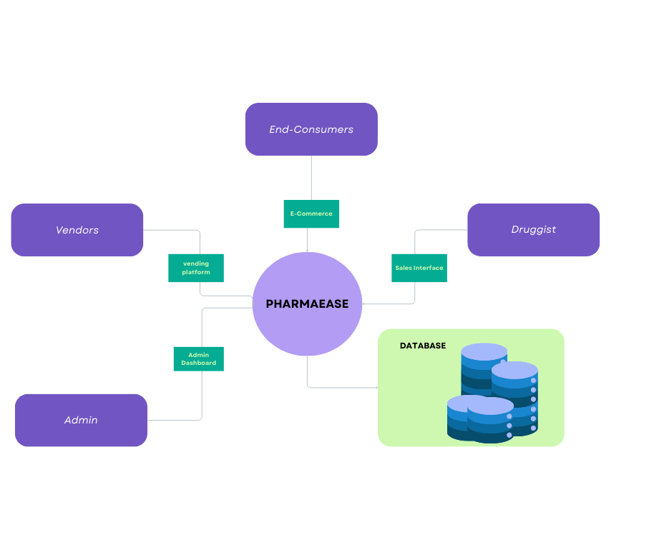
Block Diagram:

