System Design Specification (SDS) Document
Project Name: PharmaEase
Version: 1.0
Prepared By: [Your Name]
Date: [DD/MM/YYYY]

Index
- Introduction
1.1 Purpose
1.2 Scope
1.3 Intended Audience
- System Architecture
2.1 High-Level Architecture
2.2 System Components
2.3 Technology Stack
- Database Design
3.1 Schema Overview
3.2 Tables & Relationships
3.3 Entity-Relationship Diagram
- Application Design
4.1 Backend Design
4.2 Frontend Design
4.3 API Endpoints
- Security & Compliance
5.1 Authentication & Authorization
5.2 Data Encryption & Privacy
5.3 Compliance Standards
- Financial Management Design
6.1 Financial Transactions Schema
6.2 Super Admin Finance Tracking
6.3 Pharmacy-Level Financial Reports
- Prescription & Medical Records Design
7.1 Prescription Upload & Storage
7.2 Verification Process
7.3 Medical Record Retrieval
- Business Intelligence & Analytics
8.1 Sales Reports & Dashboards
8.2 Customer Behavior Analytics
8.3 Predictive Analytics for Stock Management
- Appendix

1. Introduction

1.1 Purpose
This document provides the system design specifications for PharmaEase, defining the architecture, database schema, API structure, and security considerations. This document serves as a blueprint for developers and stakeholders.

1.2 Scope
PharmaEase is a comprehensive pharmacy management system supporting multiple stakeholders. It includes inventory tracking, vendor management, prescription storage, financial tracking, and an e-commerce interface for customers.

1.3 Intended Audience
- Developers & Architects
- Product Managers
- QA Engineers
- Business Analysts

2. System Architecture

2.1 High-Level Architecture
PharmaEase follows a microservices-based architecture, ensuring modularity and scalability.

2.2 System Components
- Frontend: React-based SPA for users.
- Backend: Spring Boot microservices with REST APIs.
- Database: MySQL (Separate databases per pharmacy).
- Authentication: JWT & OAuth for security.
- Payment Gateway: Razorpay/Stripe/PhonePe for transactions.

2.3 Technology Stack
- Frontend: React, Redux, Tailwind CSS
- Backend: Spring Boot, JPA, Hibernate
- Database: MySQL (Cloud-hosted)
- Security: JWT, OAuth, HTTPS
- Other: Docker, Kubernetes (optional), CI/CD with GitHub Actions

3. Database Design

3.1 Schema Overview
Each pharmacy will have its own independent database to ensure data isolation. The Super Admin will maintain a master database for managing pharmacies.

3.2 Tables & Relationships
- Users Table (user_id, name, role, email, password, phone, address)
- Medicines Table (medicine_id, name, composition, stock, purchase_id, cost, type, exp_date, image)
- Sales Table (sales_id, medicine_list, total_amount, customer_id, druggist_id, payment_status, sales_date)
- Cart Table (cart_id, user_id, medicine_list, quantity)
- Vendors Table (vendor_id, vendor_name, medicine_list, contact)
- Finance Table (transaction_id, transaction_type (BUY/SELL), amount, date)
- Purchases Table (purchase_id, vendor_id, medicine_list, total_amount, purchase_date)
- Prescriptions Table (prescription_id, user_id, doctor_name, medicine_list, upload_date, status)

4. Application Design

4.1 Backend Design
- Controller Layer: Exposes REST APIs.
- Service Layer: Business logic implementation.
- Repository Layer: Data access using JPA.

4.2 Frontend Design
- Component-based architecture.
- Role-based dashboards for Super Admin, Admin, Druggist, Vendor, Customer.

4.3 API Endpoints
- Analytics API
  - GET /api/analytics/sales
  - GET /api/analytics/customers
  - GET /api/analytics/inventory

5. Security & Compliance

5.1 Authentication & Authorization
- JWT-based authentication with OAuth 2.0 integration.
- Role-based access control (RBAC).

5.2 Data Encryption & Privacy
- AES encryption for sensitive data.
- HTTPS for secure communication.

5.3 Compliance Standards
- HIPAA compliance for medical records.
- PCI-DSS compliance for payment transactions.

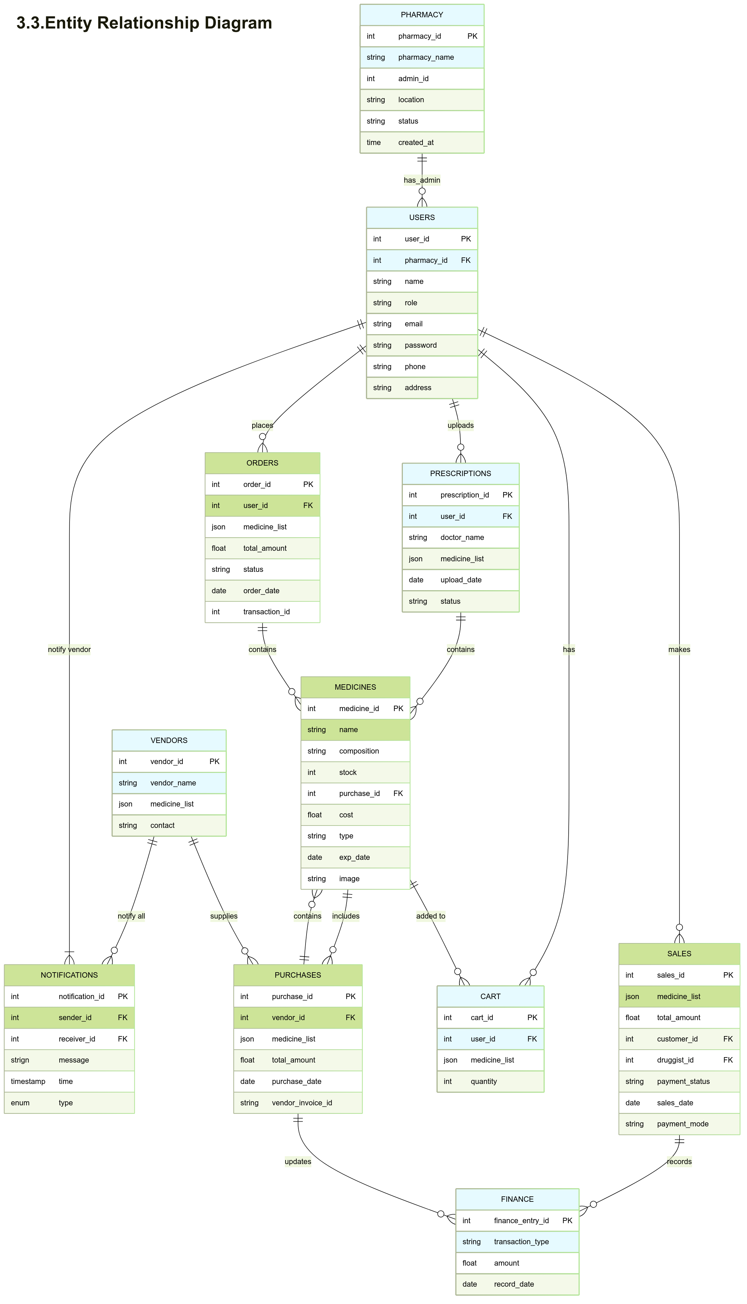

6. Financial Management Design

6.1 Financial Transactions Schema
- transaction_id (Unique identifier)
- transaction_type (BUY/SELL)
- amount (Transaction amount)
- date (Transaction date)

6.2 Super Admin Finance Tracking
- Monitor all pharmacy transactions.
- Generate revenue reports.

6.3 Pharmacy-Level Financial Reports
- Track profits/losses at pharmacy level.
- View transaction history.

7. Prescription & Medical Records Design

7.1 Prescription Upload & Storage
- Customers upload prescriptions as images or PDFs.
- System stores prescription details in encrypted format.

7.2 Verification Process
- Druggists verify prescriptions before approving orders.
- Only verified prescriptions can be used for restricted medicines.

7.3 Medical Record Retrieval
- Customers can access their medical history.
- Admins can audit records for compliance.

8. Business Intelligence & Analytics

8.1 Sales Reports & Dashboards
- Track sales by pharmacy, vendor, and medicine category.
- Generate automated reports.

8.2 Customer Behavior Analytics
- Identify frequent buyers.
- Predict demand based on past trends.

8.3 Predictive Analytics for Stock Management
- AI-based recommendations for inventory restocking.
- Prevent stock shortages using predictive analysis.

9. Appendix
- Abbreviations:
  - JWT: JSON Web Token
  - RBAC: Role-Based Access Control
  - API: Application Programming Interface
- References:
  - Pharmaceutical regulations
  - Financial compliance standards

3.3 Entity-Relationship Diagram

