Contents
1 Introduction 4
1.1 Vision 4
1.2 Mission 4
1.3 Objectives 4
1.4 Major Initiatives of the trust 4
1.5 Maha Periyava’s Message 5
1.6 History of events 5
2 Uniqueness in learning & teaching veda 5
3 Activities 6
3.1 Various Veda shakas VRNT is supporting 6
3.2 Focus on Sampradayam 6
3.2.1 Gurukula Vasam 6
3.2.2 Shikavaan 6
3.2.3 Swashaka Adyayanam 6
3.2.4 Hereditary Niyama Adhyayanam 6
3.3 Varshikam Exam 7
3.4 Poorthy Exam 7
3.5 Selection of the Best Vidyārthi (Shoorādhyāyī) 8
3.5.1 Eligibility Criteria 8
3.5.2 Examination Format 8
3.5.3 Recognition 9
4 Ensuring Tradition 9
4.1 Ensuring tradition 9
4.1.1 Niyamaadhyayaynam 9
4.1.2 Swashaka 9
4.1.3 Shikavaan 9
4.1.4 No schooling 9
4.2 Ensuring Sanskrit Knowledge 9
4.3 Honours 9
5 Others 9
5.1 Famous Graduates 9
5.2 Famous HNY vidyarthees 10
5.3 The value of the VRNT Certification 10
5.4 Patashalas we support 10
5.5 How VRNT has been supporting the Vedic Community AND how it has been growing over the years 10
5.6 Challenges current & future 10
5.7 Varshika & Poorthy exams And their challenges 10
6 How to Contribute 10
7 Needed Inputs 11

VRNT pamphlet
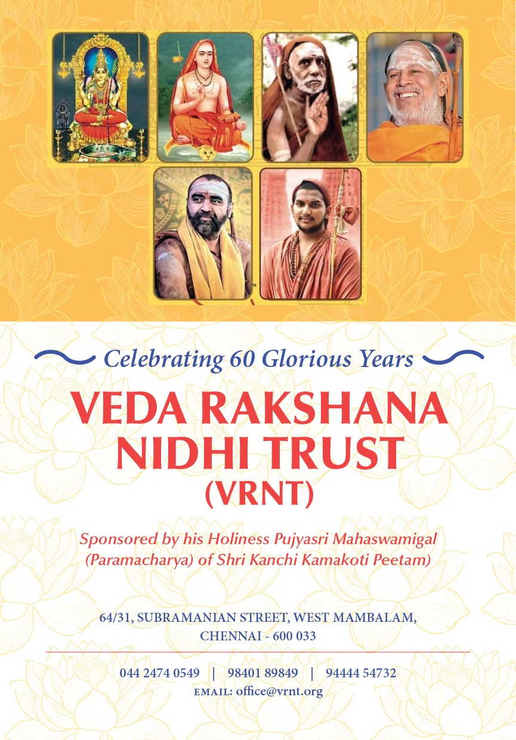

Introduction
VEDA RAKSHANA NIDHI TRUST (VRNT) is a Public Charitable Trust sponsored by Kanchi Kamakoti Peetam founded in 1963 under the guidance of His Holiness Sri Sri Chandrashekarendra Saraswati Swamigal.

Vision
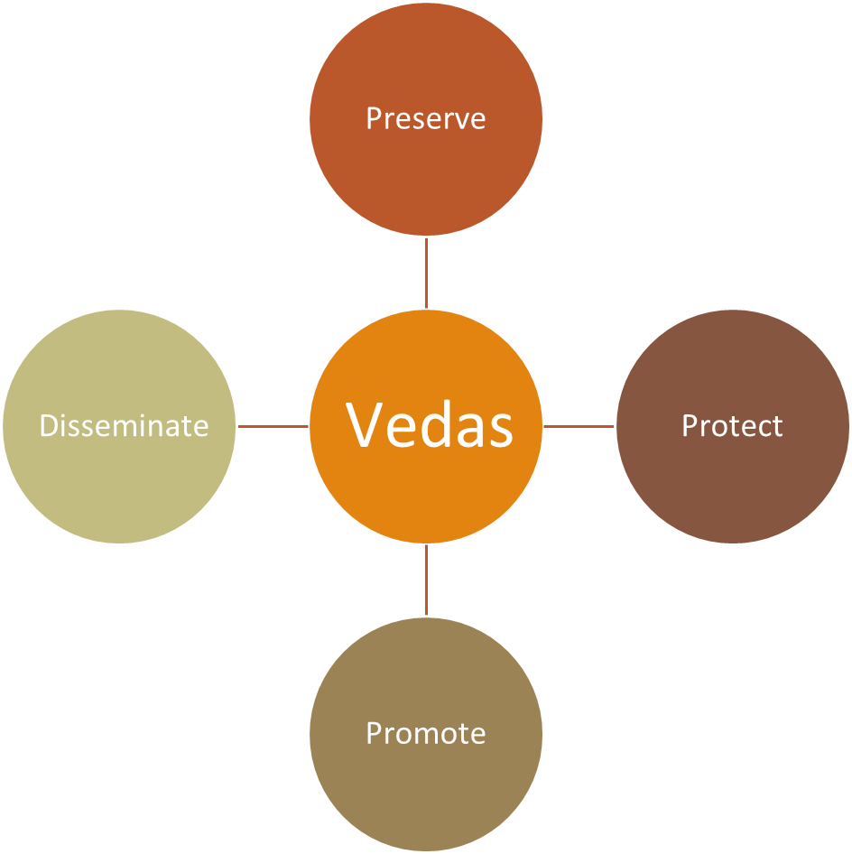
To uphold the Guru-Sishya tradition and extend educational opportunities to deserving students across linguistic and philosophical backgrounds

Mission
To ensure the survival and flourishing of Vedic knowledge through educational and financial support to Vedic scholars and institutions.

Objectives
Objectives of the trust are preserving, protecting, promoting and disseminating Vedas in the traditional manner. VRNT has dedicated itself to preserving the uniqueness and distinctiveness of each branch of vedic recitation by encouraging students, scholars and practitioners in this noble endeavour.

Major Initiatives of the Trust
Over the decades, the Veda Rakshana Nidhi Trust (VRNT) has undertaken several pioneering initiatives to uphold and propagate the sacred Vedic tradition in its pristine form. Each initiative reflects the Trust’s unwavering commitment to Veda Rakshanam — the preservation, teaching, and practice of the Vedas as a living heritage.

Hereditary Niyama Adhyayanam (HNY) Scheme
This unique initiative revives and sustains the hereditary mode of Vedic learning, where a father imparts the Vedas to his son within the family lineage. Such lineage-based teaching is considered the most authentic and time-tested method of preserving Vedic knowledge, as it ensures both precision in pronunciation (śikṣā) and purity in intonation (svara). Through this scheme, the Trust provides financial and institutional support to families who continue this sacred tradition, thus strengthening the unbroken oral chain (paramparā) of Vedic transmission.

Support for Rare Veda Shaakhas
Certain branches (śākhās) of the Vedas are now on the brink of extinction due to a dwindling number of practitioners. Recognizing this urgent need, VRNT has established and supported Veda Pāṭhaśālās dedicated to these rare Shaakhas. These institutions provide an environment where students can undergo systematic and disciplined training under the guidance of qualified scholars, thereby ensuring the revival and sustenance of endangered Vedic recensions.

Pan-India Financial Assistance
The Trust extends comprehensive financial assistance to deserving Veda Pāṭhaśālās across India. Such assistance enables institutions in even the most remote areas to maintain high standards of Vedic education, ensuring that economic challenges do not hinder the pursuit of this sacred learning.

Academic Monitoring and Varshika Examinations
To maintain academic rigor and uniformity, VRNT conducts regular inspections and annual assessments (Varshika Pariksha) across its affiliated Pāṭhaśālās in Tamil Nadu, Kerala, Andhra Pradesh, Telangana, Maharashtra, and Assam. Senior scholars from the Trust personally visit these institutions to evaluate students’ progress through oral examinations and recitation tests, ensuring adherence to traditional standards and authenticity of transmission.

Final Examinations and Recognition
At the culmination of their course, students appear for the final examinations conducted by VRNT, which serve as a comprehensive assessment of their mastery over the respective Shaakha. Successful candidates are conferred with certificates of proficiency and monetary rewards, acknowledging their hard work and devotion. This recognition not only honors their achievement but also inspires them to continue their lifelong commitment to the study and teaching of the Vedas.

Maha Periyava’s Message
- The Kanchi Mahaswami emphasizes that the preservation of the Vedas is the foremost duty of Brahmins, as the Vedas are the foundation of Sanatana Dharma and the source of all spiritual and cultural discipline.
- Though he prefers a quiet life of worship, the Mahaswami travels to cities to reach more people and remind them of their duty to protect the Vedas and support traditional Vedic families.
Niyama Adhyayana
Preserve all veda shakhas
Involve entire Hindu community
Support Rural & Semi Urban patashalas
- He urges devotees to redirect their enthusiasm and resources from grand religious celebrations like Kanakabhisheka toward establishing funds and committees for Vedic education.
- The Mahaswami proposes a practical plan—starting village-level Veda classes for young boys and financially supporting students and teachers in Veda Patashalas.
- He warns that neglecting the Vedas leads to the decay of Dharma, social unrest, and loss of spiritual discipline, while preserving them ensures prosperity and peace.
- Vedas, he says, once represented a universal spiritual culture, and their preservation can help unify different nations and religions.
- The Mahaswami insists that ancient traditions should not be discarded merely for being old but should be judged by their true value and purpose.
- He appeals for everyone’s contribution to the Veda Rakshana Nidhi Trust, ensuring a sustainable future for Vedic studies.
- Concluding, he declares that of all duties, the most vital is to preserve and transmit the Vedas to future generations, for they alone can bring lasting prosperity and unity to the world.

History of events
- Founded in 1963

Uniqueness in learning & teaching veda
Learning and teaching the Vedas through the traditional Gurukula system is not merely an academic pursuit—it is a way of life, a sacred journey that nurtures both character and intellect. In this ancient and time-honoured system, education transcends classroom boundaries and becomes an immersive spiritual discipline.
From as early as six years of age, students, known as śiṣyas, leave the comfort of their homes to live with their Guru, who becomes their teacher, mentor, and guardian. The Gurukula thus becomes their extended family, where the Guru’s home is both a temple of learning and a cradle of values. The Guru not only imparts the wisdom of the Vedas but also instills humility, discipline, devotion, and self-control—qualities that form the very foundation of a noble life.
The Gurupatni, or the Guru’s wife, plays an equally indispensable role in this sacred ecosystem. With maternal affection and care, she tends to the daily needs of the young disciples, ensuring their well-being and providing emotional comfort during their years away from home. Her contribution reflects the spirit of seva—selfless service—which is central to the Gurukula tradition.
The training in a Gurukula is rigorous and comprehensive, spanning nearly two decades of dedicated learning. Each day begins early, often before sunrise, with prayers and rituals, followed by 8 to 10 hours of intense recitation, memorization, and interpretation of Vedic hymns and texts. The process of memorization—śruti pāṭha—is not mechanical but deeply meditative, preserving the purity of pronunciation, intonation, and rhythm that have been transmitted orally for millennia.
Unlike modern education systems that rely on written examinations, assessment in the Gurukula is entirely oral. Every student must individually demonstrate mastery before the Guru through repeated recitations, corrections, and rigorous testing. This one-on-one evaluation demands extraordinary patience and commitment from both teacher and student. The Guru carefully listens to each syllable, ensuring flawless transmission of the sacred texts—an act considered both a duty and a spiritual offering.
Ultimately, the Gurukula system is not only about the preservation of the Vedas but also about building individuals of integrity, humility, and spiritual awareness. It continues to stand as a living embodiment of India’s timeless educational ideals, where learning is inseparable from living, and knowledge is revered as a divine pursuit.

Activities

Various Veda shakas VRNT is supporting
Our trust is supporting the Veda Shakas.
- Rig - Shakala
- Krishna Yajur - Thaithariyam
- Shukla Yajur - Kanva
- Shukla Yajur - Madhyanthina
- Sama - Kouthuma
- Sama - Jaimini
- Sama - Ranayani
- Atharva - Saunaka
- Atharva – Pippalada

Focus on Sampradāyam
As per the sacred guidance of His Holiness, the Trust emphasizes that Vidyaarthis (students) must not only pursue Adhyayanam (Vedic study) but also adhere to Sampradāyam—the traditional code of conduct and way of life that forms the foundation of Vedic learning. True Vedic education encompasses both intellectual study and disciplined living in accordance with Dharma.

Gurukula Vāsam
In keeping with ancient tradition, Vidyaarthis are expected to reside with their Guru in the Gurukula and engage in full-time Adhyayanam. The Gurukula environment fosters humility, devotion, and self-discipline, values that are as essential as knowledge itself.
Living away from one’s family under the guidance of the Guru is considered a form of Tapas (austerity). The young Vidyaarthis who live this life of discipline and simplicity undertake this Tapas unknowingly, yet it profoundly shapes their character and spiritual maturity.

Sva-Śākhā Adhyayanam
The term Sva-Śākhā refers to the Vedic branch belonging to one’s ancestral lineage. According to tradition, every Brahmin is expected to study the Vedas, beginning with the Śākhā specific to his family (Sva-Śākhā). Only after attaining proficiency in his own Śākhā may a student proceed to learn other branches. This principle ensures that each lineage preserves its unique recensional purity and continues its inherited tradition unbroken.

Hereditary Niyama Adhyayanam
The Hereditary Niyama Adhyayanam (HNY) scheme refers to the systematic and disciplined study of the Vedas as a sacred hereditary duty within traditional Vedic families. In this age-old practice, the father assumes the role of Guru and the son becomes the Śishya, continuing the oral tradition through generations.
This mode of learning ensures authentic preservation of Vedic recitation, pronunciation, and intonation, which can only be transmitted perfectly through Guru-Śishya Paramparā. The Trust accords special recognition and support to such hereditary scholars, acknowledging them as true custodians of Sanātana Dharma and vital pillars in sustaining the living Vedic heritage.

Varshikam Examination
The Varshikam Examination is conducted annually with the primary objective of assessing the academic progress of the Vidyaarthis (students) in each Paatashala. Through this examination, the Trust ensures that students are advancing systematically in their Adhyayanam (Vedic studies) year after year.
During the Varshikam Examination, designated Pareekshādhikāris (examiners) personally visit the respective Paatashalas and evaluate the students based on the portions they have studied during the preceding year. This oral assessment helps students become accustomed to the examination process and prepares them to face the final or Poorthy Examination with confidence and composure.
In addition to testing recitation and mastery of lessons, the Pareekshādhikāris also observe whether the Vidyaarthis are studying their Sva-Śākhā (own Vedic branch) and maintaining the Śikhā (traditional tuft) as prescribed by the Sampradāyam. Thus, the Varshikam Examination serves not only as an academic evaluation but also as a means to reinforce discipline, tradition, and adherence to Dharmic practices among the students.

Poorthy Examination
The Poorthy Examination serves as the final or graduation examination for Vidyaarthis (students) who have successfully completed their prescribed course of Vedic study. It marks the culmination of years of rigorous Adhyayanam and dedicated discipline within the Gurukula system.
Different Veda Shaakhas have distinct levels of certification, reflecting the traditional hierarchy of Vedic mastery:
- Rig Veda: The graduation levels progress through Moolam, Padam–Kramam, Ghanam, and Lakshanam.
- Yajur Veda (both Krishna and Shukla Shaakhas): The levels begin with Padam–Kramam, followed by Ghanam and Lakshanam.
- Sama Veda: The two main graduation levels are Poorva Bhagam and Uttara Bhagam.
- Atharva Veda: Certification is awarded at the Moolam level.
Each stage of certification represents a significant milestone in the student’s Vedic journey, symbolizing not only scholarly accomplishment but also spiritual growth and dedication to the preservation of the sacred oral tradition.

Ensuring Sanskrit Proficiency
In accordance with the Trust’s objective to promote comprehensive Vedic education, every Vidyaarthi is required to attain a sound knowledge of Sanskrit, the foundational language of the Vedas. To ensure this, students must successfully complete the various levels of Sanskrit examinations conducted by the Chittoor Samskrutha Sabha, which serves as the recognized academic body for assessing Sanskrit proficiency.
The prescribed levels of Sanskrit qualification corresponding to each Veda Shaakha and stage of study are as follows:
Veda Shaakha | Level of Study | Sanskrit Examination Level (Chittoor Samskrutha Sabha)
Rig Veda | Moolam | Parichaya (Introductory Level)
 | Kramam | Abhijñā (Intermediate Level)
 | Ghanam | Vichakshana (Advanced Level)
Yajur Veda | Kramam | Parichaya, Abhijñā
 | Ghanam | Vichakshana
Sama Veda | Poorva Bhagam | Parichaya, Abhijñā
 | Uttara Bhagam | Vichakshana
Atharva Veda | Moolam | (To be finalized)
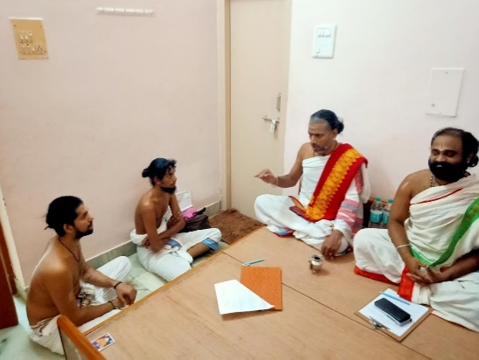
These examinations ensure that Vidyaarthis not only master the Vedic recitations but also gain the linguistic depth necessary to understand the meaning, grammar, and structure of the sacred texts they study. Sanskrit proficiency thus complements Vedic learning, reinforcing both intellectual understanding and spiritual insight.

Selection of the Best Vidyārthi (Śūrādhyāyī)
In pursuit of academic excellence and to uphold the highest standards of Vedic scholarship, the Trust has instituted a special recognition titled “Śūrādhyāyī”, awarded to the Best Vidyārthi. This distinction is conferred upon a student who demonstrates exceptional proficiency, depth of understanding, and unwavering dedication to the Vedic tradition.
The Śūrādhyāyī selection is a prestigious blend of examination and competition, designed to identify students who exemplify mastery, discipline, and the spirit of Adhyayanam at its finest.

Eligibility Criteria
To be considered for this title, candidates must satisfy the following conditions:
- Gānāntham Score: The candidate must have secured a minimum of 90% marks in the Gānāntham examination conducted by VRNT.
- Time Since Qualification: The candidate should have cleared the Gānāntham examination not less than two years and not more than four years prior to the competition. (This rule is under final review by the Trust.)
- Knowledge of Lakṣaṇam and Prātiśākhya: While formal certification in Lakṣaṇam is not mandatory, the candidate must possess a comprehensive understanding of both Lakṣaṇam and Prātiśākhya, as these disciplines are integral to the purity and precision of Vedic recitation.

Examination Format
The Śūrādhyāyī assessment is designed to test the depth, accuracy, and spontaneity of the candidate’s learning. It is an advanced-level examination that includes the following components:
- Recitation and Oral Examination in:
  - Mūlam
  - Padam
  - Kramam
  - Jaṭā
  - Gānam
- Syllabus Coverage: Questions will be drawn from both the Saṃhitā and Brāhmaṇa portions of the respective Śākhā.
- Question Type: Only high-standard, challenging questions will be posed, including intricate Kavalai Pañchati passages and complex recitational patterns.
- Recitation Duration: The candidate must recite continuously for at least two Pañchatis, amounting to a minimum duration of 10 minutes.
- Question Count: Each participant will be asked a minimum of three probing questions, requiring analytical and precise responses.
- Gānam Segment: Special emphasis will be placed on Sandhi accuracy, with continuous questioning to evaluate fluency, retention, and tonal precision.

Recognition
Only one outstanding Vidyārthi will be selected and honored with the title “Śūrādhyāyī”, making it a singular and highly prestigious distinction. The award symbolizes not only academic excellence but also dedication to the sacred duty of preserving and transmitting the Vedic heritage in its most authentic form.

