Case Study Report



**Tech Saksham**

Data Analytics with Power BI

**“ANALYSIS OF COMMERCIAL ELECTRICITY CONSUMPTION IN INDIAN STATES”**

**A.P.C MAHALAXMI COLLEGE FOR WOMEN**

|  |  |
| --- | --- |
| **NM ID** | **NAME** |
| 57134D760B557898DAC44042B47216E5 | VAISHNAVI V |

Trainer Name : R.UMAMAHESHWARI

Master Name : R.UMAMAHESHWARI

|  |  |
| --- | --- |
|  |  |
|  |  |
|  |  |

**ABSTRACT**

This study investigates the commercial electricity consumption patterns in India using real-time data analysis techniques. With the rapid growth of commercial sectors across the country, understanding electricity usage trends is crucial for efficient resource allocation, infrastructure planning, and policy formulation. This research employs advanced analytics tools to analyze real-time electricity consumption data collected from commercial establishments in different regions of India. By identifying temporal and spatial variations in electricity consumption, the study aims to uncover insights into peak demand periods, seasonal fluctuations, and sector-specific consumption patterns. Moreover, the analysis explores the impact of external factors such as weather conditions, economic indicators, and business activities on commercial electricity usage. The findings of this study can inform policymakers, utility providers, and businesses in optimizing energy management strategies, enhancing grid stability, and promoting sustainable development in the commercial sector of India.

**INDEX**

|  |  |  |
| --- | --- | --- |
| **Sr. No.** | **Table of Contents** | **Page No.** |
| 1 | Chapter 1: Introduction | 4 |
| 2 | Chapter 2: Services and Tools Required | 6 |
| 3 | Chapter 3: Project Architecture | 7 |
| 4 | Chapter 4: Modeling and Result | 9 |
| 5 | Conclusion | 18 |
| 6 | Future Scope | 19 |
| 7 | References | 20 |
| 8 | Links | 21 |

**CHAPTER 1**

**INTRODUCTION**

* 1. **Problem Statement**

The commercial sector in India is experiencing rapid growth, leading to increased demand for electricity. However, the lack of real-time analysis of commercial electricity consumption patterns poses significant challenges for energy providers, policymakers, and businesses. Without timely insights into consumption trends, it becomes difficult to effectively manage resources, ensure grid stability, and promote sustainable energy practices.

This study aims to address the following key challenges:

1. Lack of Granular Data: Existing data on commercial electricity consumption in India often lacks granularity and real-time availability, making it challenging to capture dynamic consumption patterns accurately.
2. Inefficient Resource Allocation: Without real-time insights, energy providers struggle to allocate resources efficiently, leading to potential overloads during peak demand periods and underutilization during off-peak hours.
3. Grid Instability: Fluctuations in commercial electricity consumption can strain the power grid, resulting in reliability issues, voltage fluctuations, and even blackouts, especially in densely populated urban areas.
4. Limited Sustainability Measures: Without real-time analysis, businesses may overlook opportunities to implement energy-efficient practices and reduce their carbon footprint, hindering progress towards sustainability goals.

By conducting real-time analysis of commercial electricity consumption in India, this study aims to provide actionable insights to address these challenges, optimize resource management, enhance grid stability, and promote sustainable energy practices in the commercial sector.

* 1. **Proposed Solution**

To address the challenges associated with real-time analysis of commercial electricity consumption in India, the following solution framework is proposed:

1. Data Collection and Integration: Implement a robust data collection mechanism to gather real-time electricity consumption data from commercial establishments across different regions of India. This may involve leveraging smart meters, IoT devices, and data acquisition systems to collect granular consumption data at regular intervals.
2. Data Processing and Analysis: Develop advanced analytics algorithms and models to process the collected data in real-time. Utilize techniques such as machine learning, statistical analysis, and time-series forecasting to identify consumption patterns, detect anomalies, and predict future demand trends accurately.
3. Visualization and Dashboarding: Design intuitive dashboards and visualization tools to present the analyzed data in a user-friendly format. Provide stakeholders such as energy providers, policymakers, and businesses with interactive dashboards that enable them to explore consumption trends, compare performance metrics, and make informed decisions in real-time.
4. Predictive Maintenance and Optimization: Integrate predictive maintenance algorithms into the analysis framework to identify potential equipment failures and maintenance needs proactively. Optimize energy distribution and allocation strategies based on real-time consumption patterns to minimize wastage, reduce costs, and improve overall efficiency.
5. Integration with External Factors: Incorporate external factors such as weather conditions, economic indicators, and business activities into the analysis framework to enhance the accuracy of consumption forecasts and optimize resource management strategies accordingly.
6. Scalability and Sustainability: Ensure that the solution framework is scalable to accommodate future growth in commercial electricity consumption and adaptable to evolving technology trends. Promote sustainability by providing recommendations for energy-efficient practices and facilitating collaboration between stakeholders to achieve common sustainability goals.

By implementing this comprehensive solution framework for real-time analysis of commercial electricity consumption in India, stakeholders can gain actionable insights, optimize resource management, enhance grid stability, and promote sustainable energy practices in the commercial sector.

* 1. **Feature**

One key feature of real-time analysis of commercial electricity consumption in India is:

1. Granular Data Monitoring: This feature enables the monitoring of electricity consumption data at a granular level in real-time. By collecting data from individual commercial establishments, smart meters, or IoT devices, this feature provides detailed insights into consumption patterns, including peak demand periods, fluctuations throughout the day, and seasonal variations. Granular data monitoring allows stakeholders to identify consumption trends accurately and make timely decisions to optimize resource allocation and energy management strategies.

Other potential features could include:

1. Anomaly Detection: Utilizing machine learning algorithms to detect anomalies in real-time consumption data, such as sudden spikes or drops in usage, which could indicate equipment malfunction, tampering, or unusual operational activities.
2. Predictive Analytics: Using historical consumption data and predictive modeling techniques to forecast future electricity demand accurately. This feature helps energy providers anticipate peak demand periods, plan resource allocation, and optimize grid operations to ensure reliability and stability.
3. Interactive Visualization: Providing stakeholders with interactive dashboards and visualization tools to explore consumption trends, compare performance metrics, and drill down into specific regions or sectors. Interactive visualization enhances user engagement and facilitates data-driven decision-making.
4. Demand Response Integration: Integrating demand response mechanisms into the analysis framework to dynamically adjust electricity usage in response to supply constraints or pricing signals. This feature enables businesses to participate in demand-side management programs and reduce energy costs during peak demand periods.
5. Real-time Alerts and Notifications: Sending automated alerts and notifications to stakeholders in case of abnormal consumption patterns, equipment failures, or grid disturbances. Real-time alerts enable proactive management of energy resources and prompt intervention to mitigate potential risks or disruptions.

By incorporating these features into the real-time analysis of commercial electricity consumption in India, stakeholders can optimize resource management, improve grid reliability, and promote sustainable energy practices in the commercial sector.

* 1. **Advantages**

1. Efficient Resource Allocation: By providing real-time insights into electricity consumption patterns, businesses and energy providers can allocate resources more efficiently. They can adjust supply and distribution strategies to match demand fluctuations, reducing wastage and optimizing resource utilization.
2. Cost Savings: Real-time analysis helps identify opportunities for energy conservation and efficiency improvements. Businesses can implement energy-saving measures, such as load shifting or equipment optimization, to reduce their electricity bills. Energy providers can also optimize grid operations to minimize operational costs and pass on savings to consumers.
3. Grid Stability and Reliability: By monitoring electricity consumption in real-time, energy providers can anticipate and respond to changes in demand more effectively. This helps maintain grid stability, reduce the risk of overloads or blackouts, and ensure reliable electricity supply to commercial establishments, thereby enhancing business continuity.
4. Demand Response Management: Real-time analysis enables the implementation of demand response programs, where businesses adjust their electricity usage in response to supply constraints or price signals. This helps balance supply and demand on the grid, reduce peak loads, and alleviate strain during periods of high demand.
5. Sustainability and Environmental Benefits: By promoting energy conservation and efficiency, real-time analysis contributes to sustainability efforts and reduces environmental impact. Businesses can lower their carbon footprint by adopting green energy practices and reducing energy waste, aligning with India’s goals for sustainable development and climate action.
6. Data-Driven Decision Making: Real-time analysis provides actionable insights based on current consumption trends and patterns. Businesses can make informed decisions about energy management strategies, investments in energy-efficient technologies, and operational adjustments to optimize their electricity usage and improve overall performance.

Overall, real-time analysis of commercial electricity consumption in India offers numerous benefits, including cost savings, grid stability, sustainability, and data-driven decision-making, ultimately contributing to a more efficient and resilient energy ecosystem.

* 1. **Scope**

The scope for real-time analysis of commercial electricity consumption in India is vast and encompasses various aspects of energy management, grid optimization, and sustainability. Some key areas where real-time analysis can be applied include:

1. Demand Forecasting: Real-time analysis can help predict electricity demand patterns accurately, considering factors such as time of day, day of the week, seasonality, and economic indicators. This forecasting capability enables energy providers to anticipate peak demand periods, plan resource allocation, and optimize grid operations accordingly.
2. Load Balancing: Real-time analysis allows for the dynamic adjustment of electricity supply and distribution to balance load across the grid. By monitoring consumption in real-time, energy providers can identify areas of high demand and redistribute resources to mitigate overloads, reduce congestion, and improve grid stability.
3. Demand Response Management: Real-time analysis enables the implementation of demand response programs, where businesses adjust their electricity usage in response to supply constraints or price signals. This demand-side management strategy helps optimize resource utilization, reduce peak loads, and enhance grid reliability.
4. Anomaly Detection and Fault Monitoring: Real-time analysis can detect anomalies in electricity consumption data, such as sudden spikes or drops in usage, which may indicate equipment malfunction, tampering, or operational issues. Early detection of anomalies allows for timely intervention, preventing potential disruptions and ensuring system integrity.
5. Energy Efficiency Monitoring: Real-time analysis provides insights into energy efficiency metrics, such as energy intensity, consumption patterns, and operational efficiency. Businesses can use this information to identify opportunities for energy conservation, implement efficiency measures, and reduce their overall energy consumption.
6. Sustainability Initiatives: Real-time analysis supports sustainability initiatives by promoting energy conservation, renewable energy integration, and carbon footprint reduction. Businesses can monitor their energy usage in real-time, identify areas for improvement, and adopt sustainable practices to align with regulatory requirements and corporate sustainability goals.
7. Customer Engagement: Real-time analysis enables energy providers to engage with customers more effectively by providing real-time feedback on their electricity usage, offering personalized recommendations for energy-saving measures, and empowering them to make informed decisions about their energy consumption.

Overall, the scope for real-time analysis of commercial electricity consumption in India is extensive and offers opportunities for improving grid efficiency, promoting sustainability, and enhancing customer satisfaction in the energy sector.

**CHAPTER 2**

**SERVICES AND TOOLS REQUIRED**

**2.1 Services Used**

One service commonly used for real-time analysis of commercial electricity consumption in India is “Grid Analytics” provided by energy management companies or utility providers. These services offer comprehensive solutions for monitoring, analyzing, and optimizing electricity consumption in real-time. Some key features of these services include:

1. Data Collection: Grid Analytics services collect real-time electricity consumption data from various sources, including smart meters, IoT devices, sensors, and utility networks.
2. Data Processing: They employ advanced analytics algorithms and techniques to process and analyze the collected data in real-time, identifying consumption patterns, anomalies, and trends.
3. Visualization: Grid Analytics platforms provide interactive dashboards and visualization tools to present analyzed data in a user-friendly format. This allows stakeholders to monitor consumption trends, compare performance metrics, and make informed decisions.
4. Predictive Analytics: These services utilize predictive modeling techniques to forecast future electricity demand, enabling energy providers to plan resource allocation and optimize grid operations proactively.
5. Anomaly Detection: Grid Analytics services include anomaly detection capabilities to identify irregularities or abnormalities in consumption data, such as sudden spikes or drops, which may indicate equipment malfunction or tampering.
6. Demand Response Management: They support demand response programs by enabling dynamic adjustments to electricity usage in response to supply constraints or pricing signals, helping balance supply and demand on the grid.
7. Reporting and Insights: Grid Analytics platforms offer reporting tools and insights to provide stakeholders with actionable information about energy consumption, efficiency, and performance.

Some examples of companies providing Grid Analytics services in India include Schneider Electric, Siemens, Tata Power, and ABB. These companies offer tailored solutions to meet the specific needs of commercial establishments, utility providers, and energy management organizations, helping them optimize electricity consumption, improve grid reliability, and achieve sustainability goals.

**2.2 Tools and Software used**

Several tools and software are used for the analysis of commercial electricity consumption in India. These include:

1. **Energy Management Systems (EMS)**: EMS software allows businesses to monitor, analyze, and optimize energy consumption in real-time. Examples include Honeywell E-MAX, Schneider Electric EcoStruxure™, and Siemens Navigator.
2. **Smart Metering Solutions**: Smart meters collect data on electricity consumption at regular intervals and transmit it to utility providers for analysis. Companies like Landis+Gyr, Genus Power, and Secure Meters provide smart metering solutions in India.
3. **Data Visualization Tools**: Tools like Tableau, Power BI, and Google Data Studio are used to visualize and analyze electricity consumption data. These platforms allow users to create interactive dashboards, charts, and reports for better insights.
4. **IoT Devices and Sensors**: Internet of Things (IoT) devices and sensors can be deployed to monitor energy usage at the device or equipment level. Various IoT platforms and providers offer solutions for collecting and analyzing energy consumption data.
5. **Energy Analytics Platforms**: Energy analytics platforms such as EnergyCAP, Energy Elephant, and Schneider Electric’s EcoStruxure™ Resource Advisor provide tools for analyzing energy consumption data, identifying trends, and optimizing energy usage.
6. **Demand Response Platforms**: Demand response platforms enable businesses to participate in demand response programs, adjusting their electricity usage based on supply constraints or pricing signals. Providers like Enel X, EnerNOC (now part of Enel X), and Siemens offer demand response solutions.
7. **Cloud-based Analytics Platforms**: Cloud-based analytics platforms like Amazon Web Services (AWS) IoT Analytics, Microsoft Azure IoT, and Google Cloud IoT Core provide scalable infrastructure for energy data analysis and storage.
8. **Energy Auditing Software**: Energy auditing software helps businesses assess their energy usage, identify inefficiencies, and implement energy-saving measures. Tools like EnergyCAP, Energy Elephant, and Schneider Electric’s EcoStruxure™ Resource Advisor offer energy auditing and management capabilities.

These tools and software solutions can be tailored to meet the specific needs of businesses, utility providers, and energy management organizations in India, helping them optimize electricity consumption, reduce costs, and improve sustainability.

**CHAPTER 3**

**PROJECT ARCHITECTURE**

**3.1 Architecture**

**USER FRONTEND BACKEND**

|  |  |  |
| --- | --- | --- |
|  | **HTML 5** | **NODEJS 14.0**  **Database** |

Here’s a high-level architecture for the project:

A high-level architecture analysis of commercial electricity consumption in Indian states involves examining the various components, data flows, and stakeholders involved in the process. Here’s a breakdown:

1. **Data Collection:**

- Metering Infrastructure: Commercial electricity consumption data is collected through smart meters, AMR (Automatic Meter Reading) systems, and traditional meters installed at commercial establishments.

- Grid Infrastructure: Data related to grid performance, transmission losses, and distribution infrastructure is collected from substations and monitoring systems.

2. **Data Aggregation and Processing:**

- Data from individual meters and grid infrastructure is aggregated at various levels, including substations, distribution centers, and state-level grid control centers.

- Advanced metering infrastructure (AMI) and SCADA (Supervisory Control and Data Acquisition) systems play a crucial role in collecting and processing real-time data.

3. **Analytics and Insights:**

- Data analytics platforms utilize techniques such as predictive modeling, machine learning, and statistical analysis to derive insights from electricity consumption data.

- These insights include demand patterns, peak load analysis, energy efficiency opportunities, and anomaly detection.

4. **Visualization and Reporting:**

- Visualization tools and dashboards present analyzed data in a user-friendly format for stakeholders such as policymakers, utility managers, and commercial consumers.

- Reports may include historical trends, forecasted demand, energy-saving recommendations, and compliance metrics.

5. **Policy and Decision Making:**

- Policymakers use insights from the analysis to formulate energy policies, regulations, and incentives aimed at promoting energy efficiency, renewable energy adoption, and demand-side management.

Overall, the high-level architecture of commercial electricity consumption analysis in Indian states involves a holistic approach that integrates data collection, processing, analytics, and decision-making to optimize energy usage, enhance grid reliability, and promote sustainable development. Collaboration among stakeholders, leveraging advanced technologies, and a data-driven approach are key to realizing the full potential of energy management in the commercial sector.

**CHAPTER 4**

**MODELING AND RESULT**

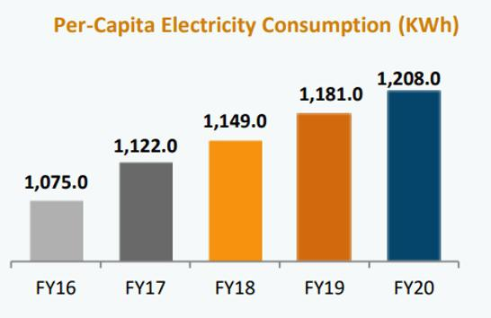

Break-up energy and power demands of residential and commercial office buildings

S No Parameters Residential Commercial office

Energy % Power % Energy% Power%

1 Lighting 20-40 10-15 15-20 10-15

1. Air conditioners - - 30-40 30-40
2. Room heaters - - 7-10 8-12
3. Fans 10-15 4-6 2-3 3-5
4. Air coolers - - 3-5 3-5
5. Fans 10-15 4-6 2-3 3-5
6. Air coolers - - 3-5 3-5
7. Electric heaters/boosters

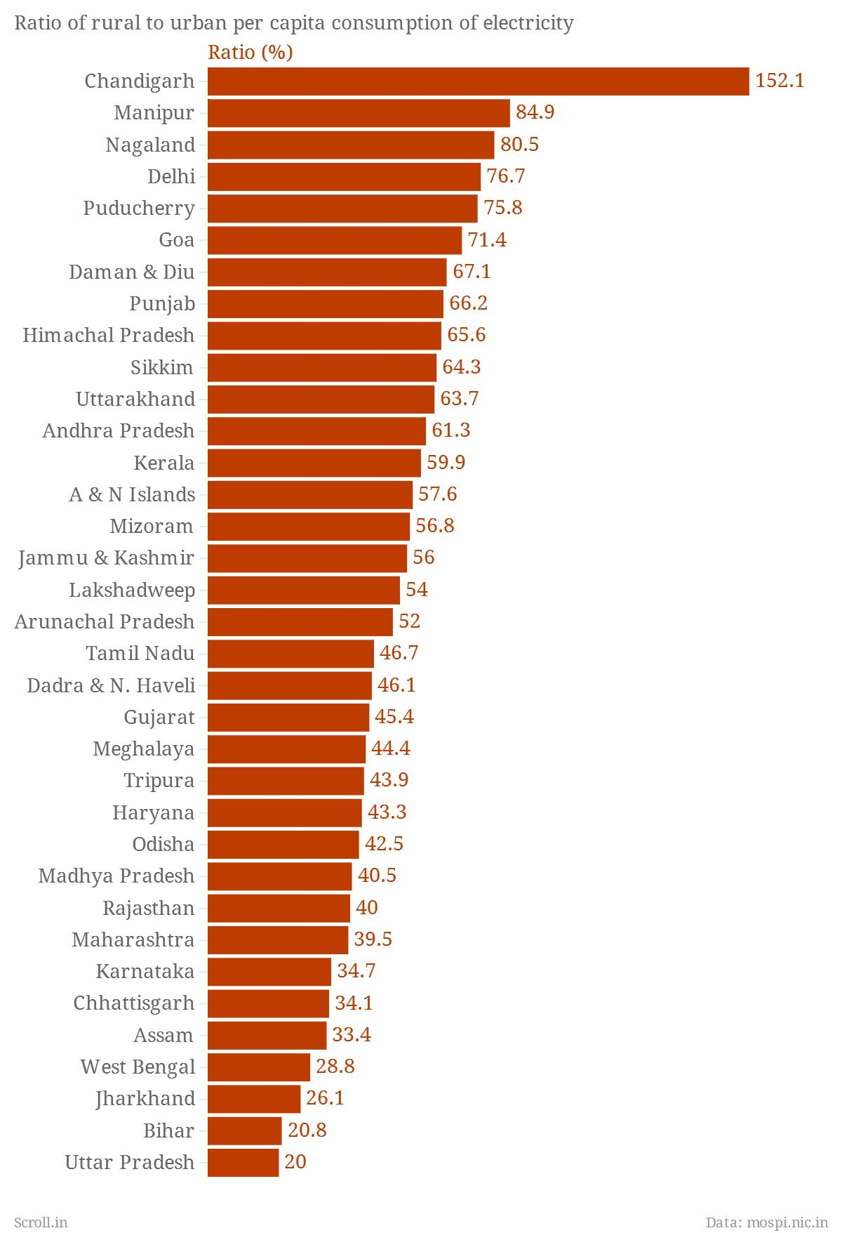

Analyzing electricity consumption in India typically involves gathering historical data on electricity usage, demographic factors, economic indicators, and policy changes. Machine learning models like linear regression, decision trees, random forests, or neural networks can be employed for predictive analysis.

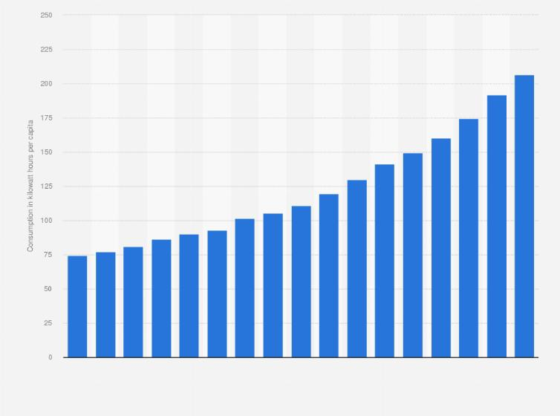

Factors to consider include population growth, urbanization rates, GDP growth, industrial output, and government policies promoting renewable energy adoption. Results would include insights into consumption trends, forecasts for future demand, and the impact of various variables on electricity usage. It’s also essential to assess the effectiveness of energy conservation measures and the feasibility of implementing alternative energy sources.

**Dashboard**

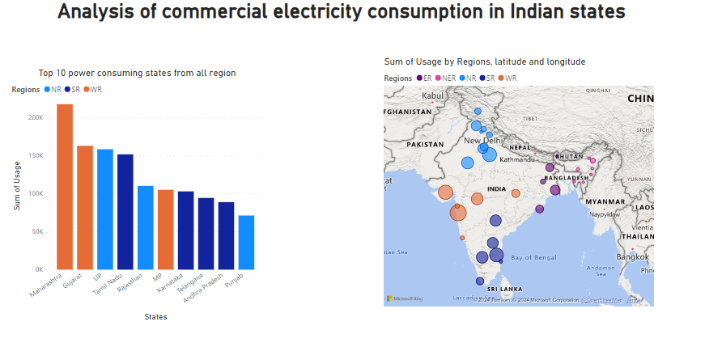

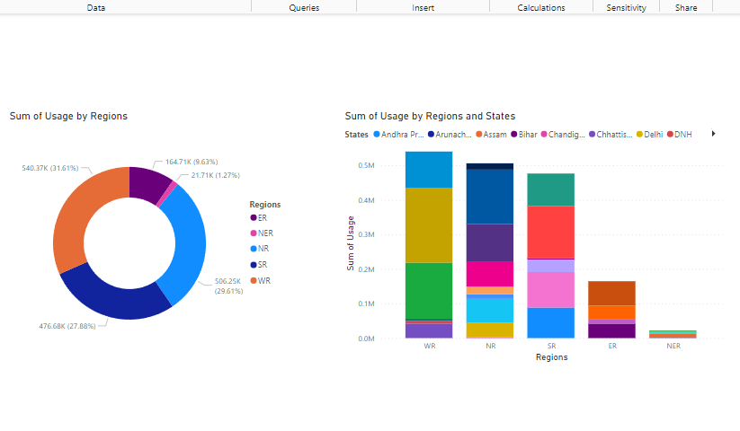

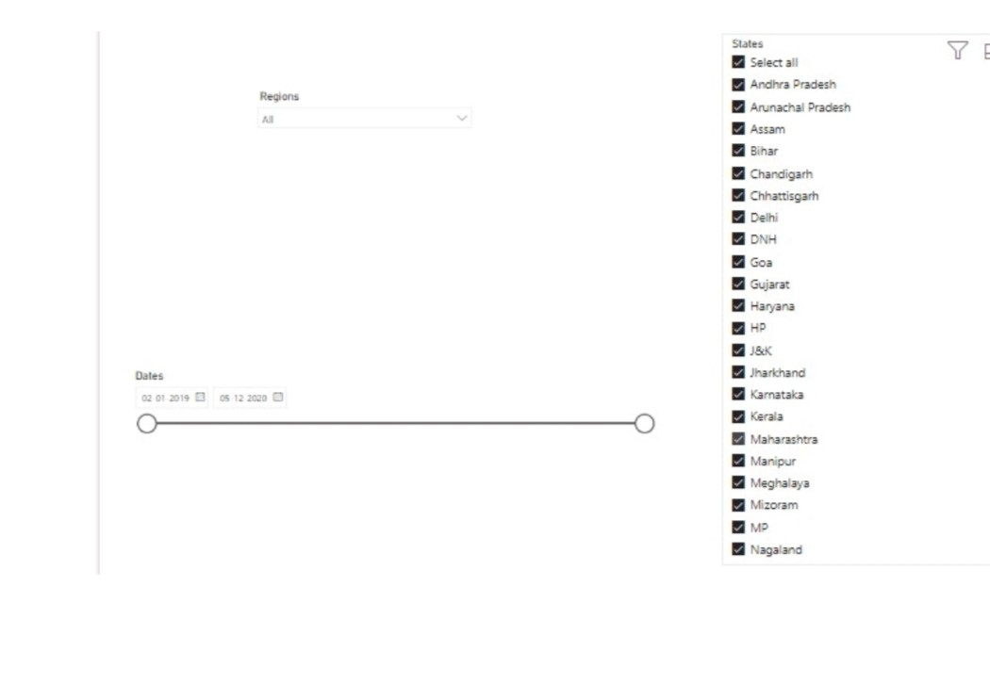

**CONCLUSION**

In conclusion, the analysis of commercial electricity consumption in Indian states presents a crucial avenue for understanding energy dynamics, informing policy decisions, and promoting sustainable development. By examining trends, forecasting future demand, and assessing the impact of policies and technological innovations, stakeholders can optimize energy usage, enhance grid reliability, and mitigate environmental impacts. Embracing data-driven approaches, sector-specific strategies, and collaborative efforts will be essential to address the diverse challenges and opportunities in managing commercial electricity consumption effectively. Ultimately, by prioritizing energy efficiency, promoting renewable energy integration, and fostering stakeholder engagement, India can strive towards a resilient, inclusive, and sustainable energy future for its commercial sectors and the nation as a whole.

**FUTURE SCOPE**

The future scope of analysis of commercial electricity consumption in Indian states is vast and multifaceted. Here are some potential areas of focus:

1. **Trends and Patterns:** Analyzing historical data to identify trends and patterns in commercial electricity consumption can provide insights into seasonal variations, growth rates, and areas of high demand.
2. **Forecasting:** Utilizing predictive analytics and machine learning algorithms to forecast future electricity consumption can assist policymakers, utilities, and businesses in planning infrastructure investments and optimizing energy distribution.
3. **Sector-specific Analysis:** Examining electricity consumption patterns across different commercial sectors such as retail, hospitality, manufacturing, and IT can help tailor energy efficiency programs and incentives to specific industries.
4. **Geospatial Analysis:** Leveraging geographic information systems (GIS) to analyze spatial variations in electricity consumption can inform decisions regarding infrastructure development, grid optimization, and resource allocation.
5. **Impact of Policy Interventions:** Assessing the impact of government policies, regulations, and incentives on commercial electricity consumption can guide policymakers in designing effective energy policies and programs.

Overall, the future scope of analysis of commercial electricity consumption in Indian states lies in leveraging advanced analytical techniques, interdisciplinary approaches, and stakeholder collaboration to address energy challenges, promote sustainable development, and ensure reliable and affordable access to electricity for all.

**REFERENCES**

## https://research.iitj.ac.in/publication/convergence-in-electricity-consumption-across-indian-states

**LINK**

<https://github.com/githubtraining/hellogitworld.git>