Helpfile

# Read in data

For reading the data, you click on the “Read file” button.

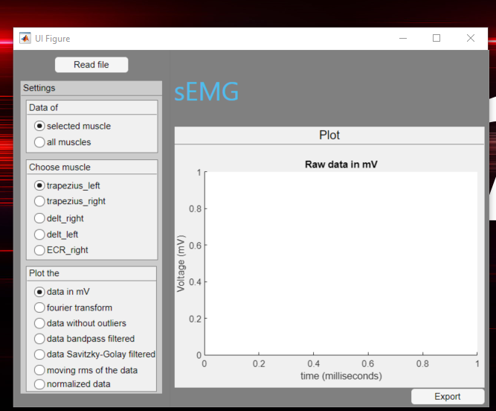

Then a new window opens where you can select a file. 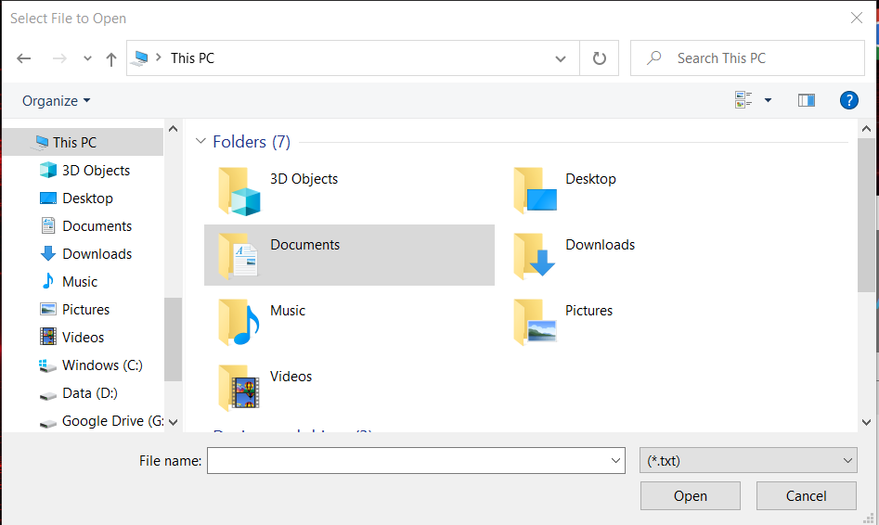

This file must have the form “S<number>_<name of file>.txt”. This file must also be in a folder with the files needed for the normalization. These files must have the following form: “S<same number as original file>_MVC_<muscle>_<links or rechts>.txt”. The next figure is an example.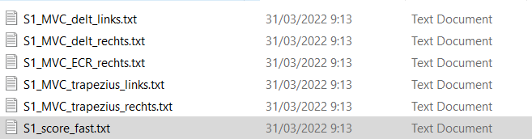

If a correct file is selected and opened, everything is calculated and you can see the graphs after a couple of seconds.

At the top of the left collum, you can choose if you want to see one specific muscle or all the muscles on the graph.

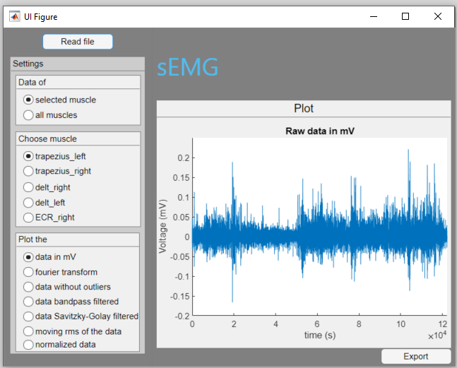

Underneath, you can choose a specific muscle if the “selected muscle” is selected in the field above. 

Underneath this, you can choose what you want to plot. You can plot

* the data converted to millivolt
* a fast Fourier transform of the data
* the data where the outliers are filtered out
* the data, filtered by a bandpass filter with a low and high cutoff frequency
* the data, filtered with a Savitzky-Golay filter with a specific order and frame length
* the moving RMS of the data
* the normalized data

In some cases, you can set some parameters to change the plots in the way you need.

# Data without outliers

Here you can select the number of deviations that an outlier can be away from the mean. The window size parameter is the number of samples that are used to take the mean, to replace this outlier.

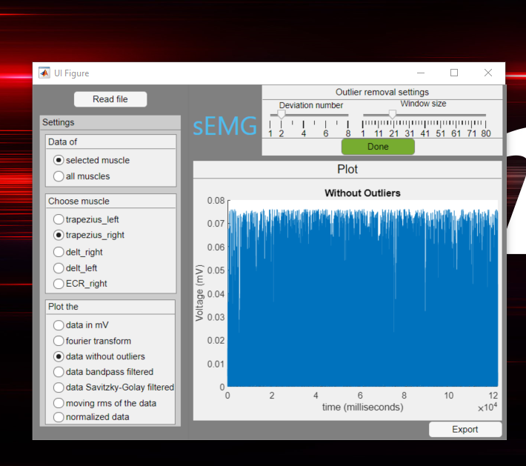

# Data bandpass filtered

Here you can choose the cutoff frequencies of this bandpass filter.

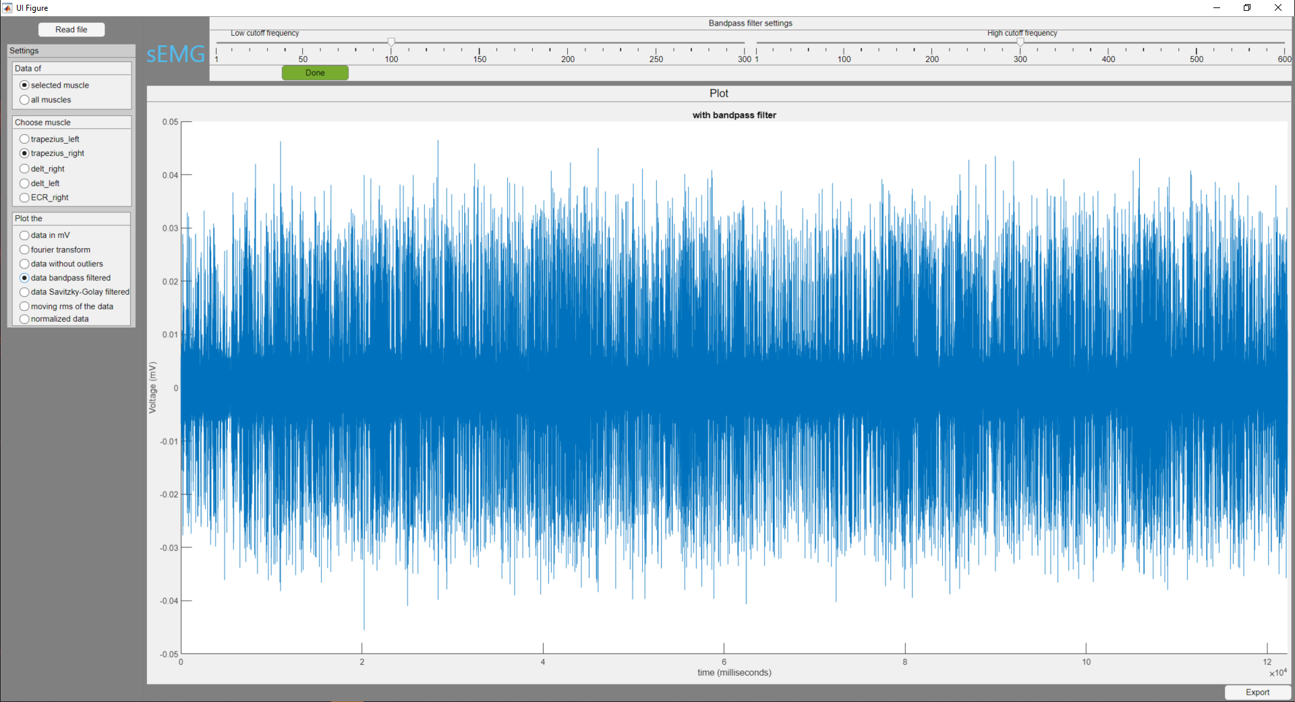

# Data Savitzky-Golay filtered

Here you can set the order and frame length of the Savitzky-Golay filter.

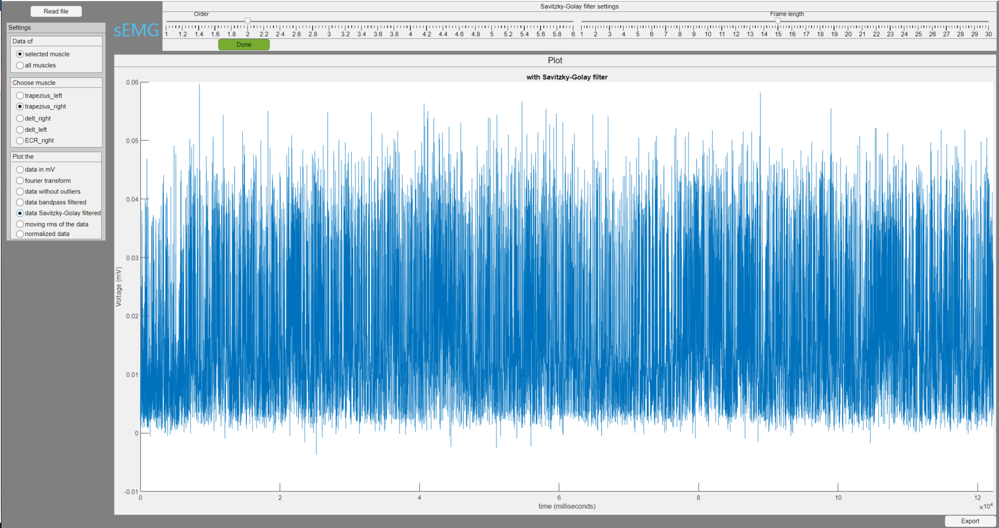

# Moving RMS of the data

Here the window length and the overlap can be set.

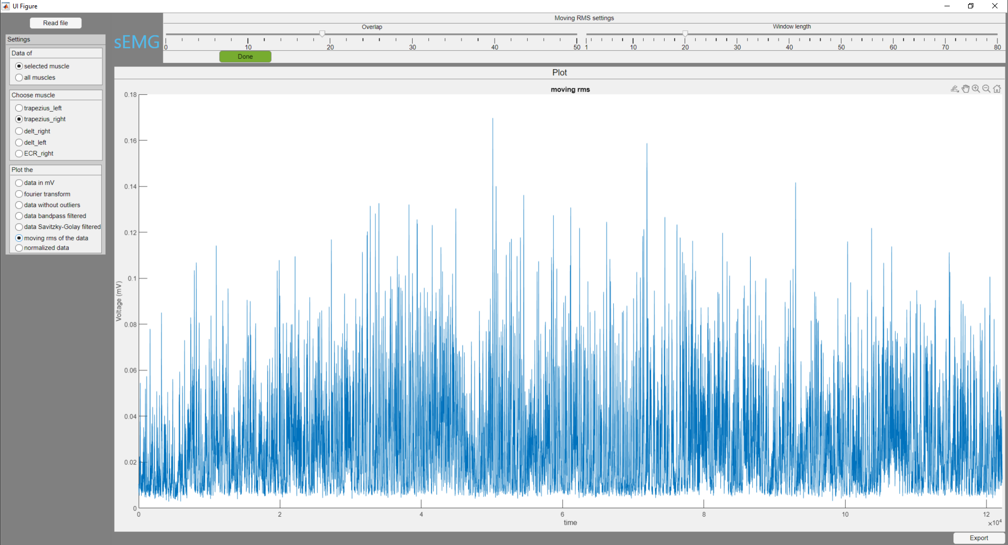

You can also plot the normalized data. This data is normalized according to the values of the MVC files.

At the bottom, there is an Export button that saves 3 files to the place where the app runs. First, a settings.txt file is created. Here you can find the settings used to become the following data. Then there are two new data files created “Processed Data after normalization.csv” and “Processed Data before normalization.csv”. This is the processed data both before and after the normalization.