Data Distribution Visualization Using Python

1. Introduction
This project focuses on visualizing the distribution of categorical and continuous variables using bar charts and histograms.

2. Objectives
• Understand data distribution
• Visualize categorical variables using bar charts
• Visualize continuous variables using histograms
• Derive meaningful insights from visual patterns

3. Tools Used
Python, Pandas, Matplotlib, Jupyter Notebook

4. Bar Chart Visualization
The following bar chart shows the distribution of Gender in the dataset.
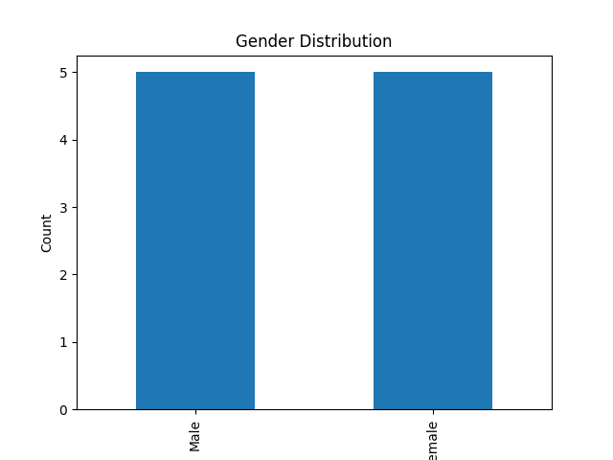

5. Histogram Visualization
The following histogram shows the distribution of Age in the dataset.
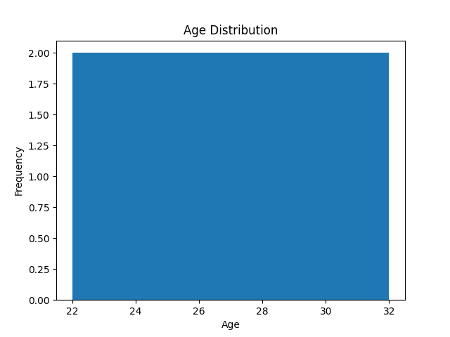

6. Conclusion
Bar charts and histograms help in understanding categorical and numerical data distribution effectively.

