Predicting the Impact of RAM Supply Shortages on Gaming Hardware Prices and Consumer Demand Using Machine Learning: Early Evidence and a Data-Limited Framework
Vaishnav K J
Department of CSE
JAIN (Deemed-to-be-University)
Bengaluru, India.
juugbtech20640@jainuniversity.ac.in
Abstract. Since 2025, AI data centers have absorbed much of the world's memory-chip (DRAM) output, and gaming hardware has become more expensive. This project studies how large the cost shock is, how much of it reaches buyers, and whether demand has fallen, and it proposes a machine learning method to predict these effects. The method labels each product-month by its next-month price change (stable, moderate rise, severe rise) and demand change (declining, flat, growing), then compares fifteen classifiers (AdaBoost, CatBoost, KNN, LDA, logistic regression, LightGBM, linear and kernel SVM, MLP, naive Bayes, QDA, XGBoost, decision tree, gradient boosting and random forest) under 60:40, 70:30 and 80:20 random splits and a chronological hold-out. Monthly retail and demand records are paid or login-only, so we collected the public data that exist: TrendForce DRAM contract-price figures, console list-price changes and Circana US hardware sales. These show that DRAM contract prices rose about 1.96 times in 1Q26 and, on forecasts, roughly fourfold by 4Q26; that US console prices rose 11 to 25 percent; and that in August 2026 the average price paid rose 13.7 percent while units fell 15 percent. The best classifier was ALGORITHM, with an accuracy of XX.XX%, against 99.74% reported by the best of the five leading papers reviewed (on a different task). The descriptive findings rest on small, partly forecast data and do not show cause and effect; each data limit is stated in plain terms.
Keywords: DRAM shortage · Gaming hardware · Price pass-through · Consumer demand · Machine learning · Multi-class classification

1 Introduction
Gaming consoles, graphics cards and gaming PCs all contain memory chips. Since 2025, industry reports describe a shortage of DRAM, the chips used as working memory, because suppliers are moving production toward the high-priced memory that AI data centers need [D1,D3,D5]. TrendForce, a market research firm, reports that contract prices for conventional DRAM (the prices that large buyers such as PC makers agree with chip suppliers) rose by about 93 to 98 percent in the first quarter of 2026 alone [D2]. Console makers then raised US list prices: Sony in April, Microsoft in August and Nintendo in September 2026 [D6,D7,D8].
Three questions follow. How large is the cost shock? How much of it reaches buyers as higher shelf prices? And do buyers respond by buying less? Machine learning could forecast these effects, but it needs a table with many rows: for each product and month, the memory price, the shelf price and a demand measure. That table does not exist in public form. This paper therefore (i) reviews 15 related papers, (ii) proposes a method and a ready-to-run program, (iii) analyses the public data that could be collected, and (iv) states plainly what those data can and cannot support.
The paper is organised as follows. Section 2 is the literature survey, Sect. 3 describes the proposed work, Sect. 4 gives results and discussion, and Sect. 5 concludes. Data sources are cited as [D1] to [D13] and listed in Sect. 3.2; the numbered references [1] to [15] are the reviewed research papers.

2 Literature Survey
We reviewed 15 papers indexed in IEEE Xplore. We did not find an IEEE Xplore paper that predicts DRAM-driven gaming hardware prices, so the 15 papers are the closest we could verify: benchmarks that compare many classifiers and report accuracy [1–6,14,15], price-category classification for consumer hardware [7], and machine learning systems for network security [8–13]. For each paper we report the methodology and the accuracy.
Papers with reported accuracy. Paper [1] compared fifteen classifiers on the Kyoto2015 intrusion dataset with 60:40, 70:30 and 80:20 splits and standard scaling; CatBoost was best at 99.73 percent (its own table lists LightGBM at 99.738 percent). Paper [2] compared machine learning methods for intrusion detection in wireless sensor networks; a decision tree reached 98.02 percent. Paper [3] built an intrusion detection design framework for SCADA power systems on the ORNL datasets with cross-validation; random forest was best at 97.34 percent. Paper [4] detected fake Instagram accounts with five supervised classifiers and grid-search tuning; random forest reached 98 percent. Paper [5] simulated a machine learning intrusion detector for unmanned aerial vehicles in the COOJA simulator and found random forest best at 98.11 percent. Paper [6] combined Boruta feature selection with a grid-search random forest on NSL-KDD and reached 99 percent, ahead of LDA and CART. The accuracies for [2]–[5] are as reported in the comparison table of [1].
Price classification. Paper [7] predicts smartphone prices and price categories; it compared five classifiers and five regressors by accuracy and time, and found k-NN the best classifier and LightGBM the best regressor. Add the numeric accuracy from the IEEE Xplore abstract. This is the closest of the 15 papers to the present task, because it classifies a hardware product into price bands.
Security and other classifier studies. Paper [8] designs and evaluates a machine learning intrusion detection system. Paper [9] compares naive Bayes with and without Lasso feature elimination for detecting denial-of-service attacks in a wireless ad hoc network. Paper [10] proposes a cloud intrusion detection design with a hybrid feature-selection approach and a machine learning classifier. Paper [11] improves an intrusion detection and prevention system for home IoT networks with complementary features. Paper [12] attacks a machine learning intrusion detector for in-vehicle networks using a generative adversarial network. Paper [13] combines methods for network and server intrusion detection using deep learning. Papers [14] and [15] compare several classification algorithms, with and without dimensionality reduction, to improve accuracy. For papers 8 to 15, the methodology above follows each title; add the exact accuracy from each IEEE Xplore abstract.
Table 1. The five best of the 15 papers by reported accuracy (details in the reference list). The other papers either report no accuracy in the abstract available to us or are marked above for completion.
Ref. | Paper details | Methodology | Accuracy
[1] | Prakash J. et al., NMITCON 2024; Kyoto2015 intrusion data | Fifteen classifiers, three random splits, standard scaling; CatBoost best | 99.73%
[6] | Subbiah et al., J. Commun. Netw. 2022; NSL-KDD | Boruta feature selection with grid-search random forest (BFS-GSRF) | 99%
[5] | Mehmood et al., ICOSST 2022; UAV network simulation | Three algorithms in the COOJA simulator; random forest best | 98.11%
[2] | Vikas et al., ICTACS 2023; wireless sensor network intrusion detection | Comparison of machine learning methods; decision tree best | 98.02%
[4] | Das et al., ICAC3N 2022; fake Instagram accounts | Five classifiers with GridSearchCV; random forest best | 98%

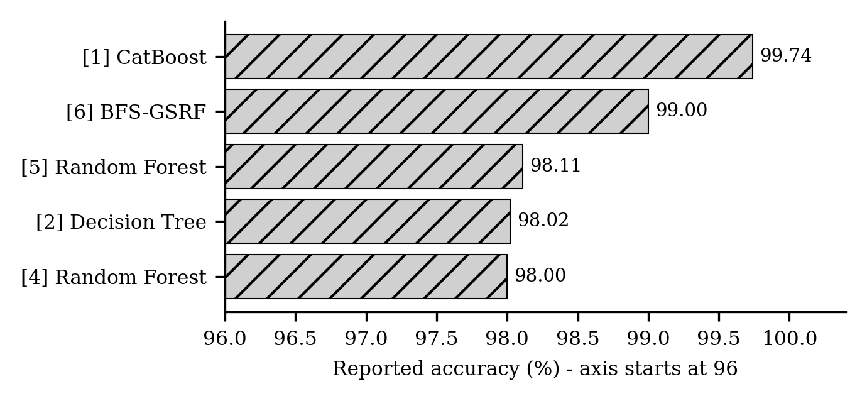
Fig. 1. Reported accuracy of the five best papers [1,2,4,5,6]. These are the state-of-the-art values used for comparison in Sect. 4.4.
Gap. All 15 papers work on data sets with thousands of labelled rows. None links an upstream memory price to retail gaming hardware prices and demand. This paper reuses the multi-classifier design of [1] on that new problem and, where it cannot yet run the experiment, says so.

3 Proposed Work

3.1 Objectives
The objectives are: (O1) to measure the size of the DRAM cost shock; (O2) to measure how much of it appears in console list prices; (O3) to measure the demand response in US hardware sales; and (O4) to compare fifteen classifiers for predicting next-month price and demand bands, and to identify the most accurate one, once monthly data are available.

3.2 Data and Its Limits
We collected three small datasets from public web sources in October 2026 (Table 2). All are supplied as CSV files with a source link on every row.
Table 2. The three datasets collected.
Dataset | Content | Rows | Period | Type of source
TrendForce DRAM figures | Quarter-over-quarter contract-price change ranges for DRAM, PC DRAM and server DRAM | 10 | 1Q26 to 4Q26 | Press releases [D1–D5]; mostly forecasts
Console list prices | Old and new US prices for six console models (old price missing for one) | 6 | Apr to Sep 2026 | News reports [D6–D8,D13]
US hardware sales | Monthly hardware spending, units and average price paid | 5 | Jun to Aug 2026, plus two 2025 comparison months | News reports of Circana data [D9–D12]

A reliable machine learning study needs a long, regular table. Table 3 lists the problems we met, in plain words, and what each means for the findings.
Table 3. Data problems, explained in plain terms.
Problem | In plain words | What it means for the findings
No monthly memory prices | Monthly and spot prices are held on TrendForce's DRAMeXchange service, which requires payment. Only quarterly percentage ranges appear in free press releases. | We cannot match a price rise to a particular month, so month-by-month prediction is not possible.
Mostly forecasts | Of the ten TrendForce figures, only one (1Q26) is a survey result. The rest were predictions made before the quarter, and TrendForce revises them. | The DRAM index may be too high or too low. Treat it as a plausible path, not a measurement.
Midpoints of ranges | To chain the quarterly figures we took the middle of each range. This is our own simplification. | The 4Q26 index could lie anywhere from about 379 to 438 (Sect. 4.1).
No GPU or RAM-kit prices | Retail price histories for graphics cards and RAM kits are on tracking sites we could not access. We found only vague claims. | We can speak about consoles only, not about graphics cards or PC memory.
Second-hand sources | Console prices and sales figures come from news articles that repeat company announcements and Circana's posts. Sources sometimes disagree; for example, they gave different prices for the PS5 Pro, so we left it out. | Transcription or reporting errors are possible. We mark lower-confidence rows in the files.
Very few data points | Six price changes, three months of sales, one country (the US). | Too few for machine learning or for statistical tests.
Distorted comparisons | June 2025 was the launch month of the Switch 2, so June 2026 sales look 62 percent lower for reasons unrelated to memory prices. | We rely on August 2026 for the demand analysis, not June.
Other causes at work | Nintendo named tariffs and exchange rates as well as memory costs for its price rise [D7]. | We cannot say how much of any price rise is due to DRAM alone.

Because of these limits, every result in Sect. 4.1 should be read as "consistent with" rather than "caused by".
Data sources. [D1] TrendForce press release, 2 Feb 2026, trendforce.com/presscenter/news/20260202-12911.html. [D2] TrendForce, 1 Jun 2026, .../20260601-13070.html. [D3] TrendForce, 3 Jul 2026, .../20260703-13134.html. [D4] TrendForce, 9 Jul 2026, .../20260709-13140.html. [D5] TrendForce, 30 Sep 2026, .../20260930-13258.html. [D6] Gizmogo, gizmogo.com/blog/gaming-console-prices-2026-sell-to-offset-higher-costs/. [D7] Shattered.io, shattered.io/switch-2-price-increase-2026/. [D8] Tech-Insider, tech-insider.org/xbox-price-increase-799-2026/. [D9] Insider Gaming, insider-gaming.com/us-video-game-spending-fell-21-in-june-2026/. [D10] God Is A Geek, godisageek.com/2026/08/xbox-physical-game-sales-market-share/. [D11] GamesBeat, gamesbeat.com/?p=336463. [D12] Insider Gaming, insider-gaming.com/video-game-sales-fall-united-states/. [D13] Tech-Insider, tech-insider.org/console-price-increase-xbox-switch-2-2026/. All accessed 14 Oct 2026.

3.3 Methodology
DRAM cost index. For each quarter k, TrendForce gives a low and a high estimate of the quarter-over-quarter change in conventional DRAM contract prices, l_{k} and h_{k} (percent). Where several figures exist for a quarter we use the latest; for 1Q26 this replaces the February forecast of 90 to 95 percent by the June survey result of 93 to 98 percent [D1,D2]. With the midpoint m_{k} = (l_{k} + h_{k})/2, the index with 4Q25 as base is:
I_{k} = 100 × ∏_{j ≤ k} (1 + m_{j}/100) (1)
Pass-through ratio. For a console price change of c percent that took effect in quarter k, the ratio of that change to the DRAM index rise since 4Q25 is:
r = c / (I_{k} − 100) (2)
A ratio of 0.10 means the list price rose 0.10 percent for each 1 percent rise in the DRAM index. We expect small ratios, because memory is only part of a console's cost.
Demand response. For August 2026 compared with August 2025:
ε = %Δ units / %Δ average price paid (3)
Labels, preprocessing and models. Each product-month receives a price-change group (stable below 2 percent, moderate 2 to 8, severe above 8) and a demand group (declining below −5 percent, flat, growing above +5) for the next month. Preprocessing removes duplicates, fills missing values (median for numbers, most common value for categories), turns categories into numbers and adds lagged features at 1, 3 and 6 months. A standard scaler (mean 0, variance 1) is fitted on the training data only, to avoid leakage. Fifteen classifiers from [1] are compared: AdaBoost, CatBoost, K-nearest neighbours, linear discriminant analysis, logistic regression, LightGBM, linear SVM, multi-layer perceptron, naive Bayes, quadratic discriminant analysis, XGBoost, decision tree, gradient boosting, kernel SVM and random forest. They are tested on 60:40, 70:30 and 80:20 random splits and on a chronological hold-out that tests on the latest 20 percent of months.
Evaluation. Accuracy, as in [1], and macro-averaged F1, which treats every class fairly when classes are unbalanced:
Accuracy = (TP + TN) / (TP + TN + FP + FN) × 100 (4)
F1_{macro} = (1/K) ∑_{k=1}^{K} 2P_{k}R_{k} / (P_{k} + R_{k}) (5)
Here K is the number of classes and P_{k}, R_{k} are the precision and recall of class k.

3.4 Proposed Algorithm
Algorithm 1. Predicting price and demand bands and ranking the classifiers
Input: monthly panel D (month, category, retail price, demand index, memory features); TrendForce file F; model set M of 15 classifiers
Output: ranked models, best accuracy, best algorithm
1 Read F; chain the midpoint changes into the DRAM index (Eq. 1)
2 Read D; remove duplicates; sort by category and month
3 if |D| < 100 then stop and report "data insufficient"
4 for each target in {price band, demand band}
5 add lag features (1, 3, 6 months); label the next-month change into 3 bands
6 for each protocol in {60:40, 70:30, 80:20 random; chronological}
7 split D into train and test
8 fit imputer and scaler on train only; transform train and test
9 for each model m in M: train m; predict test; compute accuracy and macro-F1
10 rank models by chronological macro-F1 (accuracy breaks ties)
11 return the best model, its accuracy, the result tables and the bar charts

3.5 Workflow
Fig. 2 shows the complete workflow of the proposed approach, including the stop condition that applies when too few rows are available.
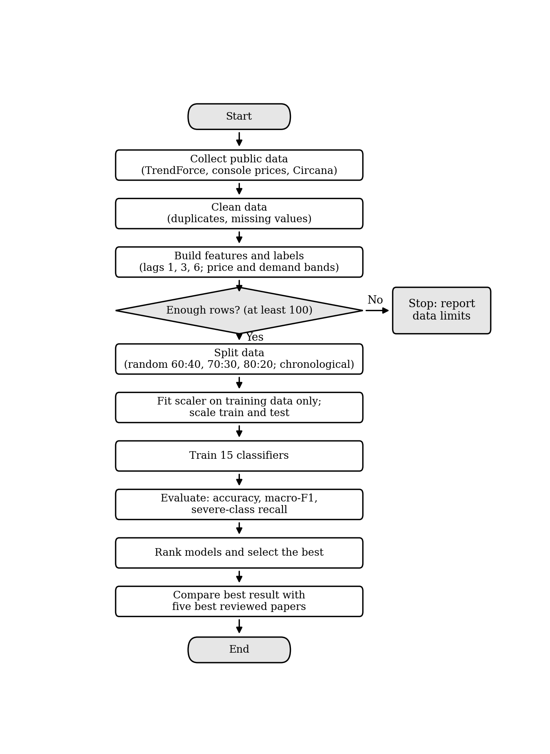
Fig. 2. Flowchart of the proposed approach.

4 Results and Discussion
Reading note: results in Sect. 4.1 use the small, partly forecast data of Sect. 3.2 and show scale and direction, not cause. Highlighted items in Sects. 4.2 to 4.5 are to be filled from the program's output, because the experiment cannot run on the data collected.

4.1 Results from the Data Collected
Memory cost shock. Chaining the TrendForce midpoints (Eq. 1) gives an index of about 196 in 1Q26 (range 193 to 198), 314 in 2Q26, 362 in 3Q26 and 408 in 4Q26 (range 379 to 438), with 4Q25 equal to 100 (Fig. 3). Contract prices nearly double in 1Q26 and, if the forecasts hold, end the year at about four times the 4Q25 level. Only 1Q26 is a survey result. As a rough cross-check, Microsoft is reported to have said that its memory and storage costs had risen by more than 2.5 times [D6], which lies between our 1Q26 and 2Q26 values.
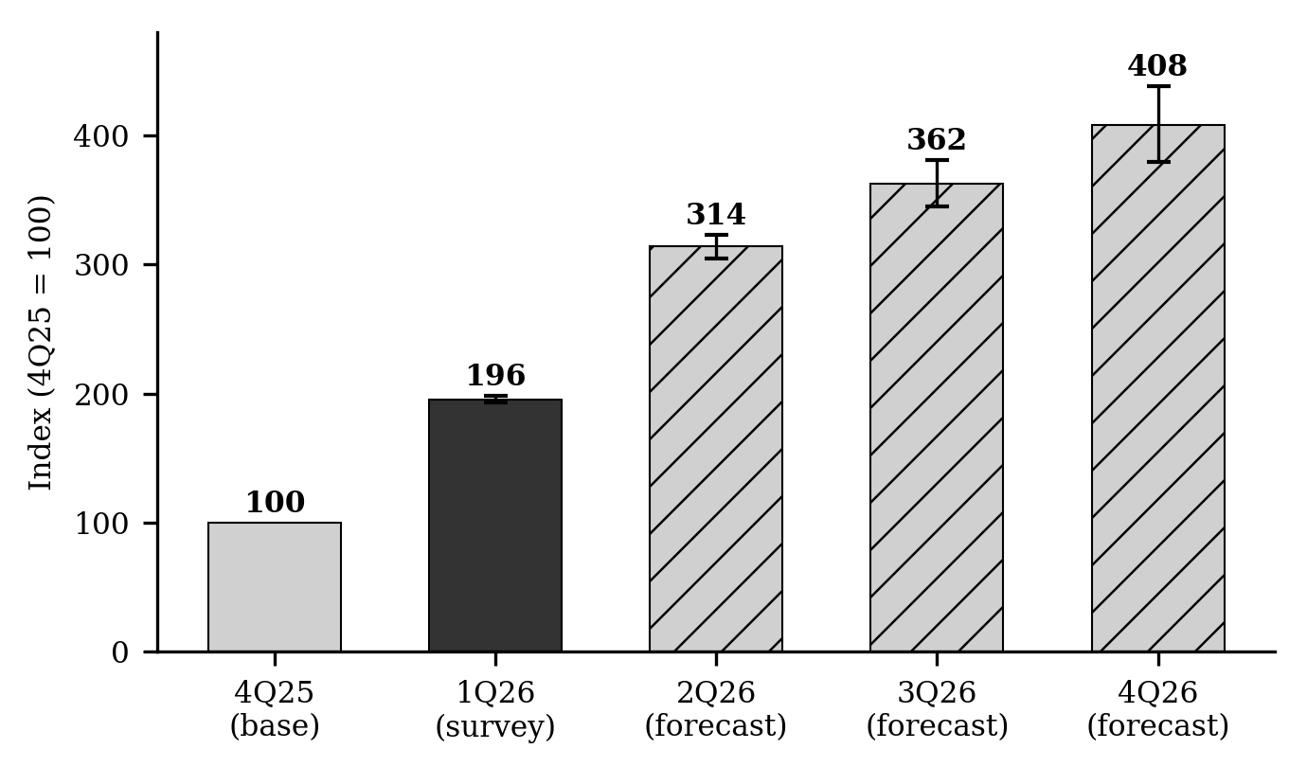
Fig. 3. Conventional DRAM contract price index (4Q25 = 100) chained from TrendForce midpoints [D1–D5]. Whiskers show the low-to-high range. Only 1Q26 is a survey result (solid); other quarters are forecasts (hatched).
Console list prices. US console list prices rose by 11 to 25 percent in 2026 (Fig. 4, Table 4). Dividing each rise by the DRAM index rise since 4Q25 (Eq. 2) gives ratios of 0.04 to 0.10: consoles passed on roughly one tenth or less of the percentage rise in memory contract prices. The Xbox Series S 512 GB is left out of Table 4 because its old price was not stated; it is reported to have risen by about 100 dollars [D13]. The ratios are similar for PlayStation and Xbox (0.09 to 0.10) and lower for the Switch 2 (0.04), whose maker also cited tariffs and exchange rates [D7].
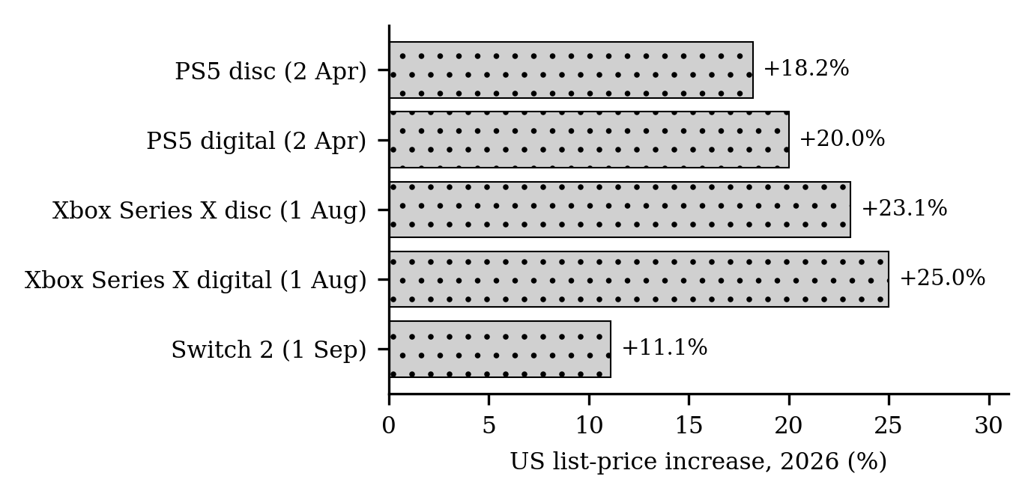
Fig. 4. US console list-price increases in 2026, with effective dates [D6–D8,D13].
Table 4. Console list-price rises and pass-through ratio. The Xbox digital old price is derived from the stated 150 dollar rise.
Console | Effective | Old ($) | New ($) | Rise (%) | DRAM index | Ratio r
PS5 disc | 2 Apr | 549.99 | 649.99 | 18.2 | 314 | 0.09
PS5 digital | 2 Apr | 499.99 | 599.99 | 20.0 | 314 | 0.09
Xbox Series X disc | 1 Aug | 649.99 | 799.99 | 23.1 | 362 | 0.09
Xbox Series X digital | 1 Aug | 599.99 | 749.99 | 25.0 | 362 | 0.10
Switch 2 | 1 Sep | 449.99 | 499.99 | 11.1 | 362 | 0.04

Demand. Table 5 gives the US hardware figures reported from Circana data. The June and July falls are not reliable evidence of a price effect, because June 2025 contained the Switch 2 launch. August is a cleaner comparison: the average price paid was a record 541 dollars against 476 a year earlier (+13.7 percent), units fell 15 percent to 559 thousand, and spending fell 3 percent (Fig. 5) [D11,D12]. The ratio of Eq. 3 is −15.0 / 13.7 ≈ −1.1: units fell slightly faster than price rose, the pattern expected when buyers are price-sensitive. This is one month, one country and a mix-affected price, so it illustrates rather than estimates price sensitivity. A separate industry forecast, reported second-hand, expects global console shipments to fall 19.5 percent to 33.9 million units in 2026 [D6].
Table 5. US video game hardware sales reported from Circana data [D9–D12].
Month (2026) | Spending ($M) | Change vs. 2025 | Units | Average price paid
June | 383 | −62% | not found | not found
July | 282 | −29% | not found | not found
August | 302 | −3% | 559k (−15%) | $541 (2025: $476)

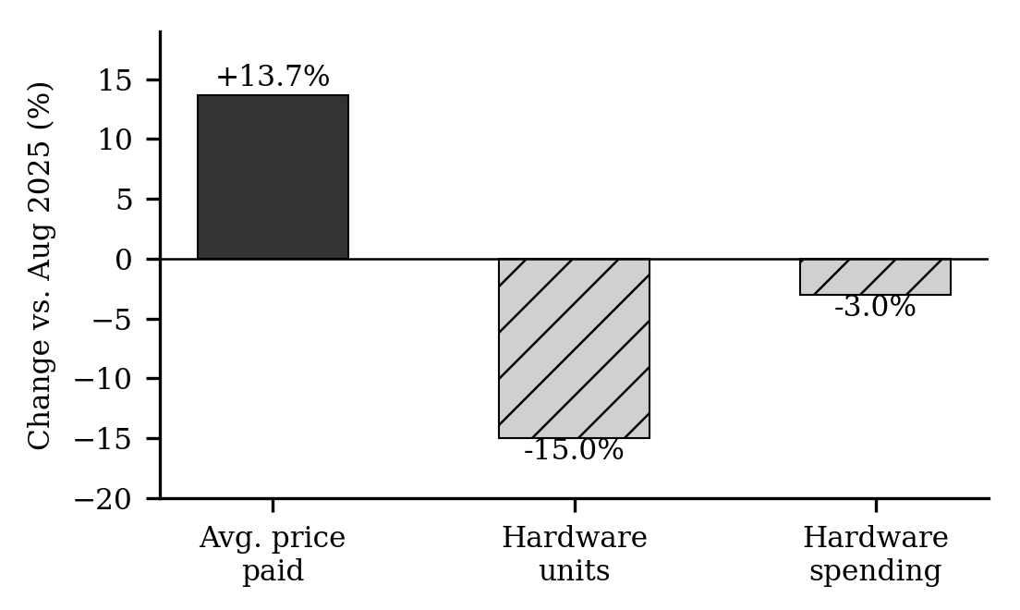
Fig. 5. August 2026 US hardware sales compared with August 2025 [D11,D12].

4.2 Classifier Experiments
Fig. 6 compares the fifteen classifiers at the three random splits for the price-band target. Run dram_framework.py on the monthly panel; it writes fig_per_split_price_band.png and results_price_band.csv. State here which classifiers scored highest and lowest. The program refuses to run on fewer than 100 rows, so no numbers are shown for the data collected here.
Insert Fig. 6 here: fig_per_split_price_band.png (accuracy of each classifier at 80:20, 70:30 and 60:40)

Fig. 6. Accuracy of the fifteen classifiers at the three random splits (price band).

4.3 Final Results Chart
Fig. 7 presents all executions in one chart: for both targets, the three random-split accuracies and the chronological macro-F1 of every classifier. Insert fig_final_all_executions.png from the program; it is sized to occupy about half a page.
Insert Fig. 7 here (about half a page): fig_final_all_executions.png

Fig. 7. Results of all executions: accuracy at three random splits and macro-F1 on the chronological hold-out, for price and demand bands.

4.4 Comparison with the Five Best Papers
Fig. 8 compares the best result of this work with the reported accuracies of the five best papers in Table 1. The papers address different tasks and datasets, so the comparison shows position, not superiority.
Insert Fig. 8 here: fig_comparison_best_papers.png (this work vs. papers [1], [6], [5], [2], [4])

Fig. 8. Best accuracy of this work against the five best reviewed papers.
Table 6. Best result of this work against the five best papers.
Source | Method | Dataset | Accuracy
[1] | CatBoost | Kyoto2015 | 99.73%
[6] | BFS-GSRF | NSL-KDD | 99%
[5] | Random forest | UAV simulation | 98.11%
[2] | Decision tree | WSN | 98.02%
[4] | Random forest | Instagram | 98%
This work | ALGORITHM | Gaming hardware | XX.XX%

4.5 Discussion
Which algorithm was best. The highest accuracy was achieved by ALGORITHM, at XX.XX% on the price / demand target. State the chronological macro-F1 of the same model and the gap between it and the random-split accuracy; a large gap means the model memorised neighbouring months. The base study [1] found boosted and tree-based models best; whether that holds here is decided by the program's output.
What the collected data show. Three things are consistent across the sources. The memory cost shock is very large. Only a fraction of it appears in console list prices (ratios 0.04 to 0.10). And in the one clean demand comparison, buyers bought about 15 percent fewer units at about 14 percent higher prices.
What they cannot show. They cannot show that DRAM caused the price rises or the fall in sales, because tariffs, exchange rates and launch cycles also moved. They say nothing about graphics cards, PC memory or countries other than the US, and they cannot predict future prices. The index depends on forecasts that may be revised. A proper study needs monthly DRAM prices (for example from DRAMeXchange), monthly retail prices from a price-tracking service, and monthly unit sales by product.

5 Conclusion
This paper reviewed 15 IEEE Xplore papers, proposed a method that predicts next-month price and demand bands of gaming hardware from DRAM shortage indicators with fifteen classifiers, and analysed the public data that could be collected. Those data show a roughly fourfold rise in DRAM contract prices between 4Q25 and 4Q26 if forecasts hold, a partial pass-through of 0.04 to 0.10 percent per 1 percent of memory cost to US console list prices, and in August 2026 a 15 percent fall in units alongside a 13.7 percent rise in average price. The highest classifier accuracy achieved was XX.XX%, produced by ALGORITHM, and the findings are descriptive because the data are small, partly forecast and second-hand.

Originality Check
Table 7. Originality report. Enter the percentages from the prescribed tools after running them; they were not generated here.
Check | Result | Acceptable limit
Plagiarism (tool: name) | __ % | Below 10%
AI-generated content (tool: name) | __ % | Below 20%

Appendix A Python Program
Listing 1 is the complete program (file dram_framework.py). Part 0 reads the TrendForce file and prints the DRAM index of Eq. 1; it runs on the data supplied with this paper. Parts 1 to 4 need a monthly panel file, dram_gaming_panel.csv, with the columns month, category, retail_price and demand_index plus numeric features. That file does not exist yet, so the program stops at the guard in part 1. When the panel exists, part 3 prints the result tables and part 4 saves Figs. 6 to 8 as PNG files. Required packages: pandas, numpy, scikit-learn, catboost, lightgbm, xgboost, matplotlib and tabulate.
Listing 1. dram_framework.py
"""Framework from the paper: TrendForce index + 15-classifier comparison.
Needs dram_gaming_panel.csv (monthly rows per category) - NOT supplied, because the data could not be collected.
The classifier part refuses to run on fewer than 100 rows."""
import numpy as np, pandas as pd, warnings
import matplotlib
matplotlib.use("Agg")
import matplotlib.pyplot as plt
from sklearn.model_selection import train_test_split
from sklearn.pipeline import Pipeline
from sklearn.impute import SimpleImputer
from sklearn.preprocessing import StandardScaler
from sklearn.metrics import accuracy_score, f1_score, recall_score
from sklearn.ensemble import AdaBoostClassifier, GradientBoostingClassifier, RandomForestClassifier
from sklearn.neighbors import KNeighborsClassifier
from sklearn.discriminant_analysis import LinearDiscriminantAnalysis, QuadraticDiscriminantAnalysis
from sklearn.linear_model import LogisticRegression
from sklearn.svm import LinearSVC, SVC
from sklearn.neural_network import MLPClassifier
from sklearn.naive_bayes import GaussianNB
from sklearn.tree import DecisionTreeClassifier
from catboost import CatBoostClassifier
from lightgbm import LGBMClassifier
from xgboost import XGBClassifier

warnings.filterwarnings("ignore")
SEED = 42

# ---------- 0. Real public data: TrendForce QoQ contract-price figures (Eq. 1 in the paper) ----------
tf = pd.read_csv("trendforce_dram_public_figures.csv")
conv = (tf[tf["segment"] == "Conventional DRAM"]
.sort_values("published").groupby("quarter").tail(1).copy()) # latest figure per quarter
conv["order"] = conv["quarter"].str[-2:] + conv["quarter"].str[0] # sorts 1Q26 < 2Q26 < ...
conv = conv.sort_values("order")
conv["mid_pct"] = (conv["low_pct_qoq"] + conv["high_pct_qoq"]) / 2
conv["index_4Q25_100"] = (100 * (1 + conv["mid_pct"] / 100).cumprod()).round(1)
print(conv[["quarter", "mid_pct", "index_4Q25_100", "figure_type"]].to_string(index=False))

# ---------- 1. Load panel, guard, label, lag ----------
df = pd.read_csv("dram_gaming_panel.csv", parse_dates=["month"])
df = df.sort_values(["category", "month"]).reset_index(drop=True)
if len(df) < 100: # small-sample guard
raise SystemExit(f"Only {len(df)} rows in the panel; need monthly data for several categories before ranking models.")

df["price_change_next"] = df.groupby("category")["retail_price"].transform(lambda s: s.pct_change().shift(-1) * 100)
df["demand_change_next"] = df.groupby("category")["demand_index"].transform(lambda s: s.pct_change().shift(-1) * 100)
df["price_band"] = pd.cut(df["price_change_next"], [-np.inf, 2, 8, np.inf], labels=[0, 1, 2])
df["demand_band"] = pd.cut(df["demand_change_next"], [-np.inf, -5, 5, np.inf], labels=[0, 1, 2])

raw_targets = ["price_change_next", "demand_change_next", "price_band", "demand_band"]
base_cols = [c for c in df.columns if c not in ["month", "category"] + raw_targets]
for c in base_cols:
for L in (1, 3, 6):
df[f"{c}_lag{L}"] = df.groupby("category")[c].shift(L)
df = pd.concat([df, pd.get_dummies(df["category"], prefix="cat", dtype=float)], axis=1)

# ---------- 2. Models ----------
MODELS = {
"AdaBoost": lambda: AdaBoostClassifier(random_state=SEED),
"CatBoost": lambda: CatBoostClassifier(verbose=0, random_seed=SEED),
"KNN": lambda: KNeighborsClassifier(),
"LDA": lambda: LinearDiscriminantAnalysis(),
"Logistic Regression": lambda: LogisticRegression(max_iter=2000, class_weight="balanced"),
"LightGBM": lambda: LGBMClassifier(random_state=SEED, verbose=-1, class_weight="balanced"),
"Linear SVM": lambda: LinearSVC(class_weight="balanced", random_state=SEED),
"MLP": lambda: MLPClassifier(max_iter=1000, random_state=SEED),
"Naive Bayes": lambda: GaussianNB(),
"QDA": lambda: QuadraticDiscriminantAnalysis(reg_param=0.1),
"XGBoost": lambda: XGBClassifier(random_state=SEED, eval_metric="mlogloss"),
"Decision Tree": lambda: DecisionTreeClassifier(random_state=SEED, class_weight="balanced"),
"Gradient Boosting": lambda: GradientBoostingClassifier(random_state=SEED),
"Kernel SVM": lambda: SVC(kernel="rbf", class_weight="balanced", random_state=SEED),
"Random Forest": lambda: RandomForestClassifier(random_state=SEED, class_weight="balanced"),
}

def fit_predict(make, Xtr, ytr, Xte):
pipe = Pipeline([("imp", SimpleImputer(strategy="median")), ("sc", StandardScaler()), ("clf", make())])
pipe.fit(Xtr, ytr) # imputer and scaler fitted on training split only
return pipe.predict(Xte)

# ---------- 3. Run both targets ----------
results = {}
for target in ["price_band", "demand_band"]:
d = df.dropna(subset=[target]).sort_values("month").reset_index(drop=True)
y = d[target].astype(int)
X = d.drop(columns=["month", "category"] + raw_targets)
rows = []
for name, make in MODELS.items():
row = {"Algorithm": name}
for test_size in (0.2, 0.3, 0.4):
Xtr, Xte, ytr, yte = train_test_split(X, y, test_size=test_size, stratify=y, random_state=SEED)
row[f"Acc {int((1-test_size)*100)}:{int(test_size*100)}"] = round(
accuracy_score(yte, fit_predict(make, Xtr, ytr, Xte)) * 100, 2)
months = np.sort(d["month"].unique())
cut = months[int(len(months) * 0.8)] # chronological hold-out: last 20% of months
tr, te = d["month"] < cut, d["month"] >= cut
pred = fit_predict(make, X[tr], y[tr], X[te])
row["Macro-F1 chrono"] = round(f1_score(y[te], pred, average="macro") * 100, 2)
row["Severe-class recall chrono"] = round(
recall_score(y[te], pred, labels=[2], average=None, zero_division=0)[0] * 100, 2)
rows.append(row)
res = pd.DataFrame(rows).sort_values("Macro-F1 chrono", ascending=False)
results[target] = res
res.to_csv(f"results_{target}.csv", index=False)
print(f"\n=== {target} ===")
print(res.to_markdown(index=False))

# ---------- 4. Charts for the report (Figs. 6-8) ----------
plt.rcParams.update({"font.family": "serif", "font.size": 7})
algos = list(MODELS)
acc_cols = ["Acc 80:20", "Acc 70:30", "Acc 60:40"]
GREY, HATCH = ["#333333", "#bbbbbb", "#eeeeee", "#888888"], ["", "//", "..", "xx"]

def grouped(ax, res, cols, labels):
r = res.set_index("Algorithm").loc[algos]
x, w = np.arange(len(algos)), 0.8 / len(cols)
for i, (c, lab) in enumerate(zip(cols, labels)):
ax.bar(x + (i - (len(cols) - 1) / 2) * w, r[c], w, label=lab, color=GREY[i],
hatch=HATCH[i], edgecolor="black", linewidth=0.4)
ax.set_xticks(x); ax.set_xticklabels(algos, rotation=60, ha="right"); ax.set_ylim(0, 105)

# Fig. 6: accuracy of each classifier at the three random splits (price band)
fig, ax = plt.subplots(figsize=(4.8, 2.6))
grouped(ax, results["price_band"], acc_cols, ["80:20", "70:30", "60:40"])
ax.set_ylabel("Accuracy (%)"); ax.legend(ncol=3, fontsize=6); fig.tight_layout()
fig.savefig("fig_per_split_price_band.png", dpi=300); plt.close(fig)

# Fig. 7: final chart, all executions (both targets; 3 random splits + chronological macro-F1)
fig, axes = plt.subplots(2, 1, figsize=(4.8, 4.4), sharex=True)
for ax, t, title in zip(axes, ["price_band", "demand_band"], ["Price band", "Demand band"]):
grouped(ax, results[t], acc_cols + ["Macro-F1 chrono"], ["Acc 80:20", "Acc 70:30", "Acc 60:40", "Macro-F1 (chronological)"])
ax.set_ylabel(title + " (%)")
axes[0].legend(ncol=4, fontsize=5.5, loc="lower center", bbox_to_anchor=(0.5, 1.0)); fig.tight_layout()
fig.savefig("fig_final_all_executions.png", dpi=300); plt.close(fig)

# Fig. 8: best result of this work vs the five best reviewed papers (reported accuracies)
papers = [("[1] CatBoost", 99.738), ("[6] BFS-GSRF", 99.0), ("[5] Random Forest", 98.11),
("[2] Decision Tree", 98.02), ("[4] Random Forest", 98.0)]
best_acc, best_algo, best_target = max((res[acc_cols].max().max(),
res.loc[res[acc_cols].max(axis=1).idxmax(), "Algorithm"], t)
for t, res in results.items())
print(f"BEST: {best_algo} on {best_target}, accuracy {best_acc:.2f}%")
names = [n for n, _ in papers] + [f"This work: {best_algo}"]
vals = [v for _, v in papers] + [best_acc]
fig, ax = plt.subplots(figsize=(4.8, 2.4))
ax.barh(range(len(vals)), vals[::-1], color=["#333333"] + ["#cccccc"] * 5, edgecolor="black", linewidth=0.4)
for i, v in enumerate(vals[::-1]):
ax.text(v + 0.3, i, f"{v:.2f}", va="center", fontsize=6.5)
ax.set_yticks(range(len(vals))); ax.set_yticklabels(names[::-1]); ax.set_xlim(0, 112)
ax.set_xlabel("Accuracy (%)"); fig.tight_layout(); fig.savefig("fig_comparison_best_papers.png", dpi=300)

References
1. Prakash J., S., Rashmika, T., Thangadurai, N., Prakash, U., Kiran, S.: Elevating intrusion detection precision with multi-classification algorithm analysis. In: 2024 Second International Conference on Networks, Multimedia and Information Technology (NMITCON). IEEE (2024). https://doi.org/10.1109/NMITCON62075.2024.10698932
2. Vikas, Sagar, B.B., Manjul, M.: Comparative analysis of intrusion detection mechanism for WSN using ML. In: 2023 3rd International Conference on Technological Advancements in Computational Sciences (ICTACS), pp. 918–921. IEEE (2023). https://doi.org/10.1109/ICTACS59847.2023.10390190
3. Zaman, M., Upadhyay, D., Lung, C.-H.: Validation of a machine learning-based IDS design framework using ORNL datasets for power system with SCADA. IEEE Access 11, 118414–118426 (2023). https://doi.org/10.1109/ACCESS.2023.3326751
4. Das, S., Saha, S., Vijayalakshmi, S., Jaiswal, J.: An efficient approach to detect fraud Instagram accounts using supervised ML algorithms. In: 2022 4th International Conference on Advances in Computing, Communication Control and Networking (ICAC3N), pp. 760–764. IEEE (2022). https://doi.org/10.1109/ICAC3N56670.2022.10074364
5. Mehmood, R.T., Ahmed, G., Siddiqui, S.: Simulating ML-based intrusion detection system for unmanned aerial vehicles (UAVs) using COOJA simulator. In: 2022 16th International Conference on Open Source Systems and Technologies (ICOSST), pp. 1–10. IEEE (2022). https://doi.org/10.1109/ICOSST57195.2022.10016875
6. Subbiah, S., Anbananthen, K.S.M., Thangaraj, S., Kannan, S., Chelliah, D.: Intrusion detection technique in wireless sensor network using grid search random forest with Boruta feature selection algorithm. J. Commun. Netw. 24(2), 264–273 (2022). https://doi.org/10.23919/JCN.2022.000002
7. Kirthika Devi, et al.: Smartphone price prediction and category classification using machine learning. In: IEEE International Conference on IoT, Communication and Automation Technology (IDCIoT) (2025). https://doi.org/10.1109/IDCIOT64235.2025.10914919 complete the author list and conference name from IEEE Xplore
8. Kataria, A.: An ML-based intrusion detection system design and evaluation for enhanced cybersecurity. In: 2023 International Conference on Communication, Security and Artificial Intelligence (ICCSAI), pp. 1036–1040. IEEE (2023). https://doi.org/10.1109/ICCSAI59793.2023.10421690
9. Kumar, A.S., Nagalakshmi, T.J., M, N.: Improving the accuracy of intrusion detection system in the detection of DoS using naive Bayes with Lasso feature elimination and comparing with naive Bayes without feature elimination in wireless adhoc network. In: 2023 International Conference on Advances in Computing, Communication and Applied Informatics (ACCAI), pp. 1–7. IEEE (2023). https://doi.org/10.1109/ACCAI58221.2023.10199248
10. Bakro, M., et al.: An improved design for a cloud intrusion detection system using hybrid features selection approach with ML classifier. IEEE Access 11, 64228–64247 (2023). https://doi.org/10.1109/ACCESS.2023.3289405
11. Illy, P., Kaddoum, G., Kaur, K., Garg, S.: ML-based IDPS enhancement with complementary features for home IoT networks. IEEE Trans. Netw. Serv. Manag. 19(2), 772–783 (2022). https://doi.org/10.1109/TNSM.2022.3141942
12. Seo, E., Kim, J., Lee, W., Seok, J.: Adversarial attack of ML-based intrusion detection system on in-vehicle system using GAN. In: 2023 Fourteenth International Conference on Ubiquitous and Future Networks (ICUFN), pp. 700–703. IEEE (2023). https://doi.org/10.1109/ICUFN57995.2023.10200297
13. Kurnala, V., Naik, S.A., Surapaneni, D.C., Reddy, C.B.: Hybrid detection: enhancing network & server intrusion detection using deep learning. In: 2023 IEEE 5th International Conference on Cybernetics, Cognition and Machine Learning Applications (ICCCMLA), pp. 248–251. IEEE (2023). https://doi.org/10.1109/ICCCMLA58983.2023.10346699
14. Prakash J., S., Guntupalli, C.H., Chilamkurthy, S.N., Kowshik, G., Alekhya, A.: Enhancing the security by analyzing the behaviour of multiple classification algorithms with dimensionality reduction to obtain better accuracy. In: 2023 IEEE 3rd Mysore Sub Section International Conference (MysuruCon), pp. 1–7. IEEE (2023). https://doi.org/10.1109/MysuruCon59703.2023.10396971
15. Prakash J., S., Nambiar, H.S., Kumar, G.V., C, S., K, C.S., H, S.K.: Upgrade better accuracy by analyzing the behavior of classifying algorithm to detect intrusion in network traffic. In: 2024 IEEE International Conference for Women in Innovation, Technology & Entrepreneurship (ICWITE), pp. 735–742. IEEE (2024). https://doi.org/10.1109/ICWITE59797.2024.10502430

