

School of Engineering

Academic Year: 2021/22
Course: EE3579 E&E Engineering Design
Assignment Title: LAB Activity 2
(Assessment worth 50% of course mark)

Student details
Perform the tree steps below:

(1) In the table below: Replace text within the # # symbols with your data; do not delete the # # symbols.

First Name: | [# Piotr #]
Family Name: | [# Rucinski#]
Student ID: | [# 5_1_9_8_5_9_6_1 #]
Digit: | [ 1st_2nd_3rd_4th_5th_6th_7th_8th ]

(2) Update the document header: Double click on the page header; Press “CTR + A”; Press F9 (alternatively, right click “Update Field”).

(3) Read the Plagiarism form on page 2; then update all fields: Double click on the page; Press “CTR + A”; Press F9 (alternatively, right click “Update Field”).

Plagiarism Awareness Declaration Form
SCHOOL OF ENGINEERING
PLAGIARISM AWARENESS DECLARATION
Course Code ……… EE3579 …………
SURNAME/FAMILY NAME: ………………# Rucinski#…………………………………..
FIRST NAME: ……………# Piotr #……………………..
ID Number: ……………# 5_1_9_8_5_9_6_1 #………………….
You MUST read the statement on “Cheating” and definition of “Plagiarism” contained in the Code of Practice on Student Discipline, Appendix 5.15 of the Academic Quality Handbook at: www.abdn.ac.uk/registry/quality/appendices.shtml#section5
I confirm that I have read, understood and will abide by the University statement on cheating and plagiarism as provided in Academic Quality Handbook, and I have been made aware of how to correctly reference materials in all my submitted work, including all my Honours project reports and thesis. I have also read and understood the penalties where cheating and/or plagiarism are detected and proven as described in the University’s Code of Practice on Student Discipline.
Signed:_______# Piotr # _# Rucinski#____

Prerequisites:
Good understanding of the concepts tested in Activity_1 (material available via MyAberdeen).
All the required HW has been provided to all students enrolled to this course.
All the required SW and documentation is available via MyAberdeen.

Report Preparation and Submission:
Each student writes a report describing the accomplished tasks and implemented system; a student submits via MyAberdeen the report (as PDF), including any library or sketch (implemented or modified for this report) in the appendix. Videos are uploaded to demonstrate the operation of the system.

Marking: The assignment can be solved to 4 degrees of complexity, leading to increasing marks, as follows:

BASIC: Section 1. Marks up to 4 CGS (if confirmed at the interview)
LOW-INTERMEDIATE: Section 2. Marks up to 6 CGS (if confirmed at the interview)
HIGH-INTERMEDIATE: Section 3. Marks up to 7 CGS (if confirmed at the interview)
ADVANCED: Section 4. Marks up to 5 CGS (if confirmed at the interview)

Timeline:
Week 33-34: Preliminary work on open-loop control and speed measurement. Design, Implement and test system components (and their interactions) for open-loop control. Report Section 1.
Week 35: Design, Implement and test system components (and their interactions) for close-loop control; complete Report Section 2.
Week 36-38: Design, Implement and test systems for the report Section 3 and Section 4.
Week 39: Final week of supervised implementation in the LAB to finalize system implementation and report writing.
Week 40: Report due on TUESDAY and Interviews on Thursday (Friday if needed).

Basic: Open-Loop Control (max 4 pages)

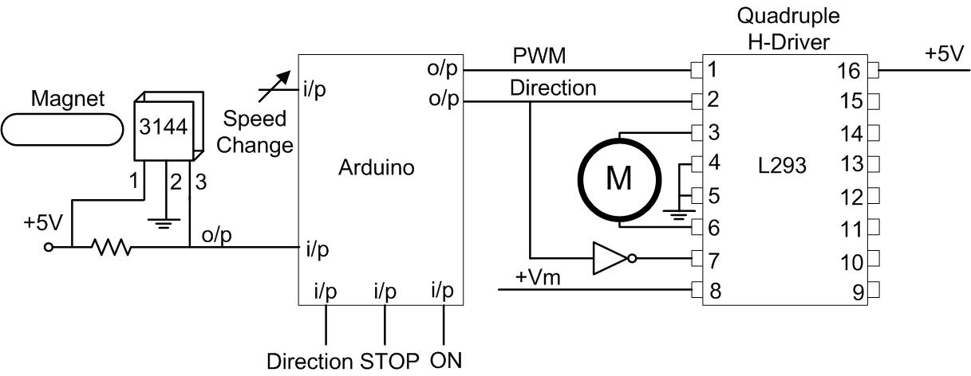
Figure 1. Open-loop control circuit.

Overview, hardware implementation
The purpose of this task was to create an open-loop, user-based control of the motor system. First, proper hardware had to be chosen and constructed on the breadboards. To power the motor, a Quadruple H-Driver L293D has been placed on the breadboard. Next to the driver, an SN54/74LS04 Hex inverter has been positioned so as to have an inverted input for the connection nr 7 of the driver.
A second breadboard has been used for user input & control. This solution was chosen as the user does not need to interact with the other breadboard at all, and all the other connections are constant for all sections. Before connecting up the hall effect sensor from the motor up to the breadboard, my Electronics skills were first successfully tested on a fan & standard Hall Effect sensor. An additional element has been added – a pushdown LED to prevent uncontrollable spinning during launch. It also provides a nice indicator that the motor should be on should something go wrong. Below is the fritzing circuit layout for the system.

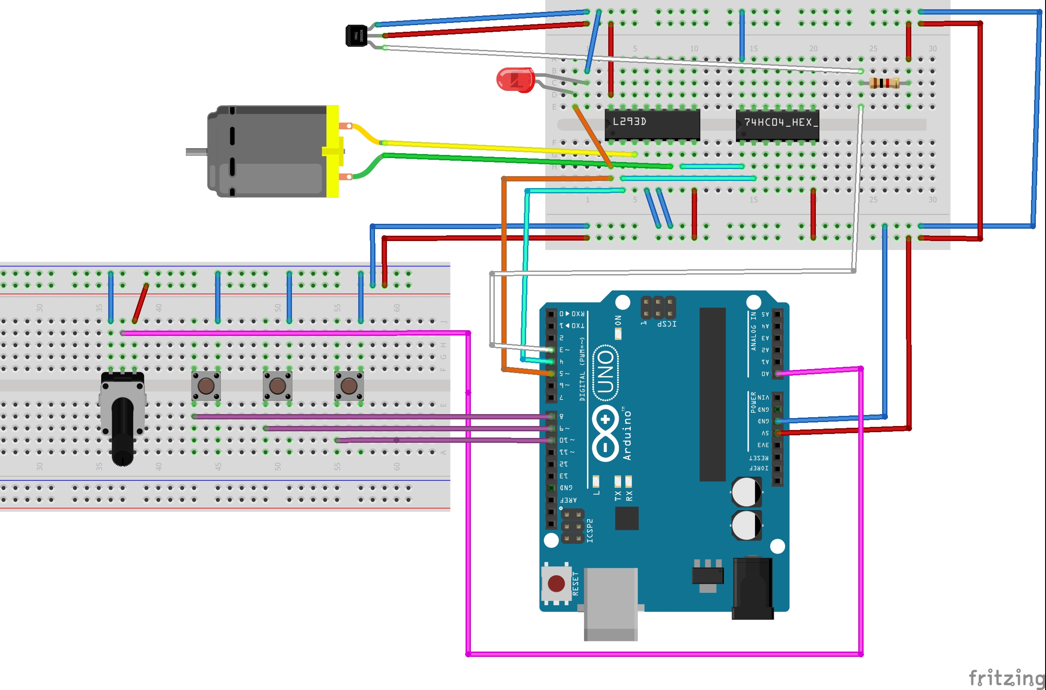
Figure 2. Fritzing circuit layout. Note that due to the motor not being a component in the software, a simple Hall Effect sensor was put separately.

Software implementation
After correctly connecting all the components and making some basic tests on the motor (such as simply switching on the pin responsible for power etc – please see SimpleMotorControlNoObject.ino), a proper software had to be written for the open-loop control. This task was not particularly challenging as a lot of the components could be reused from Activity 1. A lot of the heavy lifting has been done in classes either provided by the course coordinators or through code I have written myself for Activity 1 – for example, accepting input via potentiometer or buttons has been taken (and slightly modified) from the previous lab report.
Perhaps the most interesting part of the class is how the motor has a minimum value at which it spins, as well as a jumpstart value it needs to go to when starting from scratch. The reason for that has to do with how electric engines (motors) operate – they need a certain starting torque to begin rotation. Once the engine is spinning and has sufficient torque, the voltage delivered can be lowered (it will result in a slower spin, too).
The pin can give values from 0 to 255 (which, in reality, represent the duty cycle on the pin- from 0 to 5V). I have empirically deducted what these values should be when operating with the pushdown LED and the motor will still controllably spin at a value of 50. For the jumpstart value, I have given it a value of 90 that will be applied for 1.2s. I didn’t actually have to create a separate function to jumpstart the engine – by default, the unit will wait for 1.2s between any inputs, which gives the motor enough time to start spinning fast enough. I have chosen the value of 1.2s empirically, by checking how long the motor needs to not die upon launch from a jumpstart. It is also long enough for the system to switch direction for any motor speed.
Another feature of my system is that it will not “die” without pressing the OFF button – meaning that if the user spins the potentiometer to 0, it will stay at the minimum value. This makes it robust & intuitive for the user. Please see Motor.h library.

Minimizing noise
The speed measurement has been implemented outside the motor. This design decision has been undertaken in mind with the modularity of the system – the motor does not need a speed measurer to work, nor does the speed measurement have to work only with the given motor. It also eases the communication between the PID control, motor and the speed control.
The readings for the Hall Effect sensor are quite noisy by themselves – while this is not that big of a problem when a human is looking at them, such big dispersion between readings is unacceptable when “upgrading” to closed-loop control. In order to minimise the noise between two given readings, I used the provided Simple Moving Average speed measure. This way of measuring speed takes n previous points and creates an average point together with the current one. The one problem with this method is that it takes a relatively long time to update to the “real” value, as well as it still is noisy with high speeds – but it’s not as spurious as the first method. This allows it to be used in PID control, which will be discussed in the next section.
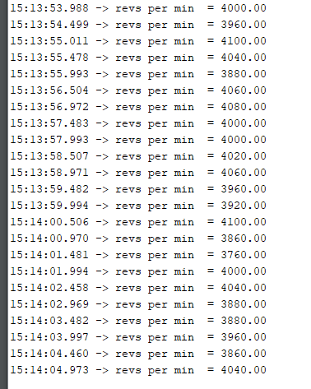
Figure 3. Readings without the average moving filter, at 500ms sampling time.

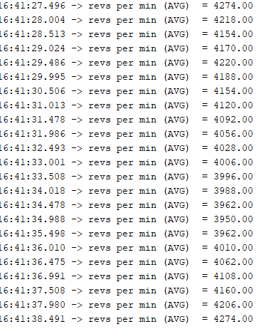
Figure 4. Readings with the average moving filter. Not much better :D

Lower-Intermediate: Closed-Loop Control (max 5 pages)

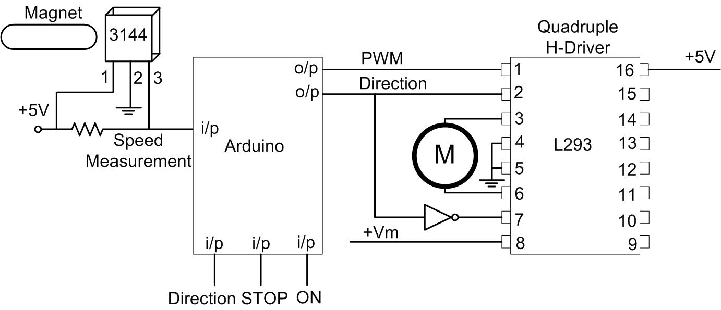
Figure 2. Closed-loop control circuit.

Overview of the task
For this and remaining tasks, the hardware remains unchanged. What does change, however, is the software – in my implementation, I have created a motor class that inherits from the one from section 1. What needs to be updated here is how the potentiometer behaves – now it needs to set the target RPM instead of adjusting the RPM itself. It also needs to have it’s method that turns the motor on updated so that it doesn’t do the jumpstart.
Thanks to the modularity of all the functions in the base class, overall the modifications are minimal.
While testing out the target pwm properties, I have found that some of the readings from the potentiometer were quite spurious. I have modified my updatePotentiometer() function to be mostly invulnerable to these spurious readings.

Determining the appropriate PID gain values to obtain a stable step response

Subsection (title and expand, if needed; remove otherwise)

Higher-Intermediate: Step-Response (max 5 pages)

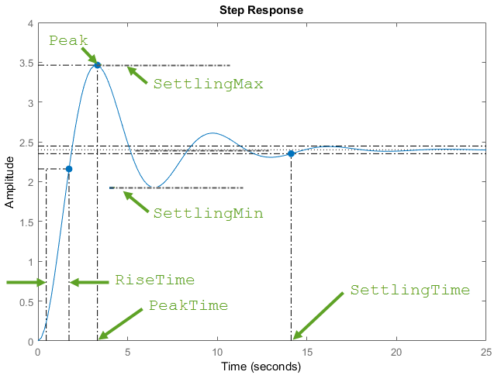
Figure 3. Closed-loop control circuit.

Sustainability environmental and ethics considerations

Advanced – details based on your student ID (max 5 pages)

Adjust PID gains to obtain a set objective

Positional Control (distance travelled)

Appendix (code)

Appendix for Section 1

Appendix for Section 2

Appendix for Section 3

Appendix for Section 4

