# **Linux Commands Assignment Report**

## **1. Creating and Renaming Files/Directories**

$ mkdir test_dir  
 $ cd test_dir  
 $ touch example.txt  
 $ mv example.txt renamed_example.txt

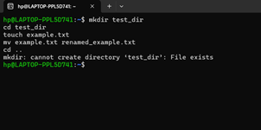

## **2. Viewing File Contents**

$ cat /etc/passwd  
 $ head -n 5 /etc/passwd  
 $ tail -n 5 /etc/passwd

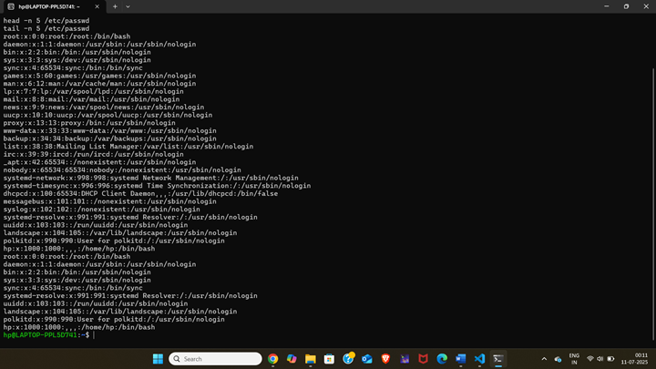

## **3. Searching for Patterns**

$ grep "root" /etc/passwd

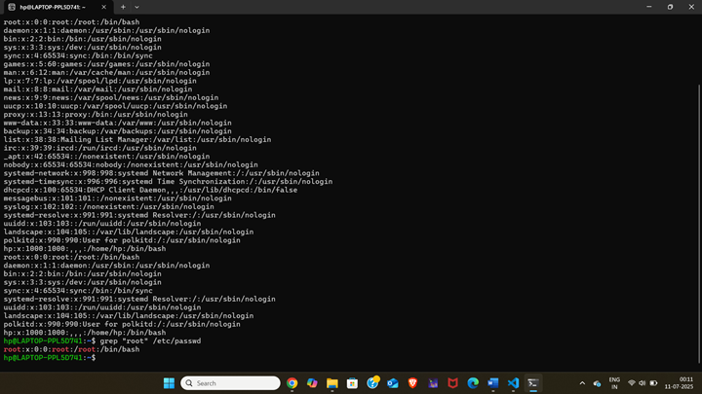

## 

## 

## 

## 

## 

## 

## 

## **4. Zipping and Unzipping**

$ zip -r test_dir.zip test_dir  
 $ unzip test_dir.zip -d unzipped_dir  
 $ ls  
 $ ls unzipped_dir/test_dir

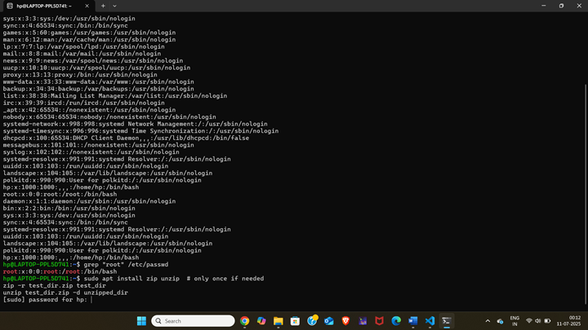

## 

## 

## 

## 

## **5. Downloading Files**

$ wget https://www.gnu.org/licenses/gpl-3.0.txt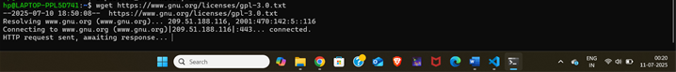

**6.Changing permissions**

$ touch secure.txt  
 $ chmod 444 secure.txt

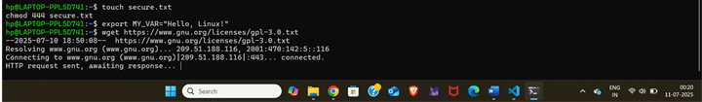

## **7. Working with Environment Variables**

$ export MY_VAR="Hello, Linux!"  
 $ echo $MY_VAR

mkdir -p test_dir: Creates a directory named test_dir if it doesn't exist.

cd test_dir: Changes into that directory.

touch example.txt: Creates an empty file named example.txt.

mv example.txt renamed_example.txt: Renames the file.

cd ..: Goes back to the parent directory

cat: Displays the full file content.

head: Shows the first 5 lines.

tail: Shows the last 5 lines.

zip -r: Recursively compresses the directory.

unzip: Extracts into the unzipped_dir.

touch: Creates the file.

chmod 444: Makes it read-only.

.

## **GitHub Repository Link**

<https://github.com/V123456789-K/linux-commands-assignment>