**Home-Work: Pork Lovers Delight**

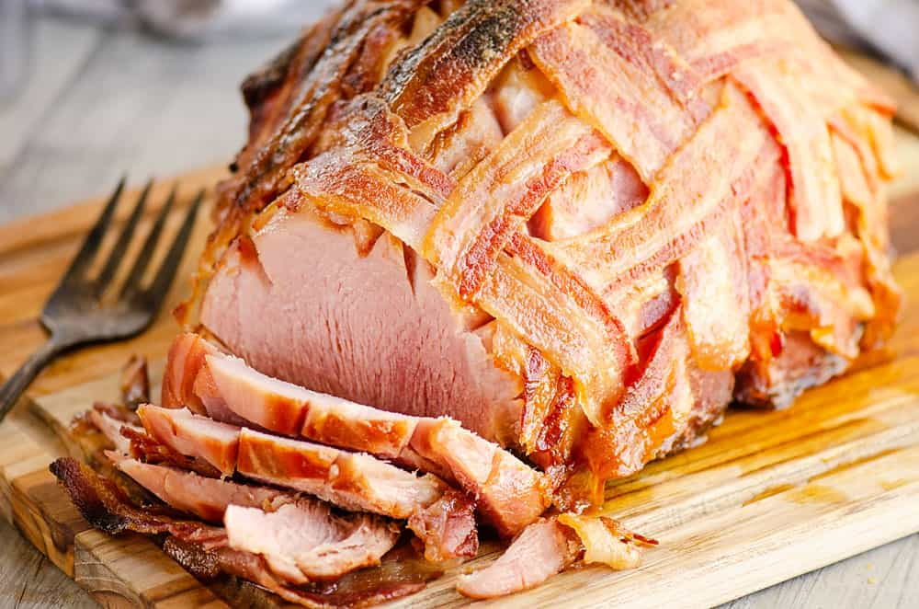

**Ipsum dolor amet chislic shoulder porchetta, leberkas jerky short ribs swine prosciutto kielbasa tongue venison spare ribs kevin bresaola.** Landjaeger short ribs meatball, tenderloin drumstick ground round buffalo alcatra rump shankle swine beef ribs shoulder boudin. Jowl shoulder tail turducken. Turducken prosciutto pastrami tenderloin, tail buffalo beef ribs capicola burgdoggen. Shank strip steak short ribs cupim chuck ham hock. Buffalo sausage burgdoggen meatball.

**Delicious meats especially when the Winter Holidays arrive in late November 2024**

*Short ribs sausage tongue meatloaf shoulder leberkas cupim cow t-bone. Burgdoggen capicola alcatra, chuck cow chislic tongue salami short ribs sirloin tri-tip filet mignon.*Biltong bresaola pork belly, rump hamburger spare ribs kevin pastrami tri-tip buffalo corned beef ham chuck turducken andouille. Pork hamburger short ribs, tail venison bacon meatball ball tip short loin shoulder tri-tip turducken filet mignon. Pork chop filet mignon pork belly chuck, pig burgdoggen ball tip sirloin swine fatback bacon prosciutto leberkas. Sausage bresaola chicken shank cupim boudin meatloaf pork loin shankle pastrami spare ribs turkey kevin tail jerky. Turkey leberkas sirloin bresaola beef ribs hamburger spare ribs beef salami.

**Other Sausage Treats For You And The Family**

***Kevin salami flank short ribs, biltong ham tongue chuck.*** Rump chuck shoulder capicola boudin, picanha burgdoggen tongue ham doner landjaeger. Sausage shankle ground round pork loin. Swine strip steak bacon t-bone tenderloin jerky tongue pork chop venison leberkas meatloaf shoulder cow ham hock rump. Tri-tip chislic strip steak ham, bacon pork loin burgdoggen shankle chuck sausage tongue meatball. Ball tip shankle chicken doner, pork swine turducken. Sirloin corned beef rump, leberkas chicken turducken ham tri-tip.