**CS F213   
Object Oriented Programming**

**PROJECT REPORT  
Car Parking Slot Booking Web Application**

**GROUP 59**

Vibhum Raj Tripathi (2020A70247H)

Aditha Venkata Animesh (2020A7PS0193H)  
Ayush Agarwal (2020A7PS0160H)

Manan Mayur Popat (2020A7PS0029H)

**UML Class Diagram**

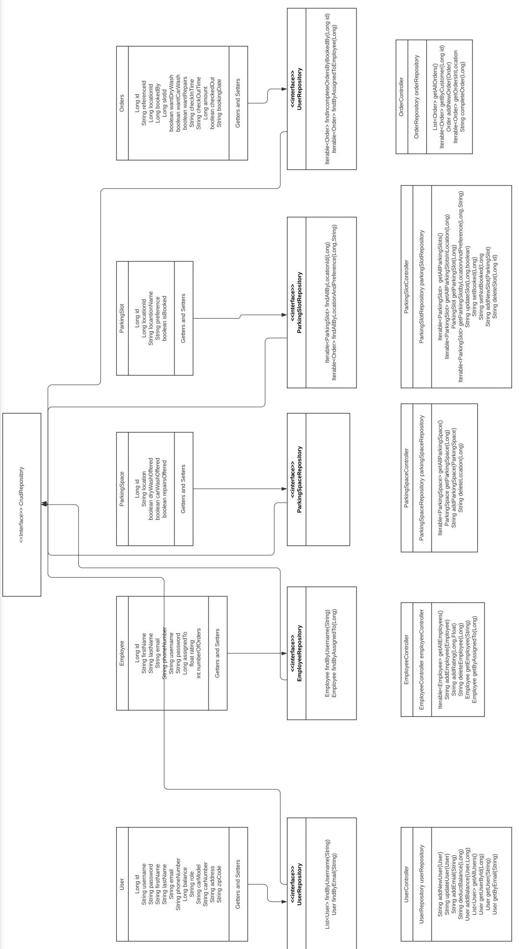

**Implementation Report:**

**Front-end:**

**1.** **React:**

* **React-Router**: Used for traversing between the various pages in the website.
* **React Functional Components**: Used to make the pages for re-usability and storing states of objects.
* **Regex**: Used for validation of various fields like email, mobile number, zip code, car number plate, etc.
* **Axios**: Used to send get, post, update and delete requests to back-end to get and send data from the database.

**2. CSS**

* For styling the page, only native CSS hierarchical filtering and style attributes are applied.

**Back-end:**

**1.** **Spring Boot:**

* **Spring Data JPA**: Used to create and store tables in the SQL database.
* **Rest Controller**: Used to create a rest controller for various objects to get, add, update and delete entries in the database.
* **Java Mail Sender**: Used to send confirmation emails and forgot password emails to the user.

**2. Firebase:**

* **OTP Verification**: Used to verify a user’s mobile number by generating and verifying OTP.
* **Google Sign-In Authentication**: Used to allow a user to login using their Gmail account.
* **Facebook Sign-In Authentication**: Used to allow a user to login using their Facebook account.

**Database:**

**1. SQL Database**: Used to store the various objects’ information in well organized tables.

**2. Firebase**: Used to store user’s email and mobile numbers for verification and sign in.

**_______ Overview of the Project_______**

1. **LOG IN / SIGN UP**

* Admin is required to enter their username and password, after which the Admin Dashboard appears.
* Car owner users, if using the application for the first time, have to register by filling the details and verifying their mobile number through OTP.
* After successful registration, the user can Login by providing their username and password.
* The user also has the option to sign in through Google or Facebook by clicking on the Google/Facebook Sign-in button respectively. This is followed by asking the user for additional details.
* (Additional functionality) There is a Forgot Password button that sends an email specifying the password on providing the correct username and email address.

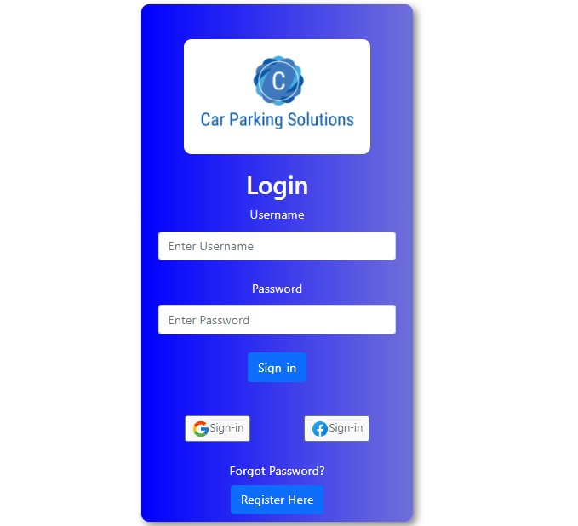

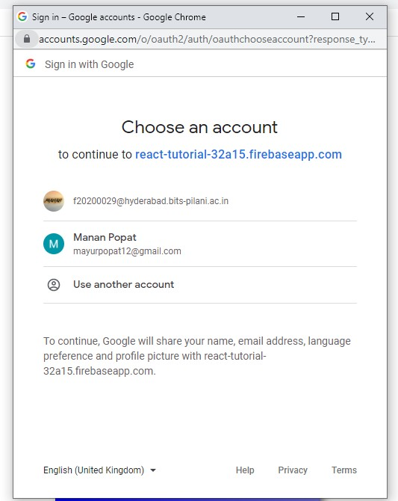

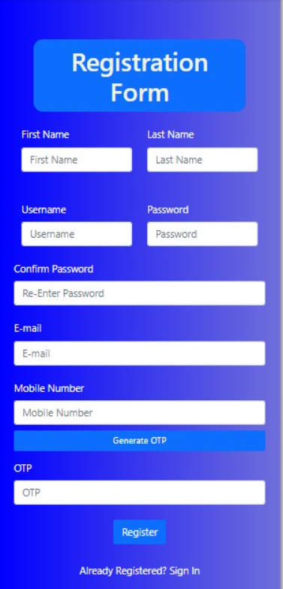

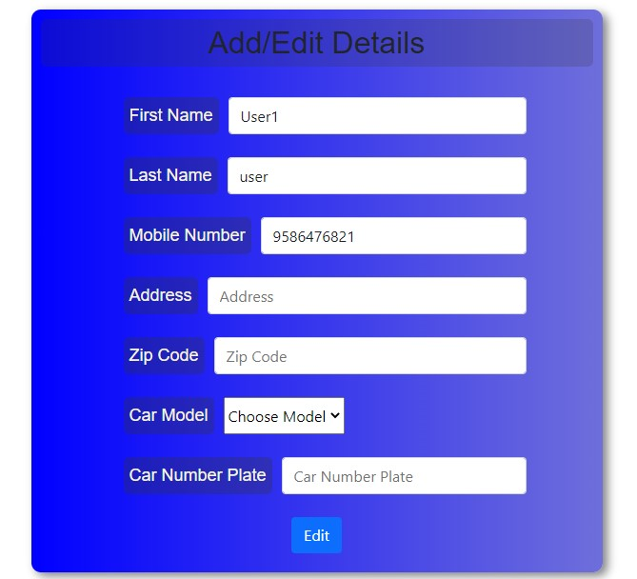

1. **DASHBOARD**

* There is an Admin Dashboard which allows the admin to manage/ add/ delete employees, parking spaces and slots.
* The Employee Dashboard can be used to notify the workers about what services (such as repairs, dry cleaning, car wash) they have to provide to the parked cars.
* The User Dashboard will allow the user to select location, check-in and check-out times (for the available slots), services offered as per his/her vehicle model.
* It also displays the cost of parking and additional services, along with the worker’s name and rating.
* (Additional functionality) Depending on the location and space, a suggestion (preference size) is also displayed beside each slot for the most suitable size of car or vehicle.

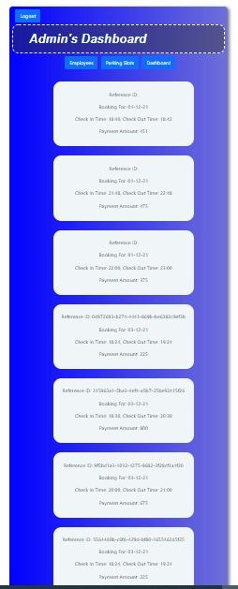 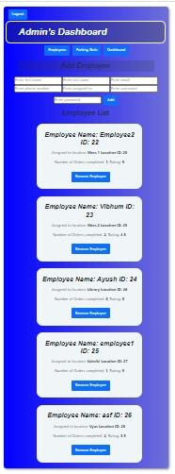

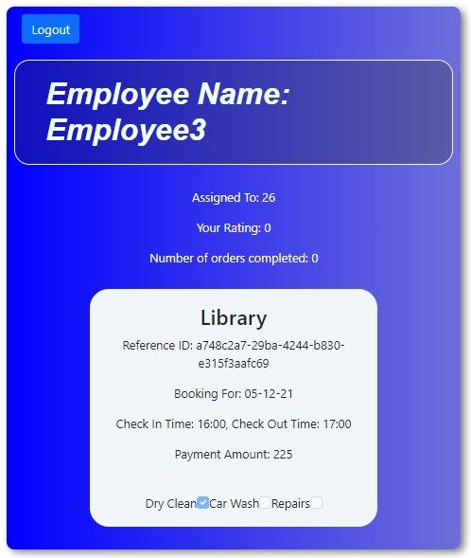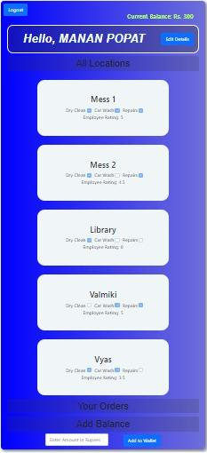

1. **MANAGE PARKING SPACES & PARKING SLOTS**

* The admin can add, delete and manage parking slots through his dashboard.
* He can also add and delete any employee.
* A report of all workers’ details such as their user ratings, number of orders completed is also shown.
* Car owner users can view their booked/allocated parking spaces and employee information.
* Upon successful booking of a particular slot, it is no longer visible to future users. Also, an email notification of ‘Booking Confirmed’ is sent to the customer.

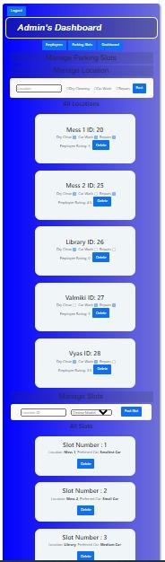

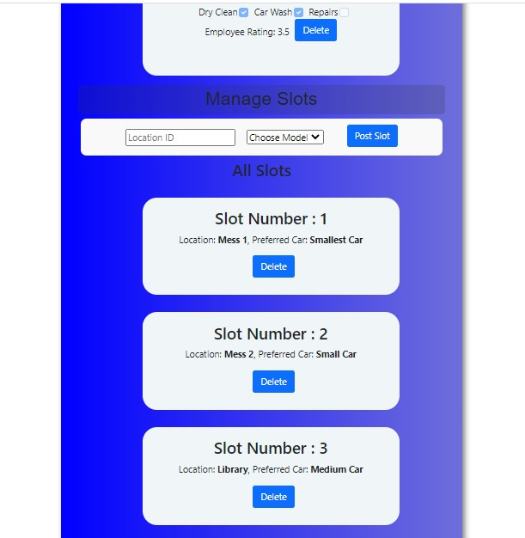

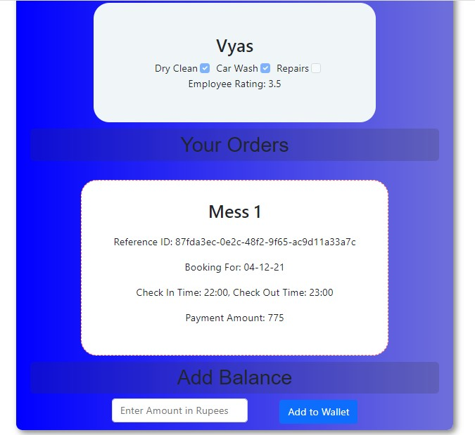

**4. BILL PAYMENT & FEEDBACK**

* During Checkout, the amount to be paid is calculated as  
  25 x No. of hours the car is parked (Check-out time - Check-in time)

+

Additional Cost for Services provided (Dry cleaning = Rs. 100, Car wash = Rs. 250, Repairs = Rs. 300)

* That amount is automatically deducted from the wallet and the user is notified of the same through an email.

**Additional Functionality**

● Depending on the car model and size, suggestions are given to the user about the most suitable slots among the available slots (*Smallest car, Small car, Medium car, Big car, Biggest car*).   
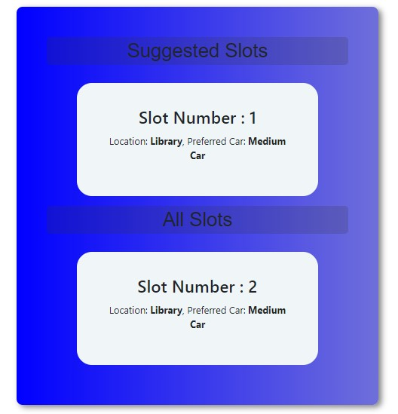

Bonus Features and Key Points

* There's an additional feature of a Logout button at the top left corner of each module except sign in.
* The webpage should be reloaded whenever a new query has been performed on the SQL table to ensure the updated data is shown.

***