Sudan

Prompt:(Write the letter which is most likely to get a response from the dictator / national embassy, which will help put you in a position to make the country more successful. I'm looking for expert local knowledge here that could give you a political edge to make the country great again. It's your responsibility to make the world a better place, but you'll need to get somebody's attention, somebody with power.)

To be able to write a persuasive letter with the hopes of making the world a better place that is likely to get a response from a politician, one must talk about ideas that will benefit the people in charge while also providing a better future for the people leaving in the country. To achieve that one must have good diplomatic skills combined with in-depth knowledge of the country, the people leaving there and the people in charge.
Let’s see what information we have about Sudan:
Sudan (Official name: Republic of Sudan), is a country in Northeast Africa. Its population is 45.7 million people as of 2022. Sudan is considered to be one of the most corrupt nations in the world.
On Transparency International's Corruption Perceptions Index ranking conducted in 2021(1), Sudan ranked 164th out of 180 countries, with a score of 20/100 (with 100 being very clean and 0 being highly corrupt).
On World Bank Worldwide Governance Indicators(2) with a scale from 0 to 100 (%), Sudan scored a single digit in almost every category for the past 11 years as of 2021 (2010 - 2021), the main ones that we are interested in being:
Rule of Law (perceptions of the extent to which agents have confidence in and abide by the rules of society, and in particular the quality of contract enforcement, property rights, the police, and the courts, as well as the likelihood of crime and violence)
Control of Corruption (perceptions of the extent to which public power is exercised for private gain, including both petty and grand forms of corruption, as well as "capture" of the state by elites and private interests)
Government Effectiveness (perceptions of the quality of public services, the quality of the civil service and the degree of its independence from political pressures, the quality of policy formulation and implementation, and the credibility of the government's commitment to such policies)
Regulatory Quality (perceptions of the ability of the government to formulate and implement sound policies and regulations that permit and promote private sector development)
Political Stability and Absence of Violence/Terrorism (perceptions of the likelihood of political instability and/or politically-motivated violence, including terrorism)
And here is the data between 2010 and 2021:
Series Name | 2010 | 2011 | 2012 | 2013 | 2014 | 2015 | 2016 | 2017 | 2018 | 2019 | 2020 | 2021
Rule of Law | 6.64 | 7.51 | 8.92 | 7.98 | 9.13 | 8.17 | 8.65 | 11.54 | 10.58 | 11.06 | 13.46 | 10.1
Control of Corruption | 8.57 | 9 | 0.47 | 0.47 | 3.37 | 3.37 | 3.37 | 2.88 | 6.25 | 5.77 | 5.77 | 7.69
Government Effectiveness | 6.22 | 5.69 | 5.21 | 4.27 | 4.81 | 5.77 | 5.77 | 6.73 | 4.81 | 4.81 | 5.77 | 5.29
Political Stability | 0.95 | 0.95 | 2.37 | 2.37 | 3.81 | 3.81 | 2.86 | 5.71 | 6.13 | 6.13 | 7.08 | 5.19
Regulatory Quality | 6.7 | 8.53 | 5.69 | 6.64 | 5.77 | 4.81 | 5.77 | 3.85 | 4.33 | 4.81 | 5.29 | 5.77
Here are some charts for better visualize what we are working with:
Here we have the above data but plotted on a graph:
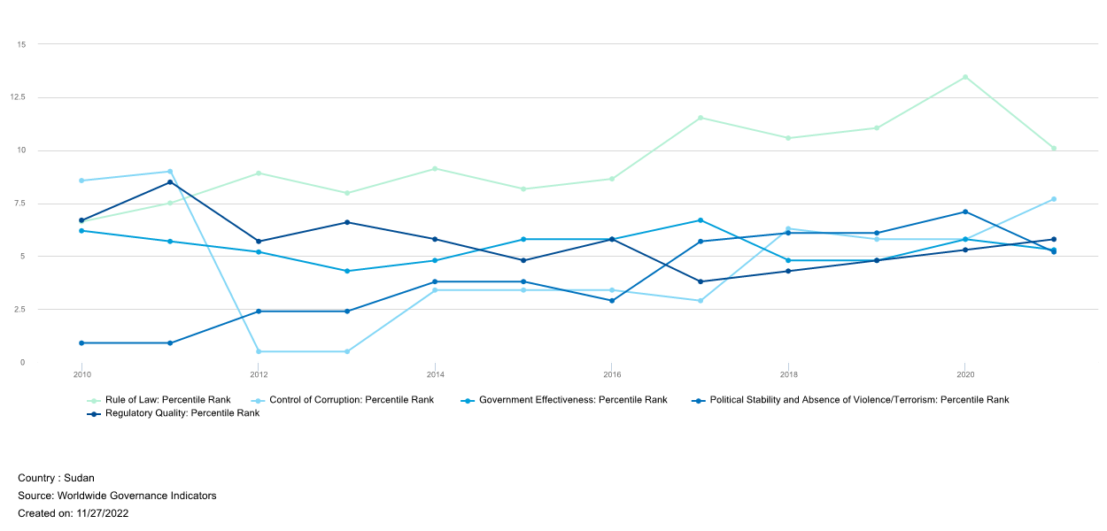
However to see where is the problem we need to compare the data with the same data from another country. Let’s take Ireland for example:
Here is the same data but for Ireland:
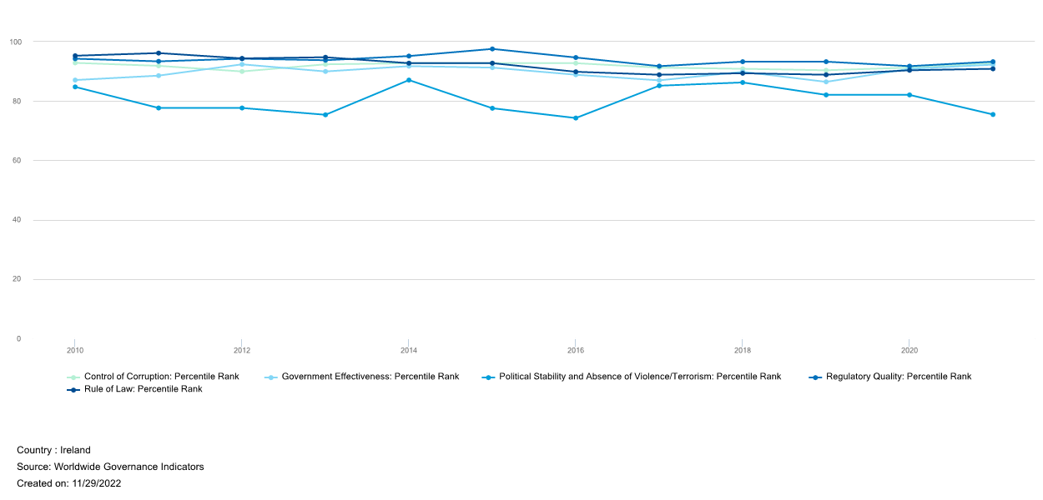
If don’t look deep into the graphs, we might wrongfully assume that Sudan is not that bad, however, we are missing one key ingredient: Scale! Let me show you:
Here is the same information as the graphs above, but everything is placed on one graph:
(The top 5 lines represent Ireland, and the bottom 5 represent Sudan)
Needless to say, we have the information to show that what is currently happening in countries like Sudan is concerning. But many questions arise when we start comparing countries like:
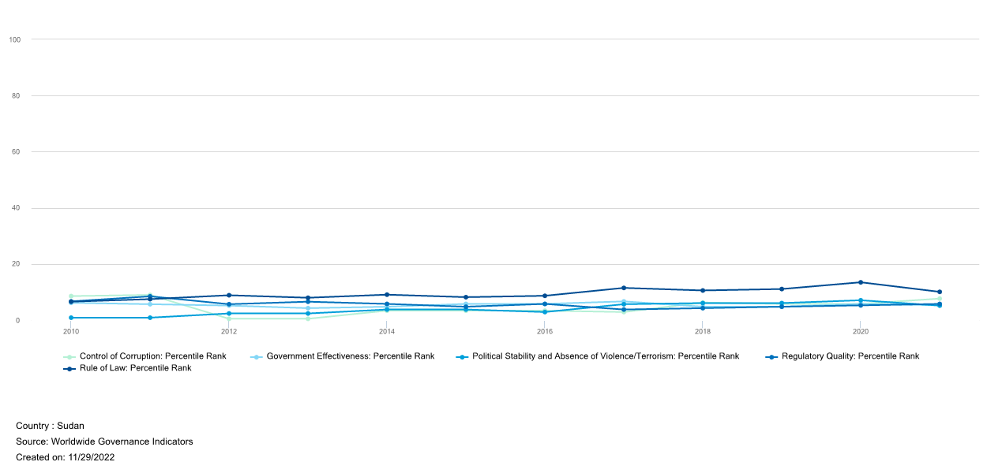

What led to that kind of situation?
We have two types of information. The history of how the country was created and the data about how the corruption in Sudan. Knowing the past of the country may help us understand how foreign interventions formed the country and correlate this to corruption and lawfulness.
So let’s see what we know:
Sudan was colonized in 1898 by the British Empire and split with Egypt. The British ruled over the north and the Egyptians ruled over the south. Britain used its power to encourage Islam in the northern part of the country, while in the south, they allowed the power to be shared between many tribes with Christian missionaries running the education system. That allowed Britain to divide and control Sudan, however, that brought the side effects of socioeconomic tensions that played a role in Sudan’s future conflicts.
Sudan gained independents from British colonial rule in 1956, however, because of Sudan’s strategic placement in the world, many countries competed to influence its future. This led to an influx of weapons from superpowers like the United States of America and its adversaries. This increased the already existing tensions between the northern and southern parts. Earning the title of “Africa’s arms dump” for the country. This continued during the cold war, with the USA selling Sudan nearly 1 billion dollars worth of arms. Nowadays Sudan become a big arms exporter reselling most of that equipment to Russia.
As we can see the situation in Sudan was not a pure coincidence. First, because of the British colonial policies, it inherited many religious and ethical tensions. Also, because of Sudan’s strategic location, it happened to be armed to the teeth of huge countries. As a result, Sudan suffered 2 civil wars only 11 years apart: from 1972, and 1983 – 2005. This caused hundreds of thousands of casualties, leading to the collapse of the economy, which in turn worsened the political instability, which made the country spiral down to total lawfulness.
In 200? South Sudan gained independence from the north and ended up losing 75% of its oil reserves, the main source of income for the country.
At this point, the military of Sudan took control of the former ruler in 2019, and manage to keep control of the north despite sanctions from the world powers.
The ruler for over 3 decades (3), was Field Marshal Omar al-Bashir(4), and he was in control of Sudan from June 1989 to April 2019. In 2019, 8 months after Omar al-Bashir was forced from office in April after months of anti-government protests, the former president was summoned to the court in Khartoum (capital of the north) facing charges of money laundering, possession of illicit foreign funds and corruption, after suitcases containing millions of dollars were discovered at his home.
He admitted to receiving millions of dollars from Saudi Arabia but denied the usage of that money for private purposes. The former leader of Sudan was sentenced to 2 years in prison, while the expected time for that kind of crime is at least 10 years. He also was indirectly responsible for the killings of demonstrators right before he was overthrown, but this was not accounted for in his sentencing.
During his ruling, Omar al-Bashir was charged by the International Criminal Court (ICC) with 2 counts of war crimes, 5 counts of crimes against humanity, 3 counts of genocide, inciting the killing of protesters, possession of illicit foreign currency, and corruption. He is also accused of genocide in the state of Darfur. The UN estimates that 300 000 people were killed during the conflict there. After he was overthrown, the UN wanted the new government to extradite Omar al-Bashir, so that he can be held accountable for his actions by the ICC.
Despite all these allegations, the new government led by General Abdel Fattah al-Burhan(5) also a military leader declined the request of the ICC.
In politics, everyone can have their own opinion, so here is mine based on the information above:
I don’t believe that what Omar al-Bashir did can’t be excused in any way. I also think that he should be by all means taken out of Sudan to be held accountable for the crimes he has committed. As to the economic situation in Sudan over the years, what happened can be related to the external powers influencing the politics in Sudan due to its strategic location and resources, but the decisions taken by the political elite made the situation even worse.
Knowing the past and the present, what can we predict?
As of now, the government is again under the rule of the military. And so if we look back at what happened in the past, the future of Sudan is not looking bright. As we can see apart from some periods, where the ruling of the country was shared broadly, Sudan has for the past 50 years predominantly been ruled by military regimes. Furthermore, the military is in a pretty comfortable situation since there is no real challenger to force them out of power. In addition, they have no incentive to allow accountability and rule of law, since the moment the county moves to any form of democracy, many dark secrets will surface. That almost certainly will bring everyone that is now in power, or was in power to be held accountable for their actions, either by the ICC or put in prison by independent local courts. So if I had to make an educated guess as to what will happen next, I think it is highly probable that the military is going to stay in power for a while. However, no hope is lost, since in the past the people already overturned the government once. This is not a question of if, but when it will happen and what can be done then.
When that happens, how can we make sure that Sudan stays resilient to corruption and have independent courts and government in the future?
Let us look at other local countries that had a similar history and now are thriving economies(6). As it happens the history of Nigeria is almost a copy of that of Sudan. But now it is prosperous despite a similar past. So what did they do to achieve that? After reading about Nigeria(7), as it turns out, the successor of their dictator, despite being a military general, took power with a coup, he adopted a modern constitution ensuring free elections with multiple parties. Then he held an election and handed over power to the representatives elected. From my research, one crucial difference, compared to other local leaders is that he studied at Kaduna Technical College and is not coming from a military academy. This brother civil education allowed him to have more modern views.
The problem with what happened last time in Sudan, when the military ruler Omar al-Bashir was overturned, was that the democratic changes did not hold. The people’s representatives were initially included in the government along with the military but were thrown out by the new 60 years old military leader Abdel Fattah al-Burhan before they even finished their first 3-year term. Which in essence didn’t change much compared to the situation under the previous ruler. Neither did his right to sweep in and take full control of power.
Knowing that I believe that the answer to that question is straightforward. Making sure that whoever is in charge next, like in Nigeria knows better and is ready to use his power to turn the country around.
Having the information we can write a persuasive letter with one clear goal in mind: To make Sudan more successful in the future.
What we can use to provoke a dictator to allow that?
After thinking about it, the most likely pitch to give results is to leverage the age of the dictator, now in his 60s, and let him think about his legacy and what he will be remembered with. Instead of pledging for democracy, we can advocate for creating better economic conditions that will allow our country to get out of poverty. We can offer to educate the youth of his country in entrepreneurship as well as in business law to ensure the economy can progress and survive under his protection. Eventually, this will create a well-educated elite able to achieve our set goal in the long run.
So without further ado, here is what an example letter may look like:
Subject: Capital of Sudan to be renamed to Abdeltown
Dear General Abdel Fattah al-Burhan,
Imagine one day the capital of your country Sudan is named after you by the grateful future generations.

I am writing to you today as a student at Maynooth University of Ireland regarding a project I am currently working on. The idea of the project is to pick a country and learn its past and present to help with ideas on how to make it more successful. I picket your country because it has great potential and has suffered enough in the past three decades.
The youth of Sudan is the key to your future. Help your loyal young people to learn technology, business and economics. That will allow them to make new businesses that will generate the capital needed to prosper as well as revive your industry.
You probably already thinking about what will be your legacy. That is why it is so important how future generations will remember you. Look around how countries with similar colonial pasts, thorn for years by wars, transformed in a short span to stable economies and peace under great leadership.
I would like to propose sending your future leaders to learn in Ireland where the education is world-class and is one of the fastest growing economies in Europe. Such a move will allow them to bring back this knowledge home and build a local education system with your support.
You can also, prepare the business environment for local enterprises by creating equal opportunities for competition in a lawful and peaceful country. Businesses should not be afraid that competition will bribe the government or courts against them.
Those moves will take time and effort but if you bring prosperity and security to your people your name will for sure be remembered. And who knows, one day, the capital of Sudan will be named after you.
Thank you for your time. It is a great honour for me if you read this and if you chose to respond to my pledge.
Yours Sincerely,
Viktor Ilchev from Maynooth University of Ireland

